**Move Know Files**

Description :

Steps How to use the bot:

1. Create an Excel File with the name “FileTypes.xlsx” or download it form my [github](https://github.com/AshishUipath1/MoveKnownFiles/raw/main/FileTypes.xlsx) URL.
2. Rename the sheet with the “File Types”.

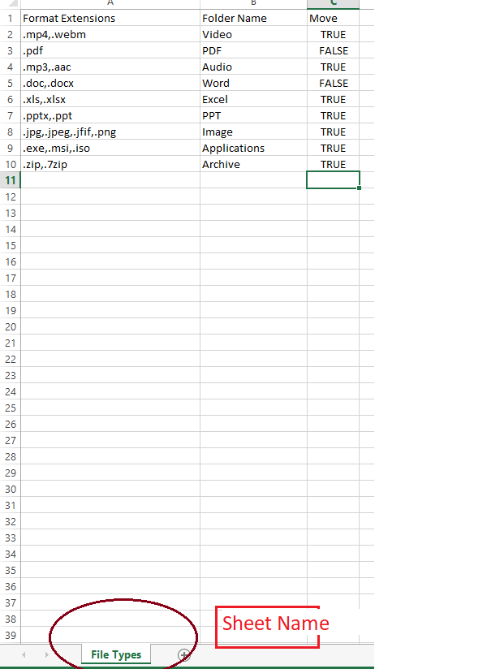

1. Then Move this excel file to a folder , and then pass the path of the folder(Not File) to the argument known as **“in_strExcelPath”.**
2. Then pass the folder where you want to run the bot , eg. In Downloads folder you want to move all similar types of files to the folder so pass the path of the download folder in the “**in_strFolderPath**” .

Eg. “C:\Users\<User-name>\Downloads”.

1. Then Open the Excel file and create three columns if you have not downloaded the file from the [link](https://github.com/AshishUipath1/MoveKnownFiles/raw/main/FileTypes.xlsx).
2. Format Extensions 2. Folder Name 3.Move
   1. then in the format extensions enter the extensions of the file you want to move

eg. Video file contains different extensions .mp4,.webm etc

then make the entries a comma separated entries , eg. “.mp4,.webm”.(Don’t forget to add dot(.) in front of extensions.

* 1. Then the Second Folder contains the name of the folder where you want to move the files of that corresponding extensions. The bot will Create the folder into the same folder.
  2. The third folder contains the value if you want to move the files of that extensions or not

**Arguments**

1. **in_strExcelPath :- “**Path of the folder where Excel File resides.”
2. **in_strFolderPath:- “**Path of the folder where u want to run the bot”.
3. **in_strOnOffFeature :- “**Pass the value as ‘true’ or false’ “.

This true or false value decides whether you want to use the 3rd Column of the Excel or not.

If you set it True , it will consider to 3rd Coolum of Excel and decide whether to move files or not.

If you set it False , then it will not consider to 3rd Coolum of Excel, and move all the files to their specified folder.

If you don’t provide any value then the value of this argument is considered to be as true.

