Table of Contents

1. Introduction ------------------------------------------------------------------------------------
2. Overview-----------------------------------------------------------------------------------------
3. Team Member Work Allocation-------------------------------------------------------------
4. Epic & Stories -----------------------------------------------------------------------------------
5. Use Cases ----------------------------------------------------------------------------------------
   * 1. Product Management System -----------------------------------------------------------
6. Add a Product ---------------------------------------------------------------------
7. Edit a Product ---------------------------------------------------------------------
8. Delete a Product------------------------------------------------------------------
9. Add a Product Master------------------------------------------------------------
10. Search a Product------------------------------------------------------------------
11. Filter a Product -------------------------------------------------------------------
    * 1. Address Management System-----------------------------------------------------------

A) Add an Address--------------------------------------------------------------------

B) Update an Address----------------------------------------------------------------

C) Delete an Address-----------------------------------------------------------------

* + 1. Wishlist Management System -----------------------------------------------------------

A) Add a Product ---------------------------------------------------------------------

B) View Wishlist ---------------------------------------------------------------------

iv)Adding Item To cart------------------------------------------------------------------------

v)Placing the Order---------------------------------------------------------------------------

vi) Cancel Management System-------------------------------------------------------------

A) Cancel an Order--------------------------------------------------------------------

B) Cancel a Product-------------------------------------------------------------------

vii) Shelf Time Report------------------------------------------------------------------------

viii)User Management System-----------------------------------------------------------

A) User Registration--------------------------------------------------------------------

B) User Login----------------------------------------------------------------

C) User Logout-----------------------------------------------------------------

ix) Retailer Inventory Management System-----------------------------------------------

A) View Inventory

B) Update Receive Time

C) Update Sale Time

x) Go Admin Report Management System

A) Revenue Report

B) Growth Report

xi) Delivery Time Report --------------------------------------------------------------------

1. Class Diagram ----------------------------------------------------------------------------------
2. ER Diagram--------------------------------------------------------------------------------------
3. Test Case Scenario -----------------------------------------------------------------------------
4. BDD------------------------------------------------------------------------------------------------
5. Conclusion----------------------------------------------------------------------------------------

# Introduction

Real Estate Management System is an app for selling or buying the properties like villas, flats, apartment, plots. This app enables admin to add the properties for selling. The best property will be displayed first to the customer by recommending as per requirement.

Overview

Real Estate Management System have the following micro services:

* User Management
* Property Management
* Admin Functionality

The model followed was an agile model. Agile SDLC model is a combination of iterative and incremental process models with focus on process adaptability and customer satisfaction by rapid delivery of working software product. Agile Methods break the product into small incremental builds. These builds are provided in iterations.

The project had eight sprints to undergo. Every sprint had incremental learning. The first sprint had design and BDD/TDD implementations to display followed by core java and collection implementation in the second sprint. The database was static made through collections to enhance and have a practical knowledge on the collections framework. The third sprint had JDBC implementation in the middle layer. The UI was not yet done so we had a presentation layer in core java itself to test our functionalities.

Team Member Work Allocation

* Ashish Verma-
* Nishant Sharma-
* Shivam Singh
* Sumit Gupta

Epic & Stories

|  |  |  |  |  |
| --- | --- | --- | --- | --- |
| **Epics** | **Stories** | **As a/an** | **I want to** | **So that…** |
| **User Management System** | Sign Up to the application | User | Enter the details to sign up | A new user’s data is added to the database |
| Login/Logout Session | User | Enter the details to Login | To gain access of the application and logout |
| Change Password | User | change account password | User can fulfil password related constraints during sign up. |
| Forget Password | User | Recover password | An email is sent to user containing the password. |
| User profile & Privacy settings | User | Add User’s additional details | A user may add additional Information |
| **Property Management System** | Add a property | User(Seller) | Enter the property details and Image | A new property is added to the database |
| Update a property | User(Seller) | Change the details entered for the property | To update the property details |
| Delete a property | User(Seller) | To delete a property | Property will be deleted from the database |
| Search Property | User(Buyer) | Search for property | User can search for the property according to the requirements. |
| View Image | User(Buyer) | View image of property | User can check the site before visit |
| Download Brochure | User(Buyer) | Download brochure | User can check more about the properties |
| **Admin Functionality** | Business Analysis | Admin |  |  |
| Admin Notification | Admin |  |  |
| Report Analysis | Admin |  |  |

Use Cases

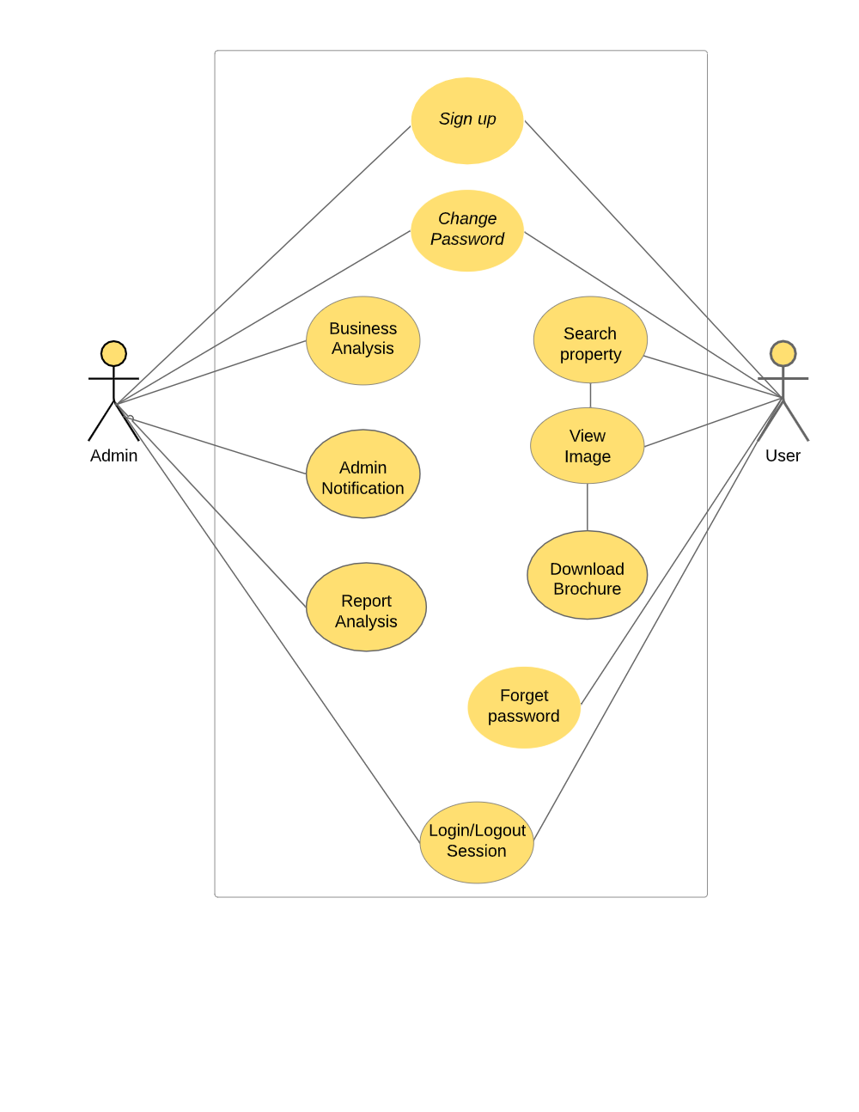

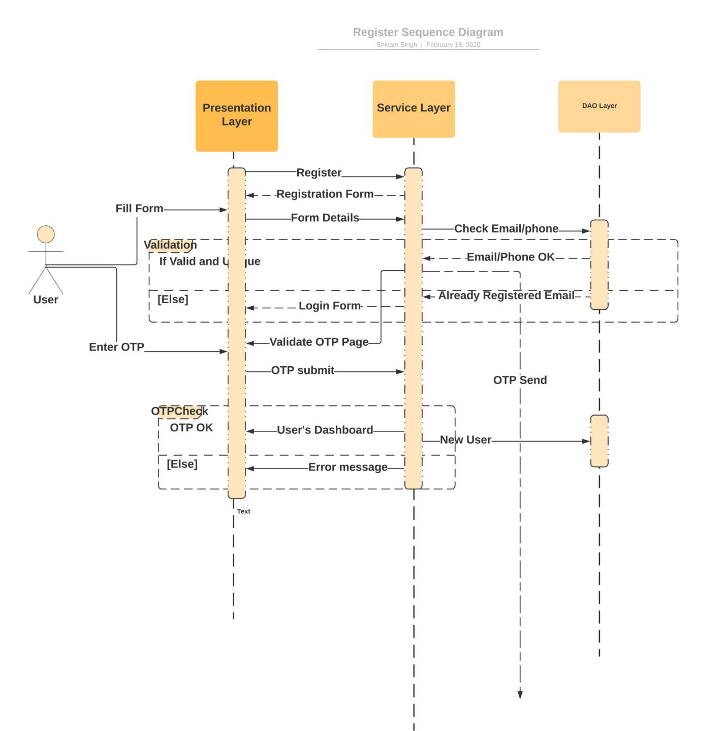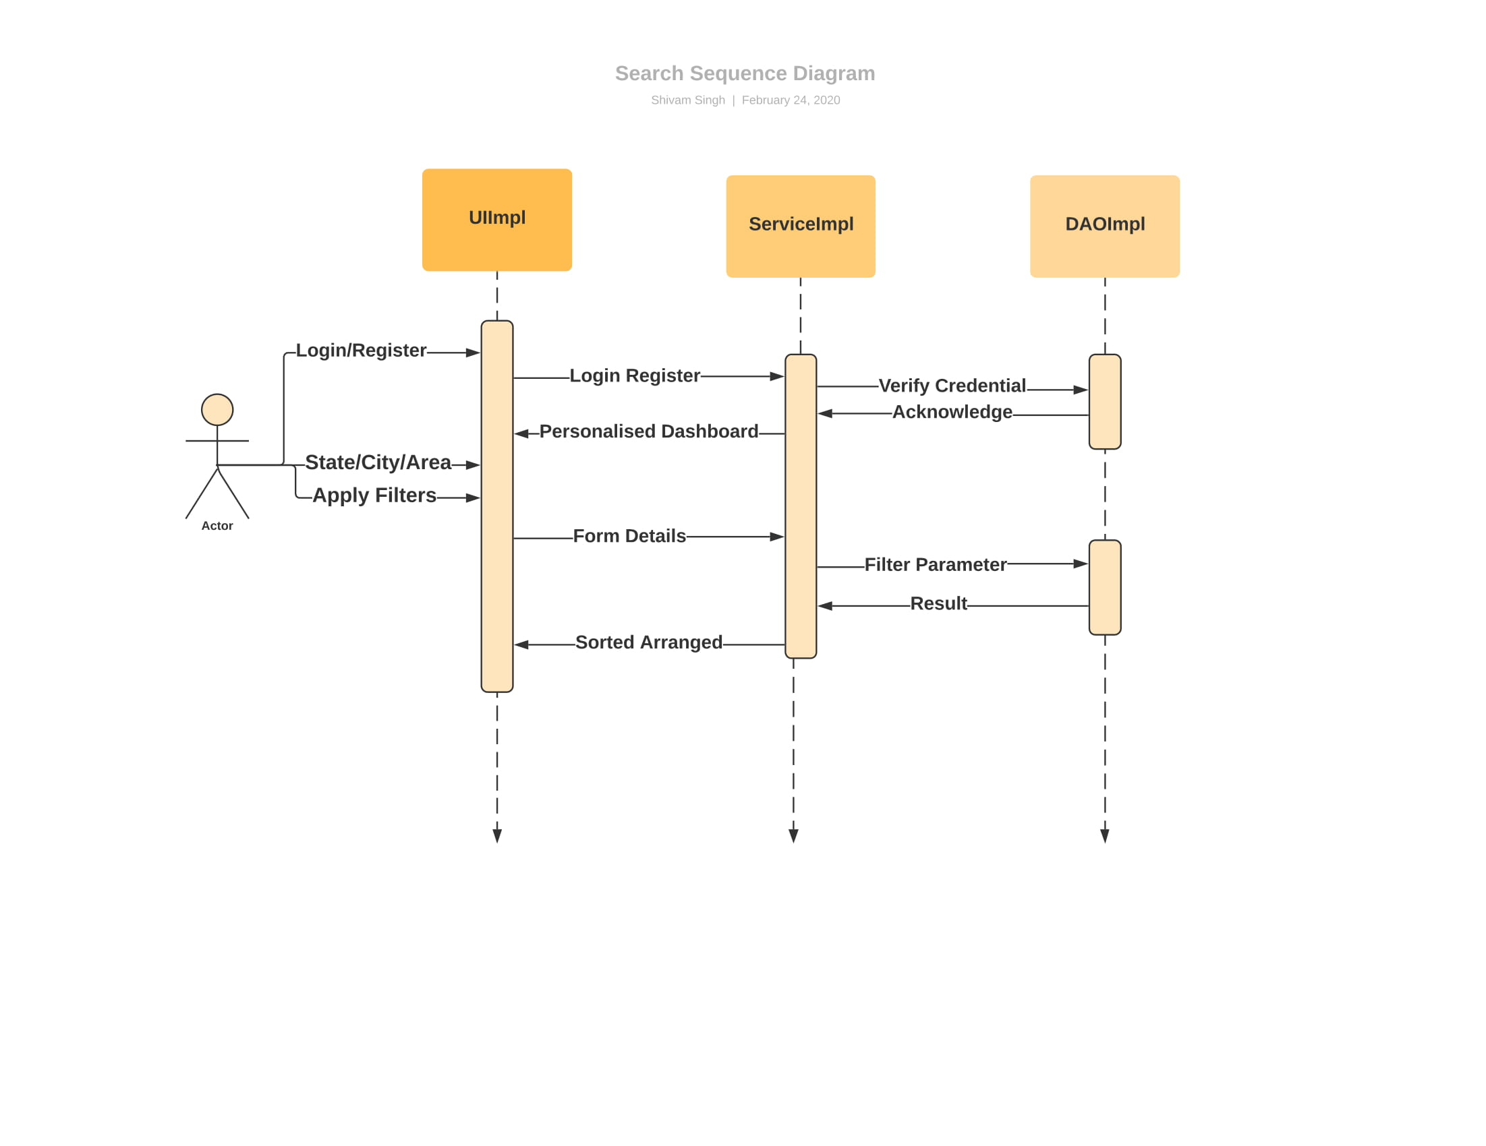

System Requirements

Below is a list of the minimum Hardware and Software requirements to access Real Estate website.

**Operating System:**

* Windows 7 and above.
* Mac OSX 10.8, 10.9, 10.10 or 10.11
* Android 3 and onwards.

**Hardware:**

* Processor (CPU) with 2 gigahertz (GHz) frequency or above
* A minimum of 4 GB of RAM
* Monitor Resolution 1024 X 768 or higher (For better view)
* A minimum of 5 GB of available space on the hard disk
* Internet Connection Broadband (high-speed) Internet connection with a speed of 2 Mbps or higher
* Keyboard and a Mouse or some other compatible pointing device

**Browsers:**

* Chrome* 58+
* Microsoft Edge* 20+
* Mozilla Firefox 40+
* Internet Explorer 11+ (Windows only)
* Safari 6+ (MacOS only)
* Android* 3+

*\**Google Chrome version 42+ and Microsoft Edge do not support NPAPI-type plug-ins, including Java plug-ins and many media browser plug-in.

*Users using unsupported browsers may experience issues submitting forms, placing orders, purchasing, updating details and transaction management threads.*

**Browser Configuration:**

Your browser must be configured as follows:

* JavaScript must be enabled
* CORS must be configured properly
* Cookies must be enabled.
* Pop-up windows must be enabled.

**Software:**

* Java — to view and interact with all available blackboard applications.
* Eclipse — Eclipse workbench was used to run JDK (write, compile and run the code).
* Visual Studio Code — for writing codes for frontend using angular, VS Code was used as a workbench.

Apache Tomcat — it was used as a server for hosting the website.