\*Git is a version control system that tracks the changes in the file and maintain the version of the files.

\*Git is a distributed version-control system.

\*Git will maintain a local as well as remote copy.

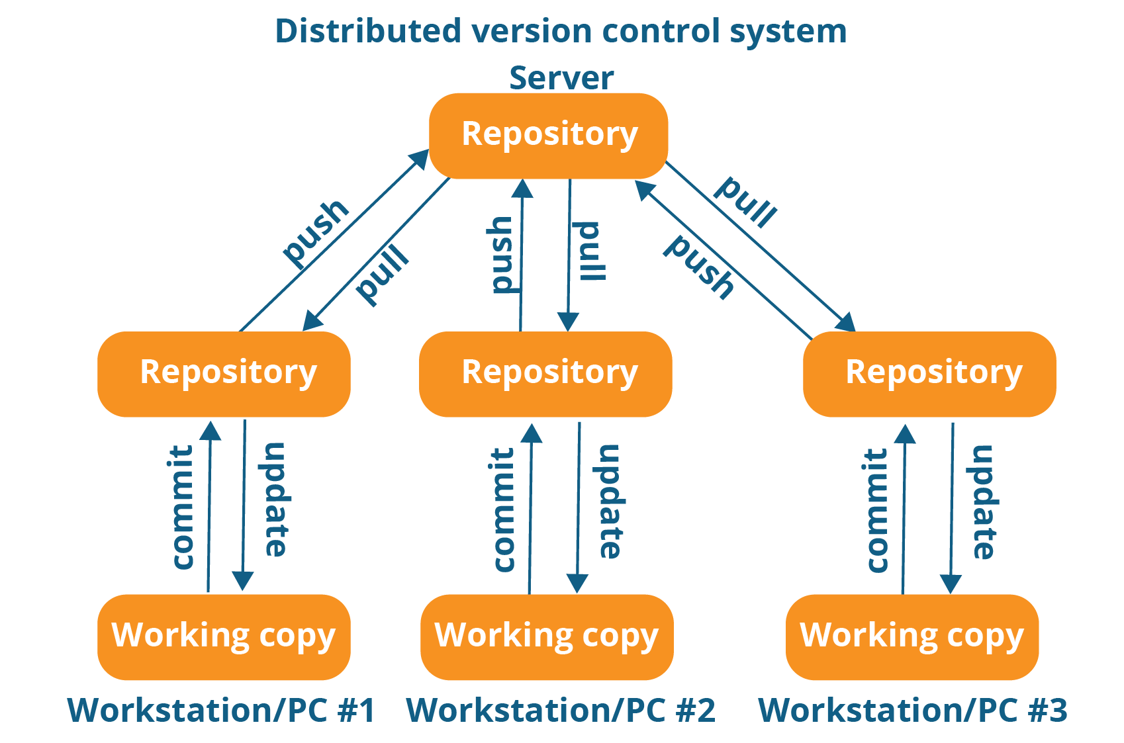

\*Git and Github are different.

\* use->add->staging area->commit->local repo->push->Github

\*Commands

1. git config --global

2. git clone => it will take a copy of remote repository.

3. git init => It will initialize the empty local repo.

4. git status => it will check the status of git repo.

5. git add => it will add file in the staging area.(similar command git add –A(add all files)).

6. git commit –m “Message”-commit the added file.

7. git remote add origin *repository* *url*.(in case of init).

8. git push –u origin master.

9. git pull => to get update of your remote repo.

10. git merge –allow-unrelated-histories.

11. git commit –am *Message*.

12. git branch.->to get the list of all branches

13.git checkout *branchname*.->to switch the branches

14. git merge *branchname*.->to merge the branch with the master branch

15. git branch –d *bracnhname.*

16. git push origin –delete *branchname.*

\*First Developer makes the remote repo. of the project and second developer will make a clone of that remote repo.

\*GIT with ECLIPSE:

->Open STS-> Workspace-> Window-> Show View->other->git-> git repository->ok

\*Already Existing:

Clone->clone url->paste url->type username and password->next->finish

RIGHT CLICK->TEAM->SHAREPROJECT->LOACATION OF REPOSITORY