Automotive Data Science Analyst Internship
Week 4: Evaluation, Insights, and Strategic Recommendations

1. Introduction
This is the final report of the internship, and it's meant to pull together everything from the last three weeks into something more useful than just a pile of charts and metrics. Week 1 was the plan, Week 2 was cleaning and exploring the Auto MPG dataset, and Week 3 was training and comparing a Linear Regression model against a Random Forest model to predict fuel efficiency (mpg). Here, I'm critically evaluating that Random Forest model, pulling out the insights that actually matter, being honest about where the approach falls short, and turning all of it into recommendations that would make sense to someone in the automotive industry, not just to another data scientist.

2. Model Evaluation

2.1 Performance Recap
The Random Forest model was the stronger of the two I tested in Week 3:
Model | RMSE (mpg) | MAE (mpg) | R²
Linear Regression | 2.887 | 2.285 | 0.845
Random Forest | 2.195 | 1.613 | 0.910

An R² of 0.910 means the model explains about 91% of the variation in fuel efficiency using just six specification-level features. The MAE of 1.613 is arguably the most useful number for a non-technical reader: on average, the model's mpg prediction is off by about 1.6 miles per gallon. For a car doing 25 mpg, that's roughly a 6% margin of error, which is solid for a model built on only 398 records and a handful of basic specs.

2.2 Strengths
- Clearly outperforms a linear baseline, which confirms the multicollinearity flagged in Week 2 (weight, displacement, horsepower, cylinders all correlated with each other) was a real issue that a tree-based model handles better.
- Residuals are centered around zero with no obvious pattern (see Figure 1), meaning the model isn't systematically biased toward over- or under-predicting at any particular mpg range.
- The model's feature importance output (Figure 2) matches what the Week 2 correlation analysis suggested — displacement, weight and horsepower dominate — so the two independent stages of analysis agree with each other, which is reassuring.

2.3 Weaknesses
- A handful of vehicles have noticeably larger residuals — one around -8 mpg, a couple around +5 to +6.5 mpg — meaning the model still misses on outlier vehicles that don't fit the typical weight/engine-size pattern.
- The test set is only 80 vehicles. That's enough to get a reasonable read on performance, but small enough that a few unusual predictions can move the aggregate metrics more than they would with a larger sample.
- The dataset only covers 1970–82 U.S.-market-style vehicles. It says nothing about hybrids, EVs, turbocharged small engines, or any vehicle technology from the last 20+ years, so the model's real-world applicability today is limited without retraining on modern data.
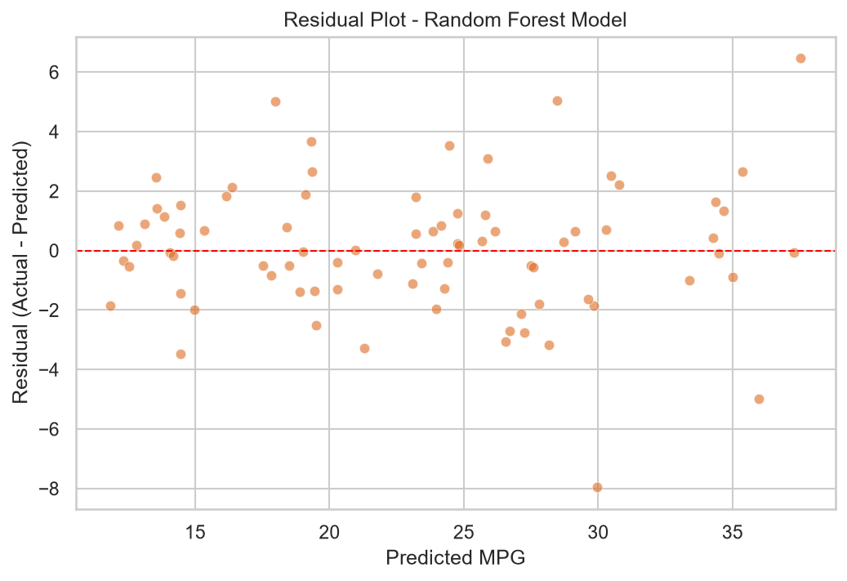
Figure 1. Residuals for the Random Forest model — centered near zero, no strong pattern, but a few larger misses.
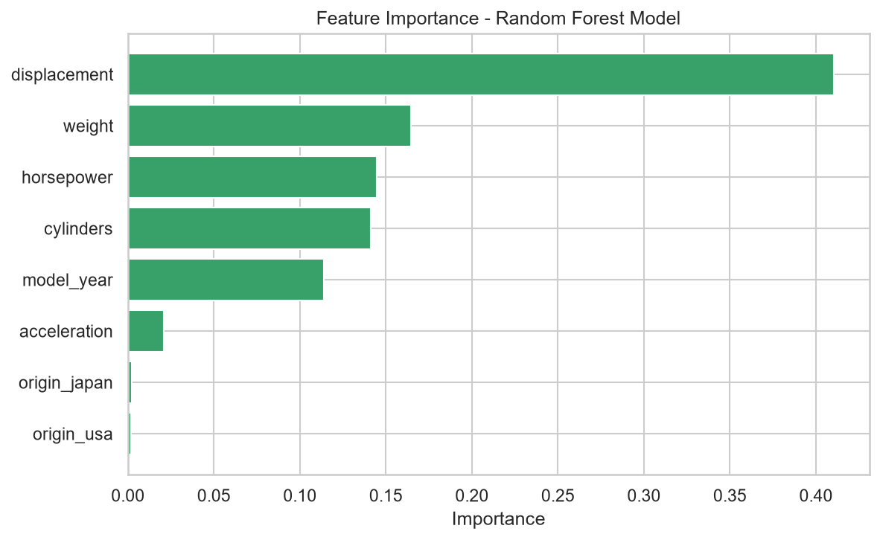
Figure 2. Feature importance — displacement, weight and horsepower dominate the prediction.

3. Key Insights
Putting the EDA from Week 2 and the modeling from Week 3 together, a few things stand out as the actual takeaways rather than just technical results:
- Engine size and vehicle weight are, by a wide margin, the biggest levers on fuel efficiency — displacement alone accounted for roughly 41% of the Random Forest's feature importance. This isn't surprising, but it's a useful confirmation that the basics still matter more than anything else in the dataset.
- Fuel efficiency improved steadily across the sampled decade (1970–82), which lines up with the historical context of the 1973 and 1979 oil crises and the introduction of U.S. CAFE fuel economy standards in 1975 — regulation and market pressure visibly moved the needle even within a single decade of data.
- Origin (USA/Japan/Europe) barely mattered to the model once weight and engine specs were already accounted for. That suggests “country of origin” isn't really a driver of efficiency on its own — it's more that vehicles from different regions historically differed in typical size and engine choice, and the model already captures that through weight and displacement directly.
- The strong performance gap between Linear Regression and Random Forest is itself an insight: fuel efficiency isn't a simple additive function of specs — there's enough non-linearity and interaction between weight, engine size and power that a flexible model meaningfully outperforms a straight-line one.

4. Limitations of This Approach
A few honest caveats worth stating clearly, since they matter for anyone deciding how much weight to put on these results:
- Data recency: the dataset stops in 1982. Modern vehicles — turbocharged small-displacement engines, hybrids, EVs — don't necessarily follow the same weight/displacement/mpg relationship that dominated this era, so these specific findings shouldn't be assumed to transfer directly to today's market without validation.
- Feature scope: the dataset only includes basic mechanical specs. It doesn't include anything about aerodynamics, transmission type, tire specs, or driving conditions, all of which affect real-world fuel economy and aren't captured here.
- Sample size: 398 vehicles is workable for a project like this, but it's small by modern machine learning standards. A production-grade model would want thousands of records, ideally spanning multiple decades and vehicle categories.
- Model interpretability trade-off: Random Forest performs better, but it's harder to explain to a non-technical stakeholder than a simple linear equation. That's a real trade-off between accuracy and explainability that would need to be weighed depending on who the model is ultimately for.

5. Strategic Recommendations
Translating the above into something an automotive stakeholder could actually act on:

5.1 For Manufacturers
- Since displacement and weight are the dominant levers, continued investment in weight reduction (lighter materials, smaller-displacement turbocharged engines) remains one of the most direct paths to improving fleet-average fuel efficiency — this is exactly the direction the industry has already been moving, and this analysis supports why.
- Given that origin/region added little predictive value beyond specs, efficiency strategy should be spec-driven rather than assumed based on a manufacturer's historical regional reputation — any manufacturer can hit similar efficiency numbers by converging on similar weight and engine-size choices.

5.2 For Analysts and Data Teams
- Retrain and validate this type of model on a modern dataset (post-2010, including hybrids/EVs) before using it for anything beyond historical analysis — the relationships here are era-specific.
- Add features this dataset lacks — transmission type, drivetrain, aerodynamic drag coefficient, or engine technology (turbocharged vs naturally aspirated) — since these would likely explain some of the residual error the current model can't account for.

5.3 For Further Study
- A logical next step would be a classification-style analysis grouping vehicles into efficiency tiers (e.g., low/medium/high mpg) to see whether a classifier surfaces cleaner boundary rules than a continuous regression does.
- Comparing this era's weight-vs-efficiency relationship against a modern dataset directly would make for a genuinely interesting follow-up — quantifying how much of today's efficiency gains come from technology (better engines) versus how much still comes down to weight, the way it did in the 1970s and 80s.

6. Conclusion
Across these four weeks, the project went from a plan, to a cleaned dataset, to a working predictive model, and now to a set of conclusions that could plausibly inform a real decision. The Random Forest model explains about 91% of the variation in fuel efficiency using nothing but basic vehicle specs, and the two clearest levers — weight and engine displacement — are also the two most actionable ones for a manufacturer to actually change. The biggest caveat is recency: this is a lens on how fuel efficiency worked in the 1970s and 80s, not a ready-to-deploy tool for evaluating a 2026 vehicle lineup. But as an end-to-end exercise in going from raw data to a defensible, explainable business recommendation, the process held up well at each stage.

