// How nodejs work

Nodejs = v8+ libuv

Libuv = event loop + thread pool
libuv handle async operation .

Thread pool have default 4 thread can upto 128 thread.

process.env.UV_THREADPOOL_SIZE = n

Use nodejs when want to perform I/O heavy task = file system, db query, network request,bcyrpt hashing passwords

Don’t use nodejs if it is cpu heavy task = image/video processing, math,cryptography.

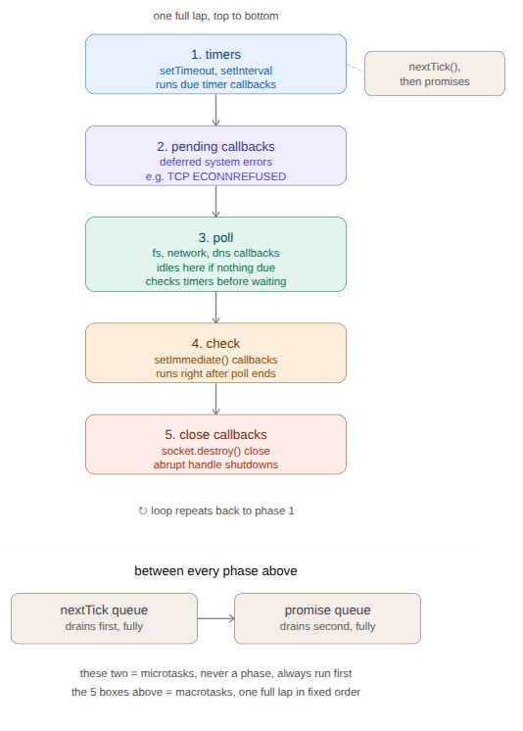

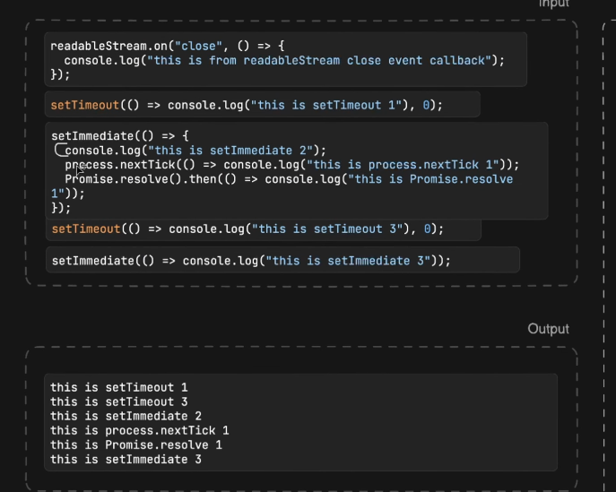

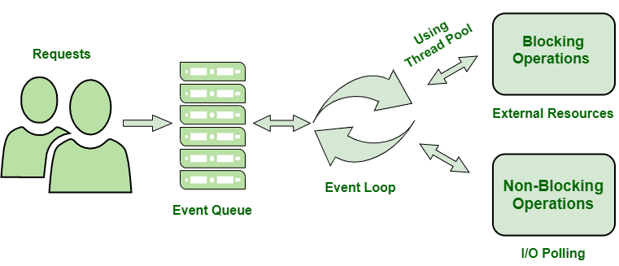

2) Short event loop notes — points to keep in mind
Phases (macrotasks) — fixed order, one lap:
a) timers → pending callbacks → poll → check → close callbacks → back to timers, forever.
b) Each phase has its own separate FIFO queue — nothing shares a queue across phases.
c) A callback never "jumps into" a phase that's currently running — it waits in its own queue for that phase's turn.
Microtasks — always deterministic, always first:
d) process.nextTick() and Promise .then() are not phases — they drain fully between every phase transition, before the loop moves on.
e) nextTick drains before promises, every time.
f) Recursive nextTick() calls can starve the whole loop (I/O, timers, everything) — setImmediate can never do this.
poll phase — the "resting" phase:
g) When poll's queue empties, it checks in this order: (1) is a timer already due? → jump back to timers. (2) is setImmediate waiting? → jump to check. (3) neither? → idle/wait here for new I/O or a timer.
h) This idling in poll is why a Node server sits at ~0% CPU between requests instead of busy-looping.
setTimeout vs setImmediate — where determinism does/doesn't hold:
i) Non-deterministic at the top level — outside any I/O callback, order depends on OS timer-registration overhead before the loop's first lap even starts. Pure process timing, no guarantee either way. It is true only when we have given setTimeout(cl,0)
if we have given some time more than 0 then it is determinstic
j) Deterministic inside an I/O callback — if both are scheduled from inside a poll-phase callback (e.g. fs.readFile's callback), setImmediate always wins, because check is the fixed next phase after poll — no timer-resolution race involved.
k) Deterministic when a timer genuinely already elapsed before poll's queue empties — that timer wins over any setImmediate scheduled at that same moment, because poll checks "timer due?" before "immediate scheduled?".
l) A fresh setTimeout(fn, 0) is almost never "already due" the instant it's scheduled — timer resolution needs a sliver of real time — so a setImmediate scheduled at that same moment usually wins in practice.
Where different events land:
m) I/O (file reads, network data, dns) → poll queue.
n) Deferred system-level errors (e.g. ECONNREFUSED) → pending callbacks queue.
o) Abrupt socket/handle destruction → close callbacks queue (graceful closes go via nextTick instead).
p) A timer's delay is a minimum, never an exact time — actual firing depends on what else the loop is doing.
Practical rule of thumb:
q) Want setImmediate to reliably beat setTimeout(fn, 0)? → schedule both from inside an I/O callback. That's the only guaranteed case.
r) When unsure, prefer setImmediate over setTimeout(fn, 0) — it can't starve the loop and its behavior relative to poll is more predictable.

