Frontend System Design
Autocomplete & Toast Notification -- HLD + LLD, Component-Level
Simple, focused examples -- ideal for really internalizing the RADIO + LLD flow

1. Autocomplete
A search input that suggests results as the user types. Small enough to fully cover end-to-end in one interview, but touches debouncing, caching, race conditions, and accessibility.
Part 1 -- High-Level Design (HLD)
INTERVIEWER
Design a search autocomplete component. Where would you like to start?
YOU (CANDIDATE)
With requirements. A couple of quick questions:
• Is this backed by a remote API, and roughly how large is the underlying dataset?
• Any specific expectations around latency, or particular need for fuzzy matching?
INTERVIEWER
Backed by a remote API, dataset is large and changes often, and assume users can type quickly.
YOU (CANDIDATE)
Got it -- that rules out shipping the dataset to the client, so I need server-side search, and I need to design around fast typing causing overlapping requests.
Architecture
YOU (CANDIDATE)
SearchInput is purely presentational. All the real behavior -- debounce, caching, cancellation -- lives in a useAutocomplete hook, decoupled from rendering. SuggestionsList owns the dropdown rendering and keyboard navigation.
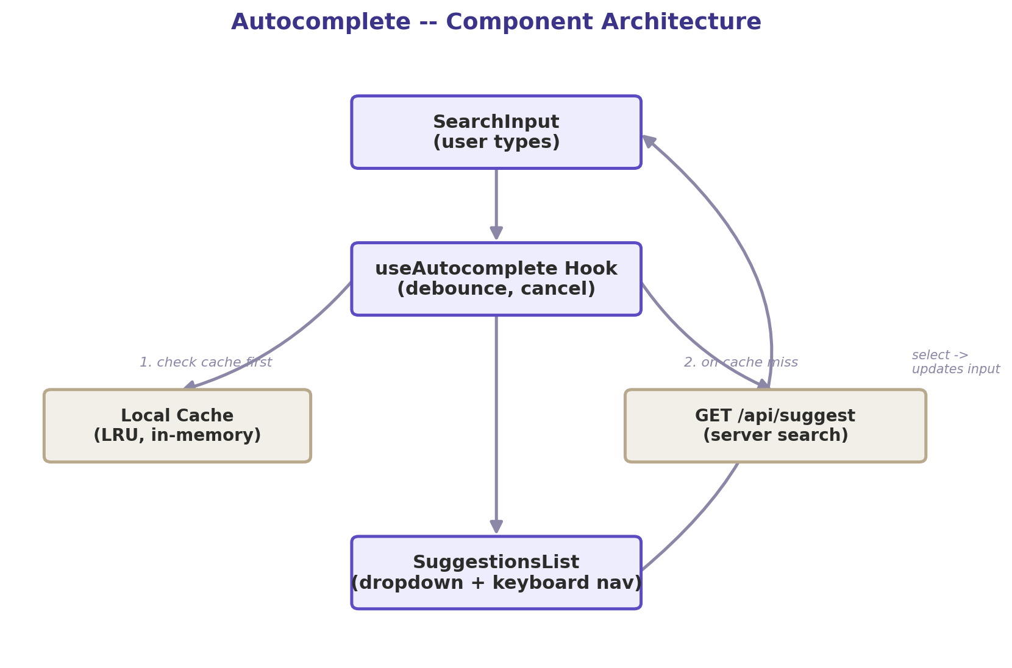
SearchInput -> useAutocomplete Hook -> (cache check, then API on miss) -> SuggestionsList
Data Model & Interface
interface Suggestion { id: string; text: string; }

GET /api/suggest?q=<query>&limit=10
→ { suggestions: Suggestion[] }
YOU (CANDIDATE)
This is local, ephemeral UI state -- it lives inside the hook, not in any global store.
INTERVIEWER
What would you optimize?
YOU (CANDIDATE)
• Debounce input (~250ms) so we're not firing a request per keystroke.
• Guard against stale responses -- ignore any response that isn't from the latest request.
• Cache results client-side by query so re-typing a prefix is instant.
• Full ARIA combobox pattern for accessibility.
Part 2 -- Low-Level Design (LLD) Deep Dive
INTERVIEWER
Show me the actual guard against stale, out-of-order responses.
function useAutocomplete(query) {
const [suggestions, setSuggestions] = useState([]);
const latestRequestId = useRef(0);

useEffect(() => {
if (!query) { setSuggestions([]); return; }
const requestId = ++latestRequestId.current;

const timer = setTimeout(async () => {
const res = await fetch(`/api/suggest?q=${query}`);
const data = await res.json();
if (requestId === latestRequestId.current) {
setSuggestions(data.suggestions); // only apply if still latest
}
}, 250);

return () => clearTimeout(timer);
}, [query]);

return suggestions;
}
⚠ INTERVIEWER PUSHES BACK
If I select a suggestion, does that trigger another fetch for the text I just selected?
YOU (CANDIDATE)
It would with the code as written -- setting query after selection re-triggers the effect. I'd guard against that with a ref that's set right before a programmatic selection and checked (then reset) at the top of the effect, so a real typed change always fetches, but a selection never does.

Key Takeaways
✓ Debounce + a request-id guard are the two non-negotiable pieces of any typeahead.
✓ Cache hits should skip the loading state entirely -- no flicker for repeated queries.
✓ Watch for the 'selecting a suggestion re-triggers a fetch' trap -- a very common LLD gotcha.

2. Toast Notification System
A global toast/snackbar system -- any component can trigger one, without prop-drilling or wrapping every page. Small in scope, but a great test of state architecture judgment.
Part 1 -- High-Level Design (HLD)
INTERVIEWER
Design a toast notification system -- any part of the app should be able to show a brief message (success, error, info) that auto-dismisses. Where do you start?
YOU (CANDIDATE)
A couple of clarifying questions:
• Can multiple toasts stack at once, or should a new one replace the current one?
• Do errors need to persist until manually dismissed, or do all types auto-dismiss?
INTERVIEWER
Multiple can stack, up to a reasonable limit. Success/info auto-dismiss; errors should stay until the user dismisses them or a longer timeout passes.
YOU (CANDIDATE)
That confirms this needs to be genuinely global state -- a save button deep in a form and a websocket-error handler in a completely unrelated part of the tree both need to trigger the same toast layer. I wouldn't reach for prop-drilling or even necessarily React Context re-rendering the whole tree -- I'd want triggering a toast to be a simple function call from anywhere, including outside React entirely (e.g. an API client's error handler).
Architecture
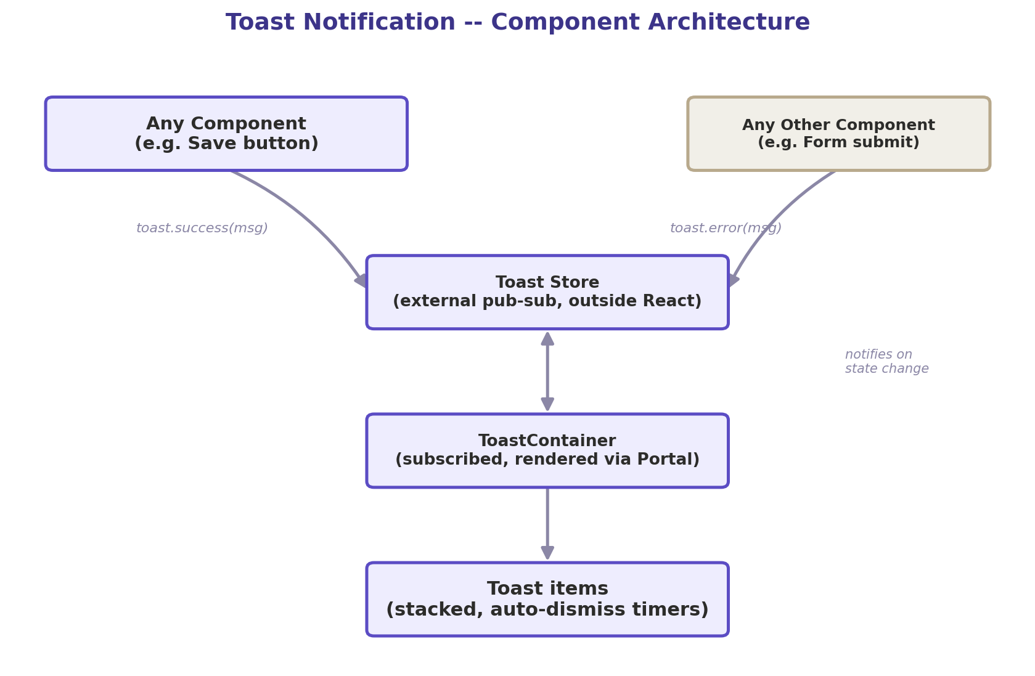
Any component calls toast.success()/error() -> external store -> ToastContainer (rendered once, via Portal)
YOU (CANDIDATE)
The key decision: the toast store lives OUTSIDE the React tree, as a plain module-level pub-sub. Only ToastContainer subscribes to it and re-renders when it changes -- calling toast.success() from a deeply nested component never re-renders that component's parents or siblings, and it works even from non-component code.
Data Model & Interface
interface ToastItem {
id: string;
message: string;
type: 'success' | 'error' | 'info' | 'warning';
duration: number; // ms; 0 = persist until manually dismissed
}

// imperative API, callable from anywhere:
toast.success("Saved!");
toast.error("Something went wrong", { duration: 0 });
toast.dismiss(id);
INTERVIEWER
What would you optimize or watch out for?
YOU (CANDIDATE)
• Render the container once via a Portal at the app root, so it's never clipped by a parent's overflow:hidden or fighting z-index issues.
• Cap the number of concurrently visible toasts -- extras queue rather than flooding the screen.
• Pause the auto-dismiss timer on hover so a user reading a message doesn't lose it mid-read.
• aria-live region so screen readers announce new toasts -- polite for info/success, assertive for errors.
• Animate with transform/opacity only, not layout-triggering properties, to keep it smooth even with several toasts stacking at once.
Part 2 -- Low-Level Design (LLD) Deep Dive
INTERVIEWER
Show me how the store itself works, and how ToastContainer subscribes to it without the whole app re-rendering.
YOU (CANDIDATE)
A minimal pub-sub outside React, consumed via useSyncExternalStore so only the subscribed component re-renders on change:
// toastStore.js -- plain module, not a React hook itself
let toasts = [];
let listeners = [];

function emit() { listeners.forEach((l) => l(toasts)); }

export function addToast(message, type = "info", duration = 4000) {
const id = crypto.randomUUID();
toasts = [...toasts, { id, message, type, duration }];
emit();
if (duration > 0) {
setTimeout(() => removeToast(id), duration);
}
return id;
}

export function removeToast(id) {
toasts = toasts.filter((t) => t.id !== id);
emit();
}

export function subscribe(listener) {
listeners.push(listener);
return () => { listeners = listeners.filter((l) => l !== listener); };
}

export const toast = {
success: (msg, opts) => addToast(msg, "success", opts?.duration ?? 4000),
error: (msg, opts) => addToast(msg, "error", opts?.duration ?? 0),
info: (msg, opts) => addToast(msg, "info", opts?.duration ?? 4000),
};
// ToastContainer.jsx -- the ONLY component that re-renders on toast changes
import { useSyncExternalStore } from "react";
import { subscribe, removeToast } from "./toastStore";

function getSnapshot() { return toastsSnapshot; } // see note below

function ToastContainer() {
const items = useSyncExternalStore(subscribe, () => toasts);
return createPortal(
<div role="region" aria-live="polite" className="toast-container">
{items.map((t) => (
<div key={t.id} role={t.type === "error" ? "alert" : "status"}>
{t.message}
<button onClick={() => removeToast(t.id)} aria-label="Dismiss">×</button>
</div>
))}
</div>,
document.body
);
}
YOU (CANDIDATE)
Because the store lives outside React and ToastContainer is the only subscriber, calling toast.success() from any component -- or from an Axios interceptor with no component context at all -- just works, and only the toast layer re-renders.
⚠ INTERVIEWER PUSHES BACK
A failing API call retries automatically and fires toast.error() five times in two seconds. What does the user see?
YOU (CANDIDATE)
As written, five separate stacked error toasts -- which is a bad experience. I'd add deduplication in addToast: before pushing a new toast, check if an existing toast has the same message and type still visible; if so, don't add a duplicate -- either ignore the new call or bump a small count badge on the existing one ('Something went wrong (×3)') and reset its timer. That turns a retry storm into one toast that stays accurate, instead of five identical ones stacking up.
INTERVIEWER
How would you implement the pause-on-hover behavior for the auto-dismiss timer?
YOU (CANDIDATE)
Instead of a single setTimeout fired once, I'd track remaining time and start/stop it around hover events:
function useAutoDismiss(id, duration, onExpire) {
const remainingRef = useRef(duration);
const startRef = useRef(null);
const timerRef = useRef(null);

const start = () => {
startRef.current = Date.now();
timerRef.current = setTimeout(onExpire, remainingRef.current);
};
const pause = () => {
clearTimeout(timerRef.current);
remainingRef.current -= Date.now() - startRef.current;
};

useEffect(() => {
if (duration > 0) start();
return () => clearTimeout(timerRef.current);
}, []);

return { onMouseEnter: pause, onMouseLeave: start };
}

Key Takeaways
✓ A truly global trigger (usable outside React components too) calls for a store OUTSIDE React, not just Context -- Context still re-renders everything subscribed to it.
✓ useSyncExternalStore is the correct primitive for subscribing a single component to external, mutable state without over-rendering.
✓ Deduplicate rapid identical toasts (e.g. from retry loops) -- this is the single most common LLD follow-up for this problem.
✓ Auto-dismiss with pause-on-hover needs remaining-time tracking, not just a naive one-shot setTimeout.

