Web Development
Complete Notes

Topics Covered
◆ Web Vitals & Core Web Vitals (LCP · INP · CLS)
◆ Web Performance & Optimizations
◆ Security (XSS · CSRF · SQL Injection · DoS · CSP · CORS)
◆ JavaScript Design Patterns
◆ React Patterns
◆ Critical Rendering Path
◆ Rendering Patterns (CSR · SSR)

Web Vitals
Web Vitals are a set of performance metrics to measure real user experience on a website. They help developers build fast, stable, and user-friendly applications.

What Web Vitals Measure
- Loading performance
- Responsiveness
- Visual stability
- Rendering performance
- Server speed

Core Web Vitals
Core Web Vitals are the most important subset that Google considers critical for user experience and SEO ranking. They focus on 3 things:
- Loading speed
- Interactivity / responsiveness
- Visual stability

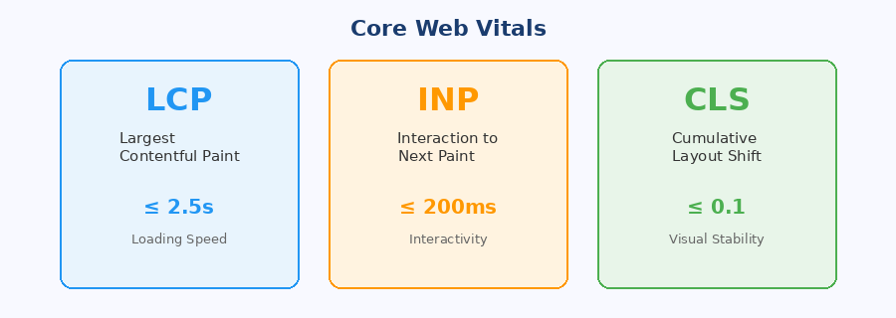

1. LCP — Largest Contentful Paint (Loading Speed)
Measures how long the largest visible content element takes to load inside the viewport. Usually an image, video, or large text block.
Good Score: ≤ 2.5 seconds

Common Causes of Poor LCP
- Large images
- Slow API / server
- Render-blocking CSS
- Heavy JS bundle
- No caching
- Slow CDN

How to Improve LCP
- Image Optimization — use WebP, compress, responsive srcset
- Reduce Render Blocking — defer/async CSS & JS
- Backend Optimization — CDN & caching
- Frontend Optimization — lazy loading, code splitting
📝 Note: Every page has its own LCP. LCP is measured per page/device/network (3G, 4G). Measuring stops when the user interacts (scroll, click).

2. INP — Interaction to Next Paint (Interactivity)
Measures how quickly the page responds after a user interaction (click, type, tap). INP covers the total delay: user interaction → browser processes JS → UI update → next paint.
Good Score: ≤ 200ms

INP Formula
INP = user click + browser process JS + UI update + next paint

Common Causes
- Heavy JavaScript
- Long tasks on main thread
- Large React re-renders
- Expensive event handlers

How to Improve INP
- Optimize JavaScript — reduce bundle size, remove unused JS
- Break Long Tasks — use Web Workers for heavy computation
- React Optimizations — useMemo, useCallback, Virtualization
- Event Optimization — Debounce & Throttle

3. CLS — Cumulative Layout Shift (Visual Stability)
Measures unexpected layout movement during page load or interaction. Examples: button suddenly shifts, text jumps, ad pushes content down.
Good Score: ≤ 0.1 (unitless)

Common Causes
- Images without width/height dimensions
- Dynamic ads
- Fonts loading late (FOIT/FOUT)
- Injected content above existing content

How to Improve CLS
- Set explicit dimensions on images and videos
- Reserve space for ads/banners with min-height
- Avoid injecting content above existing content

Non-Core Web Vitals
- FCP (First Contentful Paint) — when first visible content appears on screen
- TTFB (Time to First Byte) — server response time
- TBT (Total Blocking Time) — how long main thread is blocked

Web Performance & Optimizations

Optimising Images
- Use modern formats (WebP, AVIF)
- Compress images
- Use responsive images with srcset
- Lazy load images (loading='lazy')
- Serve from CDN
- Resize images to display size
- Avoid oversized images
- Cache images aggressively

Optimising Videos
- Compress videos
- Use modern codecs (H.264, H.265, VP9)
- Lazy load videos
- Use poster thumbnail for preview
- Use adaptive streaming (HLS/DASH)
- Reduce resolution when unnecessary
- Stream instead of full download

Optimising JavaScript
- Minify JS
- Tree shaking — remove dead code
- Code splitting — load only what's needed
- Lazy loading modules
- Remove unused JS
- Reduce third-party libraries
- Use dynamic imports
- Break long tasks with requestIdleCallback
- Use Web Workers for heavy computation

Optimising CSS
- Minify CSS
- Remove unused CSS (PurgeCSS)
- Inline critical CSS
- Avoid deep/complex selectors
- Split CSS bundles by route
- Reduce render-blocking CSS

Optimising Third-Party Resources
- Use async/defer for script tags
- Remove unnecessary third-party scripts
- Lazy load widgets (chat, maps)
- Reduce tracking scripts
- Load scripts only when needed

Optimising Web Fonts
- Use WOFF2 format
- Preload critical fonts
- Use font-display: swap
- Subset fonts (only load needed characters)
- Reduce font variants (weights/styles)
- Cache fonts with long TTL

Security

1. XSS — Cross-Site Scripting
XSS is a security vulnerability where an attacker injects malicious JavaScript into a website, which then runs in the victim's browser.
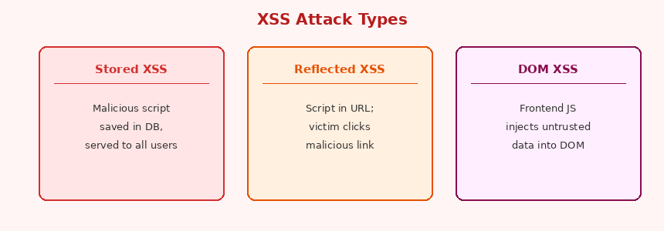

Types of XSS

a) Stored XSS
Script is saved in the database. Example: a website that shows user comments — attacker saves a script as a comment.

b) Reflected XSS
Script comes from the URL. Attacker shares a crafted URL; when victim clicks it they get hacked.
site.com?q=<script>alert(1)</script>

c) DOM XSS
Frontend JavaScript directly injects untrusted data into the DOM.
element.innerHTML = location.hash; // dangerous!

Impact
- Steal cookies / session tokens
- Log in as victim
- Modify the UI
- Redirect users to phishing sites

Prevention
✅ Escape output (HTML encode)
✅ Avoid innerHTML — use textContent
✅ Sanitize user input with DOMPurify
✅ Use HTTPOnly cookies
✅ Use Content Security Policy (CSP)

2. CSRF — Cross-Site Request Forgery
CSRF tricks a logged-in user's browser into sending unwanted requests to another site where the user is already authenticated. The attack works because browsers automatically attach cookies to all requests.

Attack Flow
- User logs into bank.com
- User visits evil.com
- evil.com triggers POST request to bank.com/payment
- Browser auto-attaches session cookie → money sent!

Prevention
✅ SameSite=Strict cookie attribute — cookie not sent cross-origin
✅ CSRF Token — server generates unique token, validates on every request

3. SQL Injection
An attacker inserts malicious SQL code into application queries to manipulate the database. Happens when user input is directly concatenated into SQL queries.

Unsafe Example
const query = `SELECT * FROM users WHERE email = '${email}' AND password = '${password}'`;
📝 Note: An attacker can input: ' OR '1'='1 to bypass authentication entirely.

Prevention
✅ Use parameterized queries / prepared statements
✅ Validate and sanitize all input
✅ Escape special characters

4. DoS & DDoS Attacks
DoS (Denial of Service) — a single system floods the server with excessive requests to make it unavailable to real users.
DDoS (Distributed DoS) — a larger version using multiple compromised systems (botnets) attacking simultaneously.

Prevention
✅ Rate limiting — limit requests per IP/user
✅ Firewall — filter malicious traffic patterns
✅ Load balancing — distribute traffic across servers
✅ CDN with DDoS protection (Cloudflare, AWS Shield)

5. CSP — Content Security Policy
CSP is a browser security mechanism (HTTP header) that controls which scripts, styles, images, and APIs the browser is allowed to load. Used to prevent XSS and malicious script execution.

Example Header
Content-Security-Policy: default-src 'self';
This tells the browser: only load resources from the same origin.

6. CORS — Cross-Origin Resource Sharing
CORS is a browser security mechanism that controls whether a web application can read responses from a different origin.
Origin = Protocol + Domain + Port e.g. https://google.com:443

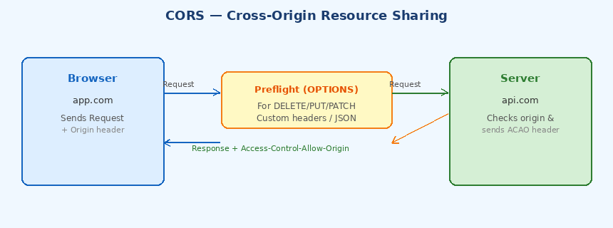

Why CORS Matters
Prevents XSS attacks from reading sensitive data from another origin.

Allow Cross-Origin Access
Access-Control-Allow-Origin: https://app.com

Preflight Request
For non-simple requests (DELETE, PUT, PATCH, custom headers), the browser first sends an OPTIONS request to ask: 'Is this cross-origin request safe?'
- If server approves → actual request is sent
- If server rejects → browser blocks the request

JavaScript Design Patterns

1. Module Pattern
Splits a large file into smaller, reusable pieces. Values within modules are private by default and cannot be modified from outside — only exported values are accessible.

Advantages
✅ Avoids global variable pollution
✅ Provides encapsulation
✅ Creates private state
✅ Organizes related code

Example
// counter.js
let count = 0; // private
export const increment = () => count++; // public
export const getCount = () => count; // public

2. Singleton Pattern
Ensures that a class/object has only ONE instance throughout the application and provides a global access point to it.

Use Cases
- Database connection pool
- Logger / error reporter
- Auth manager
- App configuration

Advantages
✅ Prevents multiple instances
✅ Saves memory / resources
✅ Maintains shared state
✅ Centralized control

3. Proxy Pattern
Provides an intermediate/placeholder object that controls access to another (real) object. Instead of accessing the object directly, you go through the proxy.

Use Cases
- Validation before setting a value
- Logging / tracking property access
- Caching / memoization
- Lazy initialization

Example
const handler = {
get(target, key) { console.log(`Getting ${key}`); return target[key]; },
set(target, key, val) { if (val < 0) throw Error('negative!'); target[key] = val; }
};
const proxied = new Proxy({}, handler);

4. Observer Pattern
Defines a one-to-many relationship where multiple observers automatically get notified when a subject (publisher) changes.
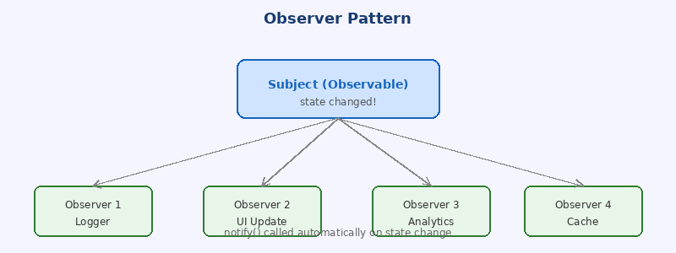

Without Observer Pattern
❌ Manual updates everywhere
❌ Hard dependencies between components
❌ Messy communication

With Observer Pattern
✅ Decoupled architecture
✅ Automatic notifications
✅ Easy to add/remove observers

Real-world Examples
- EventEmitter in Node.js
- addEventListener in the browser
- React's useState triggers re-renders
- Redux store subscriptions

5. Factory Pattern
A creational design pattern used to create objects without exposing the exact creation logic. A factory function/class decides which object type to instantiate based on input.

Use Cases
- Creating UI components based on type
- Database driver selection
- API response object creation

Example
function createUser(type) {
if (type === 'admin') return new AdminUser();
if (type === 'guest') return new GuestUser();
return new RegularUser();
}

6. Prototype Pattern
Objects are created by cloning/inheriting from another object (prototype) instead of building everything from scratch. This is JavaScript's native inheritance mechanism.

Example
const carPrototype = { drive() { console.log('vroom'); } };
const myCar = Object.create(carPrototype); // inherits drive()

React Patterns

1. Container / Presentational Pattern
Separates the logic of a component from its view.
- Presentational Component — cares about HOW data is displayed
- Container Component — cares about WHAT data is displayed (state, fetch, logic)

Advantages
✅ Presentational components are reusable across features
✅ Easy to test — no side effects in presentational layer
✅ Clear separation of concerns

Example
// Container (logic)
function UserContainer() {
const [user, setUser] = useState(null);
useEffect(() => fetchUser().then(setUser), []);
return <UserCard user={user} />;
}

// Presentational (UI only)
function UserCard({ user }) {
return <div>{user?.name}</div>;
}

2. Higher-Order Component (HOC) Pattern
A HOC is a function that takes a component and returns a new enhanced component. Used to reuse common logic across multiple components.

Typical Use Cases
- Authentication / authorization checks
- Permission guards
- API fetching wrapper
- Logging / analytics

Example
function withAuth(Component) {
return function AuthenticatedComponent(props) {
if (!isLoggedIn()) return <Redirect to='/login' />;
return <Component {...props} />;
};
}
const ProtectedDashboard = withAuth(Dashboard);

3. Render Props Pattern
A component shares reusable logic by accepting a function as a prop. That function receives the shared state and decides what UI to render.
📝 Note: Component gives state + functions. You decide what to render.

Example — shared toggle logic
function Toggle({ render }) {
const [on, setOn] = useState(false);
return render({ on, toggle: () => setOn(p => !p) });
}

// Consumer decides the UI:
<Toggle render={({ on, toggle }) => (
<button onClick={toggle}>{on ? 'ON' : 'OFF'}</button>
)} />

4. Custom Hooks Pattern
Hooks Pattern extracts reusable stateful logic into custom hooks, keeping components clean and logic shareable.

Advantages
✅ Reusable logic across multiple components
✅ Cleaner component code
✅ No extra component nesting
✅ Works only with functional components

Example — useFetch Hook
function useFetch(url) {
const [data, setData] = useState(null);
const [loading, setLoading] = useState(true);
useEffect(() => {
fetch(url).then(r => r.json()).then(setData).finally(() => setLoading(false));
}, [url]);
return { data, loading };
}

5. Provider Pattern
Shares global/common data across the component tree without prop drilling. Usually implemented with React Context API.

Use Cases
- Theme (dark/light mode)
- Auth state (current user)
- Language / i18n
- Shopping cart

Example
const ThemeContext = createContext();
function App() {
return <ThemeContext.Provider value='dark'><Page /></ThemeContext.Provider>;
}
function Page() {
const theme = useContext(ThemeContext); // no prop drilling!
}

6. Compound Component Pattern
Multiple components work together as a single unit while sharing internal state to perform one task. Avoids excessive props and creates flexible APIs.

Without Compound Pattern
❌ Too many props on parent component
❌ Rigid component API
❌ Hard to customize layout

Example — Select component
<Select value={val} onChange={setVal}>
<Select.Option value='a'>Option A</Select.Option>
<Select.Option value='b'>Option B</Select.Option>
</Select>

Real-world Examples
- HTML <select> + <option>
- Radix UI primitives
- Headless UI components

Critical Rendering Path
The Critical Rendering Path is the sequence of steps the browser takes to convert HTML, CSS, and JavaScript into pixels on the screen.

Steps
- HTML parsing → DOM Tree
- CSS parsing → CSSOM Tree
- DOM + CSSOM → Render Tree
- Layout — calculates position and size of every element
- Paint — fills in pixels on the screen

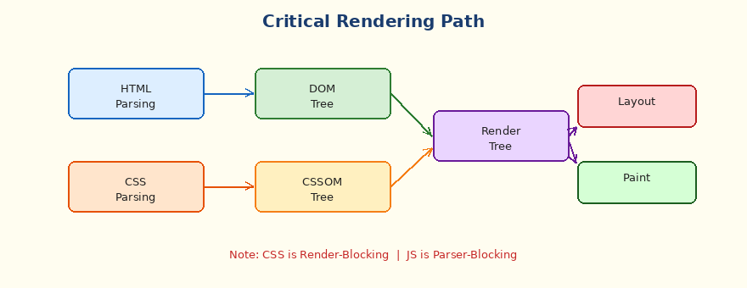

Key Blocking Behaviors
CSS is Render-Blocking: Browser must download ALL CSS files before rendering anything. It does not apply stylesheet 1 while downloading stylesheet 2.

JS is Parser-Blocking: Browser stops parsing HTML to execute JS. Modern browsers download files in parallel but still execute one at a time.

What Happens When You Type a URL / How web work
- DNS Lookup — domain resolved to IP address
- TCP Connection — browser connects to server
- TLS Handshake — secure connection established (HTTPS)
- HTTP Request — browser requests the page
- Server Response — HTML sent back (TTFB starts here)
- HTML Parsing → DOM construction begins
- CSS/JS downloaded and processed
- Render Tree built → Layout → Paint → Page visible

Rendering Patterns

1. CSR — Client Side Rendering
The server sends a minimal HTML shell (nearly empty). The browser downloads a large JavaScript bundle, executes it, fetches data from APIs, and builds the full page on the client.
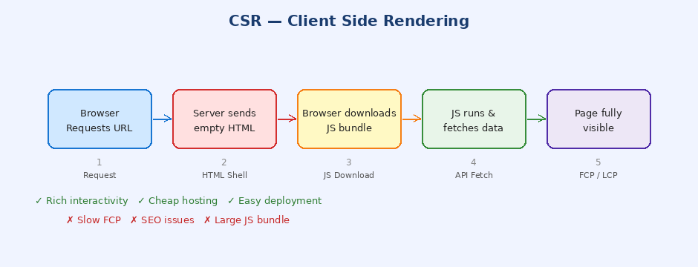

How CSR Works
- Browser requests URL
- Server returns empty HTML + script tag
- Browser downloads JS bundle
- JS executes, fetches API data
- React/Vue renders the full UI

When to Use CSR
- Highly interactive apps (dashboards, SaaS tools)
- When SEO is not critical
- Apps with real-time updates

Pros & Cons
✅ Rich interactivity after initial load
✅ Cheap hosting (just static files)
✅ Easy to deploy on CDN
❌ Slow FCP — user sees blank page initially
❌ Bad SEO — crawlers see empty HTML
❌ Large JS bundle affects performance

2. SSR — Server Side Rendering
The server fetches data, renders the full HTML on the server, and sends the complete page to the browser. The browser shows the page immediately, then React 'hydrates' it to make it interactive.
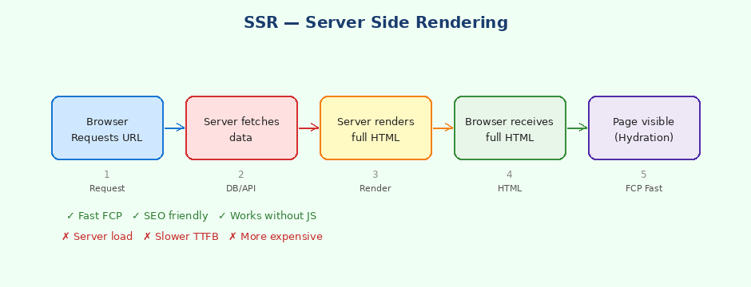

How SSR Works
- Browser requests URL
- Server fetches data from DB/API
- Server renders full HTML with data
- Browser receives and displays complete HTML
- JS downloads and React hydrates for interactivity

When to Use SSR
- Content-heavy sites (news, blogs, e-commerce)
- When SEO is critical
- Personalized pages (user-specific content)

Pros & Cons
✅ Fast FCP — user sees content immediately
✅ SEO friendly — crawlers see full HTML
✅ Works even without JavaScript
❌ Higher server load and cost
❌ Slower TTFB compared to static files
❌ More complex infrastructure

CSR vs SSR at a Glance
Aspect | CSR | SSR
Initial HTML | Empty shell | Full content
FCP Speed | Slow (JS needed) | Fast (HTML ready)
SEO | Poor | Excellent
Server Load | Low | High
Interactivity | After JS loads | After hydration
Best For | SPAs, Dashboards | Blogs, E-commerce

