Tell me something about yourself .

My name is ashish chaursiya, I have 3+ years of experience in building responsive web applications using React, Next.js, HTML5, CSS3, and JavaScript. My recent project, was an e-commerce platform, I focused on developing key features and optimizing ui.

Tell me something about your current project.

My recent project was an e-commerce platform designed to provide a seamless shopping experience for users. as a Frontend Developer, I was responsible for implementing key features such as the dashboard, product listing page, and payment gateway integration,and much more

We have used Nextjs for frontend and nodejs and mongodb for backend.

// challenge faced in project

One significant challenge I faced was reducing the application's initial load time. To address this, I implemented code splitting, asset compression, and lazy loading for images and components, which significantly improved the application's performance and user experience."

what are your roles and responsibilities in your project

My role is Frontend Developer, I am responsible for building responsive ui, implementing key features . I collaborate with designers for pixel-perfect UIs and backend developers for seamless API integration. I optimized performance, test components to maintain quality, and support deployment processes to ensure smooth delivery.

Explain the technical design/ architecture of your project.

The project architecture uses React and Next.js for the frontend, enabling SSR for better SEO and performance. The backend, built with Node.js and Express, provides RESTful APIs, while MongoDB stores data. Stripe is integrated for payments, AWS S3 for media storage, and JWT for authentication. Deployment is managed using AWS Amplify.

suppose it is the delivery time in your project and therefore you have to work on weekends then what you will do.

I’m fully committed to meeting deadlines. I would organize tasks effectively, collaborate with my team, and focus on delivering a high-quality outcome on time.

at last moment of project delivery the requirement is changed then what you will do

I would assess the new requirements, prioritize them based on their impact, and discuss with the team to create a plan. By Emphasizing on critical changes first, I’d ensure timely delivery while maintaining quality.

somebody resigned from the team and there is extra workload on you then what you will do

I would prioritize tasks, focus on the most critical first, and collaborate with the team to ensure smooth progress. If needed, I’d communicate with the manager about the situation to ensure proper workload distribution and timelines.

you are asked to learn a new technology for a new project and then in that case what you will do

I would start by researching and understanding the core concepts of the new technology through official documentation, online tutorials, and courses. Then, I would experiment with small projects or examples to gain hands-on experience. I would also reach out to colleagues or communities for guidance and best practices, ensuring I stay up-to-date with the technology.

How do you ensure the quality of the code in a collaborative project?
I implement unit testing using Jest and React Testing Library, conducted code reviews, and ensured code consistency across the team with ESLint and Prettier.

10) How do you ensure effective collaboration with cross-functional teams?
I organize regular stand-ups for alignment and used Jira for task tracking. Slack and Figma facilitated seamless communication between developers and designers, ensuring clear requirements and quick feedback

11) How do you handle conflicting ideas within the team?
I encourage an open discussion where each team member could present their perspective. I make decisions by Analyzing the pros and cons of each approach.

12) How did you mentor junior developers?
I mentor junior developers by sharing best practices, offering technical guidance, pairing on complex tasks, and providing regular feedback to support their growth.

13) How did you meet/handle tight deadlines in your projects?
I prioritized tasks. This ensured critical features were delivered first. I also allocated buffer time for unexpected issues and encouraged team members to raise blockers early.

15) What is your greatest strength?
My ability to break down complex problems and deliver efficient solutions.

16) What is your greatest weakness?
I sometimes over-analyze minor details, which can delay progress. However, I’ve learned to focus on key priorities.

17) How do you handle pressure when working on high-priority tasks?
I break tasks into smaller, manageable parts and tackle them. Staying organized with tools like Notion or Jira helps me stay on track. I also make it a point to communicate with my team to share the load when needed.

18) Where Do You See Yourself in 5 Years?

In five years, I see myself as a technical lead, mentoring junior developers and making key architectural decisions on impactful projects. I also aim to deepen my expertise in AI-driven frontend solutions.

19) how you Manage Vulnerabilities in your project

To handle vulnerabilities, I use tools like npm audit to scan dependencies and regularly update them. I validate and sanitize inputs, implement secure authentication and follow best practices.

20) Which model (SDLC) you use in your project .

In my project, I used the Agile model, which emphasizes flexibility, collaboration, and iterative development. It allowed us to quickly adapt to changing requirements and deliver incremental value through regular sprints.

How to Implement Real-Time Communication with WebRTC

I have implemented a WebRTC-based video call feature:

Here are all the steps that I have followed:

Implemented signaling server using Socket.IO for SDP and ICE candidate exchange

Used RTCPeerConnection API for peer-to-peer connectivity

Leveraged getUserMedia() API for local media stream capture (video/audio)

Implemented MediaStream API for stream handling and control

Connection Management:

Implemented auto-reconnection using oniceconnectionstatechange event handler

Performance Optimization:

Implemented adaptive bitrate control for dynamic video quality

NAT/Firewall Handling:

Configured ICE servers (STUN/TURN) for NAT traversal

What is WebRTC?

WebRTC is a technology that enables real-time communication, such as video, audio, and data sharing, directly between browsers or devices without requiring additional plugins. It's commonly used in video conferencing, chat apps.

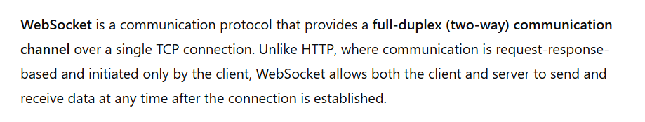

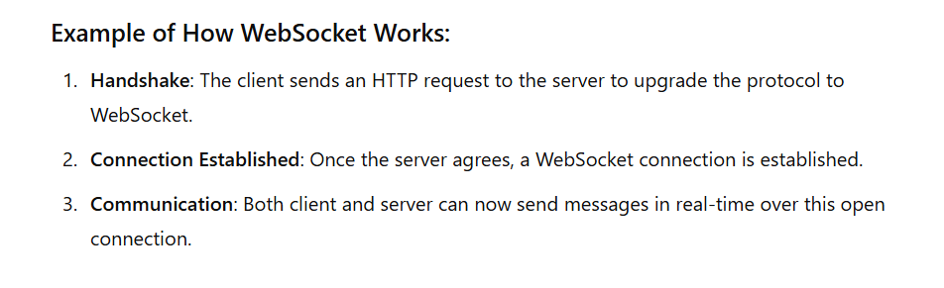

What is the Difference Between React and Next.js? Which One Would You Choose and When?

React:

Description: React is a JavaScript library for building user interfaces, particularly single-page applications (SPAs). It provides tools to create reusable components and manage state efficiently but does not include built-in features like routing, server-side rendering, or API handling.

Use Case: Use React when building SPAs or small-to-medium-sized projects where you want full control over your application's structure and don’t need features like server-side rendering (SSR).

Next.js:

Description: Next.js is a framework built on top of React. It extends React by adding features like server-side rendering (SSR), static site generation (SSG), API routes, and optimized performance for production-grade applications. It includes tools like file-based routing and image optimization out of the box.

Use Case: Use Next.js for larger projects, SEO-critical applications, or when you need features like SSR, SSG, or API routing. It’s great for e-commerce platforms, blogs, and enterprise-level projects.

