DSA questions.

Question 1:
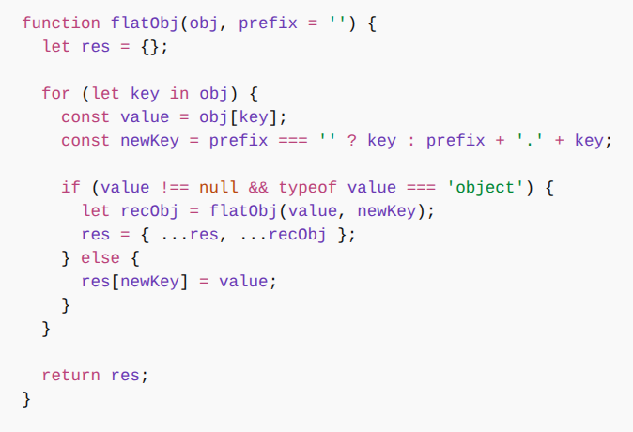

Question 2: write a function to calculate the summation of its arguments until it encounters a "." delimiter.

input: sum(2)(3)(.)

output: 5

input : sum(1)(2)(4)(4)(1)(.)

output: 12

concept : clouser,recurssion

solution: function sum(num) {

let total = num;

return function innerSum(nextNum) {

if (nextNum === '.') {

return total;

} else {

total += nextNum;

return innerSum;

}

}

}

Question 3: write a function which return all elements of nested array.

input: [1,[2,3], [1,[2,3]]]

output: [1,2,3,1,2,3]

concept: recurssion

solution: function flattenArray(arr) {

let flattenedArray = [];

arr.forEach(item => {

if (Array.isArray(item)) {

flattenedArray.push(...flattenArray(item));

} else {

flattenedArray.push(item);

}

});

return flattenedArray;

}

Question 4: Write a program to find element occurence in array.

console.log(count); // 👉 {1: 3, 2: 1, 3: 2}

Question 5: Write a program to remove duplicate item from array.

Input : [1,2,3,4,1]

Output:[1,2,3,4]

Question 6 : find max and min element in the arr

let arr = [45,21,62,89,17,95];

Question 7 : find second max and min element in the arr

function findSecondLargest(arr) {

let largest = -Infinity;

let secondLargest = -Infinity;

// largest =Infinity, secondLargest = Infinity , for second min

for (let item of arr) {

if (item > largest) {

// item<largest for second largest

secondLargest = largest;

largest = item;

} else if (item> secondLargest && item !== largest) {

// item<secondLargest for second largest

secondLargest = item;

}

}

return secondLargest;

}

let arr = [45, 21, 62, 89, 17, 95];

console.log(findSecondLargest(arr)); // Output: 89

Question : 8 How to find string is palindrome or not

function IsPalindrome(str){

let length = 0 ;

while(str[length]){

length++

}

let res= true

for(let i=0;i<parseInt(length/2);i++){

if(str[i]!=str[length-i-1]) {

res= false

break

}

}

return res

}

Question 9: Sort an array without sort function (bubble sort)

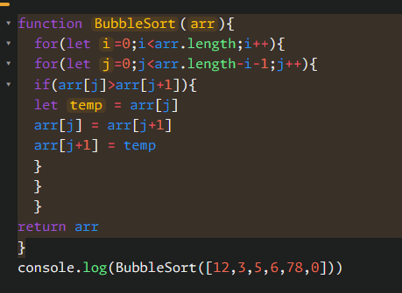

// Remove duplicate character from string

let str = "hello world" // o/p => helo wrd"

let final = ''

let map = new Map();

for(let item of str){

if(!map.has(item)){

map.set(item,item)

final+=item

}

}

console.log(final)

Note : if you have more time to prepare then you can consider these question list, otherwise abovequestions are enough.

https://www.youtube.com/watch?v=hRt9qadriyQ&list=PLe3J6mZBq1xXGugXelPwjNeWuOVrVoWQS

// Time & Space complexity

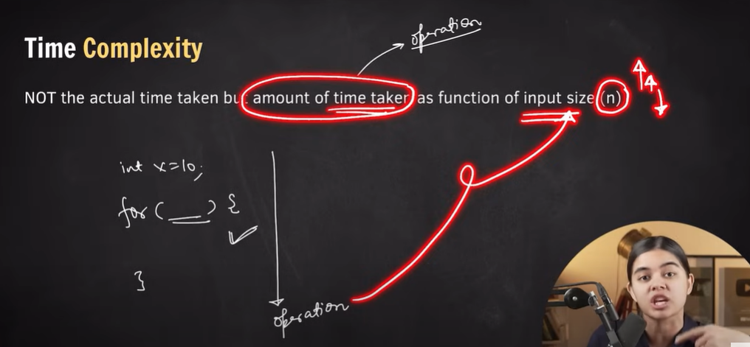

O(n2) = Big O of n2

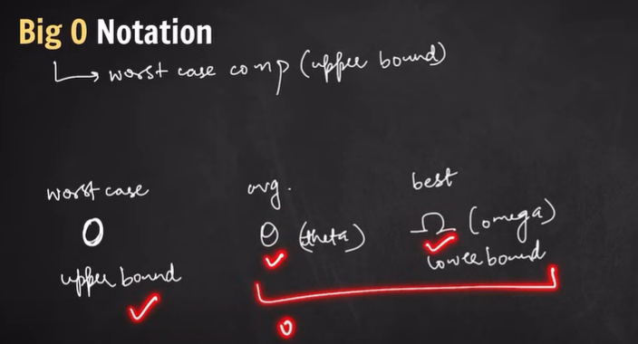

We only consider extra space while calculating space complexity

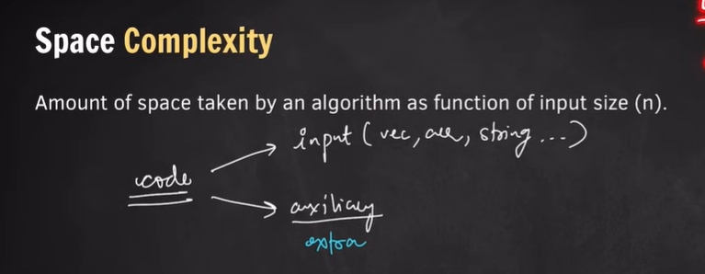

Example 1_- let say we have given arr,need to return sum of that, so we need an total variable so space complexity would be 0(1).

Example 2_- given an arr, need to return squre of it then we need an arr of same size of input arr then in this case space complexity would be O(n).

