JS Interview Questions.

How js work

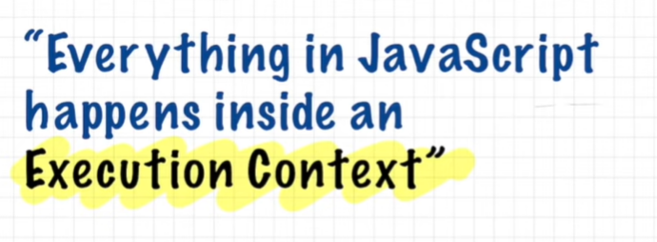

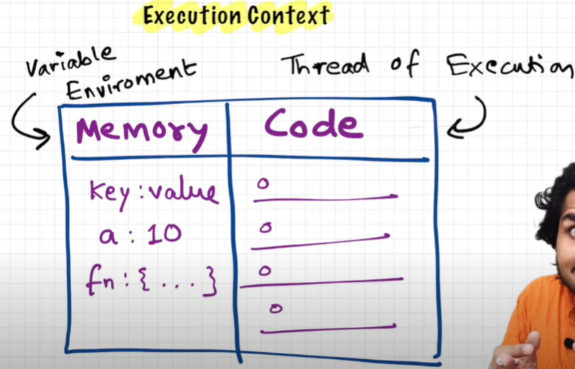

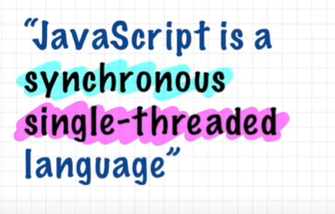

Synchronous :- code will be execute one by one (specific order) means next line will wait previous one to complete.

Single Threaded :- one command would be execute at one time.

Means it has one hand, can pick one task at one time.

Note:code run in two phases ,( memory creation, code execution ) phases

Note:- every time when function is called, execution context is created , and when fn is finish ,execution context will destroy.

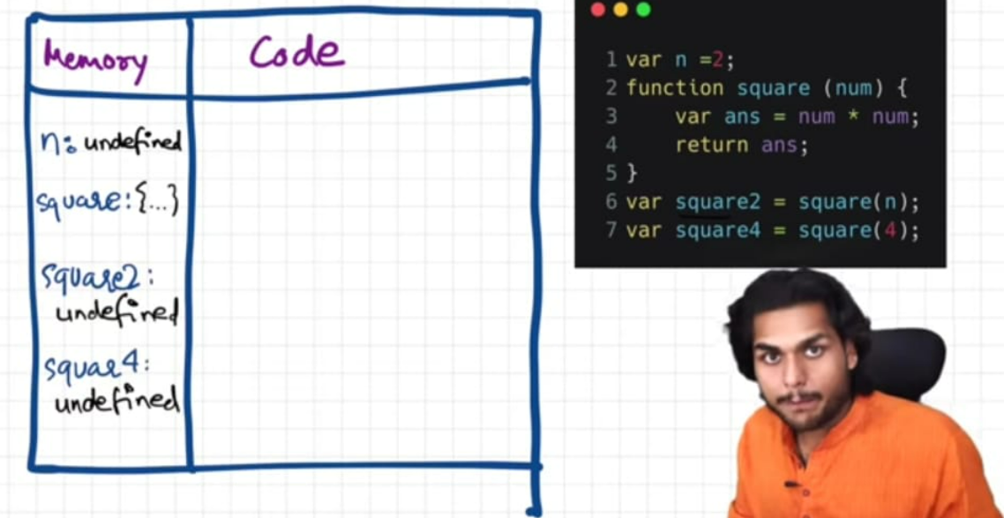

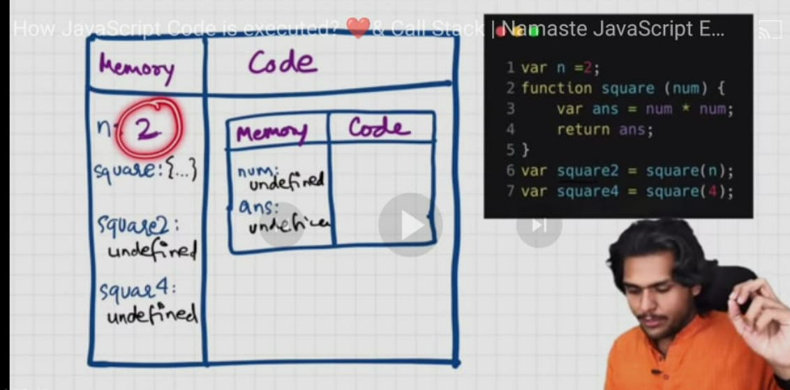

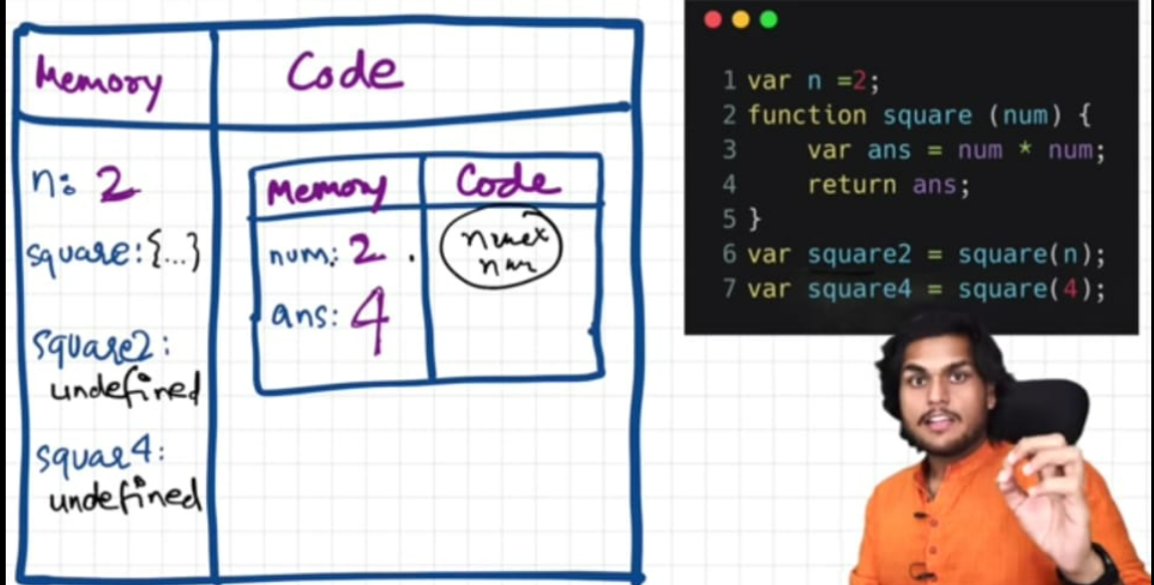

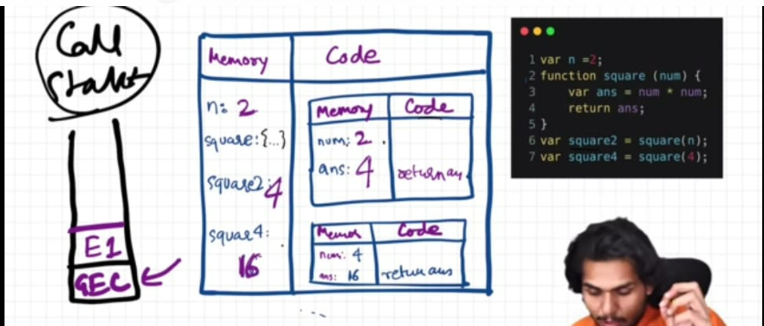

Hoisting :- when ever any code is executed or fn is invoke js follow these steps to run code.

a )Execution context is created

b )Memory allocation

Code execution

Note: if fn is created with arrow fn then in memory allocation phased it will defined as undefined behave like as variable.

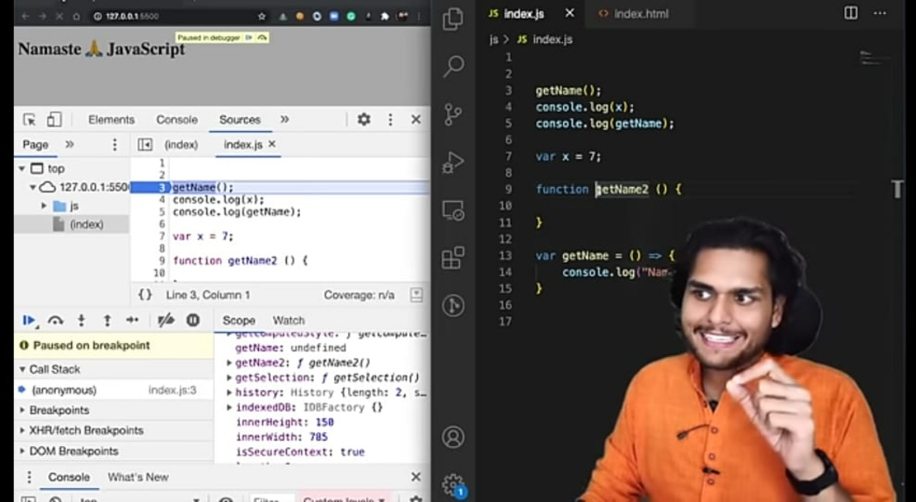

Closurers:-

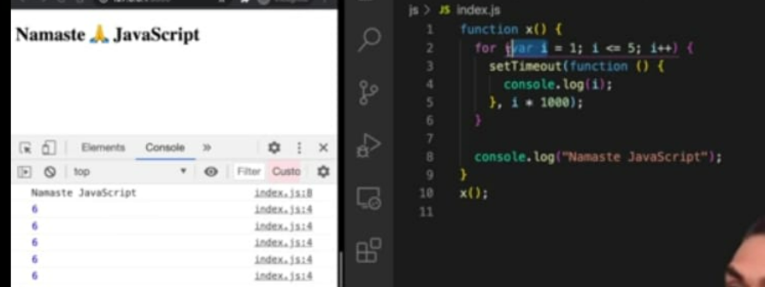

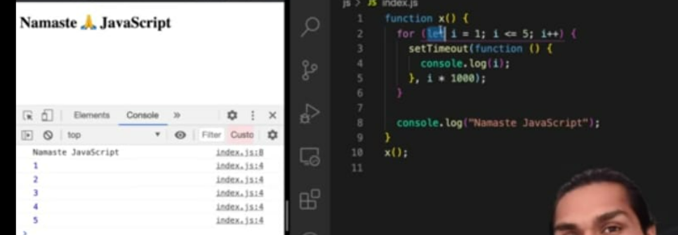

EventLoop:- 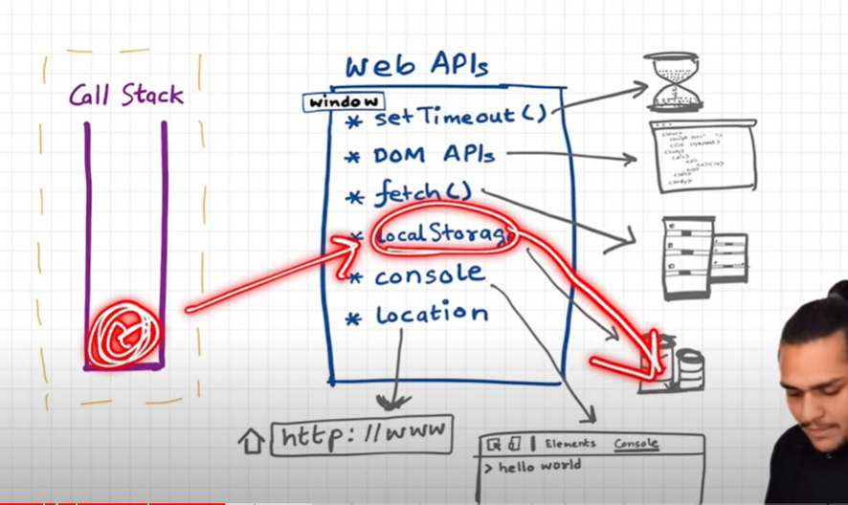
Note:- Above Web Apis functions is not part of javascript , those are feature of browser.
Note:- The job of eventLoop is constantaly checking call stack and callback/microtask queve, if call stack is empty and there is any callback fn exist in microtask queve and callback queve, then it will first pull microtask queve fn in call stack because it has more priority than callback queve.

Note:- if callback fn in callback/microtask queve is ready to execute but still present 1000 line to be execute then js first execute those 1000 line then those callback push into call stack. This means setTimeout fn timer does not give gurranty it will call after x mili sec, that is min time.
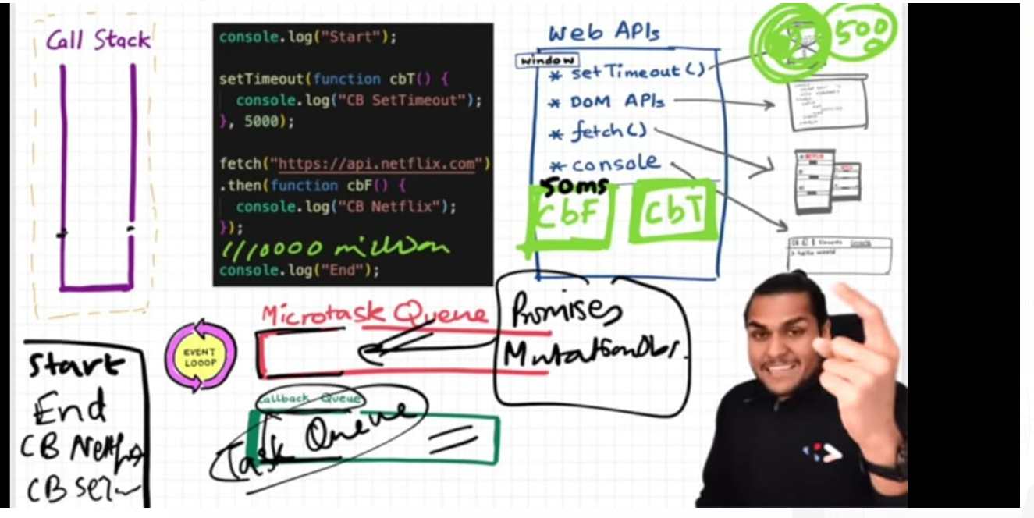

Js Engine:- to execute js code we need JS runtime environment, with the help of this we can execute js code in watch, robot, tv, everywhere.
Every browser has own js engine.
Note: Is js compiled or interpreted or both its depend on browser js engine.
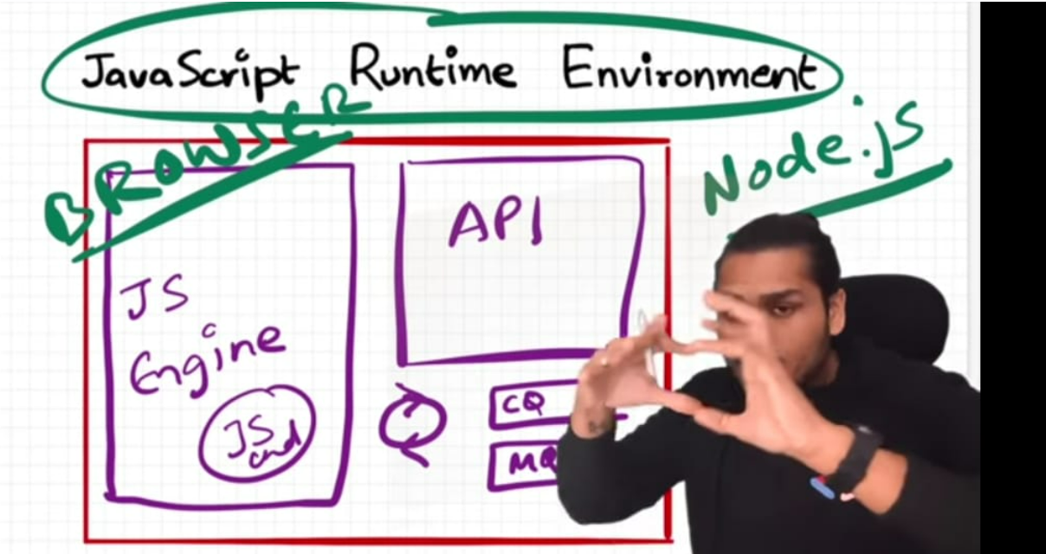
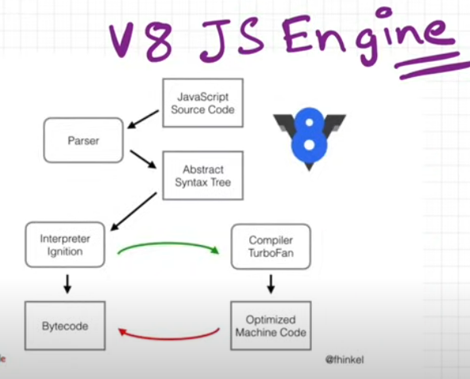
Note:- Yes, JavaScript Runtime Environment (JRE) comes under the browser. It is a part of the browser that is responsible for executing JavaScript code. Every browser has its own JRE, which is why JavaScript code may run differently in different browsers.Js engine come under the JRE.
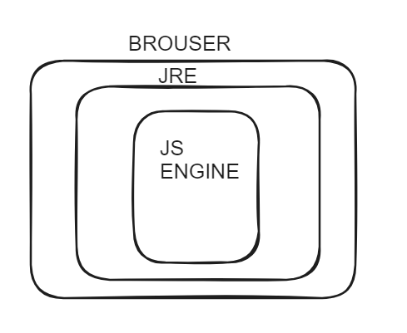

Promise :
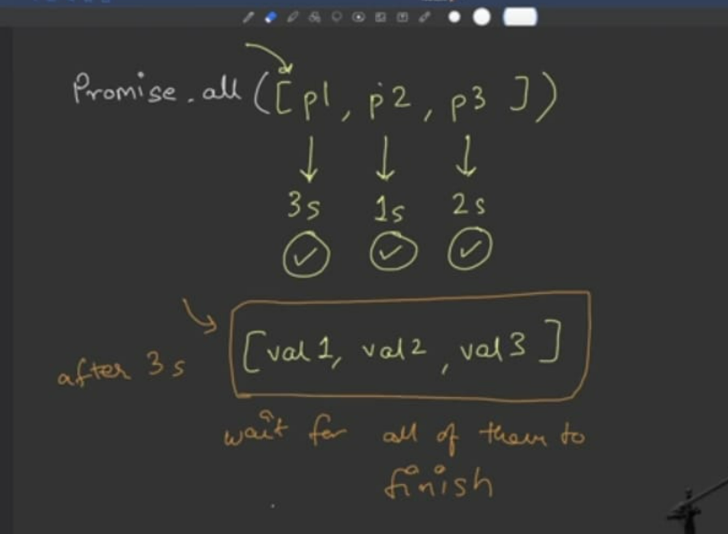
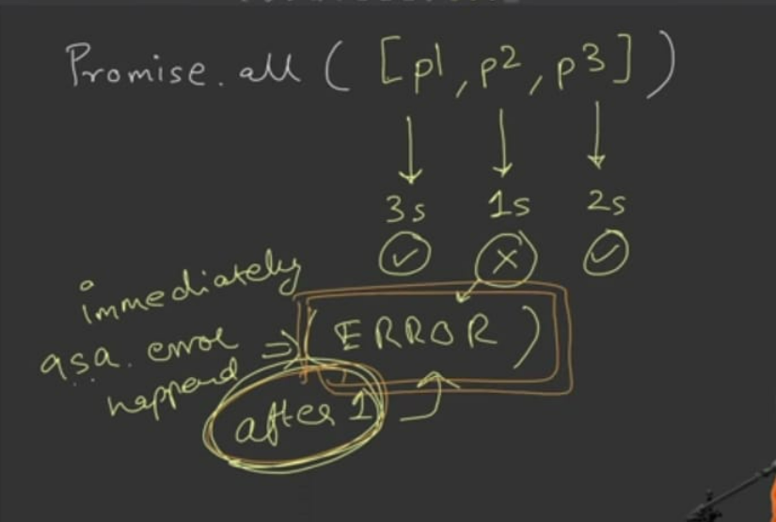
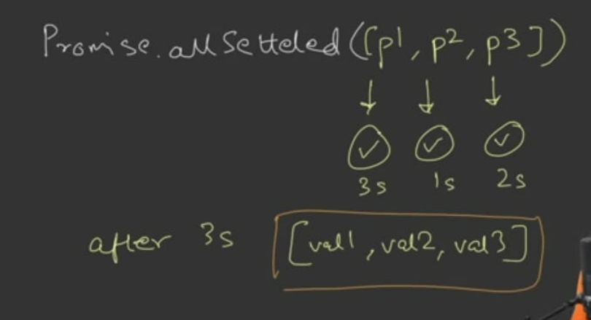
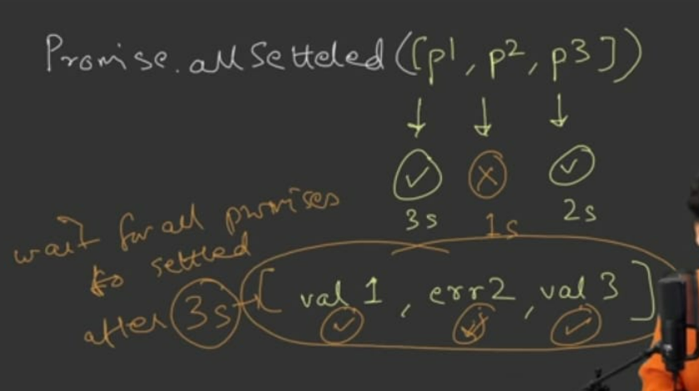
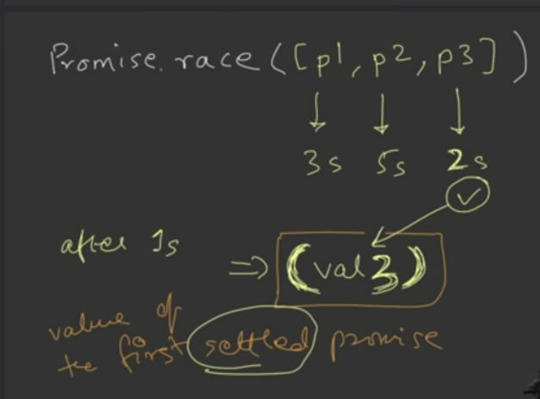
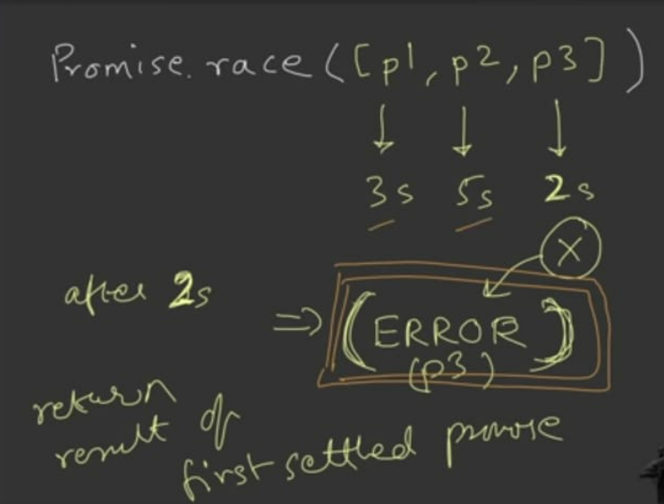
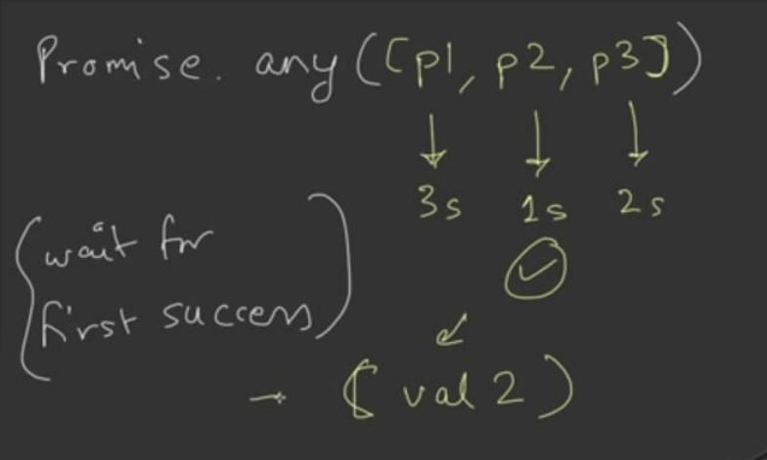
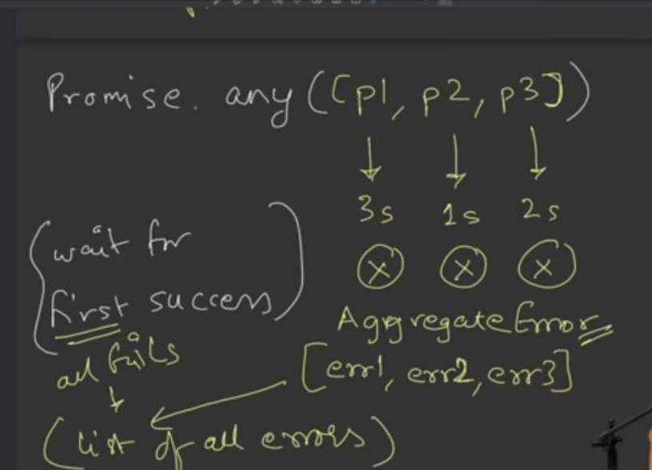

How Async/await Works :-
//Example 1
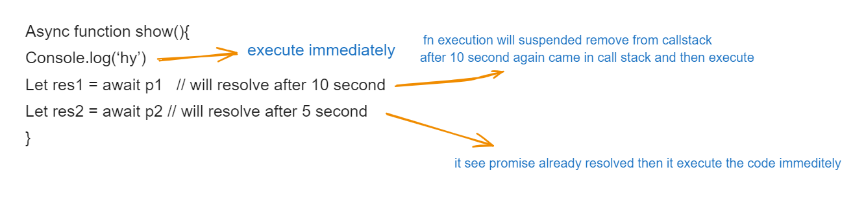

//example 2
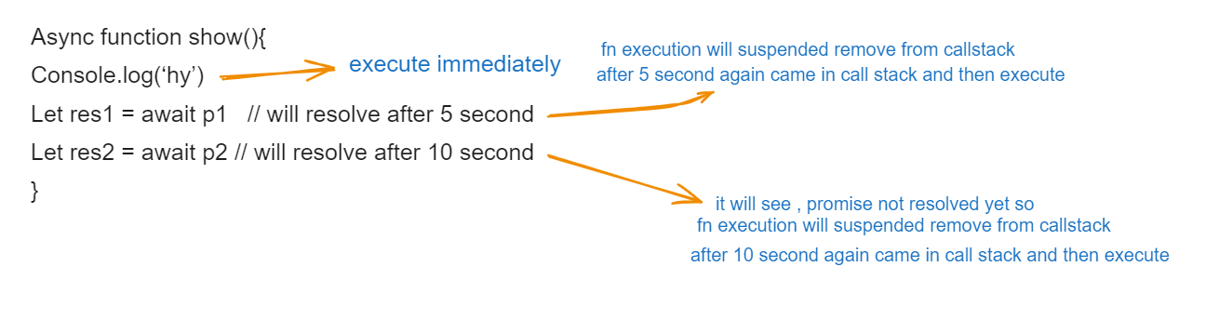
This keyword:
this is a special keyword that refers to the object that is currently executing the function. Its value is determined by how a function is called, not where it is defined
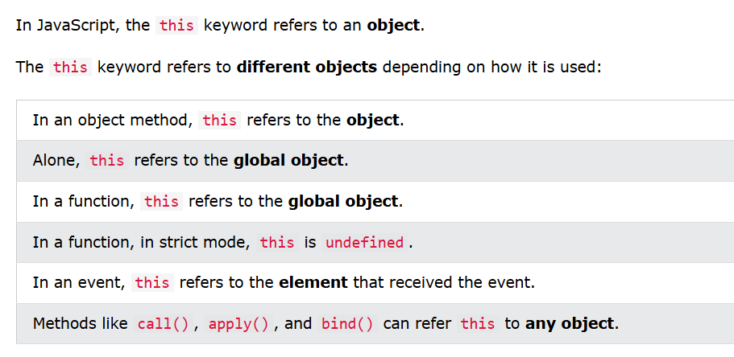

// guess the output of below code snippet.
const person = { name: "John", greet: function() { function innerFunc() { console.log(this.name); } innerFunc(); } }; person.greet();

const person = { name: "Eve", greet: function() { console.log(this.name); } }; const greetFunc = person.greet; greetFunc();

const person = { name: "Jane", greet: function() { const innerFunc = () => { console.log(this.name); }; innerFunc(); } }; person.greet();

// Practice Output base question
https://github.com/lydiahallie/javascript-questions
// Js theory question
https://workat.tech/frontend-development/article/top-javascript-interview-questions-answers-bt2553k4egca#14

