Reactjs Interview Questions.

How React work?

React works by enabling developers to build user interfaces using reusable components written in JSX syntax. When the state changes, React creates a new Virtual DOM (a lightweight copy of the real DOM) and compares it with the previous Virtual DOM using a diffing algorithm. After identifying the differences, React applies only the necessary updates to the real DOM. This entire process is called reconciliation. This is how React works.

What is component life cycle of React component ?

React Component Lifecycle refers to the sequence of events that occur from the creation of a component to its removal from the DOM. It provides flexibility to developers execute code at specific stages of a component'. Lifecycle methods are available in class components, while hooks like useEffect are used in functional components.

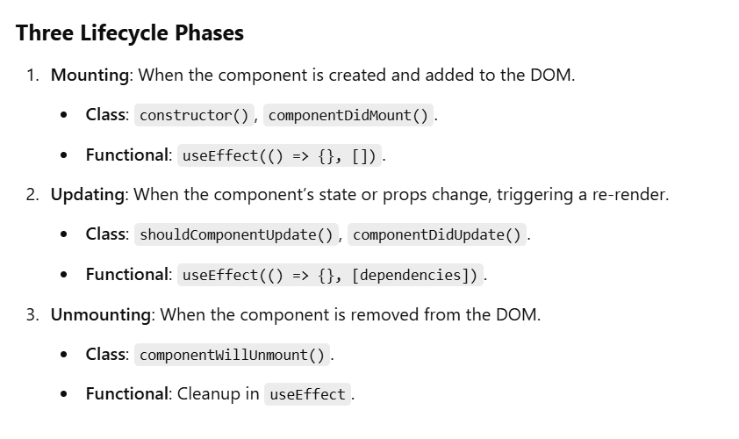
3) What are Pure components in React ?

A Pure Component in React is a component that renders the same output for the same props and state. to prevent unnecessary re-renders,we use pure component , its improve performance of react app.

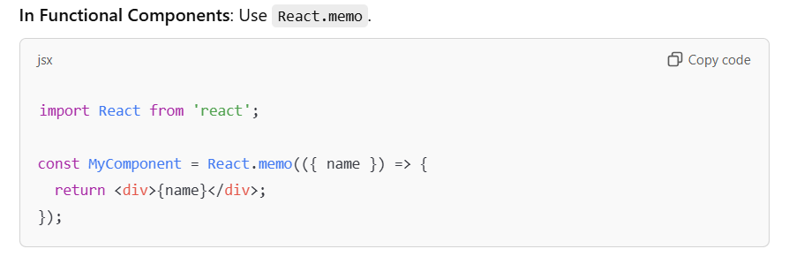
4) What are Error boundaries ?

Error Boundaries are special React components that catch errors in their child components during rendering. They prevent the entire app from crashing by isolating errors to specific parts of the UI and displaying a fallback UI.

5) What are Higher order components in react ?

A Higher-Order Component (HOC) is a function in React that takes a component as an argument and returns a new component with added functionality. It allows code reuse and abstraction by wrapping existing components with additional behavior or data.

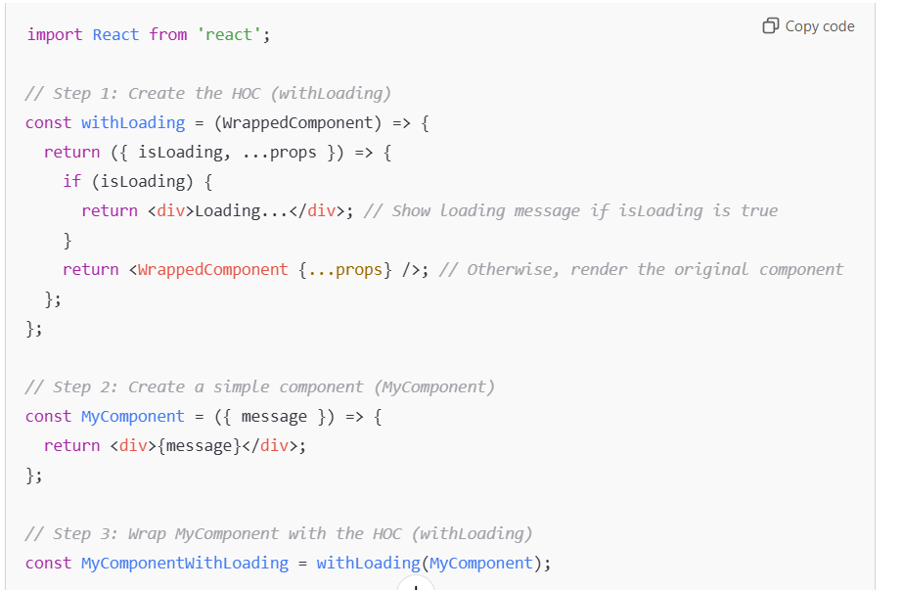

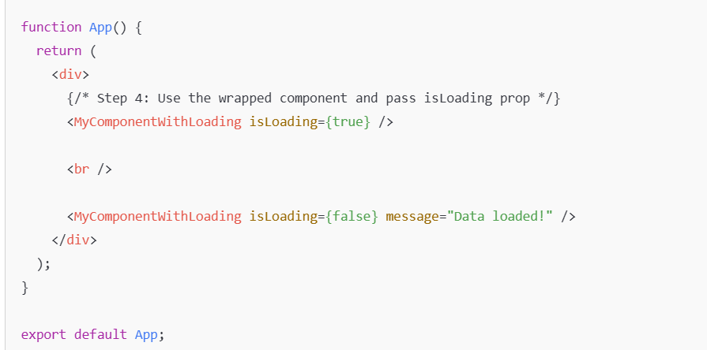

6) What are the differences between controlled and uncontrolled components ?

Controlled and uncontrolled components are just different approaches to handling input form elements in react.

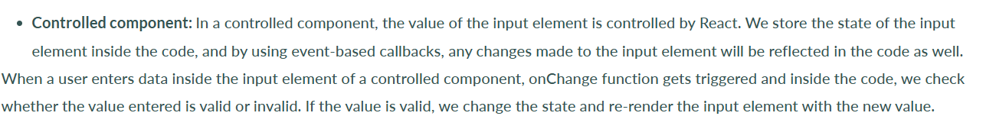 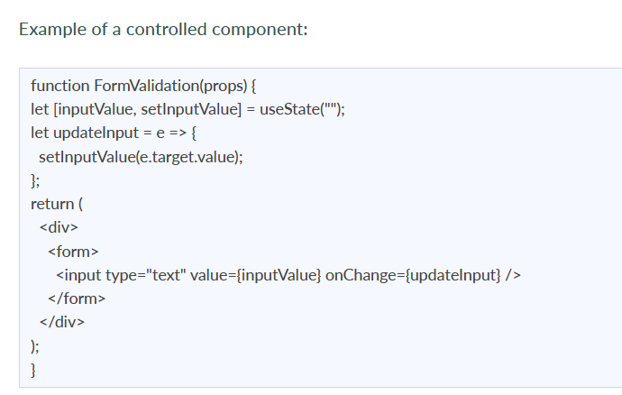 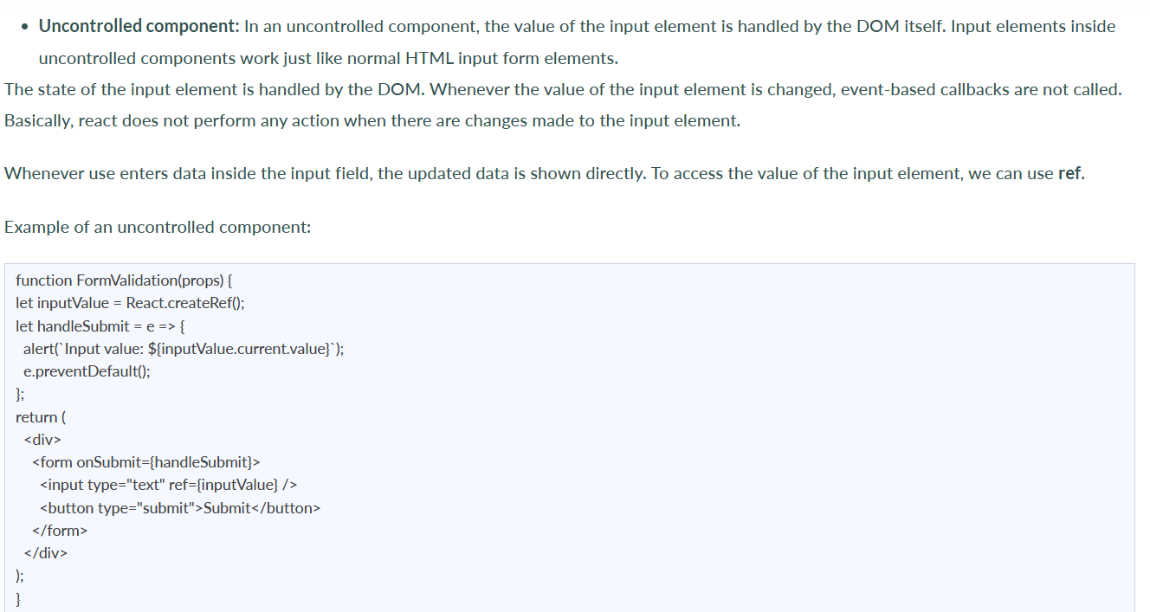
7) . What are the differences between useMemo and useCallback ?

Both useMemo and useCallback are React hooks used for optimization, but they serve different purposes and are applied in different scenarios.

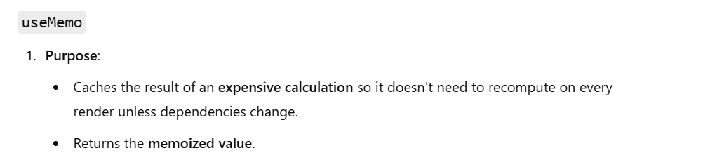

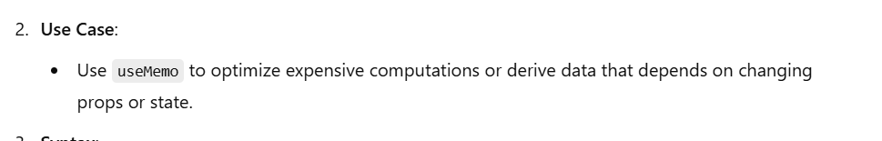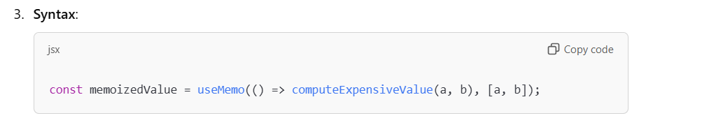

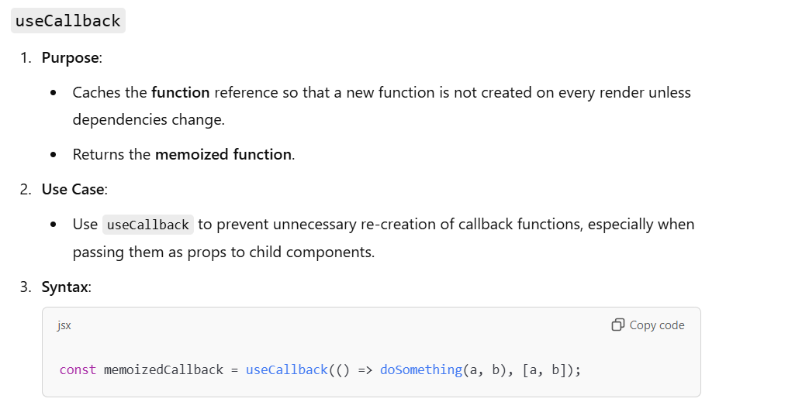

8) Functional vs class component

React provides two main ways to create components: functional components and class components. While they both serve the same purpose—building UI—they differ in structure, syntax, and features. Here’s a comparison:

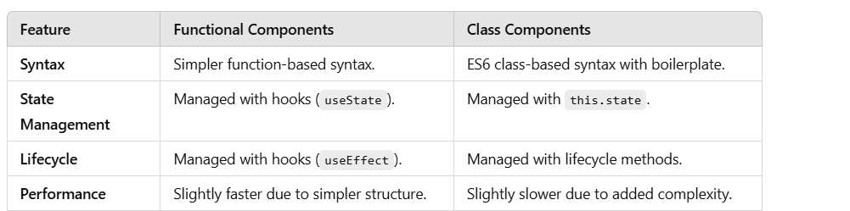

9) What is Lazy loading in React , how can we Implememnt it ?

Lazy loading in React is a performance optimization technique we load components or resources when they are needed. It helps reduce the initial load time of an application by splitting the app into smaller chunks and loading them on demand.

React provides built-in support for lazy loading components through the React.lazy function and React.Suspense component.

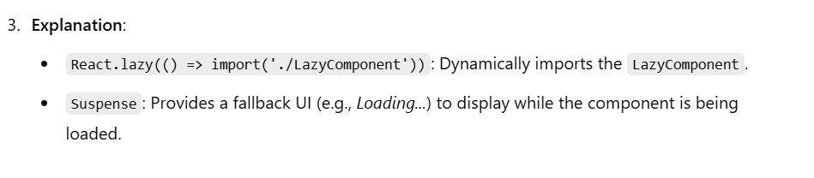

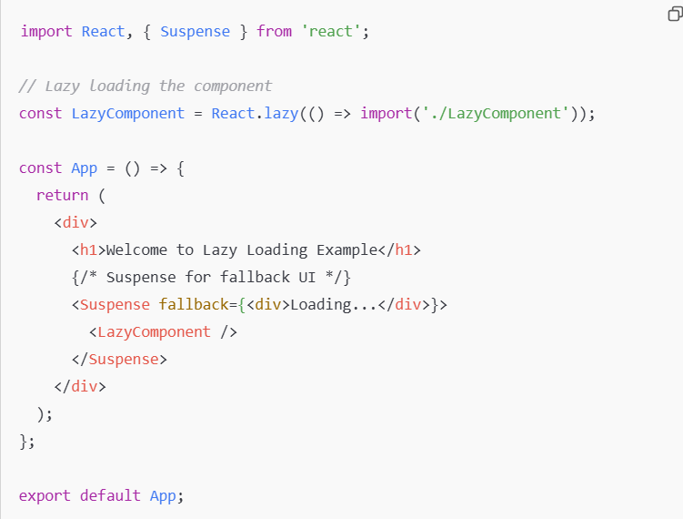

10) What is useContext in react ?

useContext is a React hook that provides an easy way to access data shared across the component tree without having to pass props manually at every level. It works with React's Context API to manage global state or share data like themes, user authentication, or settings.

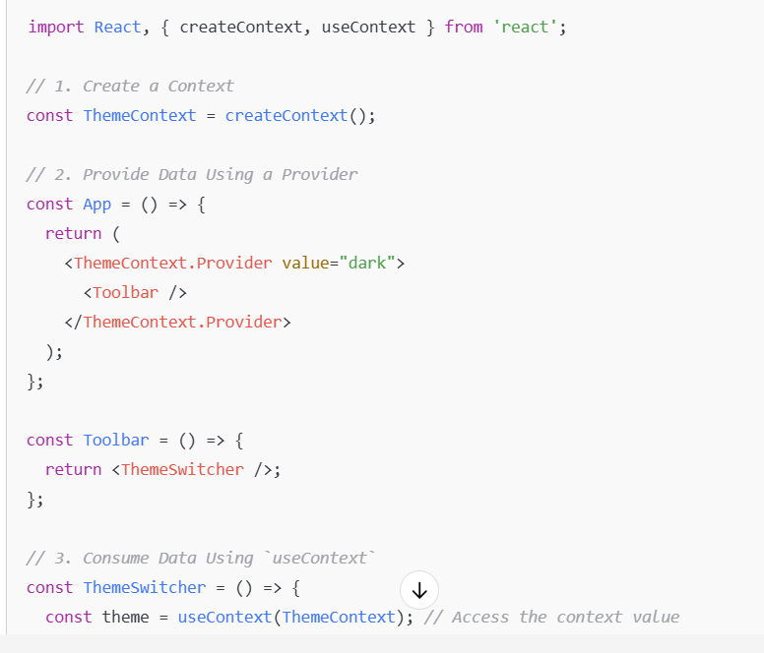

13) Name a few techniques to optimize React app performance

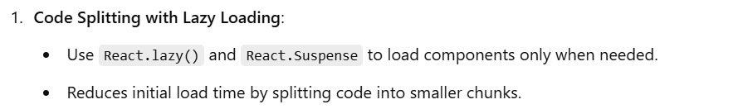

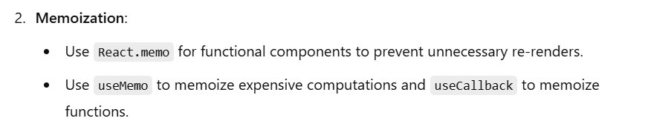

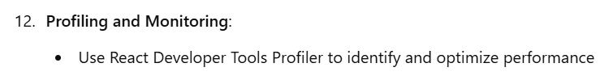

// Redux//

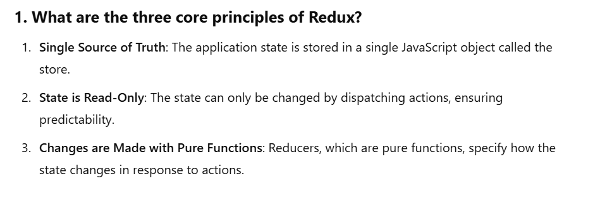

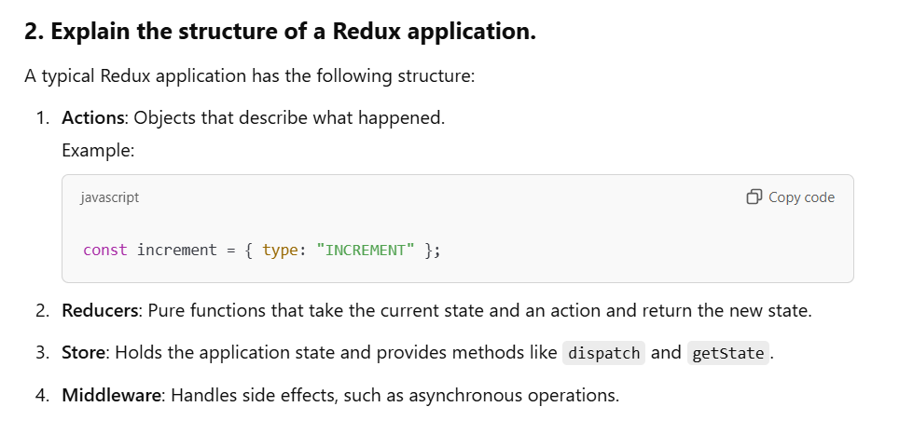

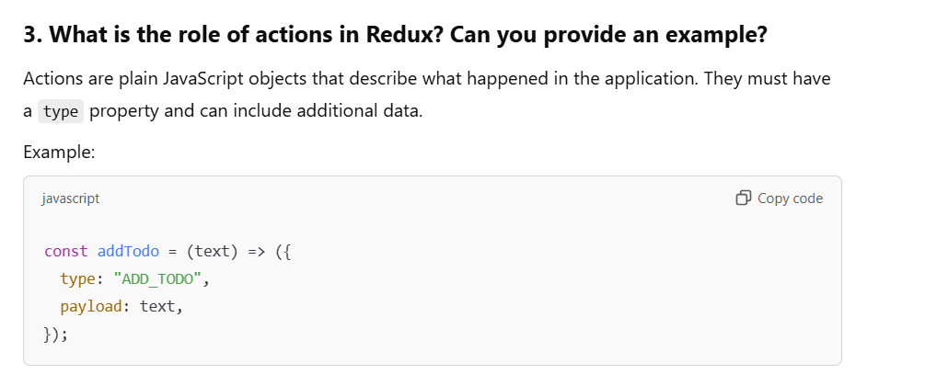

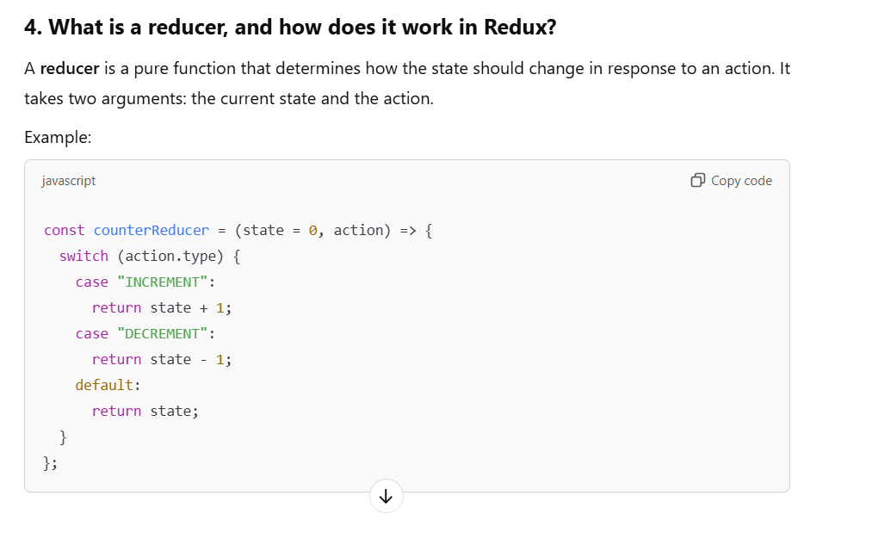

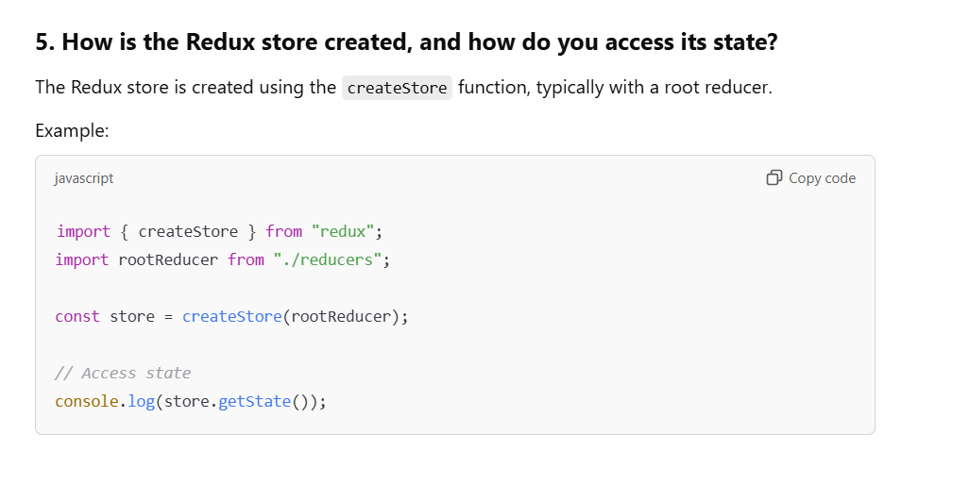

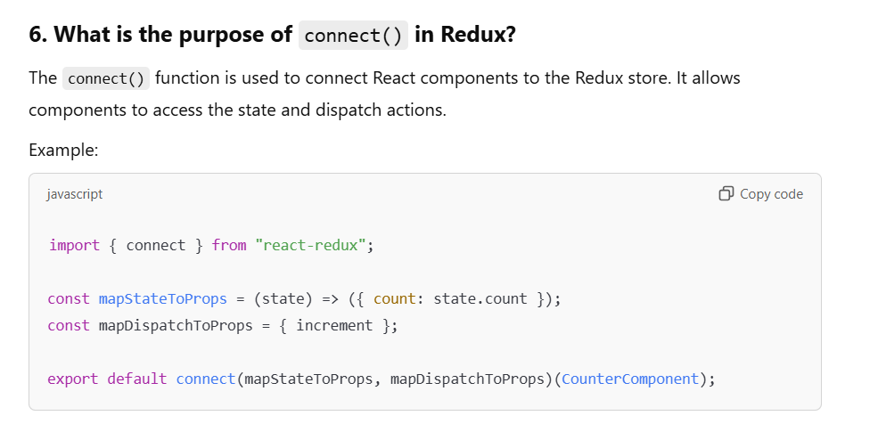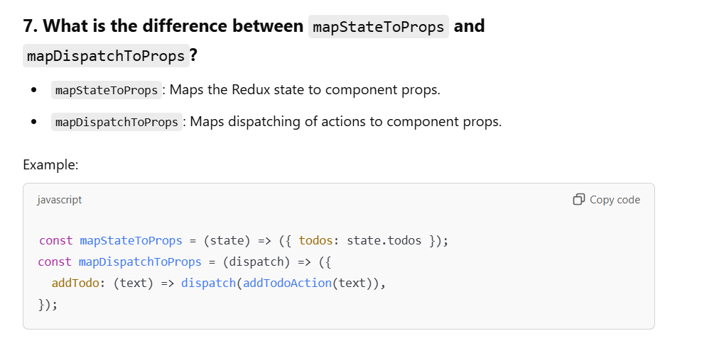

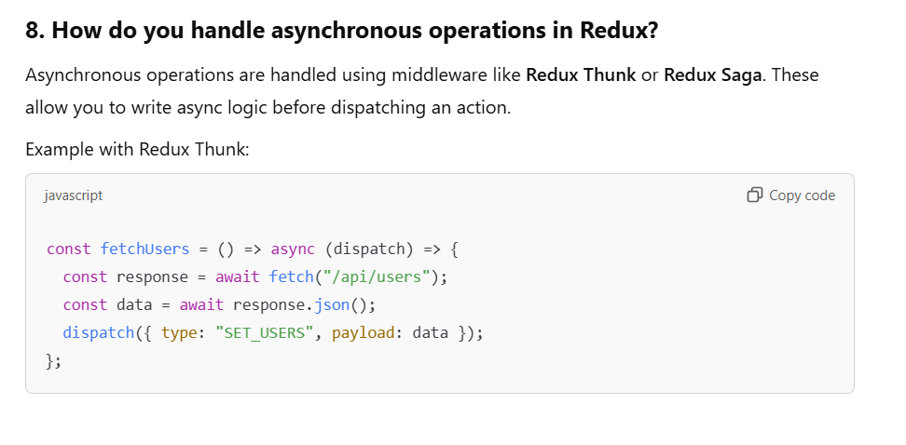

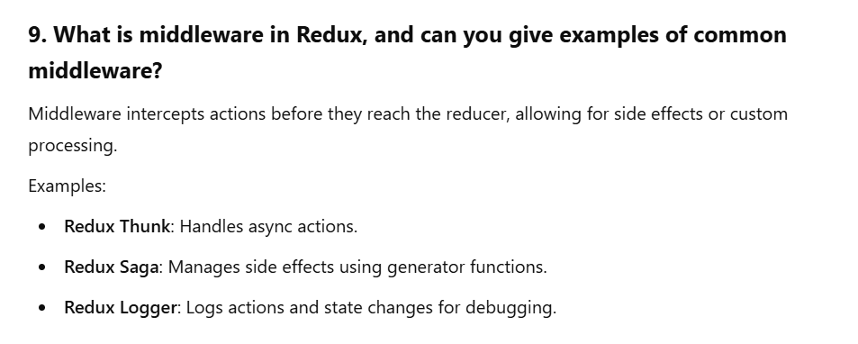

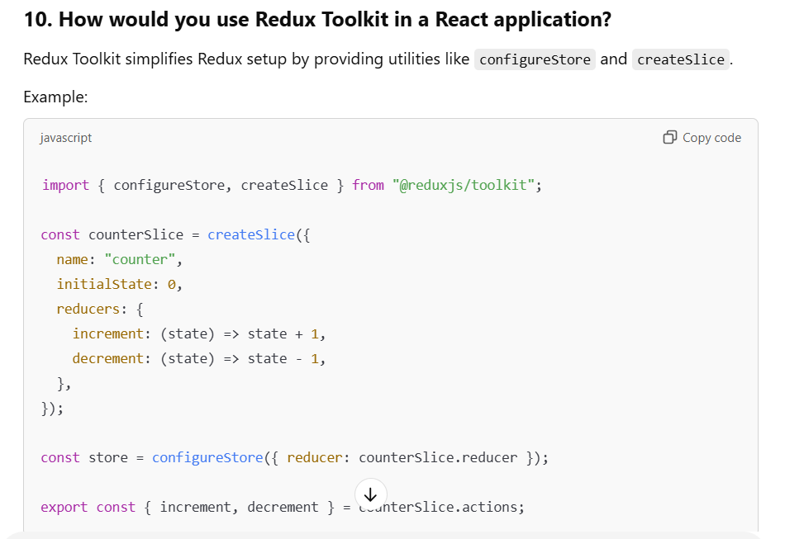

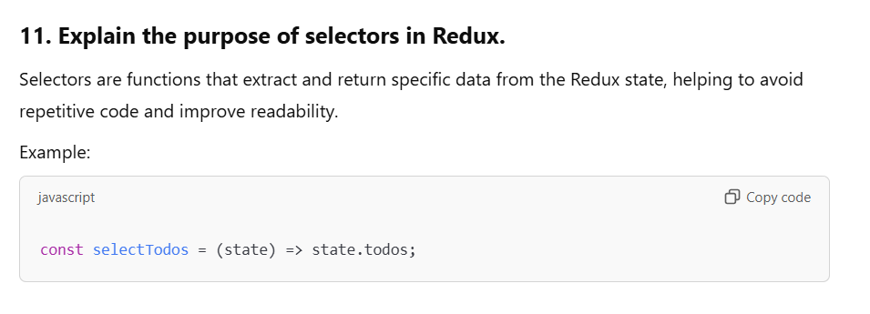

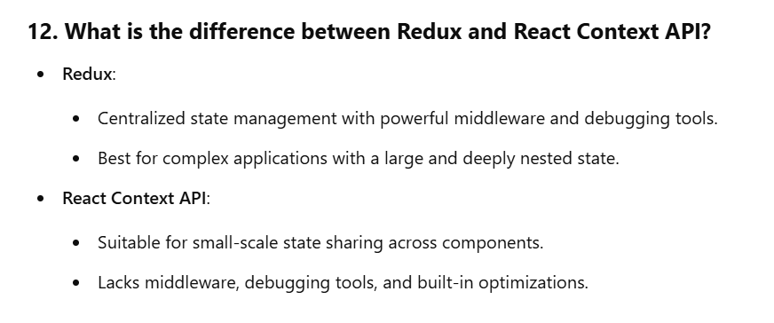

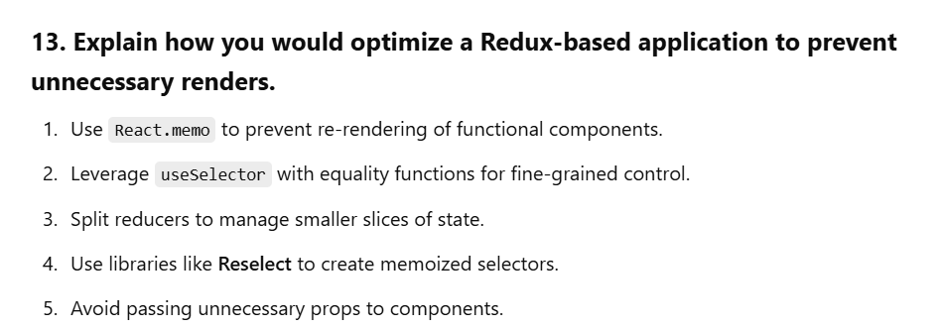

What are the features of React ?

What is JSX ?
What is Virtual Dom ?

What are fragments in react ?

.What are the differences between State and Props in react ?

What is props drilling ?

What are keys in React ?

What are Ref’s in React?

What is Strict mode in react ?

. What are Portals in react ?

what-is-reconciliation,

What is meant by forward ref ?

What are custom hook

What is react fiber

what-are-the-differences-between-useEffect-and-useLayoutEffect-hooks

