Interview Material

//intro be-confident.

My name is ashish chaursiya, I have 3+ years of experience in building responsive web applications using React, Next.js, HTML5, CSS3, and JavaScript. My recent project, was an e-commerce platform, I focused on developing key features and optimizing ui

One significant challenge I faced was reducing the application's initial load time. To address this, I implemented code splitting, asset compression, and lazy loading for images and components, which significantly improved the application's performance and user experience."

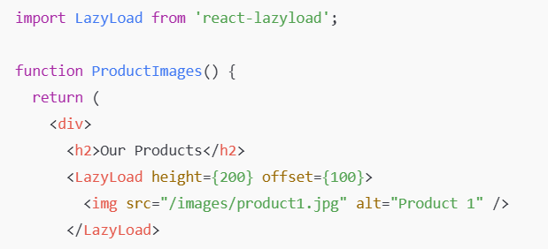

// backend challenge

One of the main challenges we faced was ensuring the platform could handle high traffic volumes during peak shopping periods.

We addressed this by implementing caching strategies using Redis, optimizing database queries,

and conducting load testing to ensure scalability and performance.

//hr question

1)Why do you want to work for our company?

I am looking for an opportunity where I can explore new technologies and take on new challenges as well. I believe this company offers the environment where I can achieve these goals.

2). Why are you looking for a change?/Why do you want to leave your current job?

"I am looking for an opportunity where I can explore new technologies and new challenges as well. This is the reason.

3)Why should we hire you?

I believe that, I have enough skillset & experience that is great for this role , also that will

bring value to your company. thats why I am best candiate for this role.

4) do you have any query.

"Could you please provide me insight into the types of projects and technologies I would be assigned to if I were to join the team.

After this round, how many more rounds will be there?

5) explain role and responsibility

As a front-end developer, I design and create responsive ui, build interactive features, optimize performance, and collaborate with designers and back-end teams to ensure seamless integration of front-end components within the overall application

// steps for interview preparation (15-30Lpa)

https://github.com/ghoshsuman845/frontend-interview-preparation-kit

// Remote Job Process.

https://vishal-raj-1.notion.site/How-to-get-remote-jobs-fd519d2236f8454cb6afb21a8143ac38

Apply on these portal. (indeed,instahire,wellfound , turing)

Do a personal message to Hr.

// Hr Round

HR: "We've reviewed your experience and skills. We can offer 10.5 LPA, which we believe is competitive and aligns with our budget for this role."
You: "Thank you for the offer, and I’m really excited for this role. However, based on my experience, market standards, and previous discussions, my expected CTC is 12 LPA. I believe that’s reasonable."

HR: " our budget is limited. but 12 LPA is a bit too high for us."
You: "I understand budget constraints, but considering my 3.5 years of experience, my contributions to previous projects, and my proficiency in React, Next.js, and knowledge in other domain as well , I believe 12 LPA is reasonable."

HR: "Hmm, let me see... the best we can do is 10.9 LPA."
You: "That’s still lower than my minimum expectation of 11 LPA

HR: "Ashish, we reviewed your interview performance. It was average, and we feel your communication skills need improvement. Based on this, we’re offering you 10 LPA."
You: "I appreciate the feedback, and I’m always working on improving my communication skills. However, I believe my technical expertise and three years of experience in React, Next.js add significant value to your comapny.
I am expecting 12 LPA, with a minimum of 11.5 LPA."

HR: " According to your performance, we can't go beyond 10.25 LPA."
You: " my work in previous projects has been impactful, and I will bring the same impact here as well. Can we go with 11 LPA?"

