RADAR TARGET
CLASSIFICATION
Project findings, Model 11 architecture, feature mathematics,
cell-by-cell notebook guide, and viva preparation

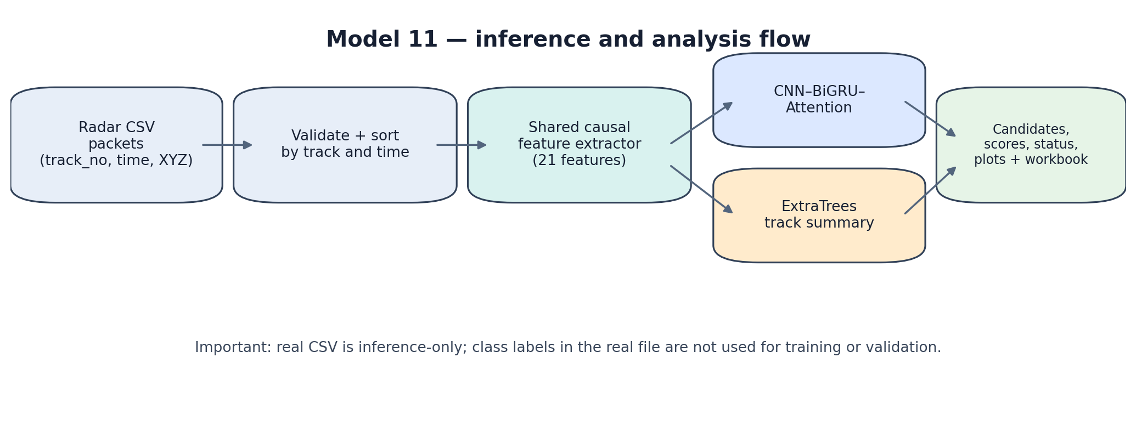
Prepared as a first-person technical study guide for explaining the work clearly to teammates, reviewers, and senior engineers.

How to use this report
This report is written in a practical “we did / our pipeline” voice so it can serve as a study guide and a basis for explaining the project. It separates three things: (1) what the current notebook code implements, (2) findings previously observed in our runs, and (3) limitations or items that still need validation.
Evidence rule
The current notebook file contains code cells but no saved execution outputs. Therefore, its exact current metrics cannot be read back from the file itself. Metrics quoted in this report are historical results previously recorded during the project and are explicitly labelled as such; rerun the notebook to regenerate the current evaluation tables.

The most important caveat
Our synthetic training and test data let us test the pipeline and compare model behavior under controlled scenarios. They do not establish real-radar classification accuracy. Our real radar CSV is unlabelled, so its predictions remain hypotheses to be reviewed, not verified target identities.

Executive summary
We built a two-model radar-track classification pipeline that reads packet-level radar data, creates physically motivated motion features, and produces two complementary classification views: a temporal deep-learning model and a tree-ensemble model operating on track summaries.
- CNN–BiGRU–attention: consumes a rolling sequence of 30 packets, with 21 engineered features per packet. It can learn how motion changes across time.
- ExtraTrees: summarizes the latest up-to-30-packet window using five statistics for each of the 21 features, then uses many randomized decision trees to classify the track.
- The two models run side by side on each real track. The notebook keeps per-track histories, marks the first 29 packets as warm-up for a full 30-packet window, and presents candidate classes and uncalibrated scores.
- We designed the notebook to preserve local model artifacts in a `model_11/` folder, produce one formatted results workbook, and provide a paced append-only packet replay.
- The visualization refinement adds a dark/light research plotting style, interactive Plotly charts, multi-track overview, 3D trajectory, optional recorded-track animation, score timeline, prediction changes, feature importance, and synthetic benchmark plots.

Current final notebook
Current notebook filename: Model_11_Portable_Dual_Model_Research_Visual_Refinement.ipynb.
This is the portable Model 11 dual-model notebook with visualization refinements. The visualization cells are intended not to alter the trained models or their inference logic. The code file itself does not include saved execution outputs, so the latest run must be executed to confirm runtime compatibility, outputs, and current metrics.
Item | Current implementation / meaning
Input | CSV with positions, timestamps and track identifiers; if `track_no` is absent, the notebook assigns one track ID.
Classes | Nine synthetic target categories: civilian aircraft, fighter aircraft, helicopter, drone, surface missile, aerial missile, skiff, boat, ship.
Feature schema | 21 shared causal motion features per packet.
Sequence length | 30 packets per track/window.
CNN artifact | `model_11/cnn_model.keras` plus preprocessing objects.
ExtraTrees artifact | `model_11/extratrees_model.joblib` and saved summary-column schema.
Metadata/evaluation | `bundle_metadata.json`, `evaluation_reports.joblib`, and an output workbook under `model_11/outputs/`.
Real data | Inference only; the real CSV is not used to train either model.
Visualization | Dark by default; change `PLOT_THEME` to `light` for print/report-friendly charts.

1. Problem framing and data boundary
Our objective is to explore whether a track’s observed motion profile can be mapped to one of nine broad target classes. Each track is a time-ordered stream of packets. A packet can include position, velocity, acceleration, timestamp, and optional sensor uncertainty fields.
We currently have no verified labelled real-radar evaluation set in this workflow. To develop the classifier, we generated synthetic tracks with class-specific but deliberately overlapping motion profiles. The overlap is important: it avoids making the simulated classes perfectly separable by construction. Even so, the simulator is only an approximation of radar target behavior.
Pipeline diagram: the real CSV flows through validation, feature extraction, both classifiers, and reporting. Real labels are not used to train or score the models.

Nine modeled classes
Class | Plain-language meaning in this project
CIVILIAN_AIRCRAFT | Conventional civilian fixed-wing aircraft profile in the simulator.
FIGHTER_AIRCRAFT | Faster/more maneuverable fixed-wing profile in the simulator.
HELICOPTER | Rotary-wing profile, generally lower speed and potentially stronger turning.
DRONE | Small unmanned aerial target profile.
SURFACE_MISSILE | Surface/sea-skim style missile profile in the simulator.
AERIAL_MISSILE | Airborne missile-like profile in the simulator.
SKIFF | Small surface craft profile.
BOAT | Surface craft profile distinct from skiff/ship in the simulator.
SHIP | Larger surface vessel profile.

These labels describe synthetic class definitions. They should not be interpreted as confirmed real-world operational envelopes or as proof that the model can reliably distinguish these objects in actual radar conditions.

2. What the synthetic experiments told us
We used synthetic data to compare models and to check whether evaluation was performed on genuinely unseen tracks. The notebook organizes synthetic scenarios into training, validation, IID test, and stress-test families. Entire physical tracks are assigned to one split, rather than letting windows from the same track appear in both training and testing.
Why track-disjoint splits matter
If neighbouring windows from one trajectory appeared in both training and testing, the model could benefit from seeing nearly identical motion in both sets. Keeping each track in only one split gives a more credible estimate of generalization to a new simulated track.

Historical project results recorded before this report:
Model / test | Previously recorded result | Interpretation
CNN–BiGRU–attention · validation | 64.8% track accuracy | Earlier synthetic validation run.
CNN–BiGRU–attention · IID test | 67.6% track accuracy | Earlier synthetic IID test run.
CNN–BiGRU–attention · stress test | 63.7% track accuracy | Earlier synthetic stress test run.
ExtraTrees · validation | 84.3% track accuracy | Earlier synthetic validation run.
ExtraTrees · IID test | 75.9% track accuracy | Earlier synthetic IID test run.
ExtraTrees · stress test | 80.0% track accuracy | Earlier synthetic stress test run.

These are historical values from earlier recorded runs, not outputs embedded in the current notebook file. They may differ when the current notebook is executed, especially if simulator settings, randomization, or saved artifacts differ.
The earlier ExtraTrees run outperformed the CNN on these synthetic splits. That makes it a strong practical baseline in our current setup, but it does not prove that ExtraTrees is inherently better for real radar. The synthetic data-generation assumptions may favor summary statistics.

Previously observed class-level weaknesses
Earlier synthetic result | What it suggests
Boat recall: 50% IID; 40% stress | The simulator’s boat examples were frequently missed; class confusion needs attention.
Skiff recall: 58.3% IID | Skiff-like motion overlapped with other simulated classes.
Ship recall: 75% IID | Some vessel cases remained difficult even in the IID setting.

Recall is the fraction of examples from a true class that the model correctly finds. Low recall means the model misses that class often. We should review the confusion matrix and per-class precision/recall/F1 rather than relying on accuracy alone.

Metrics we use
Metric | Meaning | Why it matters
Track accuracy | Correct track predictions ÷ all evaluated tracks | Easy overall summary, but can hide weak classes.
Precision | TP ÷ (TP + FP) | When the model predicts a class, how often is it correct?
Recall | TP ÷ (TP + FN) | Of the true members of a class, how many did we detect?
F1 | 2 × precision × recall ÷ (precision + recall) | Balances precision and recall for a class.
Macro-F1 | Mean of class F1 scores, giving each class equal weight | Highlights poor performance on minority or hard classes.
Balanced accuracy | Mean recall across classes | Less dominated by class frequency than raw accuracy.

3. Feature engineering: what we calculate and why
We use a shared feature extractor for both synthetic tracks and incoming real CSV data. It sorts packets by track and time, uses only the current and previous packets for rolling/cumulative features, and does not read class labels to construct predictors. This is a causal design: at packet time t, features should not depend on future packets.
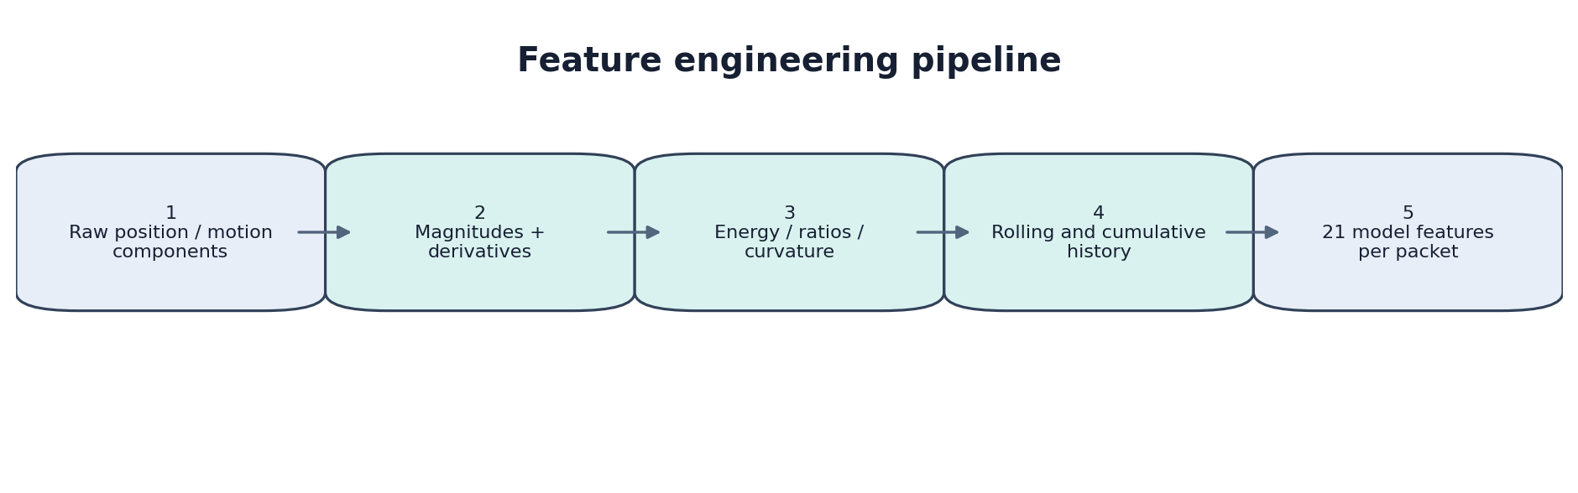

Notation
p_t = (x_t, y_t, z_t) position in metres
v_t = (v_x, v_y, v_z) velocity in metres/second
a_t = (a_x, a_y, a_z) acceleration in metres/second²
Δt = t_t − t_(t−1) elapsed time in seconds
For the real input assumptions recorded in the notebook, `pos_z` is height relative to the radar, position is in metres, velocity in m/s, acceleration in m/s², and `ntp_sec` is in seconds. The notebook does not combine `ntp_frac` with `ntp_sec` in this version.

Timestamp and missing-component handling
Δt_t = t_t − t_(t−1), if finite and positive; otherwise use 10 seconds
The fallback is `SAMPLE_SECONDS = 10.0`; the code also clips Δt to a minimum of 0.01 seconds. This prevents division by zero or negative time gaps, but it is a fallback—not a substitute for checking timestamp quality.
Derived velocity: v_x,t = (x_t − x_(t−1)) / Δt_t
Derived acceleration: a_x,t = (v_x,t − v_x,(t−1)) / Δt_t
Equivalent equations are applied to y and z. A valid sensor-provided velocity or acceleration component is retained; only missing values are derived. Within each track, the code forward-fills missing values and fills remaining leading missing values with zero.

The 21 model features
Feature | Formula / definition | Intuition
1. pos_z | Radar-relative vertical position, in metres. | Preserves height information relative to radar origin.
2. vel_mag | Speed magnitude; use valid supplied magnitude if present, otherwise vector norm. | Overall speed independent of direction.
3. vel_xy_mag | √(v_x² + v_y²). | Horizontal speed component.
4. range_mag | Radar-relative distance; use valid supplied range if present, otherwise position norm. | Distance from the radar origin.
5. accel_mag | Acceleration magnitude; valid supplied magnitude is preferred, otherwise vector norm. | How strongly velocity changes.
6. jerk_mag | Magnitude of change in acceleration per unit time. | How abruptly acceleration changes.
7. jerk_to_accel_ratio | jerk_mag / max(accel_mag, 0.1). | Jerk relative to acceleration; denominator floor limits blow-ups.
8. curvature_3d | ||v × a|| / (vel_mag³ + 0.001). | Approximate path curvature under the model’s kinematic assumptions.
9. specific_energy | 9.81 × pos_z + 0.5 × vel_mag². | Specific mechanical energy per unit mass, using radar-relative z as height proxy.
10. energy_rate | 9.81 × v_z + v · a. | Rate of change of specific energy under the same assumptions.
11. z_ratio | v_z / (vel_mag + 10⁻⁶). | Vertical velocity relative to total speed.
12. vertical_accel_ratio | a_z / (accel_mag + 10⁻⁶). | Vertical acceleration relative to total acceleration.
13. accel_mag_roll_mean | Mean of current and up to two previous acceleration magnitudes. | Short-term average acceleration.
14. accel_mag_roll_std | Rolling standard deviation over up to 3 points; one-point result filled with 0. | Short-term acceleration variability.
15. jerk_mag_roll_mean | Rolling mean jerk magnitude over up to 3 points. | Short-term abruptness average.
16. jerk_mag_roll_std | Rolling standard deviation of jerk over up to 3 points. | Short-term jerk variability.
17. energy_rate_roll_mean | Rolling mean energy rate over up to 3 points. | Short-term energy-change trend.
18. energy_rate_roll_std | Rolling standard deviation of energy rate over up to 3 points. | Short-term energy-change variability.
19. cum_max_accel | Maximum acceleration magnitude seen so far in this track. | Captures the strongest acceleration observed to date.
20. cum_max_jerk | Maximum jerk magnitude seen so far in this track. | Captures the strongest acceleration-change event so far.
21. cum_max_energy_rate | Maximum absolute energy rate seen so far. | Captures largest energy-rate magnitude to date.

Core formulas explained
Speed: ||v|| = √(v_x² + v_y² + v_z²)
This is the length of the velocity vector. It measures how fast the target moves, regardless of which direction it is moving.
Horizontal speed: ||v_xy|| = √(v_x² + v_y²)
Range: r = √(x² + y² + z²)
Range is Euclidean distance from the radar coordinate origin. This matches the notebook’s stated coordinate convention.
Acceleration magnitude: ||a|| = √(a_x² + a_y² + a_z²)
Jerk vector: j_t = (a_t − a_(t−1)) / Δt_t; jerk magnitude = ||j_t||
Jerk is the time derivative of acceleration. Large jerk can indicate a rapid change in manoeuvre, but noise can also create large jerk values.
Curvature proxy: κ = ||v × a|| / (||v||³ + 0.001)
The cross product is large when acceleration contains a component perpendicular to velocity, as occurs during turning. The small constant protects against division by zero; this is a numerical safeguard.
Specific energy proxy: E_s = g z + ½ ||v||², where g = 9.81 m/s²
This is gravitational potential energy plus kinetic energy per unit mass. Because z is relative to the radar, the absolute potential-energy offset is arbitrary; changes can still be informative if the coordinate and unit assumptions hold.
Energy rate: dE_s/dt ≈ g v_z + v · a
The term g v_z describes the rate of change in gravitational potential energy per unit mass. The dot product v·a is the derivative of ½||v||². This is a physics-motivated feature, not a claim that the target’s full energy budget is measured.
Vertical velocity ratio: ρ_z = v_z / (||v|| + 10⁻⁶)
Vertical acceleration ratio: ρ_az = a_z / (||a|| + 10⁻⁶)
The tiny denominators avoid numerical division by zero. These ratios express vertical motion relative to total motion; they should not be interpreted as probabilities.

Rolling and cumulative features
Rolling mean at t: mean(q_(t−2), q_(t−1), q_t), using available points only
Rolling standard deviation: std of the available current/prior values, with a minimum of 2 points; otherwise 0
Cumulative maximum: M_t = max(q_1, q_2, …, q_t)
These features describe local variability and historical extremes. The code groups every calculation by `track_no`, so one track’s history does not leak into another track’s features.
Important engineering caveat
The feature extractor retains supplied magnitude fields when valid, while component features may be derived from position differences. If the sensor’s components and magnitude fields disagree, the resulting feature set can be internally inconsistent. The coordinate-frame audit is diagnostic only; it does not automatically swap axes or rewrite measurements.

4. CNN–BiGRU–attention: the temporal model
The CNN model sees a sequence rather than a single summary row. Each complete input has shape 30 × 21: 30 consecutive packets, with 21 features per packet. Its purpose is to learn temporal patterns such as sustained speed, changing acceleration, and combinations of manoeuvre-related signals.
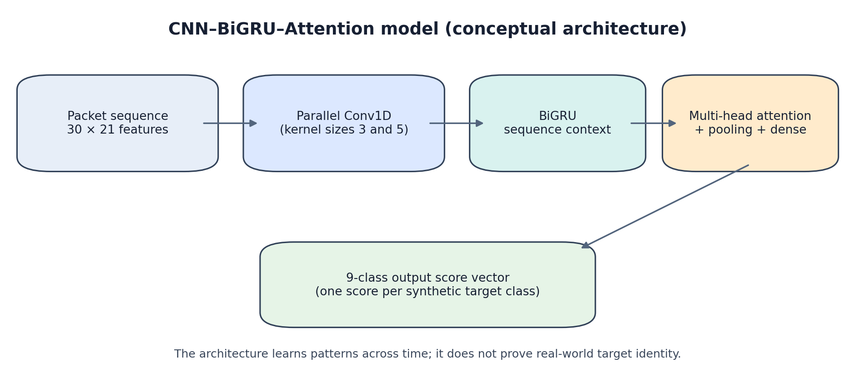
Component | What it does in plain English
Parallel Conv1D branches | Apply filters over short temporal neighbourhoods. The code uses 32 filters with kernel size 3 and another 32 with kernel size 5.
Concatenation + batch normalization | Combines the two convolutional views and stabilizes intermediate activations.
Bidirectional GRU | Reads the 30-step window in both directions during model inference, learning relationships across the window.
Multi-head attention | Lets sequence positions weigh information from other positions; four attention heads are used.
Residual + layer normalization | Adds the attention output back to the sequence representation and normalizes it.
Global average + global max pooling | Compresses the time dimension using both average and strongest activations.
Dense/dropout layers | Combine learned signals and regularize the network before output.
Softmax-style class output | Produces a score for each of the nine synthetic classes.

Training uses the Adam optimizer with learning rate 0.001 and sparse categorical cross-entropy. Early stopping monitors validation loss with patience 5 and restores the best weights. ReduceLROnPlateau halves the learning rate after two stagnant validation-loss epochs, down to 0.00001.
The training setup uses a fixed random seed of 42, 30-packet windows, a stride of 3 for training windows, a maximum of 30 epochs, and track-balanced sample weights so longer tracks do not automatically dominate simply because they yield more windows.

Preprocessing
- SimpleImputer handles missing feature values using the configured training-fitted imputation strategy.
- RobustScaler scales features using robust statistics, reducing sensitivity to extreme values compared with standard mean/variance scaling.
- LabelEncoder fixes a consistent mapping between class names and model output indices.
The imputer and scaler are fitted on training rows only and then reused for validation, test, and real inference. Fitting preprocessing on all data would leak information from held-out data.

CNN limitations to remember
- A sequence model can learn temporal patterns, but its apparent performance depends on the quality and realism of the synthetic trajectories.
- The live replay pads early sequences by repeating the first available scaled feature row until the window reaches 30 packets. Those early outputs are marked as warm-up and should not be treated as fully informed predictions.
- Bidirectional processing is within the supplied 30-packet window; it does not mean the model is allowed to inspect future real packets beyond the current window.

5. ExtraTrees classifier: simple explanation and details
ExtraTrees stands for Extremely Randomized Trees. Think of it as a committee of many decision trees. Each tree asks a series of feature-based questions—for example, whether a summary statistic is above or below a threshold—and votes for a class. The ensemble combines those votes to produce a final class ranking.
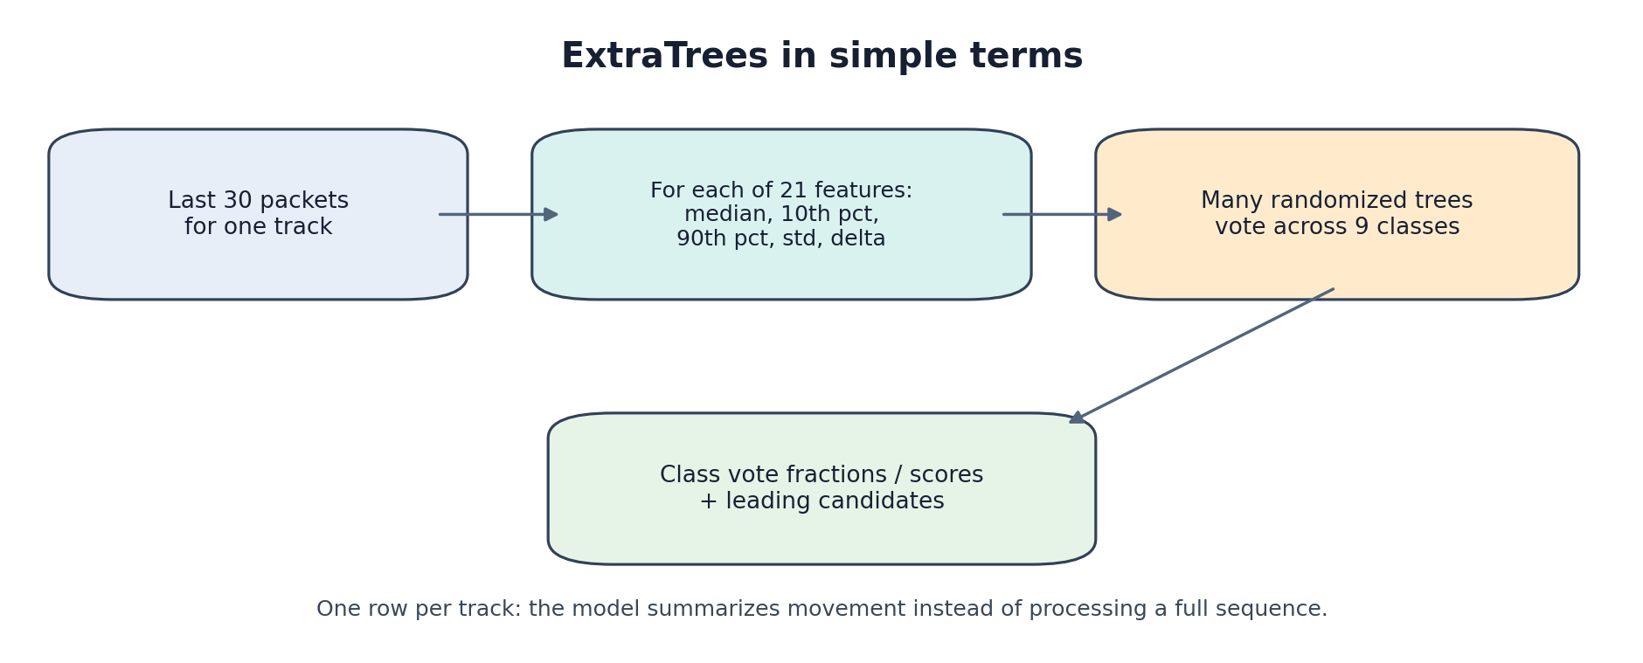

How we prepare its input
Rather than feeding all 30 packets as a sequence, we summarize each of the 21 packet-level features over the latest 30 packets. For each base feature, the code calculates five statistics:
Statistic | Definition | Why it helps
median | 50th percentile of the window | Robust typical level.
q10 | 10th percentile | Lower end of the feature’s recent range.
q90 | 90th percentile | Upper end / high activity level.
std | Standard deviation | Variability during the window.
delta | Last value − first value in the window | Direction and amount of recent change.

21 base features × 5 summary statistics = 105 ExtraTrees input columns
The summary function sorts the track by time and uses at most the latest 30 packets. The model has one summary row per physical track during synthetic evaluation. During replay, it recomputes the summary from that track’s rolling window.

What the forest learns
- Each tree learns a different set of decision rules from the training summaries.
- Extra randomization in feature/threshold choices makes the trees diverse; averaging across diverse trees can reduce variance.
- The fitted pipeline includes a SimpleImputer, so missing summary values are handled consistently with training.
- The notebook compares ExtraTrees and CNN on the same physical-track splits to make the comparison more meaningful.
In earlier recorded synthetic runs, ExtraTrees had stronger track accuracy than the CNN on validation and stress tests, and was moderately stronger on the IID test. This makes it a useful baseline and an independent perspective alongside the sequence model.

What does ExtraTrees score mean?
The notebook reports `predict_proba`-style outputs for the ensemble and tree-vote fractions during replay. These scores are not calibrated probabilities. A displayed score of 0.70 should be described as a model score or vote fraction—not as “70% chance that the target is a fighter aircraft.” Calibration would require a separate validation procedure on data representative of the intended deployment environment.

Feature importance
Tree feature importance is aggregated from the 105 summary columns back to their 21 base features. This helps us inspect which engineered features the synthetic ExtraTrees fit relied on most. Importance is not causation, and correlated features can share or distort importance. It also does not establish which features will matter most on real radar data.

6. Real radar CSV findings so far
Our previously audited real file, `radar_data.csv`, contained 82 packets for one track. It was unlabelled, so there is no ground-truth class against which to calculate real accuracy.
Observation | Finding / implication
Track count | 82 packets, one track in the file previously examined.
CNN leading candidate | FIGHTER_AIRCRAFT, score about 47.0%; DRONE was the runner-up at about 20.4%.
ExtraTrees leading candidate | FIGHTER_AIRCRAFT, score about 42.8%; CIVILIAN_AIRCRAFT about 21.0%, DRONE about 16.9%.
Agreement | Both models selected FIGHTER_AIRCRAFT as their leading candidate in that run.
Status | Candidate is unverified. Agreement between two models is useful context, not ground truth.
Packet history | Both methods require 30 packets for a full window; this file has enough packets for a full window, but early packets remain warm-up.

Correct way to report this
“On the unlabelled 82-packet track, both models ranked FIGHTER_AIRCRAFT first. The CNN score was approximately 47.0%, and the ExtraTrees vote score was approximately 42.8%. Because no verified label is available and scores are uncalibrated, we cannot claim the target is a fighter aircraft or report real-world accuracy.”

Coordinate and unit audit
- We confirmed that position/height values are in metres, velocity is in m/s, acceleration is in m/s², and `ntp_sec` is in seconds.
- The radar is treated as the coordinate origin. `pos_z` is relative to the radar; the mounting-height correction is intentionally omitted based on the team’s guidance that it is negligible for this project.
- We were told velocity and acceleration use the same coordinate frame. A diagnostic showed strong cross-axis correlations between reported velocity and position derivatives (for example, reported `vel_x` tracked `dpos_y/dt` more strongly than `dpos_x/dt` in the audited sample). The notebook flags this pattern but does not automatically swap axes.
- The meaning/encoding of `ntp_frac` has not been established in this version; the feature extractor uses differences in `ntp_sec` only.
- No automatic coordinate remapping is applied. A suspected axis convention should be verified against the sensor ICD or a known calibration manoeuvre before changing production features.

7. Live replay and user-facing behavior
The notebook processes packets in timestamp order and maintains separate rolling state for each `track_no`. The printed feed is append-only and paced using `PLAYBACK_DELAY` (default 0.12 seconds per packet). The core replay is intentionally not a blinking dashboard: plots are drawn after replay, not redrawn for every packet.
- CNN window: latest 30 scaled feature rows for that track.
- ExtraTrees window: latest 30 unscaled feature rows, summarized into the 105 track-summary columns.
- Warm-up: the ExtraTrees candidate remains in `WARMING_UP` until the track has 30 packets; the CNN is also treated as warm-up before a full window.
- Score smoothing: exponential moving averages are used for display stability. They do not calibrate the scores or improve their statistical validity.
- Stable hypothesis: the notebook uses a minimum candidate streak of three, plus score/margin thresholds, to avoid reporting a stable label after one transient score spike.
- Final results: the notebook combines the last CNN track state with the latest ExtraTrees replay state and flags low history, ambiguous evidence, model agreement, or disagreement.
The final comparison workbook is intended to be the single main results file, rather than a large pile of intermediate CSVs. It includes real-track predictions and synthetic evaluation tables when those are available from training.

8. Visualization refinement: what is new
The current refined notebook adds a presentation layer around the existing pipeline. The intention is to leave training, preprocessing, model weights, and core packet replay behavior alone.
Visualization | Purpose
Dark/light theme | Dark navy for screen demos; light theme for report figures and printing.
Multi-track overview | Compare 2D paths, toggle tracks from the legend, and hover to inspect coordinates.
CNN vs ExtraTrees score timeline | See how uncalibrated leading scores change across packets.
Candidate-change timeline | Inspect when either model changes its leading class.
Interactive 3D trajectory | Rotate and zoom through x, y, and radar-relative z.
Recorded-track animation | Play/pause and use a slider to inspect a target marker moving along its recorded path. This replays existing data; it is not a live sensor feed.
Speed and z profile | Compare speed with height relative to radar using separately labelled axes.
Synthetic benchmark plot | Display track accuracy and macro-F1 from synthetic evaluation only.
ExtraTrees feature importance | Inspect aggregated importance across the base features.
Per-class F1 plot | Find classes that are difficult for the synthetic model.

Visualization does not equal model improvement
Plots, animations, hover tools, and themes help us inspect and explain behavior. They do not improve the model’s predictive accuracy or validate the model on real targets.

9. Notebook cell-by-cell guide
The current notebook has 42 cells (numbered 0–41). The map below explains each cell’s role so we can walk a reviewer through the notebook without treating it as a black box.
Cell | Block | What it does
0 | Markdown overview | States the portable dual-model goal, artifact folder, replay, plots, and overall workflow.
1 | Dependency check | Checks required packages without automatically installing packages or requiring internet.
2 | Imports and configuration | Imports NumPy, pandas, TensorFlow, scikit-learn, sets seeds, classes, paths, sequence length, model bundle version, replay delay, and artifact loading/retraining behavior.
3 | Section heading | Introduces shared feature extraction.
4 | Feature extractor and coordinate audit | Defines the 21 feature columns, numeric coercion, causal per-track derivatives/rolling statistics, and a diagnostic for cross-axis velocity/position relationships.
5 | Section heading | Introduces synthetic track generation.
6 | Synthetic generator | Defines overlapping illustrative class profiles and generates complex synthetic trajectories for training and evaluation.
7 | Section heading | Introduces first-time setup and track-disjoint splits.
8 | Load or prepare synthetic data | Loads saved bundle if compatible; otherwise generates data, assigns tracks to train/validation/IID/stress scenario families, asserts no track leakage, fits preprocessing on training data, and creates 30-packet windows.
9 | Section heading | Introduces CNN model.
10 | CNN architecture and training | Builds Conv1D + BiGRU + attention model; trains with Adam/cross-entropy and early stopping when training is required.
11 | Section heading | Introduces CNN evaluation.
12 | CNN synthetic evaluation | Aggregates window predictions to track-level predictions and reports accuracy, macro-F1, and balanced accuracy on validation/IID/stress splits.
13 | Section heading | Introduces ExtraTrees.
14 | ExtraTrees summary model | Creates median/q10/q90/std/delta summaries per feature, fits the ExtraTrees pipeline on the same track-disjoint splits, and evaluates it.
15 | Save model bundle | Saves CNN, preprocessing objects, ExtraTrees pipeline, metadata/schema, and evaluation reports when training occurs.
16 | Section heading | Introduces real CSV inference.
17 | Load real CSV | Uploads/selects CSV, ensures track/time fields, checks/normalizes expected columns, and runs input diagnostics without using labels for training.
18 | Replay section description | Documents append-only packet-by-packet replay and warm-up expectations.
19 | Live replay engine | Maintains per-track rolling windows, generates CNN and ExtraTrees predictions, applies display smoothing/stability logic, and prints one packet update at a time.
20 | Results section description | Introduces the final comparison and workbook.
21 | Final results and workbook | Combines per-track outputs, assigns status messages, and writes the formatted Excel workbook.
22 | Visualization section description | Documents dark/light themes, individual plot cells, Plotly exports, and animation.
23 | Plot setup | Configures theme colors, Plotly availability, output figure directory, and reusable styling.
24 | Optional multi-track overview description | Explains the multi-track path comparison.
25 | Multi-track overview | Creates interactive 2D paths for tracks when Plotly is available.
26 | Plot 1 description | Introduces score timeline.
27 | Plot 1: score timeline | Plots CNN and ExtraTrees scores across packets for the selected focus track.
28 | Plot 2 description | Introduces candidate-change plot.
29 | Plot 2: candidate timeline | Shows changes in the leading candidate for each model over packet index.
30 | Plot 3 description | Introduces 3D trajectory.
31 | Plot 3: 3D path | Plots x, y, z with rotation/hover when Plotly is available.
32 | Animation description | Clarifies recorded-path animation is not live sensor streaming.
33 | Recorded-path animation | Animates the 2D path with persistent trail, moving marker, play/pause, and slider; falls back to static plot if Plotly is unavailable.
34 | Plot 4 description | Introduces speed and radar-relative height.
35 | Plot 4: motion profile | Plots speed and z over packet index with distinct axes.
36 | Plot 5 description | Clarifies synthetic benchmark is not real accuracy.
37 | Plot 5: synthetic metrics | Plots track accuracy and macro-F1 from saved synthetic evaluations.
38 | Plot 6 description | Explains feature importance limitations.
39 | Plot 6: ExtraTrees importance | Aggregates tree importance over summary statistics back to base features.
40 | Plot 7 description | Introduces per-class F1.
41 | Plot 7: per-class F1 | Plots per-class F1 for model/split combinations where saved metrics exist.

10. Files and portability
Path / file | Purpose
`model_11/cnn_model.keras` | Saved CNN model architecture and weights.
`model_11/preprocessing.joblib` | CNN preprocessing components and label mapping used by the pipeline.
`model_11/extratrees_model.joblib` | Fitted ExtraTrees pipeline, including its imputer.
`model_11/bundle_metadata.json` | Schema, feature order, sequence length, summary columns, classes, and version information.
`model_11/evaluation_reports.joblib` | Saved synthetic evaluation tables and reports.
`model_11/outputs/` | Workbook and visualization output folder.
`model_11/outputs/figures/` | Interactive HTML figures and static fallback images.

The notebook looks for a compatible model bundle in a local `model_11/` directory. If the bundle is missing, the notebook trains a new bundle; if a compatible bundle exists, it loads it and skips training. `FORCE_RETRAIN=True` is an intentional rebuild switch and should not be changed casually because it can overwrite the local model bundle.
Colab persistence
Colab runtime storage is temporary. Before the runtime resets, download or copy the complete `model_11/` folder if you need the saved models and results later. Keeping only the notebook is not enough to preserve a trained bundle.

11. What we can and cannot claim
We can say | We should not say yet
We built a reproducible dual-model pipeline that runs on synthetic data and supports real CSV inference. | We have demonstrated reliable real-world target identification.
ExtraTrees performed better in the earlier recorded synthetic experiments. | ExtraTrees is proven superior on operational radar data.
Both models ranked FIGHTER_AIRCRAFT first for the previously examined unlabelled track. | The real track was confirmed to be a fighter aircraft.
The notebook produces uncalibrated model scores / tree-vote fractions. | A score of 47% is a calibrated 47% probability of the class.
We created physically motivated kinematic features and diagnostic plots. | Every derived feature is physically correct for every sensor convention.
The plots make model behavior easier to inspect. | The visualization refinements improve classification accuracy.

12. Risks, next experiments, and research priorities
- Build a labelled real-radar evaluation set. The highest-priority improvement is reliable ground-truth labels with train/test separation by track, session, or collection scenario.
- Confirm sensor conventions. Verify axis mapping, coordinate frame, timestamp semantics, magnitude-field definitions, and any uncertainty/covariance fields against the sensor ICD or known calibration data.
- Measure generalization under domain shift. Compare performance across collection sessions, ranges, signal conditions, manoeuvres, and target classes—not only synthetic scenario families.
- Review class imbalance and confusion. Report per-class precision, recall, F1, support, and confusion matrices. Pay particular attention to the earlier weak boat and skiff results.
- Calibrate scores only when suitable labelled validation data exists. Use a calibration method and report calibration diagnostics; do not rename raw scores as probabilities.
- Test model parity before deployment. If converting the CNN to ONNX or exporting ExtraTrees to another runtime, compare predictions on a fixed set of examples and verify preprocessing, feature order, class order, and sequence/window assembly.
- Avoid target-specific operational conclusions from one track. A single unlabelled track is useful for a pipeline smoke test, not for validating a class boundary.

13. Explain it in 60 seconds
Suggested first-person explanation
“We built a radar-track classification pipeline with two complementary models. First, we turn each packet into 21 motion features, including speed, acceleration, jerk, curvature, energy-related quantities, and short-term statistics. The CNN–BiGRU–attention model processes the latest 30 packets as a time sequence, while ExtraTrees summarizes those packets using median, lower and upper percentiles, standard deviation, and change, then combines the votes of many randomized decision trees. We trained and compared both models on synthetic tracks, keeping complete tracks separate across training and test splits. ExtraTrees was the stronger baseline in our earlier synthetic runs. We then ran both models on an unlabelled real radar CSV and used the results as unverified candidates, not as proof of identity. The next major step is validation on labelled real radar data.”

14. Questions a reviewer may ask
Why two models? They represent the track differently. The CNN learns temporal sequence patterns; ExtraTrees uses compact, interpretable summary statistics. Comparing them gives a useful baseline and an independent view.
Why 30 packets? It is the configured sequence/window length for this version. It gives the model a short motion history. It is a design choice to validate, not a universal radar constant.
Why 21 features? They combine position/height, speed, horizontal speed, range, acceleration, jerk, curvature, energy-related quantities, ratios, rolling variability, and cumulative extremes.
What is jerk? The rate at which acceleration changes with time. It can capture abrupt manoeuvre changes but is also sensitive to noisy measurements and timestamp errors.
Why use ExtraTrees? It works well on engineered tabular features, handles nonlinear interactions, needs relatively little feature scaling, and offers feature-importance diagnostics. Its actual value must be confirmed on labelled real data.
Why not trust the 47% score? The score is uncalibrated, and the real input has no ground-truth label. It is a ranking signal from a model trained on synthetic data, not a validated probability.
What is leakage and how did we reduce it? Leakage occurs when information from test examples influences training. We split by complete track/scenario family and fit imputation/scaling on training rows only.
Why not automatically swap x and y? A cross-axis correlation is a warning, not proof. An automatic swap could silently corrupt valid data. We log diagnostics and require confirmation from the sensor specification or calibration.
Does the animated plot show a live radar feed? No. The trajectory animation replays recorded points from the loaded CSV. The packet text replay is a paced simulation of processing the file, not a live sensor connection.
Does agreement prove identity? No. Both models may share synthetic-data bias or similar feature assumptions. Agreement is useful context, but only labelled ground truth can verify the class.
What is the main limitation? The largest limitation is the absence of labelled real-radar validation and the gap between synthetic motion profiles and real sensor data.
What would make this research stronger? A labelled real dataset, documented sensor conventions, robust track/session splits, calibration, error analysis, and parity-tested deployment.

Appendix A. Formula reference sheet
Quantity | Formula | Units / note
Elapsed time | Δt = t_t − t_(t−1) | Seconds; fallback 10 s for invalid intervals, minimum 0.01 s.
Velocity from position | v_t ≈ (p_t − p_(t−1))/Δt | m/s; used only when component missing.
Acceleration from velocity | a_t ≈ (v_t − v_(t−1))/Δt | m/s²; used only when component missing.
Speed | ||v|| = √(v_x²+v_y²+v_z²) | m/s.
Horizontal speed | ||v_xy|| = √(v_x²+v_y²) | m/s.
Range | r = √(x²+y²+z²) | m; used when supplied range is missing/invalid.
Acceleration magnitude | ||a|| = √(a_x²+a_y²+a_z²) | m/s².
Jerk magnitude | ||j|| = ||(a_t−a_(t−1))/Δt|| | m/s³.
Jerk/acceleration ratio | ||j|| / max(||a||, 0.1) | Numerical floor 0.1.
Curvature proxy | ||v×a||/(||v||³+0.001) | Approximate curvature-like quantity.
Specific energy | g z + 0.5 ||v||² | J/kg; z is radar-relative.
Energy rate | g v_z + v·a | W/kg = J/(kg·s), under the assumptions.
Vertical velocity ratio | v_z/(||v||+10⁻⁶) | Dimensionless.
Vertical acceleration ratio | a_z/(||a||+10⁻⁶) | Dimensionless.
Rolling mean | mean of up to 3 current/prior values | Causal; per track.
Cumulative max | max(q_1,…,q_t) | Causal; per track.

Appendix B. Terminology
Term | Meaning
Track | A time-ordered series of packets associated with one target identifier.
Packet | One timestamped record of the target’s observed state.
Feature | A numerical input derived from the raw measurements.
Causal feature | A feature at time t that uses only present/past observations.
Window / sequence | A fixed-length set of consecutive packets; here 30 packets.
CNN / Conv1D | A convolutional neural network applying learned filters along the time axis.
GRU | Gated Recurrent Unit, a recurrent neural-network layer for sequence data.
Bidirectional GRU | A GRU that processes the supplied sequence in forward and reverse order.
Attention | A mechanism that learns which positions in the sequence should influence a representation.
ExtraTrees | An ensemble of randomized decision trees for tabular classification.
Imputation | Replacing missing values using a strategy learned from training data.
RobustScaler | Scaling based on robust distribution statistics such as median and interquartile range.
Label encoding | Mapping class names to stable integer indices.
Track leakage | When windows from the same physical track occur in both training and test data.
IID test | Test examples drawn from a scenario family designed to resemble training conditions.
Stress test | A held-out scenario family designed to challenge generalization.
Macro-F1 | Average F1 across classes with equal weight per class.
Uncalibrated score | A model output ranking that has not been verified to match empirical probabilities.
Feature importance | A model-specific indication of reliance on features, not causation.
ONNX | An interchange format for representing machine-learning models across runtimes.
Parity test | A comparison ensuring exported/deployed predictions match the reference implementation.

Appendix C. Checklist before presenting the project
- Run the current notebook from a clean runtime and record the exact current synthetic metrics.
- Confirm which model bundle is loaded; do not accidentally present historical metrics as current outputs.
- Keep the complete model_11 folder and outputs when moving between Colab sessions.
- Show that real CSV labels are not used for training.
- Explain that the observed real-track class is an unverified candidate.
- Be ready to explain the 21 features and the 30-packet window.
- Distinguish model score / tree vote fraction from calibrated probability.
- Mention track-disjoint splitting and why it matters.
- Explain the coordinate audit and why axes are not automatically swapped.
- Use synthetic benchmark plots only with clear synthetic-data labels.
- If asked about deployment, say preprocessing and window logic must be ported and parity-tested too.

Closing summary
Our current work establishes a structured prototype: shared causal feature engineering, a temporal CNN model, an ExtraTrees summary classifier, synthetic track-disjoint evaluation, per-track replay, portable artifacts, a results workbook, and research-oriented visualization. The most defensible conclusion today is that the pipeline runs as a research prototype and that ExtraTrees was a strong baseline on our earlier synthetic experiments. The next evidence milestone is labelled real-radar evaluation—not more visual polish alone.

