AI ASSISTED CODING

LAB - 10.4

NAME : G.Ashish

ENROLL NO : 2403A52110

BATCH : AIB04

TASK-01:
Identifyandfixsyntax,indentation,andvariableerrorsinthegivenscript. # buggy_code_task1.py
defadd_numbers(a,b) result = a + b
returnreslt
print(add_numbers(1020))
PROMPT:
Identifytheerrorsinthegivencodeandgivethecorrectedcode.
CODE& OUTPUT:
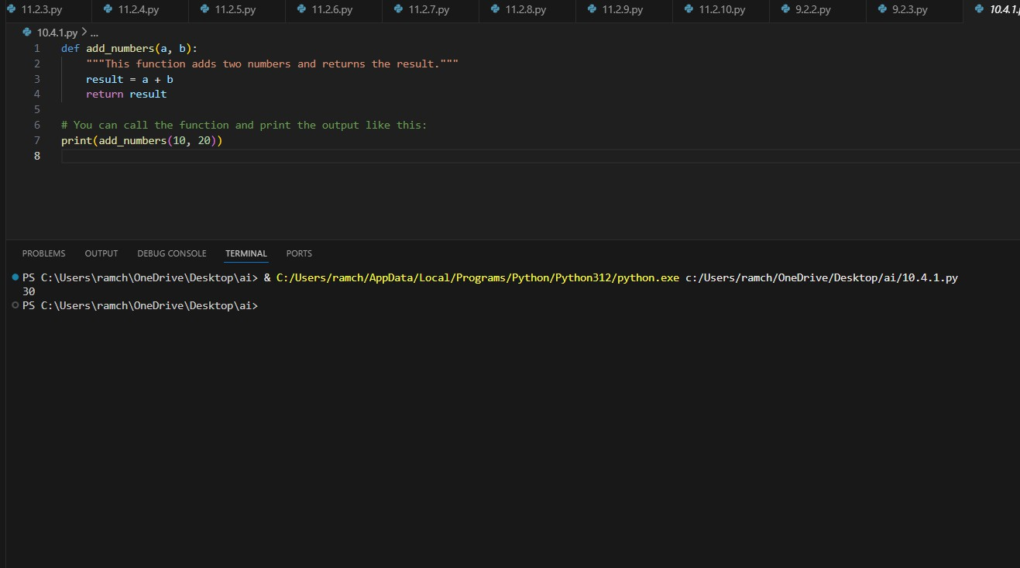
OBSERVATION:

Theaicorrectedalltheerrorsinthegivencodeandmakethecodemuchmore efficient to understand and it also gave the identation to the code.
TASK-02:
Optimizeinefficientlogicwhilekeepingtheresultcorrect. # buggy_code_task2.py
deffind_duplicates(nums):
duplicates=[]
foriinrange(len(nums)):
forjinrange(len(nums)):
ifi!=jandnums[i]==nums[j]andnums[i]notinduplicates: duplicates.append(nums[i])
returnduplicates
numbers=[1,2,3,2,4,5,1,6,1,2]
print(find_duplicates(numbers))
PROMPT:
Correctthegivencodewiththeproperindentationandgivethecorrected code.
CODE& OUTPUT:
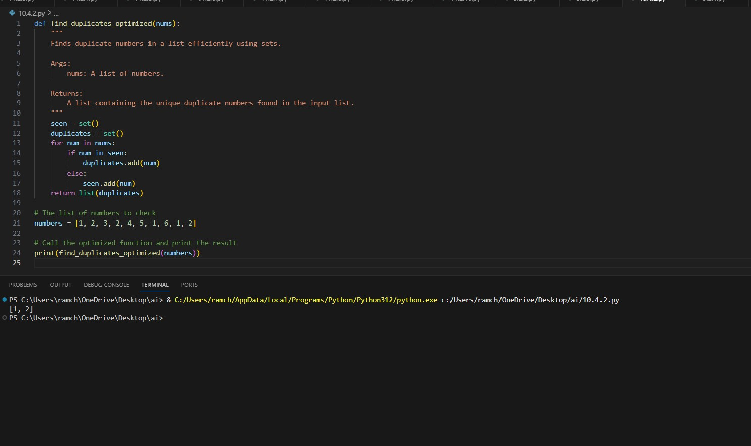
OBSERVATION:

Theaieditedthecodewithproperindentationandalsocorrectedalltheerrors and the code is finding the duplicate numbers efficiently.
TASK-03:
Refactormessycodeintoclean,PEP8–compliant,well- structured code.
# buggy_code_task3.py
defc(n):
x=1
foriinrange(1,n+1):
x=x*i
return x print(c(5))
PROMPT:
renamethefunctionnameinthegivencodeandcorrectcodewithcorrecting all the errors and also give the proper indentation.
CODE& OUTPUT:
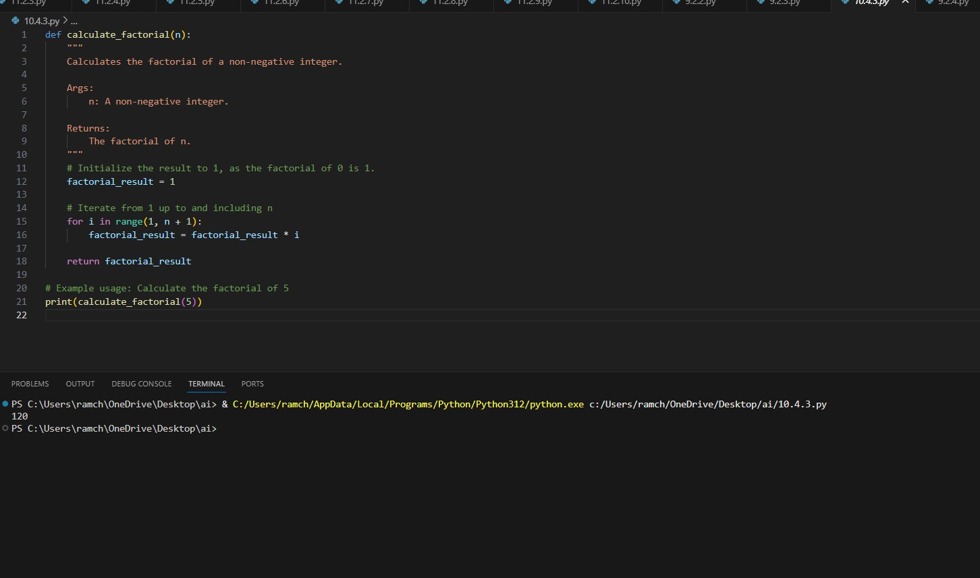
OBSERVATION:

The code is correctedby the ai according to the prompt given by me in which I havementionedthatupdatethefunctionnameandcorrecttheerrorsandgive the proper indentation.
TASK-04:
Addsecuritypracticesandexceptionhandlingtothecode. # buggy_code_task4.py
importsqlite3
defget_user_data(user_id):
conn=sqlite3.connect("users.db") cursor = conn.cursor()
query=f"SELECT*FROMusersWHEREid={user_id};"#
PotentialSQLinjectionrisk cursor.execute(query) result = cursor.fetchall() conn.close()
returnresult
user_input=input("EnteruserID:") print(get_user_data(user_input)
PROMPT:
Correctthecodebyapplyingproperindentationsandidentifyalltheerrorsand correct them give the corrected code.
CODE& OUTPUT:

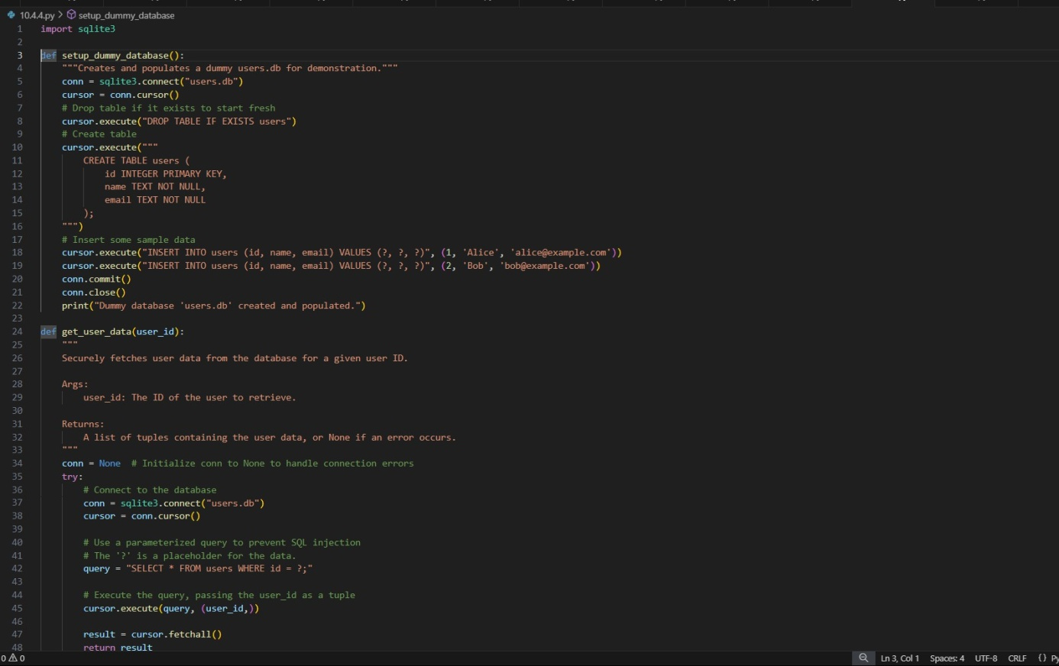
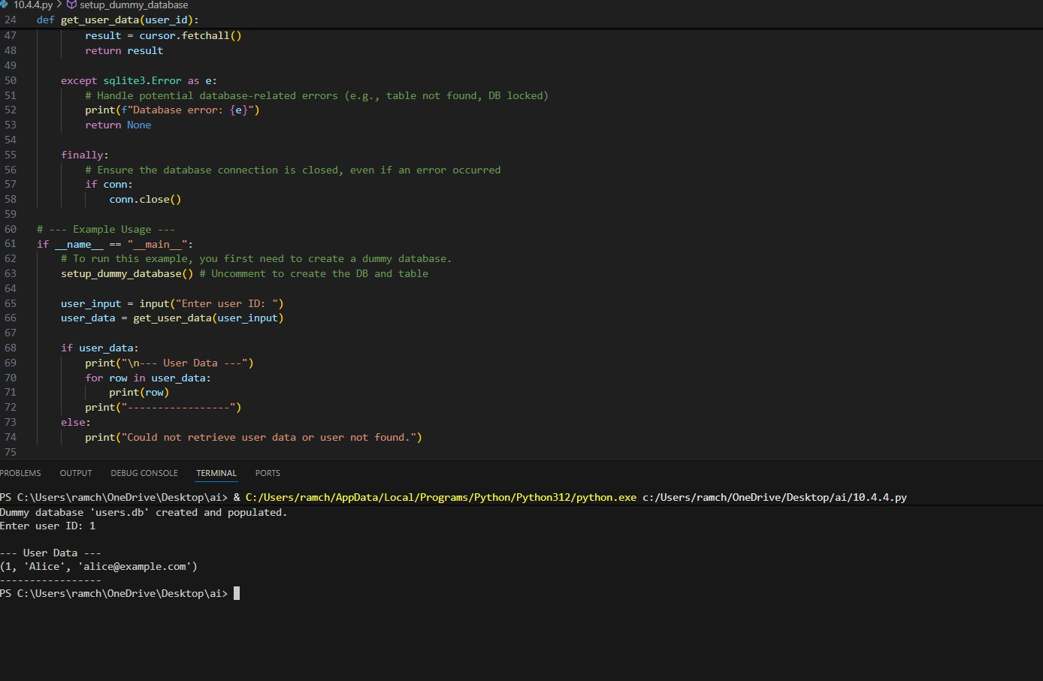
OBSERVATION:
The code corrects the code by removing all the errorsand applies the exceptionhandlingtothecodetomakeitmoreefficientandaccurate.
TASK-05:

Generateareviewreportforthismessycode. # buggy_code_task5.py
defcalc(x,y,z):
ifz=="add":
returnx+y
elifz=="sub":returnx-y elif z=="mul":
return x*y elifz=="div":
returnx/y
else: print("wrong") print(calc(10,5,"add"))
print(calc(10,0,"div"))
PROMPT:
Correctthecodeandgivethereportexplainingthecode.
CODE& OUTPUT:
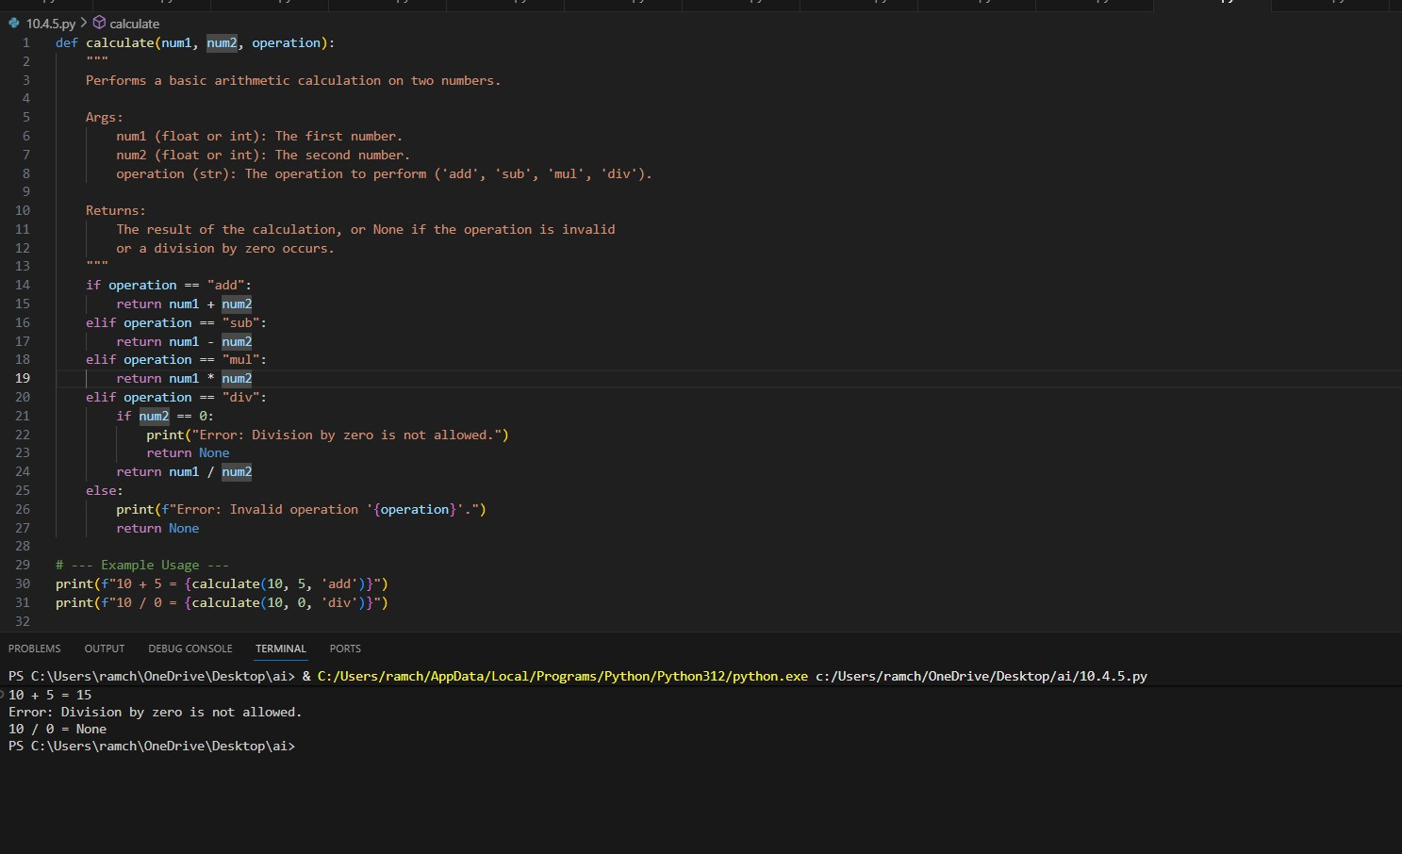

EXPLANATION:
AI-GeneratedCodeReviewReport

TheprovidedPythoncodesnippetforasimplecalculatorhasseveralareasthat canbeimprovedtomeetstandardcodingpractices.Belowisadetailedanalysis based on your criteria.
- MissingDocstrings
Thefunctioncalclacksadocstring.Docstringsarecrucialforexplainingwhata functiondoes,itsparameters,andwhatitreturns.Thismakesthecodeeasier for others (and your future self) to understand and use.
- InconsistentFormattingandPEP8Compliance
ThecodedoesnotfollowstandardPythonformattingguidelines(PEP8),which harms readability.
Indentation:Thebodiesoftheif,elif,andelsestatementsarenotcorrectly indented. Python relies on indentation to define code blocks.
Inlinereturn:Thelineelifz=="sub":returnx-yhasthereturnstatementonthe same line as the condition. While syntactically allowed, it's inconsistent with the other branches and generally discouraged for readability.
- MissingErrorHandling
Acriticalbugexistsinthecode.Thetestcaseprint(calc(10,0,"div"))willcause theprogramtocrashwithaZeroDivisionErrorbecauseitattemptstodivideby zero. The function should handle this case gracefully.
- Non-DescriptiveFunctionandVariableNames
Thenamesused(calc,x,y,z)areverygeneric.Usingmoredescriptivenames
likecalculate,num1,num2,andoperationwouldmakethefunction'spurpose immediately clear without needing to read the implementation
Summaryof Improvements:
Clarity: Function and variable names are now descriptive. Documentation:Acomprehensivedocstringhasbeenadded.
Robustness:ItnowincludesachecktopreventZeroDivisionErrorandhandles invalid operations gracefully.
Readability:ThecodeisformattedconsistentlyaccordingtoPEP8guidelines.

OBSERVATION:
AIgeneratedtheaccuratereportofthecodeanditalsocorrectedthecode according to the prompt in an efficient way.

