AI ASSISTED CODING
LAB-11.2
NAME: G.Ashish
ENROLL NO: 2403A52110
BATCH: 04
TASK-01:
Use AI to generate a Stack class with push, pop, peek, and is_emptymethods.
Sample Input Code:
class Stack:
pass
PROMPT:
Generate a python stack class using push ,pop, is empty.
CODE:
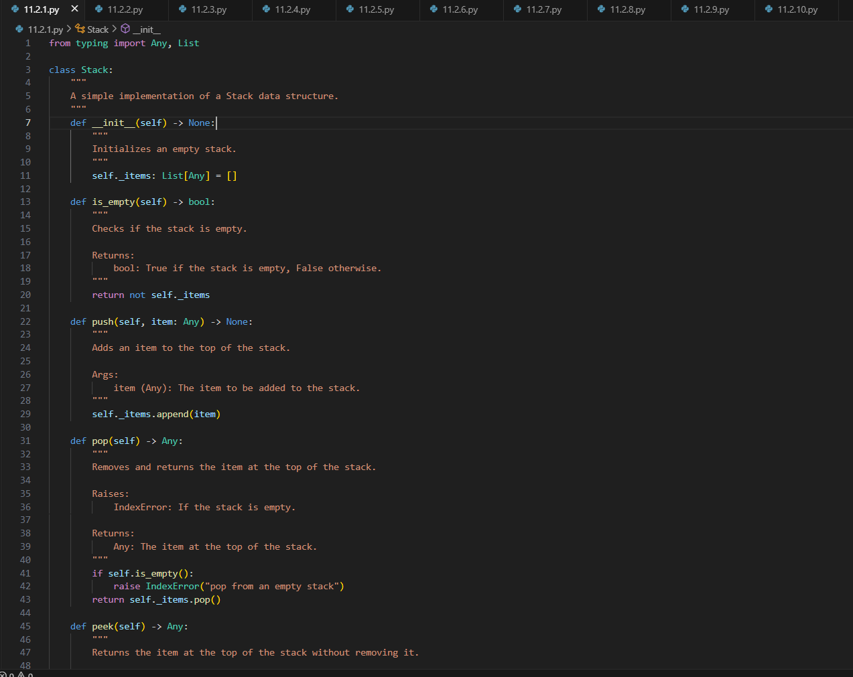
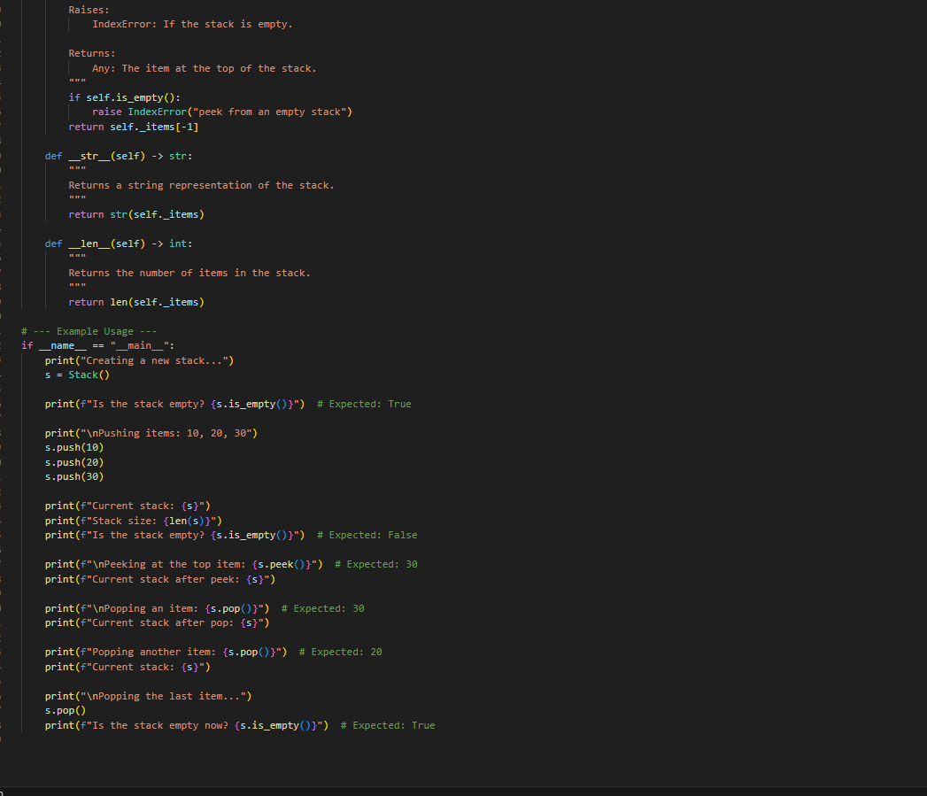
OUTPUT:
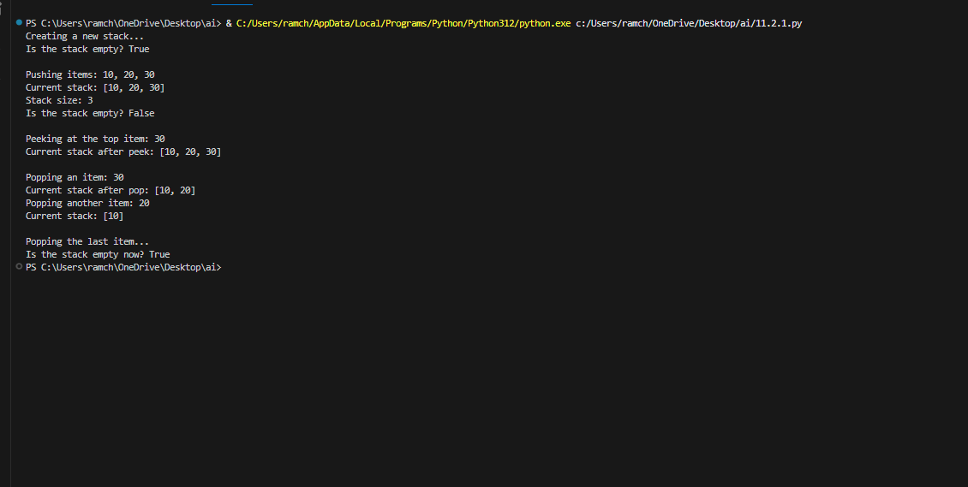
OBSERVATION:
The AI generated the code in an efficient way according to the prompt as it developed the stack class.
TASK-02:
Use AI to implement a Queue using Python lists.
Sample Input Code:
class Queue:
pass
PROMPT:
Generate a python code to implement the queue in data structures
CODE:
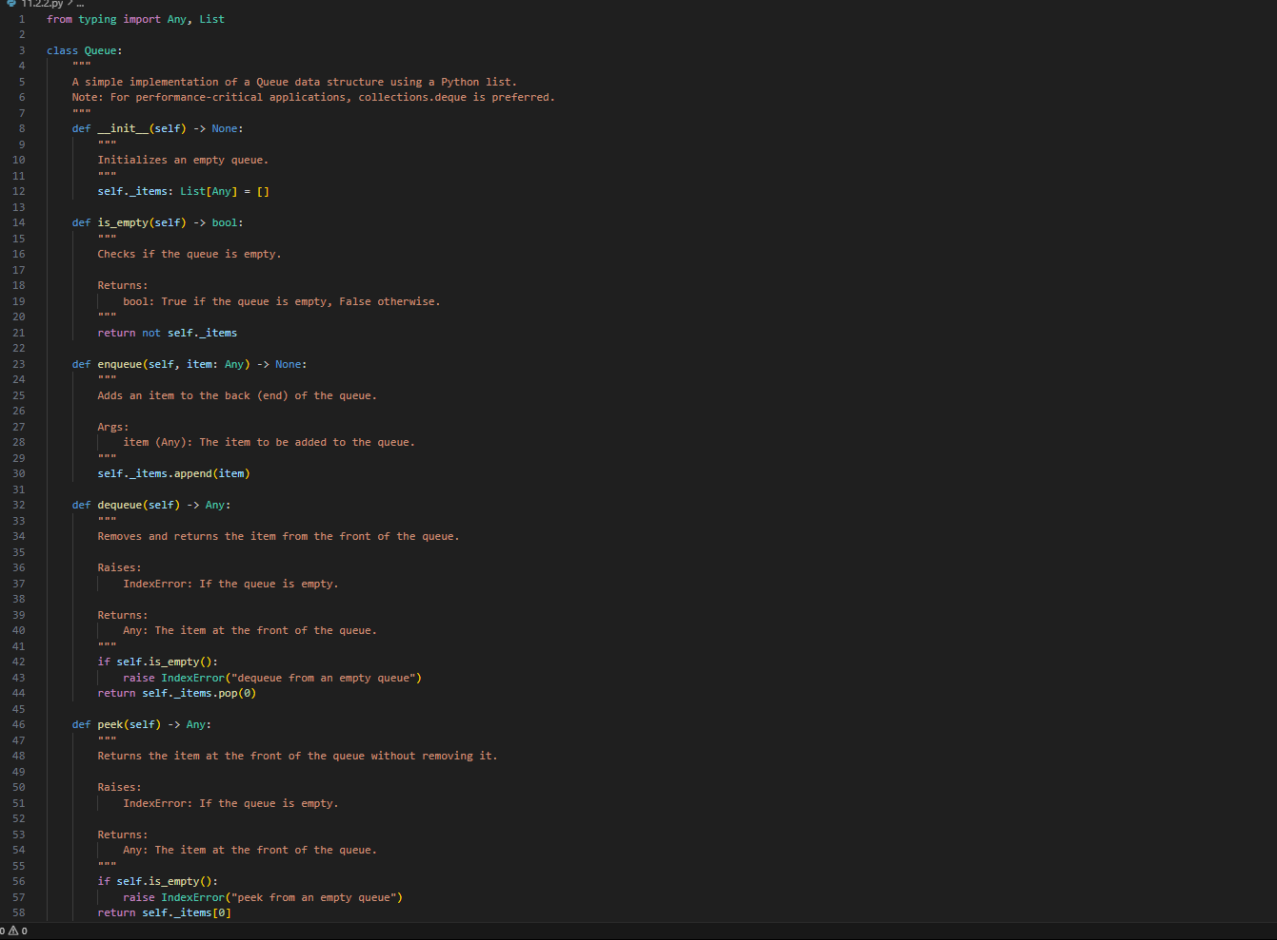
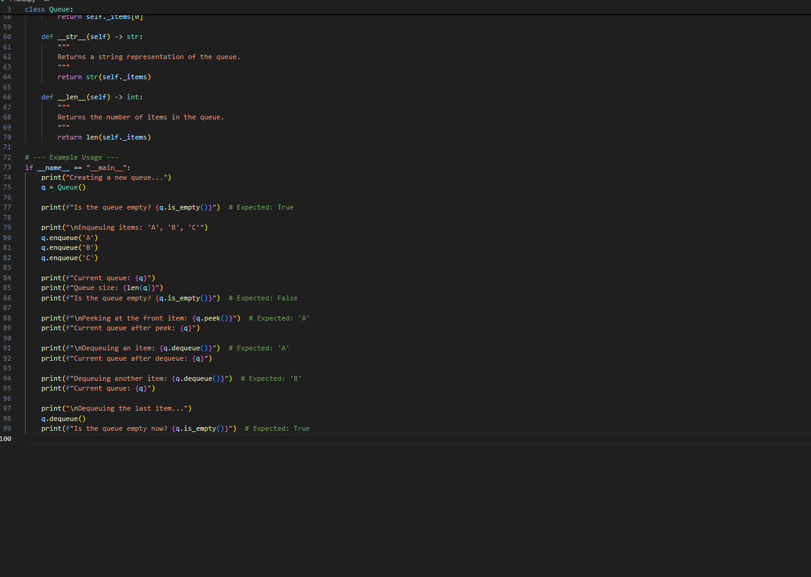
OUTPUT:
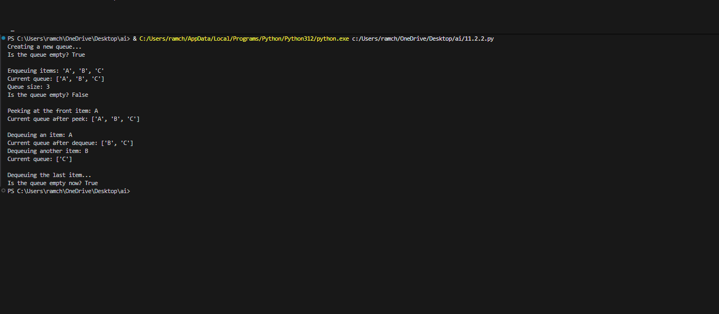
OBSERVATION:
The code generated by AI is more accurate about the queue in data structures and it also passed all the test cases.
TASK-03:
Use AI to generate a Singly Linked List with insert and display methods.
Sample Input Code:
class Node:
pass
class LinkedList:
pass
PROMPT:
Generate a python code of singly linked list with insert and display methods.
CODE:
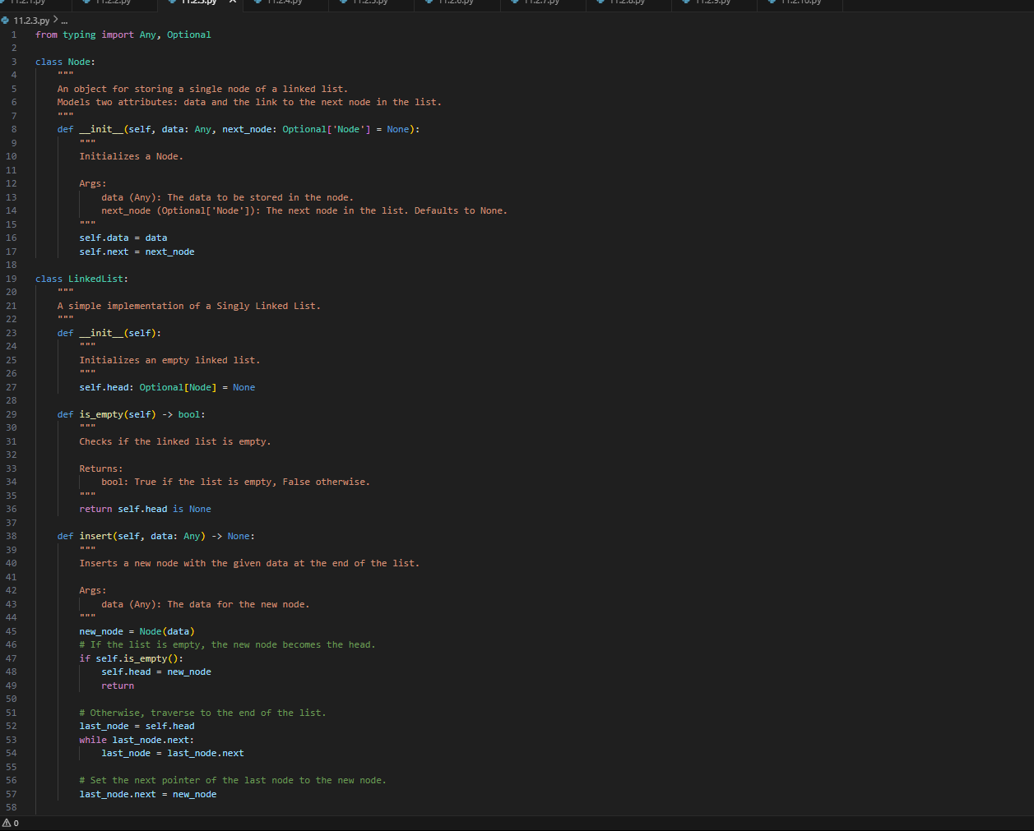
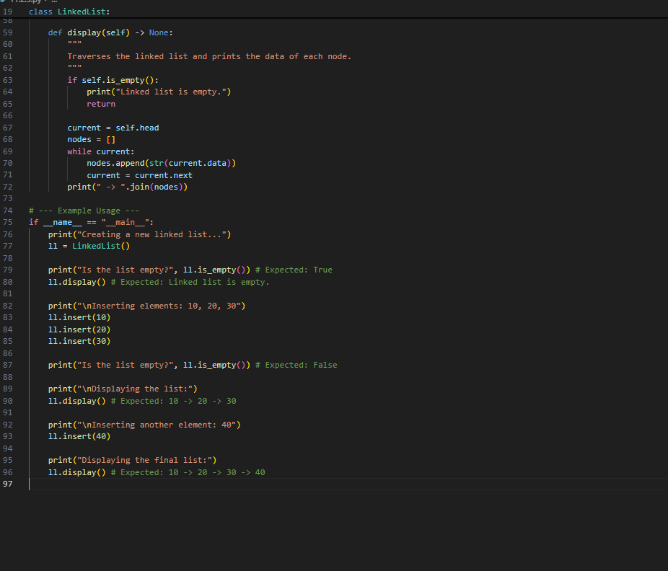
OUTPUT:
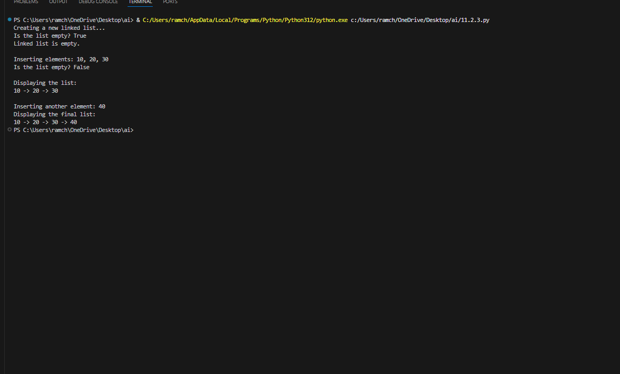
OBSERVATION:
The code generated by the AI is used to perform the operations in the data structures like singly linked list performing insert and delete operations accurately.
TASK-04:
Use AI to create a BST with insert and in-order traversal methods.
Sample Input Code:
class BST:
pass
PROMPT:
Generate a python code which creates a BST with insert and in-order methods.
CODE:
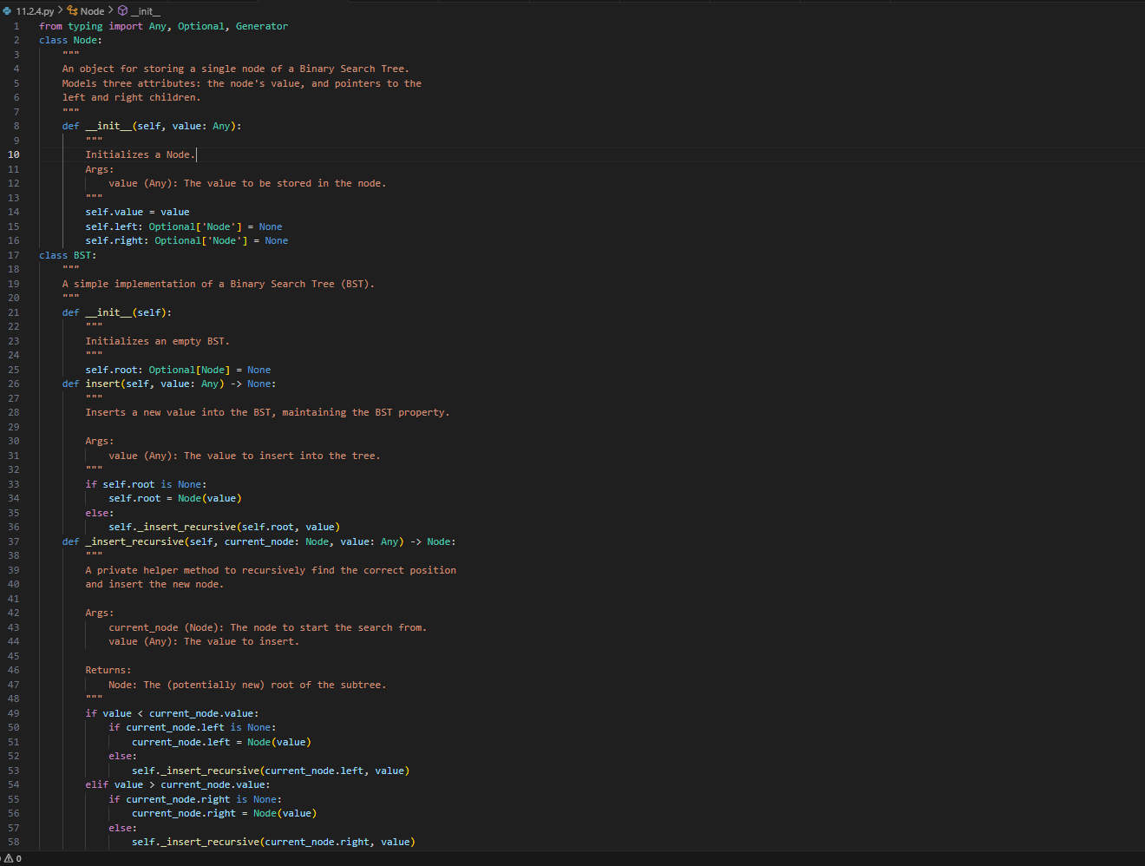
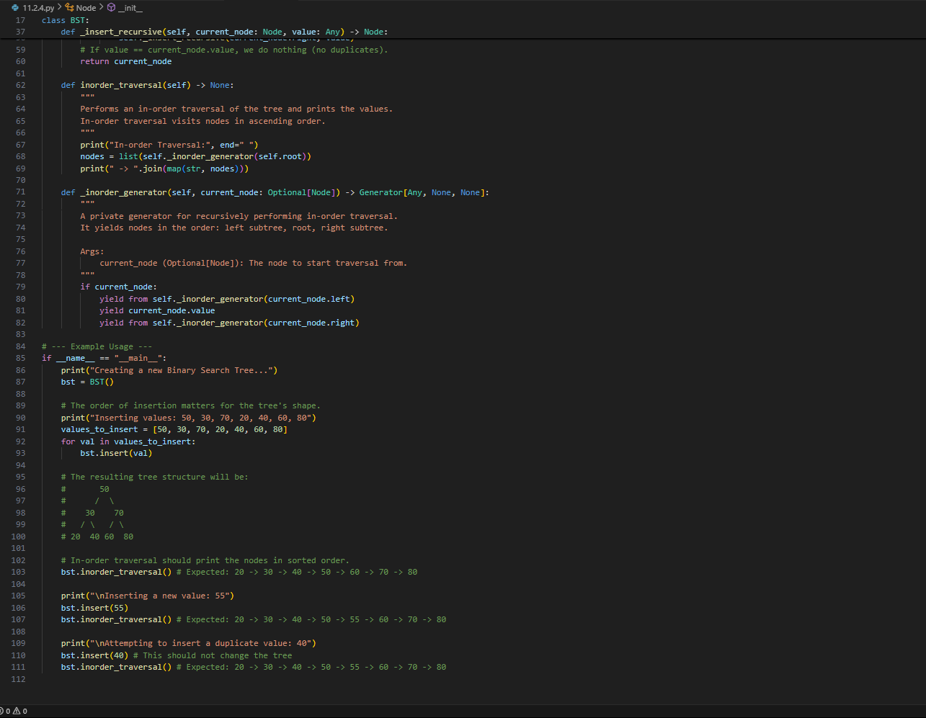

OUTPUT:
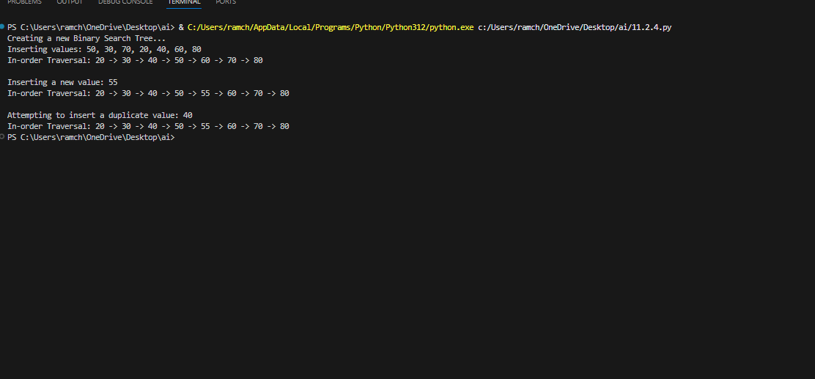
OBSERVATION:
The BST in data structures with insertion and in-order traversal methods are generated in python which are more helpful and in an efficient way to understand.
TASK-05:
Use AI to implement a hash table with basic insert, search, and delete
methods.
Sample Input Code:
class HashTable:
pass
PROMPT:
Generate a python code which helps to implement the hashtable with basic insert and delete methods.
CODE:
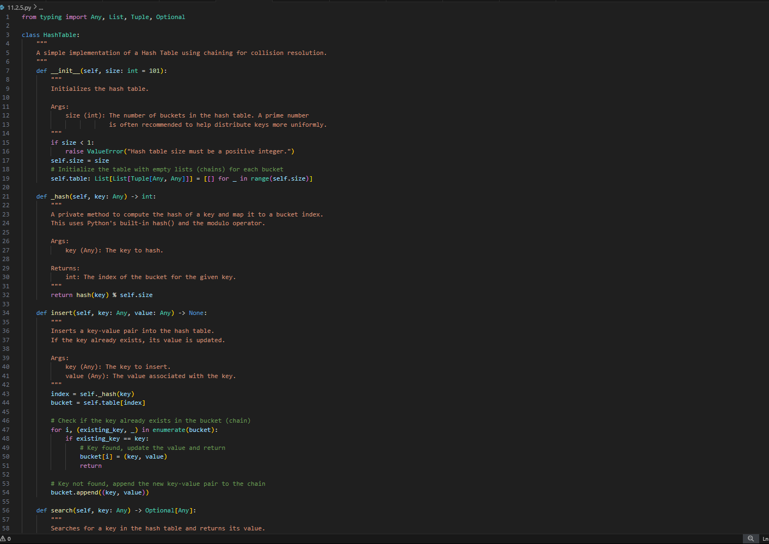
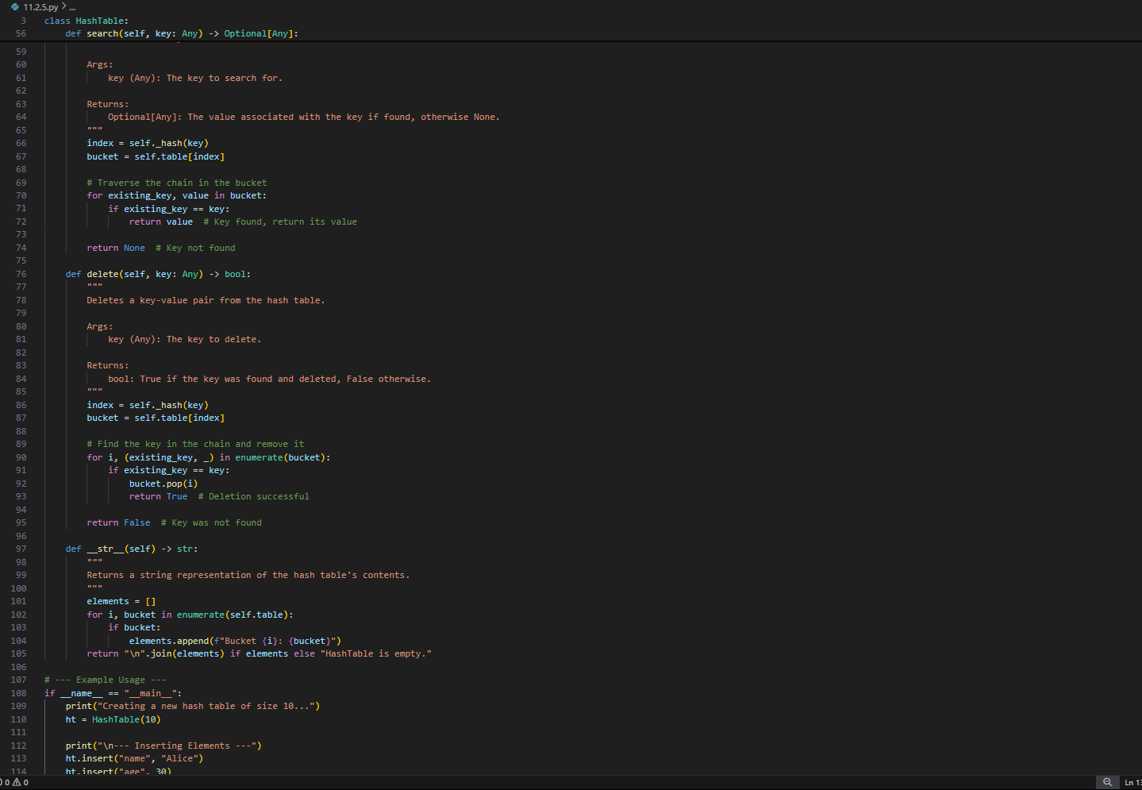
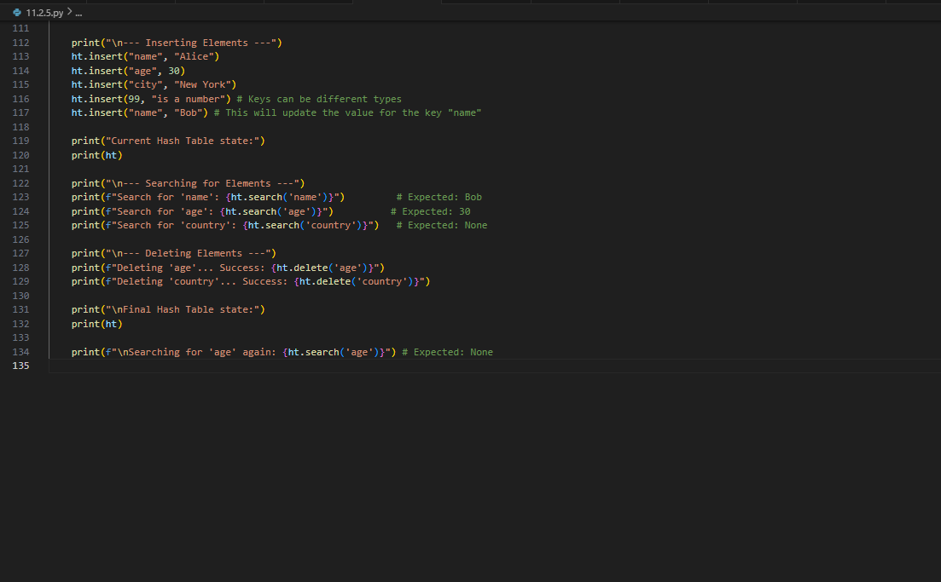
OUTPUT:
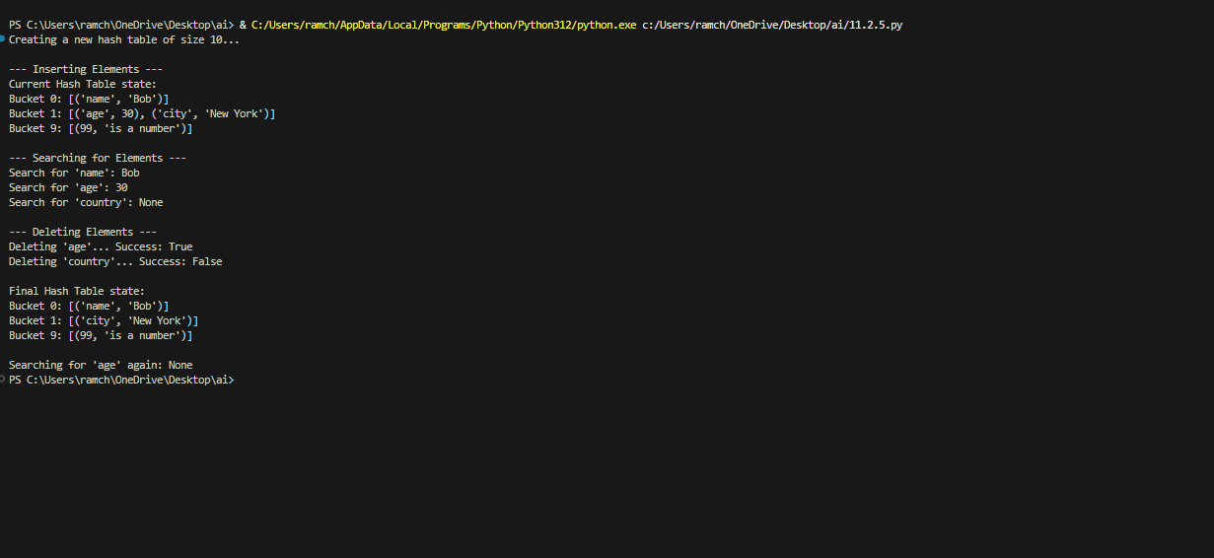
OBSERVATION:
AI generated the code of data structures topic hashtable with basic insert, search and delete which aids us to understand the hashtable using the programming language like python.
TASK-06:
Use AI to implement a graph using an adjacency list.
Sample Input Code:
class Graph:
pass
PROMPT:
Generate a python code which implements the graph using an adjacency list in data structures.
CODE:
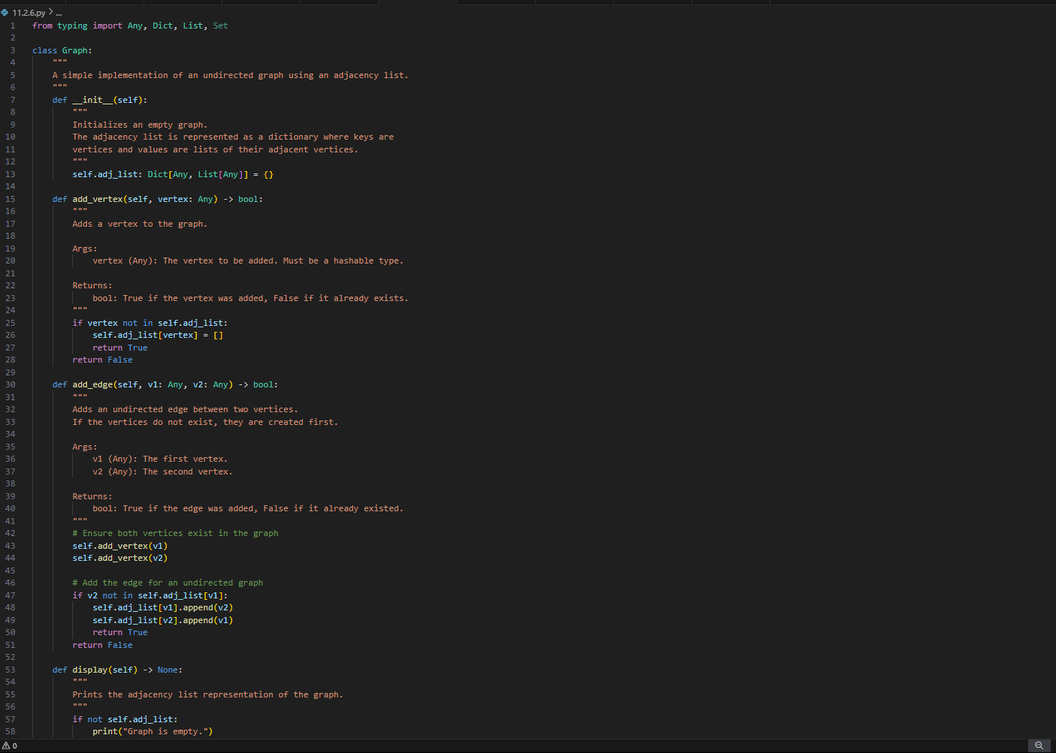
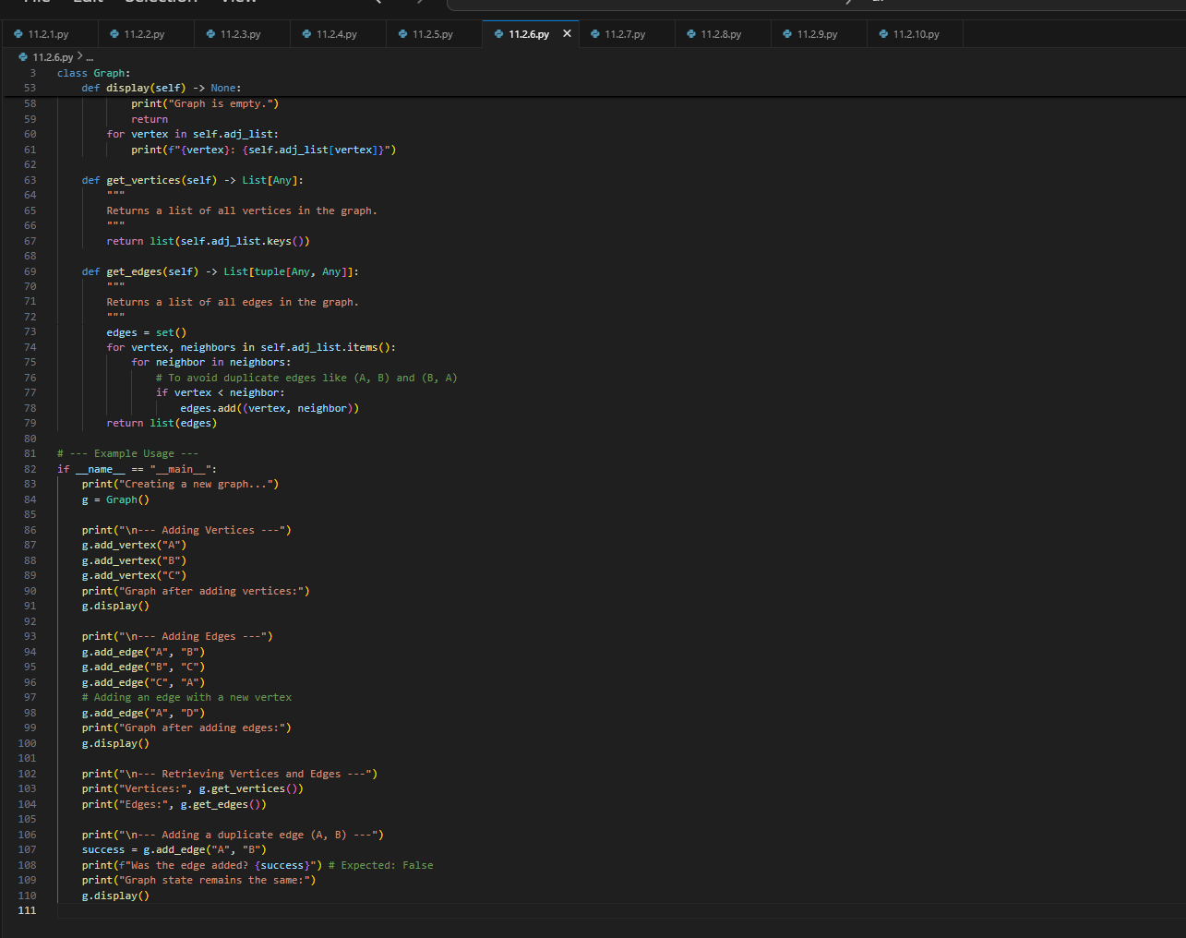
OUTPUT:
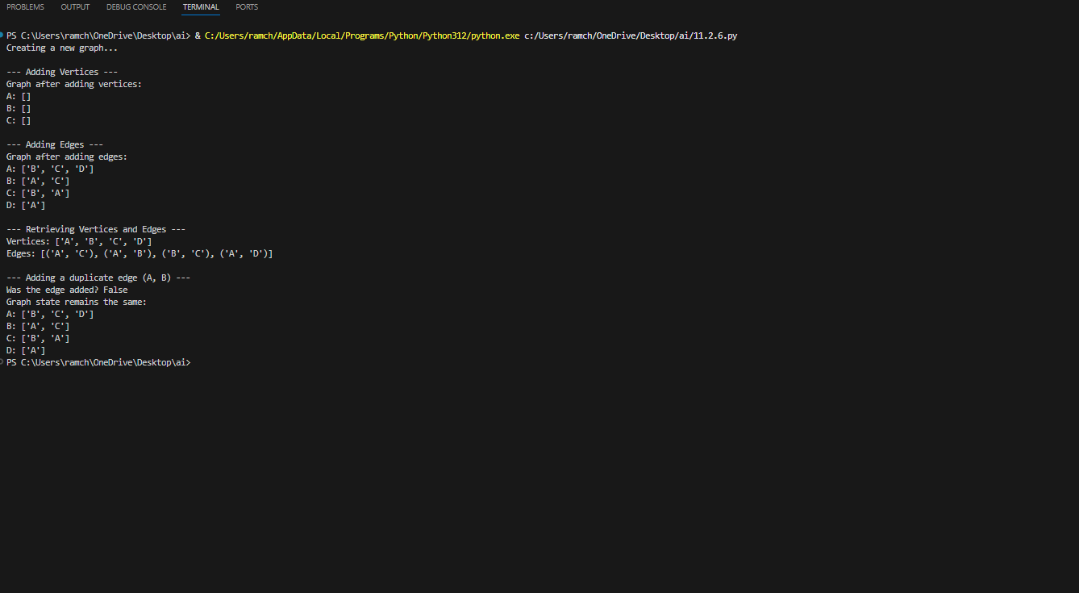
OBSERVATION:
Implementation of graph with the adjacency list is generated by the AI which makes us know about the graph in an efficient way and easy to understand.
TASK-07:
Use AI to implement a priority queue using Python’s heapq module.
Sample Input Code:
class PriorityQueue:
pass
PROMPT:
Write a python code which implement the priority queue using the heapq module.
CODE:
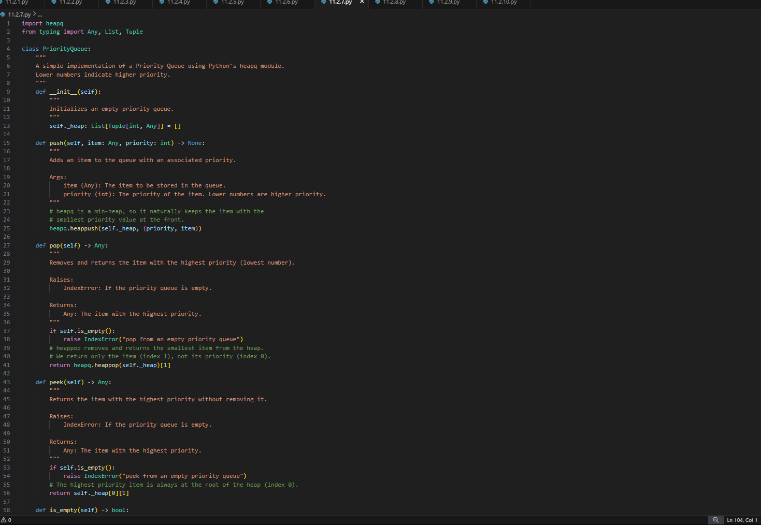
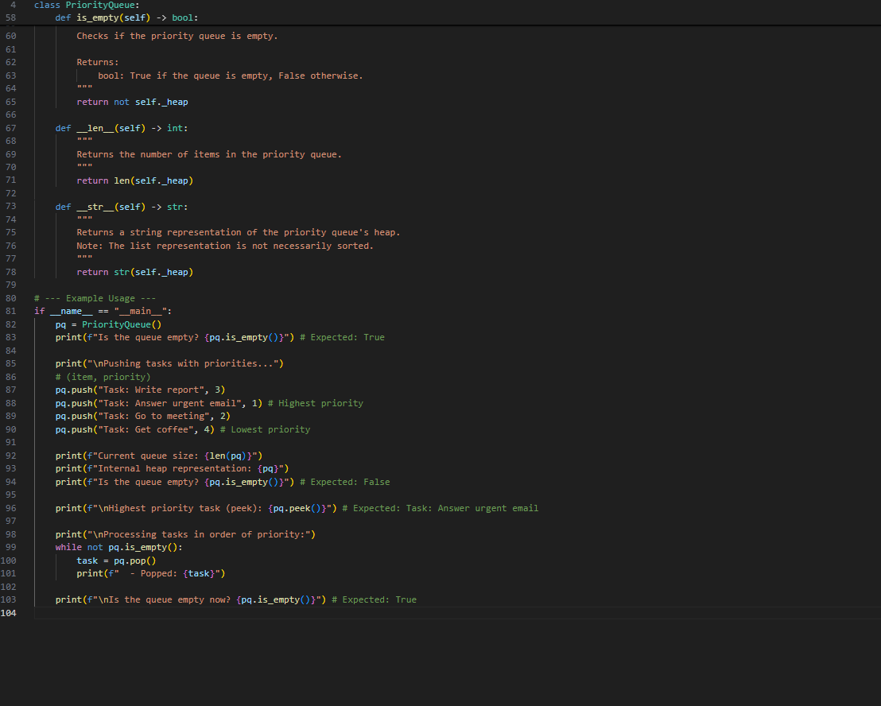
OUTPUT:
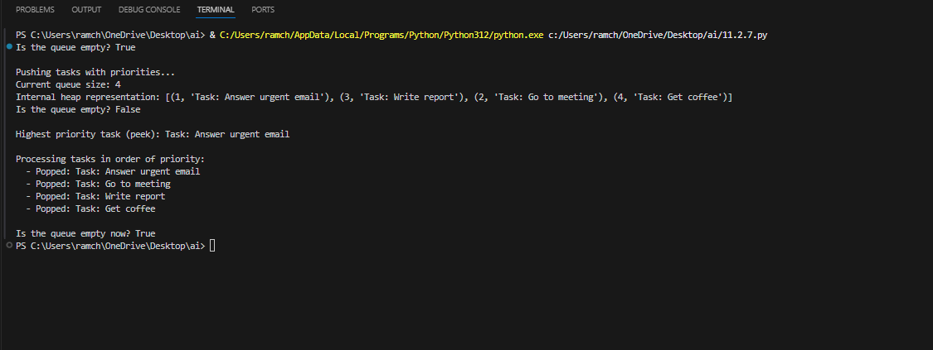
OBSERVATION:
The priority queue is generated using the heaqp module of python which implements them accurately.
TASK-08:
Use AI to implement a double-ended queue using collections.deque.
Sample Input Code:
class DequeDS:
pass
PROMPT:
Write a python code to implement the double-ended queue using collections .deque
CODE:
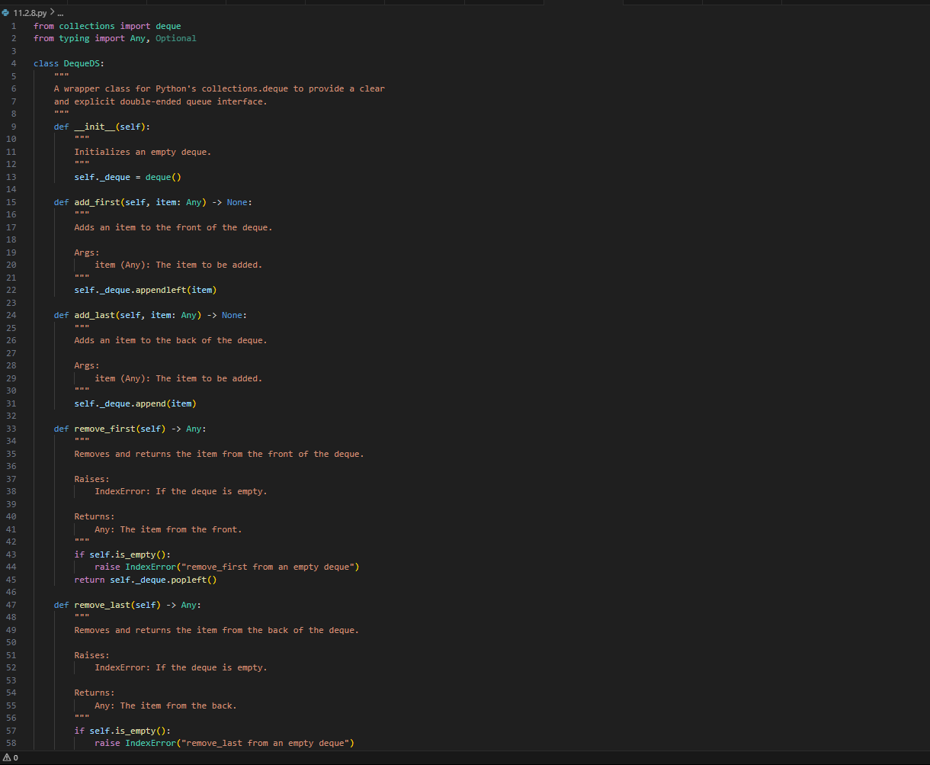
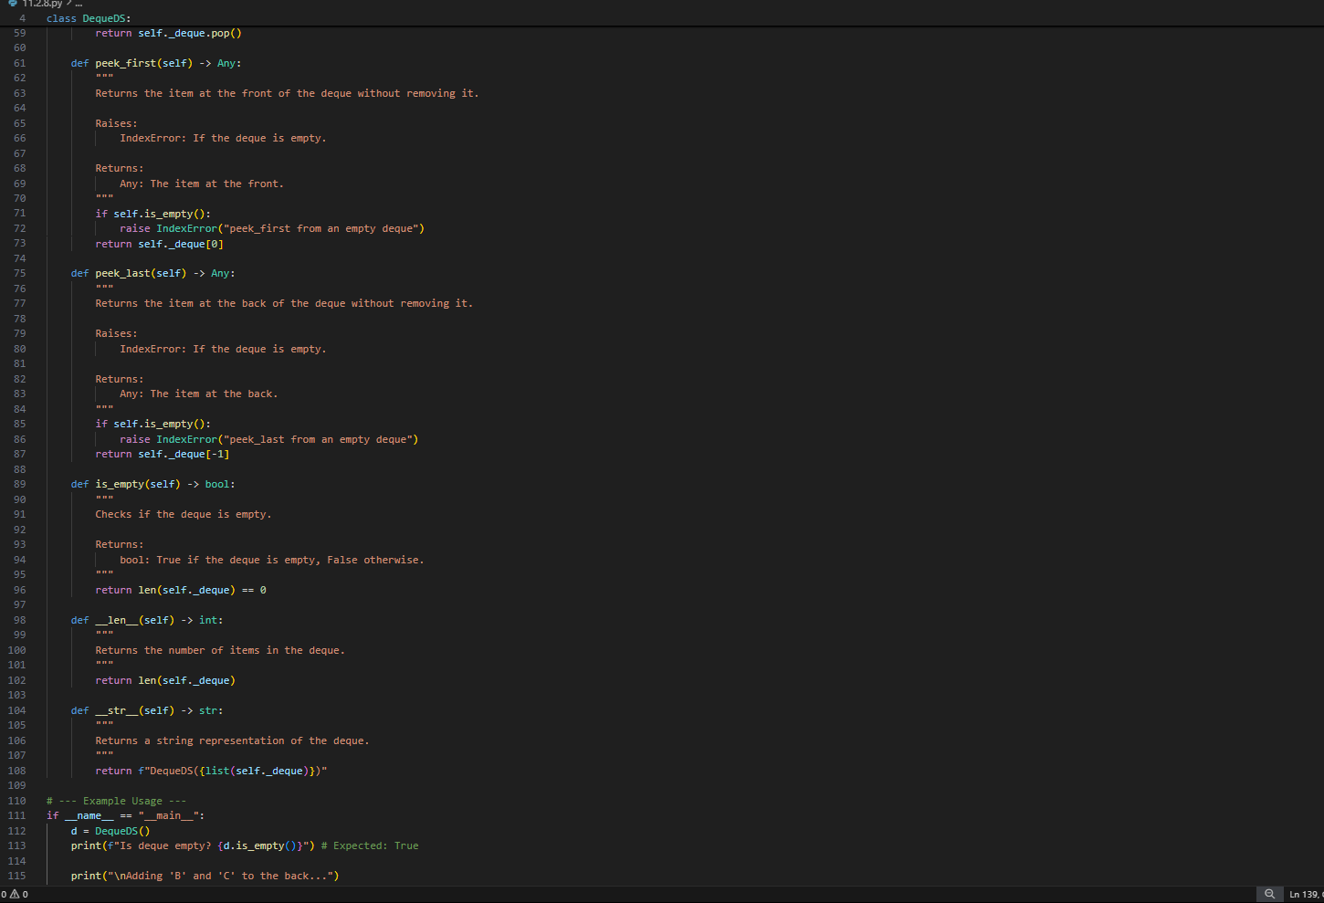
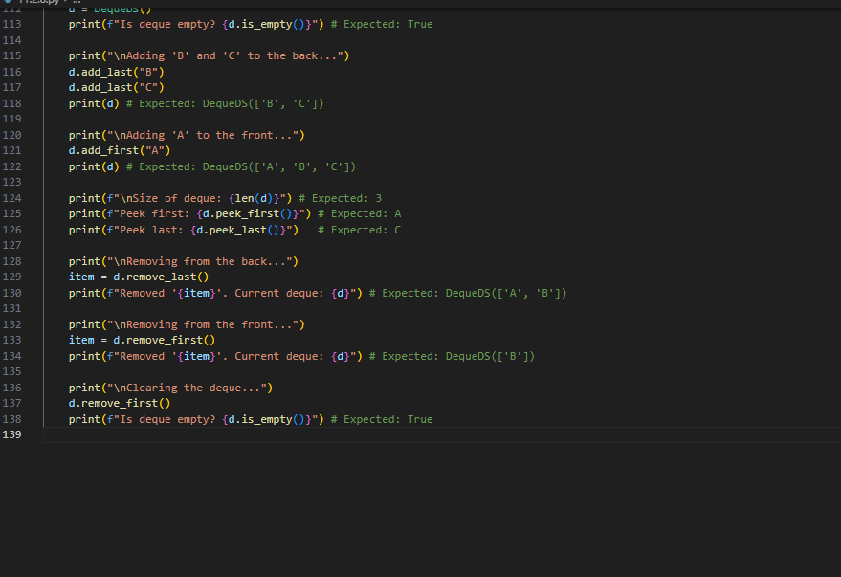
OUTPUT:
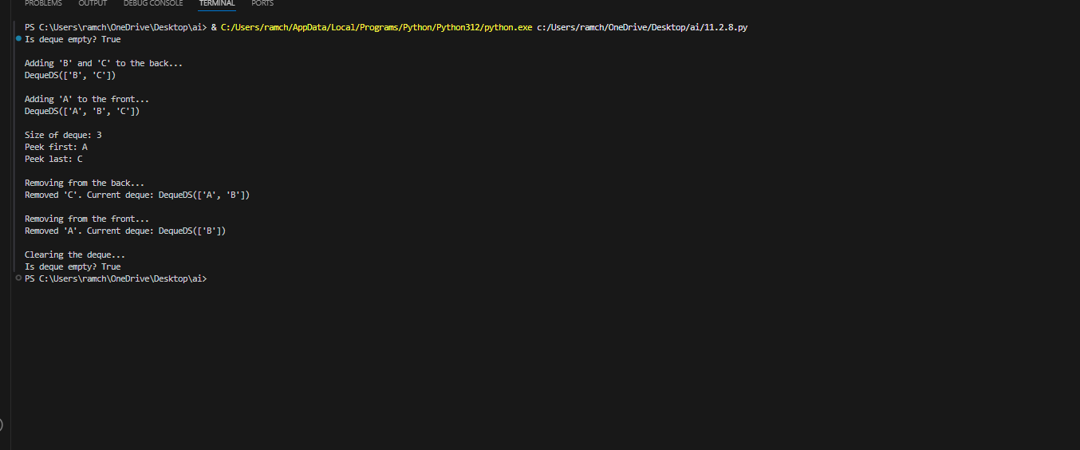
OBSERVATION:
The code generated by the AI of data structures topic of double-ended queue with the help of python to easily understand the topic accurately.
TASK-09:
Use AI to generate a comparison table of different data structures (stack,
queue, linked list, etc.) including time complexities.
Sample Input Code:
# No code, prompt AI for a data structure comparison table
PROMPT:
Generate a comparative table of different data structures including time complexities .
TABLE:
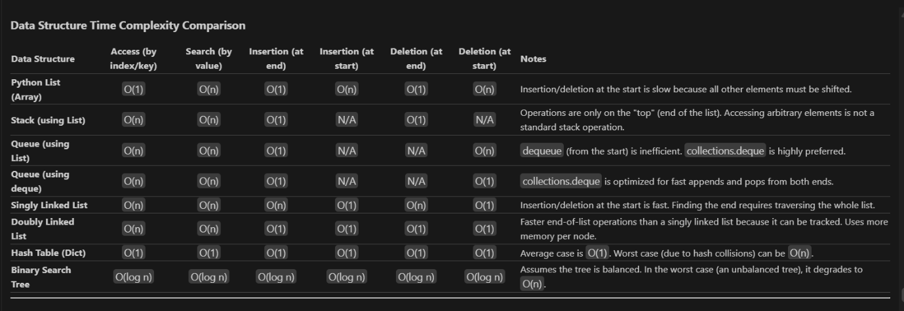
TASK-10:
Your college wants to develop a Campus Resource Management System that
handles:
1. Student Attendance Tracking – Daily log of students entering/exiting
the campus.
2. Event Registration System – Manage participants in events with quick
search and removal.
3. Library Book Borrowing – Keep track of available books and their due
dates.
4. Bus Scheduling System – Maintain bus routes and stop connections.
5. Cafeteria Order Queue – Serve students in the order they arrive.
Student Task:
• For each feature, select the most appropriate data structure from the list
below:
o Stack
o Queue
o Priority Queue
o Linked List
o Binary Search Tree (BST)
o Graph
o Hash Table
o Deque
• Justify your choice in 2–3 sentences per feature.
• Implement one selected feature as a working Python program with AI-
assisted code generation.
PROMPT:
Generate the python code according to the given above details.
CODE:
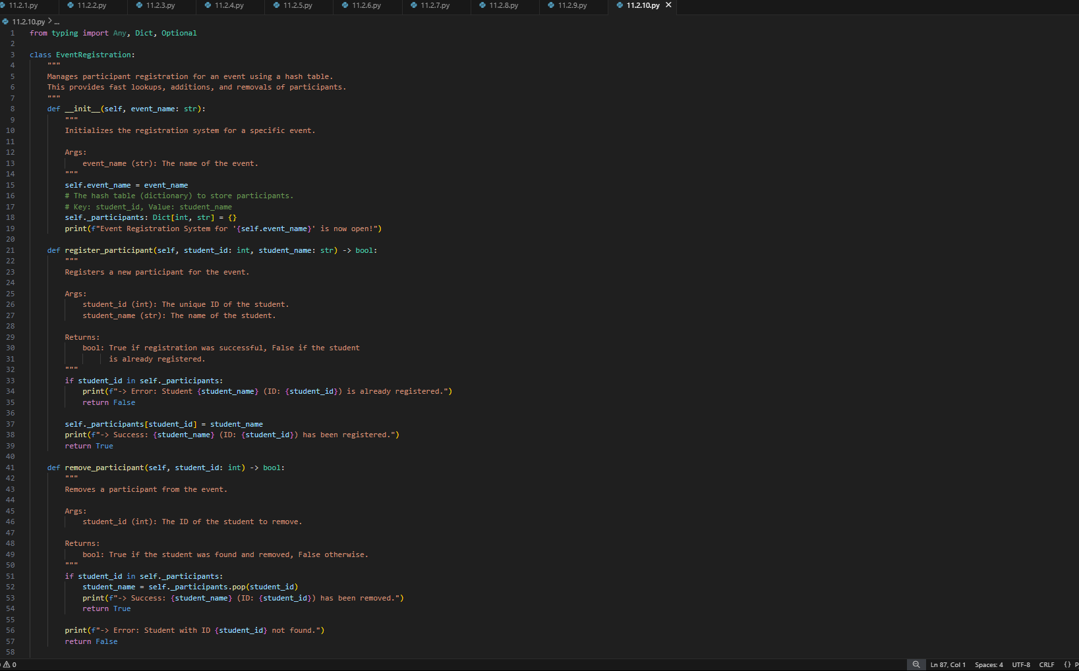
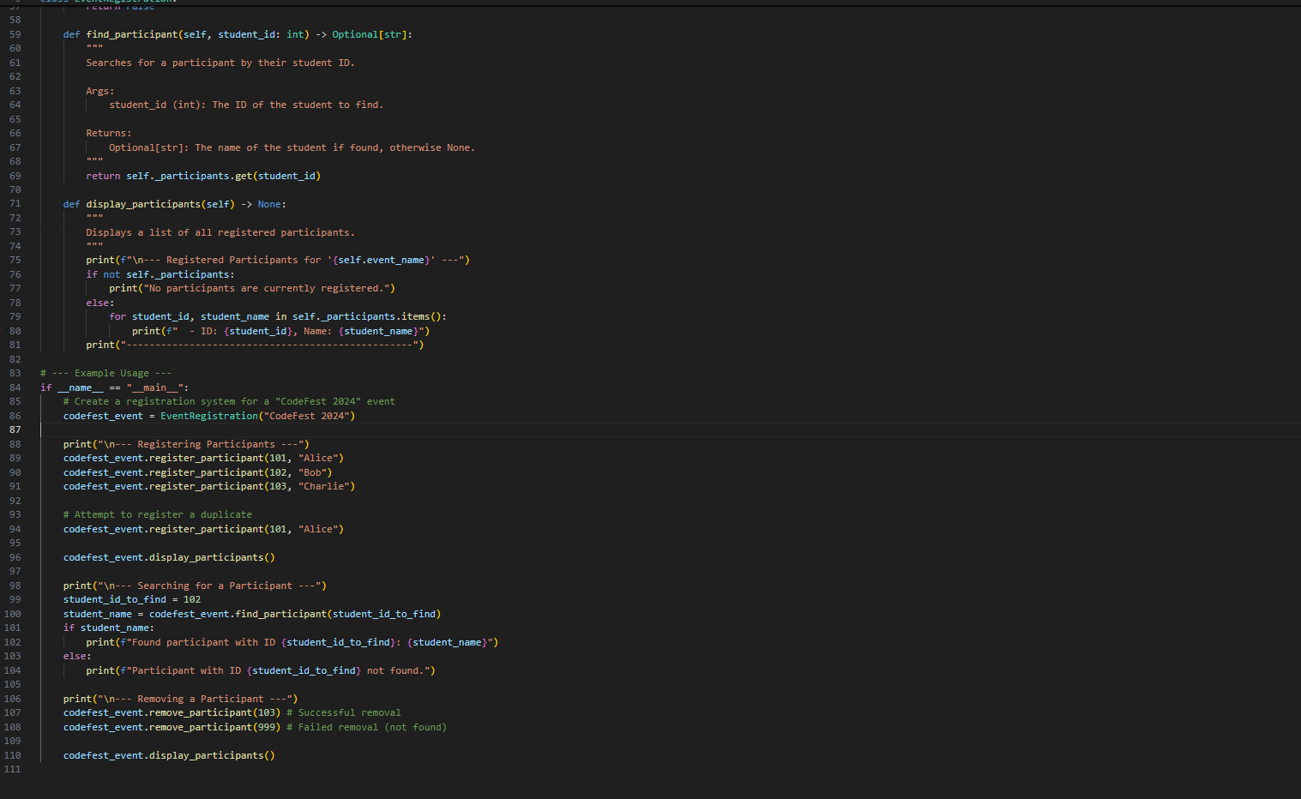
OUTPUT:
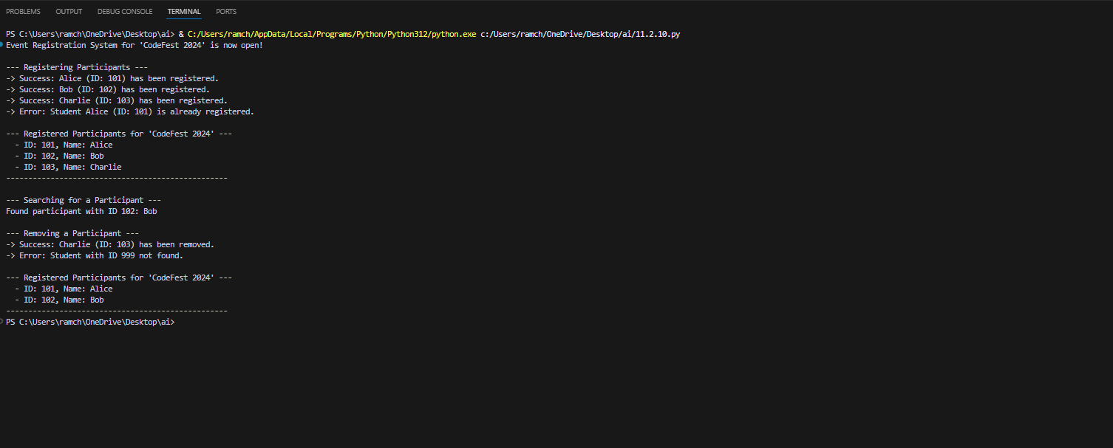
TABLE:
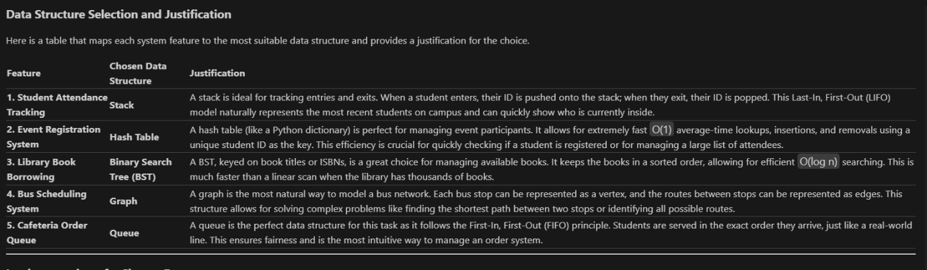
OBSERVATION:
The AI generated the code in an efficient way according to the details given in which it include all the data structures concepts to make all easily understand . As the task contains much more information it should be handled in an efficient way.

