ASSIGNMENT – 4

NAME:G.Ashish
HT.NO: 2403A52110
BATCH NO: AIB04
TASK 1:
Completeclasswithmethodslike: deposit(self, amount) withdraw(self, amount) display_balance(self)

PROMPT:
Completeclasswithmethodslike: deposit(self, amount) withdraw(self, amount) display_balance(self)

CODE:

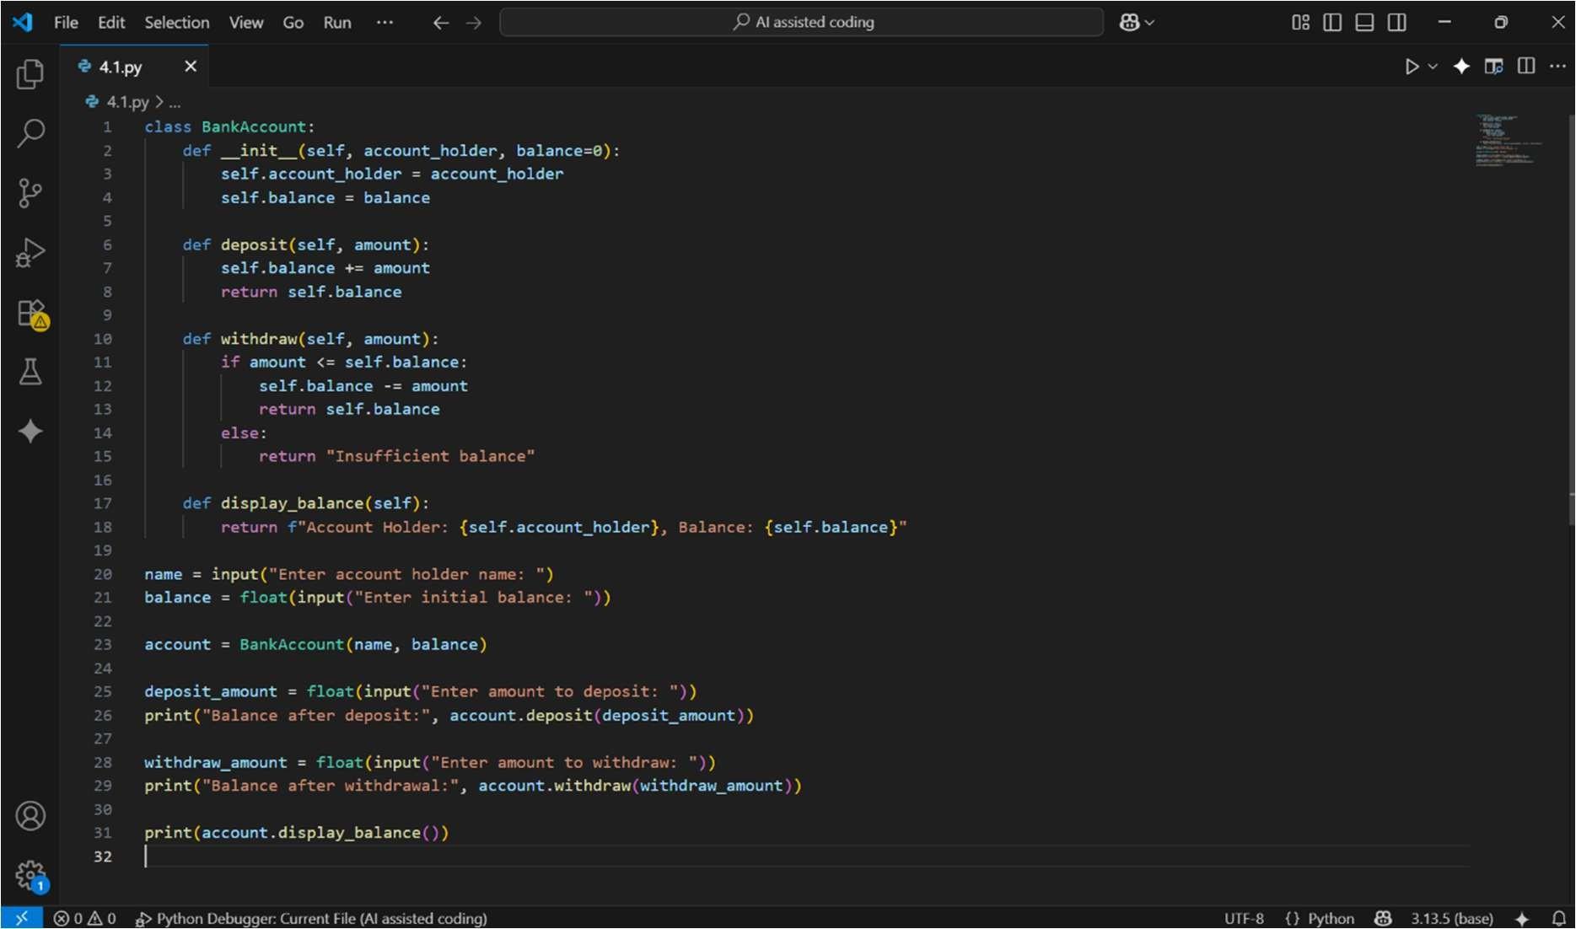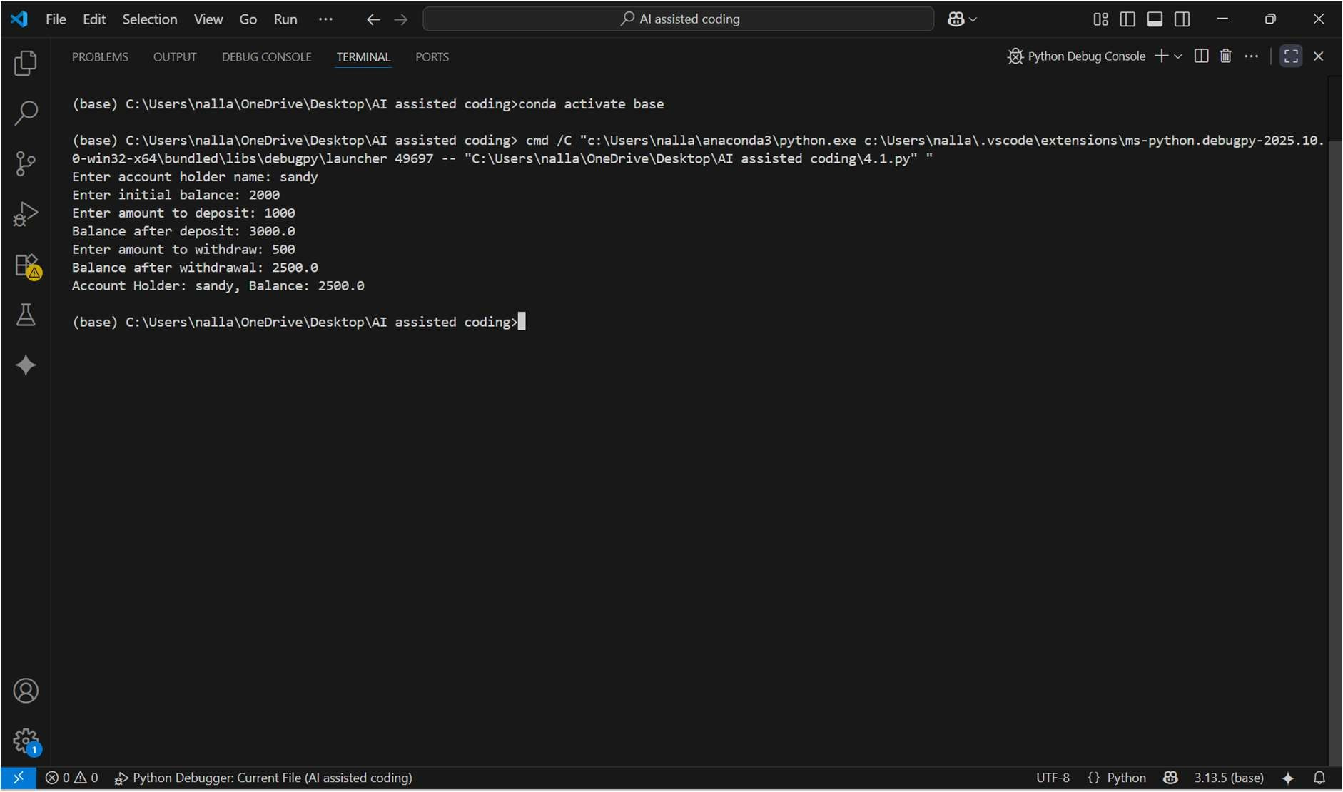

OBSERVATION:
This code defines a BankAccount class to manage a simple bank account with a holder’s name and balance. It has methods to deposit money, withdraw money if enough balance is available, and display account details. The program asksthe user for their name, initial balance, deposit, and withdrawal amounts, updates the account accordingly, and shows the final balance.

TASK 2:
Writeacommentand theinitial line of a loop to iterate over a list. Allow GitHubCopilottocompletethe logictosumallevennumbersinthelist.

PROMPT:
Write a commentand the initial line of a loop toiterate over a list.complete the logic to sum all even numbers in the list.

CODE:
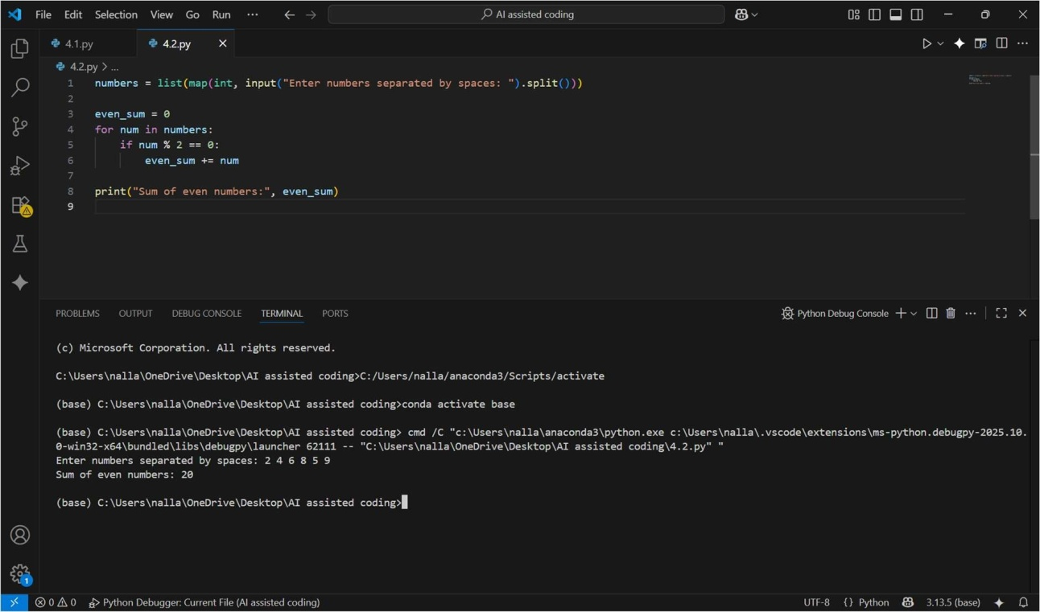

OBSERVATION:
This Python code calculates the sum of even numbers from a list entered by theuser. Itfirst prompts theusertoinput numbersseparatedby spaces,then converts that input into a list of integers using map and split. It initializes a variable even_sum to zero, then iterates through each number in the list. If a number is divisible by 2 (i.e., it’s even), it adds that number to even_sum.
Finally,itprintsthetotalsumofallevennumbersentered bytheuser.

TASK 3:

Start a function that takes age as input and returns whether the person is a child, teenager, adult,or senior using if-elif-else.Use Copilot tocomplete the conditionals.

PROMPT:
Start a function that takes age as input and returns whether the person is a child, teenager, adult, or senior using if-elif-else.

CODE:
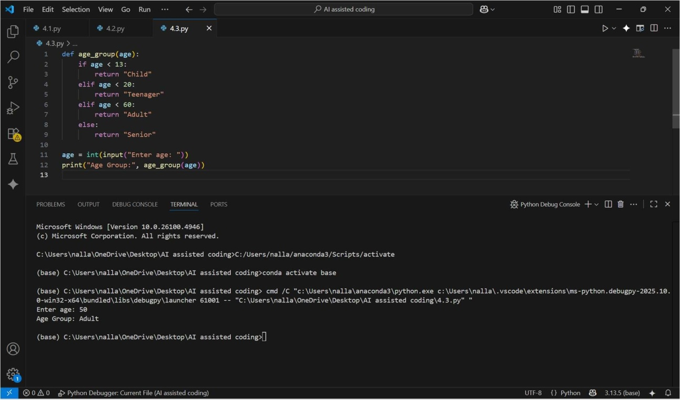

OBSERVATION:
This Pythoncode defines a function age_group that categorizes a person based on their age. It takes an integer age as input and checks several conditions: if the age is less than 13, it returns "Child"; if it is between 13 and 19, it returns "Teenager"; if it is between 20 and 59, it returns "Adult"; and if it is 60 orabove, it returns "Senior". The program prompts the user to enter their age, converts it to an integer, passes it to the age_group function, and then prints the resulting age category.

TASK 4:

Writea comment and start a while loop to reverse thedigitsof a number.Let Copilot complete
thelooplogic

PROMPT:
Writea commentandstartawhile looptoreverse thedigitsofanumber.

CODE:
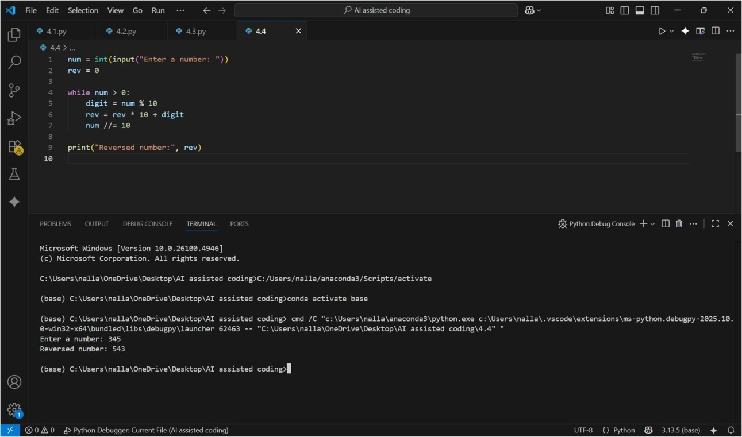

OBSERVATION:
This Python code reverses the digits of a number entered by the user. It first prompts the user to input a number and stores it in num, while initializing rev to 0to hold the reversed number. Inside a while loop that runs as long as num is greater than 0, it extracts the last digit using num % 10, adds it to rev after shifting the existing digits to the left (rev * 10 + digit), and removes the last digit from num using integer division num //= 10. After the loop finishes, it prints the reversed number stored in rev.

TASK 5:

Begin a class Employee withattributes name and salary. Then, start a derived class Manager that inherits from Employee and adds a department. Let GitHub Copilot complete the methods
andconstructorchaining

PROMPT:
Begin aclass Employee with attributes name and salary. Then, start a derived class Manager that inherits from Employee and adds a department

CODE:
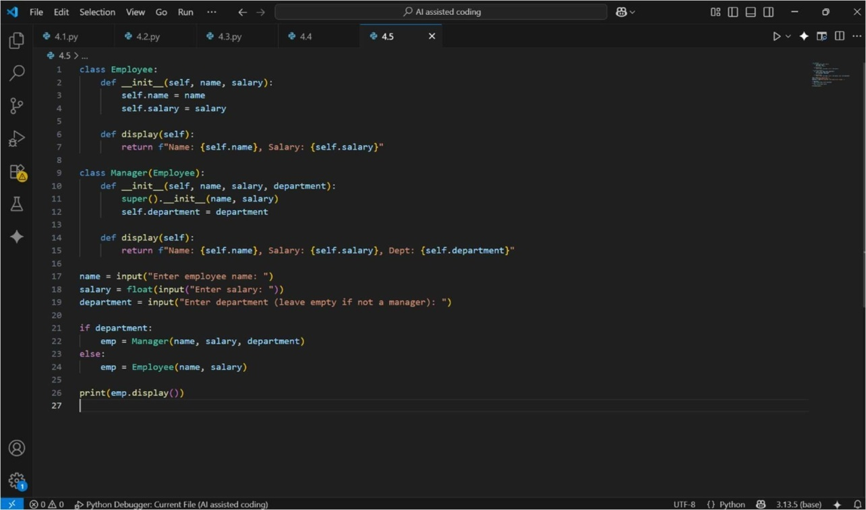

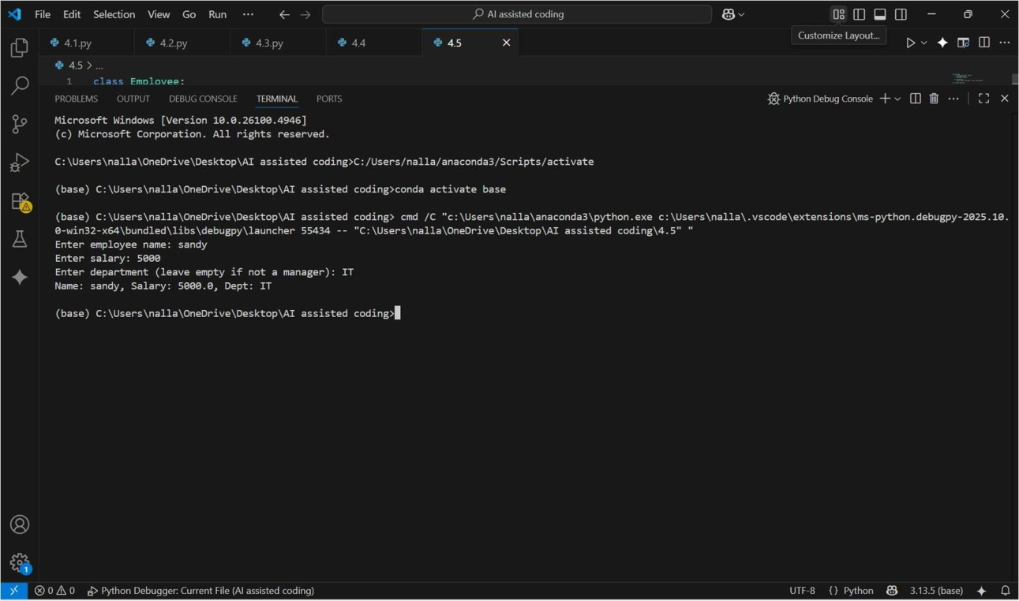

OBSERVATION:
This Python code demonstrates inheritance in classes. It defines an Employee class with a constructor that stores the employee’s name and salary, and a display method that returns these details as a string. Thenit defines a Manager class that inherits from Employee and adds a department attribute. The Manager class also overrides the display method to include the department in the output. The program asks the user to enter a name, salary, and optionally a department. If a department is provided, it creates a Manager object; otherwise, it creates a regular Employee object. Finally, it prints the details of the created object using the display method.

