AI ASSISTED CODING
LAB-7.4

NAME:G.Ashish
ENROLL NO: 2403A52110
BATCH: 04

TASK :01
Introduce a buggy Python function that calculates the factorial of a number using recursion.Use Copilot or Cursor AI to detect and fix the logical or syntax errors.

PROMPT:
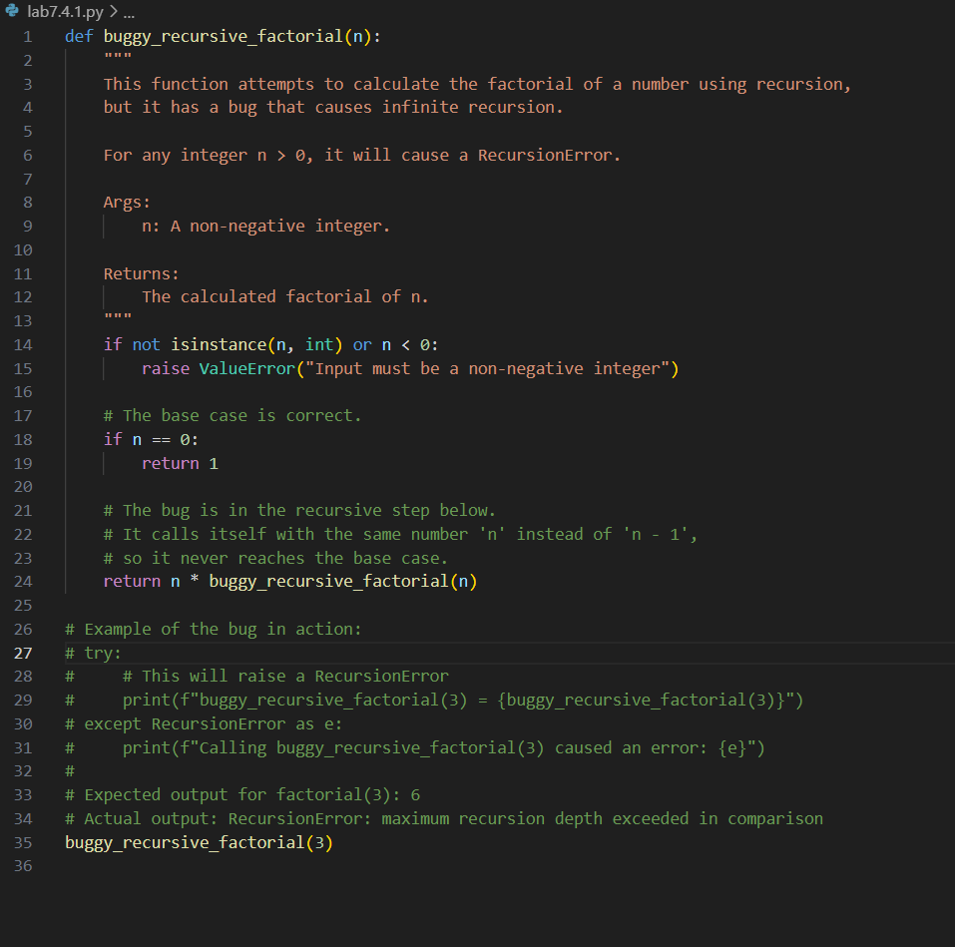
Detect the bugs in the code and correct it .
CODE:
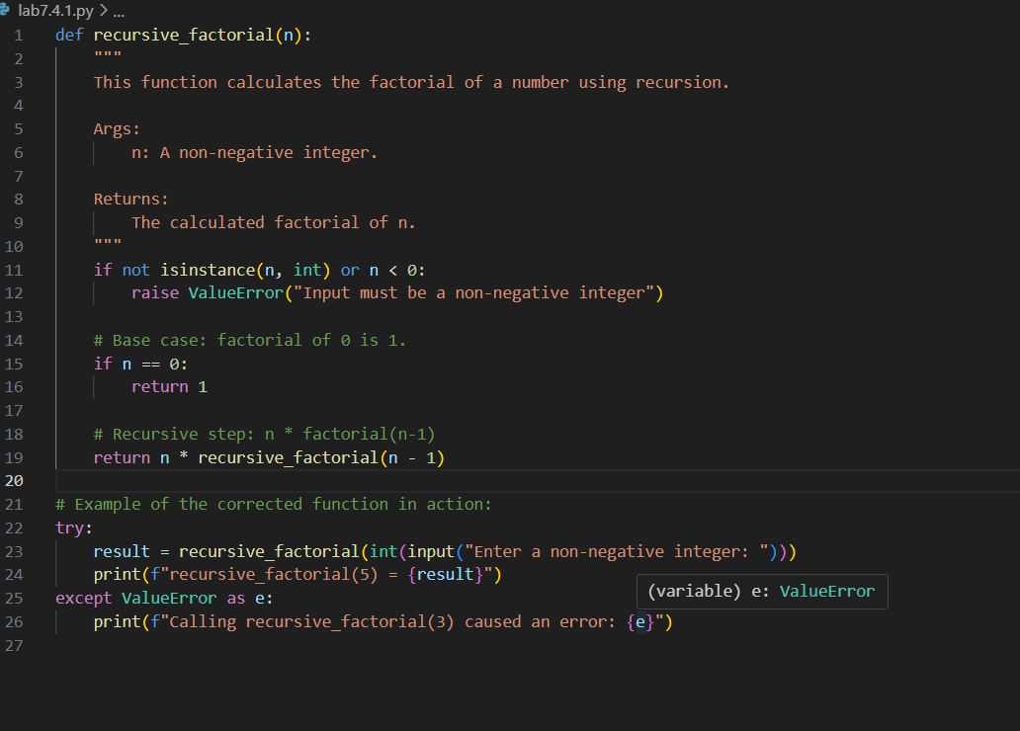
OUTPUT:
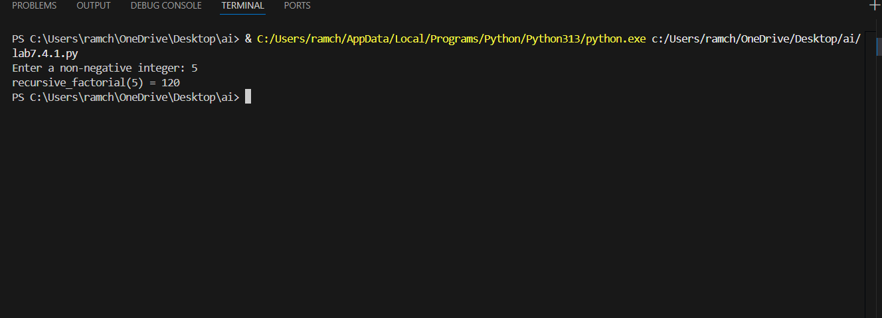
OBSERVATION:
The given prompt code has bugs which are resolved by the AI and rewrite the code.

TASK :02
Provide a list sorting function that fails due to a type error (e.g., sorting list with mixedintegers and strings). Prompt AI to detect the issue and fix the code for consistent sorting.

PROMPT:
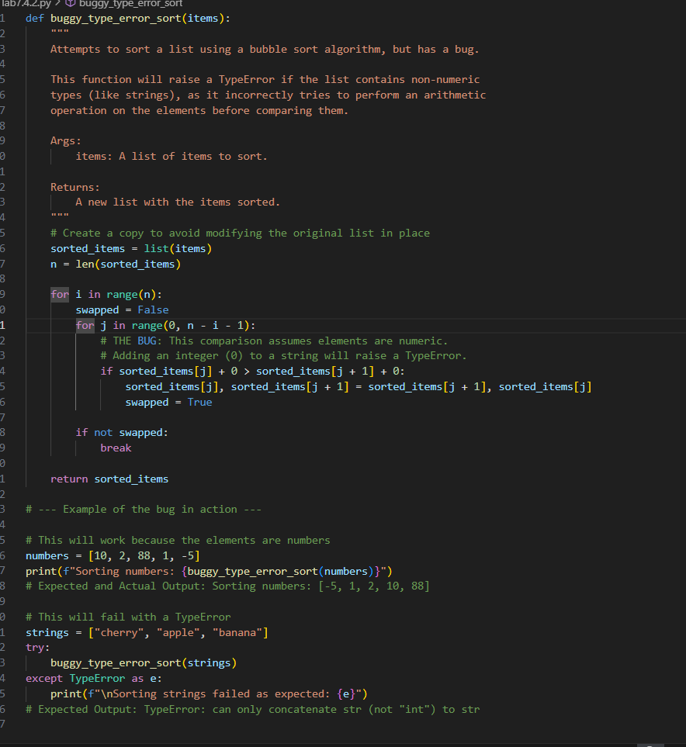
Detect the issue in the code and correct it.
CODE:
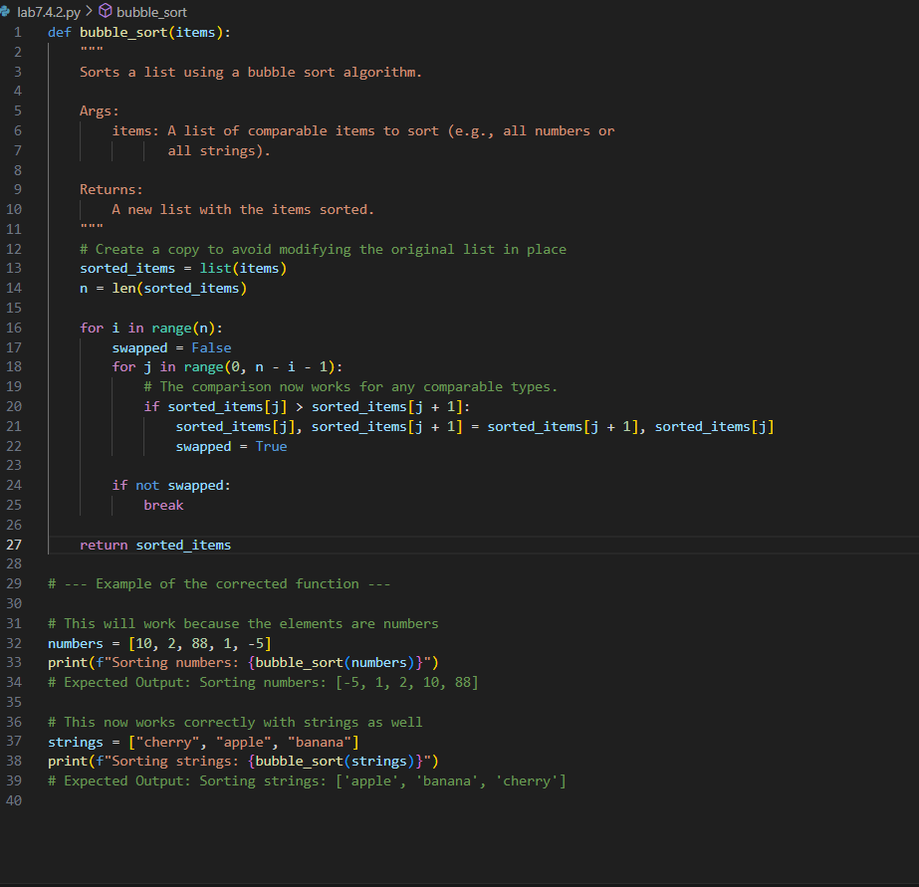
OUTPUT:
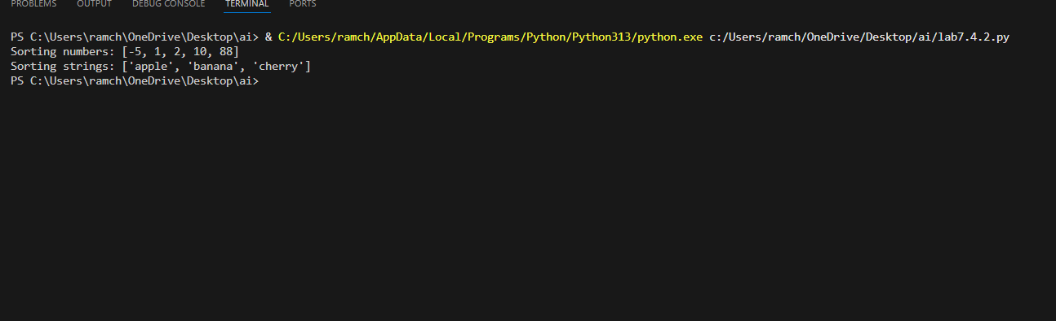
OBSERVATION:
The code has a bug of not sorting the list of names lexographically it only sorts the list of numbers in ascending order whereas in the code given by gemini has both the ability.

TASK :03
Write a Python snippet for file handling that opens a file but forgets to close it. Ask Copilot orCursor AI to improve it using the best practice (e.g., with open() block).
PROMPT:
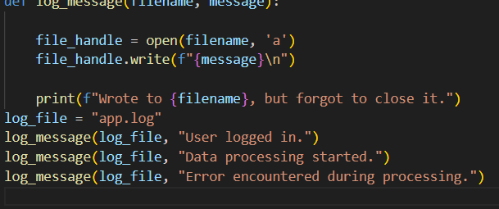
Detect the bug and correct the code.

CODE:
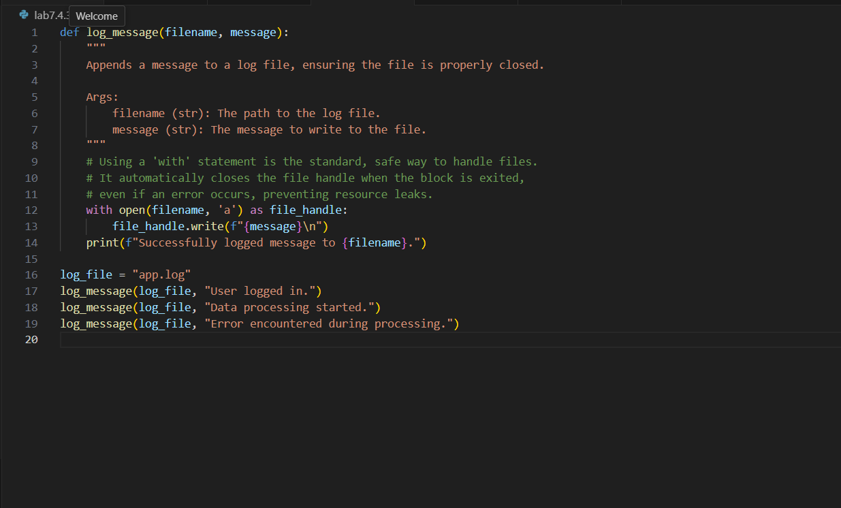
OUTPUT:
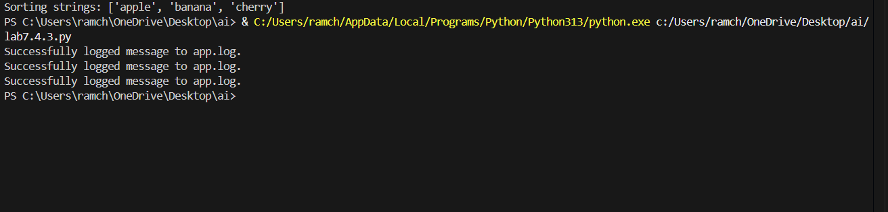
OBSERVATION:
The bug in the code is it opens a file to store some data btu forgots to close it. The bug is resolved by the AI
TASK :4
Provide a piece of code with a ZeroDivisionError inside a loop. Ask AI to add error handlingusing try-except and continue execution safely
PROMPT:
Generate a python code to perform the ZeroDivisionError and include try-except methods to improve the efficiency of the code.
CODE:
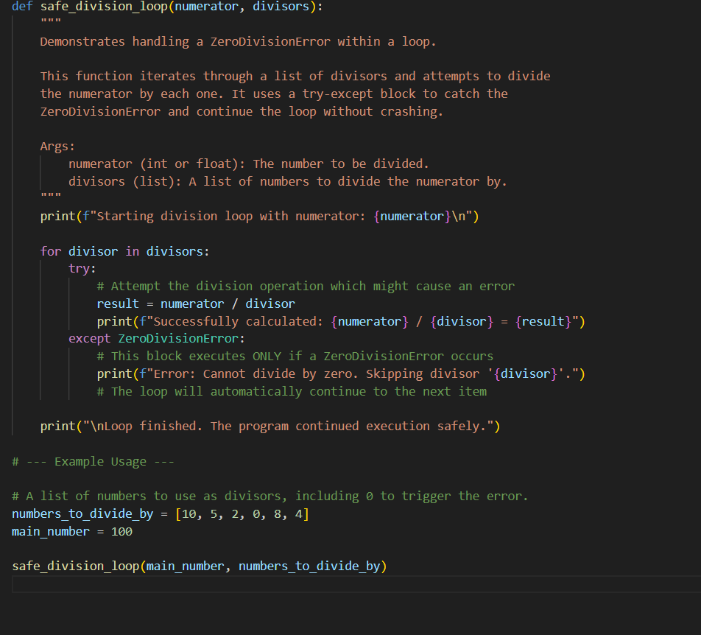
OUTPUT:
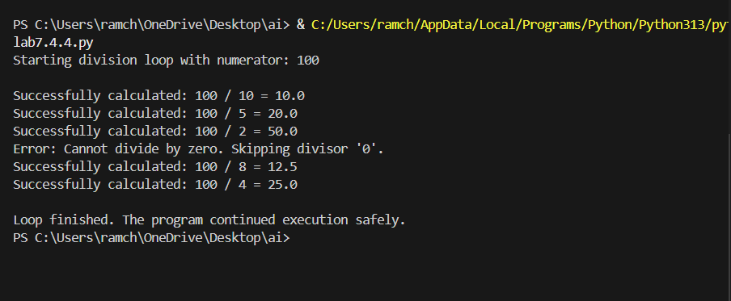
OBSERVATION:
The code generated by AI has the ability to perform the operations like ZeroDivisionError and giving an efficient output.

TASK :05
Include a buggy class definition with incorrect __init__ parameters or attribute references. AskAI to analyze and correct the constructor and attribute usage.
PROMPT:
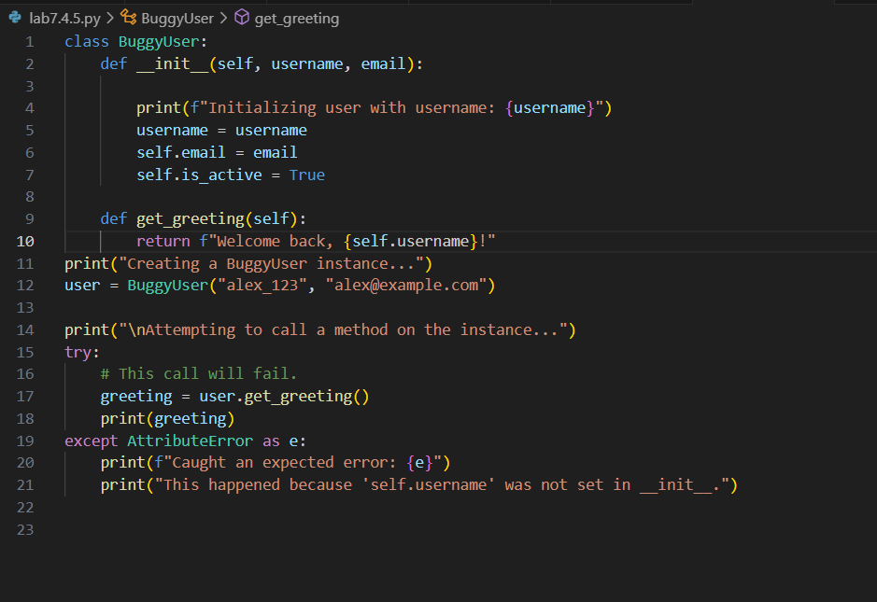
Detect the bug in the code and rewrite the correct code with the correct class.
CODE:
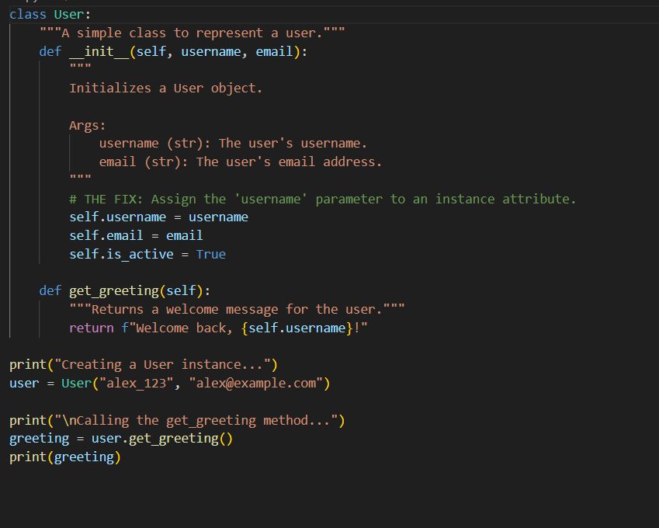
OUTPUT:
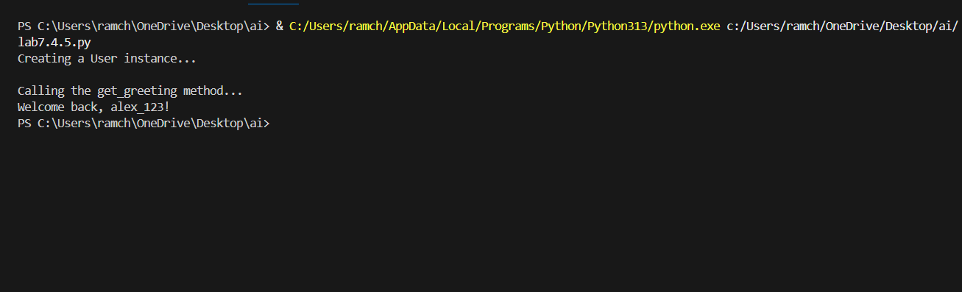
OBSERVATION:
The AI has efficiently corrected the bugs in the code provided by the user and gave the debugged code.

