ASSIGNMENT – 9.2
NAME:G.Ashish
ENROLL NO: 2403A52110
BATCH: 04
Task-1:(Documentation – Google-Style Docstrings for
Python Functions)
• Task: Use AI to add Google-style docstrings to all functions in a
given Python script.
• Instructions:
o Prompt AI to generate docstrings without providing any
input-output examples.
o Ensure each docstring includes:
▪ Function description
▪ Parameters with type hints
▪ Return values with type hints
▪ Example usage
o Review the generated docstrings for accuracy and
formatting.
• Expected Output #1:
o A Python script with all functions documented using
correctly formatted Google-style docstrings
Prompt:add Google-style docstrings to all functions in a given Python script.
Ensure each docstring includes:Function description, Parameters with type hints, Return values with type hints
Code:
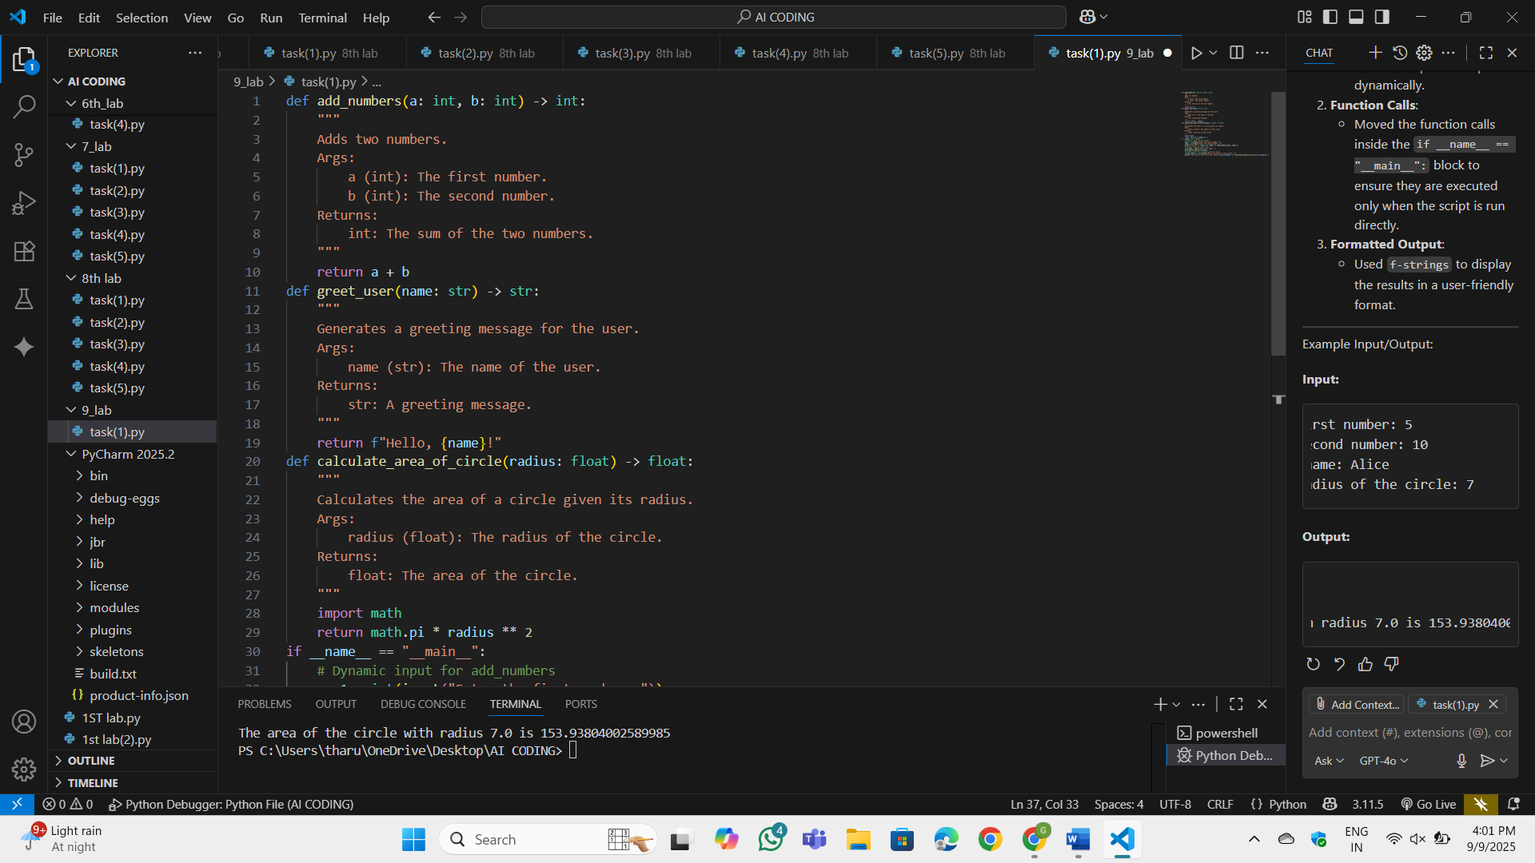
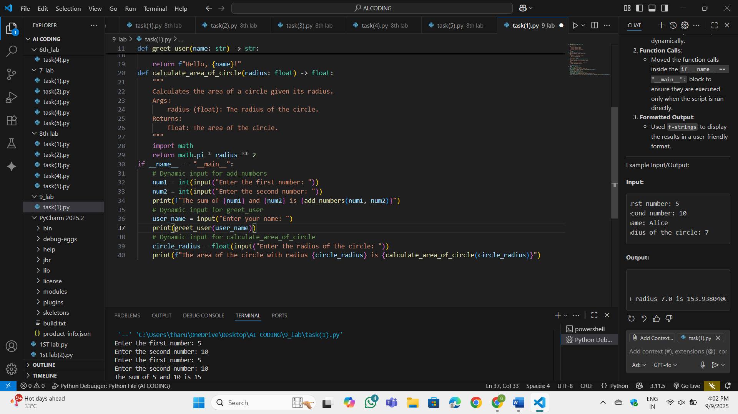
OP:
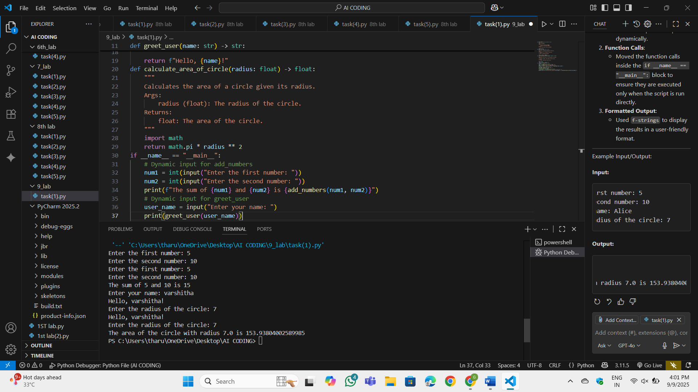
Observation:
Added input() prompts for each function to allow the user to provide input dynamically.Moved the function calls inside the if __name__ == "__main__": block to ensure they are executed only when the script is run directly.Used f-strings to display the results in a user-friendly format.
Task-2:(Documentation – Inline Comments for Complex
Logic)
• Task: Use AI to add meaningful inline comments to a Python
program explaining only complex logic parts.
• Instructions:
o Provide a Python script without comments to the AI.
o Instruct AI to skip obvious syntax explanations and focus
only on tricky or non-intuitive code sections.
o Verify that comments improve code readability and
maintainability.
• Expected Output #2:
o Python code with concise, context-aware inline comments
for complex logic blocks
Prompt: for the code I provided focusonly on tricky or non-intuitive code sections. And add meaningful inline comments to a Python
program explaining only complex logic parts
Code:
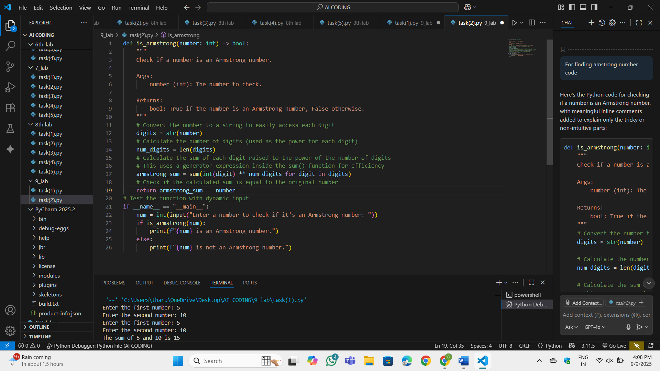
OP:
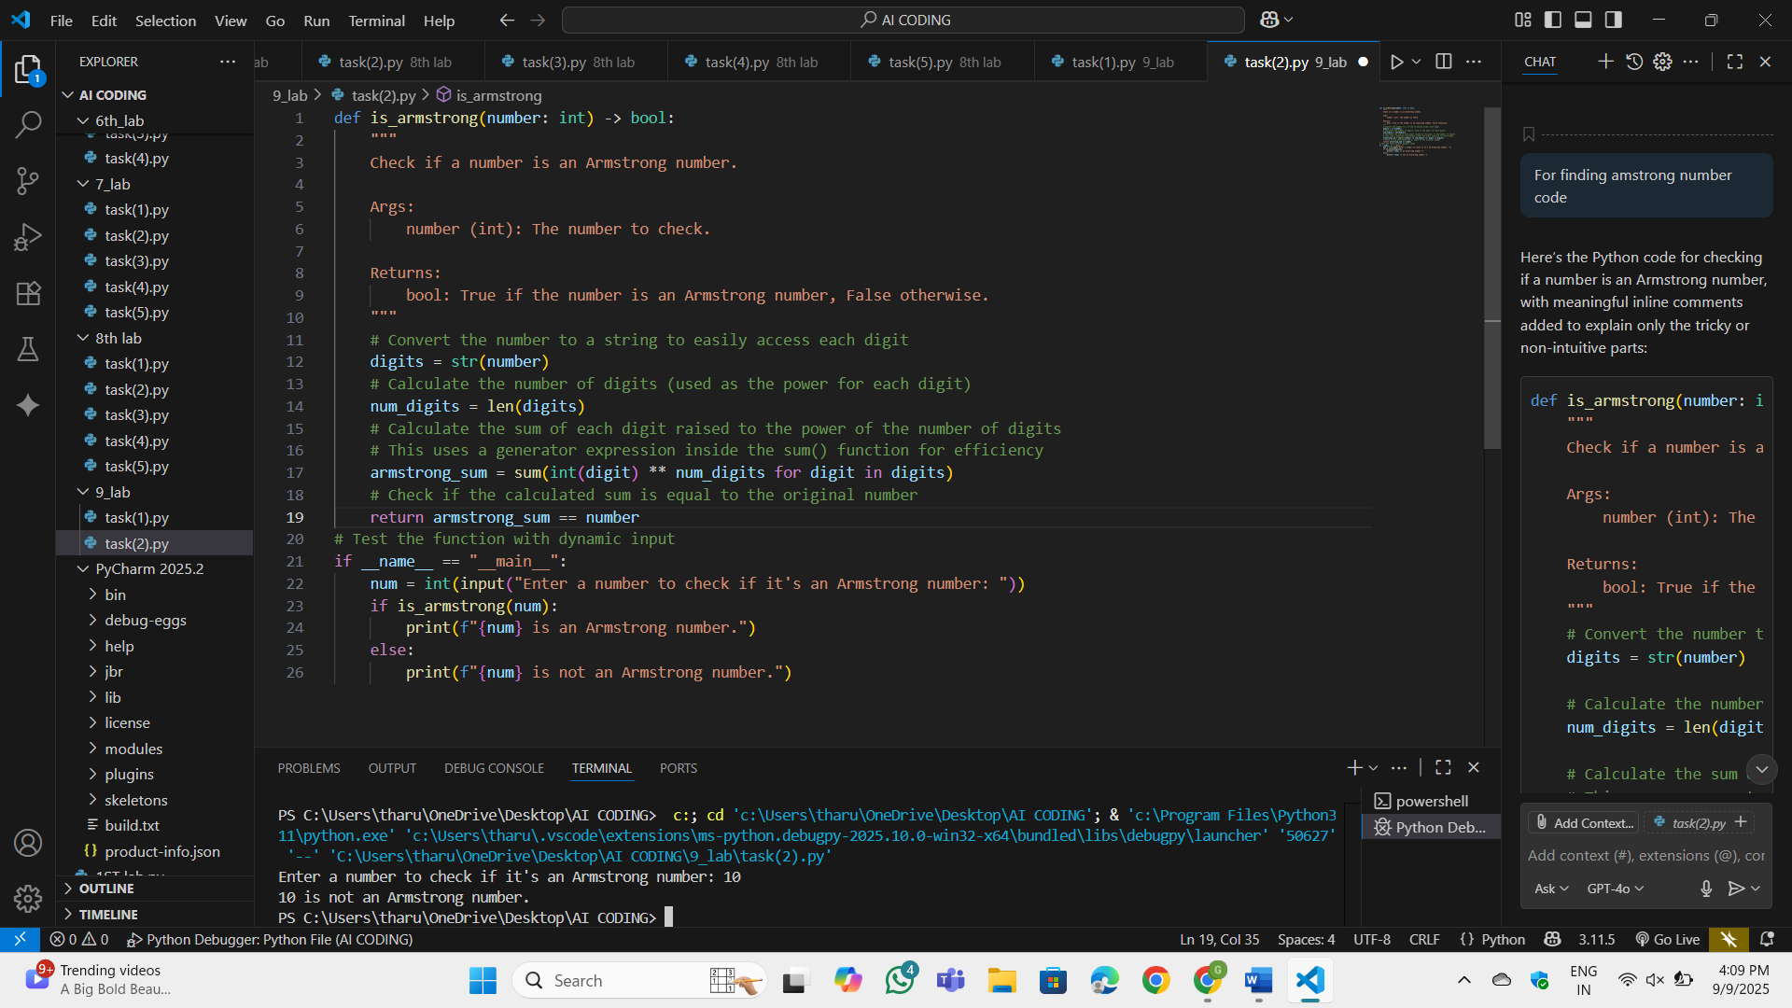
Observation:
digits = str(number): Converts the number to a string to allow iteration over its digits.num_digits = len(digits): Calculates the number of digits in the number, which determines the power to which each digit is raised.sum(int(digit) ** num_digits for digit in digits): Uses a generator expression to calculate the sum of each digit raised to the power of num_digits. This avoids creating an intermediate list, making the code more memory-efficient.return armstrong_sum == number: Compares the calculated sum to theoriginal number to determine if it’s an Armstrong number

Task-3:(Documentation – Module-Level Documentation)
• Task: Use AI to create a module-level docstring summarizing the
purpose, dependencies, and main functions/classes of a Python
file.
• Instructions:
o Supply the entire Python file to AI.
o Instruct AI to write a single multi-line docstring at the top
of the file.
o Ensure the docstring clearly describes functionality and
usage without rewriting the entire code
Prompt: for the given code describes functionality and
usage without rewriting the entire code
Code:
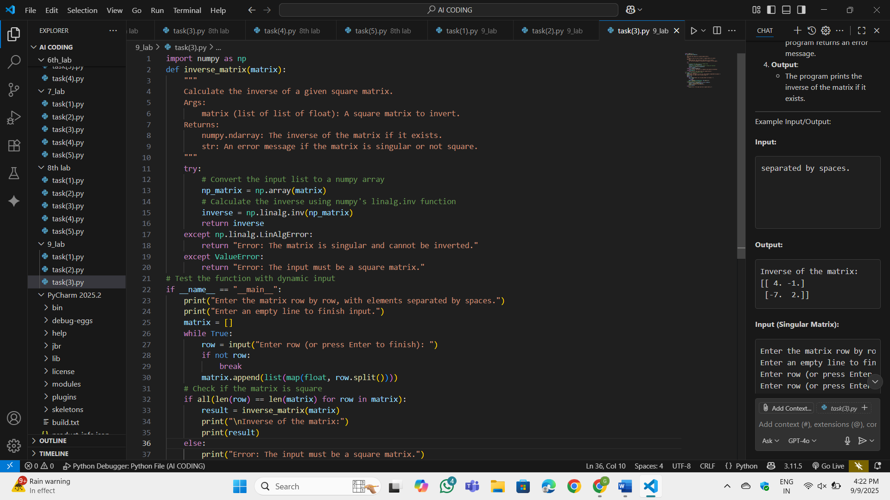
OP:
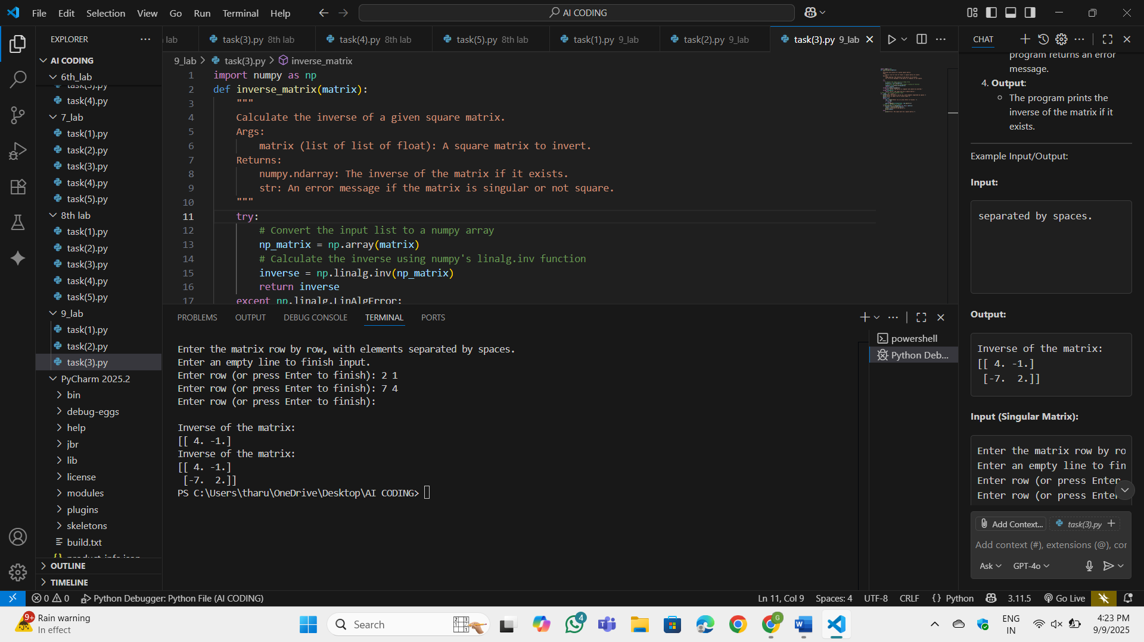
Observation:
The numpy library is used for matrix operations. The np.linalg.inv() function calculates the inverse of a matrix. The user inputs the matrix row by row. The input is converted into a list of lists, where each inner list represents a row. If the matrix is not square, the program returns an error message. If the matrix is singular (determinant = 0), the program returns an error message. The program prints the inverse of the matrix if it exists.
Task-4: (Documentation – Convert Comments to
Structured Docstrings)
• Task: Use AI to transform existing inline comments into
structured function docstrings following Google style.
• Instructions:
o Provide AI with Python code containing inline comments.
o Ask AI to move relevant details from comments into
function docstrings.
o Verify that the new docstrings keep the meaning intact
while improving structure.
• Expected Output #4:
o Python code with comments replaced by clear,
standardized docstrings
Prompt: convert Comments toStructured Docstrings for the code which I provided.
Code:
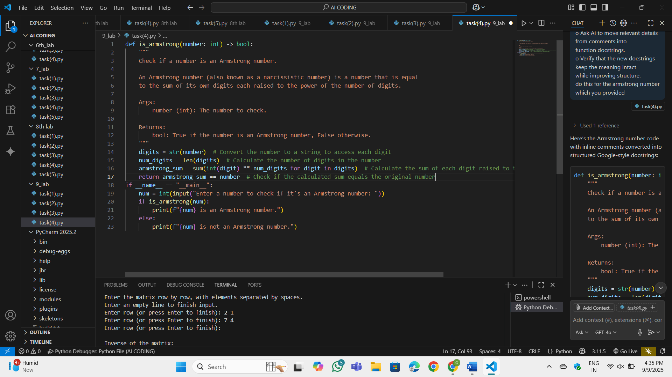
OP:
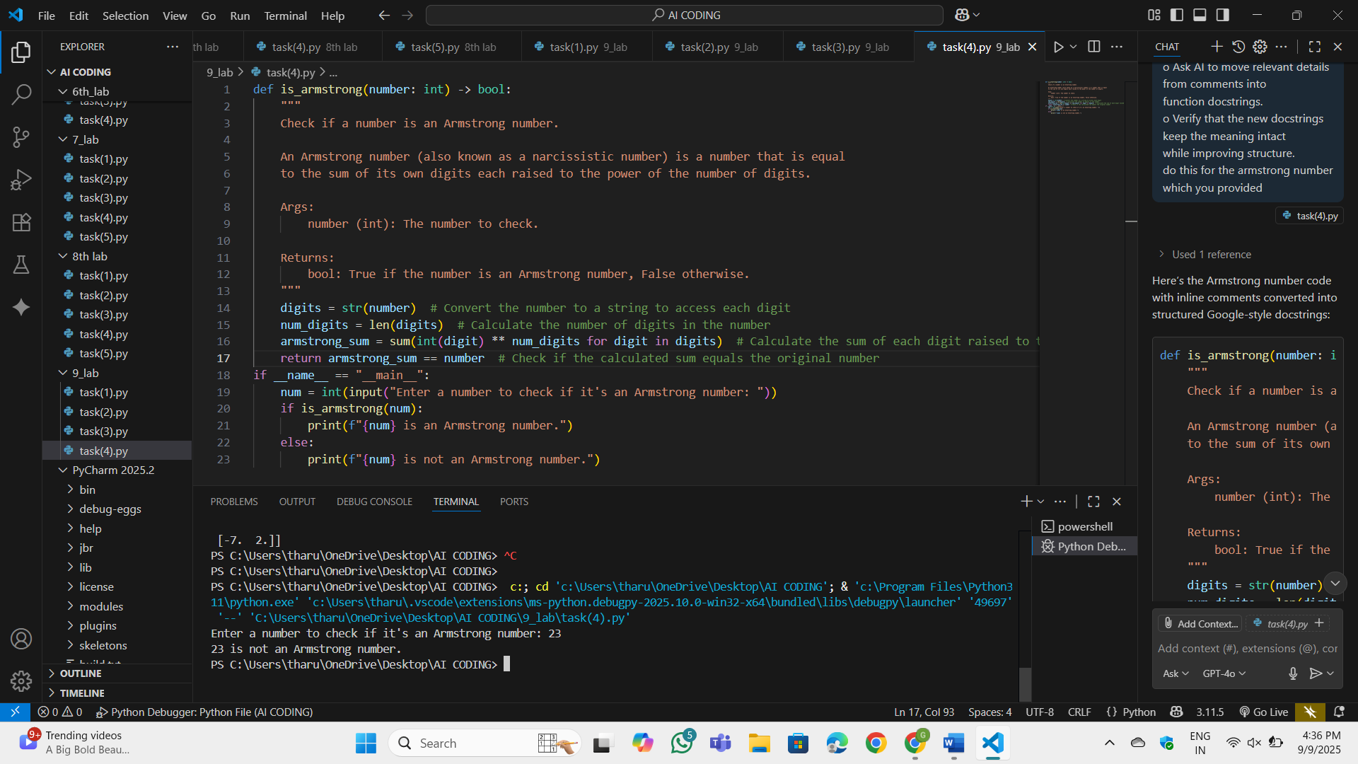
Observation:
Removed inline comments from the code. Added a detailed docstring to the is_armstrong function.The docstring explains:Purpose: What the function does.Args: The input parameter and its type.Returns: The return value and its type.Logic: A brief explanation of the Armstrong number concept.The docstring improves the structure and readability of the code while keeping the meaning intact
Task-5:(Documentation – Review and Correct
Docstrings)
• Task: Use AI to identify and correct inaccuracies in existing
docstrings.
• Instructions:
o Provide Python code with outdated or incorrect
docstrings.
o Instruct AI to rewrite each docstring to match the current
code behavior.
o Ensure corrections follow Google-style formatting.
• Expected Output #5:
o Python file with updated, accurate, and standardized
docstrings
Prompt:Identify and correct inaccuracies in existingdocstrings.
Code:
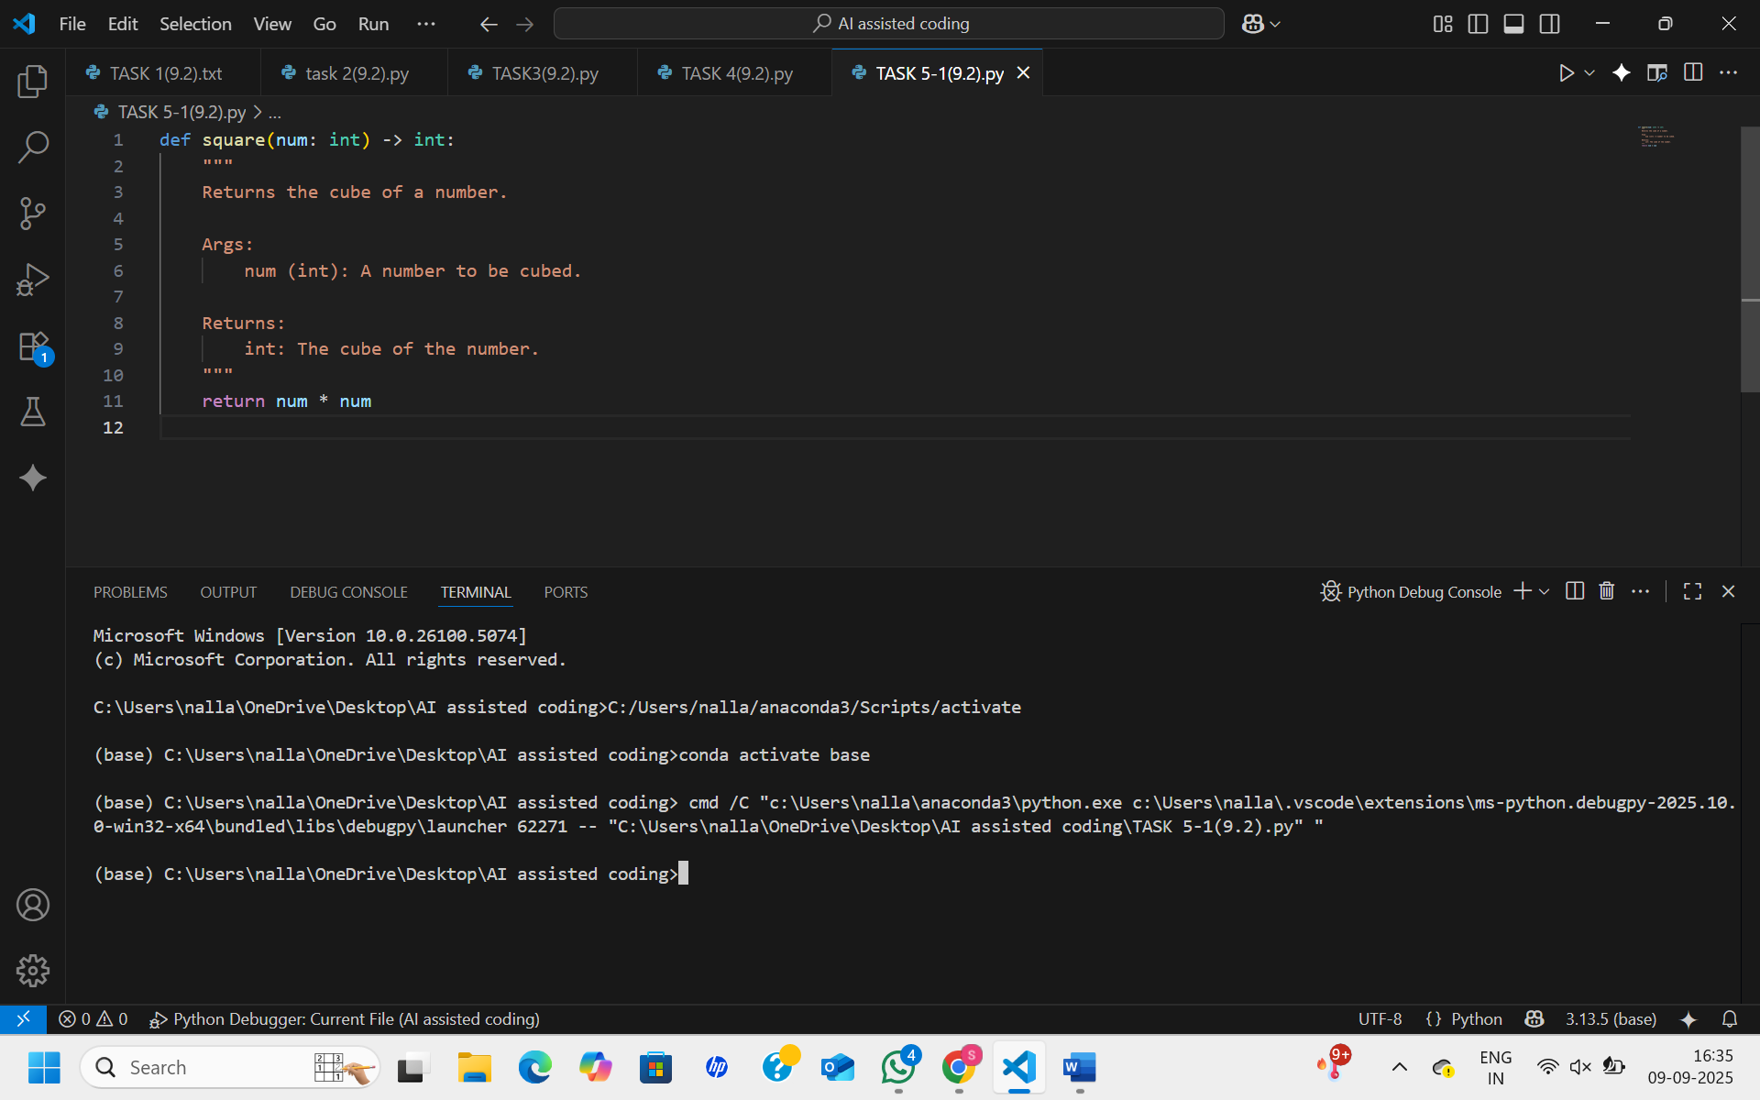
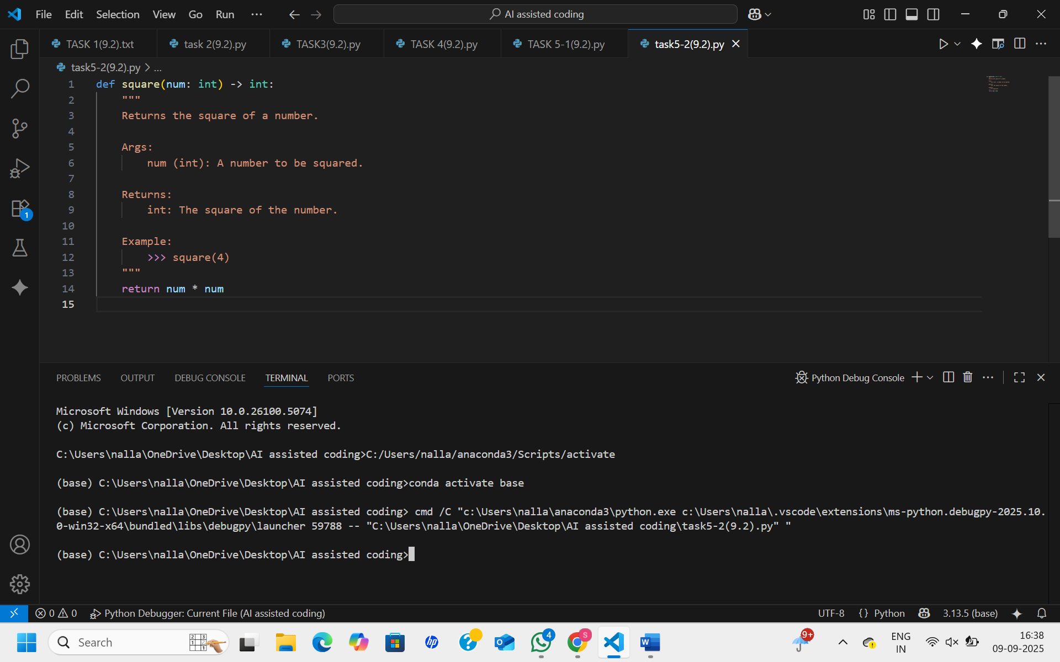
OP:

Observation:
The main issue is docstring drift—the code changes but the documentation doesn’t. Correcting the docstrings to Google style makes the functions clearer, accurate, and easier to maintain
Task-6:
(Documentation – Prompt Comparison
Experiment)
• Task: Compare documentation output from a vague prompt and a
detailed prompt for the same Python function.
• Instructions:
o Create two prompts: one simple (“Add comments to this
function”) and one detailed (“Add Google-style docstrings
with parameters, return types, and examples”).
o Use AI to process the same Python function with both
prompts.
o Analyze and record differences in quality, accuracy, and
completeness.
• Expected Output #6:
o A comparison table showing the results from both
prompts with observations
Prompt:Compare documentation output from a vague prompt and a
detailed prompt for the same Python function. Create two prompts: one simple (“Add comments to thisfunction”) and one detailed (“Add Google-style docstringswith parameters, return types, and examples”).
Code:
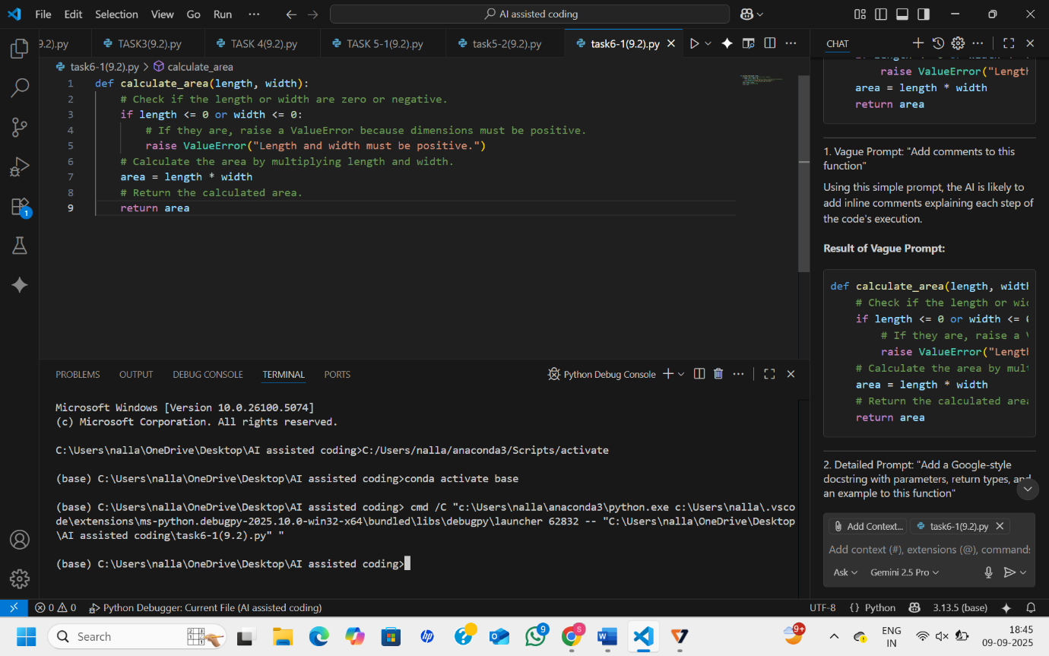
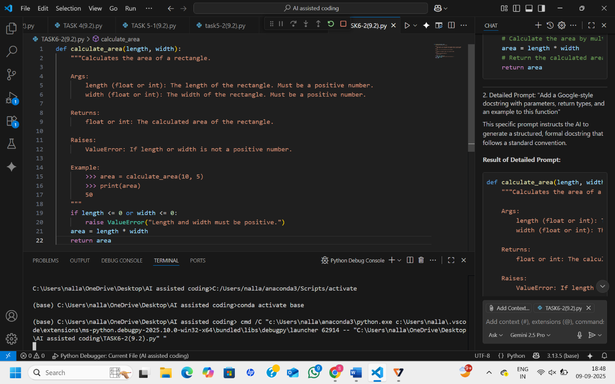
OP:
Observation:
A detailed and specific prompt yields a vastly superior documentation result. It moves beyond simple line-by-line explanations to create structured, comprehensive, and professional documentation that significantly improves code maintainability and usability.

