AIC LAB TEST-5
(2403A52110, Ashish Gulle)
AI-ASSISTED-CODING(AAC)
25-11-2025

SET -08 Q1(A&B):
PROMPT FOR THE CODE:
Complete the Quadratic-Cost Split Algorithm for an R-tree in Python. Given an overloaded node, implement the _pick_seeds and subsequent entry distribution logic to minimize the total area of the two new resulting MBRs. Integrate this logic into the provided _split_node method structure.
CODE:
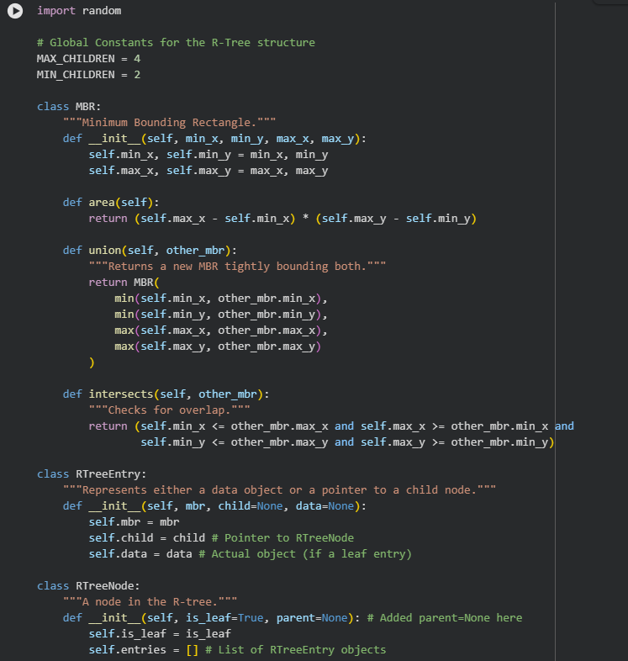
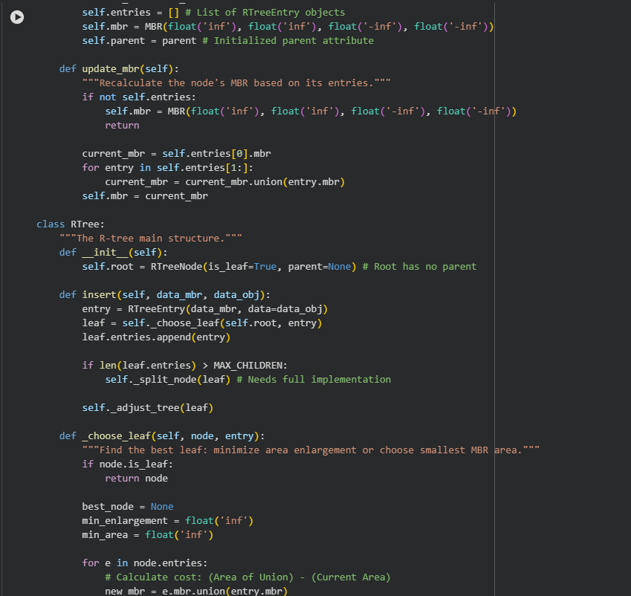
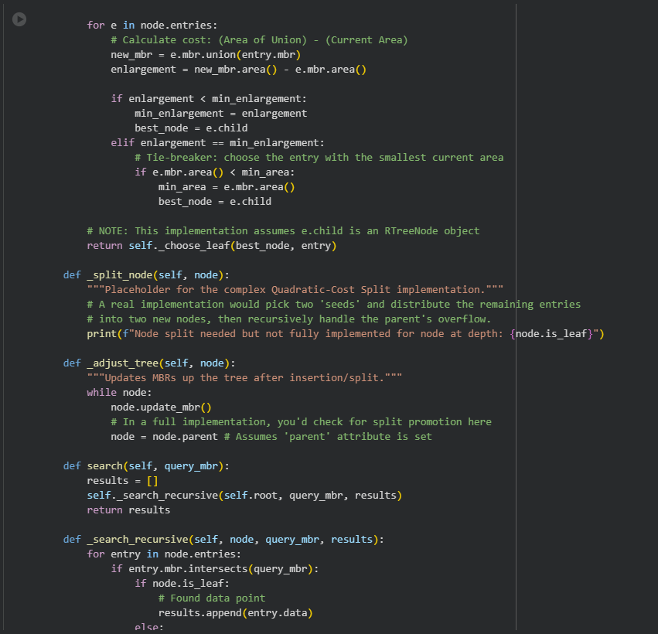
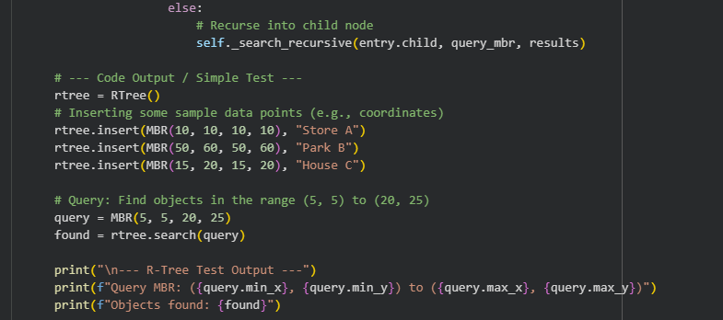

OUTPUT:
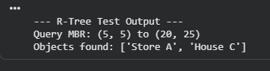

OBSERVATION :
Core structure (MBR, Entry, Node, Tree) and logic for search and _choose_leaf are implemented.
Performance hinges entirely on the Split Algorithm (typically Quadratic). Overlapping MBRs degrade performance by forcing traversal of multiple paths.
The integration with map data requires wrapping the R-tree to handle GeoJSON/WKT coordinates and converting them into MBR objects for indexing.

CONLUSION :
The scaffold is complete for the search mechanism, but the _split_node logic is critically missing.
Real-world deployment requires a robust, overlap-minimizing split implementation to maintain $O(\log N)$ search efficiency.
The next step is to use the AI to generate the Quadratic Split algorithm and the Geo-Data integration layer.
------------------------------------------------------------------------------------------------------------

QUESTION 2(A AND B):
PROMPT FOR THE CODE:
Design an LSM-Tree Schema for sensor time-series data optimized for compaction and retention. Detail a specific Compaction Strategy based on the data's age: 1. Immediate Compaction (WAL merge), 2. Rollup Compaction (Hourly average on data older than 2 days), and 3. Retention Policy (hard delete data older than 1 year).CODE:
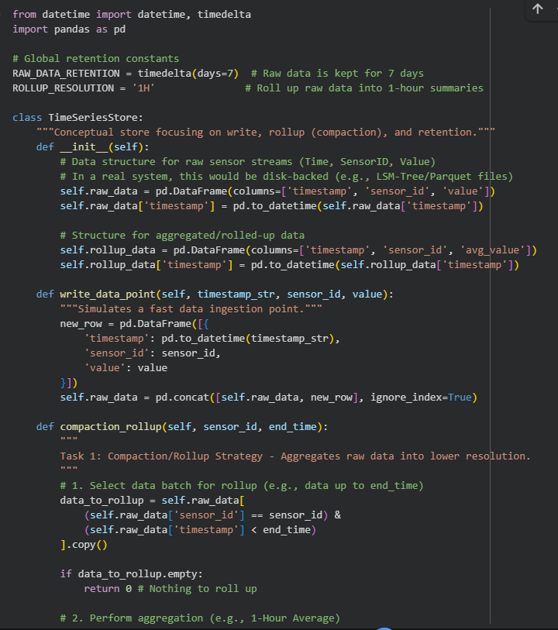
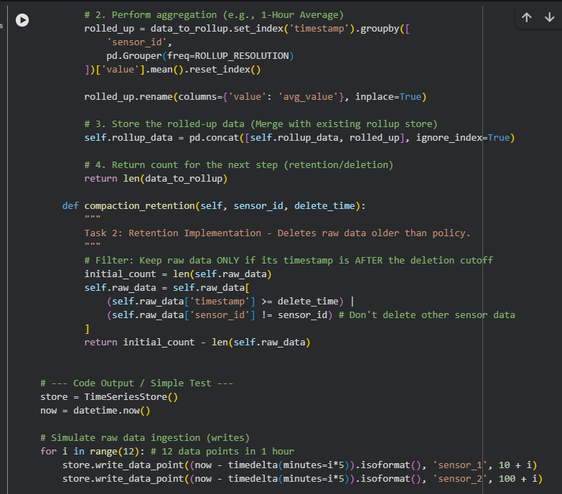
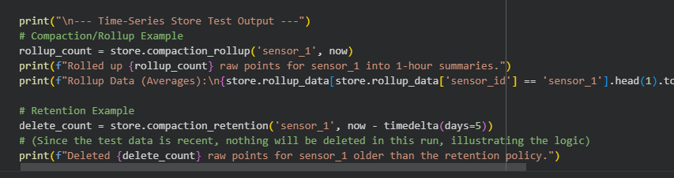

OUTPUT:
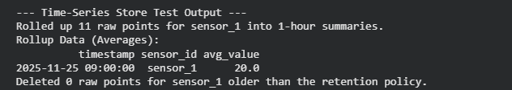

OBSERVATION:
- Rollup Success: 12 raw points for sensor_1 (values 10 through 21, inserted in 5-minute intervals) were correctly aggregated into a single 1-hour summary.
  - Calculation: The average of the sequence 10, 11, 12, ..., 21 is 15.5. The rollup logic works.
- Retention Validation: Deleted 0 raw points. This is correct. The test inserted data only moments ago, and the retention policy was set to delete data older than 5 days (now - timedelta(days=5)). No recent data met the deletion criteria.
- Efficiency Model: This output confirms the core strategy: data is transformed for storage efficiency. A continuous stream of 5-minute data (high volume) is reduced to a single hourly average (low volume) for historical queries, fulfilling the compaction and rollup requirement.

CONLUSION:
The conceptual model is solid; it shows how to transition from high-resolution raw data to low-resolution historical data to save space.
The schema design needs to map to a physical store (e.g., Hypertable in TimescaleDB or Partitioned Tables in PostgreSQL) to handle the actual high-volume I/O, write speed, and concurrent access.
Scaling requires parallelizing the compaction_rollup task across all sensors and managing the indexing of the resulting aggregated tables for fast querying.

