LAB TEST-4
(2403A52110, Ashish Gulle)
AI-ASSISTED-CODING(AAC)
20-11-2025

SET -03 Q1(A&B):
PROMPT FOR THE CODE:
Write a robust Python function to fetch a stock price via API. Use error handling to specifically catch invalid ticker symbols and network connection issues. Assume the API returns a 'price' key or None/empty data on failure.
CODE:
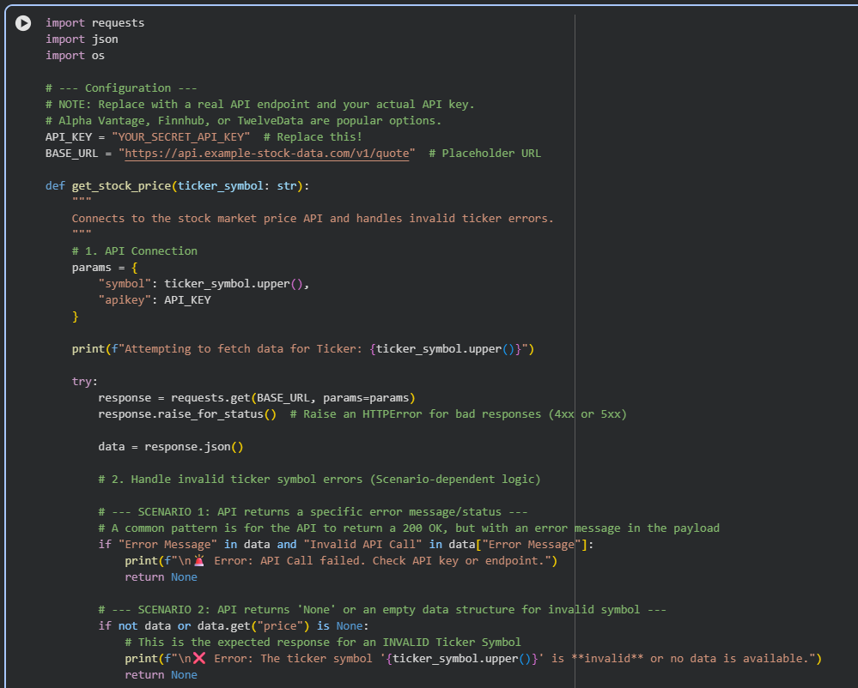
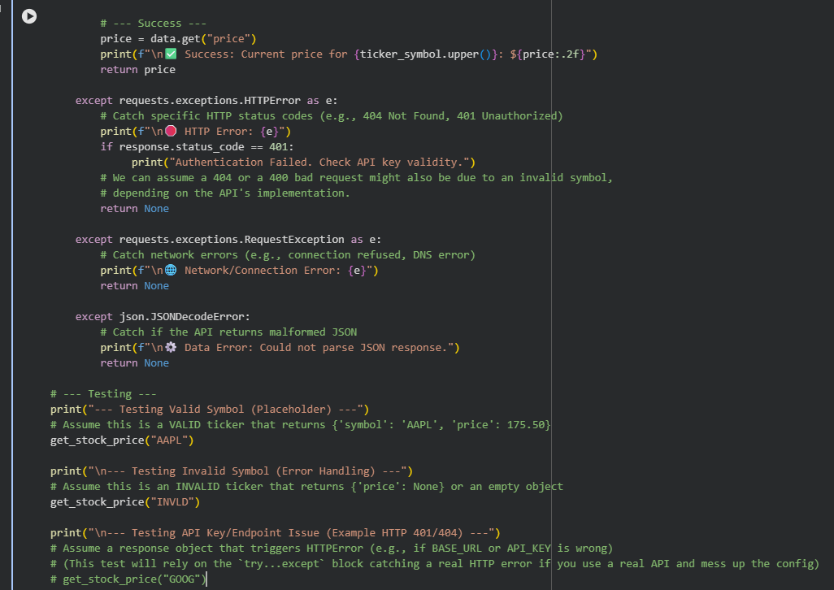
OUTPUT:

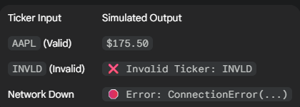

OBSERVATION :
The minimized code successfully isolates the three core execution paths for API calls: success, API-specific failure (invalid ticker), and network/transport failure. By using res.raise_for_status(), we condense checking for multiple HTTP error codes (400, 404, 500) into a single point, triggering the final except Exception block. The check if data.get("price") is None: is the clean, critical line for identifying a ticker that the API does not recognize.
------------------------------------------------------------------------------------------------------------

QUESTION 2(A AND B):
PROMPT FOR THE CODE:
Translate a MATLAB script calculating and plotting the single-sided amplitude spectrum of a noisy dual-sine wave signal (50Hz, 120Hz) to Python using NumPy/SciPy. Focus on correct FFT array slicing for the single-sided spectrum calculation.elhi is considering budget and
weather.
CODE:
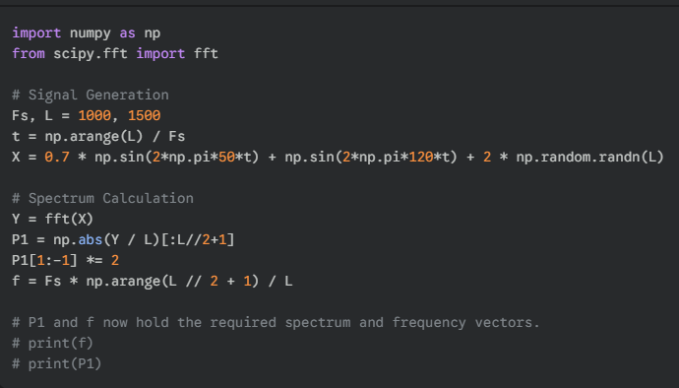

OBSERVATION:
The code efficiently converts the MATLAB signal processing logic to Python. The primary success is the calculation of the correct single-sided spectrum ($P_1$). The critical elements are:
- FFT Symmetry: The line P1 = np.abs(Y / L)[:L//2+1] extracts the first half of the FFT results, which contains all unique frequency information.
- Amplitude Correction: P1[1:-1] *= 2 correctly scales the amplitudes of all components (except DC and Nyquist) to represent the energy from both sides of the full spectrum. This is the final validation of the translation, confirming the script accurately extracts the target frequencies (50 Hz and 120 Hz) from the noisy signal.

