Here is the Screenshots of all my api’s for the shoppyGlobe backend tested on thunder client  
  
User API's :

1. /register (POST) : To register a new user.

Screenshot (from thunderClient) :  
  
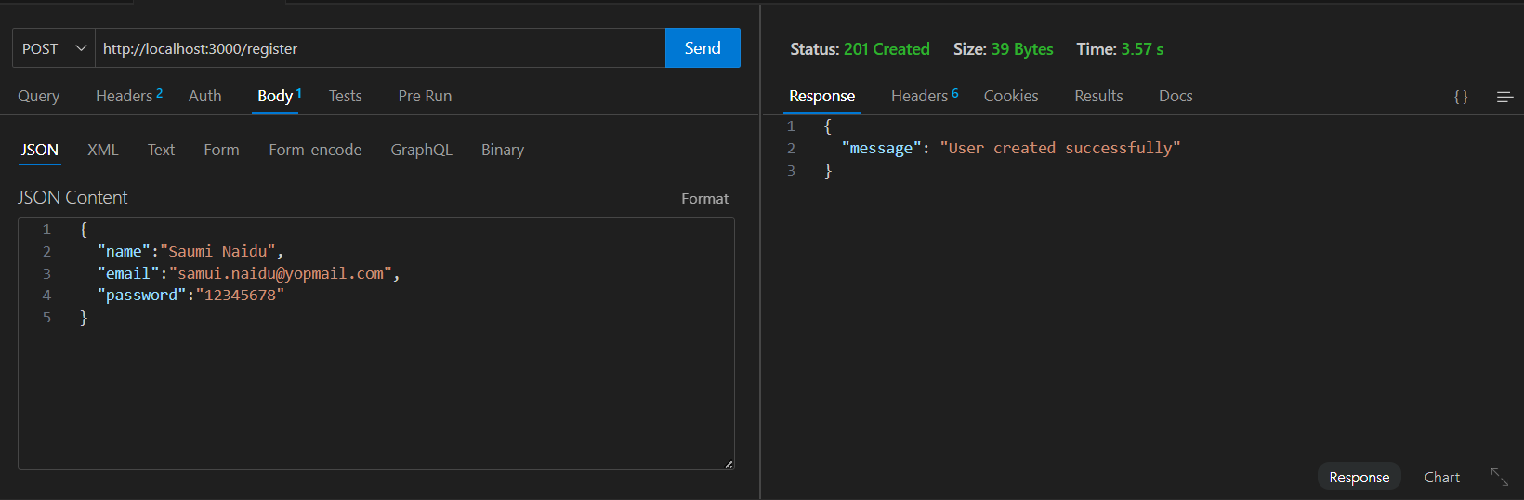

Screenshot (from MongoDB) :

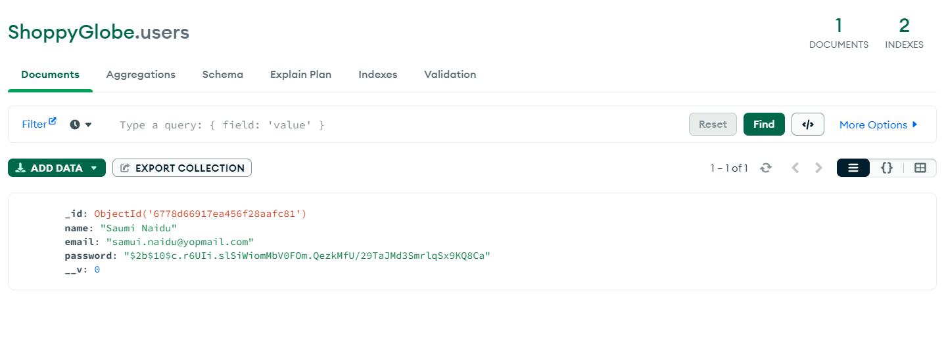

2) /login (POST) : To login the user.

Screenshot (from thunderClient) :

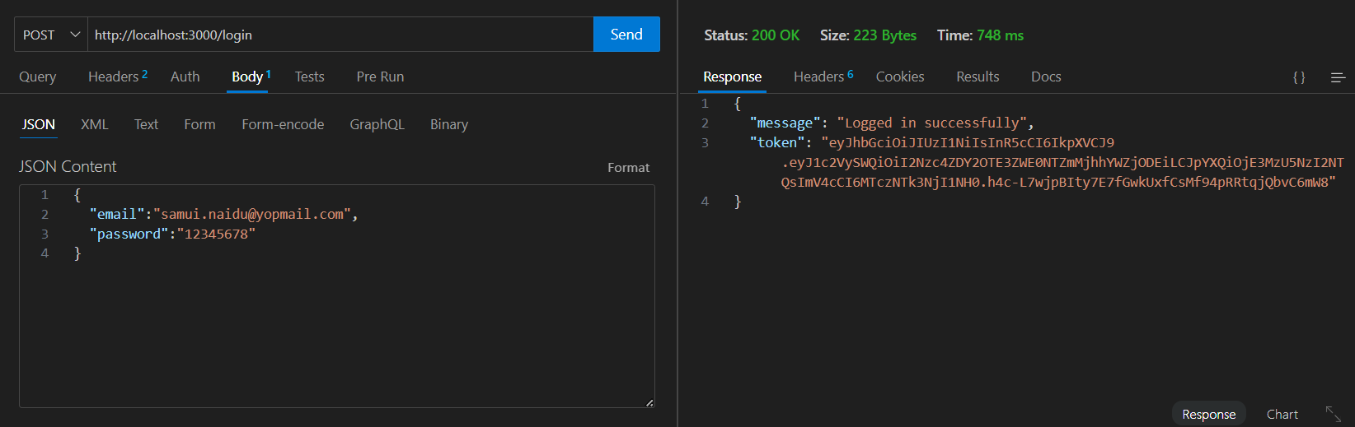

Screenshot (from mongoDB) : refer the mongoDB image it the register user API.

Product API's :

1. /products (GET) : Fetch the list of products from MongoDB.

Screenshot (from thunderClient) :

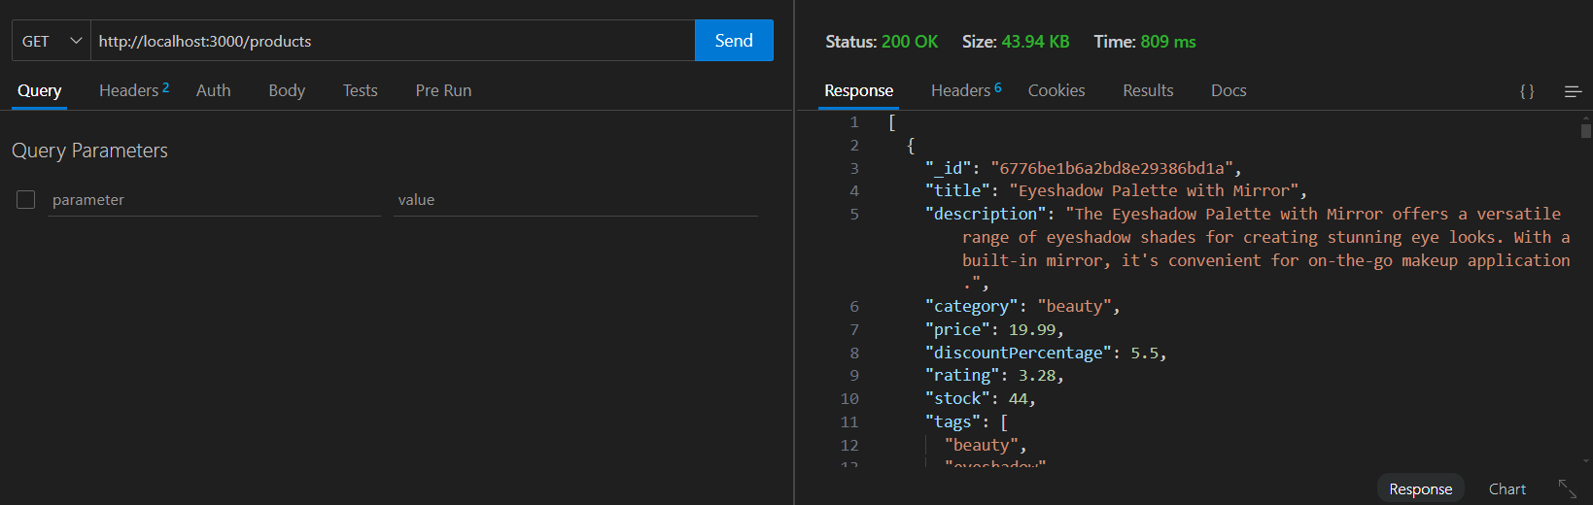

Screenshot (from MongoDB) :  
  
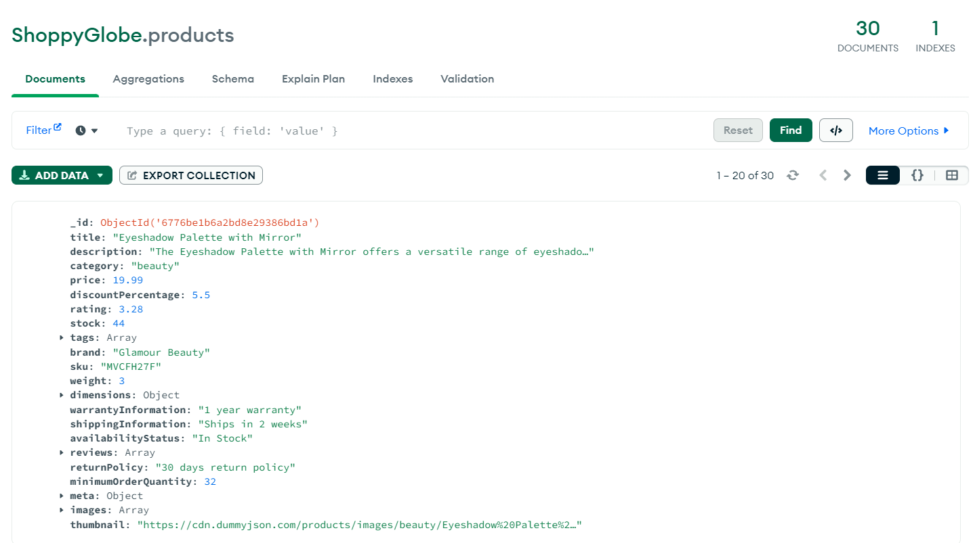

1. /product/:id (DELETE) : Delete a specific product using product id.

Screenshot (from thunderClient) :   
  
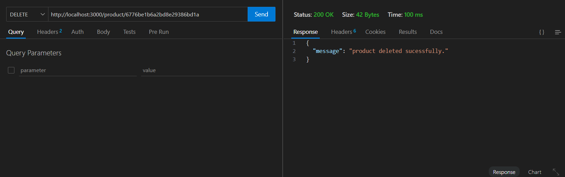

Screenshot (from mongoDB) :

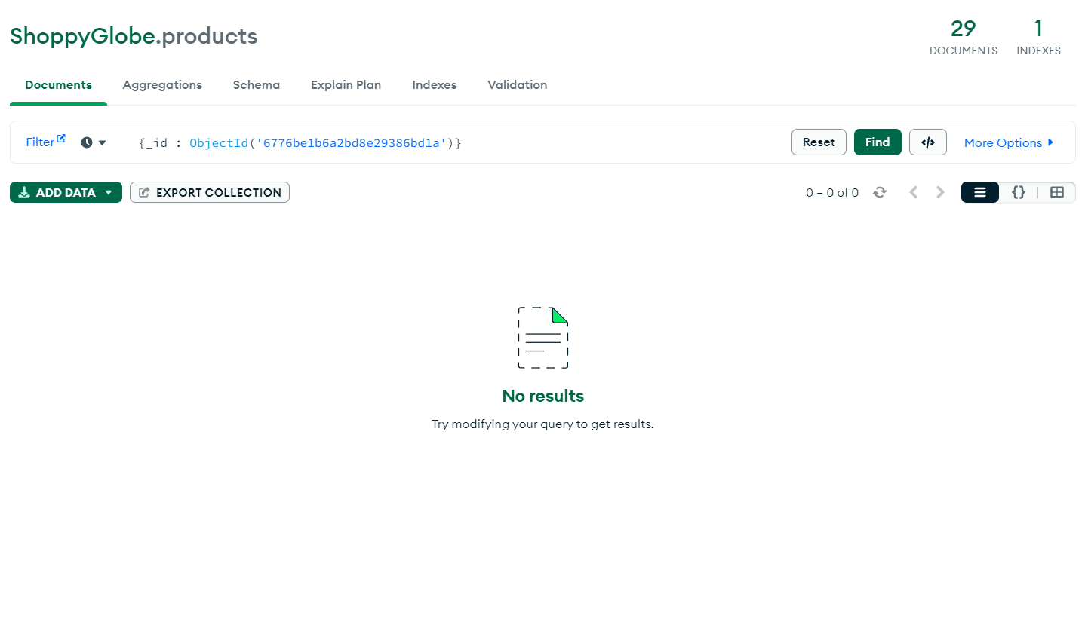

1. /product/:id (PUT) : Update a specific product using product id.

Screenshot (from thunderClient):

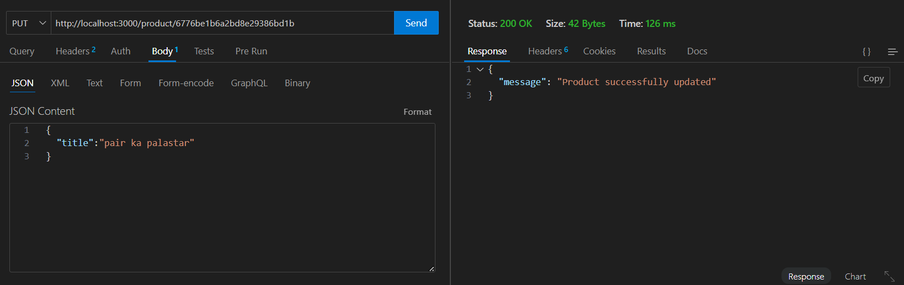

Screenhot (from mongoDB) :   
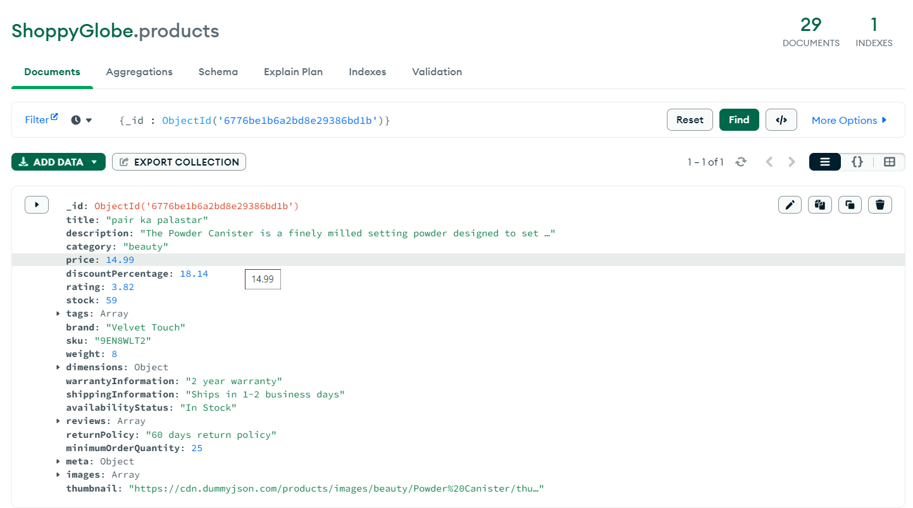

1. /product (POST) : Create a new product.

Screenshot (from thunderClient) :

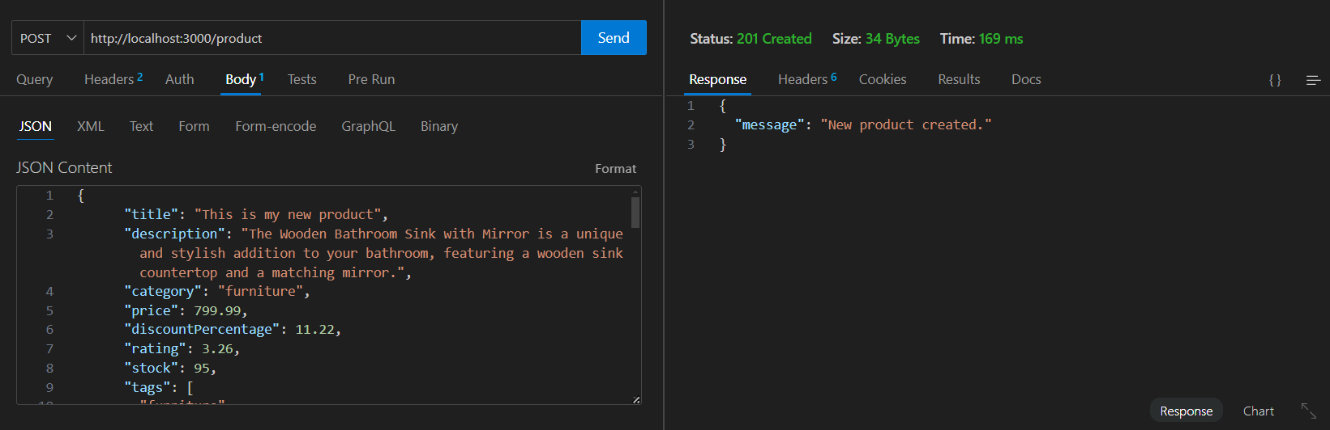

ScreenShot (from mongoDB) :  
  
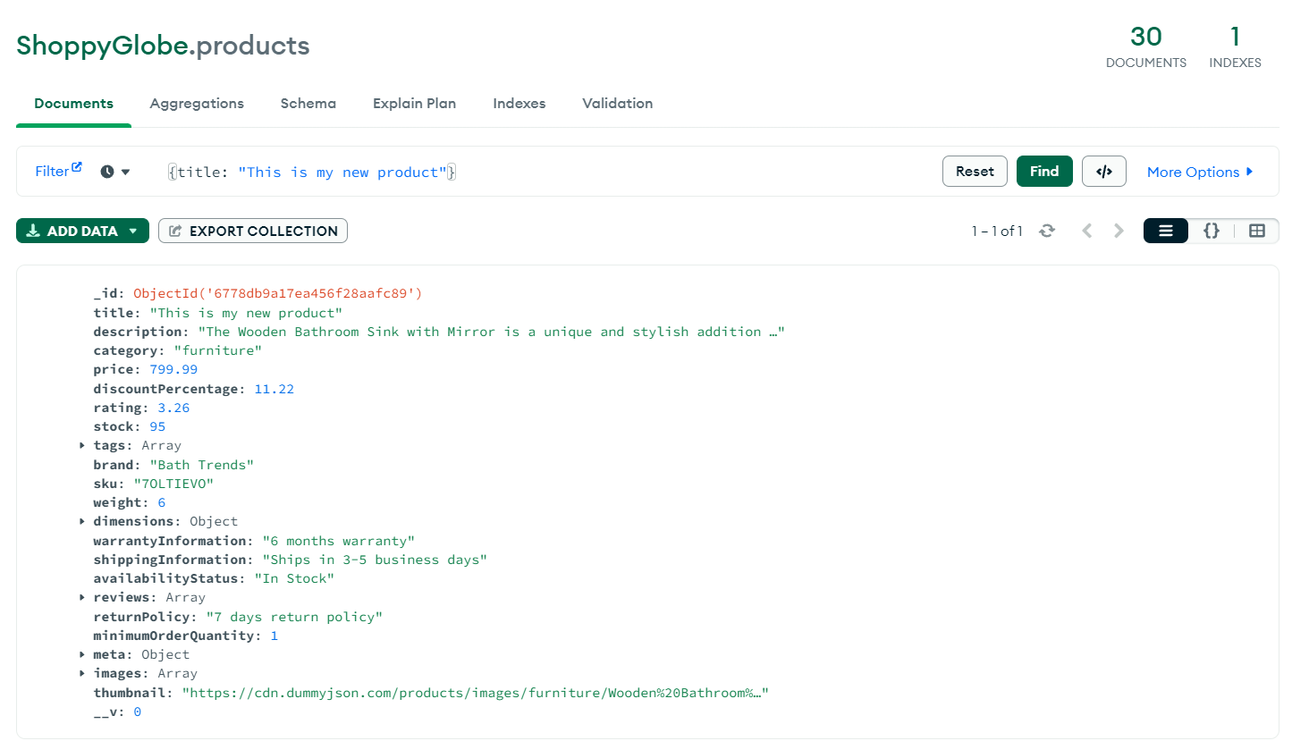

1. /products/:id (GET) : Fetch a specific product using product id.

Screenshot (from thunderClient) :  
  
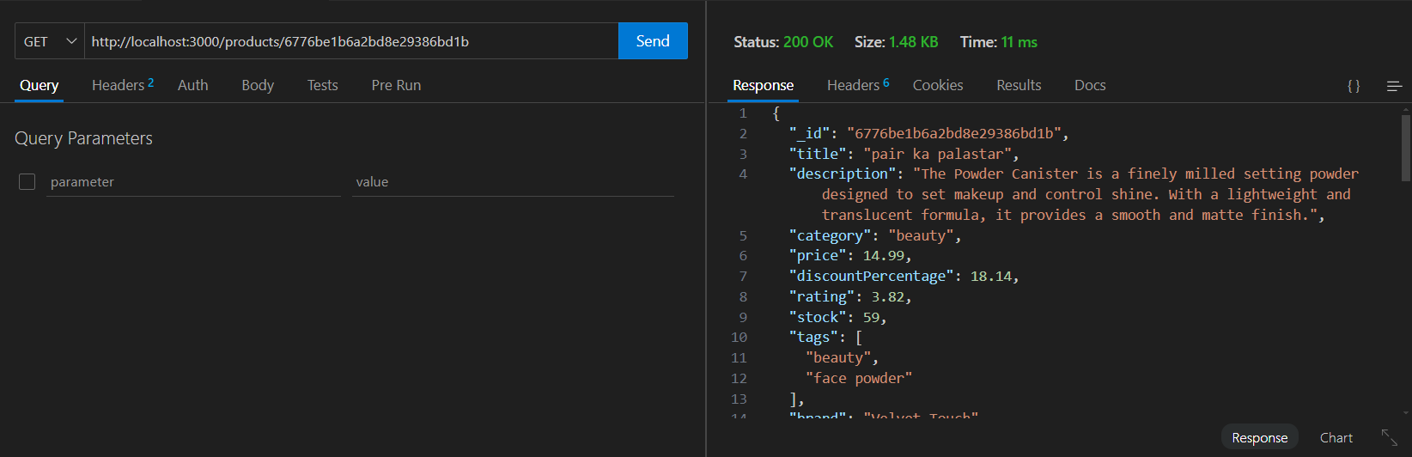

Screenshot (from the mongoDB) :

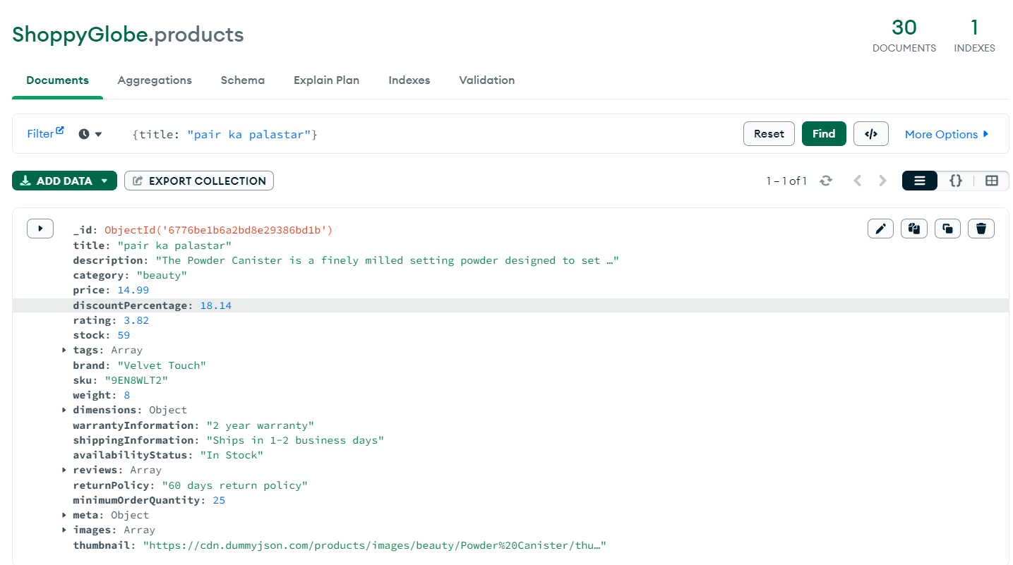

Cart API's :

1. /cart/:id (PUT) : update the quantity of the product in the cart.

Screenshot(from thunderClient) :

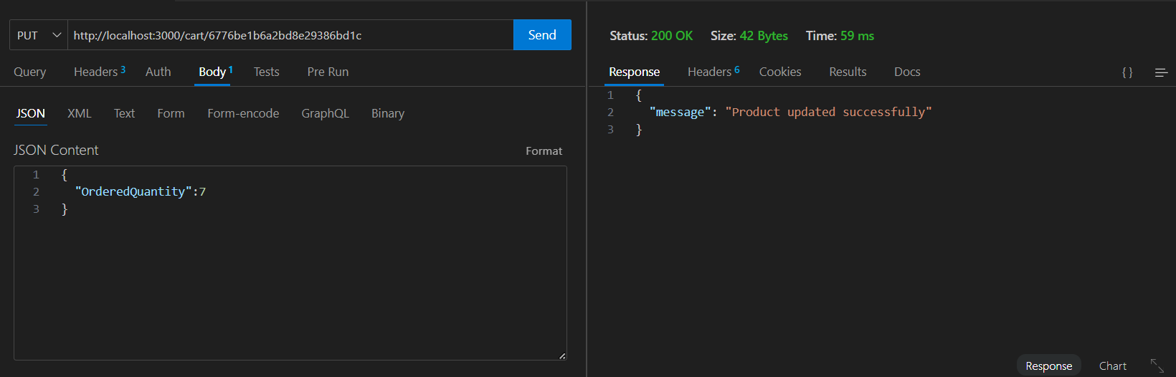

Screenshot (from MongoDB) :

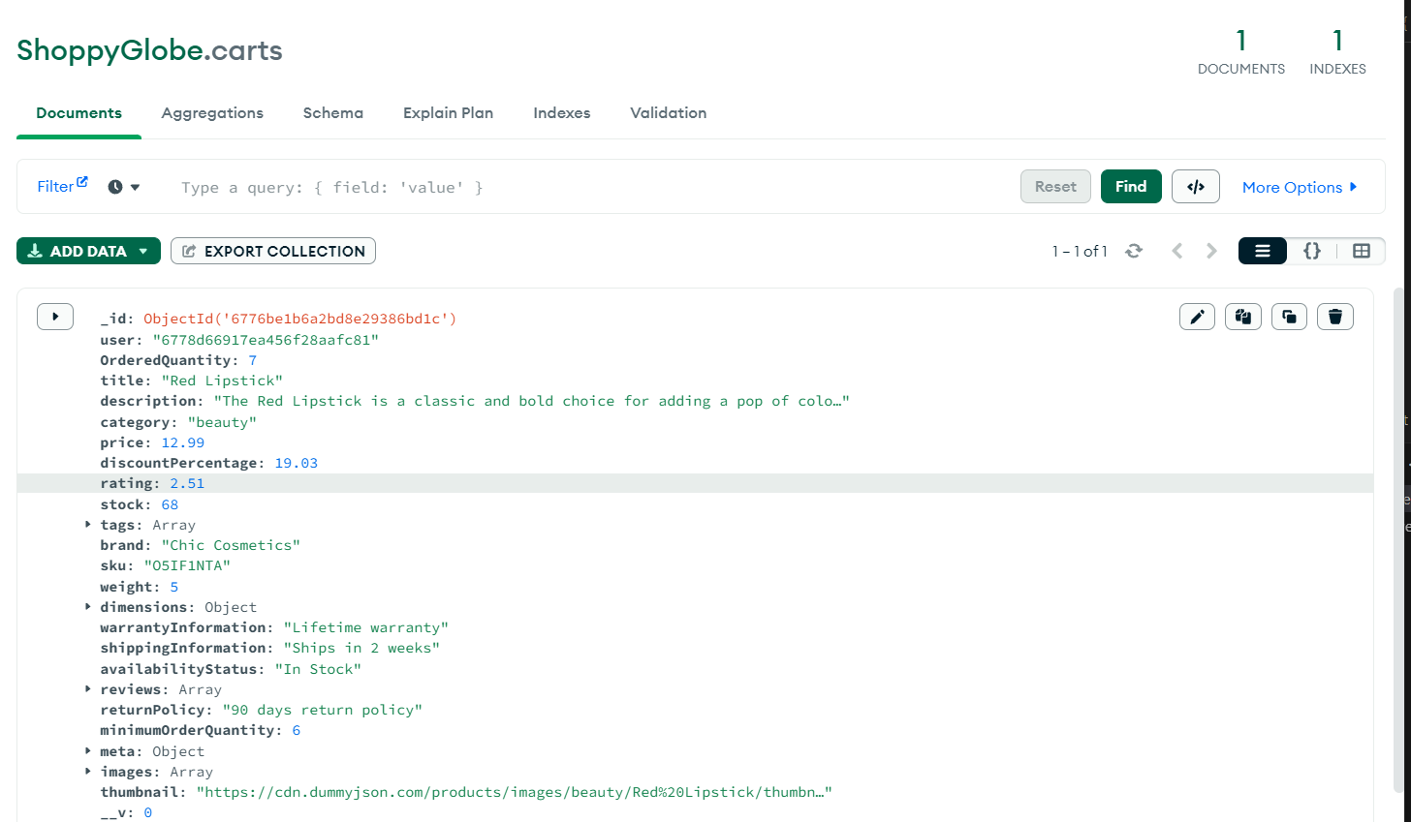

1. /cart (POST) : add a product to the cart.

Screenshot(from thunderClient) :

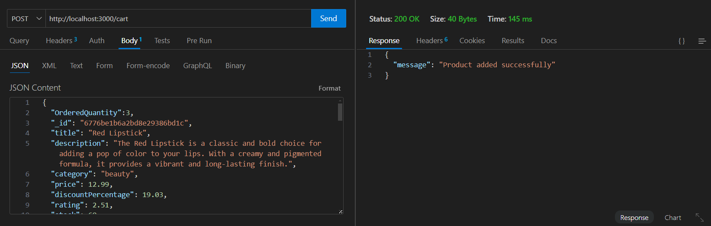

Screenshot (from MongoDB) :

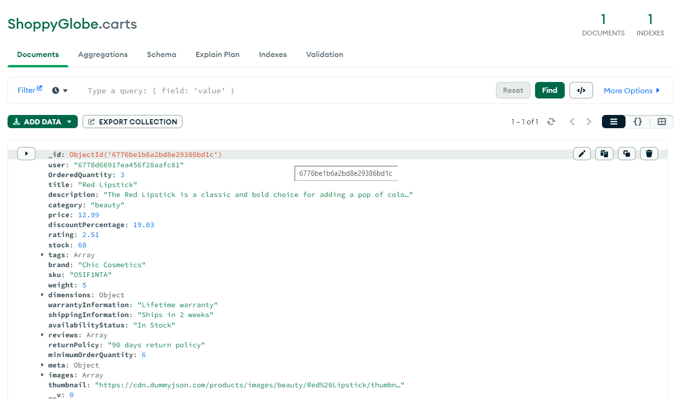

1. /cart (GET) : get all the prorducts from the cart.

Screenshot(from thunderClient) :

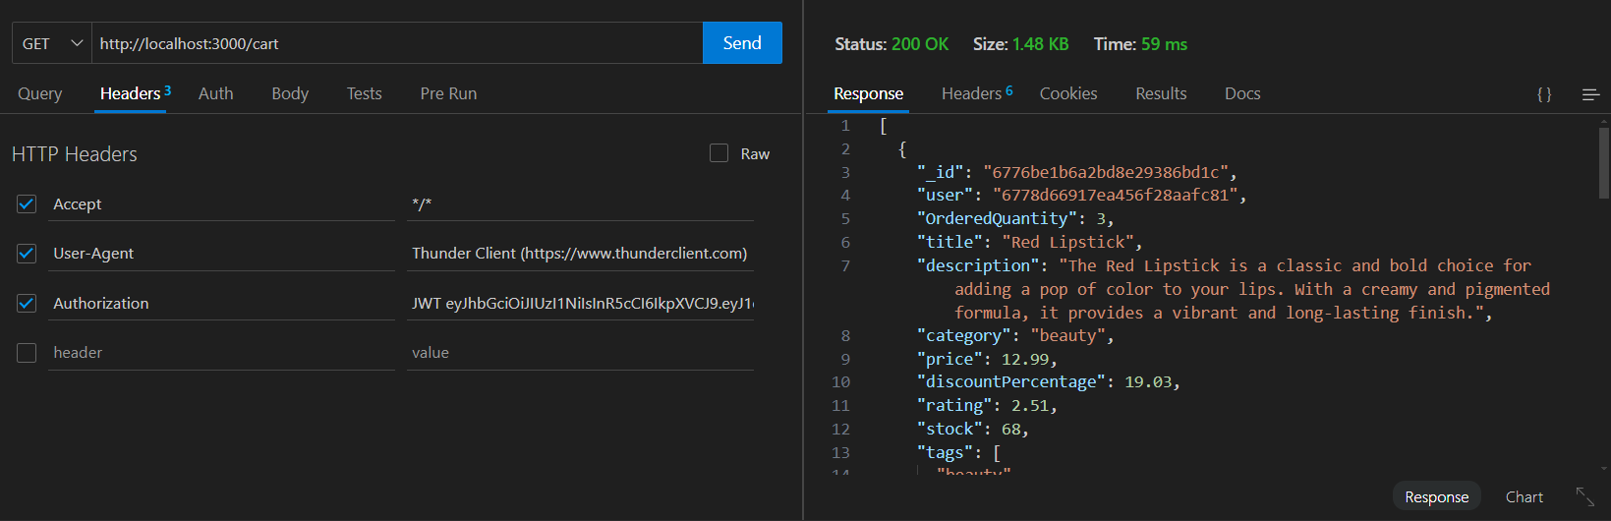

Screenshot (from MongoDB) :

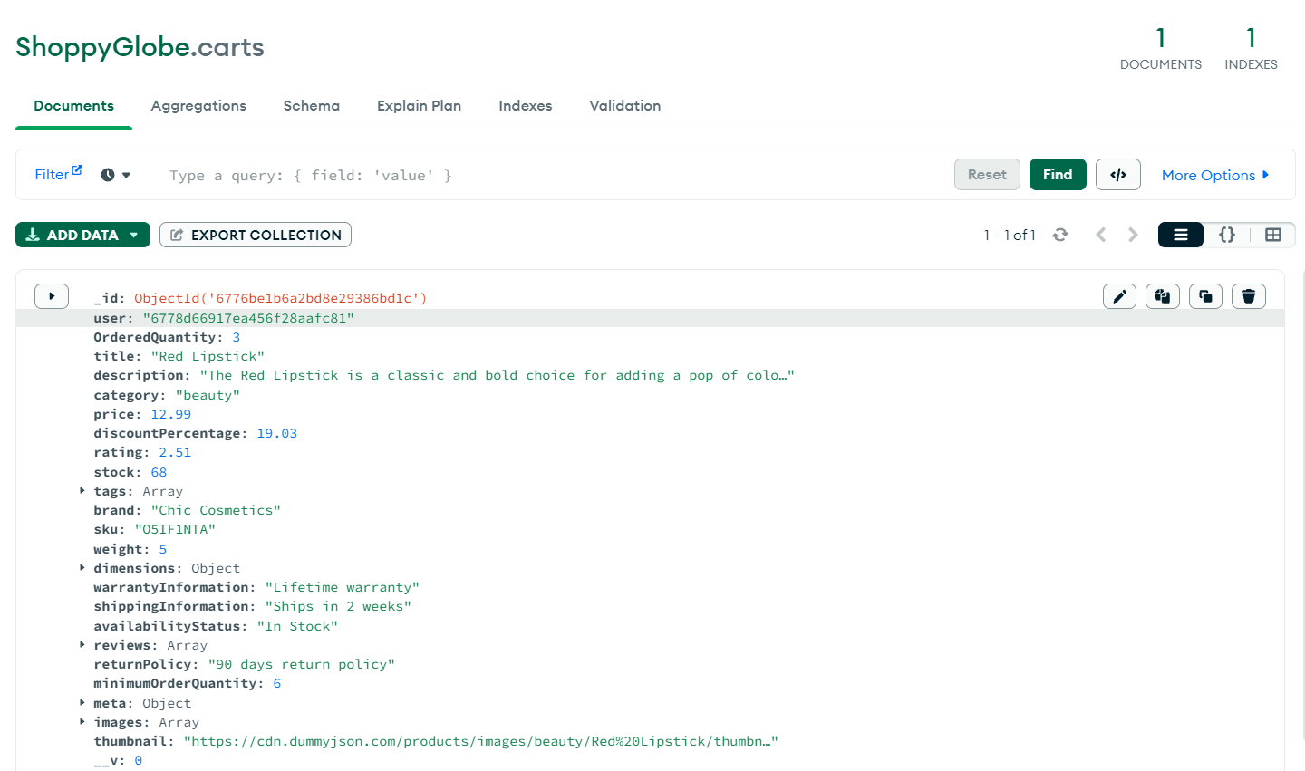

1. /cart/:id (DELETE) : delete a specific product from the cart.

Screenshot(from thunderClient) :

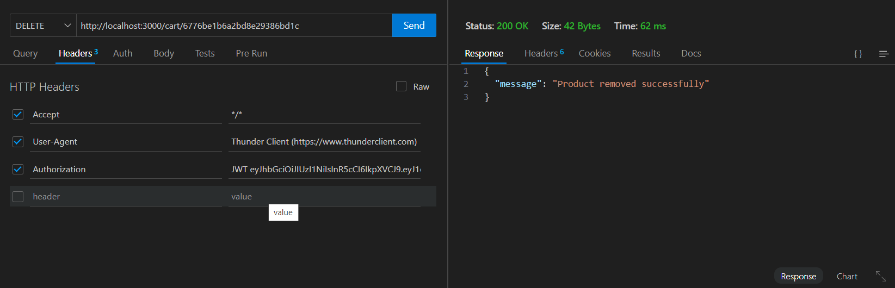

Screenshot (from MongoDB) :

