RESTful API with MongoDB using Node.js and Express  
  
1)Initiallly there is no data in the database.  
API screenshot :  
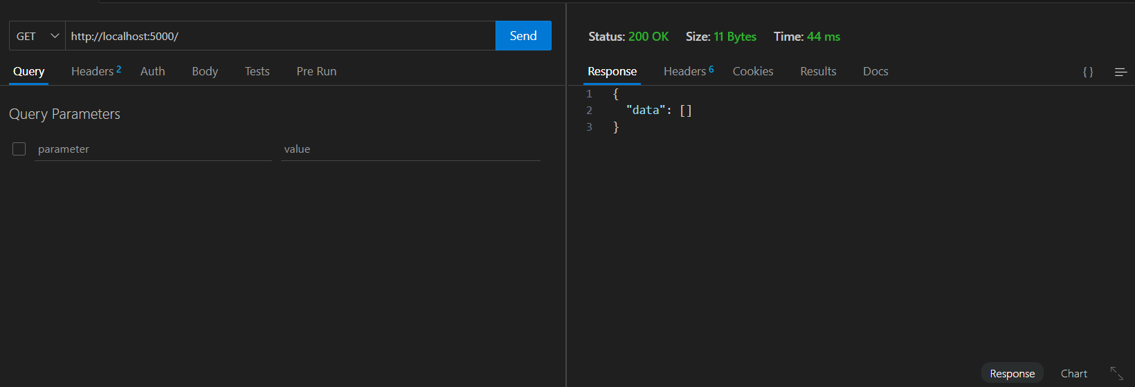

MongoDB compass Screenshot :   
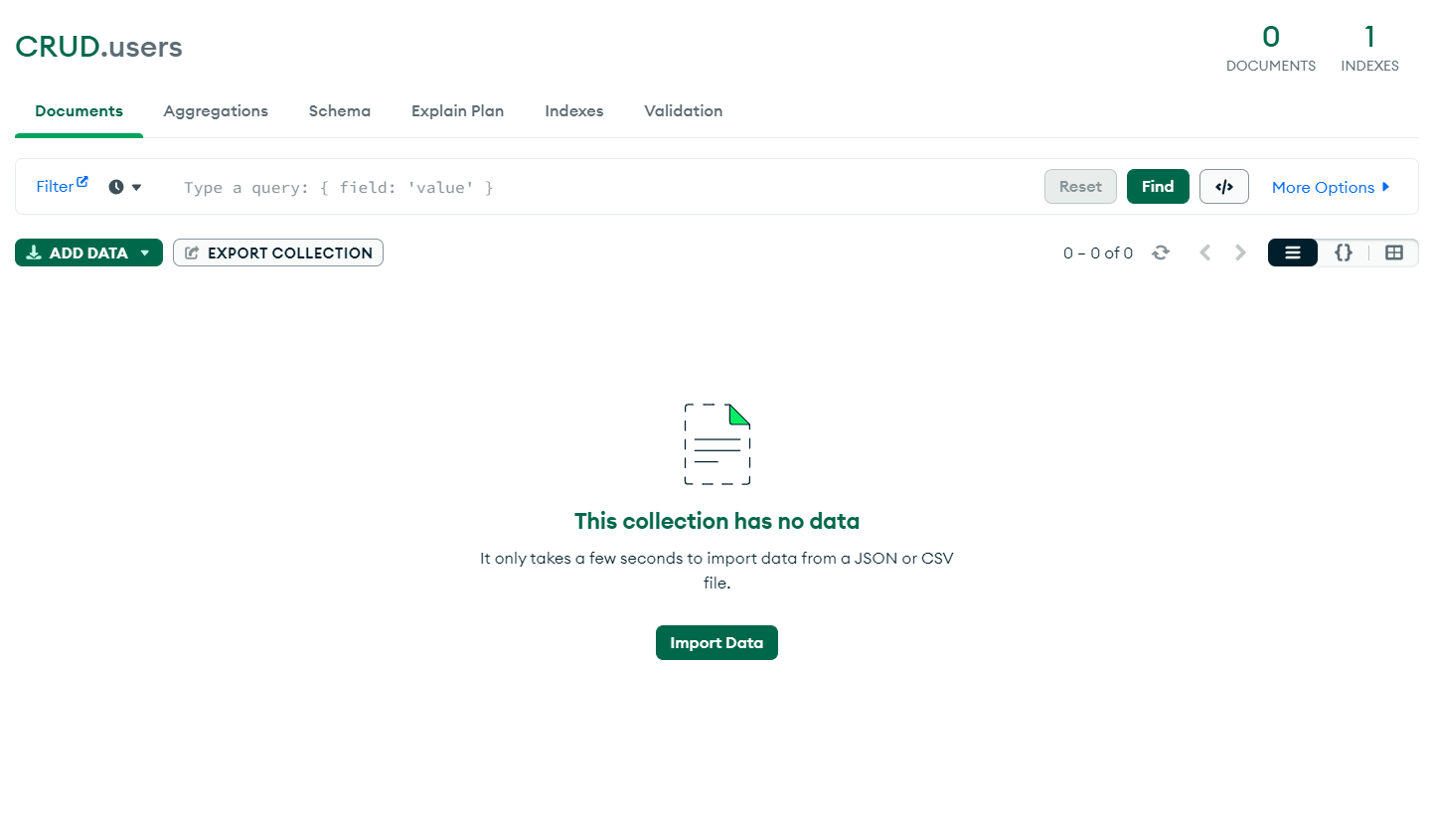

2)Let’s add some data:  
API Screenshot :  
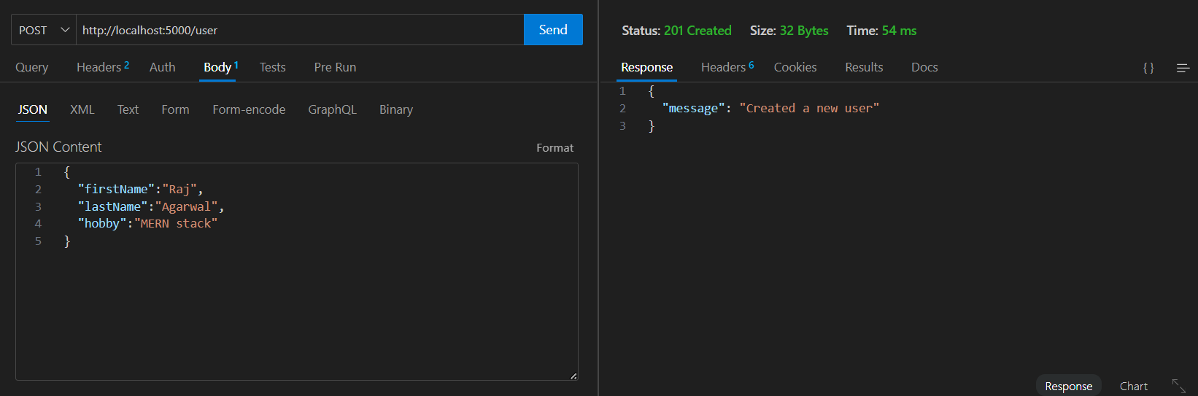

MongoDB Compass screenshot:  
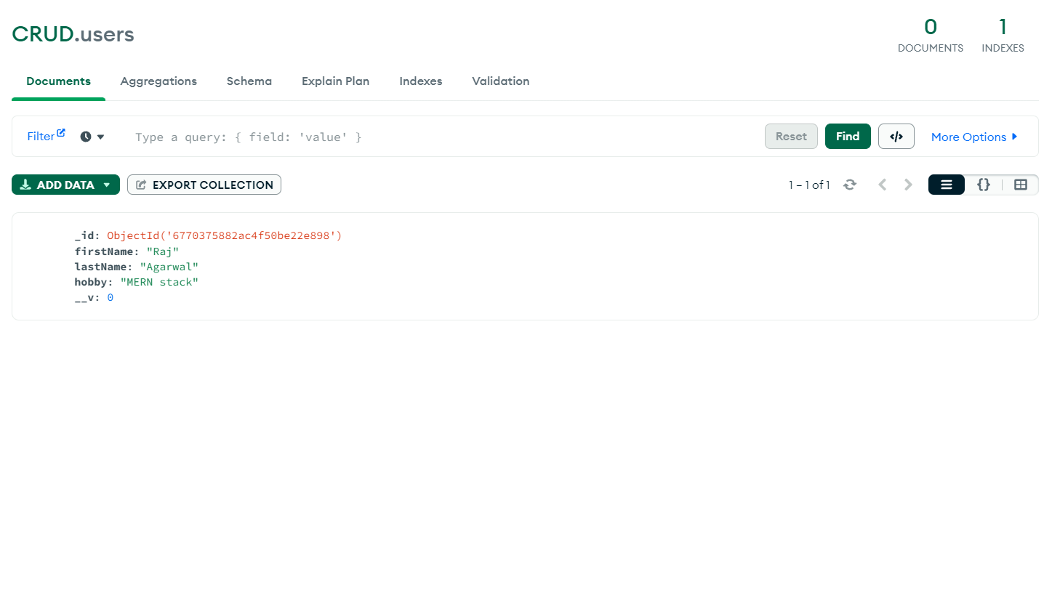

1. Let’s see our all of the data:  
   API Screenshot :  
   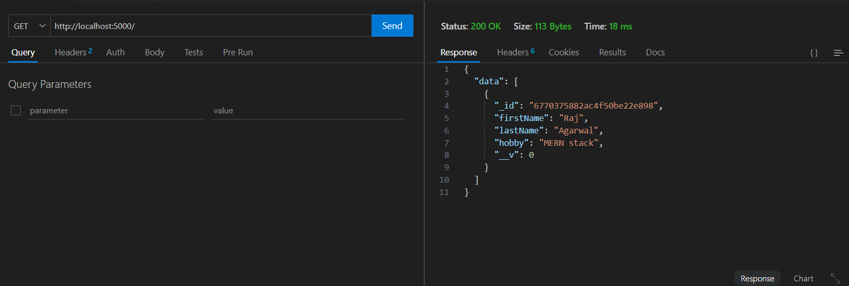
2. Let’s add some more data, then look for a specific user through object if and then see all the users at once.  
   I)Add some more users  
   API Screenshot:  
   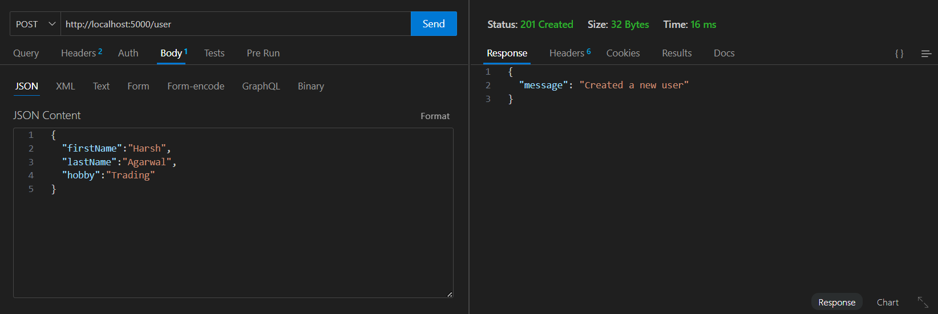

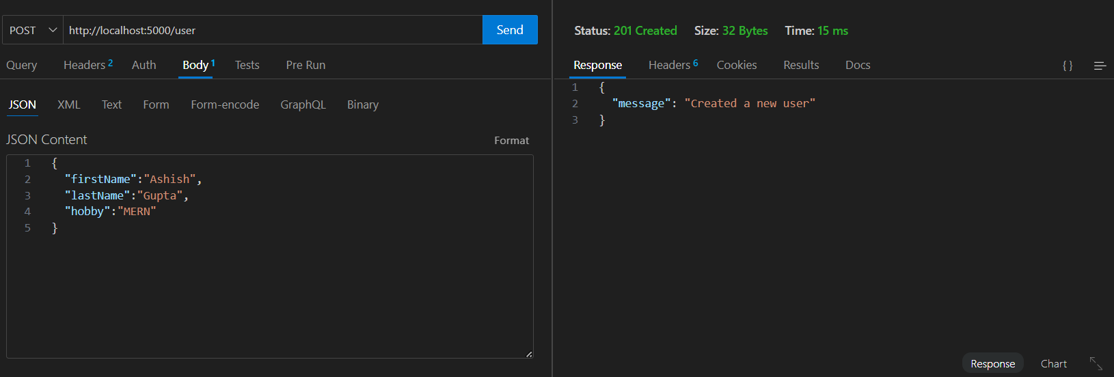

Ii) All the users:  
API Screenshot:  
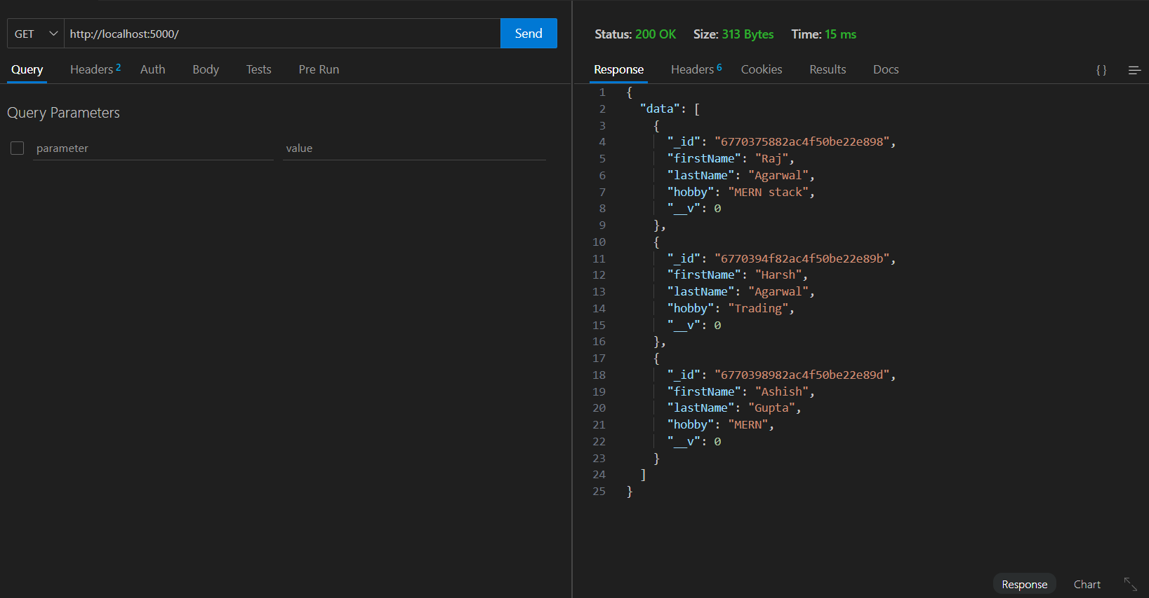

MongoDB compass screenshot:  
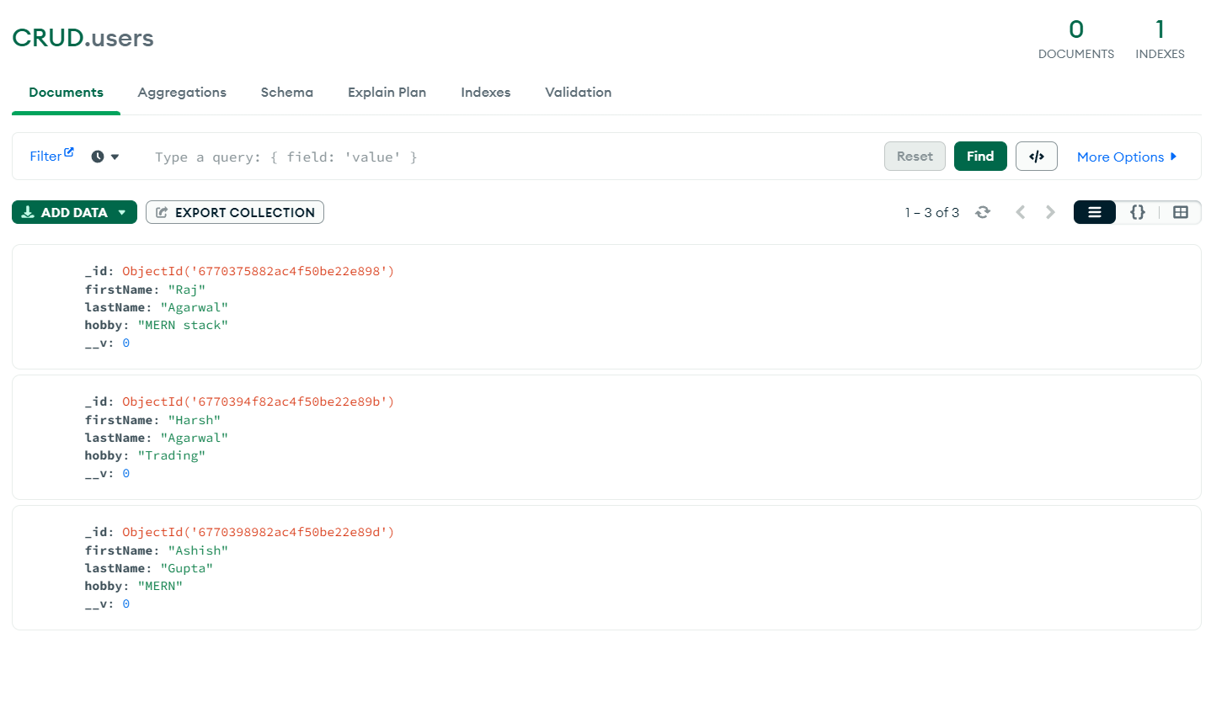

5)Get user by specific Id:  
API Screenshot:  
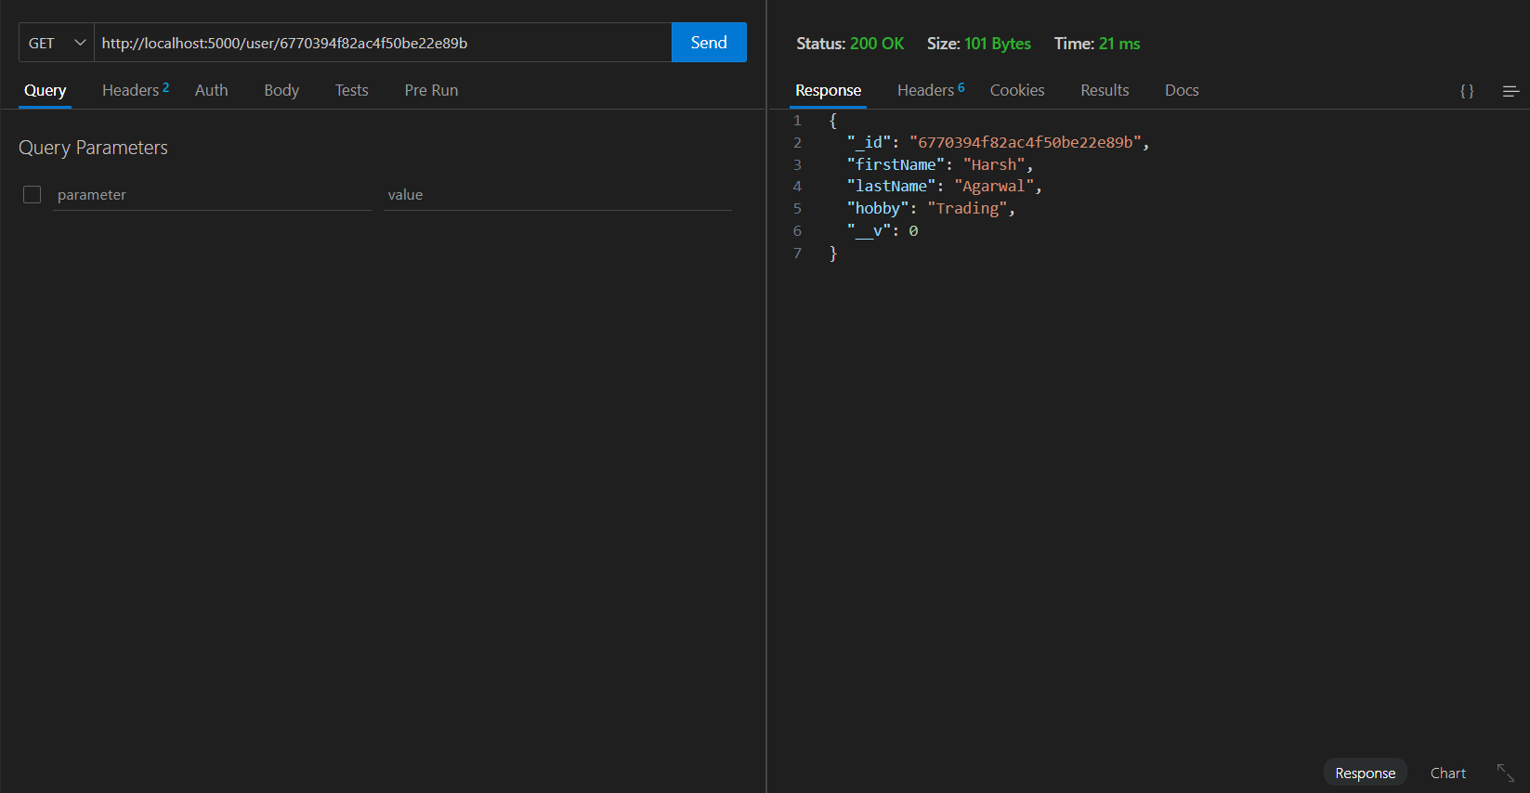

1. Let’s delete a user using object id.  
   API Screenshot:  
   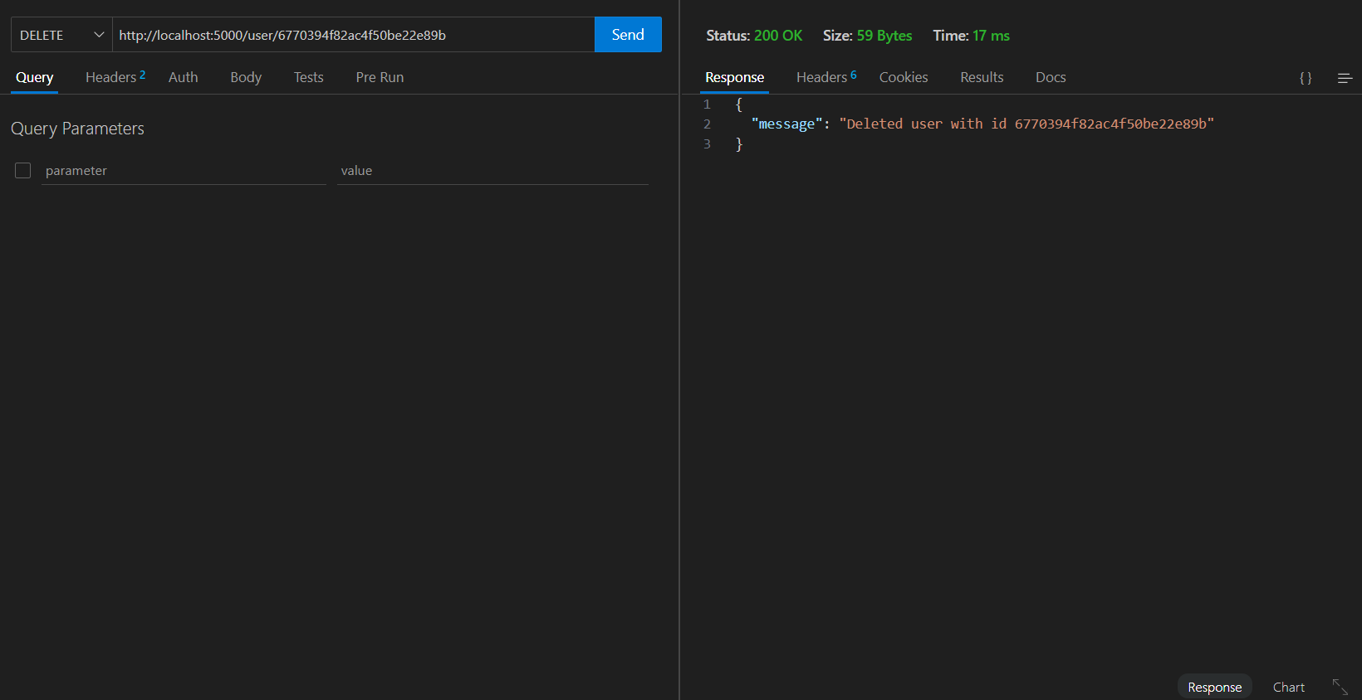

Now lets see the same data using our API and mongodb compass  
using api :  
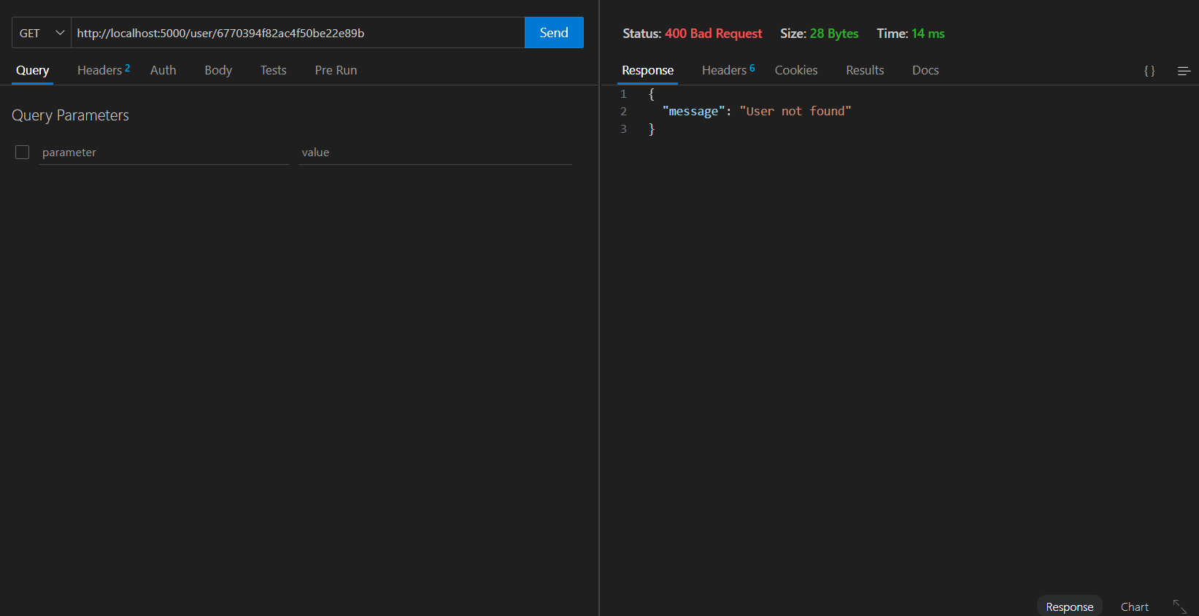

On mongodb compass  
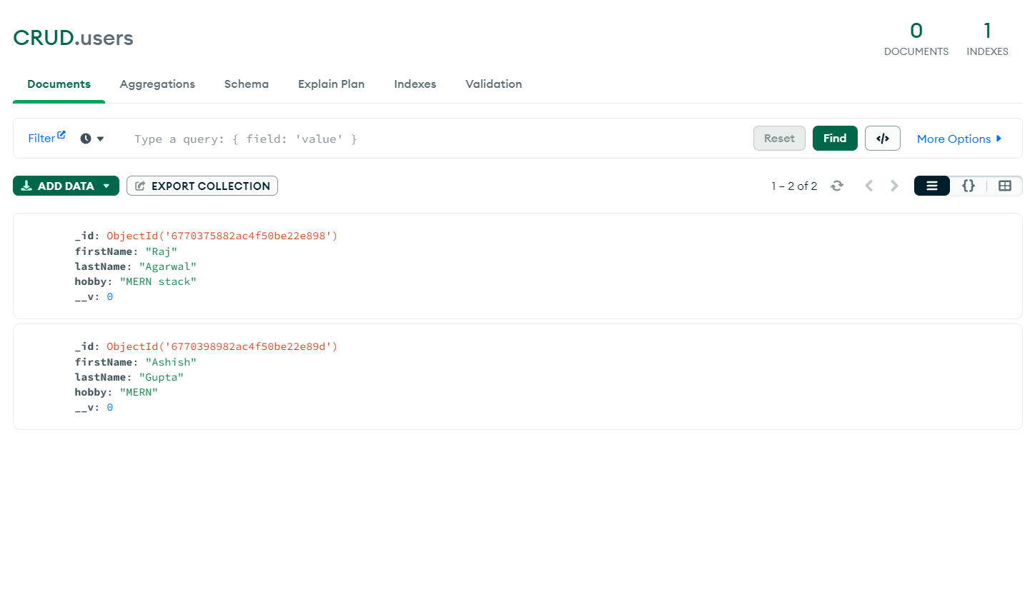

1. Now lets update a existing user:  
   using api  
   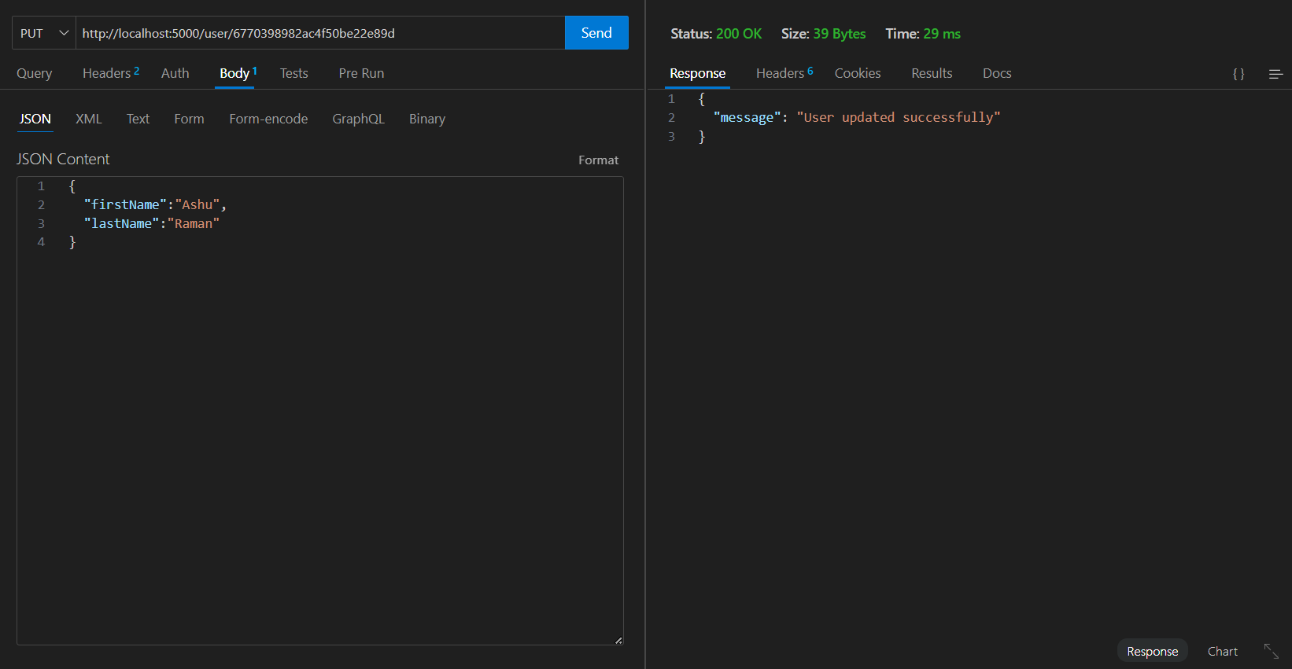

On compass :  
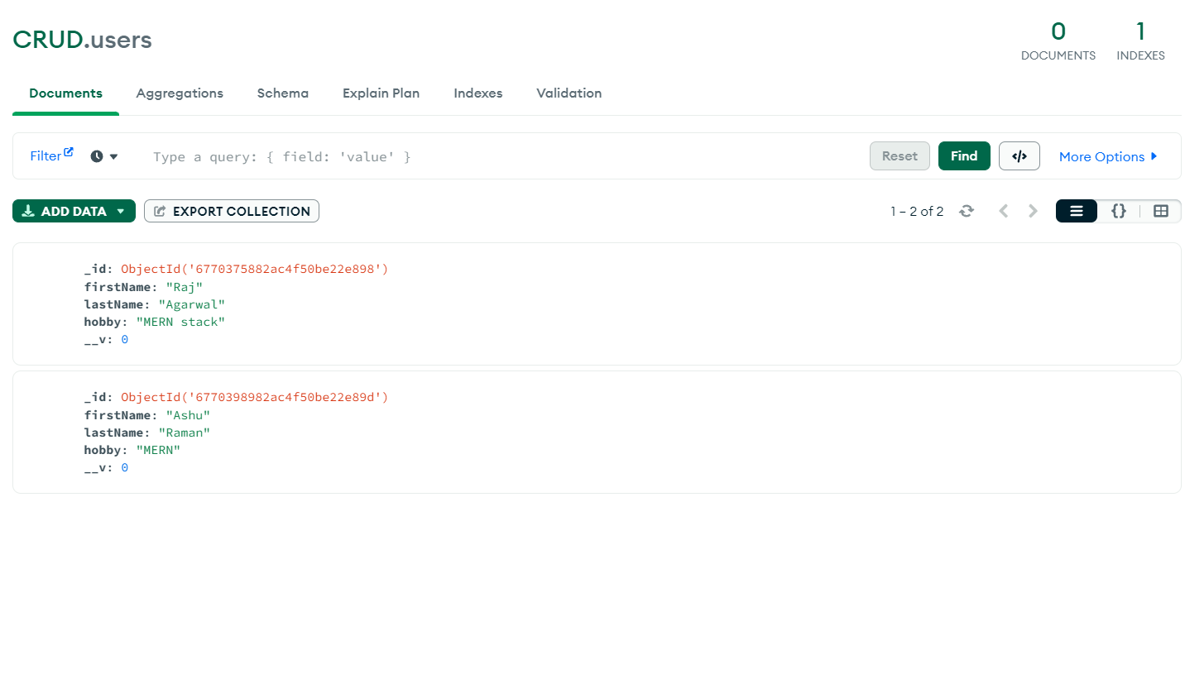

Below I have attached screenshots for various error vaildations:

There is no such id as such  
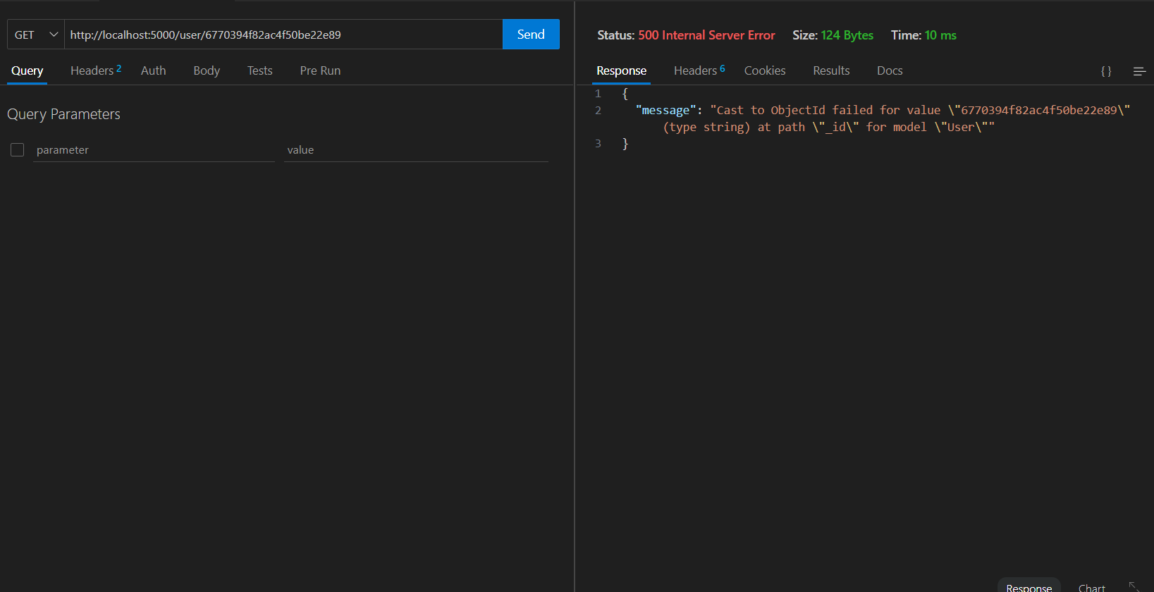

The user was previously deleted and the id is right that means user doesn’t exits but it not a error api working fine not like above where the message says that the id provided is itself wrong

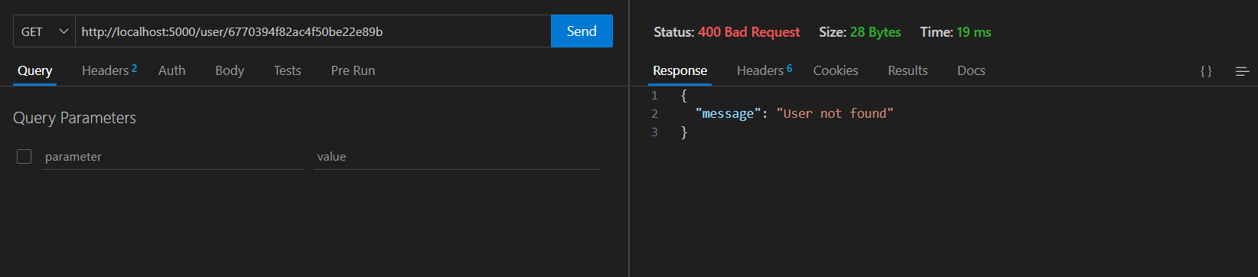

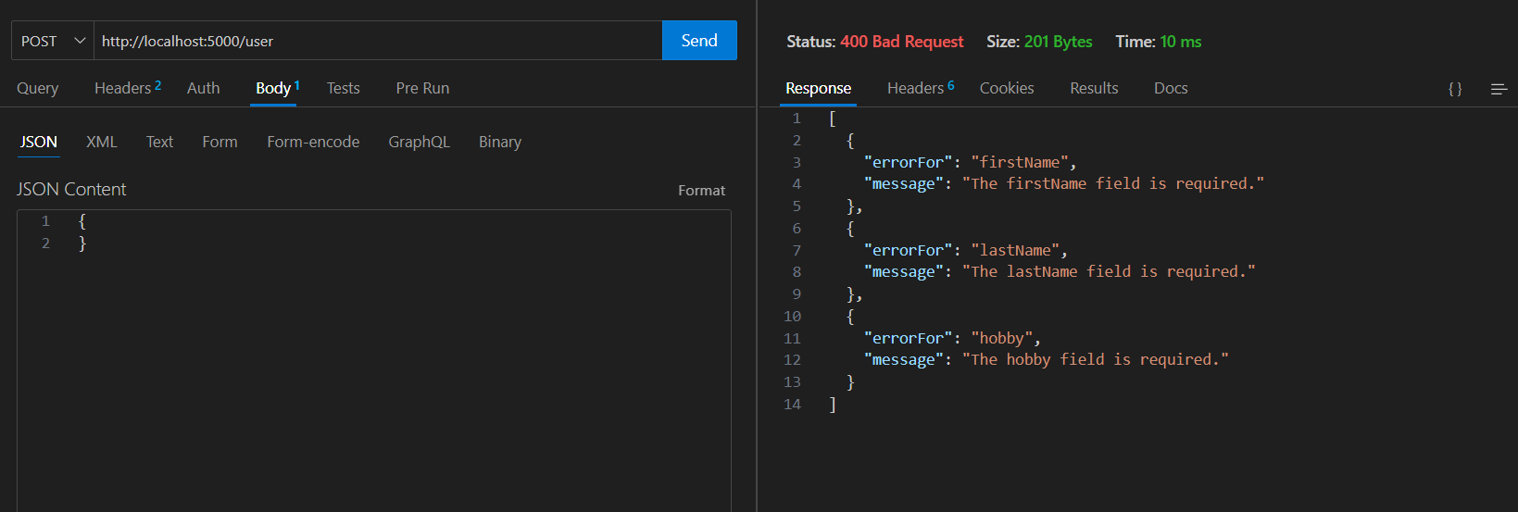

Note : The vaildations I applied on one api has also been applied on others too if needed.  
Like update doesn’t require mandatory fields we can one or more data in it.  
(validation are not missing in case of update I have used the already existed data of the user and changed only the fields in which I made changes to).