1. Initially there are no users the users array is empty.

Testing Api : GET /users – Fetch the list of all users.

Api url : <http://localhost:5000/>

Screenshot :

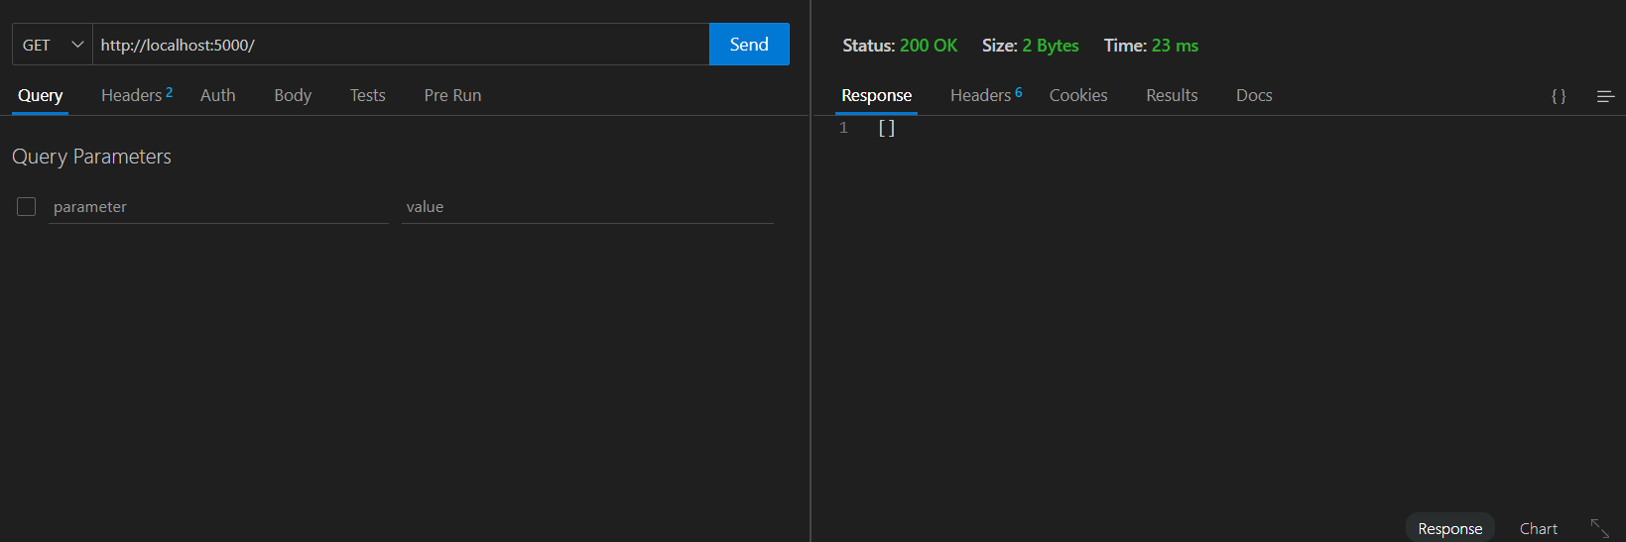

1. Lets create a user.

Testing Api : POST /user – Add a new user

Api url : <http://localhost:5000/user>

Screenshot :

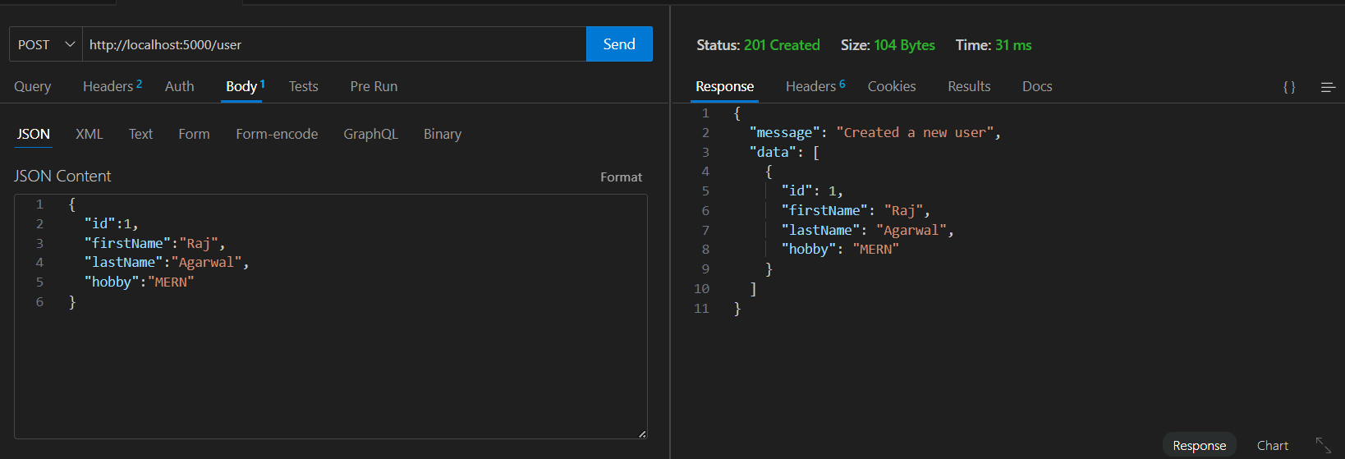

1. Now let see how many users are there using the get api to get list of all the users from refer to test 1 api there must be one user that we created in the previous step

Screenshot :

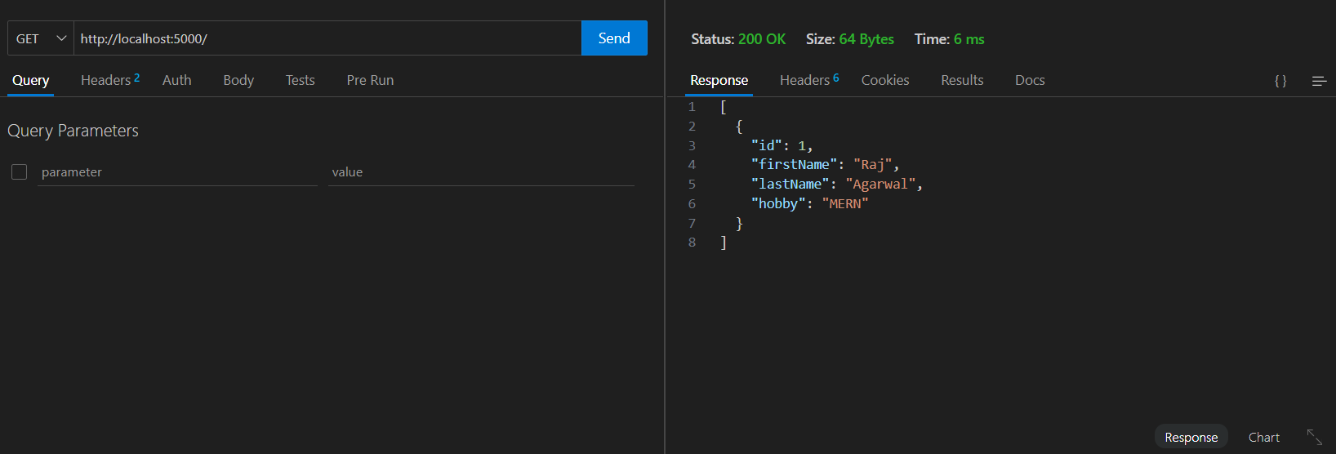

Lets add one more user and this time lets validate the fields and if there exists already a user with the requested user id.  
Screenshot :

Tried creating previous user once again witht the same user id  
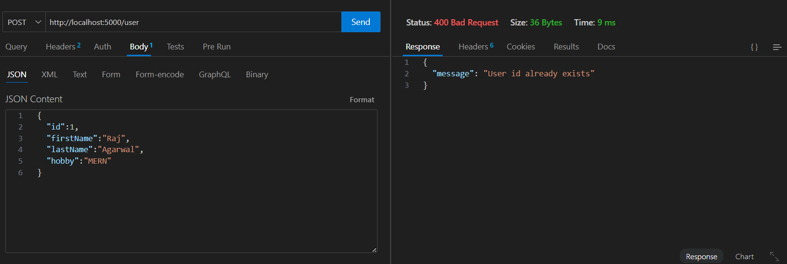

Validating field for empty and id must be number not string

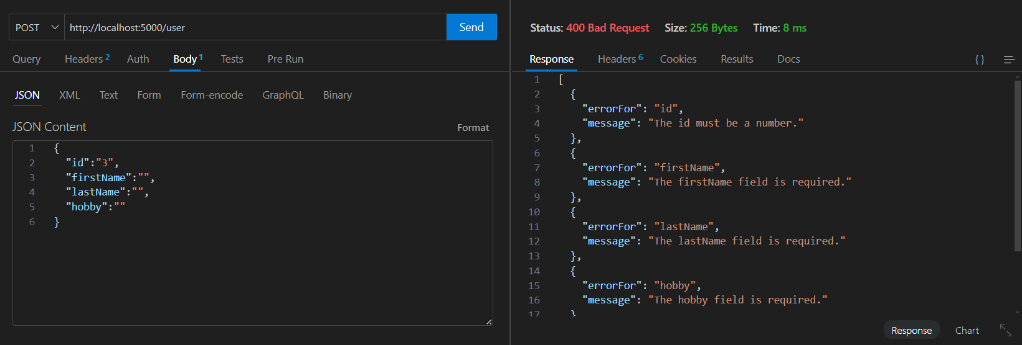

Created one more user  
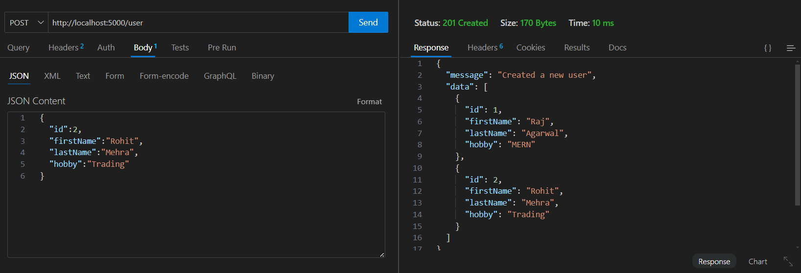

Now lets see the total user list  
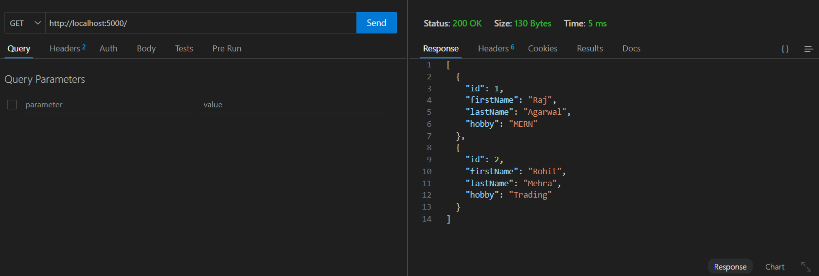

1. Try getting user with specific user id.  
   Api testing : GET /users/:id – Fetch details of a specific user by ID

ApI URL : http://localhost:5000/user/8

When the user id is not found

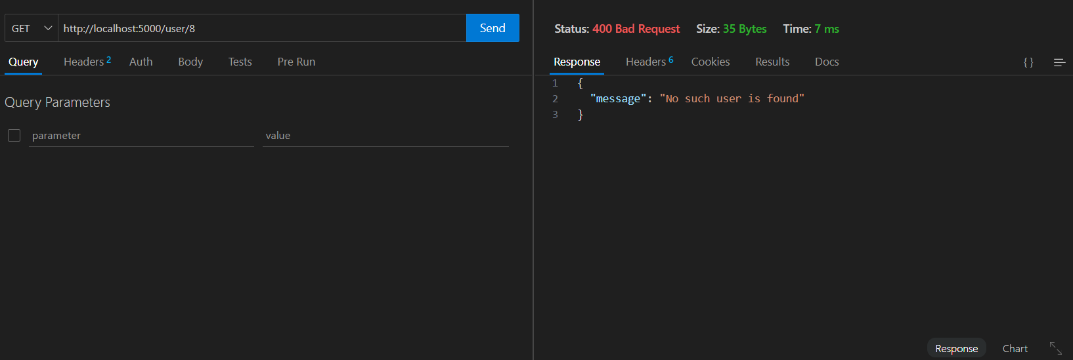

When the user id is found send the specific user data in the response

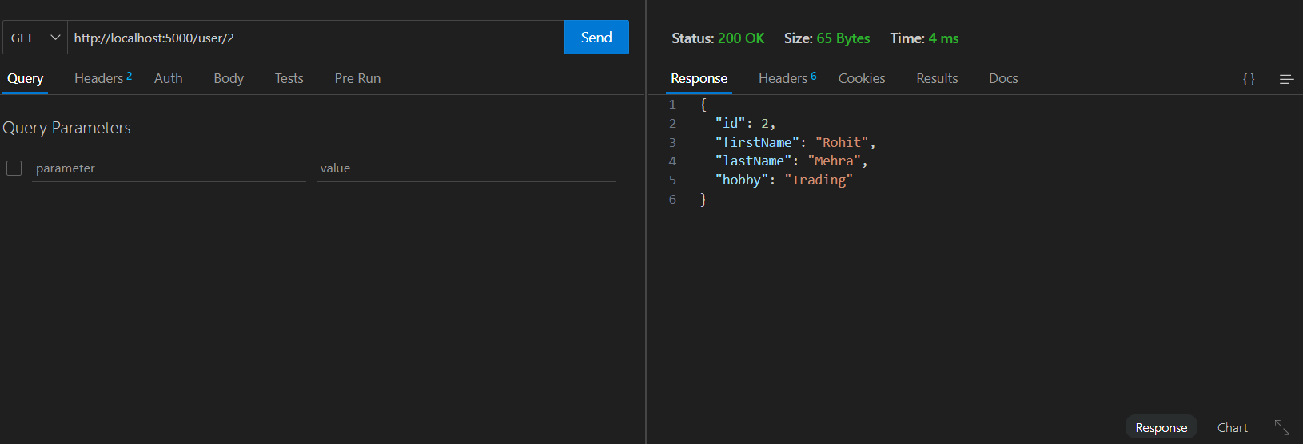

1. Trying updating the user with user id.

Api testing : PUT /user/:id – Update details of an existing user

Api url : <http://localhost:5000/user/8>

Note : I haven't implement the feature like you can update a specific field only in the user object you need to provide all the fields.  
What I am planing to do is get the found user and edit it with the changes in the field and then send the user for update in this way you will be able to update only the specific fields in the object of the user.

But this would require a front end and the form filling and getting the specific user using user id then making changes in the response and send that changed response as a request to the update user api.

If user id is not found.

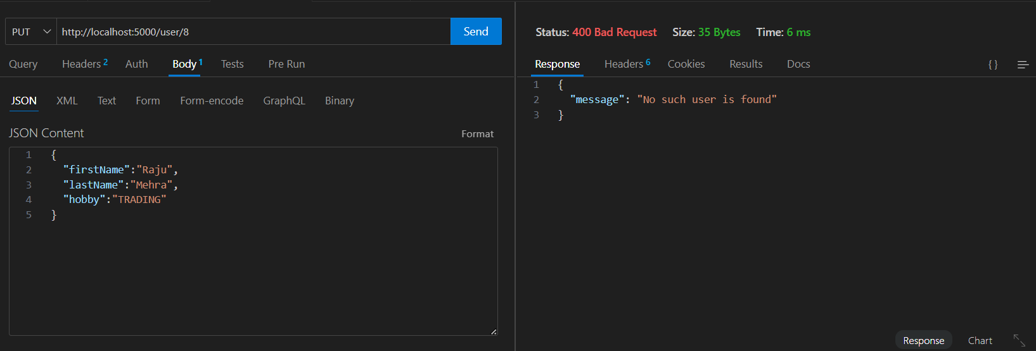

When the user id is found update the data but first we will check the validation

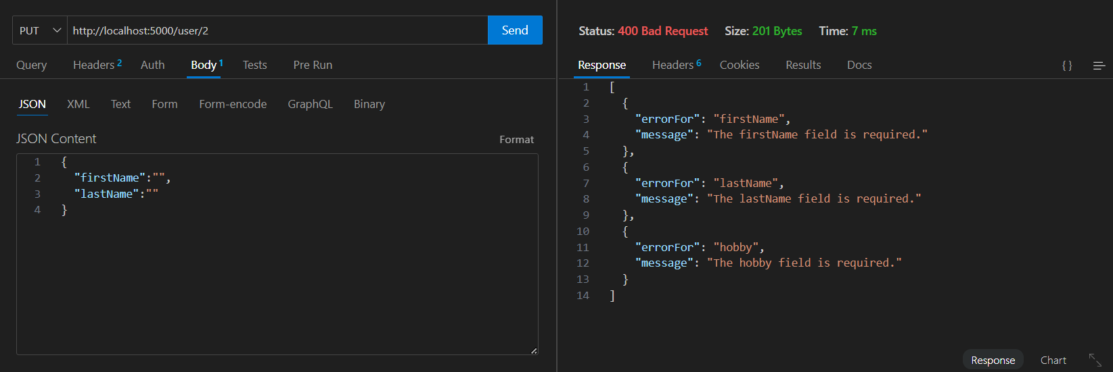

If everything goes right update the specific user :

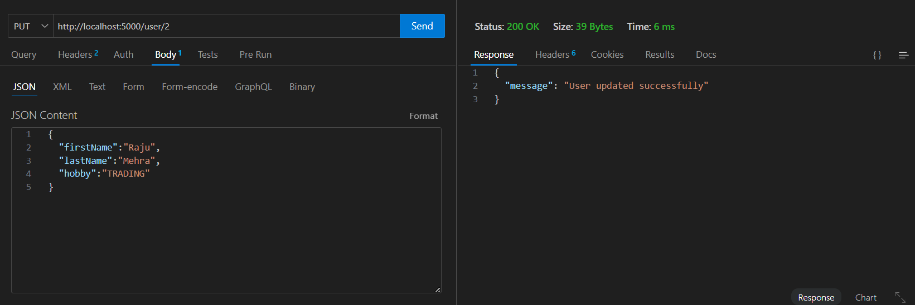

Lets see if the specific user is updated correct

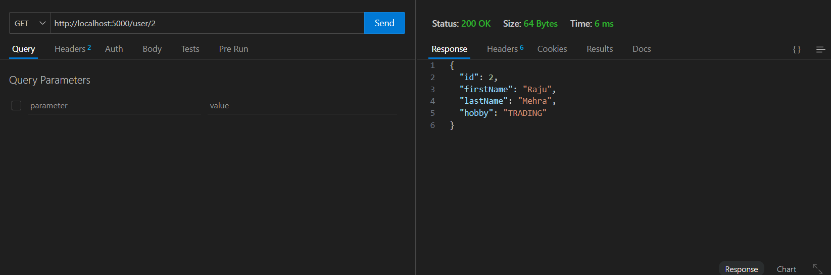

1. Lets delete a specific user after checking the validation once deleted we will see the new total user list if our user is deleted from the total user list.

Api testing : DELETE /user/:id – Delete a user by ID.  
Api url : http://localhost:5000/user/4  
  
If user id is not found

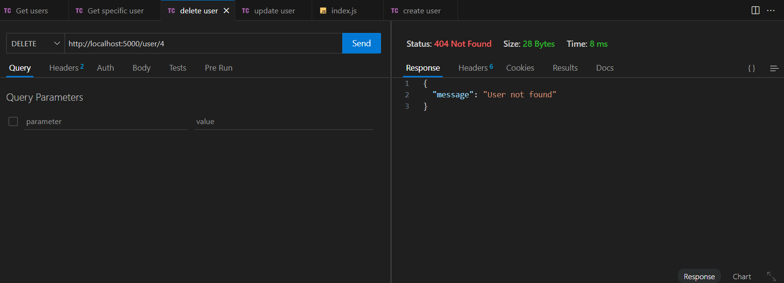

If the user is found  
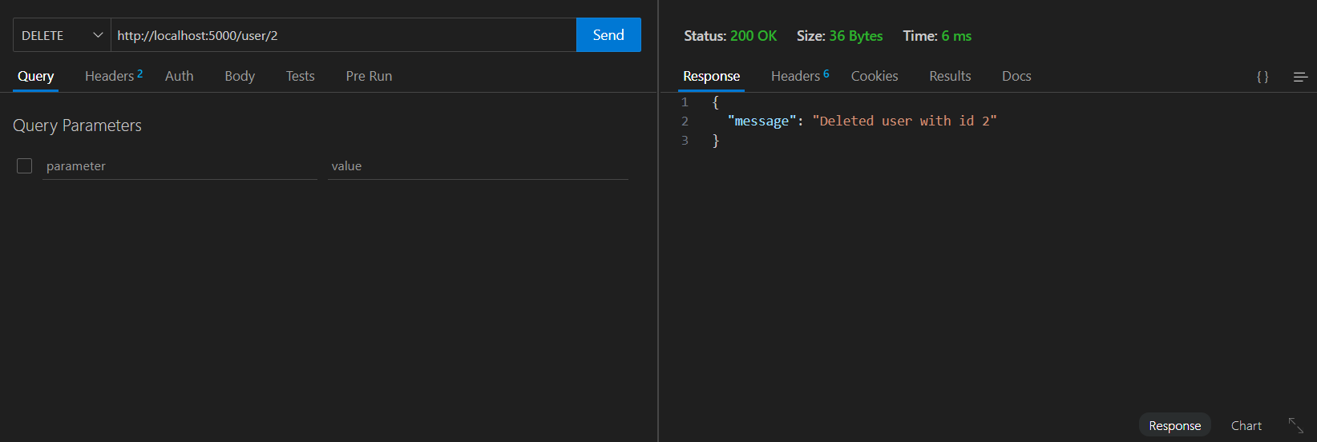

Now lets see the full user list  
