**E-COMMERCE CLONE**

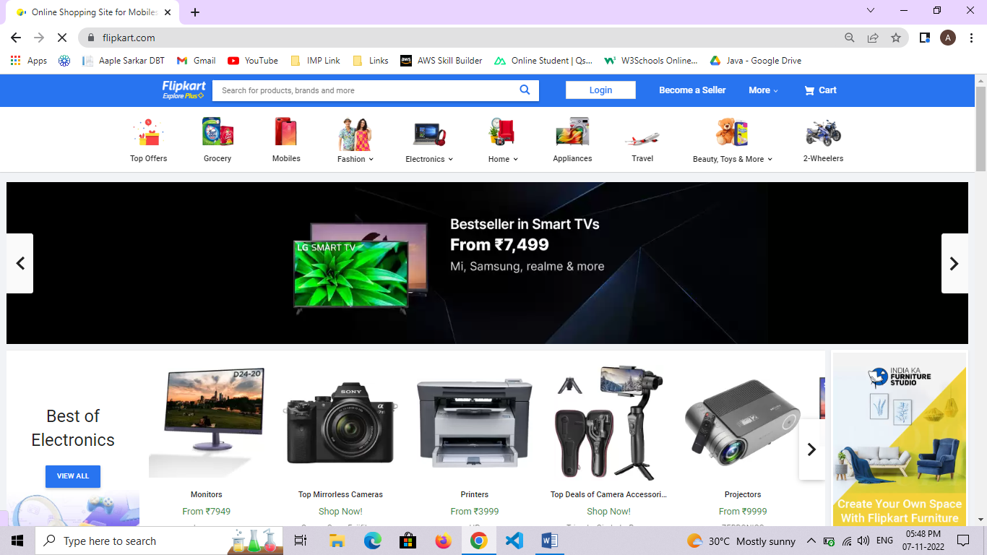

Overview:

* The webportal will have an online interface in the form of e-commerce website that will allow users to buy and sell goods.

Navigation bar(top):

* Company Logo
* Login button
* Signup button
* Search bar
* Cart

Menu bar:

* Different catergories of items are available to navigate around.

Home Page:

* Complete front view of page with contact us section at footer

Items section:

* Multiple cards to showcase multiple products
* Products images,name
* Pricing
* Buy/shop button
* User ratings
* Cart option(add/remove)

Cart Page:

* Cart page contains products added to card

Filter Page:

* Filtering option to filter
* Sort by price
* User rating
* Popular
* Discount

Login Page:

* Login section to validate user credentials and allowing access to portal
* User email
* User password
* Forgot password option

Sign up Page:

* Taking user data
* User name
* User email
* User password
* User phone number and address details

Technologies to be used:

* Html, Css, Bootstrap, Javascript, React.js, Node.js, Mongodb