LEAVE MANAGEMENT SYSTEM
An Agile Business Analysis Case Study
From requirements to release: designing a role-based leave platform for Employees, Managers, and HR
Prepared by
Business Analyst | Agile / Scrum
Methodology: Scrum • Tool: Jira • Deliverables: 12 User Stories, Wireframes, Activity Diagrams

Project Overview
The Leave Management System (LMS) is a role-based web and mobile application built to replace a manual, paper-driven leave process with a single digital workflow. Employees apply for leave and track balances in real time; managers review and act on requests without leaving their dashboard; and HR configures policy, resolves exceptions, and reports on usage across the organization.
I led this project as the Business Analyst, owning requirements gathering, user story writing, wireframing, and sprint planning from kickoff through to a fully documented, development-ready backlog.

Why It Mattered
- Manual leave tracking led to approval delays, balance errors, and no audit trail.
- Managers had no consolidated view of team availability, causing scheduling conflicts.
- HR lacked a fast way to enforce policy consistently or report on leave trends.
The LMS was scoped to solve all three problems in a single, auditable system — reducing manual effort, improving compliance, and giving every role real-time visibility.

Project Goals
- Enable employees to apply for leave through a simple, validated digital form.
- Provide real-time visibility into leave balances and request status.
- Let managers approve or reject requests efficiently, with instant notifications.
- Give HR control to configure leave types, rules, and policy overrides.
- Deliver department-level, exportable reporting for audits and trend analysis.
- Improve organization-wide transparency, compliance, and operational efficiency.

User Roles
The system was scoped around three role types, each with a distinct set of permissions and workflows:
Employee | Apply for leave, view balances, modify or cancel pending requests, and track approval status.
Manager | Review team leave requests, approve or reject, view the team calendar, and receive instant notifications.
HR / Admin | Configure leave types and rules, override decisions when needed, generate reports, and view audit logs.

Tools & Methodology
- Development Approach: Agile, Scrum-based, delivered across two sprints.
- Project Management: Jira — backlog management, user stories, and sprint planning.
- Modelling: Wireframes for UI, activity diagrams for process flow, flowcharts for workflow visualization.
- Deliverables: 12 functional user stories (LMS-01 to LMS-12), a full wireframe set, and activity-flow diagrams for every core process.

Feature Status Overview
Twelve user stories covered the full leave lifecycle. Eight were fully delivered, two carried into a later iteration, and two remained in the backlog for a following release.
ID | Feature | Status | Points
LMS-01 | Apply for Leave | Complete | 3
LMS-02 | View Leave Balance | Complete | 2
LMS-03 | View Pending Leave Requests (Manager) | To-Do | 2
LMS-04 | Approve/Reject Leave | Complete | 5
LMS-05 | View Team Leave Calendar | In Progress | 3
LMS-06 | Configure Leave Types and Rules | In Progress | 5
LMS-07 | Generate Monthly Leave Reports | Complete | 5
LMS-08 | Cancel or Modify Leave Request | Complete | 5
LMS-09 | Manager Notification on Leave | Complete | 3
LMS-10 | HR Override Leave Request | Complete | 8
LMS-11 | View Leave Request Status | Complete | 2
LMS-12 | View Company Leave Policy | To-Do | 2

Agile Delivery in Jira
All 12 stories were logged as an epic in Jira and sequenced into two sprints. Sprint 1 prioritized the core employee-facing loop — applying for leave, checking balances, and tracking status — plus the manager actions needed to close that loop. Sprint 2 layered on team visibility, HR configuration, and reporting.
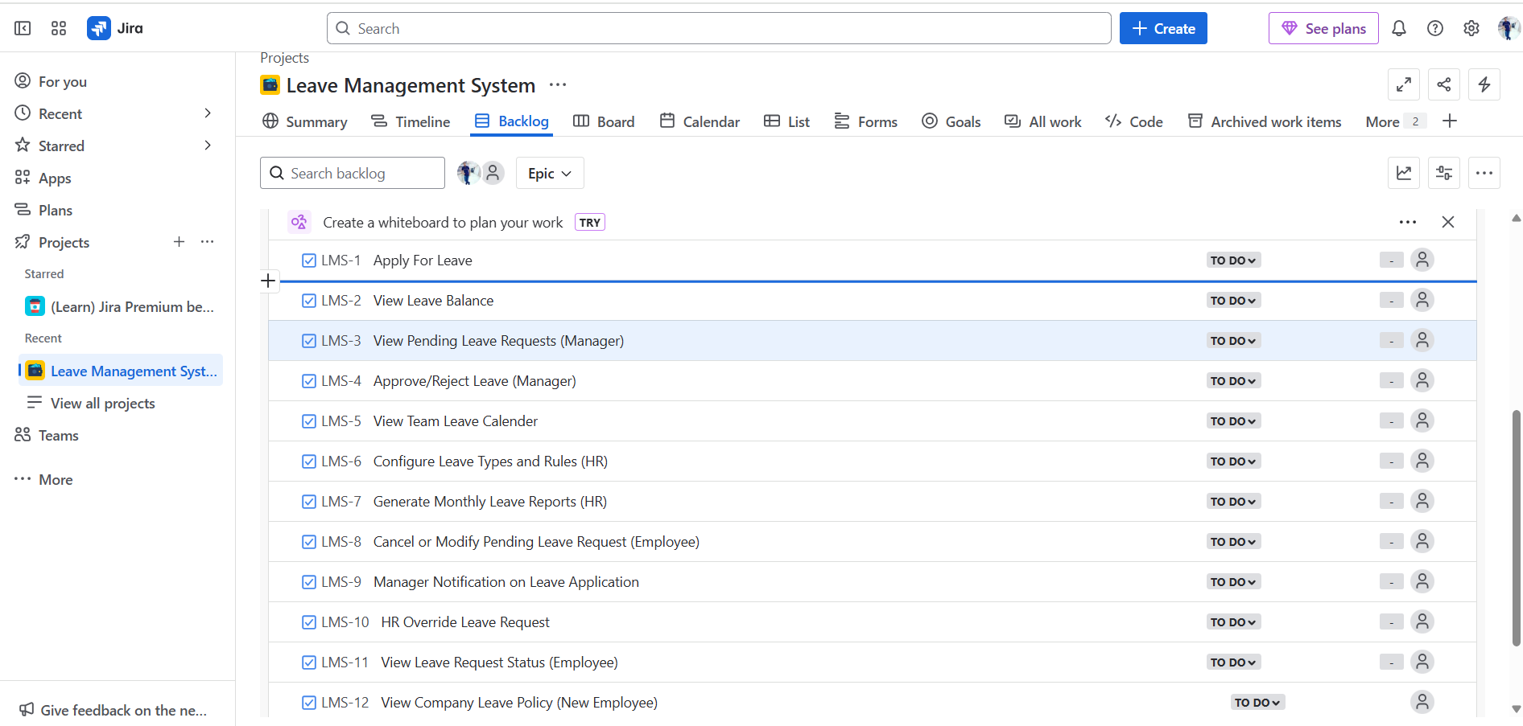
Jira backlog for the Leave Management System epic, LMS-01 through LMS-12.
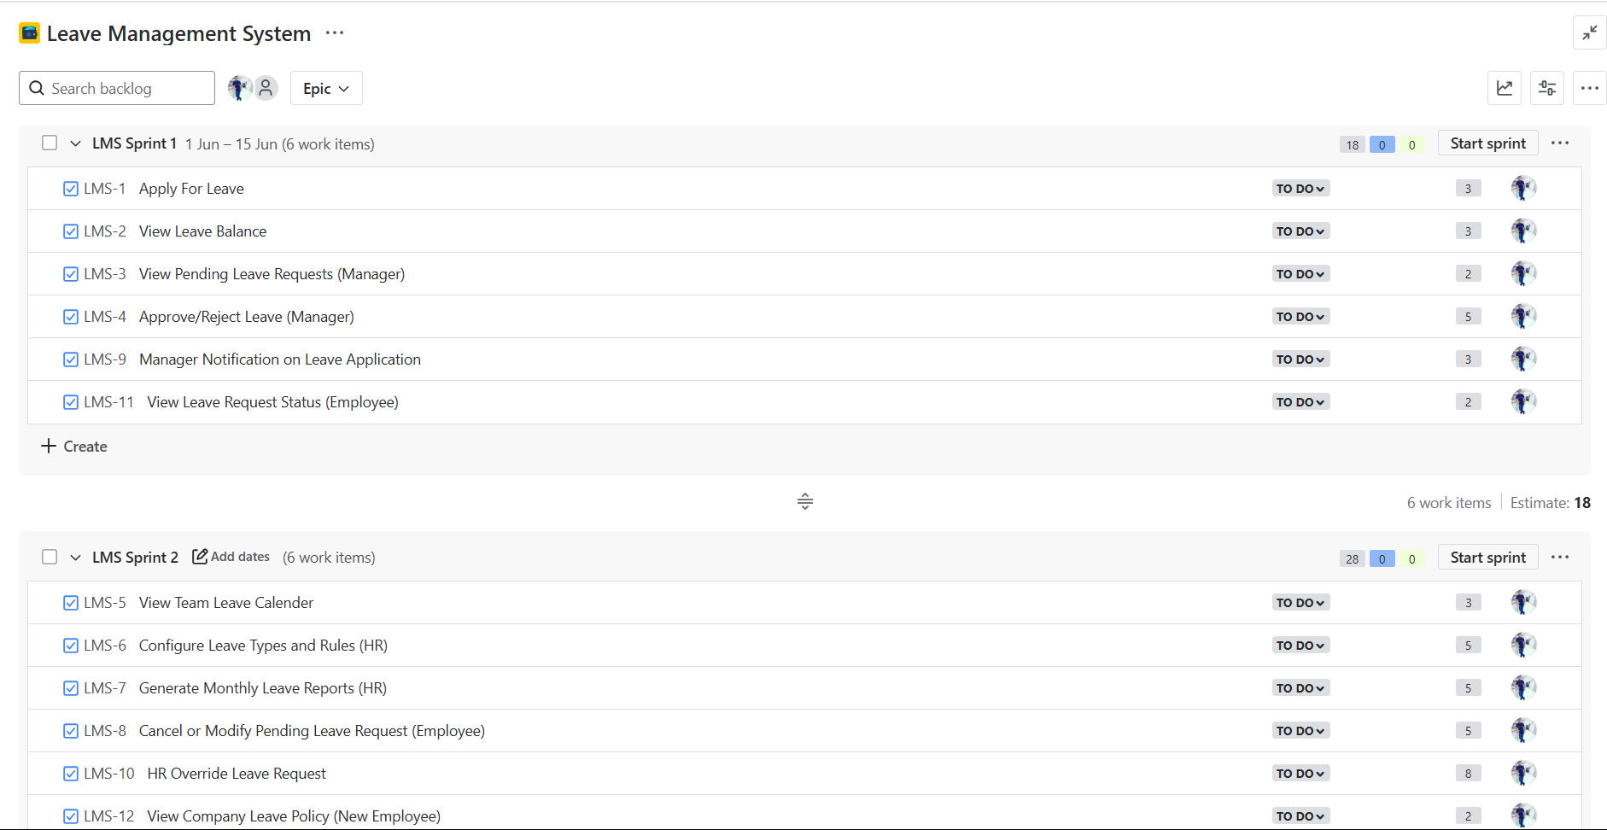
Two-sprint delivery plan: Sprint 1 covers employee-facing flows (18 points); Sprint 2 covers manager and HR workflows (28 points).

Key User Stories & Wireframes
A closer look at five of the twelve stories — spanning all three roles — shows how each requirement translated directly into a validated, development-ready screen.
LMS-01 Apply for Leave
As an employee, I want to apply for leave through an online form, so that I can request time off without going through a manual process.
- Form captures leave type, start/end dates, auto-calculated day count, and a mandatory reason.
- System blocks past dates and requests exceeding the available balance for that leave type.
- On submission: status is set to Pending Approval, the manager is notified, and the request is logged to history.
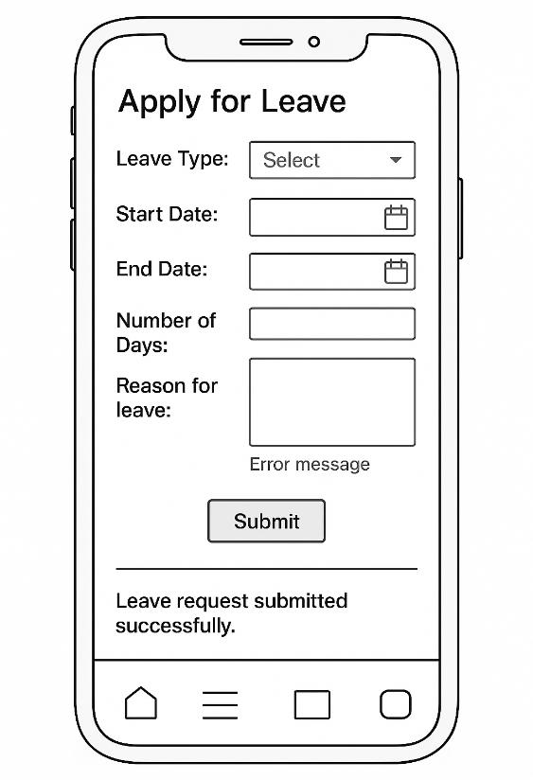
LMS-02 View Leave Balance
As an employee, I want to view my remaining leave balance, so that I can plan my vacations or leaves accordingly.
- Balances are grouped by leave type and update automatically on approval, accrual, or carry-forward.
- Employees can download the balance summary as PDF or Excel.
- Every balance change is audit-logged with a timestamp and trigger source.
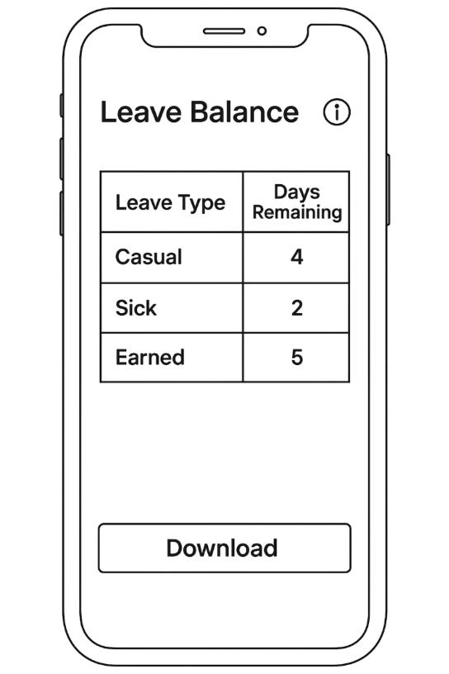
LMS-04 Approve / Reject Leave (Manager)
As a manager, I want to approve or reject leave requests so that I can manage team availability efficiently.
- Approve or reject is available from the pending-request list or the detailed view.
- Rejection requires a mandatory reason; both actions notify the employee and lock the request as read-only.
- Every decision is timestamped and logged with the manager's identity for audit purposes.
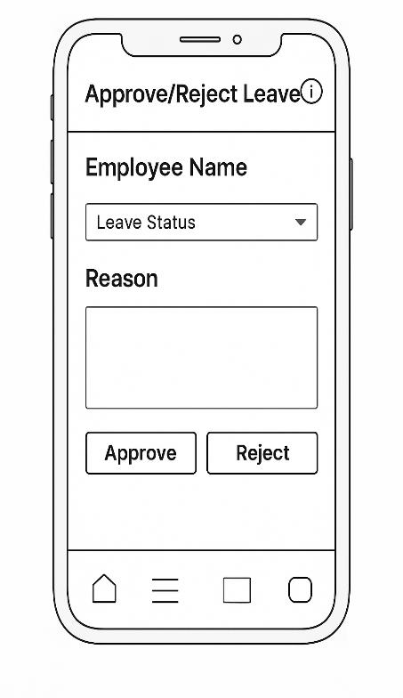
LMS-07 Generate Monthly Leave Reports (HR)
As an HR user, I want to generate downloadable monthly leave reports for departments so that I can analyze usage trends and ensure compliance.
- Filterable by date range, department, and leave type.
- Report includes department-wise summaries, approved-vs-rejected counts, and top leave takers.
- Exportable to Excel, PDF, or directly by email; every export is audit-logged.
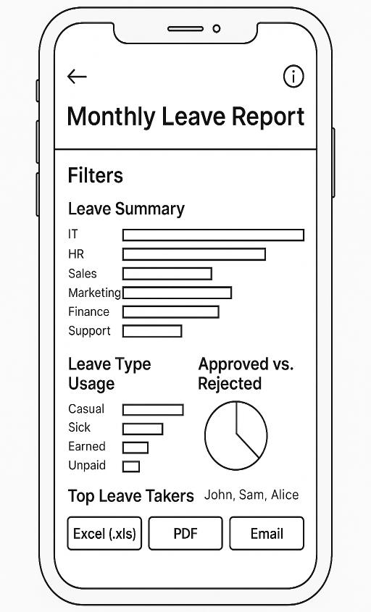
LMS-10 HR Override Leave Request
As an HR user, I want to override a leave request in special cases so that I can correct discrepancies or apply exceptions.
- Restricted to HR users; supports changing status or editing leave dates/type.
- A mandatory override reason is required before submission.
- Every override logs previous values, updated values, timestamp, and HR identity, and flags the request as 'Modified by HR.'
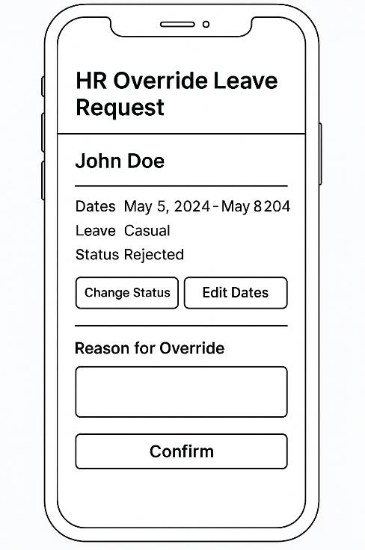

Process Flows
Activity diagrams mapped the decision logic behind each core workflow, giving developers an unambiguous spec for validation rules, branching, and system state changes.
Apply for Leave  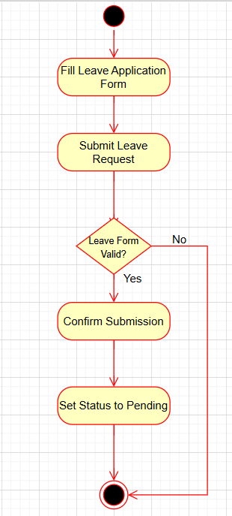 | Manager Approval  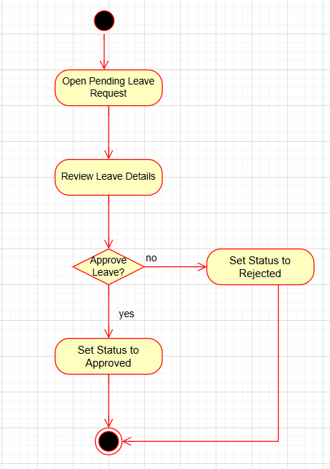 | HR Override  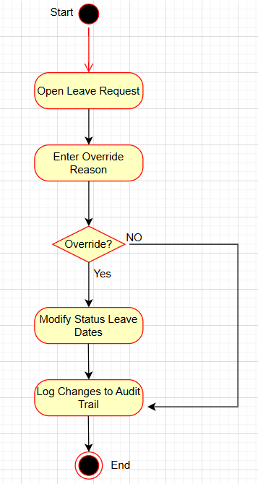

Three of the six activity flows produced for the project: employee submission, manager decision, and HR exception handling.

My Role & Contributions
As the Business Analyst driving this project end-to-end, I owned the path from raw stakeholder need to a development-ready backlog:
- Gathered and documented requirements directly from employees, managers, and HR stakeholders.
- Wrote 12 detailed user stories, each with explicit, testable acceptance criteria.
- Designed wireframes and activity-flow diagrams for every core functionality.
- Built and prioritized the Jira backlog, estimated story points, and sequenced delivery across two sprints.
- Partnered with developers and testers throughout to clarify scope and resolve ambiguity.
- Maintained Agile ceremonies and documentation to keep progress traceable sprint over sprint.

Lessons Learned
- Explicit, testable acceptance criteria removed ambiguity before development began.
- Wireframes and activity diagrams gave non-technical stakeholders a shared, concrete reference point.
- Splitting delivery into two role-focused sprints made feedback faster and prioritization easier to defend.

Conclusion & Future Enhancements
The LMS project replaced a manual, error-prone leave process with a centralized, auditable system that gives employees, managers, and HR real-time visibility into leave status and policy. The Agile approach — incremental delivery, continuous stakeholder feedback, and a fully traceable backlog — kept the scope tight and the requirements verifiable at every step.
Planned next steps include payroll integration, a native mobile app, and analytics for organization-wide leave trends.

