**Deployment Process**

1. **Heroku**

Go to <https://dashboard.heroku.com/apps>

First login and create an app as per below screenshot button.



If you further want to go by Local git connectivity to Heroku Git then follow the below steps.

1. In cmd intall the library as pip install GitPython. Go to CMD in admin mode and check if Heroku CLI is installed if not install it and check in cmd again.

Type Heroku login in cmd and once browser opens then login as per your credentials. Once logged in press enter in cmd.

Type Git init in cmd to initiate Git repository in local system.

Type Git status in cmd, it will upload all the files.

Type heroku git:remote -a <Appname> in cmd and press enter.

Type Git add . and enter in cmd

Type git commit -am "message" and enter in cmd

Type git push heroku master and enter in cmd.

You will get the link on which the app is created.

1. In case you have already pushed your support files to git hub then directly go to the below icon and select the appropriate repository from your github account.



1. **AWS**

Go to AWS Elastic beanstalk create an app. Select python as environment 3.7 or above. IN case of any issues go to browser google chrome > More tools > extension settings and disable all.

Go to Code Pipeline and create a pipeline. This is connecting Github to elastic beanstalk. Go next Select Github version 2

Go to connect Github, click on the button install an app, authorize and connect to all repositories.

Select repository name and branch name as main go next. Skip build stage.

Under Deploy select AWS Elastic Beanstalk. Click Next and create pipeline.

To kill your services go to CloudFormation go to stacks you can see any environment and stop the same from there.

**AWS Deployment with EC2 instance : https://www.youtube.com/watch?v=oOqqwYI60FI&t=612s**

**Azure**

Go to home page create a web app option and fill the form as per screenshot.

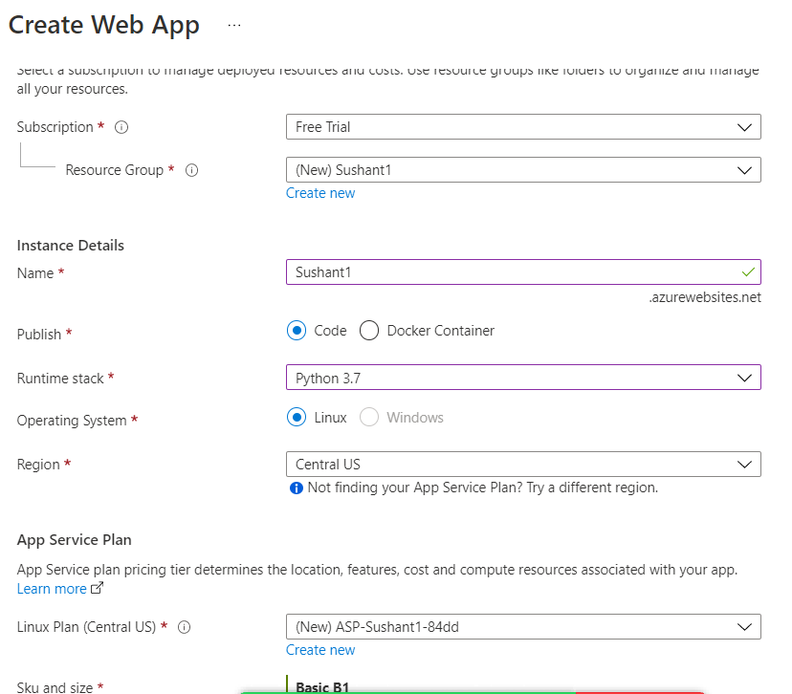

Check Review and complete and create and an app. Once created go to home page and click on the app created.

Go to Deployment Center in the app, Connect with your github account. Select the appropriate Organization, Repository and Branch and click on save(top).

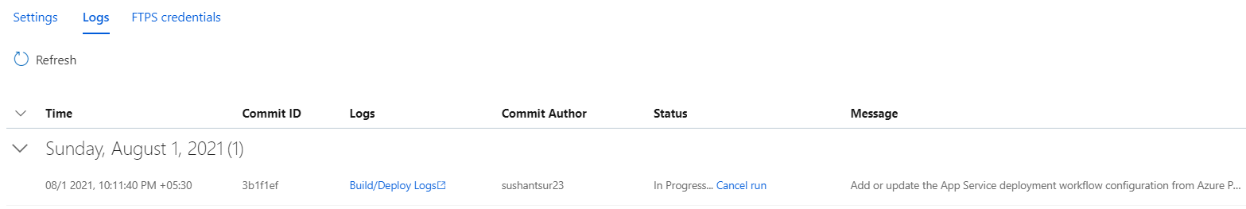

Once you go to Log tab and click on the link below Log you can see the status of the deployment.

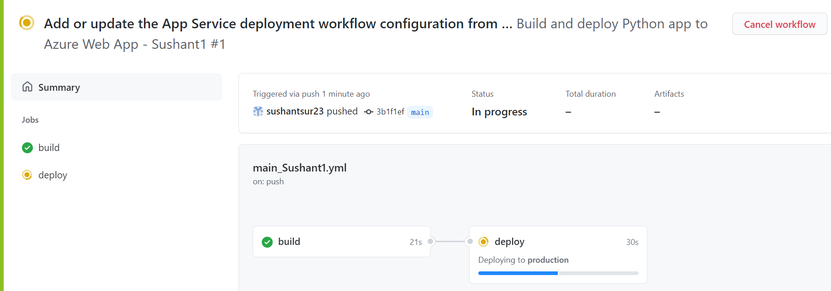

Once you come back to the app screen you will get the link where the app is deployed.

