Table of Contents

Abstract – 2

CHAPTER 1 – INTRODUCTION 4

CHAPTER 2 – LITERATURE REVIEW 6

Existing System 6

PROPOSED System 7

Software Requirements: - 7

Hardware Requirements: 8

CHAPTER 3 OVERALL DESCRIPTION OF THE PROPOSED SYSTEM 9

3.1 Module Description 9

CHAPTER 4 – DESIGN 12

4.1UML Diagrams: 12

**4.1.1Usecase Diagrams**: 12

**4.1.2 Sequence Diagram:** 14

**4.1.3 Collaboration Diagram:** 15

**4.1.4 Class Diagram:** 17

**4.1.4 Activity Diagram:** 17

**4.1.5 Data Flow Diagram:** 18

CHAPTER 6 – IMPLEMENTATION DETAILS 25

6.1 Introduction to Html Framework 25

6.2 Cascading Style Sheets (CSS) 28

6.3 MYSQL Server 33

6.4PHP 34

6.5 ANGULAR JAVA SCRIPT 36

CHAPTER 8-TECHNICAL FEASIBILITY 39

CHAPTER 9-SYSTEM TESTING 41

CHAPTER 10– CONCLUSIONS 46

CHAPTER 11- REFERENCES 47

CHAPTER 12- Coding 49

**Location Based Garbage Management System with for Smart City**

# Abstract –

Smart cities integrate multiple mobile or web solutions to build a comfortable human habitation. One of these solutions is to provide an environmentally friendly, efficient and effective garbage management system. The current garbage collection system includes routine garbage trucks doing rounds daily or weekly, which not only doesn't cover every zone of the city but is a completely inefficient use of government resources. This paper proposes a cost-effective mobile or web based system for the government to utilize available resources to efficiently manage the overwhelming amounts of garbage collected each day, while also providing a better solution for the inconvenience of garbage disposal for the citizens. This is done by a network of smart bins which integrates cloud-based techniques to monitor and analyze data collected to provide predictive routes generated through admin for garbage trucks. An android or web app is developed for the workforce and the citizens, which primarily provides the generated routes for the workforce and finds the nearest available smart bin for citizens.

# CHAPTER 1 – INTRODUCTION

Proper waste management is a basic requirement in any kind of an environment. Usually cleaning in these environments are done in the morning and the afternoon. If you take an urban city like Colombo usually there are about 1,200,000 to 1,500,000 [1][2] employees heading for their workstations every morning. For all those people, there are just not enough garbage bins available. On the streets of urban cities, hundreds of people are passing the same location around one minute. Around 95% [3] of people are carrying food covers, polythene bags, and plastic bottles. If they dispose all them at once, the bins will be filled in several minutes. When they fill up people just litter their trash around the garbage bins because there is nowhere else to put them. The obvious solution to this is for the cleaning staff to stay near garbage bins every day till they fill up to clean them. This is not a real solution. It takes way more cleaning staff and costs a lot of money. So, it is impractical. The same scenario is happening in workstations. For instance, a bank or a government office cafeteria usually has about five to six garbage bins to serve hundreds of employees. This is simply not enough. There are some notable negative effects when considering the garbage bins always being full. One of the main effects is the surrounding area starting to smell and be very unpleasant. When the garbage bins are full people put their trash on sides of the garbage bins. When this is done for some time, first it starts to smell bad. So, others who come later tend not to go close and throw their trash in the direction of the garbage bins. If there are any leftover food items, throwing it causes them to spill. This attracts animals like cats, dogs, and flies. And these animals spill them even more. Another negative effect is the diseases that spread. It's not just the garbage that spread them, but the animals also can be a source.

II.􀀁 RELATED WORK

In the paper of S. Lokuliyana et al. on "IGOE IoT framework for waste collection optimization" uses a sensor network based on disposal sites set up around the city. The sensor nodes notify relevant authorities about the availability of waste to be collected. A mobile application is built for citizens to alert authorities about an overflow of an authorized disposal site or unauthorized dumping site of waste. The same application is used by the authorities to convey messages to the citizens. An optimization algorithm is used to create the route in which thetrucks use to collect the garbage from the disposal sites. Finally, an analysis is done to calculate the delay of the waste collection process, effective waste collection rate and the waste collectio process efficiency. The whole system is built as a framework and is named the IGOE waste collection framework [4]. The paper by R. Fujdiak et al. on "Using genetic algorithm for advanced municipal waste collection in Smart City" mainly focusses on IoT vision that introduces promising and economical solutions for massive data collection and its analysis which can be applied in many domains and so make them operate more efficiently. To optimize the logistic procedure of waste collection, the paper uses own genetic algorithm implementation. The presented solution provides a calculation of more efficient garbage-truck routes. As an output, the paper provides a set of simulations focused on the mentioned area. All the algorithms are implemented within the integrated simulation framework which is developed as an open source solution with respect to future modifications. The algorithms used are as follows: Floyd-Warshal, TSP formulation, crossover algorithm, Mutation algorithm and Dijkstra, TSP formulation Algorithm [5]. Referring to a research paper by T. Anagnostopoulos et al. on “Top-k Query based Dynamic Scheduling for IoT-enabled Smart City Waste Collection” proposes a top-k query based dynamic scheduling model to address the challenges of near real-time scheduling driven by sensor data streams. An Android app along with a user-friendly GUI is developed and presented in order to prove feasibility and evaluate a waste collection scenario using experimental data. In implementation regarding spatial information, the Smart City is divided into multiple sectors which cover the entire city area. Each sector contains a number of multiple intermediate waste depots, which are temporary waste storage areas. The proposed system architecture incorporates a heterogeneous fleet of trucks for serving the waste collection infrastructure. Cloud middleware is responsible to collect data from sensors, aggregate and clean them in order to provide them to the engine which is implemented in OpenIoT. Dynamic scheduling algorithm locates the first available truck which can load waste from the filled bins. Then it is performed a top-K query which exploits real-time data from the relation. Also, data is stored in a spatial database in which mobile top-k queries specify the number of the full bins in order to initiate dynamic scheduling. An Android app is implemented in order the drivers to have a user-friendly GUI interface

# CHAPTER 2 – LITERATURE REVIEW

The Internet of Things (IoT), as expected infrastructure for envisioned concept of Smart City, brings new possibilities for the city management. IoT vision introduces promising and economical solutions for massive data collection and its analysis which can be applied in many domains and so make them operating more efficiently. In this paper, we are discussing one of the most challenging issues - municipal waste-collection within the Smart City. To optimize the logistic procedure of waste collection, we use own genetic algorithm implementation. The presented solution provides calculation of more efficient garbage-truck routes. As an output, we provide a set of simulations focused on mentioned area. All our algorithms are implemented within the integrated simulation framework which is developed as an open source solution with respect to future modifications.

## Existing System

employees heading for their workstations every morning. For all those people, there are just not enough garbage bins available. On the streets of urban cities, hundreds of people are

passing the same location around one minute.

The obvious solution to this is for the cleaning staff to stay near garbage bins every day till they fill up to clean them. This is not a real solution.

There are some notable negative effects when considering the garbage bins always being full. One of the main effects is the surrounding area starting to smell and be very unpleasant. When

the garbage bins are full people put their trash on sides of the garbage bins.

**Disadvantage**

* Time consuming and less effective: trucks go and empty containers whether theyare full or not.
* High costs.
* Unhygienic Environment and look of the city.
* Bad smell spreads and may cause illness to human beings.
* More traffic and Noise

## PROPOSED System

* The proposed system overview for this system. Solid waste management can be broadly categorized as segregation, collection, and transportation.
* The server will collect the data and store them only a database. This data will be analyzed and displayed on two different dashboards that can be accessed by the workforce and clients.
* Using data analytics, reports will be generated which can be monitored by the admins through the admin dashboard.
* Based on the data collected, garbage trucks can be given routes generated through various algorithms and google maps API to efficiently route through all necessary garbage bins and finally reach the dumping site

**Advantages**

* Real time information on the fill level of the dustbin.
* Deployment of dustbin based on the actual needs.
* Cost Reduction and resource optimization.
* Improves Environment quality
* Fewer smells
* Cleaner cities
* Intelligent management of the services in the city.
* Effective usage of dustbins.

## Software Requirements: -

Front End: HTML5, CSS3, Bootstrap

Back End: PHP, MYSQL

Control End: Angular Java Script

Android Tools:

Android Emulator

xampp-win32-5.5.19-0-VC11

Android SDK - adt-bundle-windows-x86

IDE: Eclipse Mars

jdk-8u66-windows-i586

# Hardware Requirements:

Processor : Intel 3 (R) 2.10GHz

Installed memory (RAM) : 4 GB

Hard Disk : 160 GB

Operating System : Windows (7)(10)

# CHAPTER 3 OVERALL DESCRIPTION OF THE PROPOSED SYSTEM

## 3.1 Module Description

By using garbage update information of worker, general public can communicate with adminstrate. Communication is possible among the workers, general public and administrator.

**3.2 System Features**

In the life of the software development, problem analysis provides a base for design and development phase. The problem is analyzed so that sufficient matter is provided to design a new system. Large problems are sub-divided into smaller once to make them understandable and easy for finding solutions. Same in this project all the task are sub-divided and categorized.

**System Modules:**

* **Administrator**
  1. Login
  2. Create Garbage bin
  3. Update/Delete garbage bin
  4. Assign best route for drivers
  5. Manage driver
  6. View Garbage Report
  7. View complaints from public
* **General Public**
  1. Register
  2. Login
  3. Register complaint
  4. My complaint & status
* **Driver**
  1. Login
  2. Check daily work updates
  3. Choose best route
  4. Update garbase load

**Modules Description:**

* **Administrator**
  1. Login
     1. In log in page, admin can manage all information. They can update or edit any information.
  2. Create Garbage bin
     1. Admin can create the grabage avaible in the city with details and location
  3. Update/Delete garbage bin
     1. Admin can View and update the grabage avaible in the city with details and location
  4. Assign best route for drivers
     1. Admin can update the grabage best route to reatch the bin of the city quickly
  5. Manage driver
     1. Admin can Create & View and update the driver login details
  6. View Garbage Report
     1. Admin can View work report of grabage all updates from the driver
  7. View complaints from public
     1. Admin can View the complaint and update status of the complaints
* **General Public**
  1. Register
     1. User can register to grabage application
  2. Login
     1. User can login to grabage application
  3. Register complaint
     1. User can register to complaints about the cleaning of the garbage
  4. My complaint & status
     1. User can view the status of the complaints about the cleaning of the garbage
* **Driver**
  1. Login
     1. Drive can login to grabage application
  2. Check daily work updates
     1. Drive can update the daily work status
  3. Choose best route
     1. Drive can view the route for the garbage bins
  4. Update garbase load
     1. Drive can update the load for the garbage bins

# CHAPTER 4 – DESIGN

Design is the first step in the development phase for any techniques and principles for the purpose of defining a device, a process or system in sufficient detail to permit its physical realization.

Once the software requirements have been analyzed and specified the software design involves three technical activities - design, coding, implementation and testing that are required to build and verify the software.

The design activities are of main importance in this phase, because in this activity, decisions ultimately affecting the success of the software implementation and its ease of maintenance are made. These decisions have the final bearing upon reliability and maintainability of the system. Design is the only way to accurately translate the customer’s requirements into finished software or a system.

Design is the place where quality is fostered in development. Software design is a process through which requirements are translated into a representation of software. Software design is conducted in two steps. Preliminary design is concerned with the transformation of requirements into data.

## 

## 4.1UML Diagrams:

UML stands for Unified Modeling Language. UML is a language for specifying, visualizing and documenting the system. This is the step while developing any product after analysis. The goal from this is to produce a model of the entities involved in the project which later need to be built. The representation of the entities that are to be used in the product being developed need to be designed.

There are various kinds of methods in software design:

* Use case Diagram
* Sequence Diagram
* Collaboration Diagram

**4.1.1Usecase Diagrams**:

Use case diagrams model behavior within a system and helps the developers understand of what the user require. The stick man represents what’s called an actor. Use case diagram can be useful for getting an overall view of the system and clarifying that can do and more importantly what they can’t do.



­­



Use case diagram consists of use cases and actors and shows the interaction between the use case and actors.

* The purpose is to show the interactions between the use case and actor.
* To represent the system requirements from user’s perspective.
* An actor could be the end-user of the system or an external system.

**4.1.2 Sequence Diagram:**

Sequence diagram and collaboration diagram are called INTERACTION DIAGRAMS. An interaction diagram shows an interaction, consisting of set of objects and their relationship including the messages that may be dispatched among them.

A sequence diagram is an introduction that empathizes the time ordering of messages. Graphically a sequence diagram is a table that shows objects arranged along the X-axis and messages ordered in increasing time along the Y-axis.



**4.1.3 Collaboration Diagram:**

A **collaboration diagram** is a type of visual presentation that shows how various software objects interact with each other within an overall IT architecture and how users can benefit from this **collaboration**. A **collaboration diagram** often comes in the form of a visual chart that resembles a flow chart.

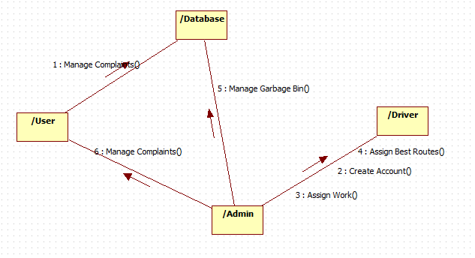

**4.1.4 Class Diagram:**



**4.1.4 Activity Diagram:**

# 

**4.1.5 Data Flow Diagram:**

**0-Level DFD**

Create Complaint

Use

**Manage Bin Details**

**App User**

**1-LEVEL DFD**

**App User**

All database

**2-Level Admin DFD**

Admin Login

Manage Bin/driver

Update Complaint Status

2 **Level User DFD**

Logout

View User Details

View Work Status

User Register/ Login

Create Complaints

View Complaint Status

Logout

My Profile

CHAPTER 5 - OUTPUT SCREENSHOTS

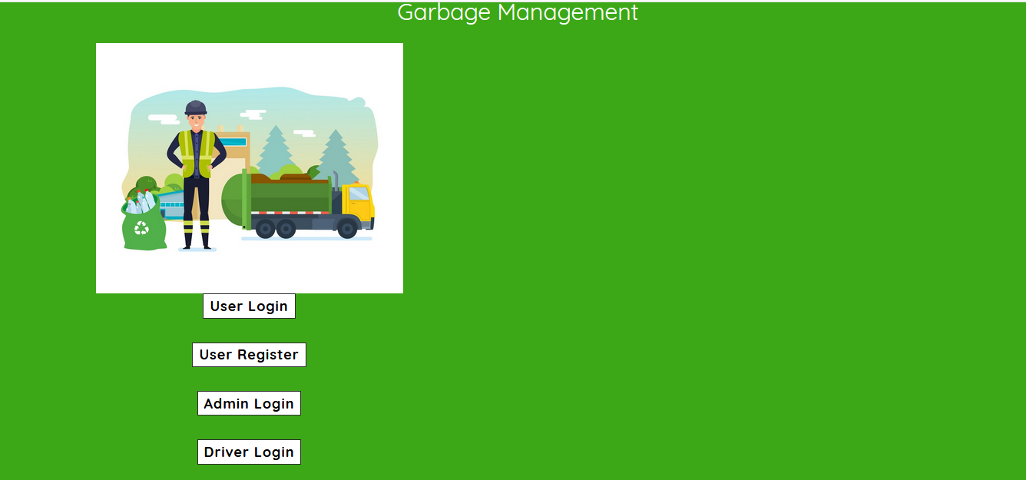

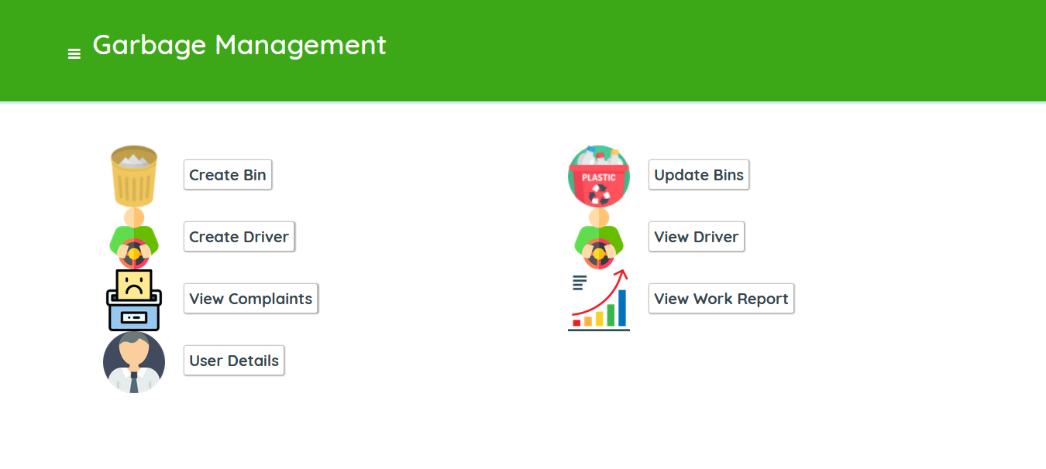

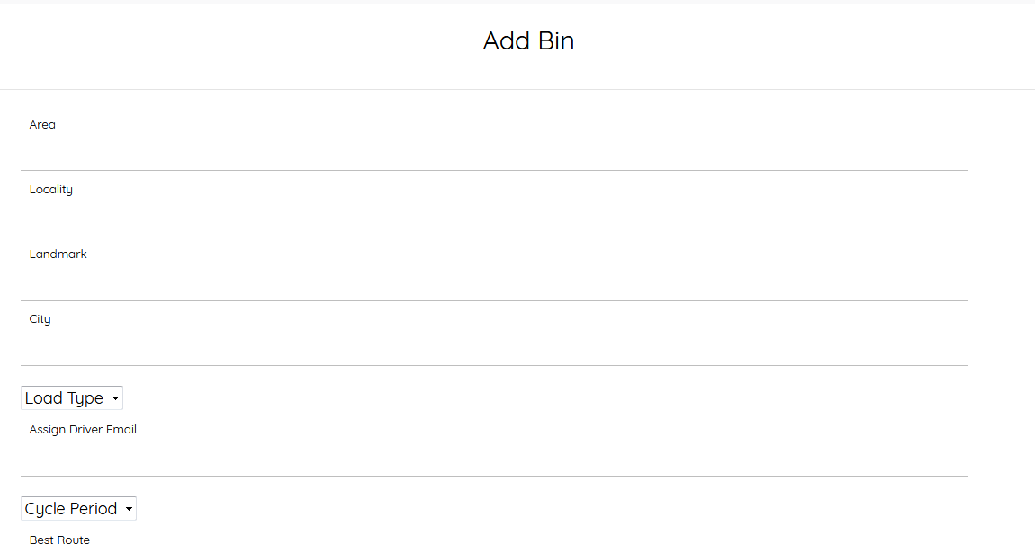

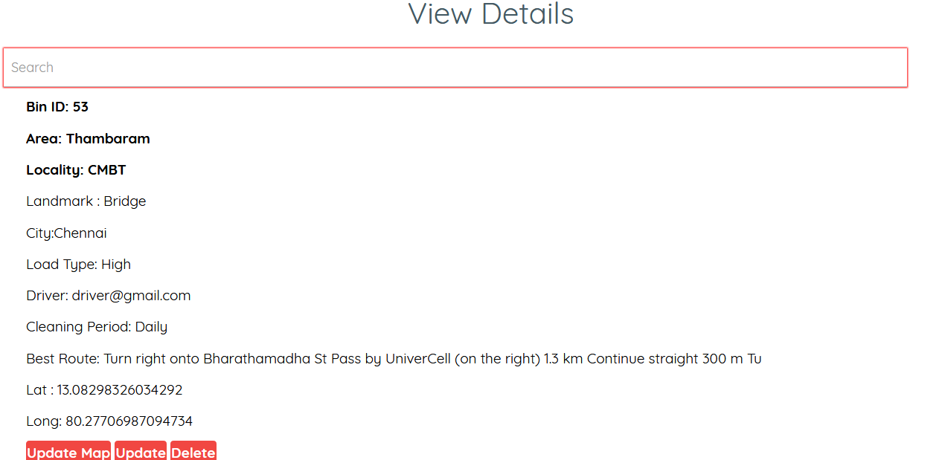

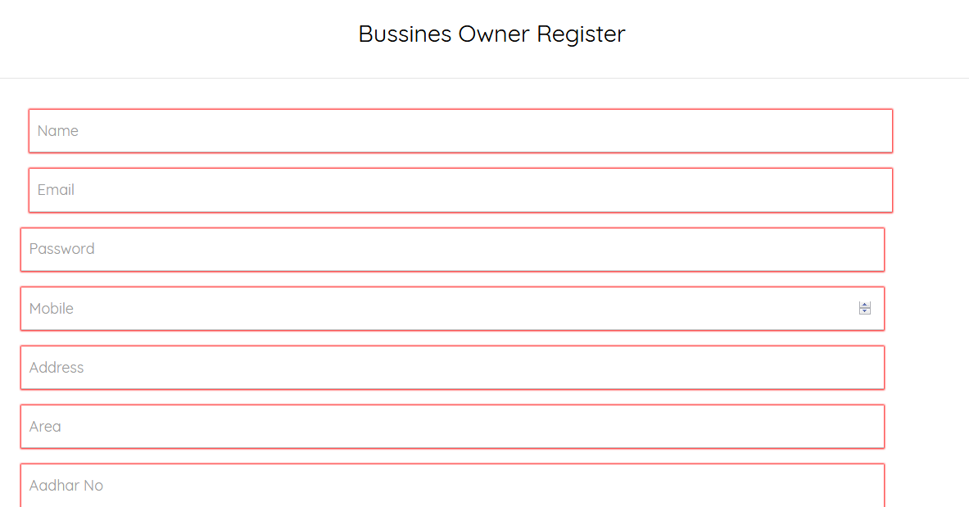

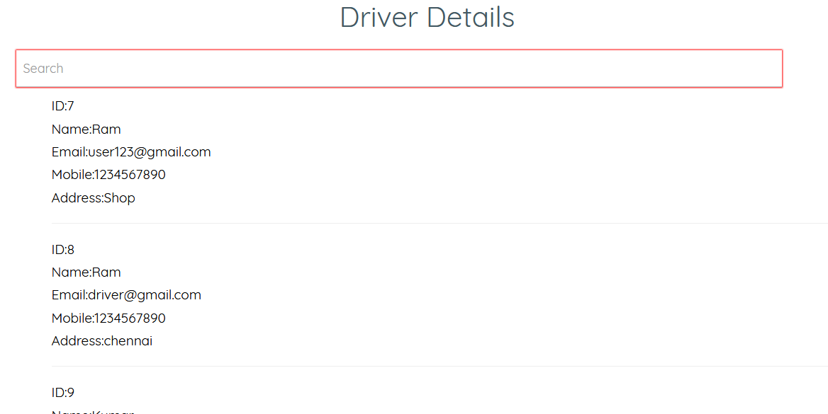

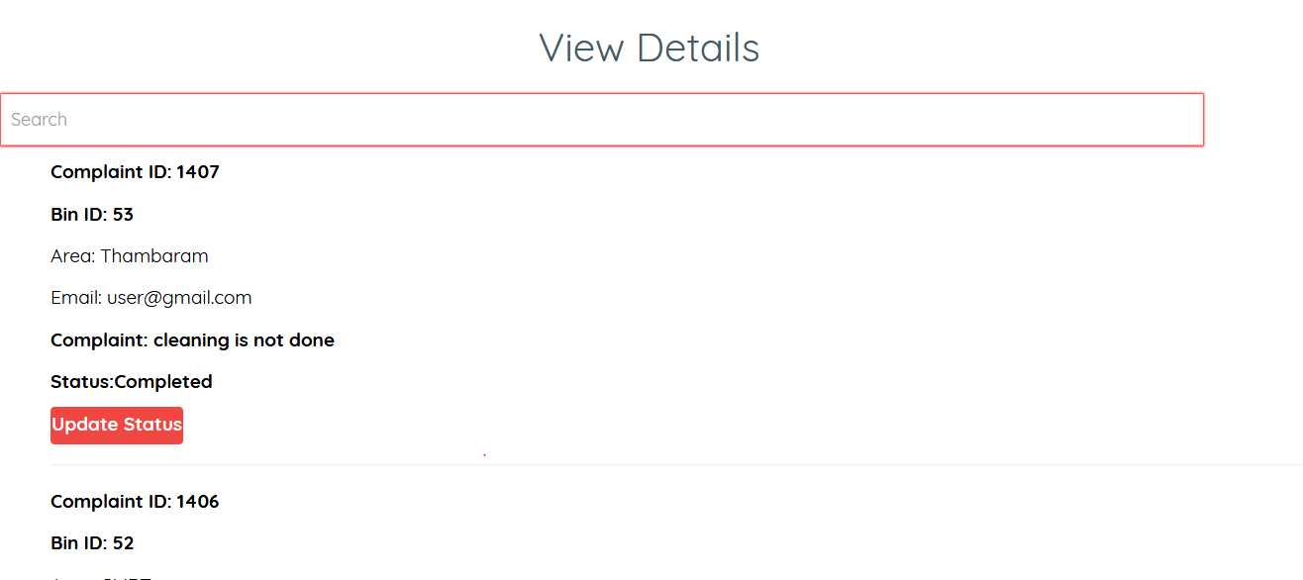

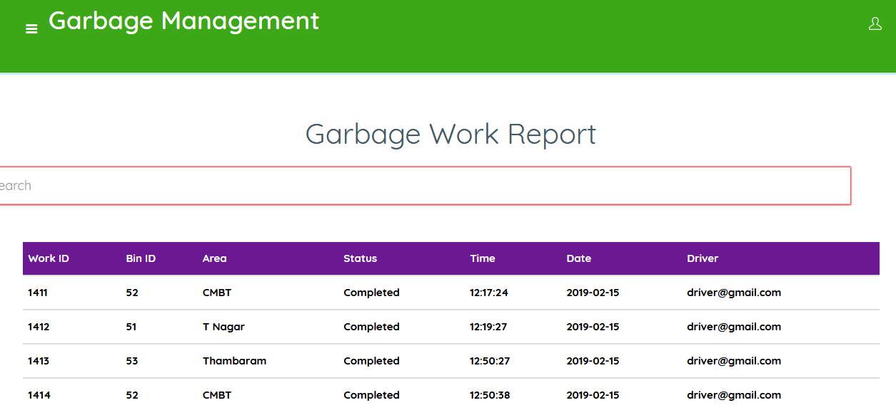

# CHAPTER 6 – IMPLEMENTATION DETAILS

## 6.1 Introduction to Html Framework

Hyper Text Markup Language, commonly referred to as HTML, is the standard [markup language](https://en.wikipedia.org/wiki/Markup_language) used to create [web pages](https://en.wikipedia.org/wiki/Web_page). Along with [CSS](https://en.wikipedia.org/wiki/Cascading_Style_Sheets), and [JavaScript](https://en.wikipedia.org/wiki/JavaScript), HTML is a cornerstone technology used to create web pages, as well as to create user interfaces for mobile and [web applications](https://en.wikipedia.org/wiki/Web_applications). [Web browsers](https://en.wikipedia.org/wiki/Web_browser) can read HTML files and render them into visible or audible web pages. HTML describes the structure of a [website](https://en.wikipedia.org/wiki/Website) [semantically](https://en.wikipedia.org/wiki/Semantic) along with cues for presentation, making it a markup language, rather than a [programming language](https://en.wikipedia.org/wiki/Programming_language).

[HTML elements](https://en.wikipedia.org/wiki/HTML_element) form the building blocks of HTML pages. HTML allows [images](https://en.wikipedia.org/wiki/Img_(HTML_element)) and other objects to be embedded and it can be used to create [interactive forms](https://en.wikipedia.org/wiki/Fieldset). It provides a means to create [structured documents](https://en.wikipedia.org/wiki/Structured_document) by denoting structural semantics for text such as headings, paragraphs, lists, [links](https://en.wikipedia.org/wiki/Hyperlink), quotes and other items. HTML elements are delineated by tags, written using [angle brackets](https://en.wikipedia.org/wiki/Bracket#Angle_brackets). Tags such as <img /> and <input /> introduce content into the page directly. Others such as <p>...</p> surround and provide information about document text and may include other tags as sub-elements. Browsers do not display the HTML tags, but use them to interpret the content of the page.

HTML can embed [scripts](https://en.wikipedia.org/wiki/Scripting_language) written in languages such as [JavaScript](https://en.wikipedia.org/wiki/JavaScript) which affect the behavior of HTML web pages. HTML markup can also refer the browser to [Cascading Style Sheets](https://en.wikipedia.org/wiki/Cascading_Style_Sheets) (CSS) to define the look and layout of text and other material.

HyperText Markup Language (HTML) is the standard [markup language](https://en.wikipedia.org/wiki/Markup_language) for creating [web pages](https://en.wikipedia.org/wiki/Web_page) and [web applications](https://en.wikipedia.org/wiki/Web_application). With [Cascading Style Sheets](https://en.wikipedia.org/wiki/Cascading_Style_Sheets) (CSS) and [JavaScript](https://en.wikipedia.org/wiki/JavaScript) it forms a triad of cornerstone technologies for the [World Wide Web](https://en.wikipedia.org/wiki/World_Wide_Web).[[1]](https://en.wikipedia.org/wiki/HTML#cite_note-1) [Web browsers](https://en.wikipedia.org/wiki/Web_browser) receive HTML documents from a [webserver](https://en.wikipedia.org/wiki/Webserver) or from local storage and render them into multimedia web pages. HTML describes the structure of a web page [semantically](https://en.wikipedia.org/wiki/Semantic) and originally included cues for the appearance of the document.

[HTML elements](https://en.wikipedia.org/wiki/HTML_element) are the building blocks of HTML pages. With HTML constructs, [images](https://en.wikipedia.org/wiki/Img_%28HTML_element%29) and other objects, such as [interactive forms,](https://en.wikipedia.org/wiki/Fieldset) may be embedded into the rendered page. It provides a means to create [structured documents](https://en.wikipedia.org/wiki/Structured_document) by denoting structural [semantics](https://en.wikipedia.org/wiki/Semantics) for text such as headings, paragraphs, lists, [links](https://en.wikipedia.org/wiki/Hyperlink), quotes and other items. HTML elements are delineated by tags, written using [angle brackets](https://en.wikipedia.org/wiki/Bracket#Angle_brackets). Tags such as <img /> and <input /> introduce content into the page directly. Others such as <p>...</p> surround and provide information about document text and may include other tags as sub-elements. Browsers do not display the HTML tags, but use them to interpret the content of the page.

HTML can embed programs written in a [scripting language](https://en.wikipedia.org/wiki/Scripting_language) such as [JavaScript](https://en.wikipedia.org/wiki/JavaScript) which affect the behavior and content of web pages. Inclusion of CSS defines the look and layout of content. The [World Wide Web Consortium](https://en.wikipedia.org/wiki/World_Wide_Web_Consortium) (W3C), maintainer of both the HTML and the CSS standards, has encouraged the use of CSS over explicit presentational HTML since 1997.[[2]](https://en.wikipedia.org/wiki/HTML#cite_note-deprecated-2)

In 1980, physicist [Tim Berners-Lee](https://en.wikipedia.org/wiki/Tim_Berners-Lee), a contractor at [CERN](https://en.wikipedia.org/wiki/CERN), proposed and prototyped [ENQUIRE](https://en.wikipedia.org/wiki/ENQUIRE), a system for CERN researchers to use and share documents. In 1989, Berners-Lee wrote a memo proposing an [Internet](https://en.wikipedia.org/wiki/Internet)-based [hypertext](https://en.wikipedia.org/wiki/Hypertext) system.[[3]](https://en.wikipedia.org/wiki/HTML#cite_note-3) Berners-Lee specified HTML and wrote the browser and server software in late 1990. That year, Berners-Lee and CERN data systems engineer [Robert Cailliau](https://en.wikipedia.org/wiki/Robert_Cailliau) collaborated on a joint request for funding, but the project was not formally adopted by CERN. In his personal notes[[4]](https://en.wikipedia.org/wiki/HTML#cite_note-4) from 1990 he listed[[5]](https://en.wikipedia.org/wiki/HTML#cite_note-5) "some of the many areas in which hypertext is used" and put an encyclopedia first.

The first publicly available description of HTML was a document called "HTML Tags", first mentioned on the Internet by Tim Berners-Lee in late 1991.[[6]](https://en.wikipedia.org/wiki/HTML#cite_note-tagshtml-6)[[7]](https://en.wikipedia.org/wiki/HTML#cite_note-7) It describes 18 elements comprising the initial, relatively simple design of HTML. Except for the hyperlink tag, these were strongly influenced by [SGMLguid](https://en.wikipedia.org/wiki/SGMLguid), an in-house [Standard Generalized Markup Language](https://en.wikipedia.org/wiki/Standard_Generalized_Markup_Language) (SGML)-based documentation format at CERN. Eleven of these elements still exist in HTML 4.[[8]](https://en.wikipedia.org/wiki/HTML#cite_note-8)

HTML is a [markup language](https://en.wikipedia.org/wiki/Markup_language) that [web browsers](https://en.wikipedia.org/wiki/Web_browser) use to interpret and [compose](https://en.wikipedia.org/wiki/Typesetting) text, images, and other material into visual or audible web pages. Default characteristics for every item of HTML markup are defined in the browser, and these characteristics can be altered or enhanced by the web page designer's additional use of [CSS](https://en.wikipedia.org/wiki/Cascading_Style_Sheets). Many of the text elements are found in the 1988 ISO technical report TR 9537 Techniques for using SGML, which in turn covers the features of early text formatting languages such as that used by the [RUNOFF command](https://en.wikipedia.org/wiki/TYPSET_and_RUNOFF) developed in the early 1960s for the [CTSS](https://en.wikipedia.org/wiki/Compatible_Time-Sharing_System) (Compatible Time-Sharing System) operating system: these formatting commands were derived from the commands used by typesetters to manually format documents. However, the SGML concept of generalized markup is based on elements (nested annotated ranges with attributes) rather than merely print effects, with also the separation of structure and markup; HTML has been progressively moved in this direction with CSS.

Berners-Lee considered HTML to be an application of SGML. It was formally defined as such by the [Internet Engineering Task Force](https://en.wikipedia.org/wiki/Internet_Engineering_Task_Force) (IETF) with the mid-1993 publication of the first proposal for an HTML specification, the "Hypertext Markup Language (HTML)" Internet Draft by Berners-Lee and [Dan Connolly](https://en.wikipedia.org/wiki/Dan_Connolly_%28computer_scientist%29), which included an SGML [Document Type Definition](https://en.wikipedia.org/wiki/Document_Type_Definition) to define the grammar.[[9]](https://en.wikipedia.org/wiki/HTML#cite_note-9)[[10]](https://en.wikipedia.org/wiki/HTML#cite_note-10) The draft expired after six months, but was notable for its acknowledgment of the [NCSA Mosaic](https://en.wikipedia.org/wiki/Mosaic_%28web_browser%29) browser's custom tag for embedding in-line images, reflecting the IETF's philosophy of basing standards on successful prototypes.[[11]](https://en.wikipedia.org/wiki/HTML#cite_note-raymond-11) Similarly, [Dave Raggett](https://en.wikipedia.org/wiki/Dave_Raggett)'s competing Internet-Draft, "HTML+ (Hypertext Markup Format)", from late 1993, suggested standardizing already-implemented features like tables and fill-out forms.[[12]](https://en.wikipedia.org/wiki/HTML#cite_note-html.2B-12)

After the HTML and HTML+ drafts expired in early 1994, the IETF created an HTML Working Group, which in 1995 completed "HTML 2.0", the first HTML specification intended to be treated as a standard against which future implementations should be based.[[13]](https://en.wikipedia.org/wiki/HTML#cite_note-13)

Further development under the auspices of the IETF was stalled by competing interests. Since 1996, the HTML specifications have been maintained, with input from commercial software vendors, by the [World Wide Web Consortium](https://en.wikipedia.org/wiki/World_Wide_Web_Consortium) (W3C).[[14]](https://en.wikipedia.org/wiki/HTML#cite_note-raggett-14) However, in 2000, HTML also became an international standard ([ISO](https://en.wikipedia.org/wiki/International_Organization_for_Standardization)/[IEC](https://en.wikipedia.org/wiki/International_Electrotechnical_Commission) 15445:2000). HTML 4.01 was published in late 1999, with further errata published through 2001. In 2004, development began on HTML5 in the [Web Hypertext Application Technology Working Group](https://en.wikipedia.org/wiki/Web_Hypertext_Application_Technology_Working_Group) (WHATWG), which became a joint deliverable with the W3C in 2008, and completed and standardized on 28 October 2014.[[15]](https://en.wikipedia.org/wiki/HTML#cite_note-15)

## 6.2 Cascading Style Sheets (CSS)

CSS is a [style sheet language](https://en.wikipedia.org/wiki/Style_sheet_language) used for describing the [presentation](https://en.wikipedia.org/wiki/Presentation_semantics) of a document written in a [markup language](https://en.wikipedia.org/wiki/Markup_language). Although most often used to set the visual style of [web pages](https://en.wikipedia.org/wiki/Web_page) and user interfaces written in [HTML](https://en.wikipedia.org/wiki/HTML) and [XHTML](https://en.wikipedia.org/wiki/XHTML), the language can be applied to any [XML](https://en.wikipedia.org/wiki/XML) document, including [plain XML](https://en.wikipedia.org/wiki/Plain_Old_XML), [SVG](https://en.wikipedia.org/wiki/Scalable_Vector_Graphics) and[XUL](https://en.wikipedia.org/wiki/XUL), and is applicable to rendering in [speech](https://en.wikipedia.org/wiki/Speech_synthesis), or on other media. Along with HTML and [JavaScript](https://en.wikipedia.org/wiki/JavaScript), CSS is a cornerstone technology used by most websites to create visually engaging webpages, user interfaces for [web applications](https://en.wikipedia.org/wiki/Web_applications), and user interfaces for many mobile applications.

CSS is designed primarily to enable [the separation of document content from document presentation](https://en.wikipedia.org/wiki/Separation_of_presentation_and_content), including aspects such as the [layout](https://en.wikipedia.org/wiki/Page_layout), [colors](https://en.wikipedia.org/wiki/Color), and [fonts](https://en.wikipedia.org/wiki/Typeface). This separation can improve content [accessibility](https://en.wikipedia.org/wiki/Accessibility), provide more flexibility and control in the specification of presentation characteristics, enable multiple HTML pages to share formatting by specifying the relevant CSS in a separate .css file, and reduce complexity and repetition in the structural content, such as [semantically insignificant tables](https://en.wikipedia.org/wiki/Tableless_web_design) that were widely used to format pages before consistent CSS rendering was available in all major browsers. CSS makes it possible to separate presentation instructions from the HTML content in a separate file or style section of the HTML file. For each matching [HTML element](https://en.wikipedia.org/wiki/HTML_element), it provides a list of formatting instructions. For example, a CSS rule might specify that "all heading 1 elements should be [bold](https://en.wikipedia.org/wiki/Bold)", leaving pure semantic HTML markup that asserts "this text is a level 1 heading" without formatting code such as a<bold> tag indicating how such text should be displayed.

This separation of formatting and content makes it possible to present the same markup page in different styles for different rendering methods, such as on-screen, in print, by voice (when read out by a speech-based browser or[screen reader](https://en.wikipedia.org/wiki/Screen_reader)) and on [Braille-based](https://en.wikipedia.org/wiki/Braille_display), tactile devices. It can also be used to display the web page differently depending on the screen size or device on which it is being viewed. Although the author of a web page typically links to a CSS file within the markup file, readers can specify a different style sheet, such as a CSS file stored on their own computer, to override the one the author has specified. If the author or the reader did not link the document to a style sheet, the default style of the browser will be applied. Another advantage of CSS is that aesthetic changes to the [graphic design](https://en.wikipedia.org/wiki/Graphic_design) of a document (or hundreds of documents) can be applied quickly and easily, by editing a few lines in one file, rather than by a laborious (and thus expensive) process of crawling over every document line by line, changing markup.

The CSS specification describes a priority scheme to determine which style rules apply if more than one rule matches against a particular element. In this so-called cascade, priorities (or weights) are calculated and assigned to rules, so that the results are predictable.

Cascading Style Sheets (CSS) is a [style sheet language](https://en.wikipedia.org/wiki/Style_sheet_language) used for describing the [presentation](https://en.wikipedia.org/wiki/Presentation_semantics) of a document written in a [markup language](https://en.wikipedia.org/wiki/Markup_language).[[1]](https://en.wikipedia.org/wiki/Cascading_Style_Sheets#cite_note-1) Although most often used to set the visual style of [web pages](https://en.wikipedia.org/wiki/Web_page) and user interfaces written in [HTML](https://en.wikipedia.org/wiki/HTML) and [XHTML](https://en.wikipedia.org/wiki/XHTML), the language can be applied to any [XML](https://en.wikipedia.org/wiki/XML) document, including [plain XML](https://en.wikipedia.org/wiki/Plain_Old_XML), [SVG](https://en.wikipedia.org/wiki/Scalable_Vector_Graphics) and [XUL](https://en.wikipedia.org/wiki/XUL), and is applicable to rendering in [speech](https://en.wikipedia.org/wiki/Speech_synthesis), or on other media. Along with HTML and [JavaScript](https://en.wikipedia.org/wiki/JavaScript), CSS is a cornerstone technology used by most websites to create visually engaging webpages, user interfaces for [web applications](https://en.wikipedia.org/wiki/Web_applications), and user interfaces for many mobile applications.[[2]](https://en.wikipedia.org/wiki/Cascading_Style_Sheets#cite_note-2)

CSS is designed primarily to enable [the separation of document content from document presentation](https://en.wikipedia.org/wiki/Separation_of_presentation_and_content), including aspects such as the [layout](https://en.wikipedia.org/wiki/Page_layout), [colors](https://en.wikipedia.org/wiki/Color), and [fonts](https://en.wikipedia.org/wiki/Typeface).[[3]](https://en.wikipedia.org/wiki/Cascading_Style_Sheets#cite_note-3) This separation can improve content [accessibility](https://en.wikipedia.org/wiki/Accessibility), provide more flexibility and control in the specification of presentation characteristics, enable multiple HTML pages to share formatting by specifying the relevant CSS in a separate .css file, and reduce complexity and repetition in the structural content.

Separation of formatting and content makes it possible to present the same markup page in different styles for different rendering methods, such as on-screen, in print, by voice (via speech-based browser or [screen reader](https://en.wikipedia.org/wiki/Screen_reader)), and on [Braille-based](https://en.wikipedia.org/wiki/Braille_display) tactile devices. It can also display the web page differently depending on the screen size or viewing device. Readers can also specify a different style sheet, such as a CSS file stored on their own computer, to override the one the author specified.

Changes to the [graphic design](https://en.wikipedia.org/wiki/Graphic_design) of a document (or hundreds of documents) can be applied quickly and easily, by editing a few lines in the CSS file they use, rather than by changing markup in the documents.

The CSS specification describes a priority scheme to determine which style rules apply if more than one rule matches against a particular element. In this so-called cascade, priorities (or weights) are calculated and assigned to rules, so that the results are predictable.

The CSS specifications are maintained by the [World Wide Web Consortium](https://en.wikipedia.org/wiki/World_Wide_Web_Consortium) (W3C). Internet media type ([MIME type](https://en.wikipedia.org/wiki/MIME_media_type)) text/css is registered for use with CSS by [RFC 2318](https://tools.ietf.org/html/rfc2318) (March 1998). The W3C operates a free [CSS validation service](https://en.wikipedia.org/wiki/W3C_Markup_Validation_Service#CSS_validation) for CSS documents.

In CSS, selectors declare which part of the markup a style applies to by matching tags and attributes in the markup itself.

Selectors may apply to:

all [elements](https://en.wikipedia.org/wiki/HTML_element) of a specific type, e.g. the second-level headers [h2](https://en.wikipedia.org/wiki/HTML_element#Basic_text)

elements specified by [attribute](https://en.wikipedia.org/wiki/HTML_attribute), in particular:

id: an identifier unique within the document

class: an identifier that can annotate multiple elements in a document

elements depending on how they are placed relative to others in the [document tree](https://en.wikipedia.org/wiki/Document_Object_Model).

Classes and IDs are case-sensitive, start with letters, and can include alphanumeric characters and underscores. A class may apply to any number of instances of any elements. An ID may only be applied to a single element.

Pseudo-classes are used in CSS selectors to permit formatting based on information that is not contained in the document tree. One example of a widely used pseudo-class is :hover, which identifies content only when the user "points to" the visible element, usually by holding the mouse cursor over it. It is appended to a selector as in a:hover or #elementid:hover. A pseudo-class classifies document elements, such as :link or :visited, whereas a pseudo-element makes a selection that may consist of partial elements, such as ::first-line or ::first-letter.[[5]](https://en.wikipedia.org/wiki/Cascading_Style_Sheets#cite_note-5)

Selectors may be combined in many ways to achieve great specificity and flexibility.[[6]](https://en.wikipedia.org/wiki/Cascading_Style_Sheets#cite_note-6) Multiple selectors may be joined in a spaced list to specify elements by location, element type, id, class, or any combination thereof. The order of the selectors is important. For example, div .myClass {color: red;} applies to all elements of class myClass that are inside div elements, whereas .myClass div {color: red;} applies to all div elements that are in elements of class myClass.

CSS information can be provided from various sources. These sources can be the web browser, the user and the author. The information from the author can be further classified into inline, media type, importance, selector specificity, rule order, inheritance and property definition. CSS style information can be in a separate document or it can be embedded into an HTML document. Multiple style sheets can be imported. Different styles can be applied depending on the output device being used; for example, the screen version can be quite different from the printed version, so that authors can tailor the presentation appropriately for each medium.

The style sheet with the highest priority controls the content display. Declarations not set in the highest priority source are passed on to a source of lower priority, such as the user agent style. This process is called cascading.

One of the goals of CSS is to allow users greater control over presentation. Someone who finds red italic headings difficult to read may apply a different style sheet. Depending on the browser and the web site, a user may choose from various style sheets provided by the designers, or may remove all added styles and view the site using the browser's default styling, or may override just the red italic heading style without altering other attributes.

CSS was first proposed by [Håkon Wium Lie](https://en.wikipedia.org/wiki/H%C3%A5kon_Wium_Lie) on October 10, 1994.[[16]](https://en.wikipedia.org/wiki/Cascading_Style_Sheets#cite_note-chss-proposal-16) At the time, Lie was working with [Tim Berners-Lee](https://en.wikipedia.org/wiki/Tim_Berners-Lee) at [CERN](https://en.wikipedia.org/wiki/CERN).[[17]](https://en.wikipedia.org/wiki/Cascading_Style_Sheets#cite_note-chapter20-17) Several other style sheet languages for the web were proposed around the same time, and discussions on public mailing lists and inside [World Wide Web Consortium](https://en.wikipedia.org/wiki/World_Wide_Web_Consortium) resulted in the first W3C CSS Recommendation (CSS1)[[18]](https://en.wikipedia.org/wiki/Cascading_Style_Sheets#cite_note-w3c-css1-18) being released in 1996. In particular, [Bert Bos](https://en.wikipedia.org/wiki/Bert_Bos)' proposal was influential; he became co-author of CSS1 and is regarded as co-creator of CSS.[[19]](https://en.wikipedia.org/wiki/Cascading_Style_Sheets#cite_note-WWW3-19)

Style sheets have existed in one form or another since the beginnings of Standard Generalized Markup Language ([SGML](https://en.wikipedia.org/wiki/SGML)) in the 1980s, and CSS was developed to provide style sheets for the web.[[20]](https://en.wikipedia.org/wiki/Cascading_Style_Sheets#cite_note-css-phd-20) One requirement for a web style sheet language was for style sheets to come from different sources on the web. Therefore, existing style sheet languages like [DSSSL](https://en.wikipedia.org/wiki/Document_Style_Semantics_and_Specification_Language) and [FOSI](https://en.wikipedia.org/wiki/Formatting_Output_Specification_Instance) were not suitable. CSS, on the other hand, let a document's style be influenced by multiple style sheets by way of "cascading" styles.[[20]](https://en.wikipedia.org/wiki/Cascading_Style_Sheets#cite_note-css-phd-20)

As [HTML](https://en.wikipedia.org/wiki/HTML) grew, it came to encompass a wider variety of stylistic capabilities to meet the demands of [web developers](https://en.wikipedia.org/wiki/Web_development). This evolution gave the designer more control over site appearance, at the cost of more complex HTML. Variations in [web browser](https://en.wikipedia.org/wiki/Web_browser) implementations, such as [ViolaWWW](https://en.wikipedia.org/wiki/ViolaWWW) and [WorldWideWeb](https://en.wikipedia.org/wiki/WorldWideWeb),[[21]](https://en.wikipedia.org/wiki/Cascading_Style_Sheets#cite_note-IEEE-21) made consistent site appearance difficult, and users had less control over how web content was displayed. The browser/editor developed by Tim Berners-Lee had style sheets that were hard-coded into the program. The style sheets could therefore not be linked to documents on the web.[[22]](https://en.wikipedia.org/wiki/Cascading_Style_Sheets#cite_note-cssdftw-22) [Robert Cailliau](https://en.wikipedia.org/wiki/Robert_Cailliau), also of CERN, wanted to separate the structure from the presentation so that different style sheets could describe different presentation for printing, screen-based presentations, and editors.[[21]](https://en.wikipedia.org/wiki/Cascading_Style_Sheets#cite_note-IEEE-21)

Improving web presentation capabilities was a topic of interest to many in the web community and nine different style sheet languages were proposed on the www-style mailing list.[[20]](https://en.wikipedia.org/wiki/Cascading_Style_Sheets#cite_note-css-phd-20) Of these nine proposals, two were especially influential on what became CSS: Cascading HTML Style Sheets[[16]](https://en.wikipedia.org/wiki/Cascading_Style_Sheets#cite_note-chss-proposal-16) and Stream-based Style Sheet Proposal (SSP).[[19]](https://en.wikipedia.org/wiki/Cascading_Style_Sheets#cite_note-WWW3-19)[[23]](https://en.wikipedia.org/wiki/Cascading_Style_Sheets#cite_note-ssp-23) Two browsers served as testbeds for the initial proposals; Lie worked with [Yves Lafon](https://en.wikipedia.org/w/index.php?title=Yves_Lafon&action=edit&redlink=1) to implement CSS in [Dave Raggett](https://en.wikipedia.org/wiki/Dave_Raggett)'s [Arena](https://en.wikipedia.org/wiki/Arena_%28web_browser%29) browser.[[24]](https://en.wikipedia.org/wiki/Cascading_Style_Sheets#cite_note-24)[[25]](https://en.wikipedia.org/wiki/Cascading_Style_Sheets#cite_note-25)[[26]](https://en.wikipedia.org/wiki/Cascading_Style_Sheets#cite_note-26) [Bert Bos](https://en.wikipedia.org/wiki/Bert_Bos) implemented his own SSP proposal in the [Argo](https://en.wikipedia.org/wiki/Argo_%28web_browser%29) browser.[[19]](https://en.wikipedia.org/wiki/Cascading_Style_Sheets#cite_note-WWW3-19) Thereafter, Lie and Bos worked together to develop the CSS standard (the 'H' was removed from the name because these style sheets could also be applied to other markup languages besides HTML).[[17]](https://en.wikipedia.org/wiki/Cascading_Style_Sheets#cite_note-chapter20-17)

Lie's proposal was presented at the "[Mosaic and the Web](https://en.wikipedia.org/w/index.php?title=Mosaic_and_the_Web&action=edit&redlink=1)" conference (later called WWW2) in [Chicago, Illinois](https://en.wikipedia.org/wiki/Chicago,_Illinois) in 1994, and again with Bert Bos in 1995.[[17]](https://en.wikipedia.org/wiki/Cascading_Style_Sheets#cite_note-chapter20-17) Around this time the W3C was already being established, and took an interest in the development of CSS. It organized a workshop toward that end chaired by [Steven Pemberton](https://en.wikipedia.org/wiki/Steven_Pemberton). This resulted in W3C adding work on CSS to the deliverables of the HTML editorial review board (ERB). Lie and Bos were the primary technical staff on this aspect of the project, with additional members, including [Thomas Reardon](https://en.wikipedia.org/wiki/Thomas_Reardon) of [Microsoft](https://en.wikipedia.org/wiki/Microsoft), participating as well. In August 1996 [Netscape Communication Corporation](https://en.wikipedia.org/wiki/Netscape) presented an alternative style sheet language called [JavaScript Style Sheets](https://en.wikipedia.org/wiki/JavaScript_Style_Sheets) (JSSS).[[17]](https://en.wikipedia.org/wiki/Cascading_Style_Sheets#cite_note-chapter20-17) The spec was never finished and is deprecated.[[27]](https://en.wikipedia.org/wiki/Cascading_Style_Sheets#cite_note-27) By the end of 1996, CSS was ready to become official, and the CSS level 1 Recommendation was published in December.

Development of HTML, CSS, and the [DOM](https://en.wikipedia.org/wiki/Document_Object_Model) had all been taking place in one group, the HTML Editorial Review Board (ERB). Early in 1997, the ERB was split into three [working groups](https://en.wikipedia.org/wiki/Working_group): [HTML Working group](https://en.wikipedia.org/wiki/HTML_Working_group), chaired by [Dan Connolly](https://en.wikipedia.org/wiki/Dan_Connolly_%28computer_scientist%29) of W3C; DOM Working group, chaired by Lauren Wood of [SoftQuad](https://en.wikipedia.org/wiki/SoftQuad); and [CSS Working group](https://en.wikipedia.org/wiki/CSS_Working_group), chaired by [Chris Lilley](https://en.wikipedia.org/wiki/Chris_Lilley_%28W3C%29) of W3C.

The CSS Working Group began tackling issues that had not been addressed with CSS level 1, resulting in the creation of CSS level 2 on November 4, 1997. It was published as a W3C Recommendation on May 12, 1998. CSS level 3, which was started in 1998, is still under development as of 2014.

In 2005 the CSS Working Groups decided to enforce the requirements for standards more strictly. This meant that already published standards like CSS 2.1, CSS 3 Selectors and CSS 3 Text were pulled back from Candidate Recommendation to Working Draft level.

## 6.3 MYSQL Server

MySQL  is an [open-source](https://en.wikipedia.org/wiki/Open-source) [relational database management system](https://en.wikipedia.org/wiki/Relational_database_management_system) (RDBMS);[[6]](https://en.wikipedia.org/wiki/MySQL#cite_note-6) in July 2013, it was the world's second most widely used RDBMS, and the most widely used open-source [client–server model](https://en.wikipedia.org/wiki/Client%E2%80%93server_model) RDBMS. It is named after co-founder [Michael Widenius](https://en.wikipedia.org/wiki/Michael_Widenius)'s daughter, My. The [SQL](https://en.wikipedia.org/wiki/SQL) acronym stands for [Structured Query Language](https://en.wikipedia.org/wiki/Structured_Query_Language). The MySQL development project has made its [source code](https://en.wikipedia.org/wiki/Source_code) available under the terms of the [GNU General Public License](https://en.wikipedia.org/wiki/GNU_General_Public_License), as well as under a variety of [proprietary](https://en.wikipedia.org/wiki/Proprietary_software) agreements. MySQL was owned and sponsored by a single [for-profit](https://en.wikipedia.org/wiki/Business) firm, the [Swedish](https://en.wikipedia.org/wiki/Sweden)company [MySQL AB](https://en.wikipedia.org/wiki/MySQL_AB), now owned by [Oracle Corporation](https://en.wikipedia.org/wiki/Oracle_Corporation). For proprietary use, several paid editions are available, and offer additional functionality.

SQL Server Management Studio (SSMS) is a software application first launched with [Microsoft](https://en.wikipedia.org/wiki/Microsoft) [SQL Server 2005](https://en.wikipedia.org/wiki/Microsoft_SQL_Server) that is used for configuring, managing, and administering all components within [Microsoft SQL Server](https://en.wikipedia.org/wiki/Microsoft_SQL_Server). The tool includes both script editors and graphical tools which work with objects and features of the server.[[1]](https://en.wikipedia.org/wiki/SQL_Server_Management_Studio#cite_note-1)

A central feature of SSMS is the Object Explorer, which allows the user to browse, select, and act upon any of the objects within the server.[[2]](https://en.wikipedia.org/wiki/SQL_Server_Management_Studio#cite_note-2) It also shipped a separate Express edition that could be freely downloaded, however recent versions of SSMS are fully capable of connecting to and manage any SQL Server Express instance. Microsoft also incorporated backwards compatibility for older versions of SQL Server thus allowing a newer version of SSMS to connect to older versions of SQL Server instances.

Starting from version 11, the application was based on the [Visual Studio 2010](https://en.wikipedia.org/wiki/Visual_Studio_2010) shell, using [WPF](https://en.wikipedia.org/wiki/Windows_Presentation_Foundation) for the user interface.

In June 2015, Microsoft announced their intention to release future versions of SSMS independently of SQL Server database engine releases.[[3]](https://en.wikipedia.org/wiki/SQL_Server_Management_Studio#cite_note-3).

## 6.4PHP

PHP is a [server-side scripting](https://en.wikipedia.org/wiki/Server-side_scripting) language designed for [web development](https://en.wikipedia.org/wiki/Web_development) but also used as a [general-purpose programming language](https://en.wikipedia.org/wiki/General-purpose_programming_language). Originally created by [RasmusLerdorf](https://en.wikipedia.org/wiki/Rasmus_Lerdorf) in 1994, the PHP [reference implementation](https://en.wikipedia.org/wiki/Reference_implementation) is now produced by The PHP Group. PHP originally stood for Personal Home Page, but it now stands for the[recursive](https://en.wikipedia.org/wiki/Recursive_acronym) [backronym](https://en.wikipedia.org/wiki/Backronym) PHP: Hypertext Preprocessor.

PHP code may be embedded into [HTML](https://en.wikipedia.org/wiki/HTML) code, or it can be used in combination with various [web template systems](https://en.wikipedia.org/wiki/Web_template_system), web content management system and [web frameworks](https://en.wikipedia.org/wiki/Web_framework). PHP code is usually processed by a PHP[interpreter](https://en.wikipedia.org/wiki/Interpreter_(computing)) implemented as a [module](https://en.wikipedia.org/wiki/Plugin_(computing)) in the web server or as a [Common Gateway Interface](https://en.wikipedia.org/wiki/Common_Gateway_Interface) (CGI) executable. The web server combines the results of the interpreted and executed PHP code, which may be any type of data, including images, with the generated web page. PHP code may also be executed with a [command-line interface](https://en.wikipedia.org/wiki/Command-line_interface)(CLI) and can be used to implement [standalone](https://en.wikipedia.org/wiki/Computer_software) [graphical applications](https://en.wikipedia.org/wiki/Graphical_user_interface).

The standard PHP interpreter, powered by the [Zend Engine](https://en.wikipedia.org/wiki/Zend_Engine), is [free software](https://en.wikipedia.org/wiki/Free_software) released under the [PHP License](https://en.wikipedia.org/wiki/PHP_License). PHP has been widely ported and can be deployed on most web servers on almost every [operating system](https://en.wikipedia.org/wiki/Operating_system) and[platform](https://en.wikipedia.org/wiki/Computing_platform), free of charge.

The PHP language evolved without a written [formal specification](https://en.wikipedia.org/wiki/Formal_specification) or standard until 2014, leaving the canonical PHP interpreter as a [de facto](https://en.wikipedia.org/wiki/De_facto) standard. Since 2014 work has gone on to create a formal PHP specification.

PHP is a [server-side scripting](https://en.wikipedia.org/wiki/Server-side_scripting) language designed primarily for [web development](https://en.wikipedia.org/wiki/Web_development) but also used as a [general-purpose programming language](https://en.wikipedia.org/wiki/General-purpose_programming_language). Originally created by [Rasmus Lerdorf](https://en.wikipedia.org/wiki/Rasmus_Lerdorf) in 1994,[[4]](https://en.wikipedia.org/wiki/PHP#cite_note-History_of_PHP-4) the PHP [reference implementation](https://en.wikipedia.org/wiki/Reference_implementation) is now produced by The PHP Development Team.[[5]](https://en.wikipedia.org/wiki/PHP#cite_note-about_PHP-5) PHP originally stood for Personal Home Page,[[4]](https://en.wikipedia.org/wiki/PHP#cite_note-History_of_PHP-4) but it now stands for the [recursive acronym](https://en.wikipedia.org/wiki/Recursive_acronym) PHP: Hypertext Preprocessor.[[6]](https://en.wikipedia.org/wiki/PHP#cite_note-6)

PHP code may be embedded into [HTML](https://en.wikipedia.org/wiki/HTML) or HTML5 code, or it can be used in combination with various [web template systems](https://en.wikipedia.org/wiki/Web_template_system), [web content management systems](https://en.wikipedia.org/wiki/Web_content_management_system) and [web frameworks](https://en.wikipedia.org/wiki/Web_framework). PHP code is usually processed by a PHP [interpreter](https://en.wikipedia.org/wiki/Interpreter_%28computing%29) implemented as a [module](https://en.wikipedia.org/wiki/Plugin_%28computing%29) in the web server or as a [Common Gateway Interface](https://en.wikipedia.org/wiki/Common_Gateway_Interface) (CGI) executable. The web server combines the results of the interpreted and executed PHP code, which may be any type of data, including images, with the generated web page. PHP code may also be executed with a [command-line interface](https://en.wikipedia.org/wiki/Command-line_interface) (CLI) and can be used to implement [standalone](https://en.wikipedia.org/wiki/Computer_software) [graphical applications](https://en.wikipedia.org/wiki/Graphical_user_interface).[[7]](https://en.wikipedia.org/wiki/PHP#cite_note-7)

The standard PHP interpreter, powered by the [Zend Engine](https://en.wikipedia.org/wiki/Zend_Engine), is [free software](https://en.wikipedia.org/wiki/Free_software) released under the [PHP License](https://en.wikipedia.org/wiki/PHP_License). PHP has been widely ported and can be deployed on most web servers on almost every [operating system](https://en.wikipedia.org/wiki/Operating_system) and [platform](https://en.wikipedia.org/wiki/Computing_platform), free of charge.[[8]](https://en.wikipedia.org/wiki/PHP#cite_note-foundations-8)

The PHP language evolved without a written [formal specification](https://en.wikipedia.org/wiki/Formal_specification) or standard until 2014, leaving the canonical PHP interpreter as a [de facto](https://en.wikipedia.org/wiki/De_facto) standard. Since 2014 work has gone on to create a formal PHP specification.[[9]](https://en.wikipedia.org/wiki/PHP#cite_note-9)

PHP development began in 1995 when [Rasmus Lerdorf](https://en.wikipedia.org/wiki/Rasmus_Lerdorf) wrote several [Common Gateway Interface](https://en.wikipedia.org/wiki/Common_Gateway_Interface) (CGI) programs in C,[[10]](https://en.wikipedia.org/wiki/PHP#cite_note-php_origins-10)[[11]](https://en.wikipedia.org/wiki/PHP#cite_note-11)[[12]](https://en.wikipedia.org/wiki/PHP#cite_note-12) which he used to maintain his [personal homepage](https://en.wikipedia.org/wiki/Personal_homepage). He extended them to work with [web forms](https://en.wikipedia.org/wiki/Web_form) and to communicate with [databases](https://en.wikipedia.org/wiki/Database), and called this implementation "Personal Home Page/Forms Interpreter" or PHP/FI.

PHP/FI could help to build simple, dynamic [web applications](https://en.wikipedia.org/wiki/Web_application). To accelerate [bug](https://en.wikipedia.org/wiki/Software_bug) reporting and to improve the code, Lerdorf initially announced the release of PHP/FI as "Personal Home Page Tools (PHP Tools) version 1.0" on the [Usenet](https://en.wikipedia.org/wiki/Usenet) discussion group comp.infosystems.www.authoring.cgi on June 8, 1995.[[13]](https://en.wikipedia.org/wiki/PHP#cite_note-13)[[14]](https://en.wikipedia.org/wiki/PHP#cite_note-14) This release already had the basic functionality that PHP has as of 2013. This included [Perl-like variables](https://en.wikipedia.org/wiki/Local_variable#Local_variables_in_Perl), form handling, and the ability to embed HTML. The [syntax](https://en.wikipedia.org/wiki/Syntax) resembled that of Perl but was simpler, more limited and less consistent.[[5]](https://en.wikipedia.org/wiki/PHP#cite_note-about_PHP-5)

Lerdorf did not intend the early PHP to become a new programming language, but it grew organically, with Lerdorf noting in retrospect: "I don’t know how to stop it, there was never any intent to write a programming language […] I have absolutely no idea how to write a programming language, I just kept adding the next logical step on the way."[[15]](https://en.wikipedia.org/wiki/PHP#cite_note-itconversations-15) A development team began to form and, after months of work and [beta](https://en.wikipedia.org/wiki/Beta_development_stage) testing, officially released PHP/FI 2 in November 1997.

The fact that PHP lacked an original overall design but instead developed organically has led to inconsistent naming of functions and inconsistent ordering of their parameters.[[16]](https://en.wikipedia.org/wiki/PHP#cite_note-16) In some cases, the function names were chosen to match the lower-level libraries which PHP was "wrapping",[[17]](https://en.wikipedia.org/wiki/PHP#cite_note-17) while in some very early versions of PHP the length of the function names was used internally as a [hash function](https://en.wikipedia.org/wiki/Hash_function), so names were chosen to improve the distribution of hash values.[[18]](https://en.wikipedia.org/wiki/PHP#cite_note-php-internals-70691-18)

## 6.5 ANGULAR JAVA SCRIPT

AngularJS (commonly referred to as "Angular" or "Angular.js") is an [open-source](https://en.wikipedia.org/wiki/Open-source_software) [web application framework](https://en.wikipedia.org/wiki/Web_application_framework) mainly maintained by [Google](https://en.wikipedia.org/wiki/Google) and by a community of individuals and corporations to address many of the challenges encountered in developing [single-page applications](https://en.wikipedia.org/wiki/Single-page_application). It aims to simplify both the development and the [testing](https://en.wikipedia.org/wiki/Software_testing) of such applications by providing a framework for client-side [model–view–controller](https://en.wikipedia.org/wiki/Model%E2%80%93view%E2%80%93controller) (MVC) and [model–view–viewmodel](https://en.wikipedia.org/wiki/Model_View_ViewModel)(MVVM) architectures, along with components commonly used in [rich Internet applications](https://en.wikipedia.org/wiki/Rich_Internet_Application).

The AngularJS framework works by first reading the [HTML](https://en.wikipedia.org/wiki/HTML) page, which has embedded into it additional custom [tag attributes](https://en.wikipedia.org/wiki/HTML_attribute). Angular interprets those attributes as directives to bind input or output parts of the page to a model that is represented by standard [JavaScript](https://en.wikipedia.org/wiki/JavaScript) variables. The values of those JavaScript variables can be manually set within the code, or retrieved from static or dynamic [JSON](https://en.wikipedia.org/wiki/JSON) resources.

According to [JavaScript](https://en.wikipedia.org/wiki/JavaScript) analytics service [Libscore](https://en.wikipedia.org/wiki/Libscore), AngularJS is used on the websites of [Wolfram Alpha](https://en.wikipedia.org/wiki/Wolfram_Alpha), [NBC](https://en.wikipedia.org/wiki/NBC),[Walgreens](https://en.wikipedia.org/wiki/Walgreens), [Intel](https://en.wikipedia.org/wiki/Intel), [Sprint](https://en.wikipedia.org/wiki/Sprint_Nextel), [ABC News](https://en.wikipedia.org/wiki/ABC_News), and approximately 8,400 other sites out of 1 million tested in July 2015.

AngularJS is the frontend part of the [MEAN stack](https://en.wikipedia.org/wiki/MEAN_(software_bundle)), consisting of [MongoDB](https://en.wikipedia.org/wiki/MongoDB) database, [Express.js](https://en.wikipedia.org/wiki/Express.js) web application server framework, Angular.js itself, and [Node.js](https://en.wikipedia.org/wiki/Node.js) runtime environment.

AngularJS is an open source web application framework. It was originally developed in 2009 by Misko Hevery and Adam Abrons. It is now maintained by Google. Its latest version is 1.4.3.

Definition of AngularJS as put by its [official documentation](https://docs.angularjs.org/guide/introduction) is as follows −

AngularJS is a structural framework for dynamic web apps. It lets you use HTML as your template language and lets you extend HTML's syntax to express your application's components clearly and succinctly. Angular's data binding and dependency injection eliminate much of the code you currently have to write. And it all happens within the browser, making it an ideal partner with any server technology.

**Features**

* AngularJS is a powerful JavaScript based development framework to create RICH Internet Application(RIA).
* AngularJS provides developers options to write client side application (using JavaScript) in a clean MVC(Model View Controller) way.
* Application written in AngularJS is cross-browser compliant. AngularJS automatically handles JavaScript code suitable for each browser.
* AngularJS is open source, completely free, and used by thousands of developers around the world. It is licensed under the Apache License version 2.0.
* Overall, AngularJS is a framework to build large scale and high performance web application while keeping them as easy-to-maintain.

**Core Features**

Following are most important core features of AngularJS −

* **Data-binding** − It is the automatic synchronization of data between model and view components.
* **Scope −** These are objects that refer to the model. They act as a glue between controller and view.
* **Controller −** These are JavaScript functions that are bound to a particular scope.
* **Services −** AngularJS come with several built-in services for example $https: to make a XMLHttpRequests. These are singleton objects which are instantiated only once in app.
* **Filters** − These select a subset of items from an array and returns a new array.
* **Directives −** Directives are markers on DOM elements (such as elements, attributes, css, and more). These can be used to create custom HTML tags that serve as new, custom widgets. AngularJS has built-in directives (ngBind, ngModel...)
* **Templates** − These are the rendered view with information from the controller and model. These can be a single file (like index.html) or multiple views in one page using "partials".
* **Routing** − It is concept of switching views.
* **Model View Whatever** − MVC is a design pattern for dividing an application into different parts (called Model, View and Controller), each with distinct responsibilities. AngularJS does not implement MVC in the traditional sense, but rather something closer to MVVM (Model-View-ViewModel). The Angular JS team refers it humorously as Model View Whatever.
* **Deep Linking** − Deep linking allows you to encode the state of application in the URL so that it can be bookmarked. The application can then be restored from the URL to the same state.
* **Dependency Injection** − AngularJS has a built-in dependency injection subsystem that helps the developer by making the application easier to develop, understand, and test.

**CHAPTER 7- SYSTEM STUDY**

**7.1 FEASIBILITY STUDY**

The feasibility of the project is analyzed in this phase and business proposal is put forth with a very general plan for the project and some cost estimates. During system analysis the feasibility study of the proposed system is to be carried out. This is to ensure that the proposed system is not a burden to the company. For feasibility analysis, some understanding of the major requirements for the system is essential.

Three key considerations involved in the feasibility analysis are

* ECONOMICAL FEASIBILITY
* TECHNICAL FEASIBILITY
* SOCIAL FEASIBILITY

**ECONOMICAL FEASIBILITY**

This study is carried out to check the economic impact that the system will have on the organization. The amount of fund that the company can pour into the research and development of the system is limited. The expenditures must be justified. Thus the developed system as well within the budget and this was achieved because most of the technologies used are freely available. Only the customized products had to be purchased.

# CHAPTER 8-TECHNICAL FEASIBILITY

This study is carried out to check the technical feasibility, that is, the technical requirements of the system. Any system developed must not have a high demand on the available technical resources. This will lead to high demands on the available technical resources. This will lead to high demands being placed on the client. The developed system must have a modest requirement, as only minimal or null changes are required for implementing this system.

**SOCIAL FEASIBILITY**

The aspect of study is to check the level of acceptance of the system by the user. This includes the process of training the user to use the system efficiently. The user must not feel threatened by the system, instead must accept it as a necessity. The level of acceptance by the users solely depends on the methods that are employed to educate the user about the system and to make him familiar with it. His level of confidence must be raised so that he is also able to make some constructive criticism, which is welcomed, as he is the final user of the system.

**8.1Non Functional Requirements**

Non-functional requirements are the quality requirements that stipulate how well software does what it has to do. These are Quality attributes of any system; these can be seen at the execution of the system and they can also be the part of the system architecture.

**8.2 Accuracy:**

The system will be accurate and reliable based on the design architecture. If there is any problem in the accuracy then the system will provide alternative ways to solve the problem.

**8.3 Usability:**

The proposed system will be simple and easy to use by the users. The users will comfort in order to communicate with the system. The user will be provided with an easy interface of the system.

**8.4 Accessibility:**

The system will be accessible through internet and there should be no any known problem.

* 1. **Performance:**

The system performance will be at its best when performing the functionality of the system.

* 1. **Reliability:**

The proposed system will be reliable in all circumstances and if there is any problem that will be affectively handle in the design.

* 1. **Security:**

The proposed system will be highly secured; every user will be required registration and username/password to use the system. The system will do the proper authorization and authentication of the users based on their types and their requirements. The proposed system will be designed persistently to avoid any misuse of the application.

# CHAPTER 9-SYSTEM TESTING

The purpose of testing is to discover errors. Testing is the process of trying to discover every conceivable fault or weakness in a work product. It provides a way to check the functionality of components, sub-assemblies, assemblies and/or a finished product It is the process of exercising software with the intent of ensuring that the

Software system meets its requirements and user expectations and does not fail in an unacceptable manner. There are various types of test. Each test type addresses a specific testing requirement.

**TYPES OF TESTS**

**Unit testing**

Unit testing involves the design of test cases that validate that the internal program logic is functioning properly, and that program inputs produce valid outputs. All decision branches and internal code flow should be validated. It is the testing of individual software units of the application .it is done after the completion of an individual unit before integration. This is a structural testing, that relies on knowledge of its construction and is invasive. Unit tests perform basic tests at component level and test a specific business process, application, and/or system configuration. Unit tests ensure that each unique path of a business process performs accurately to the documented specifications and contains clearly defined inputs and expected results.

**Integration testing**

Integration tests are designed to test integrated software components to determine if they actually run as one program. Testing is event driven and is more concerned with the basic outcome of screens or fields. Integration tests demonstrate that although the components were individually satisfaction, as shown by successfully unit testing, the combination of components is correct and consistent. Integration testing is specifically aimed at exposing the problems that arise from the combination of components.

**Functional test**

Functional tests provide systematic demonstrations that functions tested are available as specified by the business and technical requirements, system documentation, and user manuals.

Functional testing is centered on the following items:

Valid Input : identified classes of valid input must be accepted.

Invalid Input : identified classes of invalid input must be rejected.

Functions : identified functions must be exercised.

Output : identified classes of application outputs must be exercised.

Systems/Procedures: interfacing systems or procedures must be invoked.

Organization and preparation of functional tests is focused on requirements, key functions, or special test cases. In addition, systematic coverage pertaining to identify Business process flows; data fields, predefined processes, and successive processes must be considered for testing. Before functional testing is complete, additional tests are identified and the effective value of current tests is determined.

**System Test**

System testing ensures that the entire integrated software system meets requirements. It tests a configuration to ensure known and predictable results. An example of system testing is the configuration oriented system integration test. System testing is based on process descriptions and flows, emphasizing pre-driven process links and integration points.

**White Box Testing**

White Box Testing is a testing in which in which the software tester has knowledge of the inner workings, structure and language of the software, or at least its purpose. It is purpose. It is used to test areas that cannot be reached from a black box level.

**Black Box Testing**

Black Box Testing is testing the software without any knowledge of the inner workings, structure or language of the module being tested. Black box tests, as most other kinds of tests, must be written from a definitive source document, such as specification or requirements document, such as specification or requirements document. It is a testing in which the software under test is treated, as a black box .you cannot “see” into it. The test provides inputs and responds to outputs without considering how the software works.

**9.1 Unit Testing:**

Unit testing is usually conducted as part of a combined code and unit test phase of the software lifecycle, although it is not uncommon for coding and unit testing to be conducted as two distinct phases.

**Test strategy and approach**

Field testing will be performed manually and functional tests will be written in detail.

**Test objectives**

* All field entries must work properly.
* Pages must be activated from the identified link.
* The entry screen, messages and responses must not be delayed.

**Features to be tested**

* Verify that the entries are of the correct format
* No duplicate entries should be allowed
* All links should take the user to the correct page

**9.2 Integration Testing**

Software integration testing is the incremental integration testing of two or more integrated software components on a single platform to produce failures caused by interface defects.

The task of the integration test is to check that components or software applications, e.g. components in a software system or – one step up – software applications at the company level – interact without error.

**Test Results:** All the test cases mentioned above passed successfully. No defects encountered.

**9.3 Acceptance Testing**

User Acceptance Testing is a critical phase of any project and requires significant participation by the end user. It also ensures that the system meets the functional requirements.

**Test Results:** All the test cases mentioned above passed successfully. No defects encountered.

# CHAPTER 10– CONCLUSIONS

Future work can include many areas. One area that can beimproved on, but limited at this time due to trying to making this project low cost, is identifying types of garbage from the bin itself, thus removing human segregation. If this is mplemented, in a single location instead of four bins for the four different types of garbage, one large bin can be placed which segments the garbage by itself. Another area which can be improved is instead of each bin connecting to an access point to communicate with the server, bins can communicate with each other and connect to an access point through the main hub. This method may reduce network costs and make the network process more efficient.

**Future Enhancement**

To use IOT App to mointoring and collecting the data. The system can be used as a benchmark by the people who are willing to take one step further for increasing the cleanliness in their respected areas. Ultrasonic sensor is being used in this system to check the level of garbage in the dustbins but in future various other types of sensors can be used with the ultrasonic sensor to get more precise output and to take this system to another level. Now this system can be used in certain areas but as soon as it proves its credibility it can be used in all the big areas. As this system also reduces manual work certain changes can be done in the system to take it to another level and make it more useful for the employees and people who are using it. In future, a team can be made which will be in charge for handling and maintaining this system and also to take care of its maintenances.

# CHAPTER 11- REFERENCES

[1]􀀁 "Colombo Vehicle Statistics (2015)." Indi.ca. [Online]. Available:

http://indi.ca/2015/10/colombo-vehicle-statistics-2015/. [Accessed: 09-

Jan-2017]

[2]􀀁 "Population and Housing." Population and Housing. [Online]. Available:

http://www.statistics.gov.lk/page.asp?page=Population%20and%20Hous

ing/. [Accessed: 09-Jan-2017]

[3]􀀁 Council, Colombo Municipal. "Colombo Municipal Council." Garbage

Collection. [Online]. Available: http://colombo.mc.gov.lk/garbagecollection.

php/. [Accessed: 04-Jan-2017]

[4]􀀁 S. Lokuliyana, J. A. D. C. A. Jayakody, L. Rupasinghe, and S. Kandawala,

"IGOE IoT framework for waste collection optimization," 2017 6th

National Conference on Technology and Management (NCTM), Malabe,

2017, pp. 12-16.

[5]􀀁 R. Fujdiak, P. Masek, P. Mlynek, J. Misurec and E. Olshannikova, "Using

genetic algorithm for advanced municipal waste collection in Smart City,"

2016 10th International Symposium on Communication Systems,

Networks and Digital Signal Processing (CSNDSP), Prague, 2016, pp. 1-

6.

[6]􀀁 T. Anagnostopoulos, A. Zaslavsky, A. Medvedev, S. Khoruzhnikov,

“Top-k Query based Dynamic Scheduling for IoT-enabled Smart City

Waste Collection,” In Proc. of 41 the 16th IEEE International Conference

on Mobile Data Management (MDM 2015), Pittsburgh, US.

[7]􀀁 "National Solid Waste Management Support Center." National Solid

Waste Management Support Center « Ministry of Provincial Councils and

Local Government. [Online]. Available:

http://www.lgpc.gov.lk/eng/?page_id=1118/. [Accessed: 03-Jan- 2017]

[8]􀀁 See Ultrasonic Sensor. PDF. [Accessed: 23-Jan-2017]

[9]􀀁 "Raspberry Pi Zero." Raspberry Pi. [Online]. Available:

https://www.raspberrypi.org/products/pi-zero/. [Accessed: 25-Jan-2017]

[10]􀀁 “Waypoints in directions | Google Maps JavaScript API | Google

Developers." Google Developers. [Online]. Available:

https://developers.google.com/maps/documentation/javascript/examples/

directionswaypoints/. [Accessed: 15-Mar-2017]

[11]􀀁 “2.2.3 determining current domestic waste generation per capita.” 2.2.3

Determining current domestic waste generation per capita | Integrated

Waste Management Plan (IWMP). [Online].

Available:http://iwmp.environment.gov.za/guideline/2/2_2_3/.[Accessed

: 23-Apr-2017]

# CHAPTER 12- Coding

<!DOCTYPE html>

<html ng-app="myapp">

<head>

<!-- Basic -->

<meta charset="utf-8">

<meta name="keywords" content="HTML5 Template" />

<meta name="description" >

<meta name="author" content="pixelgeeklab.com">

<!-- Mobile Metas -->

<meta name="viewport" content="width=device-width, initial-scale=1.0">

<!-- Web Fonts -->

<link href='css/css.css' rel='stylesheet' type='text/css'>

<link rel="stylesheet" href="fonts/font.css">

<!-- Vendor CSS -->

<link rel="stylesheet" href="vendor/fontawesome/css/font-awesome.css">

<link rel="stylesheet" href="vendor/owlcarousel/owl.carousel.css" media="screen">

<link rel="stylesheet" href="vendor/owlcarousel/owl.theme.css" media="screen">

<link href="vendor/owl-carousel/owl.transitions.html" rel="stylesheet" media="screen">

<link rel="stylesheet" href="vendor/flexslider/flexslider.css" media="screen">

<link rel="stylesheet" href="vendor/chosen/chosen.css" media="screen">

<link rel="stylesheet" href="vendor/magnific-popup/magnific-popup.css" media="screen">

<!-- Theme CSS -->

<link rel="stylesheet" href="css/theme.css">

<link rel="stylesheet" href="css/theme-animate.css">

<!-- Style Switcher-->

<!-- Head libs -->

<script src="vendor/modernizr/modernizr.js"></script>

<!--[if IE]>

<link rel="stylesheet" href="css/ie.css">

<![endif]-->

<!--[if lte IE 8]>

<script src="vendor/respond/respond.js"></script>

<script src="vendor/excanvas/excanvas.js"></script>

<![endif]-->

<style>

.page-wrap {

max-width: 75rem;

margin: 0 auto;

}

h1 {

font-size: 1.5rem;

letter-spacing: -1px;

margin: 1.25rem 0;

}

input:focus ~ label, textarea:focus ~ label, input:valid ~ label, textarea:valid ~ label {

font-size: 0.75em;

top: -2.25rem;

-webkit-transition: all 0.125s ease;

transition: all 0.125s ease;

}

.styled-input {

left:10px;

width: 90%;

margin: 2rem 0 1rem;

position: relative;

}

.styled-input label {

color: #999;

padding: 1rem;

position: absolute;

top: 0;

left: 0;

-webkit-transition: all 0.25s ease;

transition: all 0.25s ease;

pointer-events: none;

}

input,

textarea {

position: relative;

height: 2.9em;

border: 0px solid #bebebe;

border-bottom-width: 1px;

width: 100%;

}

input ~ span,

textarea ~ span {

display: block;

width: 0;

height:1px;

background: #03a3e8;

position: absolute;

bottom: 0;

left: 0;

-webkit-transition: all 0.125s ease;

transition: all 0.125s ease;

}

input:focus,

textarea:focus { outline: 0; }

input:focus ~ span,

textarea:focus ~ span {

width: 100%;

-webkit-transition: all 0.075s ease;

transition: all 0.075s ease;

}

textarea {

width: 100%;

min-height: 15em;

}

</style>

<!-- script back button -->

<script src="cordova.js"></script>

<script>

function onLoad()

{

document.addEventListener("deviceready", deviceReady, false);

}

function deviceReady()

{

document.addEventListener("backbutton", backButtonCallback, false);

}

function backButtonCallback()

{

navigator.app.exitApp();

}

</script>

</head>

<!-- angular js -->

<script src="js/angular-1.3.js"></script>

<script src="js/angular_cookies.js"></script>

<body ng-controller="myappCtrl" class="front bg-pattern-dark">

<div class="body">

<header id="header">

<div class="header-top" style="height:8em;">

<div class="container">

<a href="#offcanvas" class="uk-navbar-toggle" style="float:left; margin:50px 5px 10px 5px;" data-uk-offcanvas>

<span class="sr-only">Toggle navigation</span>

<i class="fa fa-bars"></i>

</a>

<nav>

<ul class="nav nav-pills nav-top nav-top-left">

<div class="head">Garbage Management </div>

</ul>

<ul class="nav nav-pills nav-top nav-top-right">

<li class="login">

<a data-target=".form-wrapper" data-toggle="modal" ng-click="admin_logout()"><img style="margin-top:37px;" class="fa icon-x" src="images/icons/user1.png"/> </a>

</li>

</ul>

</nav>

</div>

</div>

</header>

</div>

<div id="offcanvas" class="uk-offcanvas">

<div class="uk-offcanvas-bar">

<ul id="main-menu-offcanvas" class="uk-nav-offcanvas" data-uk-nav>

<h2 style="color:#000;padding:1.5em;font-weight:bold;font-family:'Quicksand';">Garbage Management</h2>

<span class="uk-parent">

<a href="user_home.html"><img src="images/icons/house.png" class="fa icon"> &nbsp;&nbsp;&nbsp;Home</a>

</span>

<span class="uk-parent">

<a href="#"><img src="images/icons/laptop-1.png" class="fa icon"> &nbsp;&nbsp;&nbsp;About Us</a>

</span>

<span class="uk-parent">

<a href="#"><img src="images/icons/smartphone.png" class="fa icon"> &nbsp;&nbsp;&nbsp;Contact Us</a>

</span>

<span class="uk-parent">

<a href="#"><img src="images/icons/notepad.png" class="fa icon"> &nbsp;Terms & Conditions</a>

</span>

<span class="uk-parent">

<a href="#"><img src="images/icons/speech-bubble.png" class="fa icon"> &nbsp;&nbsp;&nbsp;Versions</a>

</span>

<span class="uk-parent">

<a style="cursor:pointer" ng-click="user_logout()" >

<img src="images/icons/smartphone-2.png" class="fa icon"> &nbsp;&nbsp;&nbsp;Logout</a>

</span>

</ul>

</div>

</div>

<div class="content" style="margin-top:3em">

<div class="container">

<section class="content-inner">

<div class="container-fluid">

<div class="col-md-4" ng-repeat="x in balance" >

<a ng-bind="x.balance"></a>

</div>

<div class="row" style="margin-left:50px;">

<div class="col-md-6" >

<img style="width:80px; height:80px;" src="images/garbage.png"/>

<a href="view_business.html" style="font-family:'Quicksand';border-radius:2px;box-shadow:1px 1px 1px 1.5px #B6B6B4; margin:1em 0 3em 1em; font-weight:bold;color:rgb(55,71,79);font-size:1.11em;padding:0.3em">

Register Complaints</a>

</div>

<div class="col-md-6" >

<img style="width:80px; height:80px;" src="images/garbage.png"/>

<a href="view_user_complaint.html" style="font-family:'Quicksand';border-radius:2px;box-shadow:1px 1px 1px 1.5px #B6B6B4; margin:1em 0 3em 1em; font-weight:bold;color:rgb(55,71,79);font-size:1.11em;padding:0.3em">

My Complaints</a>

</div>

<!--

<div class="col-md-6" >

<img style="width:80px; height:80px;" src="images/learning.png"/>

<a href="view_students.html" style="border-radius:2px;box-shadow:1px 1px 1px 1.5px #B6B6B4; margin:1em 0 3em 1em; font-weight:bold;color:rgb(55,71,79);font-size:1.11em;padding:0.3em">

Update Business</a>

</div>

-->

<div class="col-md-6" >

<img style="width:80px; height:80px;" src="images/user.png"/>

<a href="user_update_info.html" style="border-radius:2px;box-shadow:1px 1px 1px 1.5px #B6B6B4; margin:1em 0 3em 1em; font-weight:bold;color:rgb(55,71,79);font-size:1.11em;padding:0.3em">

My Profile</a>

</div>

</div>

</div>

</section>

<!--<h2 class="content-sub-heading" style="text-align:center;color:rgb(69,90,100);font-family:'Quicksand';">

Analysis Report</h2>

<div class="row" style="margin-left:50px;">

<div class="col-md-6" >

<h2 class="content-sub-heading" style="text-align:center;color:rgb(69,90,100);font-family:'Quicksand';">

Enquries</h2>

<table class="table table-hover table-stripe" title="Default Tabl">

<thead class="fontsforweb_fontid_1409" style="color:#000;">

<tr>

<th >No of Enquries</th>

<th >Estimated Cost</th>

</tr>

</thead>

<tbody ng-repeat="x in enquiry">

<tr>

<td ng-bind="x.total"></td>

<td ng-bind="x.estimate_cost"></td>

</tr>

</tbody>

</table>

</div>

<div class="col-md-6" >

<h2 class="content-sub-heading" style="text-align:center;color:rgb(69,90,100);font-family:'Quicksand';">

Project's Ongoing</h2>

<table class="table table-hover table-stripe" title="Default Tabl">

<thead class="fontsforweb_fontid_1409" style="color:#000;">

<tr>

<th >No of Projects</th>

<th >Estimated Payment</th>

<th >Payed</th>

<th >Pending Payment</th>

</tr>

</thead>

<tbody ng-repeat="x in project ">

<tr>

<td ng-bind="x.total"></td>

<td ng-bind="x.estimate_cost"></td>

<td ng-bind="x.payed"></td>

<td >{{x.estimate_cost - x.payed}}</td>

</tr>

</tbody>

</table>

</div>

</div>-->

<!--

<h2 class="content-sub-heading" style="text-align:center;color:rgb(69,90,100);font-family:'Quicksand';">

Project Management</h2>

<!-- Search Results

<div style="position: relative;left: 10px;">

<!--<h2 class="content-sub-heading" style="color:rgb(69,90,100);font-family:'Quicksand';">Search Results</h2>

<form class="form" >

<div class="styled-input">

<input ng-model="search_field" type="text" required />

<label>Search</label>

<span></span>

</div>

</form>

</div>

<div class="col-md-6" >

<table class="table table-hover table-stripe" title="Default Tabl">

<thead class="fontsforweb_fontid_1409" style="color:#000;">

<tr>

<th >Project</th>

<th >Student Name</th>

<th >Start Date</th>

<th >Delivery Date</th>

<th >% Completed</th>

<th >Mobile</th>

<th >Email</th>

</tr>

</thead>

<tbody ng-repeat="x in task ">

<tr>

<td ng-bind="x.lname"></td>

<td ng-bind="x.email"></td>

<td ng-bind="x.chequeno"></td>

<td ng-bind="x.bank"></td>

</tr>

</tbody>

</table>

</div> -->

</div>

</div>

<script src="vendor/jquery/jquery.js"></script>

<script src="vendor/bootstrap/bootstrap.js"></script>

<script src="vendor/jquery.validation/jquery.validation.js"></script>

<script src="vendor/owlcarousel/owl.carousel.js"></script>

<script src="vendor/flexslider/jquery.flexslider-min.js"></script>

<script src="vendor/countdown/countdown.min.js"></script>

<script src="vendor/chosen/chosen.jquery.min.js"></script>

<script src="vendor/pricefilter/jquery.pricefilter.js"></script>

<script src="vendor/masonry/imagesloaded.pkgd.min.js"></script>

<script src="vendor/masonry/masonry.pkgd.min.js"></script>

<script src="vendor/uikit/uikit.js"></script>

<script src="vendor/magnific-popup/jquery.magnific-popup.js"></script>

<!-- Theme Base, Components and Settings -->

<script src="js/theme.js"></script>

<!-- Style Switcher -->

<script type="text/javascript" src="style-switcher/js/switcher.js"></script>

<!-- angular js -->

<script src="js/angular_data.js"></script>

<body onload="onLoad()">

</body>

</html>

<?php

/*********************

**** CPanel ******************

*********/

/* Following code will match admin login credentials */

//user temp array

$response = array();

// include db connect class

require_once __DIR__ . '/db_connect.php';

// connecting to db

$db = new DB_CONNECT();

$data = json_decode(file_get_contents("php://input"));

//$get_field_3 = mysql_real_escape_string($data->dept);

$result = mysql_query("SELECT * FROM garbage ");

if(mysql_num_rows($result))

{

$response["details"] = array();

while($Alldetails = mysql_fetch_array($result))

{

// temp user array

$details = array();

$details = $Alldetails;

array_push($response["details"],$details);

}

$response["success"] = 1;

echo json_encode($response);

}

else

{

$response["success"] = 0;

echo json_encode($response);

}

?>

<?php

/*********************

**** CPanel ******************

*********/

/* Following code will match admin login credentials */

//user temp array

$response = array();

// include db connect class

require_once __DIR__ . '/db_connect.php';

// connecting to db

$db = new DB_CONNECT();

$data = json_decode(file_get_contents("php://input"));

$get_email = "48";//mysql_real_escape_string($data->email);

$result = mysql_query("SELECT * FROM answer where question='$get_email' ");

$get_quality_rating =0;

$get_pol_rating =0;

$get_money_rating =0;

$get_dis_rating =0;

$count =0;

if(mysql_num_rows($result))

{

$response["details"] = array();

while($Alldetails = mysql_fetch_array($result))

{

// temp user array

$details = array();

$details = $Alldetails;

$question = $Alldetails["field_3"];

$get_rating = $Alldetails["field_9"];

// Find the age metrics

if (strcmp($question,'Quality of Service' )==0)

{

$get_quality_rating = $get_quality_rating + $get_rating;

$count++;

}

if (strcmp($question,'Politeness' )==0)

{

$get_pol_rating = $get_pol_rating + $get_rating;

}

if (strcmp($question,'Value for Money' )==0)

{

$get_money_rating = $get_money_rating + $get_rating;

}

if (strcmp($question,'Discount Policy' )==0)

{

$get_dis_rating = $get_dis_rating + $get_rating;

}

}

//echo $count;

$details["get_dis_rating"] = $get_dis_rating/$count;

$details["get_money_rating"] = $get_money_rating/$count;

$details["get_pol_rating"] = $get_pol_rating/$count;

$details["get_quality_rating"] = $get_quality_rating/$count;

array_push($response["details"],$details);

$response["success"] = 1;

echo json_encode($response);

}

else

{

$response["success"] = 0;

echo json_encode($response);

}

?>