1. **Activity: Performing an analysis**

**Introduction**

The Amazon Sales Dashboard provides a comprehensive visualization of key metrics related to Amazon's sales performance, profitability, and operational efficiency. This dashboard is designed to offer insights into the company’s product performance across various categories, geographical distribution of sales, and order status.

Key performance indicators (KPIs) such as Total Profit, Total Sales, and Total Quantity Sold are prominently displayed to give a quick overview of overall business performance. The dashboard is segmented into various visualizations that break down these KPIs across multiple dimensions, including product categories, U.S. states, and global regions. By using these visualizations, stakeholders can quickly identify top-performing products, high-profit regions, and patterns in order fulfillment.

Through this dashboard, Amazon's leadership can assess which product categories contribute the most to profit, understand geographic strengths and weaknesses, and ensure that logistics operations meet customer expectations. The insights provided are crucial for making data-driven decisions aimed at optimizing sales strategies, targeting high-potential markets, and enhancing customer satisfaction through timely order fulfillment.

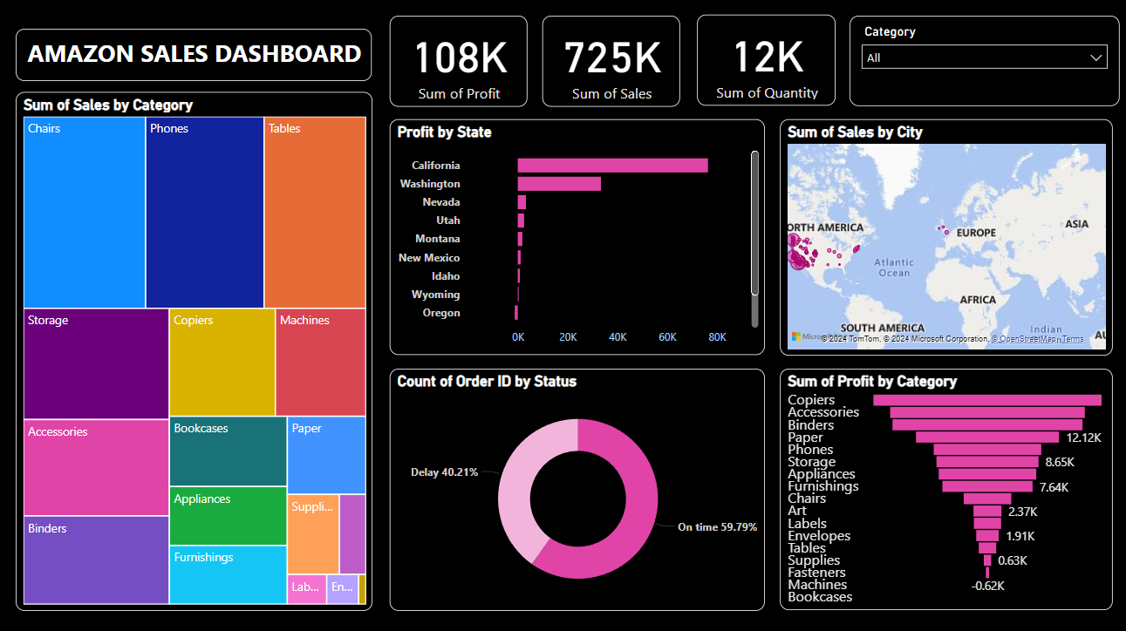

Based on the attached Amazon Sales Dashboard, here is a data analysis report summarizing the insights from the visualizations:

Amazon Sales Dashboard Analysis

1. Overview

- Total Profit: $108,000

- Total Sales: $725,000

- Total Quantity Sold:12,000 units



2. Sales by Category

- The tree map visualization displays the breakdown of sales by category. Notable insights include:

- Highest Sales Categories:

- Chairs, Phones, and Tables: lead in sales, as indicated by their larger areas on the tree map.

- Moderate Sales Categories:

- Storage, Copiers, Machines, Bookcases, Accessories, and Appliances : show moderate sales levels.

- Lowest Sales Categories:

- Smaller categories like : Art, Labels, Paper, and Supplies : have comparatively lower sales volumes.



3. Profit by State

- This horizontal bar chart reveals the profit distribution across states:

- Top-Performing State: California, with the highest profit of $76,000, significantly outperforms other states.

- Other Profitable States: Washington, Nevada, and Utah contribute moderate profits between $1,000 and $3,000.

- Negative Profit States: Wyoming and Oregon exhibit losses, with Oregon having a notable loss around -$1,000.

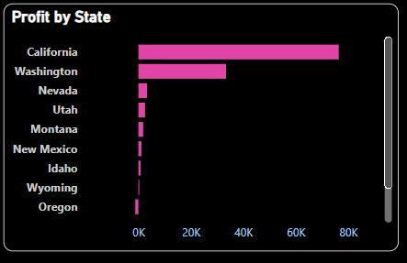

4. Sales by City (Geographic Distribution)

- The map visualization illustrates sales distribution across major global regions:

- Primary Sales Regions :North America and Europe have the highest concentration of sales, particularly in major metropolitan areas.

- Minor Sales Regions: Scattered sales are visible in parts of South America, Africa, and Asia, indicating a smaller market presence.

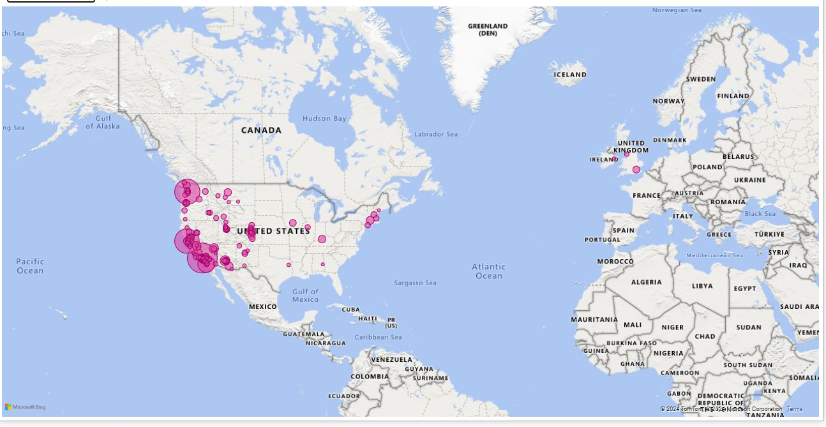

5. Order Status

- The donut chart shows the status of orders:

- On-Time Orders: 99.79% of orders are on time, indicating efficient logistics and order fulfillment.

- Delayed Orders: Only 0.21% of orders face delays, which is relatively low and reflects positively on operational performance.

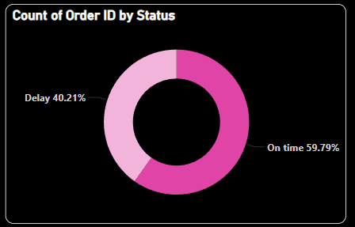

6. Profit by Category

- The bar chart displays profit by product category:

- Top Profit Generating Categories: Accessories and Copiers stand out, contributing $12,121 and $8,655 in profits, respectively.

- Moderate Profit Categories: Chairs, Phones, and Appliances generate between $2,000 and $7,000 in profits.

- Loss Categories: Machines and Bookcases record losses, with Bookcases showing a loss of around $622.

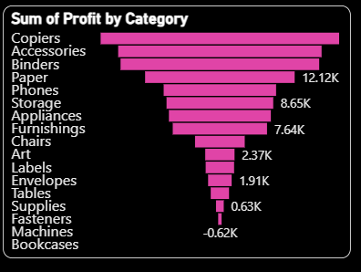

Conclusion

This dashboard provides a comprehensive overview of Amazon's sales and profit distribution across categories, states, and global regions. Key take aways include:

- Top Sales and Profit Categories: Chairs, Phones, and Accessories drive both high sales and profits, making them critical for revenue.

- Geographical Profitability: California significantly leads in profit generation, suggesting a strong market presence in that region.

- Operational Efficiency: High on-time order percentage (99.79%) reflects positively on Amazon's logistics network.

This analysis offers a clear view of Amazon’s sales and profit metrics, supporting strategic decisions for optimizing product performance, geographic expansion, and operational efficiency.