K.R. MANGALAM UNIVERSITY
Bachelor of Technology
Computer Science and Engineering
Web Programming with Python and JavaScript Lab- SEC035
Assignment - 2
Event Management System
Submitted By:
Prem Kumar
B.Tech CSE (Core)
Semester IV, Section B
Roll No: 2401010243
Submitted To:
Ms. Mansi Kajal

Aim
To develop and understand web applications using Python and JavaScript with proper frontend and backend integration.
Tech Stack
Frontend: HTML, CSS, JavaScript
Backend: Python (Flask)
Database/Other: As per project requirements
Code
app.py
# ============================================================
# Project Title : Event Management Website
# File : app.py (Flask Application Entry Point)
# Description : Backend routes, session management, CRUD ops
# ============================================================
from flask import Flask, render_template, request, redirect, url_for, session, flash
from datetime import datetime
app = Flask(__name__)
app.secret_key = "event_mgmt_secret_2024"
# ─── In-memory data store ────────────────────────────────────
events = [
{
"id": 1,
"name": "Tech Summit 2024",
"date": "2024-08-15",
"time": "10:00 AM",
"venue": "Delhi Convention Centre",
"description": "Annual technology summit featuring keynotes from industry leaders.",
"category": "Technology",
"image_url": "https://images.unsplash.com/photo-1540575467063-178a50c2df87?w=400",
"rsvp_count": 0,
},
{
"id": 2,
"name": "Music Fiesta",
"date": "2024-09-01",
"time": "06:00 PM",
"venue": "JLN Stadium, Delhi",
"description": "Live performances by top artists across multiple genres.",
"category": "Music",
"image_url": "https://images.unsplash.com/photo-1470229722913-7c0e2dbbafd3?w=400",
"rsvp_count": 0,
},
{
"id": 3,
"name": "Startup Pitch Day",
"date": "2024-09-20",
"time": "09:00 AM",
"venue": "T-Hub, Hyderabad",
"description": "Entrepreneurs pitch their startups to top VCs and angel investors.",
"category": "Business",
"image_url": "https://images.unsplash.com/photo-1556761175-5973dc0f32e7?w=400",
"rsvp_count": 0,
},
{
"id": 4,
"name": "Art & Culture Fest",
"date": "2024-10-05",
"time": "11:00 AM",
"venue": "NGMA, Mumbai",
"description": "Celebrating Indian art, heritage, and contemporary culture.",
"category": "Art",
"image_url": "https://images.unsplash.com/photo-1513364776144-60967b0f800f?w=400",
"rsvp_count": 0,
},
{
"id": 5,
"name": "Health & Wellness Expo",
"date": "2024-10-22",
"time": "08:00 AM",
"venue": "Pragati Maidan, Delhi",
"description": "Yoga, nutrition talks, fitness demos, and wellness workshops.",
"category": "Health",
"image_url": "https://images.unsplash.com/photo-1544367567-0f2fcb009e0b?w=400",
"rsvp_count": 0,
},
]
registrations = []
next_event_id = 6 # auto-increment counter
# ─── Helper ──────────────────────────────────────────────────
def find_event(event_id):
return next((e for e in events if e["id"] == event_id), None)
# ═══════════════════════════════════════════════════════════════
# TASK 1 — Landing Page
# ═══════════════════════════════════════════════════════════════
@app.route("/")
def index():
"""Root route — renders the landing / hero page."""
featured = events[:3]
return render_template("index.html", featured=featured)
# ═══════════════════════════════════════════════════════════════
# TASK 2 — Event Listing Page
# ═══════════════════════════════════════════════════════════════
@app.route("/events")
def event_list():
"""Display all events; supports ?category= and ?search= filters."""
category_filter = request.args.get("category", "").strip()
search_query = request.args.get("search", "").strip().lower()
filtered = events
if category_filter:
filtered = [e for e in filtered if e["category"] == category_filter]
if search_query:
filtered = [
e for e in filtered
if search_query in e["name"].lower() or search_query in e["description"].lower()
]
categories = sorted(set(e["category"] for e in events))
return render_template(
"events.html",
events=filtered,
categories=categories,
selected_category=category_filter,
search_query=search_query,
)
# ═══════════════════════════════════════════════════════════════
# TASK 4 — Registration Form
# ═══════════════════════════════════════════════════════════════
@app.route("/register", methods=["GET", "POST"])
def register():
"""GET: Show form. POST: Process registration."""
if request.method == "POST":
name = request.form.get("full_name", "").strip()
email = request.form.get("email", "").strip()
phone = request.form.get("phone", "").strip()
event_id = request.form.get("event_id", type=int)
tickets = request.form.get("tickets", type=int, default=1)
# Server-side validation
errors = []
if not name:
errors.append("Full name is required.")
if not email or "@" not in email:
errors.append("A valid email address is required.")
if not phone or not phone.isdigit() or len(phone) < 10:
errors.append("A valid 10-digit phone number is required.")
if not event_id:
errors.append("Please select an event.")
if not tickets or tickets < 1 or tickets > 10:
errors.append("Ticket count must be between 1 and 10.")
if errors:
for err in errors:
flash(err, "error")
return render_template("register.html", events=events)
# Store registration
chosen_event = find_event(event_id)
if chosen_event:
chosen_event["rsvp_count"] += tickets
registrations.append({
"name": name,
"email": email,
"phone": phone,
"event_id": event_id,
"event_name": chosen_event["name"] if chosen_event else "Unknown",
"tickets": tickets,
"registered_at": datetime.now().strftime("%Y-%m-%d %H:%M"),
})
flash(f"🎉 Registration successful! You have booked {tickets} ticket(s) for {chosen_event['name']}.", "success")
return redirect(url_for("event_list"))
# Pre-select event if ?event_id= is passed from event card
preselect_id = request.args.get("event_id", type=int)
return render_template("register.html", events=events, preselect_id=preselect_id)
# ═══════════════════════════════════════════════════════════════
# TASK 5 — Admin Panel (session-protected)
# ═══════════════════════════════════════════════════════════════
@app.route("/admin/login", methods=["GET", "POST"])
def admin_login():
if request.method == "POST":
username = request.form.get("username")
password = request.form.get("password")
if username == "admin" and password == "admin123":
session["is_admin"] = True
flash("Welcome, Admin!", "success")
return redirect(url_for("admin_panel"))
flash("Invalid credentials.", "error")
return render_template("admin_login.html")
@app.route("/admin/logout")
def admin_logout():
session.pop("is_admin", None)
flash("Logged out successfully.", "success")
return redirect(url_for("index"))
@app.route("/admin")
def admin_panel():
if not session.get("is_admin"):
flash("Please log in to access the admin panel.", "error")
return redirect(url_for("admin_login"))
return render_template("admin.html", events=events, registrations=registrations)
@app.route("/admin/add", methods=["POST"])
def admin_add():
global next_event_id
if not session.get("is_admin"):
return redirect(url_for("admin_login"))
new_event = {
"id": next_event_id,
"name": request.form.get("name", "").strip(),
"date": request.form.get("date", ""),
"time": request.form.get("time", ""),
"venue": request.form.get("venue", "").strip(),
"description": request.form.get("description", "").strip(),
"category": request.form.get("category", "General").strip(),
"image_url": request.form.get("image_url", "").strip() or "https://images.
index.html
{# ============================================================
File : templates/index.html
Purpose : Landing / hero page (Task 1)
Extends base.html; shows hero + 3 featured events
============================================================ #}
{% extends "base.html" %}
{% block title %}Home{% endblock %}
{% block content %}
<!-- ── HERO SECTION ─────────────────────────────────────── -->
<section class="hero">
<div class="hero__content">
<h1 class="hero__title">Discover & Attend<br><span class="highlight">Amazing Events</span></h1>
<p class="hero__subtitle">
Browse hundreds of events, register in seconds, and create memories that last a lifetime.
</p>
<div class="hero__actions">
<a href="{{ url_for('event_list') }}" class="btn btn--primary btn--lg">Explore Events</a>
<a href="{{ url_for('register') }}" class="btn btn--outline btn--lg">Register Now</a>
</div>
</div>
<div class="hero__badge-row">
<div class="badge">🎤 Live Events</div>
<div class="badge">🎟️ Easy Booking</div>
<div class="badge">📅 All Categories</div>
</div>
</section>
<!-- ── FEATURED EVENTS ──────────────────────────────────── -->
<section class="section">
<div class="section-header">
<h2>Featured Events</h2>
<a href="{{ url_for('event_list') }}" class="btn btn--outline">View All →</a>
</div>
<div class="events-grid">
{% for event in featured %}
<article class="event-card">
<figure class="event-card__img-wrap">
<img src="{{ event.image_url }}" alt="{{ event.name }}" loading="lazy" />
<span class="event-card__category">{{ event.category }}</span>
</figure>
<div class="event-card__body">
<h3 class="event-card__title">{{ event.name }}</h3>
<p class="event-card__meta">
📅 {{ event.date }} &nbsp;|&nbsp; 🕐 {{ event.time }}
</p>
<p class="event-card__meta">📍 {{ event.venue }}</p>
<p class="event-card__desc">{{ event.description }}</p>
<div class="event-card__footer">
<span class="rsvp-badge" data-event-id="{{ event.id }}">
👥 {{ event.rsvp_count }} RSVP
</span>
<a href="{{ url_for('register', event_id=event.id) }}" class="btn btn--primary">Register</a>
</div>
</div>
</article>
{% endfor %}
</div>
</section>
<!-- ── HOW IT WORKS ─────────────────────────────────────── -->
<section class="section section--alt">
<h2 class="text-center">How It Works</h2>
<div class="steps-grid">
<div class="step-card">
<div class="step-icon">🔍</div>
<h3>Browse Events</h3>
<p>Search and filter events by category, date, or keyword.</p>
</div>
<div class="step-card">
<div class="step-icon">📝</div>
<h3>Register</h3>
<p>Fill in your details and book your seats in under 60 seconds.</p>
</div>
<div class="step-card">
<div class="step-icon">🎉</div>
<h3>Attend & Enjoy</h3>
<p>Show up, have a great time, and create lasting memories.</p>
</div>
</div>
</section>
{% endblock %}
style.css
/* ============================================================
Project : Event Management Website
File : static/css/style.css
Purpose : Global styles — reset, typography, navbar, cards,
forms, admin tables, responsive media queries (Task 3)
============================================================ */
/* ── 1. CSS RESET&CUSTOM PROPERTIES ────────────────────── */
*, *::before, *::after { box-sizing: border-box; margin: 0; padding: 0; }
:root {
--primary: #6c63ff;
--primary-dk: #574fd6;
--accent: #ff6584;
--success: #28a745;
--danger: #dc3545;
--bg: #f8f9fc;
--card-bg: #ffffff;
--text: #1a1a2e;
--text-muted: #6b7280;
--border: #e5e7eb;
--radius: 12px;
--shadow: 0 4px 20px rgba(0,0,0,.08);
--shadow-hov: 0 8px 30px rgba(108,99,255,.2);
--nav-h: 64px;
--transition: .25s ease;
}
html { scroll-behavior: smooth; }
body {
font-family: 'Inter', system-ui, sans-serif;
font-size: 16px;
line-height: 1.6;
color: var(--text);
background: var(--bg);
}
a { text-decoration: none; color: inherit; }
img { display: block; width: 100%; object-fit: cover; }
ul { list-style: none; }
/* ── 2. TYPOGRAPHY ───────────────────────────────────────── */
h1 { font-size: clamp(1.8rem, 4vw, 2.8rem); font-weight: 700; line-height: 1.2; }
h2 { font-size: clamp(1.3rem, 3vw, 1.9rem); font-weight: 600; }
h3 { font-size: 1.1rem; font-weight: 600; }
.text-center { text-align: center; }
.highlight { color: var(--primary); }
.page-title { margin-bottom: .5rem; }
.page-subtitle { color: var(--text-muted); margin-bottom: 1.5rem; }
/* ── 3. LAYOUT HELPERS ───────────────────────────────────── */
.section {
max-width: 1200px;
margin: 0 auto;
padding: 3rem 1.25rem;
}
.section--alt {
background: linear-gradient(135deg, #ede9fe 0%, #fce7f3 100%);
max-width: 100%;
padding: 3rem 1.25rem;
}
.section--alt>* { max-width: 1200px; margin-left: auto; margin-right: auto; }
.section--narrow { max-width: 560px; }
.section-header {
display: flex;
align-items: center;
justify-content: space-between;
margin-bottom: 2rem;
flex-wrap: wrap;
gap: .75rem;
}
/* ── 4. NAVIGATION BAR ───────────────────────────────────── */
.navbar {
position: sticky;
top: 0;
z-index: 100;
background: var(--card-bg);
border-bottom: 1px solid var(--border);
height: var(--nav-h);
box-shadow: 0 1px 8px rgba(0,0,0,.06);
}
.nav-container {
max-width: 1200px;
margin: 0 auto;
padding: 0 1.25rem;
height: 100%;
display: flex;
align-items: center;
justify-content: space-between;
}
.nav-logo {
font-size: 1.25rem;
font-weight: 700;
color: var(--primary);
letter-spacing: -.5px;
}
.nav-links {
display: flex;
gap: 1.75rem;
align-items: center;
}
.nav-links a {
font-size: .9rem;
font-weight: 500;
color: var(--text-muted);
transition: color var(--transition);
position: relative;
}
.nav-links a:hover,
.nav-links a.active { color: var(--primary); }
.nav-links a.active::after {
content: '';
position: absolute;
bottom: -4px;
left: 0; right: 0;
height: 2px;
background: var(--primary);
border-radius: 2px;
}
/* Hamburger (hidden on desktop) */
.hamburger { display: none; background: none; border: none; cursor: pointer; flex-direction: column; gap: 5px; }
.hamburger span { display: block; width: 24px; height: 2px; background: var(--text); border-radius: 2px; transition: var(--transition); }
/* ── 5. BUTTONS ──────────────────────────────────────────── */
.btn {
display: inline-flex;
align-items: center;
justify-content: center;
gap: .4rem;
padding: .55rem 1.25rem;
border-radius: 8px;
font-size: .9rem;
font-weight: 600;
cursor: pointer;
border: 2px solid transparent;
transition: transform var(--transition), box-shadow var(--transition), background var(--transition);
}
.btn:hover { transform: translateY(-2px); box-shadow: var(--shadow-hov); }
.btn:active { transform: translateY(0); }
.btn--primary { background: var(--primary); color: #fff; }
.btn--primary:hover { background: var(--primary-dk); }
.btn--outline { border-color: var(--primary); color: var(--primary); }
.btn--outline:hover { background: var(--primary); color: #fff; }
.btn--danger { background: var(--danger); color: #fff; border-color: var(--danger); }
.btn--danger:hover { background: #b02a37; }
.btn--lg { padding: .75rem 2rem; font-size: 1rem; }
.btn--sm { padding: .35rem .75rem; font-size: .8rem; }
.btn--full { width: 100%; }
/* ── 6. FLASH MESSAGES ───────────────────────────────────── */
.flash-container { position: fixed; top: calc(var(--nav-h) + .75rem); right: 1rem; z-index: 999; display: flex; flex-direction: column; gap: .5rem; }
.flash {
display: flex; align-items: center; justify-content: space-between;
gap: 1rem;
padding: .75rem 1.25rem;
border-radius: var(--radius);
font-size: .9rem;
font-weight: 500;
min-width: 280px;
max-width: 420px;
box-shadow: var(--shadow);
animation: slideIn .3s ease;
}
@keyframes slideIn { from { opacity: 0; transform: translateX(60px); } }
.flash--success { background: #d1fae5; color: #065f46; border-left: 4px solid var(--success); }
.flash--error { background: #fee2e2; color: #991b1b; border-left: 4px solid var(--danger); }
.flash--info { background: #dbeafe; color: #1e40af; border-left: 4px solid #3b82f6; }
.flash__close { background: none; border: none; font-size: 1.2rem; cursor: pointer; opacity: .6; }
.flash__close:hover { opacity: 1; }
/* ── 7. HERO SECTION ─────────────────────────────────────── */
.hero {
background: linear-gradient(135deg, #6c63ff 0%, #574fd6 60%, #ff6584 100%);
color: #fff;
padding: 5rem 1.25rem 3.5rem;
text-align: center;
}
.hero__content { max-width: 640px; margin: 0 auto 2.5rem; }
.hero__title { color: #fff; margin-bottom: 1rem; }
.hero__subtitle { font-size: 1.1rem; opacity: .9; margin-bottom: 2rem; }
.hero__actions { display: flex; gap: 1rem; justify-content: center; flex-wrap: wrap; }
.hero .btn--primary { background: #fff; color: var(--primary); }
.hero .btn--primary:hover { background: #f0f0f0; }
.hero .btn--outline { border-color: rgba(255,255,255,.7); color: #fff; }
.hero .btn--outline:hover { background: rgba(255,255,255,.15); }
.hero__badge-row { display: flex; gap: 1rem; justify-content: center; flex-wrap: wrap; }
.badge {
background: rgba(255,255,255,.18);
border: 1px solid rgba(255,255,255,.3);
color: #fff;
padding: .4rem 1rem;
border-radius: 99px;
font-size: .85rem;
font-weight: 500;
backdrop-filter: blur(4px);
}
/* ── 8. EVENT CARDS (GRID) ───────────────────────────────── */
.events-grid {
display: grid;
grid-template-columns: repeat(auto-fill, minmax(290px, 1fr));
gap: 1.5rem;
}
.event-card {
background: var(--card-bg);
border-radius: var(--radius);
box-shadow: var(--shadow);
overflow: hidden;
display: flex;
flex-direction: column;
transition: transform var(--transition), box-shadow var(--transition);
}
.event-card:hover { transform: translateY(-5px); box-shadow: var(--shadow-hov); }
.event-card__img-wrap { position: relative; height: 190px; overflow: hidden; }
.event-card__img-wrap img { height: 100%; transition: transform .4s ease; }
.event-card:hover .event-card__img-wrap img { transform: scale(1.06); }
.event-card__category {
position: absolute; top: .75rem; right: .75rem;
background: var(--primary); color: #fff;
padding: .25rem .75rem; border-radius: 99px; font-size: .75rem; font-weight: 600;
}
.event-card__body { padding: 1.25rem; flex: 1; display: flex; flex-direction: column; gap: .4rem; }
.event-card__title { color: var(--text); font-size: 1.05rem; }
.event-card__meta { font-size: .82rem; color: var(--text-muted); }
.event-card__desc { font-size: .85rem; color: var(--text-muted); flex: 1; line-height: 1.5; }
.event-card__footer {
display: flex; align-items: center; justify-content: space-between;
margin-top: .75rem; padding-top: .75rem; border
script.js
/* ============================================================
Project : Event Management Website
File : static/js/script.js
Purpose : All client-side behaviour
- Hamburger menu toggle
- Registration form validation (Task 4)
- Live search / DOM filter (Task 6 Bonus)
- RSVP counter fetch (Task 6 Bonus)
- Auto-dismiss flash messages
============================================================ */
"use strict";
/* ── Run after DOM is fully loaded ──────────────────────── */
document.addEventListener("DOMContentLoaded", () =>{
initHamburger();
initRegisterValidation();
initLiveSearch();
initAutoFlashDismiss();
});
/* ════════════════════════════════════════════════════════════
1. HAMBURGER MENU TOGGLE
Toggles .nav--open class on the <ul class="nav-links"> so
CSS can slide it in/out on small screens (Task 3).
════════════════════════════════════════════════════════════ */
function initHamburger() {
const hamburger = document.getElementById("hamburger");
const navLinks = document.getElementById("nav-links");
if (!hamburger || !navLinks) return;
hamburger.addEventListener("click", () => {
navLinks.classList.toggle("nav--open");
// Animate bars → X
hamburger.classList.toggle("is-open");
});
// Close menu when any nav link is clicked
navLinks.querySelectorAll("a").forEach((link) => {
link.addEventListener("click", () => navLinks.classList.remove("nav--open"));
});
}
/* ════════════════════════════════════════════════════════════
2. REGISTRATION FORM VALIDATION (Task 4)
Runs before the form submits; prevents native POST if errors
exist. Displays inline error messages under each field.
════════════════════════════════════════════════════════════ */
function initRegisterValidation() {
const form = document.getElementById("register-form");
if (!form) return;
form.addEventListener("submit", (e) => {
// Clear all previous errors
clearErrors();
let isValid = true;
/* ── Full Name ── */
const nameField = document.getElementById("full_name");
if (!nameField.value.trim()) {
showError("err-name", nameField, "Full name is required.");
isValid = false;
} else if (nameField.value.trim().length < 3) {
showError("err-name", nameField, "Name must be at least 3 characters.");
isValid = false;
}
/* ── Email ── */
const emailField = document.getElementById("email");
const emailRegex = /^[^\s@]+@[^\s@]+\.[^\s@]+$/;
if (!emailField.value.trim()) {
showError("err-email", emailField, "Email address is required.");
isValid = false;
} else if (!emailRegex.test(emailField.value.trim())) {
showError("err-email", emailField, "Enter a valid email address (e.g. user@example.com).");
isValid = false;
}
/* ── Phone ── */
const phoneField = document.getElementById("phone");
const phoneRegex = /^\d{10}$/;
if (!phoneField.value.trim()) {
showError("err-phone", phoneField, "Phone number is required.");
isValid = false;
} else if (!phoneRegex.test(phoneField.value.trim())) {
showError("err-phone", phoneField, "Enter a valid 10-digit phone number.");
isValid = false;
}
/* ── Event Selection ── */
const eventField = document.getElementById("event_id");
if (!eventField.value) {
showError("err-event", eventField, "Please select an event.");
isValid = false;
}
/* ── Tickets ── */
const ticketsField = document.getElementById("tickets");
const ticketVal = parseInt(ticketsField.value, 10);
if (isNaN(ticketVal) || ticketVal < 1 || ticketVal > 10) {
showError("err-tickets", ticketsField, "Please enter a ticket count between 1 and 10.");
isValid = false;
}
if (!isValid) {
e.preventDefault(); // Stop form from submitting
// Scroll to the first errored field
const firstError = form.querySelector(".input--error");
if (firstError) firstError.scrollIntoView({ behavior: "smooth", block: "center" });
}
});
// Real-time field clearing on user input
form.querySelectorAll("input, select").forEach((el) => {
el.addEventListener("input", () => {
el.classList.remove("input--error");
const errSpan = form.querySelector(`[id^='err-']`);
// Clear the specific error for this field
});
});
}
/* Helper: show error message + mark field invalid */
function showError(spanId, field, message) {
const span = document.getElementById(spanId);
if (span) span.textContent = message;
if (field) field.classList.add("input--error");
}
/* Helper: wipe all error spans and field classes */
function clearErrors() {
document.querySelectorAll(".form-error").forEach((s) => (s.textContent = ""));
document.querySelectorAll(".input--error").forEach((f) => f.classList.remove("input--error"));
}
/* ════════════════════════════════════════════════════════════
3. LIVE SEARCH (Task 6 Bonus)
Filters .event-card elements in the DOM without any page
reload. Reads data-name and data-desc attributes injected
by Jinja2 in events.html.
════════════════════════════════════════════════════════════ */
function initLiveSearch() {
const searchInput = document.getElementById("live-search");
const grid = document.getElementById("events-grid");
const noResults = document.getElementById("no-results");
if (!searchInput || !grid) return;
searchInput.addEventListener("input", () => {
const query = searchInput.value.trim().toLowerCase();
const cards = grid.querySelectorAll(".event-card");
let visibleCount = 0;
cards.forEach((card) => {
const name = card.dataset.name || "";
const desc = card.dataset.desc || "";
const matches = name.includes(query) || desc.includes(query);
card.style.display = matches ? "" : "none";
if (matches) visibleCount++;
});
// Show / hide "no results" message
if (noResults) {
noResults.style.display = visibleCount === 0 ? "block" : "none";
}
});
}
/* ════════════════════════════════════════════════════════════
4. AUTO-DISMISS FLASH MESSAGES
Each flash disappears after 5 seconds automatically.
════════════════════════════════════════════════════════════ */
function initAutoFlashDismiss() {
document.querySelectorAll(".flash").forEach((flash) => {
setTimeout(() => {
flash.style.transition = "opacity 0.4s, transform 0.4s";
flash.style.opacity = "0";
flash.style.transform = "translateX(60px)";
setTimeout(() => flash.remove(), 400);
}, 5000);
});
}

Output

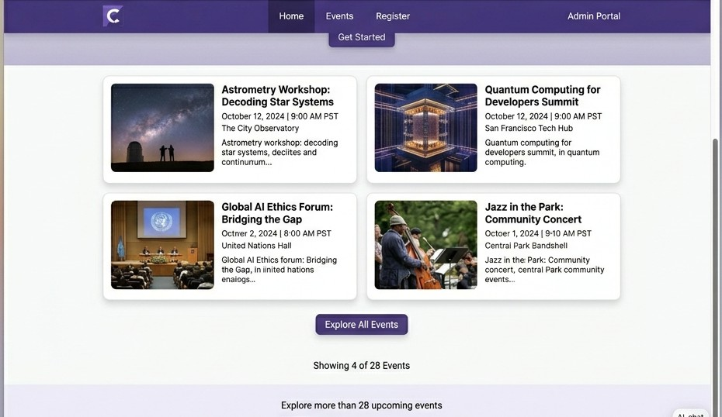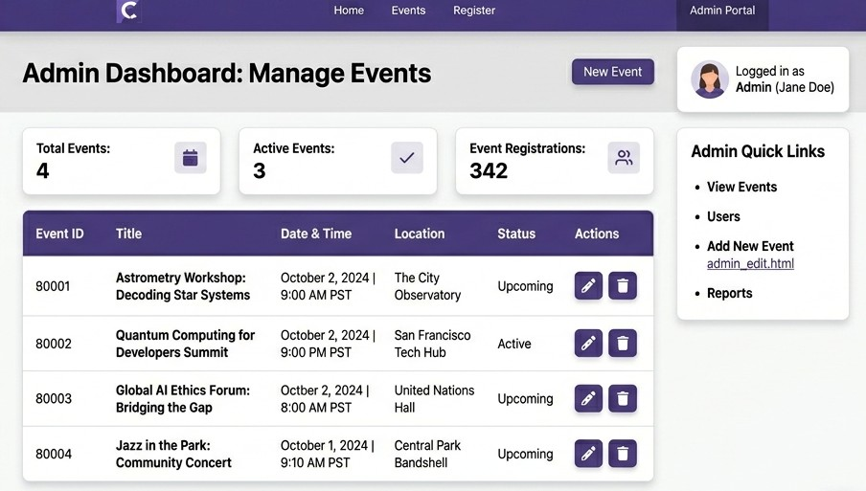

Conclusion

This assignment demonstrates the implementation of a web-based application using Python and JavaScript. It highlights frontend-backend interaction, dynamic content handling, and practical understanding of web development concepts.

