<https://collegescorecard.ed.gov/>

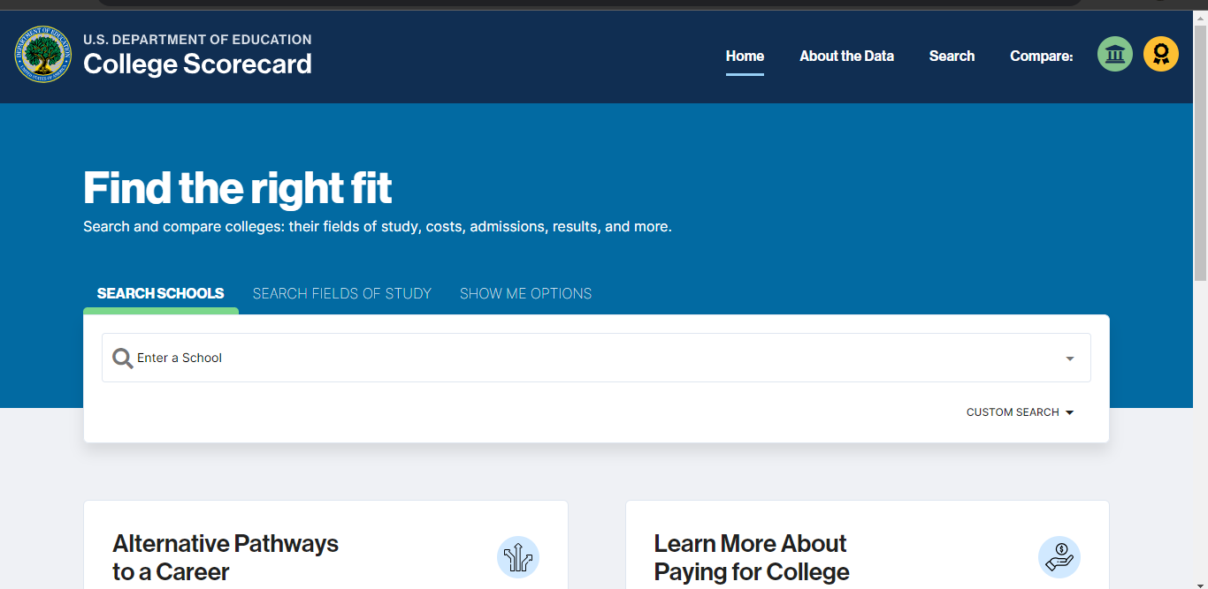

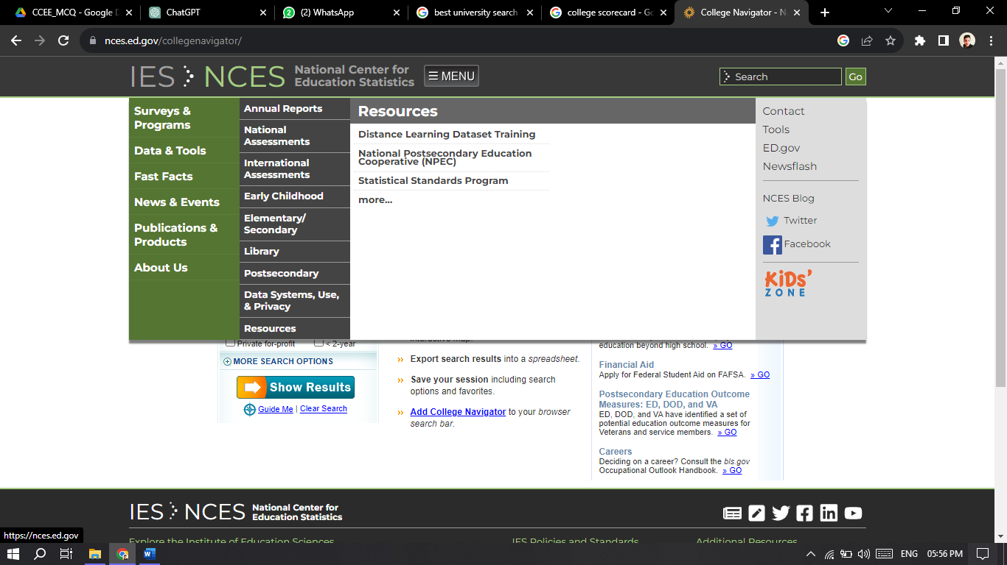

https://targetstudy.com/

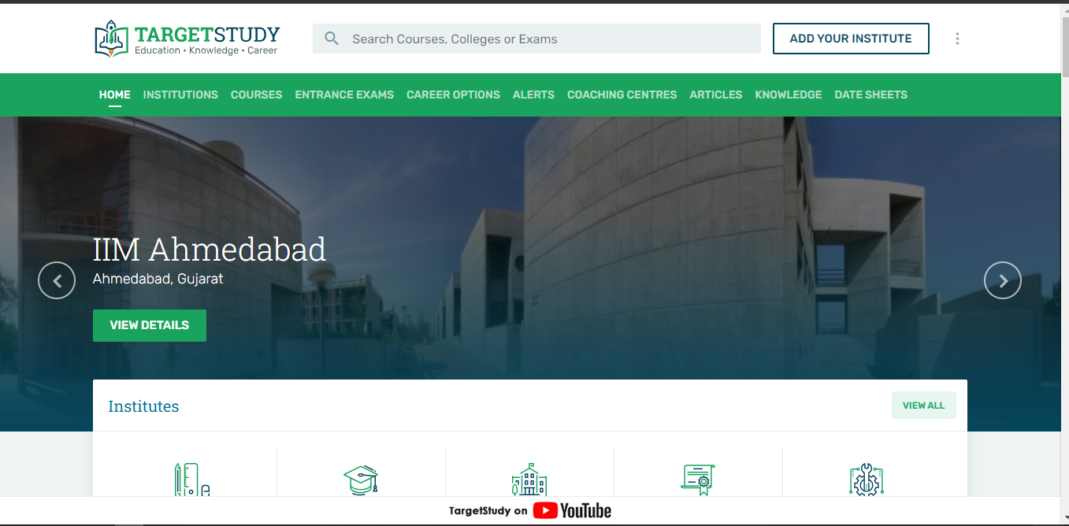

<https://www.yourfreecareertest.com/result/?id=4591391&set_id=6>

For career and interest test