In recent days, global trade tensions have shifted into overdrive, as U.S. tariffs climb to heights not seen since the early 1900s, shaking up industries worldwide. According to the WTO and IMF, the current average U.S. tariff rate now stands at a staggering 20.1%, the highest level since the 1910s — compared to just 2.4% back when Donald Trump entered office.

That’s not all. Earlier this year, tariff levels briefly spiked to 24.8% in May, a figure not reached since 1904, before slipping down slightly amid a temporary trade truce.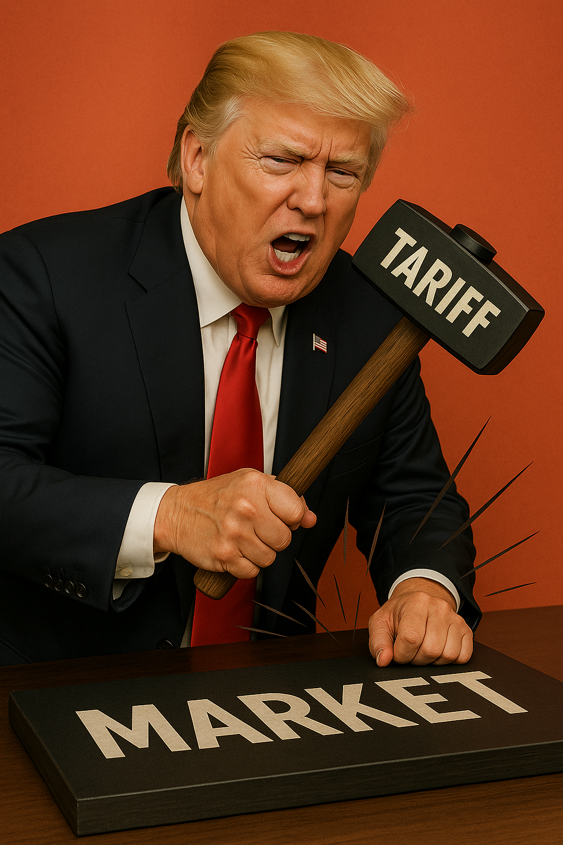

This whirlwind of Trump’s Aggressive policy is hitting several industries hard. Manufacturing and industrial firms are grappling with soaring import costs for steel and components. Automakers are seeing elevated expenses from pricier raw materials and parts, while fast food chains and hospitality outfits are squeezed by rising costs for packaging, aluminum, and logistics. Import-reliant consumer goods and retail are also under pressure, with prices already beginning to edge upward in many categories.
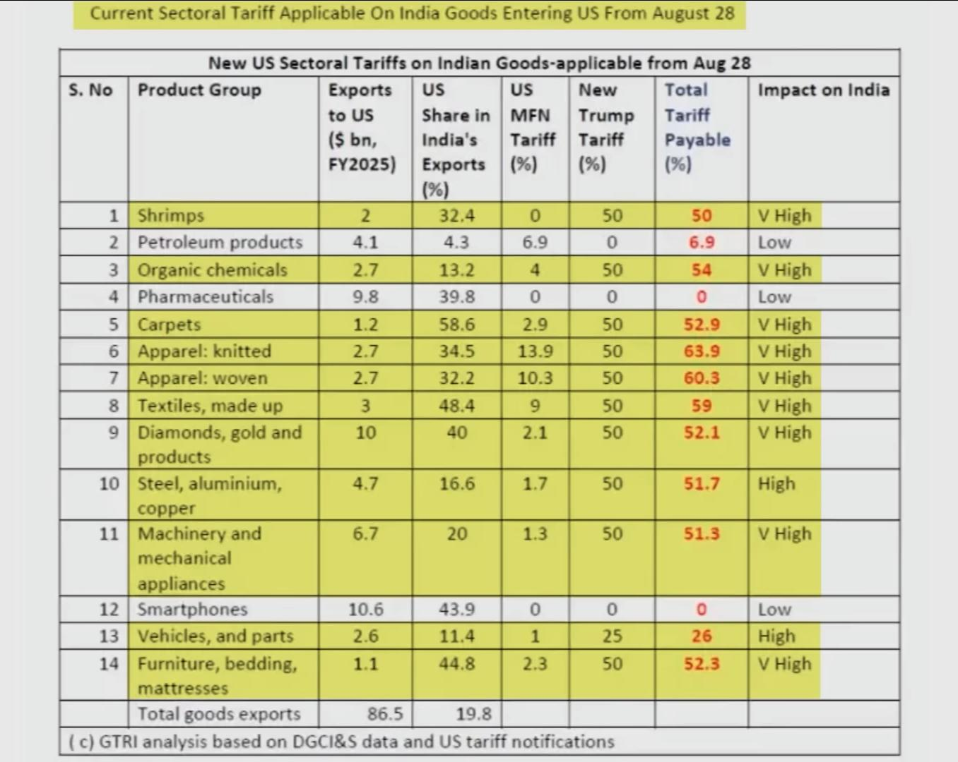

For Indian investors, this surge means heightened market volatility -especially in mutual funds or index funds exposed to global stocks. Even modest investments can be affected by erratic swings in global sentiment.

But you don’t need to ride this roller coaster. Consider shifting your focus to safer domestic options. Schemes like the Public Provident Fund (PPF), National Savings Certificates (NSC), or fixed deposits offer steady, government-backed returns. Small savings instruments such as the Sukanya Samriddhi Yojana or the Senior Citizens’ Savings Scheme are also excellent for reliable, compounding growth. And if you still want some market exposure, low-volatility hybrid mutual fund; those that blend equity with deb can offer a smoother ride.

When markets become unpredictable, what’s most important isn’t chasing uncertain gains; it’s safeguarding what you've built. Fixed-return, secure investments provide stability and peace of mind in turbulent times. That approach might not feel flashy, but it keeps you steadily moving forward when markets fluctuate.

