DEEP LEARNING

ICP-4

FOR SIMPLE AE:

GRAPHS FOR SIMPLE AE with Adagrad Optimizer:

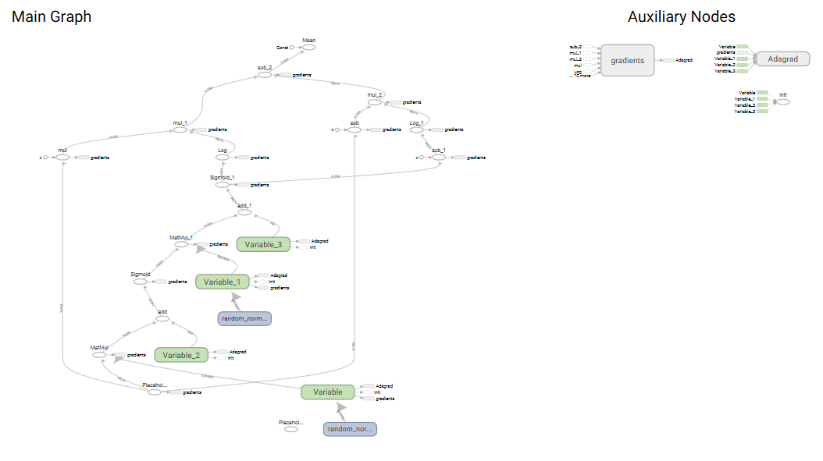  
Loss with Adagrad optimizer:

step, loss = 0: 0.723

step, loss = 1000: 0.262

step, loss = 2000: 0.249

step, loss = 3000: 0.228

step, loss = 4000: 0.231

step, loss = 5000: 0.220

loss (test) = 0.21512201

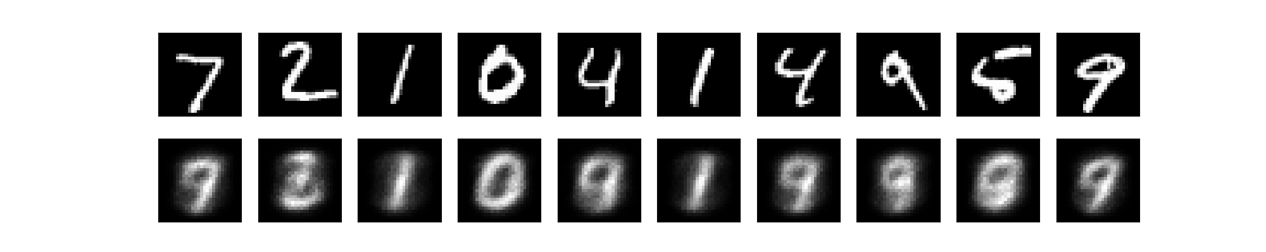

LOSS WITH RMSPropOptimizer:

step, loss = 0: 0.716

step, loss = 1000: 0.169

step, loss = 2000: 0.152

step, loss = 4000: 0.147

step, loss = 5000: 0.139

loss (test) = 0.15810013

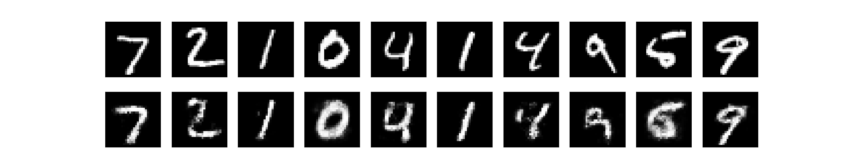

LOSS WITH Gradient Descent optimizer:

step, loss = 0: 0.738

step, loss = 1000: 0.279

step, loss = 2000: 0.263

step, loss = 3000: 0.265

step, loss = 4000: 0.263

step, loss = 5000: 0.252

loss (test) = 0.2528922

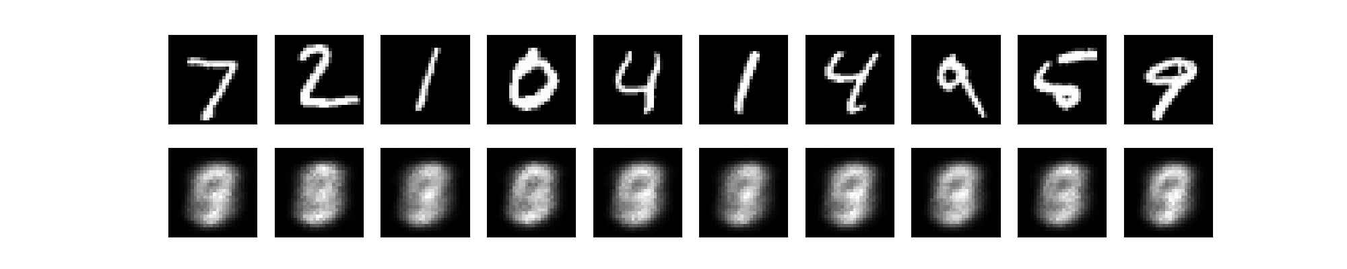

FOR STACKED AE:

PLOTTING THE LOSS IN TENSOR BOARD FOR STACKED AE:

Results for loss with learning rate of 0.01 and with 4000 steps

Step 1: Minibatch Loss: 0.423324

Step 1000: Minibatch Loss: 0.132818

Step 2000: Minibatch Loss: 0.113322

Step 3000: Minibatch Loss: 0.103984

Step 4000: Minibatch Loss: 0.091093

Original Images

Reconstructed Images

Epoch: 0001 cost= 0.361016415

Epoch: 0002 cost= 0.182465330

Epoch: 0003 cost= 0.162657455

Epoch: 0004 cost= 0.151494410

Epoch: 0005 cost= 0.141249410

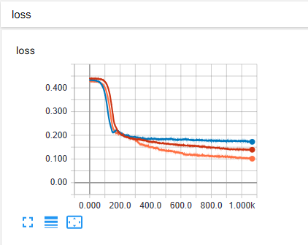

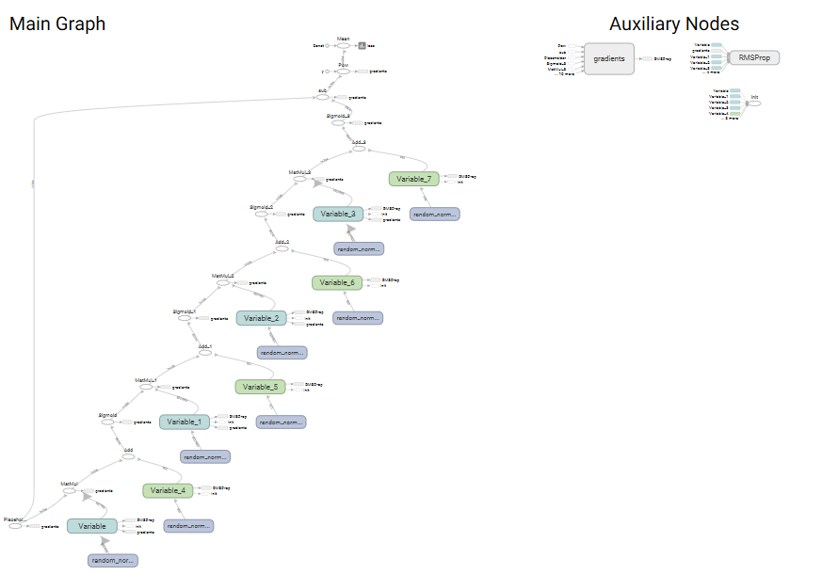

Results for loss with learning rate of 0.02 and with 5000 steps

Step 1: Minibatch Loss: 0.452073

Step 1000: Minibatch Loss: 0.109352

Step 2000: Minibatch Loss: 0.092546

Step 3000: Minibatch Loss: 0.080189

Step 4000: Minibatch Loss: 0.073648

Step 5000: Minibatch Loss: 0.066765

Original Images

Reconstructed Images

Epoch: 0001 cost= 0.337786927

Epoch: 0002 cost= 0.172654915

Epoch: 0003 cost= 0.132019694

Epoch: 0004 cost= 0.114282844

Epoch: 0005 cost= 0.106516035

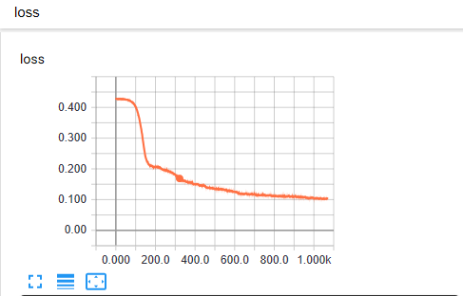

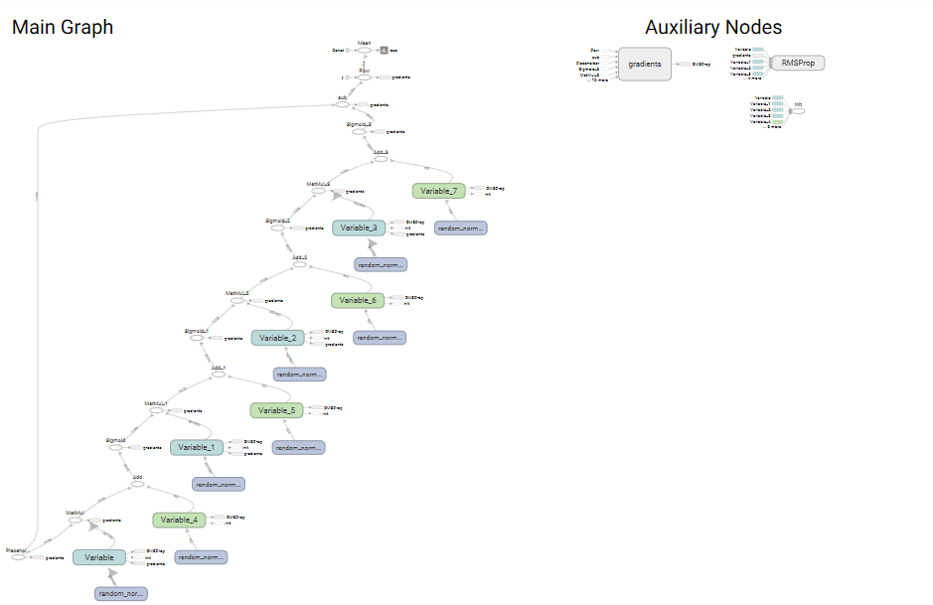

Results for loss with learning rate of 0.05 and with 6000 steps

Step 1: Minibatch Loss: 0.454448

Step 1000: Minibatch Loss: 0.166902

Step 2000: Minibatch Loss: 0.162688

Step 3000: Minibatch Loss: 0.160086

Step 4000: Minibatch Loss: 0.156209

Step 5000: Minibatch Loss: 0.154004

Step 6000: Minibatch Loss: 0.148975

Original Images

Reconstructed Images

Epoch: 0001 cost= 0.327490644

Epoch: 0002 cost= 0.190585490

Epoch: 0003 cost= 0.182836599

Epoch: 0004 cost= 0.178789218

Epoch: 0005 cost= 0.175569163

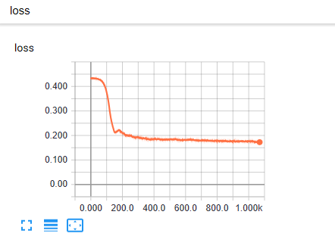

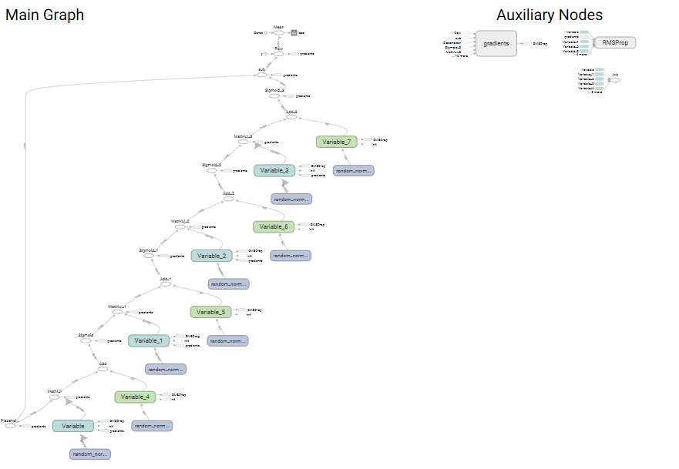

When hidden layer is added

Step 1: Minibatch Loss: 0.435171

Step 1000: Minibatch Loss: 0.117976

Step 2000: Minibatch Loss: 0.080651

Step 3000: Minibatch Loss: 0.072082

Step 4000: Minibatch Loss: 0.065462

Step 5000: Minibatch Loss: 0.063142