DEEP LEARNING

ICP-5 DOCUMENTATION

ASHISH MOTANAM GURUNADHAM

CLASS ID-20

TEAM ID-14

Observation-1:

|  |  |  |  |  |  |  |  |
| --- | --- | --- | --- | --- | --- | --- | --- |
| Optimizer | Filter sizes | Number of filters | Droupout probability | Batch size | Number of epochs | Loss | Accuracy |
| Gradient descent optimizer | 1,2,3 | 120 | 0.2 | 64 | 200 | 0.747737 | 0.3 |

Graph:

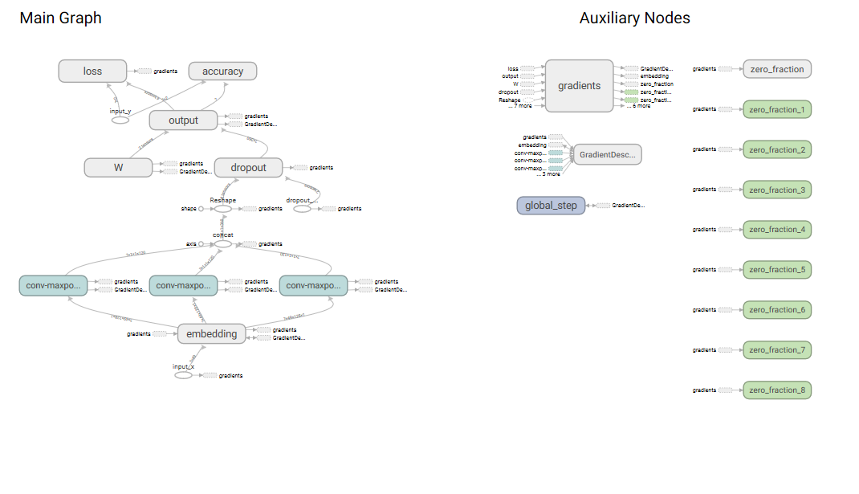

Obsevation-2:

|  |  |  |  |  |  |  |  |
| --- | --- | --- | --- | --- | --- | --- | --- |
| Optimizer | Filter sizes | Number of filters | Droupout probability | Batch size | Number of epochs | Loss | Accuracy |
| RMS PROP | 2,3,4 | 60 | 0.3 | 32 | 100 | 0.589842 | 0.65 |

Graph:

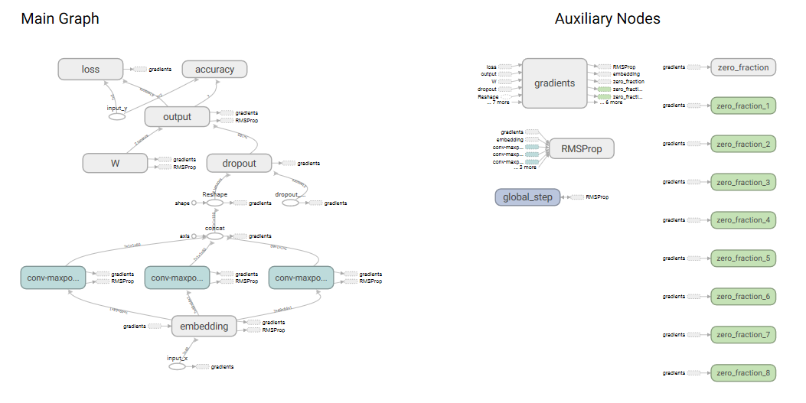

Observation-3:

|  |  |  |  |  |  |  |  |
| --- | --- | --- | --- | --- | --- | --- | --- |
| Optimizer | Filter sizes | Number of filters | Droupout probability | Batch size | Number of epochs | Loss | Accuracy |
| Adagrad Optimizer | 2,3,4 | 60 | 0.4 | 32 | 150 | 0.817297 | 0.4 |

Graph:

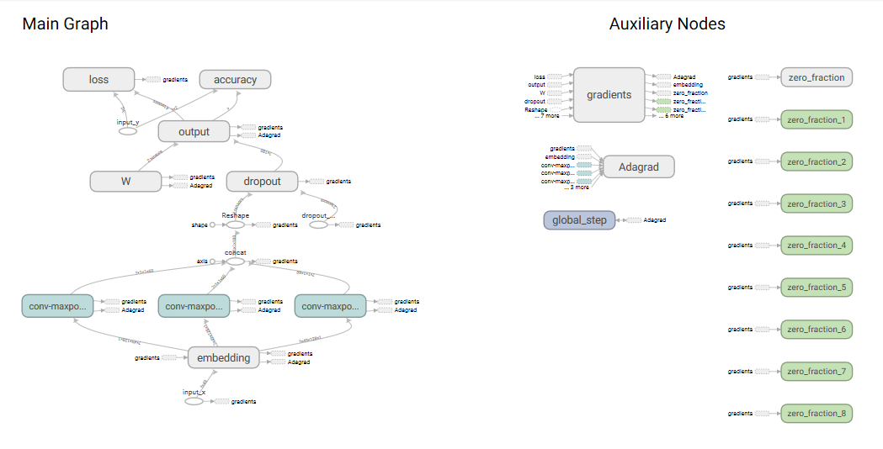

Comparing all observation the one with RMSPROP optimizer has less loss with highest accuracy.