# Netflix Recommendation System (Revised)

The motivation for this project is different age groups and their preferences. Netflix collected data from various users about their preferences and they observed that most of the people preffer to watch movies based on their moods. But there are some users who are family guys, they can’t see movies they wish because of kids in house so our project mostly helps people to watch movies they preffer. In this project we have created an algorithm to sort Movies and TV Shows based on some filter. The motivation behind this project is the search task and filter options in various online shopping applications. We are planning to add filters on our data set to classify them.

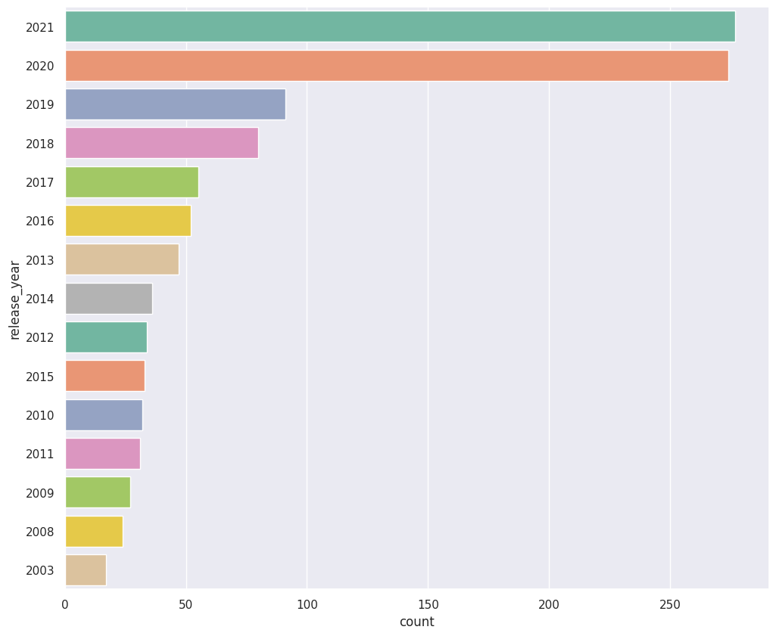

Release Year

We tried to perform basic operations of filterations to make a user friendly interface whis is easy to understand and shows best results based on the search and flters which we have used. The earlier interface of streaming websites shows results based on either search or catogery. If a person want to see new movies or shows then there is no such option of filtering. We have filtered our data based on length or duration of movie. We also tried to classify it on the basis of ratings. Our model still needs updates and modifications to form a perfect operating system.

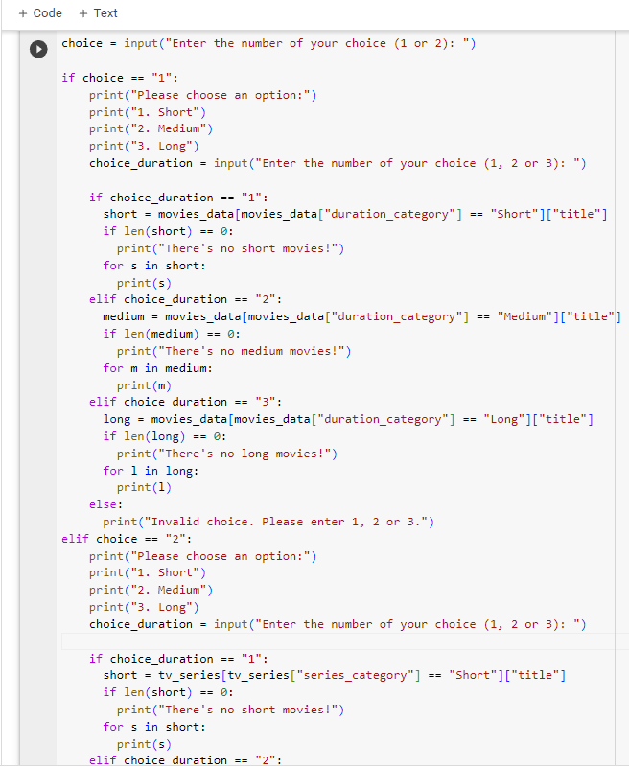

It was easy to gather the data which was pre exesting on Kaggle and perform operations. The basic need for training our model was to first train it, we performed the task using mini data set of 2000 entities which were having 13 different columns or attributes like cast, director, year of release, country released, etc. Our main task was to differentiate movies and TV series from the data set, which was done using list code (to separate movies and TV Shows)

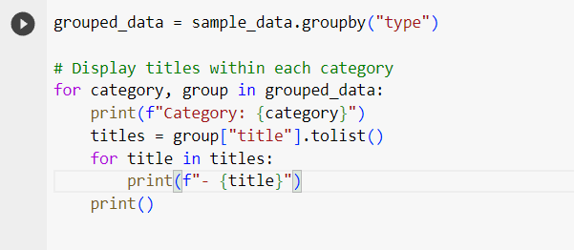

Our main task to separate the data set was resolved but now we needed to store the dataset somewhere, we stored the data in our local files by giving them separate names as moves and tv shows to distinguish them while performing future operations.

The stored data was now to be processed, we processed it by their types, rating, country and release date. The data which was of 7823 entities was changed to 2000 to save time, now these 2000 data opints are read and following results were obtained.

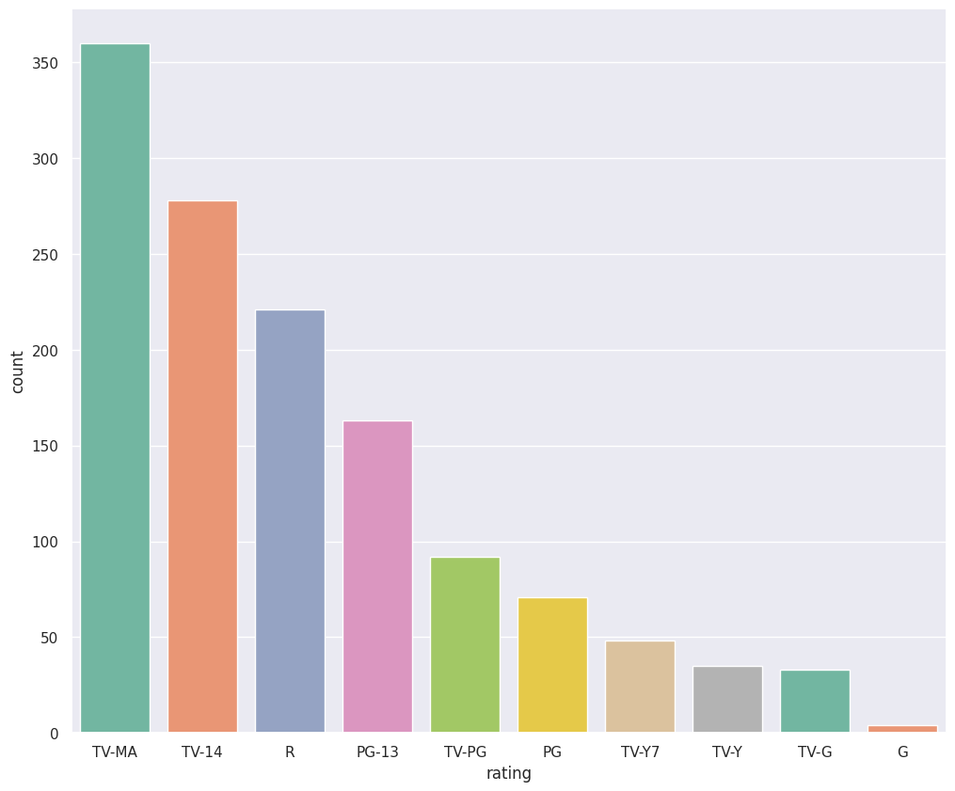

Ratings of Movies and Shows

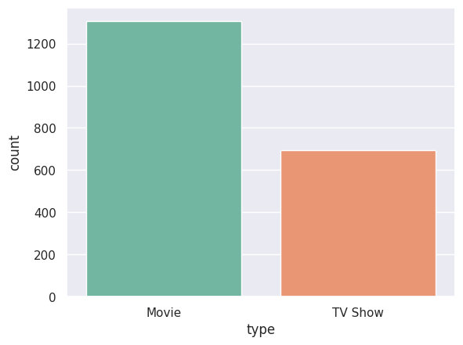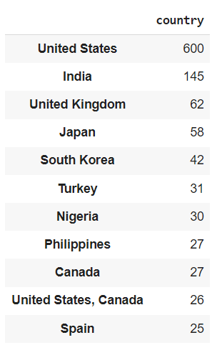

Movie and TV Show count Country Count

The classification was successful after many attempts but due to various data in ratings we were not able to do more better classification. The scope of improvement is still there if we are able to add more filters in our output window like the rating, language etc. We are hoping that someone will carry on the project and improve the classification system and will be able to add filters for the people who don’t know what they want to watch. Lets make our entertainment as easy as browsing a product to fit our choice even when we don’t know what to buy or watch.

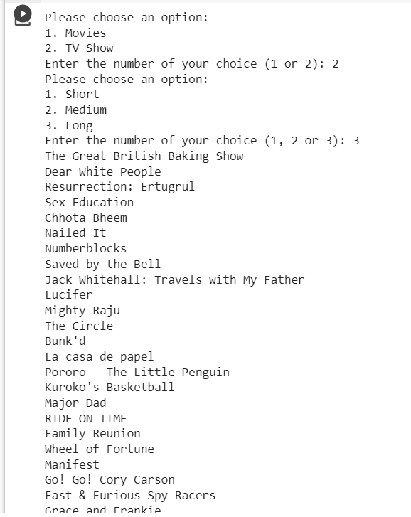

Output Window

##REFERENCES

1. <https://www.kaggle.com/code/sukhdeepk/netflix-dataset-eda>
2. <https://colab.research.google.com/drive/1K3ulb8EydtEN9Lx7YgIXwBbetCoBsgho#scrollTo=E8bF-_riQBV9>
3. Chat GPT
4. <https://github.com/Ashishnain2004/ClassificationOfNetflixData>