# Cucumber-BDD-Automation-Framework

Behavior Driven Development Cucumber - Selenium based automation framework including Allure reports

This framework contains Purchase Pillow code containing:
- 1 feature (feature file)
- 2 Scenarios
- Scenario 1: Purchase pillow with valid credit card payment
- Scenario 2: Purchase pillow with invalid credit card payment

Directory structure:
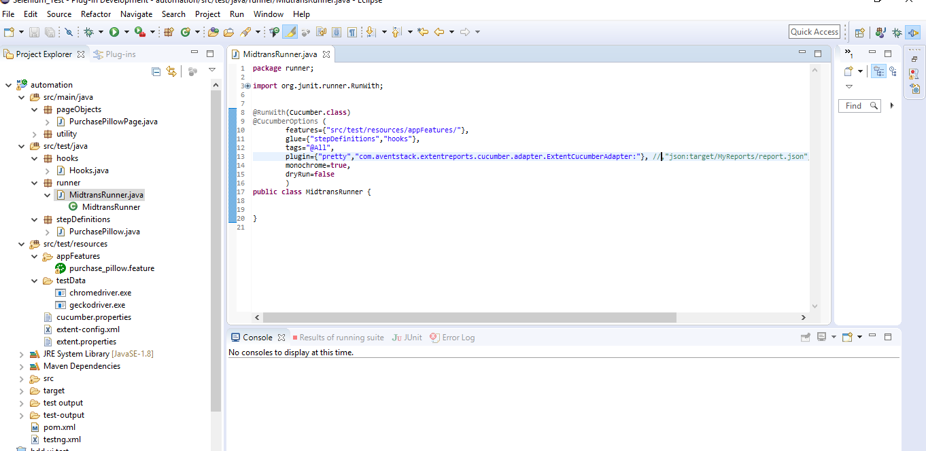

Pr-requisite:
- JDK8
- Eclipse
- Maven
- Cucumber plug-in in Eclipse
- Junit
- TestNG

Steps to run at your system:
- Clone the repository using "git clone "
- Open cmd and go to project directory then enter “mvn verify” command

Cucumber Reports: com.aventstack.extentreports.cucumber.adapter.ExtentCucumberAdapter - This will generate two reports
- Spark Report (folder - "test-output\SparkReport"), file - "index.html"
- PDF Report(folder - "test output\PdfReport"), file – "Extent.pdf"

Folders for these reports:
