**GitHub Installation Guide**

1. You should have OS installed (Session will be on Windows 10 OS)
2. Download Git from the link <https://git-scm.com/download/win>

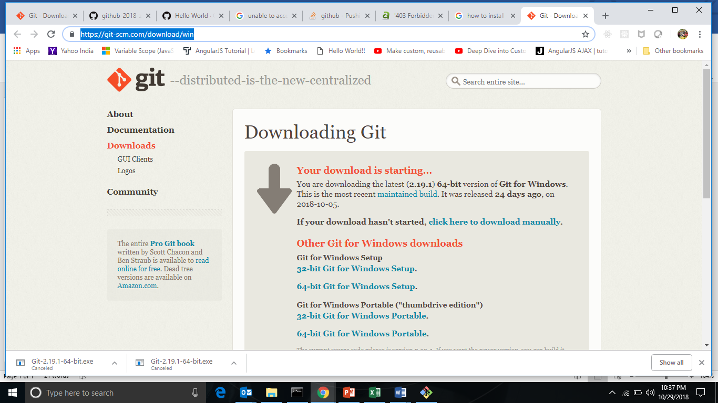

1. Execute the Git.exe file downloaded in step 2 above
2. GitBash will be installed when the exe in step 3 is executed.
3. In the search window type GitBash as the screen shot below.

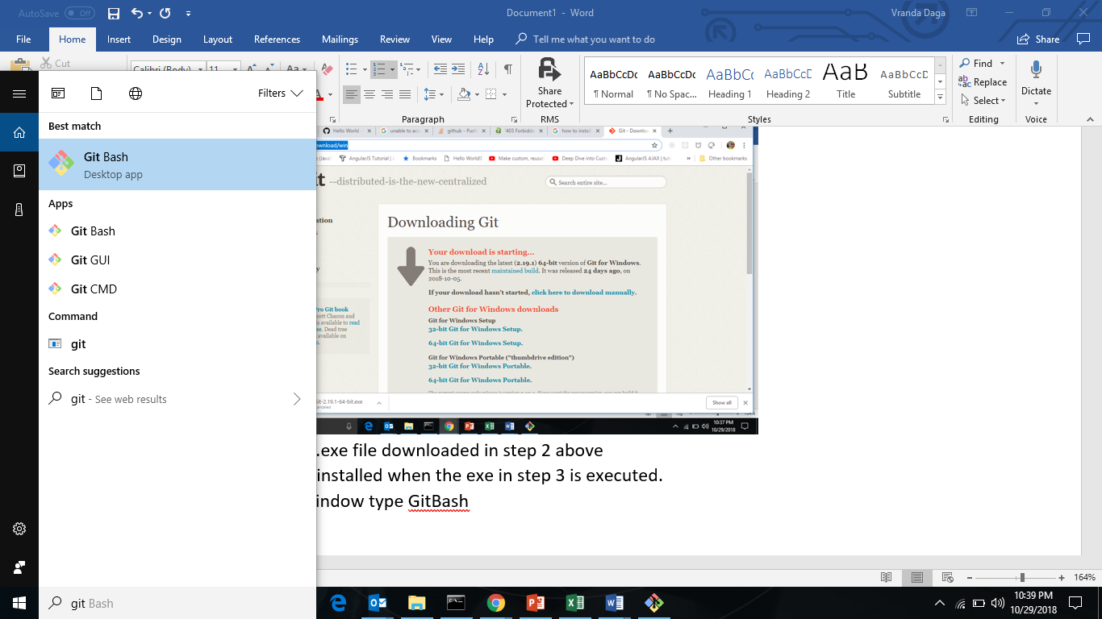

1. The GitBash window will open for writing your Git commands.
2. Install Notepad++ editor from the link <https://notepad-plus-plus.org/>
3. Click on the download button to download the exe as per the screen shot below.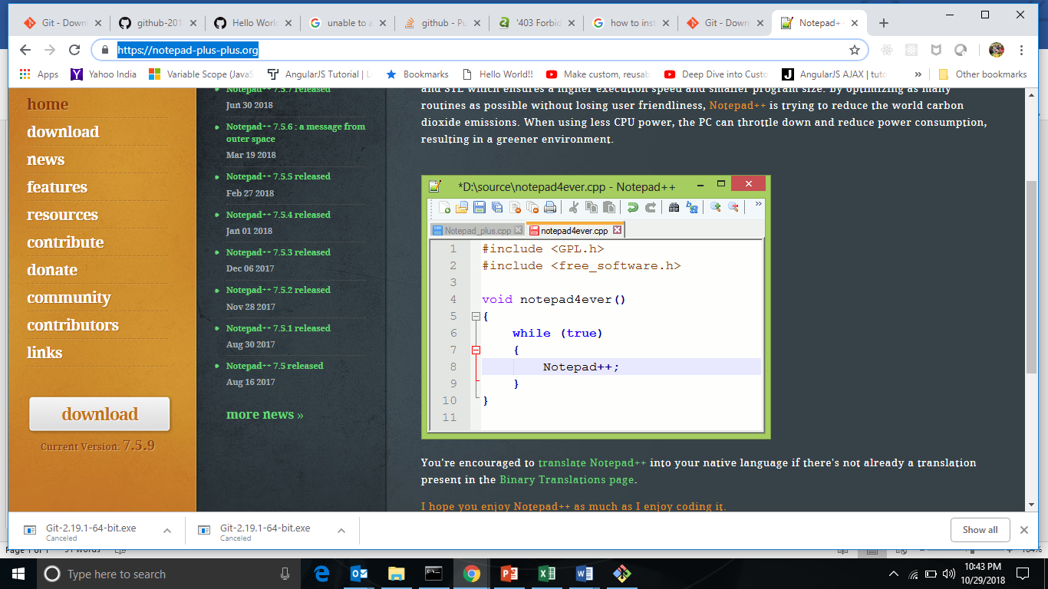
4. Install notepad++ on your system.