Group Statistics
 | Algorithm | N | Mean | Std. Deviation | Std. Error Mean
Accuracy | XG | 10 | 68.3860 | 36.04512 | 11.39847
Accuracy | DECISION | 10 | 57.9470 | 13.10035 | 4.14269

Independent Samples Test
 |  | Levene's Test for Equality of Variances |  | t-test for Equality of Means
 |  | F | Sig. | t | df | Sig. (2-tailed) | Mean Difference | Std. Error Difference | 95% Confidence Interval of the Difference
 |  |  |  |  |  |  |  |  | Lower | Upper
Accuracy | Equal variances assumed | 10.155 | .005 | .861 | 18 | .401 | 10.43900 | 12.12794 | -15.04086 | 35.91886
Accuracy | Equal variances not assumed |  |  | .861 | 11.337 | .407 | 10.43900 | 12.12794 | -16.15797 | 37.03597

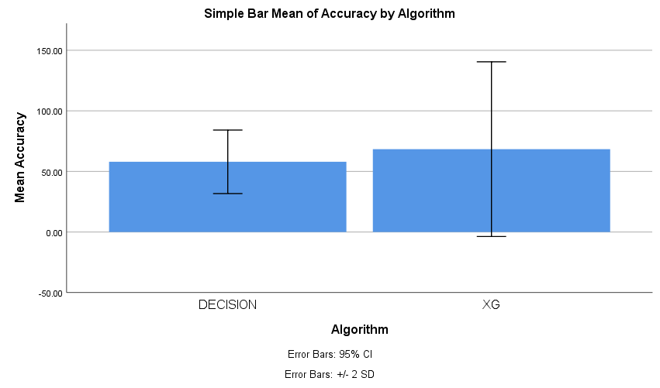

Group Statistics
 | Algorithm | N | Mean | Std. Deviation | Std. Error Mean
Accuracy | XG | 10 | 68.3860 | 36.04512 | 11.39847
Accuracy | RANDOM | 10 | 61.1800 | 30.15544 | 9.53599

Independent Samples Test
 |  | Levene's Test for Equality of Variances |  | t-test for Equality of Means
 |  | F | Sig. | t | df | Sig. (2-tailed) | Mean Difference | Std. Error Difference | 95% Confidence Interval of the Difference
 |  |  |  |  |  |  |  |  | Lower | Upper
Accuracy | Equal variances assumed | .646 | .432 | .485 | 18 | .634 | 7.20600 | 14.86136 | -24.01657 | 38.42857
Accuracy | Equal variances  not assumed |  |  | .485 | 17.456 | .634 | 7.20600 | 14.86136 | -24.08646 | 38.49846

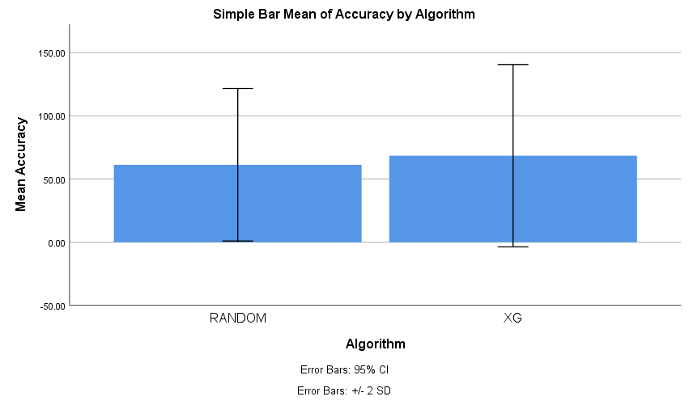

Group Statistics
 | Algorithm | N | Mean | Std. Deviation | Std. Error Mean
Accuracy | XG | 10 | 68.3860 | 36.04512 | 11.39847
Accuracy | SVM | 10 | 91.8590 | 1.51487 | .47904

Independent Samples Test
 |  | Levene's Test for Equality of Variances |  | t-test for Equality of Means
 |  | F | Sig. | t | df | Sig. (2-tailed) | Mean Difference | Std. Error Difference | 95% Confidence Interval of the Difference
 |  |  |  |  |  |  |  |  | Lower | Upper
Accuracy | Equal variances assumed | 24.886 | .000 | -2.057 | 18 | .054 | -23.47300 | 11.40853 | -47.44143 | .49543
Accuracy | Equal variances not assumed |  |  | -2.057 | 9.032 | .070 | -23.47300 | 11.40853 | -49.26705 | 2.32105

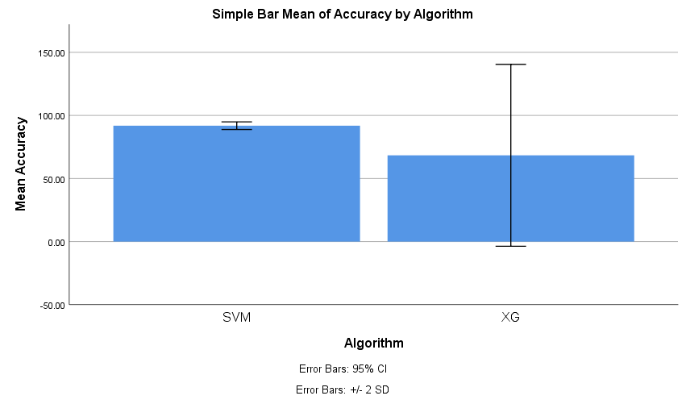

Group Statistics
 | Algorithm | N | Mean | Std. Deviation | Std. Error Mean
Accuracy | XG | 10 | 68.3860 | 36.04512 | 11.39847
Accuracy | Logistic | 10 | 87.0000 | 6.68331 | 2.11345

Independent Samples Test
 |  | Levene's Test for Equality of Variances |  | t-test for Equality of Means
 |  | F | Sig. | t | df | Sig. (2-tailed) | Mean Difference | Std. Error Difference | 95% Confidence Interval of the Difference
 |  |  |  |  |  |  |  |  | Lower | Upper
Accuracy | Equal variances assumed | 18.115 | .000 | -1.606 | 18 | .126 | -18.61400 | 11.59275 | -42.96946 | 5.74146
Accuracy | Equal variances not assumed |  |  | -1.606 | 9.618 | .141 | -18.61400 | 11.59275 | -44.58395 | 7.35595

