ONION QUALITY GRADING FROM A SINGLE PHOTOGRAPH
A Deep-Learning Pipeline for Per-Onion Defect Measurement and AGMARK Grading
A PROJECT REPORT

BACHELOR OF TECHNOLOGY
in
COMPUTER SCIENCE AND ENGINEERING
(ARTIFICIAL INTELLIGENCE AND MACHINE LEARNING)
Submitted by
ASHISH Reg. No. 12413705
VINAYAK TIWARI Reg. No. 12402289
Under the guidance of
ABHISHEK TIWARI
SCHOOL OF COMPUTER SCIENCE AND ENGINEERING


LOVELY PROFESSIONAL UNIVERSITY
PHAGWARA, PUNJAB
October 2026

CERTIFICATE
This is to certify that the project report entitled “Onion Quality Grading from a Single Photograph: A Deep-Learning Pipeline for Per-Onion Defect Measurement and AGMARK Grading” is a Bonafide record of the work carried out by Ashish (Registration Number 12413705) and Vinayak Tiwari (Registration Number 12402289), in partial fulfilment of the requirements for the award of the degree of Bachelor of Technology in Computer Science and Engineering (Artificial Intelligence and Machine Learning) from Lovely Professional University, Phagwara, during the fifth semester of the academic year 2026–27.
The work presented in this report is original and has been carried out under my supervision. To the best of my knowledge, the contents of this report have not been submitted elsewhere for the award of any other degree or diploma.

Signature of the Supervisor:
Abhishek Tiwari
School of Computer Science and Engineering
Lovely Professional University, Phagwara

DECLARATION
We hereby declare that the project report entitled “Onion Quality Grading from a Single Photograph” submitted to the School of Computer Science and Engineering, Lovely Professional University, Phagwara, is a record of original work carried out by us under the guidance of Abhishek Tiwari.
We further declare that the results reported in this work were obtained by us, that every figure quoted is traceable to a file in the project repository, and that all external sources of information — datasets, pre-trained models and published literature — have been duly acknowledged and cited in the References. This work has not been submitted, in whole or in part, for the award of any other degree or diploma.

Ashish
Registration No. 12413705
Vinayak Tiwari
Registration No. 12402289
Place: Phagwara
Date: 22 October 2026

ACKNOWLEDGEMENT
We express our sincere gratitude to our supervisor, Abhishek Tiwari, School of Computer Science and Engineering, Lovely Professional University, for continuous guidance, constructive criticism and encouragement throughout this project. The insistence on measuring every claim, rather than asserting it, shaped this work more than any other single influence.
We are thankful to the faculty members of the School of Computer Science and Engineering for providing the facilities and the academic environment required to carry out this work.
We also acknowledge the open-source community whose work this project builds upon — the Ultralytics YOLO framework, the Segment Anything and MobileSAM authors, the EfficientNet authors and the OpenCV Zoo — and Kaggle, whose free GPU resources made model training possible without dedicated hardware.
Finally, we thank our families and friends for their patience and support.

Ashish
Vinayak Tiwari

ABSTRACT
Onion grading in Indian markets is performed by visual inspection, which is slow, inconsistent between graders and leaves no record of the decision. In a controlled comparison carried out during this work, two human graders agreed with each other at a quadratic-weighted kappa of only 0.701 on the same 120 onions. Existing automated approaches largely treat the task as image classification — one photograph in, one label out — which cannot produce the quantity a statutory grade is actually defined by: the fraction of the onion’s surface that is damaged.
This project presents a measurement-first grading pipeline that operates on an ordinary mobile-phone photograph containing several onions. A YOLO26-m detector, fine-tuned on onion photographs, locates every onion; a three-class EfficientNet-B0 gate verifies that each detected object is genuinely an onion and simultaneously judges its condition; MobileSAM, prompted with the detector’s bounding box, produces a pixel-exact mask of each onion; and a deterministic measurement layer computes the damaged surface fraction inside that mask, calibrates it to human judgement through an isotonic map, and assigns an AGMARK-style grade. With a one-rupee coin in the frame, absolute size in millimetres and an AGMARK size code are also reported; without any reference object no millimetre figure is reported at all, because absolute scale is not present in a single photograph.
The system was evaluated under a leakage-free protocol: photographs were split by session, and the quality classifier was assessed by five-fold cross-validation split by photograph with nested threshold selection. On 538 onions labelled individually, it achieves 98.3 % balanced accuracy (193 of 198 defective onions detected, 337 of 340 sound onions passed), against 88.5 % for the previous model. The detector achieves 0.998 recall on the same set and mAP@50 of 0.950 on its validation split. End to end, the system agrees with a human grader at kappa 0.819 — higher than the agreement between two human graders. Objects that are not onions are rejected before grading (0 of 50 non-onion images produced a grade), photographs outside the calibrated domain raise a warning at run time, and onions on which the classifier is uncertain are reported as BORDERLINE rather than forced into a class. The complete pipeline runs in 1.3 s per photograph on a sixteen-core CPU with no GPU and no cloud service.

TABLE OF CONTENTS
(Right-click anywhere in the table below and choose “Update Field” in Word to generate page numbers.)
CERTIFICATE ii
DECLARATION iii
ACKNOWLEDGEMENT iv
ABSTRACT v
TABLE OF CONTENTS vi
LIST OF FIGURES viii
LIST OF TABLES ix
CHAPTER 1: INTRODUCTION 1
1.1 Background 1
1.2 Problem Statement 1
1.3 Objectives 1
1.4 Scope and Limitations 2
1.5 Organisation of the Report 2
CHAPTER 2: LITERATURE SURVEY 3
2.1 Overview 3
2.2 CNN-based classification 3
2.3 Robotic sorting systems 3
2.4 Anomaly-detection-based industrial inspection 4
2.5 Summary of the reviewed literature 4
2.6 Research gaps identified 4
CHAPTER 3: SYSTEM DESIGN AND METHODOLOGY 6
3.1 System architecture 6
3.2 Models employed 6
3.3 Stage descriptions 7
3.3.1 Detection and reference-object identification 7
3.3.2 Verification gate 7
3.3.3 Segmentation 7
3.3.4 Defect measurement and grading 8
3.3.5 Health verdict and uncertainty 8
3.3.6 Domain guard 9
3.4 Datasets 9
3.5 Training methodology 9
3.5.1 Detector 9
3.5.2 Classifier 9
3.6 Evaluation methodology 10
CHAPTER 4: IMPLEMENTATION 12
4.1 Tools and technologies 12
4.2 Module organisation 12
4.3 Key implementation details 12
4.3.1 Measurement 12
4.3.2 Duplicate, fragment and merge filtering 13
4.3.3 Application and caching 13
4.4 Live camera mode 13
CHAPTER 5: RESULTS AND DISCUSSION 15
5.1 Detector performance 15
5.2 Quality classifier 16
5.3 End-to-end agreement with a human grader 16
5.4 Robustness 17
5.5 Processing time 18
5.6 Comparison with recent published work 18
5.7 Reproducing the results 19
5.8 Limitations observed 19
CHAPTER 6: CONCLUSION AND FUTURE WORK 20
6.1 Conclusion 20
6.2 Future work 20
REFERENCES 22
APPENDIX A: SYSTEM CONSTANTS 24
APPENDIX B: RUNNING THE SYSTEM 25

LIST OF FIGURES
Figure 3.1 Block diagram of the proposed grading pipeline
Figure 3.2 Per-onion measurement views: crop, measured boundary, damaged pixels
Figure 4.1 Web application interface (photo-analysis mode)
Figure 5.1 Detector training curve over 100 epochs
Figure 5.2 Annotated output on a field photograph

LIST OF TABLES
Table 2.1 Summary of the reviewed literature
Table 2.2 Research gaps identified and the corresponding contribution
Table 3.1 Models used in the system
Table 3.2 Datasets used
Table 3.3 Training hyper-parameters
Table 5.1 Detector performance
Table 5.2 Cross-validated classifier performance
Table 5.3 Agreement between the system and human graders
Table 5.4 Robustness checks
Table 5.5 Processing time per photograph
Table 5.6 Comparison with recent published work

CHAPTER 1: INTRODUCTION

1.1 Background
India is among the largest producers and consumers of onions in the world, and the price a lot fetches at the mandi depends directly on its assessed quality. That assessment is made today by visual inspection: a trader or a grader looks at the lot and assigns it a grade. The method is slow at volume, it depends on the individual, and it produces no record that can be re-examined if the buyer and the seller disagree.
The inconsistency is measurable. During this work, two human graders independently graded the same 120 onions; their agreement, measured by quadratic-weighted Cohen's kappa, was 0.701. The same grader, repeating the exercise on the same onions, agreed with herself at 0.852. Any automated system must be judged against these numbers rather than against an implicit assumption that human grading is exact.
Computer vision is an obvious candidate for automating this task, and a considerable literature exists on classifying onion images as healthy or defective using convolutional neural networks. However, the statutory grade defined by the AGMARK Fruits and Vegetables Grading and Marking Rules is not a class label: it is expressed in terms of the proportion of the surface of the bulb affected by defects. A system that outputs only a class cannot produce that proportion, and therefore cannot produce a defensible grade.

1.2 Problem Statement
To design and implement a system that accepts an ordinary mobile-phone photograph containing one or more onions and, for each onion in the photograph, reports the fraction of its visible surface that is damaged, a corresponding AGMARK-style grade, a health verdict with an explicit uncertainty state, and — when a reference object is present — its size in millimetres, while rejecting objects that are not onions and indicating when the photograph lies outside the conditions the system was calibrated for.

1.3 Objectives
- To detect every onion in a hand-held photograph containing multiple onions, with high recall.
- To verify that each detected object is genuinely an onion before any grade is computed, and to refuse photographs that are not photographs of onions.
- To obtain a pixel-exact boundary for each onion without requiring hand-drawn segmentation masks for training.
- To measure the damaged surface fraction inside that boundary and calibrate it against human judgement.
- To assign an AGMARK-style grade and a health verdict, and to declare uncertainty explicitly rather than guessing.
- To report absolute size only when a reference object of known dimension is present in the frame.
- To evaluate the system under a protocol that cannot be inflated by data leakage, and to compare it against human-to-human agreement.
- To deliver the system as a usable application that runs on an ordinary laptop without a GPU.

1.4 Scope and Limitations
The system grades visible, external quality from an RGB photograph. The following are outside its scope, by design rather than by omission:
- Firmness, dryness, internal soundness and smell are part of the legal grade and cannot be observed in a photograph; every output is therefore labelled provisional.
- The species of a disease is not determinable from the outer skin in RGB, and is never named; the system reports how much of the surface is affected and flags damage that appears unusual in kind.
- Absolute size cannot be recovered from a single photograph without a reference object, because a small onion near the lens produces the same pixels as a large onion further away.
- In tightly packed heaps the detector locates approximately 17 of 20 onions; the system is designed for onions spread in a single layer.

1.5 Organisation of the Report
Chapter 2 reviews the recent literature on onion grading and states the research gaps this work addresses. Chapter 3 describes the system architecture, the four models employed, the datasets and the training and evaluation methodology. Chapter 4 describes the implementation, including the software modules and the user interface. Chapter 5 presents the measured results and compares them with published work. Chapter 6 concludes and identifies future work.

CHAPTER 2: LITERATURE SURVEY

2.1 Overview
Published work on automated onion quality assessment falls into three groups: image classification with convolutional neural networks, mechanical sorting systems that combine a detector with actuation hardware, and industrial inspection systems based on anomaly detection. Three recent works, one from each group, are reviewed in detail below because together they represent the current state of the art and, between them, exhibit every gap this project addresses.

2.2 CNN-based classification
Jajur and Siddamallappa (ICTACT Journal on Image and Video Processing, 2026) compare a custom convolutional network against MobileNetV2, VGG16 and ResNet50 for binary classification of onion images as healthy or unhealthy. Input images are resized to 224 × 224, and the networks are trained with the RMSprop optimiser at a learning rate of 0.001 with extensive augmentation. Their proposed model attains 98.33 % accuracy on their curated dataset, and the authors additionally establish that RGB input outperforms greyscale and colour-filtered variants. Significantly, the same model attains only 72.35 % accuracy on the independent Onion-det dataset, with the area under the ROC curve falling from 99.94 to 76.60.
Earlier work in the same group includes classification of sweet onions from X-ray images using Bayesian feature selection (≈90 % accuracy), SWIR hyperspectral detection of sour skin (87.14 % with an SVM classifier), and a multimodal machine-vision system combining X-ray, 3-D and hyperspectral sensors (88.9 %). These achieve internal-defect detection that RGB cannot, at instrument costs that place them outside the reach of a farmer or a small trader.

2.3 Robotic sorting systems
Suryawanshi et al. (IEEE ICONAT, 2025) present a complete sorting line: a conveyor with two proximity sensors, a programmable logic controller, a four-degree-of-freedom robotic arm with a vacuum gripper, and a DepthAI camera mounted on the arm. A YOLOv8 model detects onions and a convolutional network classifies each as Good or Bad, after which the arm places it in the corresponding bin. The reported detection performance is a mean average precision of 85.5 %, with precision 78.4 % and recall 80.0 %. The evaluation is presented largely as a stage-by-stage pass or fail table, and although the paper states that grading considers size and shape, no scale reference or size result is reported.

2.4 Anomaly-detection-based industrial inspection
Song, Buayai, Makino and Mao (Smart Agricultural Technology, 2025) describe an industrial onion inspection system consisting of a vision module and a physical filtering module. YOLOv8s locates onions and conveyor rollers; a student–teacher anomaly detection model, trained on normal onions only, assigns an anomaly score to each onion, and air-driven flappers eject the defective ones. Training on normal samples alone is an elegant response to label scarcity: the authors used 5 000 images of normal onions and only 350 of defective ones. The system attains 97.02 % accuracy on the test dataset and 86.37 % in a real production run of 2 236 onions, at approximately four frames per second. Examining their real-world confusion matrix, 281 of 2 099 sound onions (13.4 %) were rejected and 114 of 137 defective onions (83.2 %) were caught.

2.5 Summary of the reviewed literature
Work | Approach | Reported result | Principal limitation
Jajur & Siddamallappa, 2026 | Custom CNN vs MobileNetV2 / VGG16 / ResNet50; whole-image binary classification | 98.33 % on own dataset; 72.35 % on Onion-det | No per-onion output and no damaged-area measurement; random 80/20 split; large drop on a second dataset
Suryawanshi et al., 2025 | Conveyor + PLC + 4-DOF arm; YOLOv8 detection with CNN classification | mAP 85.5 %; precision 78.4 %; recall 80.0 % | Requires dedicated hardware; no measured area or size; limited quantitative evaluation
Song et al., 2025 | Student–teacher anomaly detection on an industrial line with air-jet ejection | 97.02 % (test); 86.37 % on 2 236 onions in production | Binary accept/reject, not a grade; 13.4 % of sound onions rejected in production
Shahin et al.; Wang & Li (as cited) | X-ray, hyperspectral and multimodal sensing | 87–90 % | Instrument cost far beyond a mobile-phone-based deployment
Table 2.1 Summary of the reviewed literature

2.6 Research gaps identified
Six gaps recur across the reviewed work, and each is addressed by a specific mechanism in the proposed system.
No. | Gap in existing work | Contribution of this work
1 | The grade is never measured. Systems output a class label, whereas the statutory grade is defined by damaged surface area. | Box-prompted segmentation followed by pixel-level defect measurement inside each onion's own boundary, calibrated to human judgement by isotonic regression.
2 | Evaluation can leak. Random splits of datasets containing repeated views of the same physical onion inflate accuracy. | Group splitting by photographic session, five-fold cross-validation by photograph, and nested threshold selection.
3 | Input validity is assumed. A binary classifier must return a class even for a hand, a potato or a face. | A three-class gate with an explicit Not-Onion class, context re-scoring, a dedicated face detector, and photograph-level refusal.
4 | Domain shift is reported as a caveat rather than detected at run time. | A two-directional domain guard computed from statistics already available, plus an explicit BORDERLINE verdict.
5 | Millimetre sizes are reported from a single photograph, in which absolute scale is not present. | Size reported only when a reference object is detected; relative size always reported; an explicit warning otherwise.
6 | Shortcut learning is untested, although studio backgrounds allow a network to learn the background instead of the object. | Background substitution during training and a masked re-score at inference; the earlier model's soil-based shortcut was identified and removed.
Table 2.2 Research gaps identified and the corresponding contribution

CHAPTER 3: SYSTEM DESIGN AND METHODOLOGY

3.1 System architecture
The system is organised as a pipeline of five stages. Three stages employ neural networks; the remaining two are deterministic arithmetic, which is what makes the reported measurement reproducible and auditable. The same photograph always produces identical output.
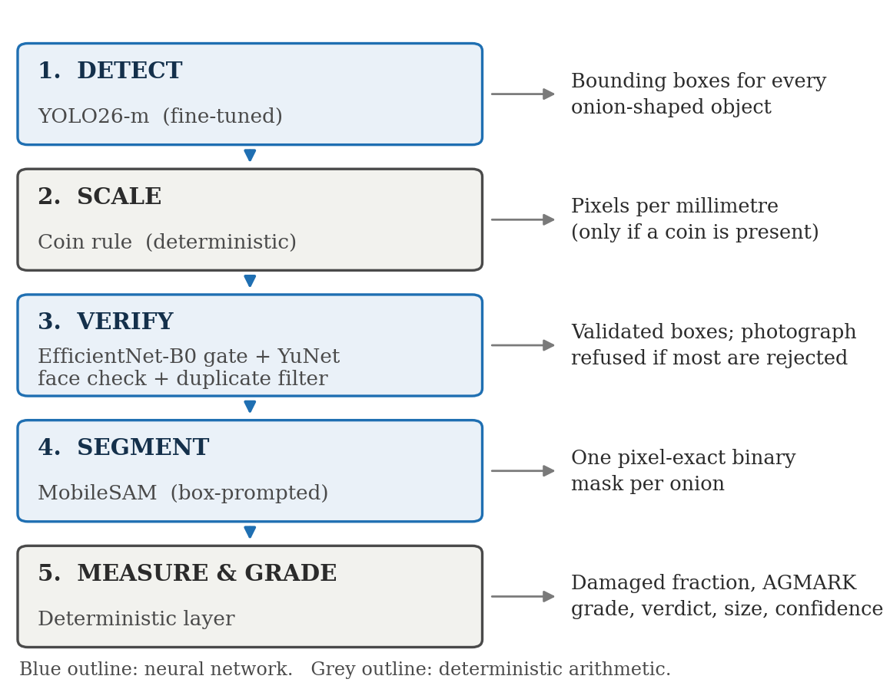
Figure 3.1 Block diagram of the proposed grading pipeline

3.2 Models employed
Two models were trained for this project and two were used as published. The principle is that models requiring onion-specific knowledge were trained, whereas models solving a general problem equally well on any object were reused; this is also why no segmentation annotation was required.
Model | Parameters | Status | Role and justification
YOLO26-m | 21.77 M | Fine-tuned | Object detection. The current Ultralytics generation; removes Distribution Focal Loss from the head, supports NMS-free end-to-end inference, and adds small-target-aware label assignment, which suits photographs containing many small onions.
EfficientNet-B0 | 4.01 M | Trained | Three-class gate and quality classifier (Healthy / Unhealthy / Not Onion). Compound scaling gives the best accuracy per parameter in its class; one forward pass answers both questions and the model runs on CPU.
MobileSAM | 10.14 M | As published | Promptable segmentation. Class-agnostic and prompted with the detector's box, it yields exact boundaries with zero segmentation annotation; its encoder is a distilled TinyViT, enabling CPU operation.
YuNet | 0.076 M | As published | Face rejection. The classifier alone scored a vendor's face only 12 % not-onion in a market photograph; a dedicated face detector scores real faces 0.88–0.92.
Table 3.1 Models used in the system

3.3 Stage descriptions

3.3.1 Detection and reference-object identification
The fine-tuned detector returns bounding boxes for onion-shaped objects. A reference coin is separated from the produce by two comparisons rather than by a second model: a coin is small relative to the median box area in the same photograph (below 45 %) and low in saturation (below 0.25). Because the comparison is made against the median of the same image, the rule is scale-free. Measured on the development set, it removed 54 of 72 spurious boxes and none of 537 onions.

3.3.2 Verification gate
Each box is classified into Healthy, Unhealthy or Not Onion. A box whose Not-Onion probability reaches 0.80 is discarded; between 0.50 and 0.80 it is graded but flagged for review. Each box is scored twice — once as cropped and once widened by 50 % on every side — and the higher Not-Onion probability governs rejection. This context re-scoring was introduced after a tight crop on a human toenail scored only 0.33–0.77, below the rejection threshold, whereas with the surrounding foot visible it scores 0.83–0.94. Across 575 real onions the widened view never exceeded 0.65, so the mechanism costs no true onions. If more than half the detections in a photograph are rejected, the photograph itself is refused.

3.3.3 Segmentation
MobileSAM encodes the photograph once and decodes every box against the cached embedding, so twenty onions cost little more than one. Masks are cleaned by retaining only the connected component containing the box centre. The boundary drawn for the user is the actual measured mask edge — obtained by binary erosion and subtraction — and not a fitted curve, so an incorrect measurement is visible to the user as an incorrect outline.

3.3.4 Defect measurement and grading
A pixel is counted as damaged when it is simultaneously low in saturation, low in value, and inside the mask. The raw fraction is passed through a 27-point monotone isotonic map fitted against human-graded onions, which converts “fraction flagged by the rule” into “fraction a person would call damaged”; monotonicity guarantees that the calibration can compress or stretch the scale but can never reverse the ordering of two onions. The calibrated fraction is then digitised against three cut points — a fitted detection limit of 0.10 and the statutory one-fifth and one-half — producing four grades: Extra Class eligible, Class I, Class II and Below minimum. A confidence value is computed as the distance from the nearest grade boundary.
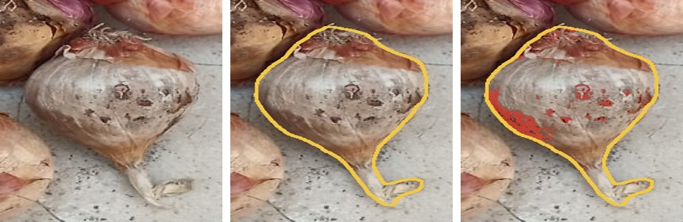
Figure 3.2 Per-onion measurement views: the crop as photographed, the measured boundary returned by segmentation, and the pixels counted as damaged.

3.3.5 Health verdict and uncertainty
The health verdict is taken from the classifier rather than from the pixel rule, because the pixel rule over-reads dark cultivars: on 50 onions a grader judged free of visible defect, the correlation between skin darkness and measured defect was +0.54 and 17 were nevertheless flagged. The classifier score is computed as P(unhealthy)/(P(healthy)+P(unhealthy)) and evaluated on both the plain crop and a background-removed crop, the lower value being taken, so that an onion is declared unhealthy only if it appears so both as photographed and with its background removed. Scores below 0.3 are HEALTHY, above 0.7 UNHEALTHY, and the interval between is reported as BORDERLINE. The grade is then reconciled with the verdict so that contradictory output cannot be displayed.

3.3.6 Domain guard
Two run-time checks operate in opposite directions. The first fires when the photograph is unlike the calibration set, measured by the median Mahalanobis anomaly of onion pixels against a Gaussian fitted to healthy onion skin. The second fires when no onion in the photograph registers any defect at all, which occurs when over-exposure drives every raw fraction to zero — a failure the first check cannot see because the anomaly score falls rather than rises. When either fires, counts, outlines and relative sizes are retained, the grades are reported with a warning, and the anomaly score is withdrawn.

3.4 Datasets
Three sources were used. The hand-labelled tray set is the primary evaluation set because it is the only one labelled at the level of the individual onion and it was photographed with a camera not represented in the other sources.
Dataset | Size | Label level | Use
Public onion quality dataset (re-cut with our detector) | ≈44 000 crops | Per photograph, propagated to crops | Training (weak labels weighted 0.5)
Hand-labelled tray set | 538 onions from 61 photographs (198 defective, 340 sound) | Per onion | Primary evaluation, five-fold cross-validation; also training in v5
VegQual (public) | 763 crops | Per photograph | Second training source and independent held-out test
Non-onion set | 50 photographs | Negative | Gate audit
Table 3.2 Datasets used

3.5 Training methodology

3.5.1 Detector
Every onion in every training photograph was annotated with a bounding box in YOLO format, described by a dataset YAML with a single class. Training began from COCO-pretrained weights, so that general features — edges, curvature, texture — were already present, and proceeded for 100 epochs on two GPUs with mixed precision. Mosaic augmentation was disabled for the final fifteen epochs so that training concluded on realistic images.

3.5.2 Classifier
Training crops were produced by the project's own detector so that training and inference crops are identically framed. The network was initialised from ImageNet weights — never from the previous version of the model, which had already seen the evaluation photographs — and its classifier head was replaced with a dropout layer and a three-way linear layer. Class imbalance was handled by a weighted sampler balanced over class and photograph type, and photograph-level (weak) labels were included at half weight, never for validation or testing.
Against shortcut learning, the pixels outside the onion were replaced during training, half of the time, with a flat random colour, blurred noise or another crop's background. This was introduced after the previous model was found to have learnt that soil implies decay, causing field photographs to be graded almost entirely as unhealthy.
Parameter | Detector (YOLO26-m) | Classifier (EfficientNet-B0)
Initialisation | COCO-pretrained yolo26m.pt | ImageNet-pretrained
Epochs | 100 (patience 25) | 6 per fold, 5 folds + final model
Input size | 960 px | 224 × 224
Batch size | 8 | 64
Optimiser | auto (lr0 0.01 → ×0.01, momentum 0.937) | AdamW, lr 3 × 10⁻⁴, weight decay 10⁻⁴
Schedule | Warm-up 3 epochs, linear decay | OneCycleLR, 10 % warm-up
Loss | Box + classification + L1 (no DFL term) | Cross-entropy, label smoothing 0.1, per-sample weights
Augmentation | Mosaic, ±25° rotation, flips, scale 0.5, HSV jitter, random erasing | Flips, ±20° rotation, colour jitter, blur, crop jitter, background substitution
Hardware / time | 2 × Kaggle GPU, 64 minutes | 1 × Kaggle GPU, ≈1 hour for all six runs
Table 3.3 Training hyper-parameters

3.6 Evaluation methodology
Because the evaluation protocol is itself a contribution of this work, it is stated explicitly. Photographs were grouped into sessions of twenty-five consecutive frames and whole sessions assigned to training, validation or test, so that near-identical views of the same physical onion cannot appear on both sides of the split. The quality classifier was then assessed by five-fold cross-validation over the 538 hand-labelled onions, with the folds formed by photograph rather than by onion. Within each fold, the decision threshold was selected using only the remaining folds — nested selection — so that the reported accuracy is not optimistic. The previous model was scored on exactly the same crops, making the comparison like-for-like. Balanced accuracy, the mean of the two class recalls, is reported because the classes are unbalanced; the two raw counts are always reported alongside it because the two error types carry different costs.

CHAPTER 4: IMPLEMENTATION

4.1 Tools and technologies
Component | Version | Purpose
Python | 3.11 | Implementation language
Ultralytics | 8.4.x | Loading and running YOLO26 and MobileSAM; ByteTrack in live mode
PyTorch / torchvision | 2.x | Classifier training and inference; mixed precision
NumPy | 2.x | All pixel arithmetic: saturation, value, defect mask, geometry
SciPy (ndimage) | 1.x | Connected components, morphological erosion and dilation, texture filter
Pillow | 12.x | Image input/output and all drawing
Streamlit | 1.x | Web application, caching, embedded components
OpenCV | 4.x | Camera capture and the YuNet face detector
Kaggle Notebooks | — | Free GPU used for training only; inference requires no GPU
No cloud vision service or paid application-programming interface is used at any point. All computation is local, and the complete set of model weights occupies approximately 100 MB.

4.2 Module organisation
Module | Responsibility
grader.py | The pipeline: detection, gate orchestration, segmentation, measurement, grading, rendering and the command-line interface. Defines the OnionGrader, Result and Onion classes.
gate.py | The EfficientNet wrapper, the YuNet face check, the duplicate/fragment/merge filter and the face-overlap rule.
calibration.json | Every fitted constant and threshold, so that no fitted number is hard-coded in the pipeline and the system can be re-tuned without modifying code.
app.py | The Streamlit application: upload, annotated result, statistics, per-onion inspection, tabular results and JSON export.
live.py, live_page.py | Live camera mode: the tracking loop, background grading and the live tab of the interface.
training/ | prepare_crops.py (crop extraction with group splitting), train_classifier.py, train_v5.py (cross-validation), evaluate_classifier.py.
benchmark.py, gatecheck.py, selftest.py | Measurement utilities: folder benchmark, gate audit, timing and device self-check.

4.3 Key implementation details

4.3.1 Measurement
The defect fraction is computed as the number of pixels that are simultaneously dull, dark and inside the mask, divided by the number of pixels in the mask. Using the mask rather than the bounding box as the denominator is essential: a bounding box of a round object contains roughly a fifth background even in the best case, and in a heap it also contains parts of neighbouring onions. The identical boolean array is used to paint the red overlay in the per-onion view, so the displayed evidence cannot disagree with the reported number.

4.3.2 Duplicate, fragment and merge filtering
Overlapping detections are resolved by a coverage matrix rather than by intersection-over-union alone, which allows three cases to be distinguished: a duplicate, a fragment (for example a bulb without its stalk lying inside the full box) and a merge (one box drawn across two onions). A box is treated as a merge only when it contains at least two mutually non-overlapping boxes that together occupy at least half its area; this condition was added after a defect in which two fragments of a single onion triggered the merge rule and the correct box was discarded.

4.3.3 Application and caching
Model objects are loaded once per process and per-photograph products are cached against a digest of the uploaded bytes, so that navigating between onions never re-grades the photograph. The per-onion inspection panel is delivered as a single self-contained HTML component so that user interaction does not trigger a server round trip.
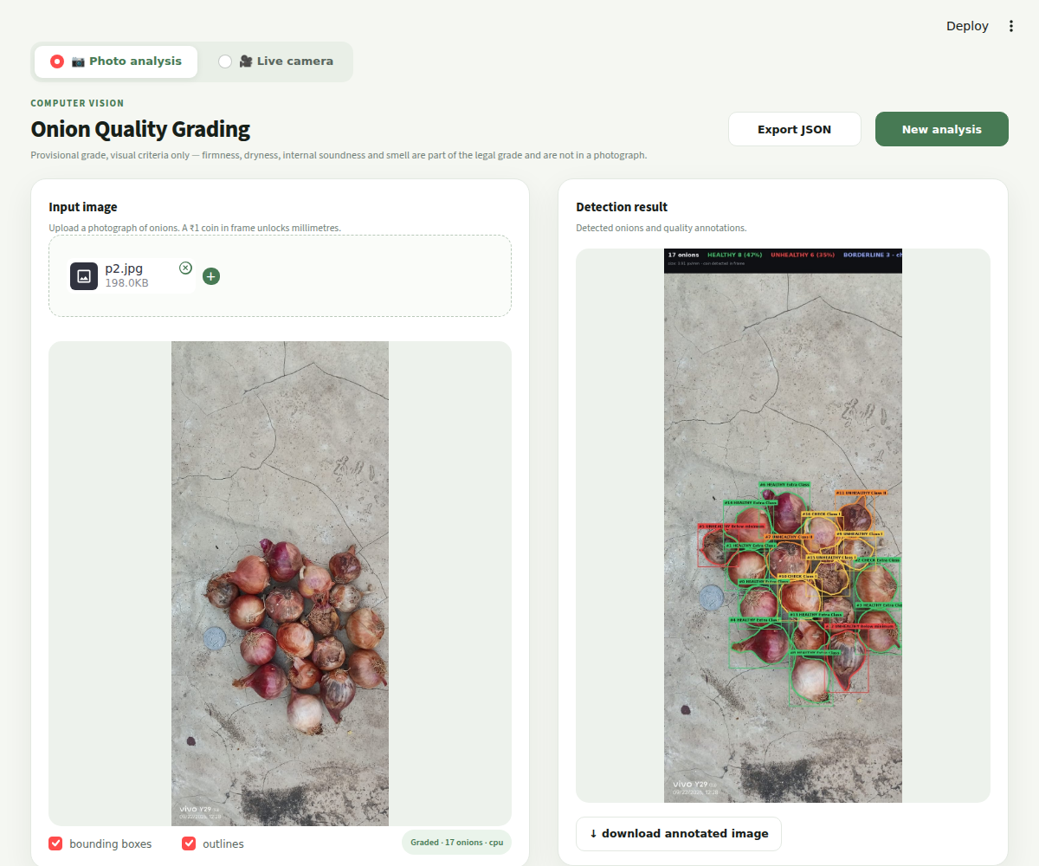
Figure 4.1 Web application interface (photo-analysis mode)

4.4 Live camera mode
Because a full grade requires seconds while a camera delivers thirty frames per second, live operation uses two loops. The fast loop tracks every frame with ByteTrack at reduced resolution, assigning each onion a stable identity, and draws the most recent grade associated with that identity. The slow loop copies a frame every few seconds and runs the complete pipeline in a background thread at full resolution, attaching each grade to the identity whose box it overlaps. A dedicated reader thread retains only the newest frame, since the video capture layer otherwise buffers frames and the displayed image falls behind. The header reports the age of the grades, and onions not yet graded are drawn in grey. Live operation is an interface onto the instrument rather than a validated mode of it: all accuracy figures in this report were measured on still photographs.

CHAPTER 5: RESULTS AND DISCUSSION
Every figure in this chapter is reproducible from a file in the project: the detector metrics are stored inside the model checkpoint, the classifier results in the cross-validation report, and the remaining measurements can be regenerated with the utilities listed in Section 5.7.

5.1 Detector performance
Training ran for the full 100 epochs in 63.7 minutes on two GPUs; the best epoch was 95. The validation metrics stored in the checkpoint are given below.
Metric | Value | Interpretation
Precision | 0.8925 | Of the boxes predicted, the proportion that were real onions
Recall | 0.9132 | Of the onions present, the proportion that were found
mAP@50 | 0.9507 | Detection quality at 50 % overlap — “was it found”
mAP@50–95 | 0.8925 | Averaged over overlap thresholds 0.50–0.95 — also measures how tightly the box fits
Recall in the complete pipeline | 0.998 (537 of 538) | Measured on the hand-counted evaluation set with onions spread in one layer
Precision after the coin rule | 0.968 | The coin rule removed 54 of 72 spurious boxes and no true onions
Table 5.1 Detector performance
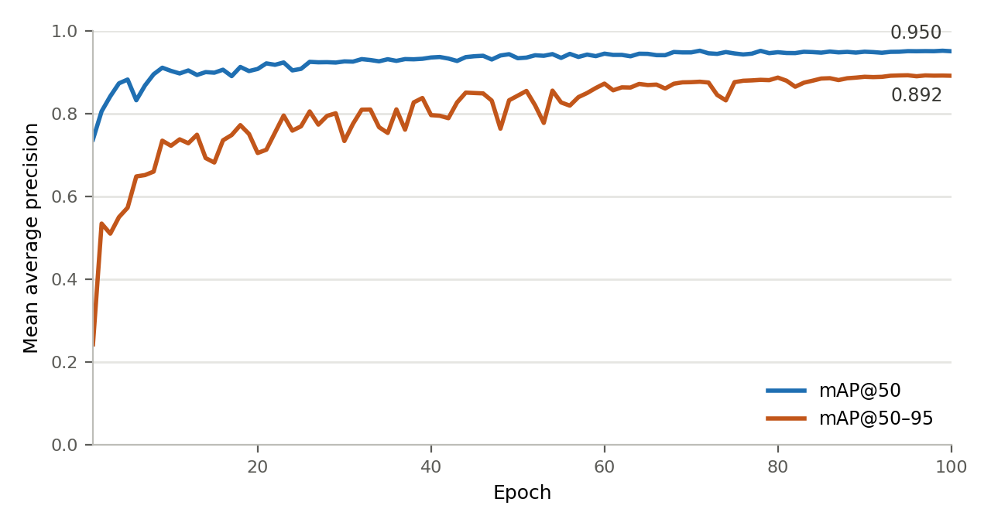
Figure 5.1 Detector training curve over 100 epochs
The curve shows that mAP@50 reaches 0.74 after a single epoch, which is attributable to COCO pre-training: a network that already recognises round objects requires little adaptation to locate onions. The substantial learning over the remaining epochs occurs in mAP@50–95, rising from 0.24 to 0.89, which corresponds to the boxes becoming progressively tighter rather than more numerous. No divergence between the two curves is observed in the later epochs, indicating that overfitting did not occur within the training budget.

5.2 Quality classifier
The classifier was evaluated by five-fold cross-validation over 538 individually labelled onions, the folds formed by photograph, with the decision threshold selected on the remaining folds in each case. The preceding model was scored on the same crops.
Model | Balanced accuracy | Defective detected | Sound passed | Threshold
Previous model (v3) | 88.5 % | 180 / 198 | 293 / 340 | tuned per fold
Proposed model (v5) | 98.3 % | 193 / 198 | 337 / 340 | tuned per fold
Proposed model (v5), fixed threshold 0.5 | 98.8 % | 194 / 198 | 339 / 340 | 0.50
Table 5.2 Cross-validated classifier performance on 538 hand-labelled onions
The improvement is concentrated in the false-rejection rate: the previous model rejected 47 of 340 sound onions, whereas the proposed model rejects three. This error type is borne directly by the producer, since a sound onion classified as defective is a sound onion removed from the saleable lot. On the independent held-out photographs of the second public dataset, balanced accuracy rose from 97.2 % to 98.8 %.
An intermediate version of the model, trained on a single dataset, is instructive. It attained 99.6 % validation F1 and 100 % on its own held-out split, yet scored only 81.1 % on the independent hand-labelled set — below the model it was intended to replace — and was therefore rejected. This outcome is the clearest justification for the evaluation protocol described in Section 3.6.

5.3 End-to-end agreement with a human grader
The complete system was compared against a human grader on 120 individually graded onions, with the calibration cross-validated by physical onion so that no onion was graded by a curve fitted on it.
Comparison | Quadratic kappa | Exact band | Within one band
Proposed system versus human grader | 0.819 | 0.617 | 0.950
Earlier pipeline with hand-clicked prompts | 0.757 | 0.617 | 0.925
Two human graders with each other | 0.701 | 0.542 | 0.858
One human grader with herself, repeated | 0.852 | 0.600 | —
Table 5.3 Agreement between the system and human graders
The system therefore agrees with a human grader more closely than a second human grader does, and approaches the self-consistency of a single grader. This comparison is reported because an accuracy figure quoted without an agreement baseline cannot be interpreted: the task itself has an irreducible subjective component.

5.4 Robustness
Measurement | Result | Note
Non-onion photographs producing a grade | 0 of 50 | Eleven objects were graded by the previous configuration
Separation on held-out crops | 0.47 / 0.91 | Highest Not-Onion score on a true onion; lowest on a non-onion
Cost of context re-scoring | 0 of 575 onions | No true onion approached the rejection threshold (maximum 0.65)
Grades unchanged by the gate on tray photographs | 436 of 438 | The two removed detections were patches of bare floor
Repeatability across four photographs of one heap | 12 of 17 identical | Five borderline onions varied between 0.2 and 0.8 and are now reported as BORDERLINE
BORDERLINE rate, in domain | 0 of 538 | The band does not fire on familiar photographs
BORDERLINE rate, new camera | 19 of 126 (15 %) | The band fires precisely where the model should not be trusted
Table 5.4 Robustness checks
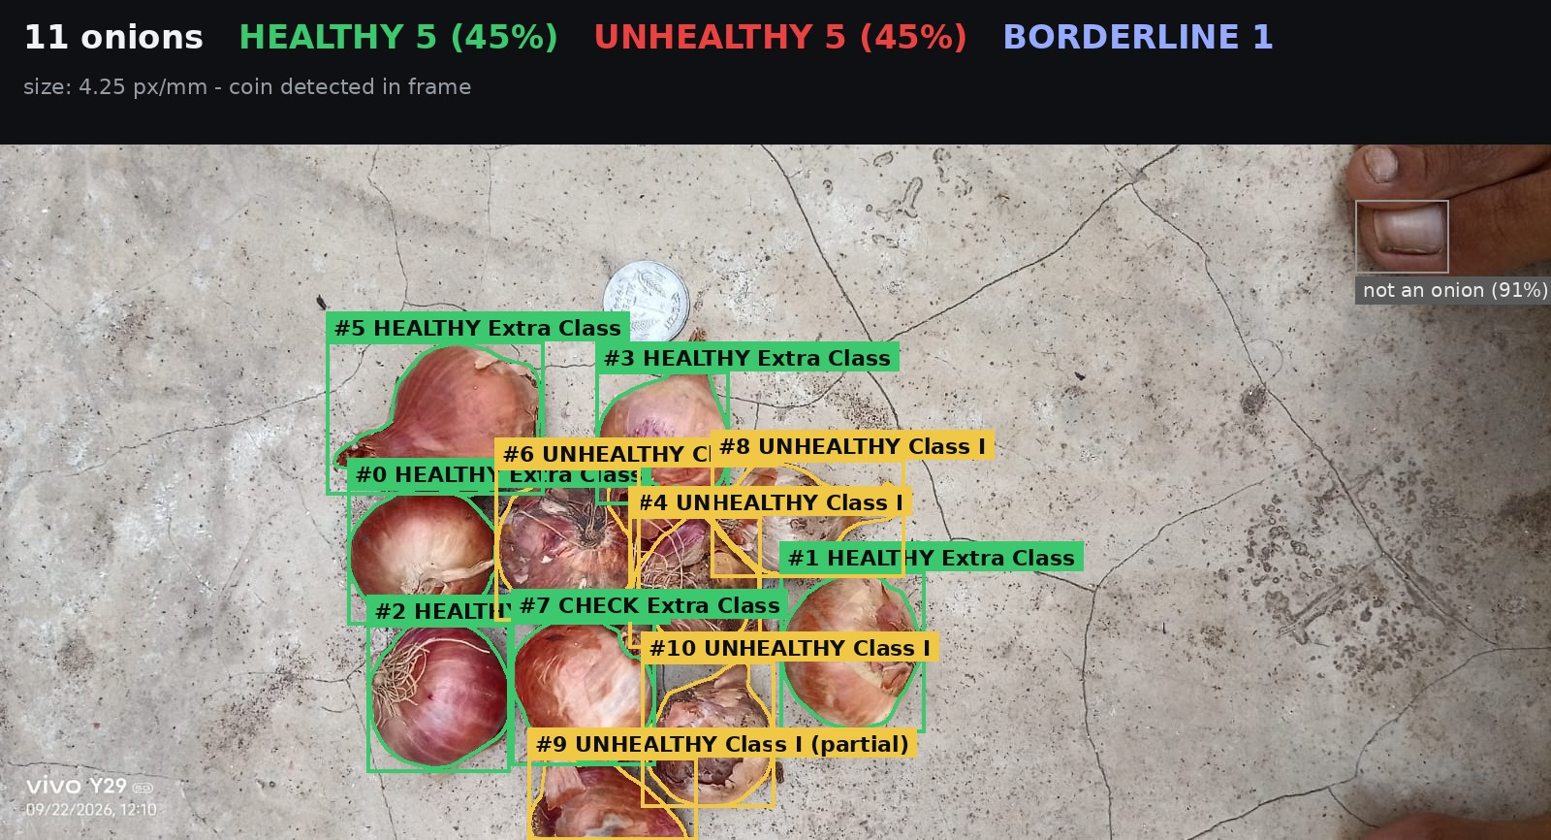
Figure 5.2 Annotated output on a field photograph. Each onion carries its measured outline and grade; the object at the upper right is a human foot, rejected by the gate at a Not-Onion probability of 0.91.

5.5 Processing time
Stage (960 × 640 photograph) | 16-core CPU | 2-core CPU
Detection | 0.34 s | 1.35 s
Segmentation (encode and decode) | 0.86 s | 3.20 s
Measurement, grading and rendering | 0.10 s | 0.16 s
Total | 1.30 s | 4.70 s
Table 5.5 Processing time per photograph
The two network passes account for approximately 92 % of the total, of which the segmentation encoder is the largest single item. No GPU is required.

5.6 Comparison with recent published work
A direct numerical comparison across these systems would be misleading, because each figure was obtained on a different test set under a different protocol. What can properly be compared is what each system outputs, how it behaves on an invalid input, and how it was validated.
Criterion | Jajur & Siddamallappa (2026) | Song et al. (2025) | Proposed system
Unit of assessment | Whole photograph | One onion per roller | Every onion in the photograph
Output | Healthy / unhealthy label | Normal / abnormal decision | Damaged area fraction, AGMARK grade, verdict, size
Evidence provided | Confusion matrix | Anomaly score | The pixel set the measurement was computed over
Invalid input | Not addressed | Not addressed | Three-class gate, face check, photograph refusal
Uncertainty | None | Fixed threshold | Explicit BORDERLINE verdict
Reported performance | 98.33 % own set; 72.35 % second set | 97.02 % test; 86.37 % in production (2 236 onions) | 98.3 % cross-validated on 538 individually labelled onions
Hardware required | None (offline images) | Conveyor, camera, ejector | A mobile phone and a laptop
Table 5.6 Comparison with recent published work
Two observations deserve emphasis. First, both published systems exhibit a substantial fall between their controlled evaluation and an independent or production setting — 98.33 % to 72.35 % and 97.02 % to 86.37 % respectively — which is precisely the failure mode the domain guard and the BORDERLINE verdict are designed to make visible rather than silent. Second, the production evaluation reported by Song et al. rejected 281 of 2 099 sound onions, a false-rejection rate of 13.4 %; the corresponding figure for the proposed system is 3 of 340, although on a different and less demanding test setting.
It should equally be recorded that the reviewed systems achieve results this project does not. Song et al. validated on a live production line with 2 236 onions and physically removed the defective ones, and their use of anomaly detection trained on normal samples alone addresses label scarcity more elegantly than the supervised approach adopted here. Suryawanshi et al. achieve physical actuation, which this work does not attempt.

5.7 Reproducing the results
The following utilities regenerate the measurements reported above: python -m onion_grader.selftest (timing and device); python -m onion_grader.benchmark (grades on labelled folders); python -m onion_grader.gatecheck (gate audit, saving every rejected box as an image); python training/evaluate_classifier.py (model comparison across the three test sets); and python training/train_v5.py (the complete cross-validated comparison).

5.8 Limitations observed
- In tightly packed heaps the detector locates approximately 17 of 20 onions. Lowering the confidence threshold recovers them but admits spurious boxes; the appropriate remedy is additional training photographs of heaps, not a different architecture.
- The pixel-based measurement over-reads dark cultivars, with a correlation of +0.54 between skin darkness and measured defect on onions judged free of visible defect. Three corrections were evaluated and rejected because two cost accuracy and the third did not meaningfully reduce the bias.
- The domain guard fired on only 20 % of a genuinely foreign dataset and should therefore be regarded as a tripwire for gross shifts rather than as a domain detector.
- Live camera operation has not been quantitatively validated; motion blur and varying viewing angle appear in none of the reported measurements.
- No controlled comparison was performed between YOLO26 and earlier YOLO generations on this dataset; the choice rests on documented architectural properties and on the measured recall of 0.998, not on a head-to-head experiment.

CHAPTER 6: CONCLUSION AND FUTURE WORK

6.1 Conclusion
This project set out to produce, from an ordinary photograph, the quantity that a statutory onion grade is actually defined by — the fraction of the surface that is damaged — rather than a category label. The resulting system detects every onion in a hand-held photograph, verifies that each detected object is genuinely an onion, obtains a pixel-exact boundary without any segmentation annotation, measures the damaged fraction inside that boundary, calibrates it against human judgement, and assigns an AGMARK-style grade together with a health verdict, a confidence and, when a reference object is present, a size in millimetres.
Under a leakage-free evaluation protocol the quality classifier attains 98.3 % balanced accuracy on 538 individually labelled onions, the detector attains 0.998 recall in the complete pipeline, and the system as a whole agrees with a human grader at a quadratic kappa of 0.819 — higher than the 0.701 agreement measured between two human graders on the same onions. Objects that are not onions are rejected before grading, photographs outside the calibrated domain are flagged at run time, and onions on which the classifier is not confident are reported as BORDERLINE rather than assigned arbitrarily. The complete pipeline runs in 1.3 seconds per photograph on a conventional CPU, requiring neither a graphics processor nor any cloud service.
The contribution is therefore not a new neural architecture but a system design and an evaluation discipline: measurement accompanied by its evidence, validity checking of the input, explicit declaration of uncertainty, and a test protocol that cannot be inflated by leakage. That protocol proved its own worth during development by identifying and rejecting an intermediate model of this project which had achieved 99.6 % validation F1.

6.2 Future work
- Annotating the 126 onions most recently photographed and retraining, which should convert the majority of BORDERLINE outcomes on that camera into confident decisions.
- Fine-tuning the detector on photographs of densely packed heaps to close the remaining recall gap in that condition.
- Averaging the classifier score across several frames of the same tracked onion in live mode, which directly addresses the frame-to-frame variation measured in Section 5.4.
- Investigating anomaly detection trained on sound onions alone, following Song et al., to reduce dependence on hand-labelled defective samples.
- Replacing the pixel-based defect rule with a learned area regressor once sufficient per-onion area annotations exist, which would directly address the dark-cultivar bias.
- Exporting the models to ONNX or TensorRT and providing a service interface, and subsequently an on-device deployment so that no laptop is required.
- Validating the system against a second independent, per-onion labelled dataset from a different camera and cultivar, which is the principal requirement for publication.

REFERENCES
[1] G. Jocher, J. Qiu, M. Liu, S. Lyu, F. C. Akyon and M. E. Kalfaoglu, “Ultralytics YOLO26: Unified Real-Time End-to-End Vision Models,” arXiv:2606.03748, 2026.
[2] A. Wang et al., “YOLOv10: Real-Time End-to-End Object Detection,” arXiv:2405.14458, 2024.
[3] X. Li et al., “Generalized Focal Loss: Learning Qualified and Distributed Bounding Boxes for Dense Object Detection,” in Proc. NeurIPS, 2020, arXiv:2006.04388.
[4] M. Tan and Q. Le, “EfficientNet: Rethinking Model Scaling for Convolutional Neural Networks,” in Proc. ICML, 2019, arXiv:1905.11946.
[5] A. Kirillov et al., “Segment Anything,” in Proc. IEEE/CVF ICCV, 2023, arXiv:2304.02643.
[6] C. Zhang et al., “Faster Segment Anything: Towards Lightweight SAM for Mobile Applications,” arXiv:2306.14289, 2023.
[7] W. Wu, H. Peng and S. Yu, “YuNet: A Tiny Millisecond-level Face Detector,” Machine Intelligence Research, vol. 20, pp. 656–665, 2023.
[8] Y. Zhang et al., “ByteTrack: Multi-Object Tracking by Associating Every Detection Box,” in Proc. ECCV, 2022, arXiv:2110.06864.
[9] B. Zadrozny and C. Elkan, “Transforming Classifier Scores into Accurate Multiclass Probability Estimates,” in Proc. ACM SIGKDD, 2002.
[10] C. Guo, G. Pleiss, Y. Sun and K. Q. Weinberger, “On Calibration of Modern Neural Networks,” in Proc. ICML, 2017, arXiv:1706.04599.
[11] K. Lee, K. Lee, H. Lee and J. Shin, “A Simple Unified Framework for Detecting Out-of-Distribution Samples and Adversarial Attacks,” in Proc. NeurIPS, 2018, arXiv:1807.03888.
[12] R. Geirhos et al., “Shortcut Learning in Deep Neural Networks,” Nature Machine Intelligence, vol. 2, pp. 665–673, 2020, arXiv:2004.07780.
[13] S. Kapoor and A. Narayanan, “Leakage and the Reproducibility Crisis in Machine-Learning-Based Science,” Patterns, vol. 4, no. 9, 2023, arXiv:2207.07048.
[14] J. A. Jajur and U. K. Siddamallappa, “Onion Image Classification using CNN Models,” ICTACT Journal on Image and Video Processing, vol. 16, no. 3, pp. 3839–3847, Feb. 2026.
[15] R. Suryawanshi et al., “Vision Based Automation System for Onion Grading Using Robotic Arm,” in Proc. IEEE 4th Int. Conf. for Advancement in Technology (ICONAT), Goa, India, Sep. 2025.
[16] Z. Song, P. Buayai, K. Makino and X. Mao, “Feature-adaptive anomaly detection model for onion inspection system,” Smart Agricultural Technology, vol. 11, art. 100983, 2025.
[17] P. Rybacki et al., “Development and application of a model for the automatic evaluation and classification of onions (Allium cepa L.) using a Deep Neural Network,” Acta Sci. Pol. Hortorum Cultus, vol. 23, no. 5, pp. 39–57, 2024.
[18] Directorate of Marketing and Inspection, Ministry of Agriculture and Farmers Welfare, Government of India, “Fruits and Vegetables Grading and Marking Rules, 2004” (AGMARK).
[19] M. Ahmed et al., “VegNet: Dataset of vegetable quality images for machine learning applications,” Data in Brief, 2022.
[20] Ultralytics, “YOLO26 model documentation” and “MobileSAM in Ultralytics,” docs.ultralytics.com, accessed September 2026.

APPENDIX A: SYSTEM CONSTANTS
All fitted constants reside in a single configuration file, so that the system can be re-tuned for a different camera or cultivar without modifying any code. The statutory one-fifth and one-half boundaries are never fitted.
Parameter | Value | Meaning
detector.conf / imgsz | 0.25 / 960 | Detection confidence threshold and inference resolution
coin_rule.max_area_ratio / max_saturation | 0.45 / 0.25 | A reference coin is small relative to the median box and low in saturation
onion_gate.reject_at / review_at | 0.80 / 0.50 | Not-Onion probability at which a box is discarded, and at which it is flagged
onion_gate.context_pad | 0.50 | Box widening used for the second, context-aware scoring pass
onion_gate.photo_reject_fraction | 0.50 | Fraction of rejected boxes above which the whole photograph is refused
verdict.unhealthy_at / borderline | 0.50 / [0.30, 0.70] | Health threshold and the uncertainty band
defect.s_thr / v_thr | 0.500 / 0.450 | Saturation and value thresholds defining a damaged pixel
defect.detection_limit | 0.10 | Fitted boundary of the “free from defects” band
defect.agmark_cuts | [0.20, 0.50] | Statutory one-fifth and one-half surface limits — never fitted
scale.coin_mm | 21.93 | Diameter of the one-rupee coin (2011 series)
scale.resolution_exponent | 1.525 | Measured exponent relating mask area to image resolution
size_codes | A/B/C/D | Below 30 mm, 30–45 mm, 45–60 mm, above 60 mm on the major axis
domain_guard | 0.30 / 0.40 / 0.05 / 3 | Median anomaly limit, flagged-fraction limit, raw-defect floor, minimum onion count

APPENDIX B: RUNNING THE SYSTEM
Installation requires a Python environment with the packages listed in Section 4.1; model weights are located automatically. The system offers three interfaces:
Command line: python -m onion_grader.grader photo.jpg --out graded.jpg --json out.json
Web application: streamlit run onion_grader/app.py
Python: from onion_grader.grader import OnionGrader; res = OnionGrader().grade("tray.jpg")
Training is reproduced in three steps: python training/prepare_crops.py --masks to extract crops with group splitting; python training/make_kaggle_v5.py to package the run; and, on a Kaggle notebook with a GPU, python training/train_v5.py --datasets DATA, which performs the five-fold cross-validation and writes the final model together with its evaluation report.

