**Topic:- Online Ticket Reservation System**

Introduction:-

* Online Ticket Reservation is a software you can use for managing reservations for your ticket booking service. An Online Ticket Reservation System allows to accept bookings online with ease.
* Basically, an online reservation system allows a potential customer to book Tickets.The Ticket reservation system facilitates the passengers to enquire about the trains available on the basis of source and destination, booking and cancellation of tickets, enquire about the status of the booked ticket, etc.

Objective :-

* To make ticket reservations convenient and easy through a simple website.
* The main objective of the Project on Ticket Reservation System is to manage the details of Train, Ticket, Booking, Passenger, Train Schedule. It manages all the information about Train, Train Route, Train Schedule, Train. The project is totally built at administrative end and thus only the administrator is guaranteed the access. The purpose of the project is to build an application program to reduce the manual work for managing the Train, Ticket, Train Route, Booking. It tracks all the details about the Booking, Passenger, Train Schedule.

Languages Used:-

◆ - HTML

◆ -CSS

◆ -PHP

◆ -Javascript

◆ -MySQL Database

◆ -Bootstrap Features :-

◆ 1) Searching of data is easy.

◆ 2) Passengers don’t have to wait for a long time.

◆ 3) Information is accurate.

◆ 4) It is a fast process.

◆ 5) Data efficiency is more.

Content of Online Ticket Reservation System :-

◆ Admin Login/Logout

◆ Reservation

◆ Confirm Reservation

◆ Cancel Reservation

◆ List All Confirmed/Paid Reservation

Home Page:-

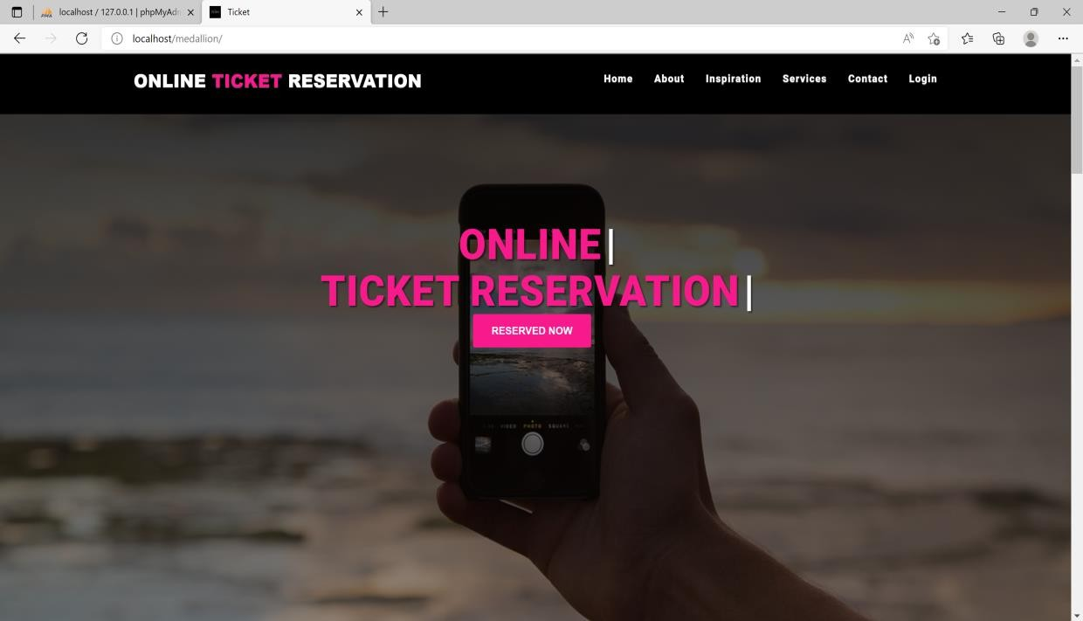

Admin Login:-

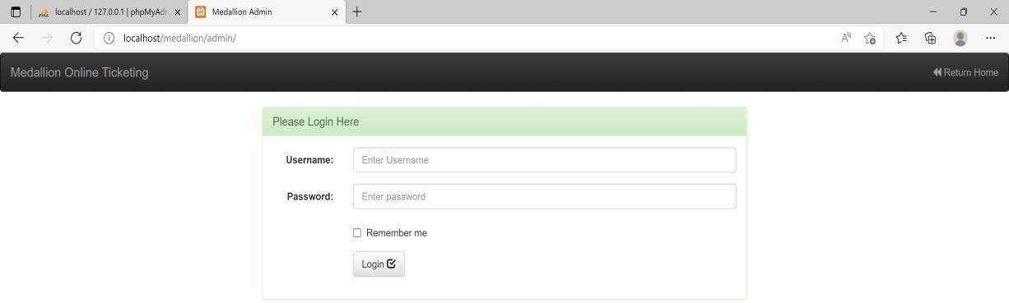

Reservation Page:-

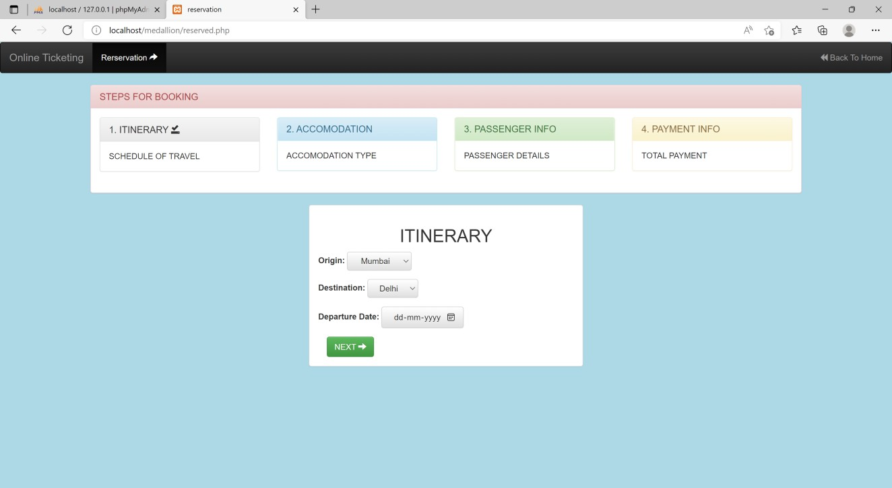

Accomodation Page:-

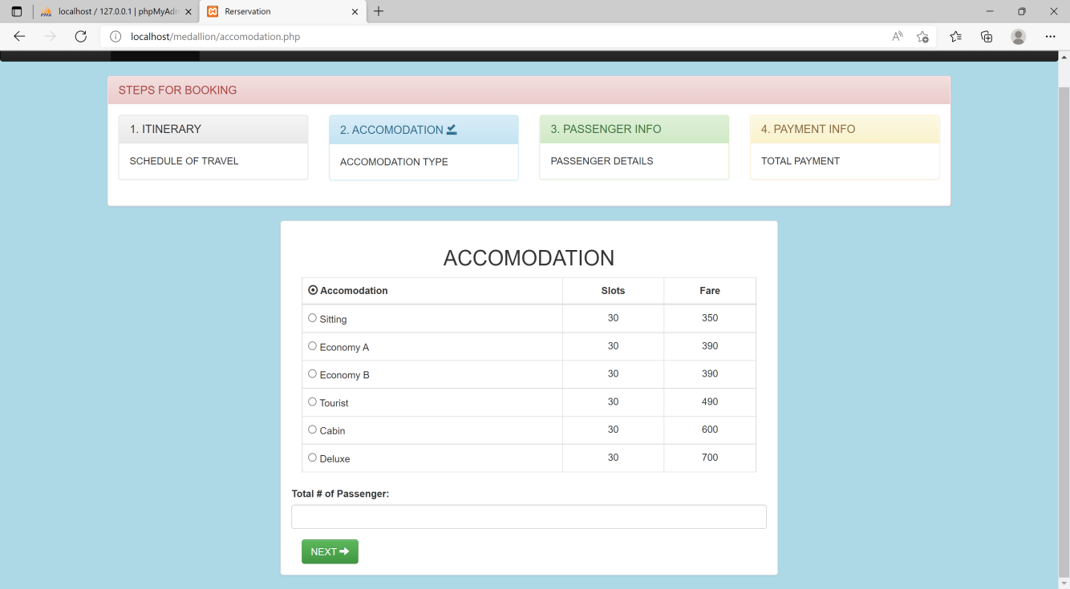

Passenger Info:-

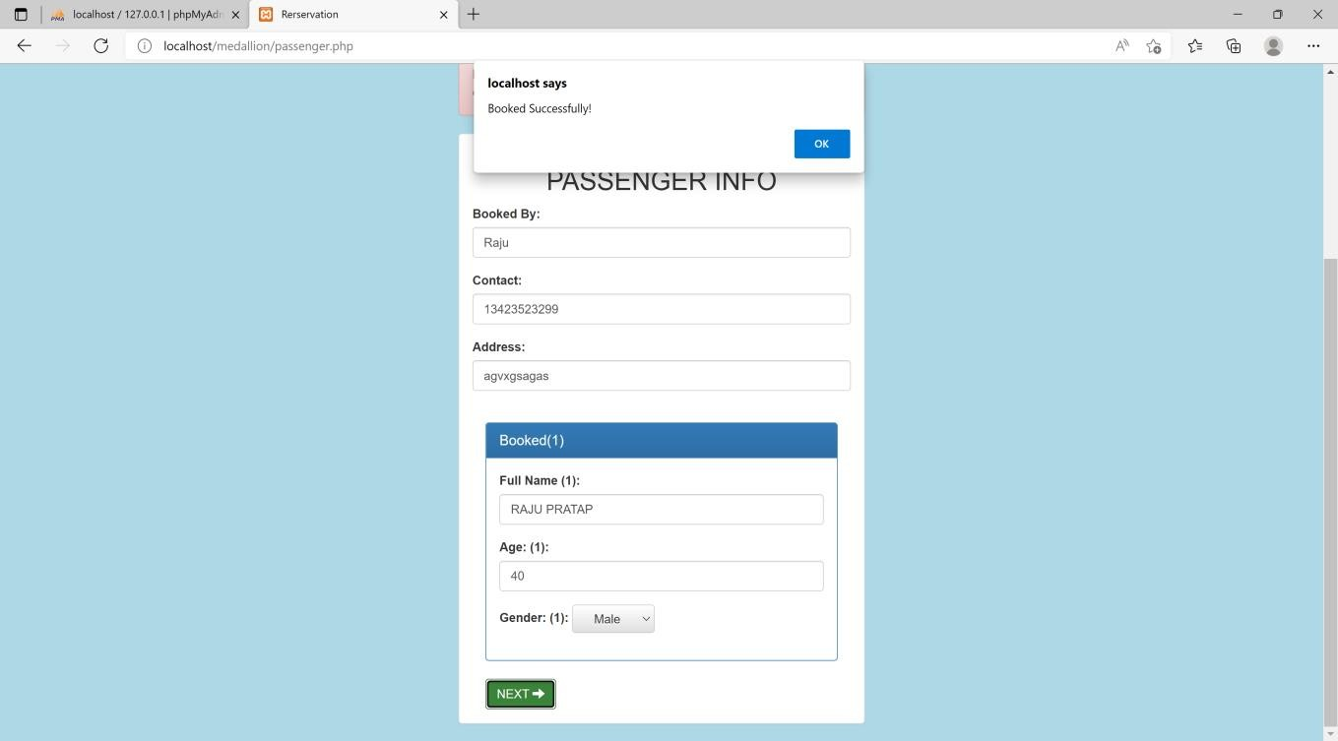

Booked info/cancellation:-

