1.Display vehicles which is available.

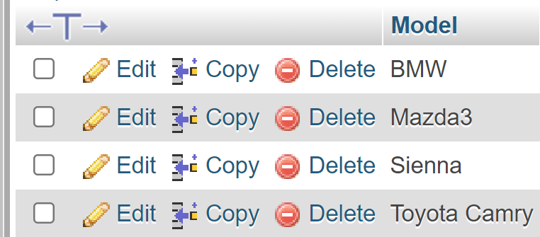

2.Display vehicle name having maximum seating capacity.

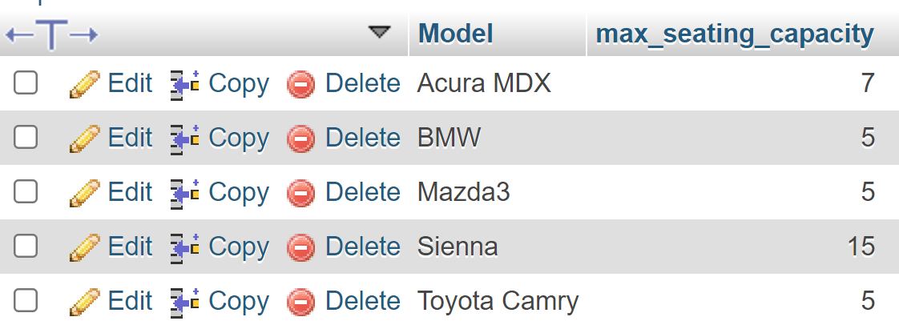

3.Delete all the reservations whose location is in “irving”.



4. Find names of Drivers whose last name starts with ‘P’.

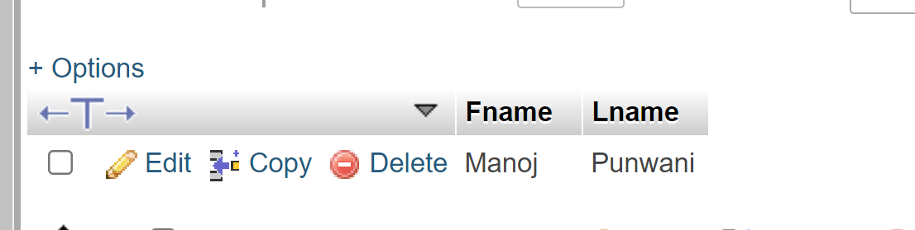

5.Display the list of additional drivers .

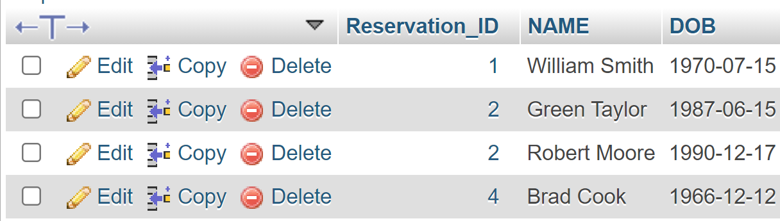

6.Show the list of available promo codes.

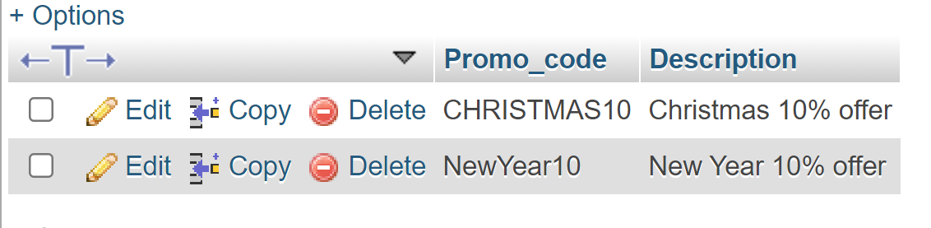

7.Show the driver phone number,licence number whose name is Patrick.

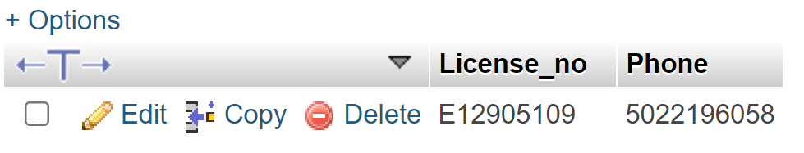

8. Display the type of vehicle having Minimum price.

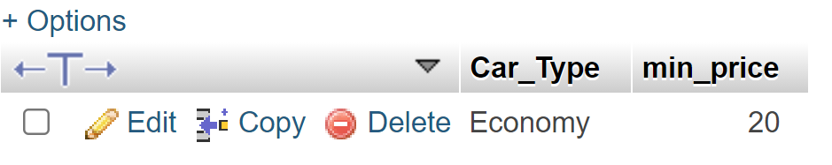

9. Display the price of car Insurance whose type is 'Comprehesive'.

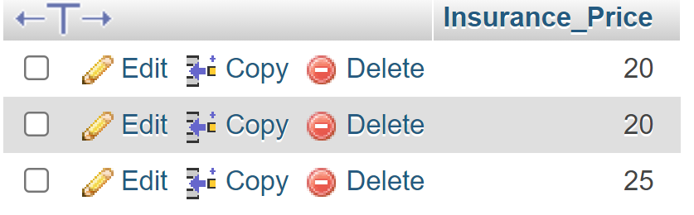

10.Write a query to fetch the number of Additional Driver working.



11.Write query to find all the car whose price is between 20 to 100 per day.

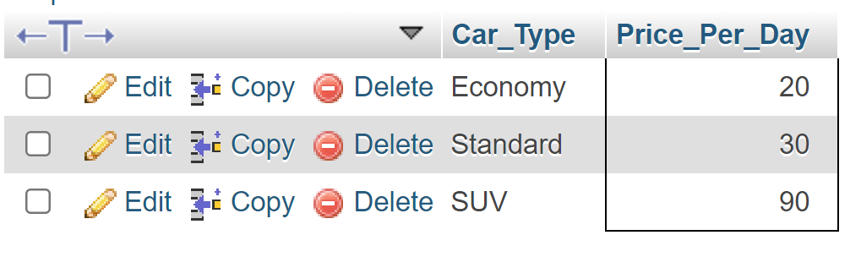

12. Select all the different values from the Insurance type column in the car insurance table.

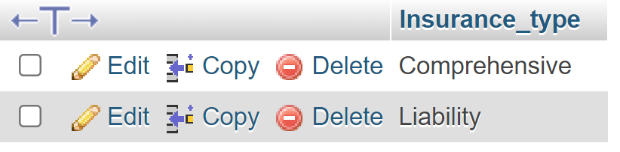

13.Display car size is the most preferred.

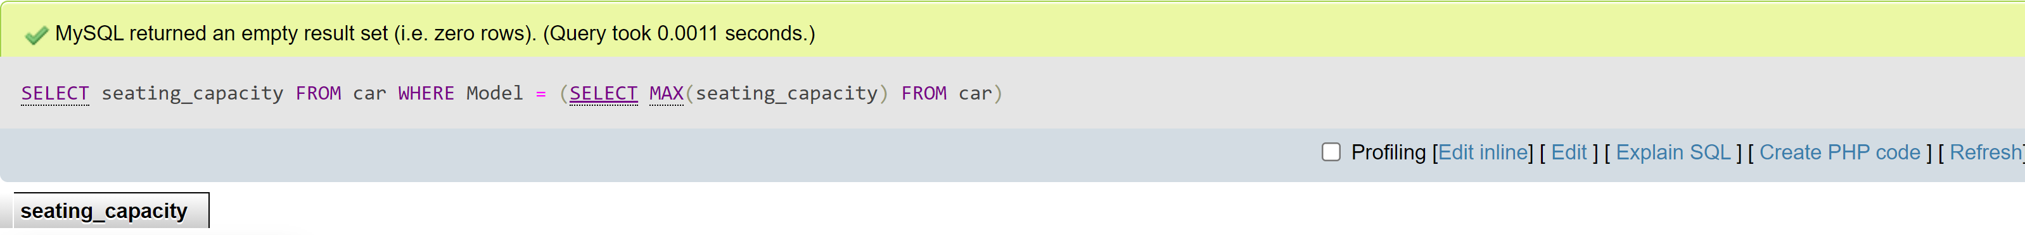

14.Delete all the reservations for customer whose last name starts with ‘S’.

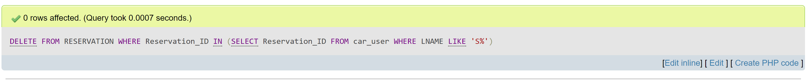

15.

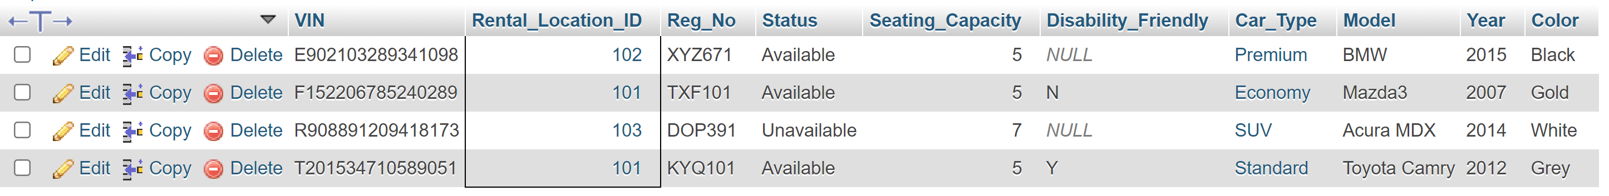

16. Query To excute Right Join.

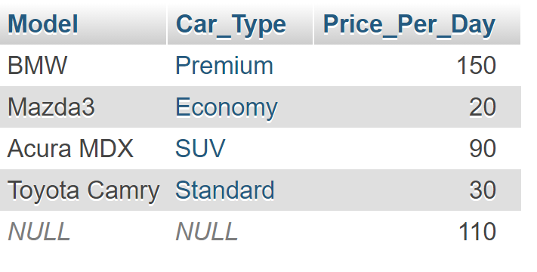

17. Query To excute Left join.

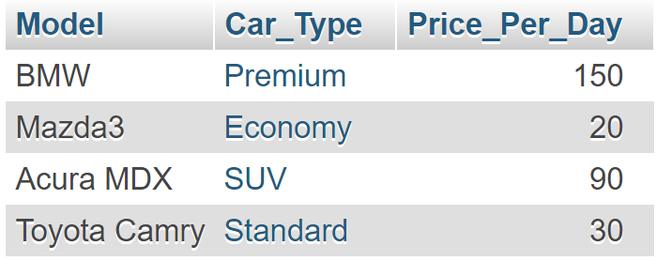

18. Query To excute Inner join.

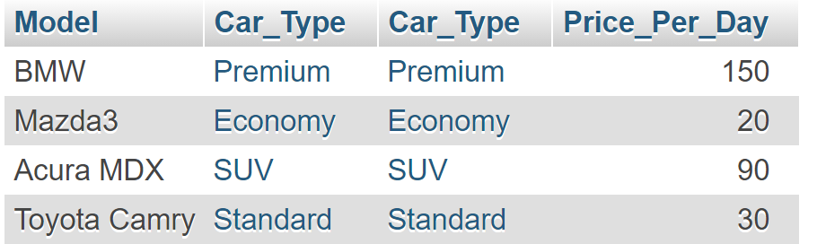

19.



## 20. Display the Car type and the Model of the car where the Rental_location_ID is ' 102 '.

## 