**18CSE365J - MODERN WEB APPLICATIONS**

**SEMESTER – VI**



2021- 2022

**DEPARTMENT OF DATA SCIENCE AND BUSINESS SYSTEMS**

**SCHOOL OF COMPUTING**

**CHENNAI – 603 203**



**SRM INSTITUTE OF SCIENCE & TECHNOLOGY**

**(UNDER SECTION 3 OF THE UGC ACT, 1956)**

**S.R.M. NAGAR, KATTANKULATHUR – 603203**

**KANCHEEPURAM DIST**

**BONAFIDE CERTIFICATE**

**REGISTER NO________________**

Certified to Be the Bonafide Record of the work done by _______________________________of_____________________B.TECH degree course in the practical ____________________ in **SRM INSTITUTE OF SCIENCE & TECHNOLOGY**, Kattankulathur during the academic year_________

Date: **Head of the Department**

Submitted for University Examination held in ________________________________________**SRM INSTITUTE OF SCIENCE & TECHNOLOGY**. at **Kattankulathur.**

**Date Examiner 1 Examiner 2**

**INDEX**

|  |  |  |  |  |
| --- | --- | --- | --- | --- |
| Sn. No | Date | Title | Page Number | Signature |
| 1 | 19/01/22 | Implementation of Basic HTML Tags  -Table Creation  -Form Creation |  |  |
| 2 | 27/01/22 | Implementation of Style Sheets  -Listing Page (Bootstrap) |  |  |
| 3 | 03/02/22 | Implementation of JavaScript Validation  -Test Marks Entry |  |  |
| 4 | 24/02/22 | Implementation of XML - XSL transformation |  |  |
| 5 | 03/03/22 | Implementation of PHP Form Processing  -Student Mark Entry |  |  |
| 6 | 10/03/22 | Implementation of PHP Form Processing  -Product Quantity Calculations |  |  |
| 7 | 31/03/22 | Implementation of DB Integration  -Insert Student Marks  -Update Student Marks |  |  |
| 8 | 07/04/22 | Implementation of DB integration  -Listing Student Marks / Average  -Sorting Top Scorers |  |  |

|  |  |
| --- | --- |
| **EXP-1** | **Implementation of Basic HTML Tags**  **-Table Creation**  **-Form Creation** |
| **19/01/2022** |

# AIM:

TO CREATE THE TABLE AND FORM USING BASIC HTML TAGS.

# PROCEDURE:

* Open a Html Document
* Create a table using the tags <table></table>.
* Create rows in the table using <tr>This is the row tag</tr>.
* Insert the data into rows using <td> Table Data</td> tags.
* Close the table tag.
* Close the html tag </html>

# SOURCE CODE:

<html>

<head>

<title> TIME TABLE

</title>

</head>

<body>

<h1>

<u> CS&BS TIME TABLE </u>

</h1>

<table>

<table border = 5 width = 1000 >

<tr>

<th> TIME </th>

<th> 8:30 - 9:20 </th>

<th> 9:20 - 10:10 </th>

<th> 10:10 - 10:30 </th>

<th> 10:30 - 11:20 </th>

<th> 11:20 - 12:10 </th>

<th> 12:10 - 12:50 </th>

<th> 12:50 - 1:40 </th>

<th> 1:40 - 2:30 </th>

<th> 2:30 - 3:20 </th>

</tr>

<tr>

<th> PERIOD </th>

<th> 1 </th>

<th> 2 </th>

<th rowspan="6">Break</th>

<th> 3 </th>

<th> 4 </th>

<th rowspan="6">Lunch</th>

<th> 5 </th>

<th> 6 </th>

<th> 7 </th>

</tr>

<tr>

<th> DAY 1 </th>

<th> IS </th>

<th> PE2 </th>

<th> AI </th>

<th> CN </th>

<th colspan="2">PE2 Lab</th>

<th> BCVS </th>

</tr>

<tr>

<th> DAY 2 </th>

<th> PE2 </th>

<th> CN </th>

<th> IS </th>

<th> PE3 </th>

<th> IAF </th>

<th colspan="2">PE3 Lab</th>

</tr>

<tr>

<th> DAY 3 </th>

<th> PE3 </th>

<th> IS </th>

<th> FCA </th>

<th> AI </th>

<th> CN </th>

<th colspan="2">IS/CN LAb</th>

</tr>

<tr>

<th> DAY 4 </th>

<th> CN </th>

<th> IAF </th>

<th> BCVS </th>

<th> PE2 </th>

<th> AI </th>

<th colspan="2">AI/CN Lab</th>

</tr>

<tr>

<th> DAY 5 </th>

<th> FCA </th>

<th> AI </th>

<th> IS </th>

<th> PE2 </th>

<th colspan="2">AI/IS Lab</th>

<th> CPS </th>

</tr>

</table>

</body>

</html>

# AIM

TO CREATE A FORM **(STUDENT MARK ENTRY)**USING BASIC HTML TAGS.

# PROCEDURE:

1. Open your HTML document.
2. The content of an HTML form must be typed within the <form> and </form> tags. 3- Create a text box using <input type="text" />.

4-Add combo buttons for options. Using <select> tag. 5- Create a Submit <button>.

1. Create a Reset <button>.
2. Type </form> at the end of the form. SOURCE CODE:

<html>

<head>

<title>Student Mark Entry</title>

</head>

<body>

<center>

<br>

<h1>Student Mark Entry</h1>

<table>

<form>

<tr>

<td>NAME:</td>

<td><input type="text"></td>

</tr>

<tr>

<td>REGISTRATION NO:</td>

<td><input type="text"></td>

</tr>

<tr>

<td>SECTION:</td>

<td><select name="sec" id="sec">

<option value="" disabled selected hidden>Choose a Section</option>

<option value="A">CSE A</option>

<option value="B">CSE B</option>

<option value="C">CSE C</option>

<option value="D">AI&ML</option>

<option value="E">CS&BS</option>

</select></td>

</tr>

<tr>

<td>ENTER MARKS:</td>

</tr>

<tr>

<td>ADVANCE FINANCE:</td>

<td><input type="number"></td>

</tr>

<tr>

<td>ARTIFICAL INTELLIGENCE:</td>

<td><input type="number"></td>

</tr>

<tr>

<td>BUSINESS COMMUNICATION & VALUE SCIENCE:</td>

<td><input type="number"></td>

</tr>

<tr>

<td>COMPUTER NETWORK:</td>

<td><input type="number"></td>

</tr>

<tr>

<td>FINANCIAL AND COST ACCOUNTING:</td>

<td><input type="number"></td>

</tr>

<tr>

<td>INFORMATION SECURITY:</td>

<td><input type="number"></td>

</tr>

<tr>

<td>MODERN WEB APPLICATION:</td>

<td><input type="number"></td>

</tr>

<tr>

<td><input type="submit" value="submit"></td>

<td><input type="reset" value="reset"></td>

</tr>

</form>

</table>

</center>

</body>

# OUTPUT:



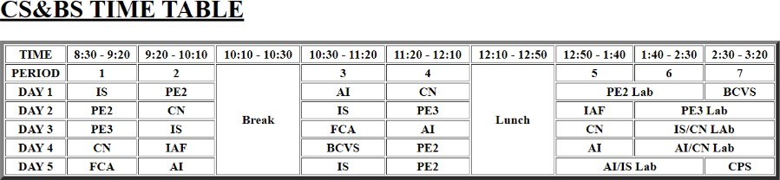

**RESULT:**

TO CREATE THE TABLE AND FORM USING BASIC HTML TAGS IS SUCCESSFULLY COMPLETED.

|  |  |
| --- | --- |
| **EXP-2** | **Implementation of Style Sheets**  **-Listing Page (Bootstrap)** |
| **27/01/2022** |

# Aim:

To create a listing page using bootstrap with different colours for each row.

**Program code:**

<html>

<head>

<title> LISTING PAGE </title>

<link rel="stylesheet" href="https://maxcdn.bootstrapcdn.com/bootstrap/3.4.1/css/bootstrap.min.css">

</head>

<body>

<div class="container">

<h2>FAVOURITE BOOKS LIST</h2>

<div class="list-group">

<a href="#" class="list-group-item list-group-item-action list-group-item-success"> The Brothers Karamazov by Fyodor Dostoyevsky</a>

<a href="#" class="list-group-item list-group-item-action list-group-item-danger">Crime and Punishment by Fyodor Dostoyevsky</a>

<a href="#" class="list-group-item list-group-item-action list-group-item-info">To Kill a Mockingbird by Harper Lee</a>

<a href="#" class="list-group-item list-group-item-action list-group-item-warning"> The Midnight Library by Matt Haig</a>

<a href="#" class="list-group-item list-group-item-action list-group-item-success"> Anxious People by Fredrik Backman</a>

<a href="#" class="list-group-item list-group-item-action list-group-item-danger">And Then There Were None by Agatha Christie</a>

<a href="#" class="list-group-item list-group-item-action list-group-item-warning">The Girl with the Dragon Tattoo by Stieg Larsson</a>

<a href="#" class="list-group-item list-group-item-action list-group-item-info">Anna Karenina by Leo Tolstoy</a>

</div>

</div>

</body>

</html>

**Output:**

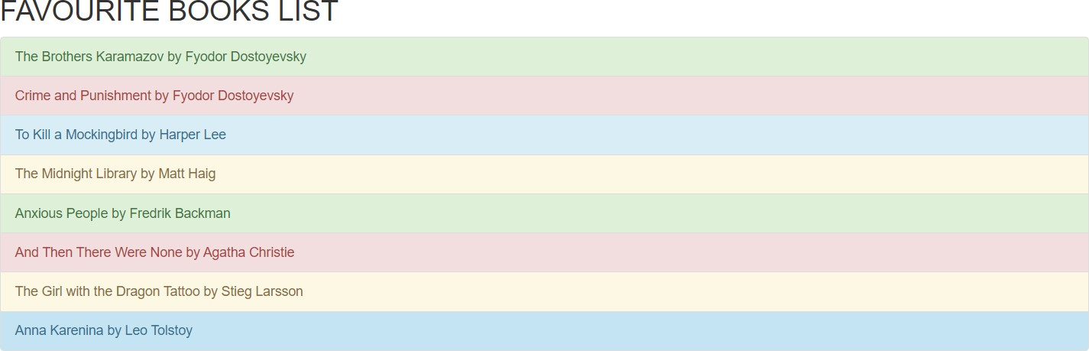

**Result:**

Thus the listing page has been created using bootstrap.

|  |  |
| --- | --- |
| **EXP-3** | **Implementation of JavaScript Validation**  **-Test Marks Entry** |
| **03/02/2022** |

**Aim:**

To write a php program to create a HTML form and validate the details entered by the user using Javascript

**Procedure:**

* + Start the server.
  + Save the program in htdocs folder.
  + Write the html code to display the text fields to get the user input.
  + Write the php code to calculate and display the average and grade.
  + Write Javascript validation code to validate required field checking, test marks not to be greater than

**Source Code:**

<html>

<head>

<script>

function checkdata()

{

if (checkregno())

{

comparedate();

var no=document.ft.txtregno.value; var name=document.ft.txtname.value; if(no=="")

{

alert("Enter Regno"); return false;

}

if(name=="")

{

alert("Enter Name");

document.ft.txtname.focus(); return false;

}

//Mark validation if(document.ft.txtm1.value > 25)

{

alert("Enter Mark less than 25"); return false;

}

if(document.ft.txtm2.value > 25)

{

alert("Enter Mark less than 25"); return false;

}

if(document.ft.txtm3.value > 25)

{

alert("Enter Mark less than 25"); return false;

}

if(document.ft.txtm4.value > 25)

{

alert("Enter Mark less than 25"); return false;

}

if(document.ft.txtm5.value > 25)

{

alert("Enter Mark less than 25"); return false;

}

var m1= document.ft.txtm1.value; var m2= document.ft.txtm2.value;

var m3= document.ft.txtm3.value; var m4= document.ft.txtm4.value; var m5= document.ft.txtm5.value; var total=m1+m2+m3+m4+m5; var p=(total/125)*100;

if(p>90)

{alert("Grade : O , Result : PASS");} else if(p>80)

{alert("Grade : A+ , Result : PASS");} else if(p>70)

{alert("Grade : A , Result : PASS");} else if(p>60)

{alert("Grade : B+ , Result : PASS");} else if(p>50)

{alert("Grade : B , Result : PASS");} else if(p>40)

{alert("Grade : C , Result : PASS");} else if(p>30)

{alert("Grade : D , Result : PASS");} else if(p>20)

{alert("Grade : E , Result : FAIL");} else

{alert("Grade : F, Result : FAIL");}

}

}

function comparedate()

{

var todayDate = new Date(); //Today Date var dateOne = new Date();

if (todayDate > dateOne) {

alert("Date of Birth cannot be greater than today.");

return false;

}

}

function checkregno()

{

var strno = document.ft.txtregno.value; first = strno.substr(0,2).toUpperCase(); if(first!="RA")

{

alert("Enter a valid Regno"); return false;

}

return true;

}

</script>

<style>

label{

display:block; margin: 1px; padding: 1px;

}

.field{

margin: 1px; padding: 1px;

}

input :invalid{

background-color: #ffdddd;

}

form:invalid{

background-color: #ffdddd;

}

input:valid{

background-color: #54B4BC;

}

form:valid{

border: 5px solid #54B4BC;

}

input :required{

border-color: #800000; border-width: 3px;

}

input :required :invalid{ border-color: #c00000;

}

</style>

</head>

<body>

<h2> Cycle Test 1 </h2>

<form name="ft" onsubmit="return checkdata();">

<table cellspacing="5" cellpadding="5">

<tr>

<td>Regno</td>

<td><input type="text" name="txtregno" size="20" maxlength="15"/></td>

</tr>

<tr>

<td>Name</td>

<td><input type="text" name="txtname" size="20" maxlength="30"/></td>

</tr>

<tr>

<td>Year/Sem</td>

<td><input type="text" name="txtyear" size="3" maxlength="1"/> /

<input type="text" name="txtsem" size="3" maxlength="2"/> </td>

</tr>

<tr>

<td>Email Address</td>

<td><input type="email" name="txtemail" size="20" /> </td>

</tr>

<tr>

<td>Date of Birth</td>

<td><input type="date" name="txtdob" size="3" /> </td>

</tr>

<tr>

<td>Subjects:</td>

</tr>

<tr>

<td>Modern Web Application</td>

<td><input type="number" name="txtm1" size="3" /></td>

</tr>

<tr>

<td>Advance Finance</td>

<td><input type="number" name="txtm2" size="3"/></td>

</tr>

<tr>

<td>Computer Networks</td>

<td><input type="number" name="txtm3" size="3" /></td>

</tr>

<tr>

<td>Artificial Intelligence</td>

<td><input type="number" name="txtm4" size="3" /></td>

</tr>

<tr>

<td>Finance and Cost Accounting</td>

<td><input type="number" name="txtm5" size="3" /></td>

</tr>

<tr>

<td><input type="submit" value="Submit" name="sbtn"/></td>

<td><input type="reset" name="rstcancel" value="Cancel"/></td>

</tr>

</table>

</form>

</body>

</html>

# Output:

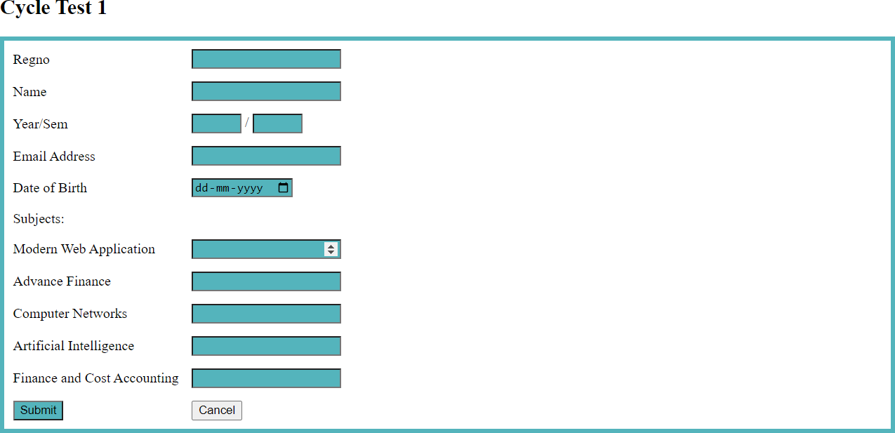

**RESULT:**

To write a PHP program to create a HTML form and validate the details entered by the user using JavaScript is Successfully completed.

|  |  |
| --- | --- |
| **EXP-4** | **Implementation of XML - XSL transformation** |
| **24/02/2022** |

**Aim:**

To create an XML file student.xml which has data of 5 students and then write an XSL file style.xsl into HTML for displaying detail with red background if result is FAIL and display detail in bold if average is above 95%

**Source code:**

**Student.xml**

<?xml version="1.0" encoding="UTF-8"?>

<?xml-stylesheet type="text/xsl" href="style.xsl"?>

<studentdetails>

<student>

<regno>1001</regno>

<name>Katherine Pierce</name>

<average>73</average>

<result>PASS</result>

</student>

<student>

<regno>1002</regno>

<name>Damon Salvatore</name>

<average>98</average>

<result>PASS</result>

</student>

<student>

<regno>1003</regno>

<name>Tejas Sheek</name>

<average>23</average>

<result>FAIL</result>

</student>

<student>

<regno>1004</regno>

<name>Ayesha Khan</name>

<average>68</average>

<result>PASS</result>

</student>

<student>

<regno>1005</regno>

<name>Manasa Shaik</name>

<average>17</average>

<result>FAIL</result>

</student>

</studentdetails>

**style.xsl**

<?xml version="1.0" encoding="UTF-8"?>

<xsl:stylesheet version="1.0" xmlns:xsl=["ht](http://www.w3.org/1999/XSL/Transform)t[p://www.w3.org/1999/XSL/Transform">](http://www.w3.org/1999/XSL/Transform)

<xsl:template match="/">

<html>

<body>

<h2>Student Details</h2>

<table border="1">

<tr bgcolor="grey">

<th style="text-align:left">regno</th>

<th style="text-align:left">name</th>

<th style="text-align:left">average</th>

<th style="text-align:left">result</th>

</tr>

<xsl:for-each select="studentdetails/student">

<tr>

<td><xsl:value-of select="regno"/></td>

<td><xsl:value-of select="name"/></td>

<xsl:choose>

<xsl:when test="average > 95">

<td><b><xsl:value-of select="average"/></b></td>

</xsl:when>

<xsl:otherwise>

<td><xsl:value-of select="average"/></td>

</xsl:otherwise>

</xsl:choose>

<xsl:choose>

<xsl:when test="result='FAIL'">

<td bgcolor="red"><xsl:value-of select="result"/></td>

</xsl:when>

<xsl:otherwise>

<td><xsl:value-of select="result"/></td>

</xsl:otherwise>

</xsl:choose>

</tr>

</xsl:for-each>

</table>

</body>

</html>

</xsl:template>

</xsl:stylesheet>

**Output:**

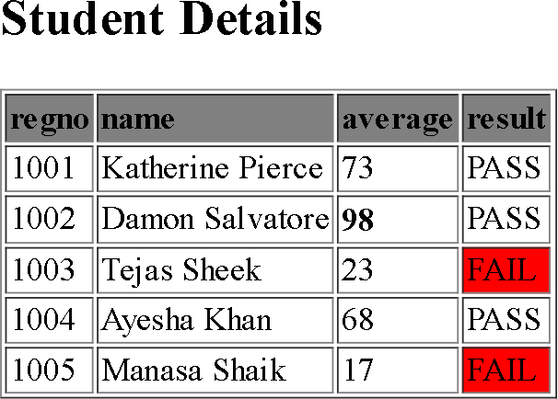

**Result:**

The XML XSL transformation for the above problem has been implemented and executed successfully.

|  |  |
| --- | --- |
| **EXP-5** | **Implementation of PHP Form Processing**  **-Student Mark Entry** |
| **03/03/2022** |

**Aim:**

To write a PHP program to calculate internal marks.

**Procedure:**

* + Start the Apache server.
  + Save the program in the htdocs folder.
  + Write the HTML code to display the text fields to get the user input.
  + Write the PHP code to calculate and display the average and grade.

**Source Code:**

<html>

<body style="background-color:cyan;">

<form method="POST" action="internalmarkssys.php">

<table align="center">

<h1 align="center">Internal Marks system</h1>

<tr><td align="center">Enter marks out of 100<br><br></td></tr>

<tr><td>Enter marks for AI <input type="text" name="n1" id="mk1"><br><br></td></tr>

<tr><td>Enter marks for AF <input type="number" name="n2"><br><br></td></tr>

<tr><td>Enter marks for FCA <input type="number" name="n3"><br><br></td></tr>

<tr><td>Enter marks for BCVS <input type="number" name="n4"><br><br></td></tr>

<tr><td>Enter marks for WEB <input type="number" name="n5"><br><br></td></tr>

<tr><td align="center"><input type="submit" value="Calculate Internal Marks"></td></tr>

</form>

</body>

</html>

<?php if(!empty($_POST['n1']))

{

$n1=$_POST['n1'];

$n2=$_POST['n2'];

$n3=$_POST['n3'];

$n4=$_POST['n4'];

$n5=$_POST['n5'];

$avg=($n1+$n2+$n3+$n4+$n5)/5;

if($n1>100||$n1<0||$n2>100||$n2<0||$n3>100||$n3<0||$n4>100||$n4<0|

|$n5>100||$n5<0)

{

echo "<tr><td align='center'style='font-size:25;'>Enter Proper Marks</td></tr>";

}

else{

echo "<tr><td>Marks: ".$n1."&nbsp;&nbsp;&nbsp;&nbsp;&nbsp;"; if($n1>50){echo "Subject AI- Pass";} else{echo "Subject AI- Fail";} echo "<tr><td>Marks: ".$n2."&nbsp;&nbsp;&nbsp;&nbsp; "; if($n2>50){echo "Subject AF- Pass";} else{echo "Subject AF- Fail";} echo "<tr><td>Marks: ".$n3."&nbsp;&nbsp;&nbsp;&nbsp; "; if($n3>50){echo "Subject FCA- Pass";} else{echo "Subject FCA- Fail";} echo "<tr><td>Marks: ".$n4."&nbsp;&nbsp;&nbsp;&nbsp; ";

if($n4>50){echo "Subject BCVS- Pass";} else{echo "Subject BCVS- Fail";} echo "<tr><td>Marks: ".$n5."&nbsp;&nbsp;&nbsp;&nbsp; "; if($n5>50){echo "Subject WEB- Pass";} else{echo "Subject WEB- Fail";}

echo"<tr><td align='center'style='font-size:25;'>Average: ".number_format($avg,2,".",".")."</tr></td> ";

if($avg>50 && $avg<60){echo "<tr><td align='center'style='font- size:25;'>Grade D</tr></td>";}

if($avg>60 && $avg<70){echo "<tr><td align='center'style='font- size:25;'>Grade C</tr></td>";}

if($avg>70 && $avg<80){echo "<tr><td align='center'style='font- size:25;'>Grade B</tr></td>";}

if($avg>80 && $avg<90){echo "<tr><td align='center'style='font- size:25;'>Grade A</tr></td>";}

if($avg>90){echo "<tr><td align='center'style='font-size:25;'>Grade O</tr></td>";}

}

}

?>

**Output:**

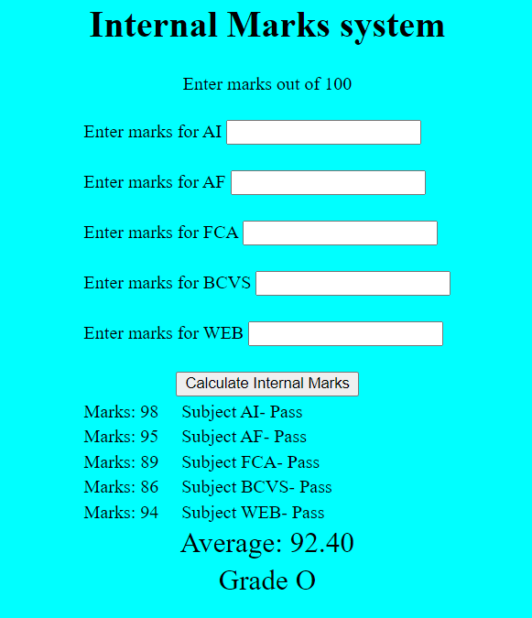

**RESULT:**

To write a PHP program to calculate internal marks is Successfully Completed.

|  |  |
| --- | --- |
| **EXP-6** | **Implementation of PHP Form Processing**  **-Bill Receipt Calculation** |
| **10/03/2022** |

**Aim:**

To write a PHP program to calculate price based on quantity given.

**Procedure:**

* + Start the Apache server.
  + Save the program in htdocs folder.
  + Write the html code to display the text fields to get the user input.
  + Write the PHP code to calculate the total and display it.

**Source Code:**

<html>

<body style="background-color:cyan;">

<form method="POST" action="pricetotall.php" >

<table align="center" border="1"cellspacing="5" cellpadding="10">

<h1 align="center">Bill Receipt </h1>

<?php if(!empty($_POST['i1']))

{

$i1=$_POST['i1'];

$i2=$_POST['i2'];

$i3=$_POST['i3'];

$i4=$_POST['i4'];

$pen=10*$i1;

$paper=2*$i2;

$pencil=5 * $i3;

$white=15 * $i4;

$sum=$pen+$paper+$pencil+$white;

}

?>

<th>Product name</th><th>Product Price Per Unit (In Rupees)</th><th>Quantity</th> <?php if (isset($_POST['i1'])) { echo "<th> Price </th>"; } ?>

<tr><td>Pen </td><td align="center">10</td><td><input type="text" name="i1" <?php if(!empty($_POST['i1'])) echo "value=" .$_POST['i1']?>

><br><br></td><?php if (!empty($i1)) echo "<td>". $pen ."</td>" ?></tr>

<tr><td>Paper </td><td align="center">2</td><td><input type="text" name="i2" <?php if(!empty($_POST['i2'])) echo "value=" .$_POST['i2']?>>

<br><br></td><?php if (!empty($i2)) echo "<td>". $paper ."</td>" ?></tr>

<tr><td>Pencil </td><td align="center">5</td><td><input type="text" name="i3" <?php if(!empty($_POST['i3'])) echo "value=" .$_POST['i3']?>>

<br><br></td><?php if (!empty($i3)) echo "<td>". $pencil ."</td>" ?></tr>

<tr><td>Whitener </td><td align="center">15</td><td><input type="text" name="i4" <?php if(!empty($_POST['i4'])) echo "value=" .$_POST['i4']?>>

<br><br></td><?php if (!empty($i4)) echo "<td>". $white ."</td>" ?></tr>

<tr><td align="center"><input type="submit" value="Calculate Price"></td>

<td colspan="2"> <?php if (!empty($sum)) echo "Grand Total : " . $sum ?>

</tr>

</table>

</form>

</body>

</html>

**Output:**

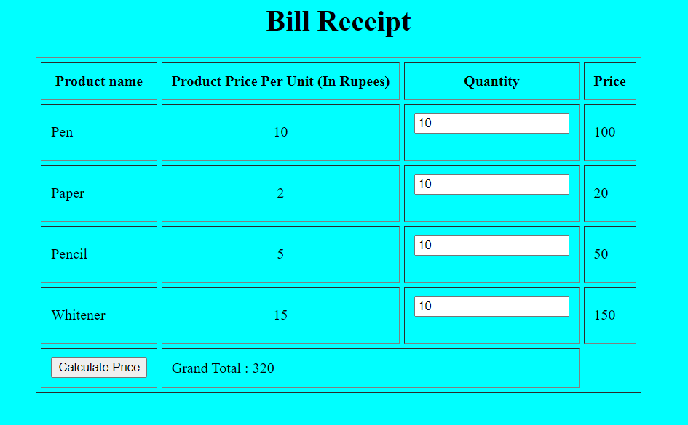

**RESULT:**

To write a php program to calculate price based on quantity given is Successfully Completed.

|  |  |
| --- | --- |
| **EXP-7** | **Implementation of DB Integration**  **-Insert Student Marks**  **-Update Student Marks** |
| **31/03/2022** |

**Aim:**

To Develop and Form Using PHP with Database integration to:

1. INSERT STUDENT MARKS
2. UPDATE STUDENT MARKS

**Procedure:**

* + Start the Apache server.
  + Save the program in htdocs folder.
  + Write the html code to display the text fields to get the user input.
  + Write the PHP code to get marks and display it with update and delete Option.

**Source code:**

***Connect.php:***

<?php

$con=new mysqli('localhost','root','root','marks');

if(!$con){

die (mysqli_error($con));

}

?>

Delete.php:

<?php include'connect.php'; if(isset($_GET['deleteid'])){

$id=$_GET['deleteid'];

$query = "DELETE FROM mark WHERE id='$id'";

$result=mysqli_query($con,$query); if($result){

echo '<script>location.href="display.php";</script>';

}

else{

die(mysqli_error($con));

}

}

?>

**Display.php:**

<?php include'connect.php';

?>

<!DOCTYPE html>

<html lang="en">

<head>

<style>

h1{text-align : center;}

</style>

<meta charset="UTF-8">

<meta http-equiv="X-UA-Compatible" content="IE=edge">

<meta name="viewport" content="width=device-width, initial-scale=1.0">

<title>IS CT3</title>

<link href=["https](https://cdn.jsdelivr.net/npm/bootstrap%405.1.3/dist/css/bootstrap.min.css):[//cdn.jsdelivr.net/npm/bootstrap@5.1.3/dist/css/bootstrap.min.css"](https://cdn.jsdelivr.net/npm/bootstrap%405.1.3/dist/css/bootstrap.min.css) rel="stylesheet" >

</head>

<body>

<header><h1> DISPLAY OF MARKS </h1>

</header>

<div class="container">

<button class ="btn btn-primary my-5"><a href="index.php" class="text-light">Add user</a>

</button>

<button class ="btn btn-primary my-5"><a href="markavg.php" class="text-light">Average Page</a> </button>

<table class="table">

<thead>

<tr>

<th scope="col">Sl no</th>

<th scope="col">Name</th>

<th scope="col">reg</th>

<th scope="col">mw</th>

<th scope="col">dm</th>

<th scope="col">ai</th>

</tr>

</thead>

<tbody>

<?php

$query = "SELECT * FROM mark";

$result=mysqli_query($con,$query); if(mysqli_num_rows($result) > 0)

{

while($row = mysqli_fetch_array($result))

{

?>

<tr>

<th scope="row"><?php echo $row['id']; ?></th>

<td><?php echo $row['name']; ?></td>

<td><?php echo $row['reg']; ?></td>

<td><?php echo $row['mw']; ?></td>

<td><?php echo $row['dm']; ?></td>

<td><?php echo $row['ai']; ?></td>

<td>

<a class="btn btn-primary text-light" href="update.php?updateid=<?php echo $row['id']; ?>"

>Update</a>

<a class="btn btn-danger text-light" href="delete.php?deleteid=<?php echo $row['id']; ?>"

>Delete</a>

</td>

</tr>

<?php

}

}

?>

</tbody>

</table>

</div>

</body>

</html>

Index page:

<?php

include 'connect.php'; if(isset($_POST['submit'])){

$name=$_POST['name'];

$reg=$_POST['reg'];

$mw=$_POST['mw'];

$dm=$_POST['dm'];

$ai=$_POST['ai'];

$total = $mw + $dm + $ai;

$average = $total / 3.0;

$percentage = ($total / 300.0) * 100;

$query = "INSERT INTO mark(name,reg,mw,dm,ai,average) VALUES('".$name."','".$reg."','".$mw."','".$dm."','".$ai."','".$percentage."')";

$result=mysqli_query($con,$query); if($result){

echo "data inserted successfully";

?>

<script> location.href='display.php';

</script>

<?php

}

else{

die (mysqli_error($con));

}

}

?>

<!doctype html>

<html lang="en">

<head>

<!-- Required meta tags -->

<meta charset="utf-8">

<meta name="viewport" content="width=device-width, initial-scale=1">

<!-- Bootstrap CSS -->

<link href=["https](https://cdn.jsdelivr.net/npm/bootstrap%405.1.3/dist/css/bootstrap.min.css):[//cdn.jsdelivr.net/npm/bootstrap@5.1.3/dist/css/bootstrap.min.css"](https://cdn.jsdelivr.net/npm/bootstrap%405.1.3/dist/css/bootstrap.min.css) rel="stylesheet"

<title>STUDENT MARKS ENTRY</title>

<style>

h1{text-align : center;}

</style>

</head>

<body>

<header>

<h1>SRM STUDENT MARKS ENTRY</h1>

</header>

<div class ="container my-5">

<form method="post">

<div class="form-group">

<label > Name </label>

<input type="text" class="form-control" placeholder="Enter your name" name="name" autocomplete="off">

</div>

<div class="form-group">

<label > Reg No</label>

<input type="text" class="form-control" placeholder="Enter your registration number" name="reg"autocomplete="off" >

</div>

<div class="form-group">

<label > Marks for MW </label>

<input type="name" class="form-control" placeholder="Enter marks for modern web" name="mw" autocomplete="off" >

</div>

<div class="form-group">

<label > Marks for DM</label>

<input type="name" class="form-control" placeholder="Enter marks for data mining" name="dm" autocomplete="off" >

</div>

<div class="form-group">

<label > Marks for AI</label>

<input type="name" class="form-control" placeholder="Enter marks for artificial intelligence" name="ai" autocomplete="off" >

</div><br>

<button type="submit" name="submit" class="btn btn-success">Submit</button>

</form>

</div>

</body>

</html>

### Update.php:

### <?php include'connect.php';

$id=$_GET['updateid']; echo $id;

$query = "SELECT * FROM mark WHERE id = '".$id."' ";

$result=mysqli_query($con,$query);

$row=mysqli_fetch_assoc($result);

$name=$row['name'];

$reg=$row['reg'];

$mw=$row['mw'];

$dm=$row['dm'];

$ai=$row['ai'];

if(isset($_POST['submit']))

{

$name=$_POST['name'];

$reg=$_POST['reg'];

$mw=$_POST['mw'];

$dm=$_POST['dm'];

$ai=$_POST['ai'];

$sql="update'mark' set id=$id,name=$name,reg='$reg',mw='$mw',dm='$dm',ai='$ai','where id=$id";

$query = "UPDATE mark SET name='$name',reg='$reg',mw='$mw',dm='$dm',ai='$ai' WHERE id='$id'";

$result=mysqli_query($con,$query);

if($result)

{

header('location:display.php');

}

else{ die(mysqli_error($con));

}

}

?>

<!doctype html>

<html lang="en">

<head>

<meta charset="utf-8">

<meta name="viewport" content="width=device-width, initial-scale=1">

<link href=["https](https://cdn.jsdelivr.net/npm/bootstrap%405.1.3/dist/css/bootstrap.min.css):[//cdn.jsdelivr.net/npm/bootstrap@5.1.3/dist/css/bootstrap.min.css"](https://cdn.jsdelivr.net/npm/bootstrap%405.1.3/dist/css/bootstrap.min.css) rel="stylesheet" >

<title>STUDENT MARKS ENTRY</title>

<style>

h1{text-align : center;}

</style>

</head>

<body>

<header>

<h1>SRM STUDENT MARKS ENTRY</h1>

</header>

<div class ="container my-5">

<form method="post">

<div class="form-group">

<label > Name </label>

<input type="text" class="form-control" placeholder="Enter your name" name="name" value="<?php echo $name; ?>" autocomplete="off">

</div>

<div class="form-group">

<label > Reg No</label>

<input type="text" class="form-control" placeholder="Enter your registration number" name="reg" value="<?php echo $reg; ?>" autocomplete="off" >

</div>

<div class="form-group">

<label > Marks for MW </label>

<input type="name" class="form-control" placeholder="Enter marks for modern web" name="mw" value="<?php echo $mw; ?>" autocomplete="off" >

</div>

<div class="form-group">

<label > Marks for DM</label>

<input type="name" class="form-control" placeholder="Enter marks for data mining" name="dm" value="<?php echo $dm; ?>" autocomplete="off" >

</div>

<div class="form-group">

<label > Marks for AI</label>

<input type="name" class="form-control" placeholder="Enter marks for artificial intelligence" name="ai" value="<?php echo $ai; ?>" autocomplete="off" >

</div>

<button type="submit" class="btn btn-primary" name ="submit">Submit</button>

</form>

</div>

</body>

</html>

OUTPUT:

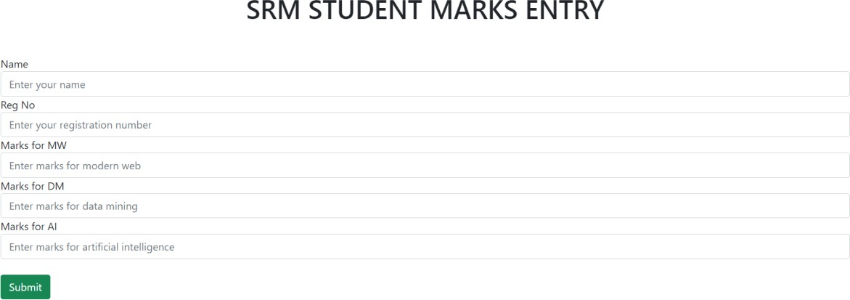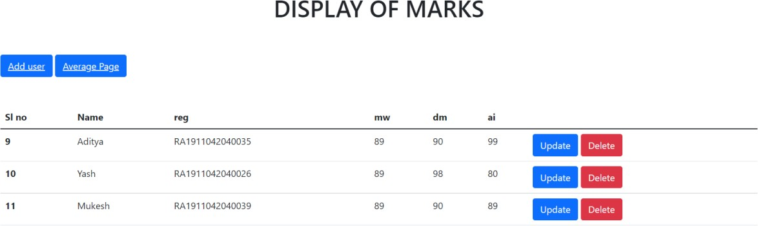

# RESULT:

## To Develop and Form Using PHP with Database integration to:

1. INSERT STUDENT MARKS
2. UPDATE STUDENT MARKS Is Successfully Completed.

|  |  |
| --- | --- |
| **EXP-8** | **Implementation of DB integration**  **-Listing Student Marks / Average**  **-Sorting Top Scorers** |
| **07/03/2022** |

**Aim:**

To Develop and Form Using PHP with Database integration to:

1. CALCULATE ENTERED STUDENT MARK AVERAGE.
2. SHOW TOP SCORERS IN CLASS.

**Procedure:**

* + Start the Apache server.
  + Save the program in htdocs folder.
  + Write the html code to display the text fields to get the user input.
  + Write the PHP code to get marks and display it with update and delete Option, with total average of the student marks Updated and Rank they hold.

**Source code:**

### Update Page:

<?php include'connect.php';

$id=$_GET['updateid']; echo $id;

$query = "SELECT * FROM mark WHERE id = '".$id."' ";

$result=mysqli_query($con,$query);

$row=mysqli_fetch_assoc($result);

$name=$row['name'];

$reg=$row['reg'];

$mw=$row['mw'];

$dm=$row['dm'];

$ai=$row['ai'];

if(isset($_POST['submit']))

{

$name=$_POST['name'];

$reg=$_POST['reg'];

$mw=$_POST['mw'];

$dm=$_POST['dm'];

$ai=$_POST['ai'];

$sql="update'mark' set id=$id,name=$name,reg='$reg',mw='$mw',dm='$dm',ai='$ai','where id=$id";

$query = "UPDATE mark SET name='$name',reg='$reg',mw='$mw',dm='$dm',ai='$ai' WHERE id='$id'";

$result=mysqli_query($con,$query);

if($result)

{

header('location:display.php');

}

else{ die(mysqli_error($con));

}

}

?>

<!doctype html>

<html lang="en">

<head>

<meta charset="utf-8">

<meta name="viewport" content="width=device-width, initial-scale=1">

<link href=["https](https://cdn.jsdelivr.net/npm/bootstrap%405.1.3/dist/css/bootstrap.min.css):[//cdn.jsdelivr.net/npm/bootstrap@5.1.3/dist/css/bootstrap.min.css"](https://cdn.jsdelivr.net/npm/bootstrap%405.1.3/dist/css/bootstrap.min.css) rel="stylesheet" >

<title>STUDENT MARKS ENTRY</title>

<style>

h1{text-align : center;}

</style>

</head>

<body>

<header>

<h1>SRM STUDENT MARKS ENTRY</h1>

</header>

<div class ="container my-5">

<form method="post">

<div class="form-group">

<label > Name </label>

<input type="text" class="form-control" placeholder="Enter your name" name="name" value="<?php echo $name; ?>" autocomplete="off">

</div>

<div class="form-group">

<label > Reg No</label>

<input type="text" class="form-control" placeholder="Enter your registration number" name="reg" value="<?php echo $reg; ?>" autocomplete="off" >

</div>

<div class="form-group">

<label > Marks for MW </label>

<input type="name" class="form-control" placeholder="Enter marks for modern web" name="mw" value="<?php echo $mw; ?>" autocomplete="off" >

</div>

<div class="form-group">

<label > Marks for DM</label>

<input type="name" class="form-control" placeholder="Enter marks for data mining" name="dm" value="<?php echo $dm; ?>" autocomplete="off" >

</div>

<div class="form-group">

<label > Marks for AI</label>

<input type="name" class="form-control" placeholder="Enter marks for artificial intelligence" name="ai" value="<?php echo $ai; ?>" autocomplete="off" >

</div>

<button type="submit" class="btn btn-primary" name ="submit">Submit</button>

</form>

</div>

</body>

</html>

### Connect.php:

<?php

$con=new mysqli('localhost','root','root','marks');

if(!$con){

die (mysqli_error($con));

}

?>

<?php include'connect.php'; if(isset($_GET['deleteid'])){

$id=$_GET['deleteid'];

$query = "DELETE FROM mark WHERE id='$id'";

$result=mysqli_query($con,$query); if($result){

echo '<script>location.href="display.php";</script>';

}

else{

die(mysqli_error($con));

}

}

?>

Display:

<?php include'connect.php';

?>

<!DOCTYPE html>

<html lang="en">

<head>

<style>

h1{text-align : center;}

</style>

<meta charset="UTF-8">

<meta http-equiv="X-UA-Compatible" content="IE=edge">

<meta name="viewport" content="width=device-width, initial-scale=1.0">

<title>IS CT3</title>

<link href=["https](https://cdn.jsdelivr.net/npm/bootstrap%405.1.3/dist/css/bootstrap.min.css):[//cdn.jsdelivr.net/npm/bootstrap@5.1.3/dist/css/bootstrap.min.css"](https://cdn.jsdelivr.net/npm/bootstrap%405.1.3/dist/css/bootstrap.min.css) rel="stylesheet" >

</head>

<body>

<header>

<h1> DISPLAY OF MARKS </h1>

</header>

<div class="container">

<button class ="btn btn-primary my-5"><a href="index.php" class="text-light">Add user</a>

</button>

<button class ="btn btn-primary my-5"><a href="markavg.php" class="text-light">Average Page</a> </button>

<table class="table">

<thead>

<tr>

<th scope="col">Sl no</th>

<th scope="col">Name</th>

<th scope="col">reg</th>

<th scope="col">mw</th>

<th scope="col">dm</th>

<th scope="col">ai</th>

</tr>

</thead>

<tbody>

<?php

$query = "SELECT * FROM mark";

$result=mysqli_query($con,$query); if(mysqli_num_rows($result) > 0)

{

while($row = mysqli_fetch_array($result))

{

?>

<tr>

<th scope="row"><?php echo $row['id']; ?></th>

<td><?php echo $row['name']; ?></td>

<td><?php echo $row['reg']; ?></td>

<td><?php echo $row['mw']; ?></td>

<td><?php echo $row['dm']; ?></td>

<td><?php echo $row['ai']; ?></td>

<td>

<a class="btn btn-primary text-light" href="update.php?updateid=<?php echo $row['id']; ?>"

>Update</a>

<a class="btn btn-danger text-light" href="delete.php?deleteid=<?php echo $row['id']; ?>"

>Delete</a>

</td>

</tr>

<?php

}

}

?>

</tbody>

</table>

</div>

</body>

</html>

Indexpage:

<?php

include 'connect.php'; if(isset($_POST['submit'])){

$name=$_POST['name'];

$reg=$_POST['reg'];

$mw=$_POST['mw'];

$dm=$_POST['dm'];

$ai=$_POST['ai'];

$total = $mw + $dm + $ai;

$average = $total / 3.0;

$percentage = ($total / 300.0) * 100;

$query = "INSERT INTO mark(name,reg,mw,dm,ai,average) VALUES('".$name."','".$reg."','".$mw."','".$dm."','".$ai."','".$percentage."')";

$result=mysqli_query($con,$query); if($result){

echo "data inserted successfully";

?>

<script> location.href='display.php';

</script>

<?php

}

else{

die (mysqli_error($con));

}

}

?>

<!doctype html>

<html lang="en">

<head>

<!-- Required meta tags -->

<meta charset="utf-8">

<meta name="viewport" content="width=device-width, initial-scale=1">

<!-- Bootstrap CSS -->

<link href=["https](https://cdn.jsdelivr.net/npm/bootstrap%405.1.3/dist/css/bootstrap.min.css):[//cdn.jsdelivr.net/npm/bootstrap@5.1.3/dist/css/bootstrap.min.css"](https://cdn.jsdelivr.net/npm/bootstrap%405.1.3/dist/css/bootstrap.min.css) rel="stylesheet" >

<title>STUDENT MARKS ENTRY</title>

<style>

h1{text-align : center;}

</style>

</head>

<body>

<header>

<h1>SRM STUDENT MARKS ENTRY</h1>

</header>

<div class ="container my-5">

<form method="post">

<div class="form-group">

<label > Name </label>

<input type="text" class="form-control" placeholder="Enter your name" name="name" autocomplete="off">

</div>

<div class="form-group">

<label > Reg No</label>

<input type="text" class="form-control" placeholder="Enter your registration number" name="reg"autocomplete="off" >

</div>

<div class="form-group">

<label > Marks for MW </label>

<input type="name" class="form-control" placeholder="Enter marks for modern web" name="mw" autocomplete="off" >

</div>

<div class="form-group">

<label > Marks for DM</label>

<input type="name" class="form-control" placeholder="Enter marks for data mining" name="dm" autocomplete="off" >

</div>

<div class="form-group">

<label > Marks for AI</label>

<input type="name" class="form-control" placeholder="Enter marks for artificial intelligence" name="ai" autocomplete="off" >

</div><br>

<button type="submit" name="submit" class="btn btn-success">Submit</button>

</form>

</div>

</body>

</html>

### Mark Average:

<?php include'connect.php';

?>

<!DOCTYPE html>

<html lang="en">

<head>

<style>

h1{text-align : center;}

</style>

<meta charset="UTF-8">

<meta http-equiv="X-UA-Compatible" content="IE=edge">

<meta name="viewport" content="width=device-width, initial-scale=1.0">

<title>IS CT3</title>

<link href=["https](https://cdn.jsdelivr.net/npm/bootstrap%405.1.3/dist/css/bootstrap.min.css):[//cdn.jsdelivr.net/npm/bootstrap@5.1.3/dist/css/bootstrap.min.css"](https://cdn.jsdelivr.net/npm/bootstrap%405.1.3/dist/css/bootstrap.min.css) rel="stylesheet" >

</head>

<body>

<header>

<h1> DISPLAY OF MARKS </h1>

</header>

<div class="container">

<button class ="btn btn-primary my-5"><a href="rank.php" class="text-light">Rank Page</a>

</button>

<table class="table">

<thead>

<tr>

<th scope="col">Sl no</th>

<th scope="col">Name</th>

<th scope="col">reg</th>

<th scope="col">mw</th>

<th scope="col">dm</th>

<th scope="col">ai</th>

<th scope="col">Average</th>

</tr>

</thead>

<tbody>

<?php

$query = "SELECT * FROM mark";

$result=mysqli_query($con,$query); if(mysqli_num_rows($result) > 0)

{

while($row = mysqli_fetch_array($result))

{

?>

<tr>

<th scope="row"><?php echo $row['id']; ?></th>

<td><?php echo $row['name']; ?></td>

<td><?php echo $row['reg']; ?></td>

<td><?php echo $row['mw']; ?></td>

<td><?php echo $row['dm']; ?></td>

<td><?php echo $row['ai']; ?></td>

<td><?php echo $row['average']; ?></td>

<td>

<td>

<a class="btn btn-primary text-light" href="update.php?updateid=<?php echo $row['id']; ?>"

>Update</a>

<a class="btn btn-danger text-light" href="delete.php?deleteid=<?php echo $row['id']; ?>"

>Delete</a>

</td>

</tr>

<?php

}

}

?>

</tbody>

</table>

</div>

</body>

</html>

OUTPUT:



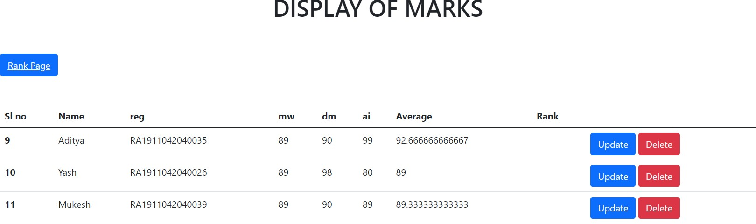

**RESULT:**

To Develop and Form Using PHP with Database integration to:

1. CALCULATE STUDENT MARK AVERAGE.
2. SHOW TOP SCORERS IN CLASS. Is Successfully Completed.