Panopticon – real time installation(windows)
Prerequisites:
Download:
- Apache tomcat version 10,
- Panopticon real-time,
- Jdk version-17 or above

Hardware Requirements:
Deployment Type | CPU | RAM | Disk Space | In-Memory Caching
Development / Test | 1 × Dual-Core CPU (hyper-threaded to 4 cores/threads) | 8 GB | 4 GB | Limited to available server RAM
Small-Scale Deployment | 1 × Quad-Core CPU (hyper-threaded to 8 cores/threads) | 16 GB | 4 GB | Limited to available server RAM
Medium-Scale Deployment | 4 × Quad-Core CPUs (hyper-threaded to 32 cores/threads) | 32 GB | 4 GB | Limited to available server RAM
Large-Scale Deployment | 8 × Quad-Core CPUs (hyper-threaded to 64 cores/threads) | 64 GB | 4 GB | Limited to available server RAM

1. After completing the installation, create a new environment variable named JAVA_HOME and set its value to the installation path of JDK 17. Then, edit the Path variable and add the path to the bin directory of JDK 17 to ensure proper execution of Java commands.
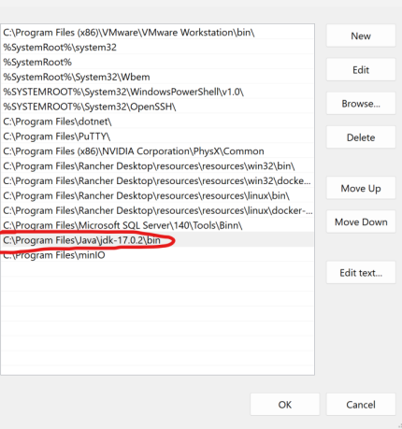
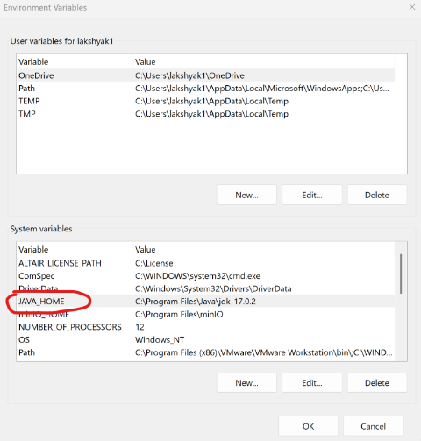

2. Program Files -> Apache Software Foundation -> bin folder -> startup.bat (or startup file).Check on localhost:8080 to verify that the Tomcat server is running. After completion, go back to the bin folder and click on shutdown.bat (or shutdown file) to stop the server.
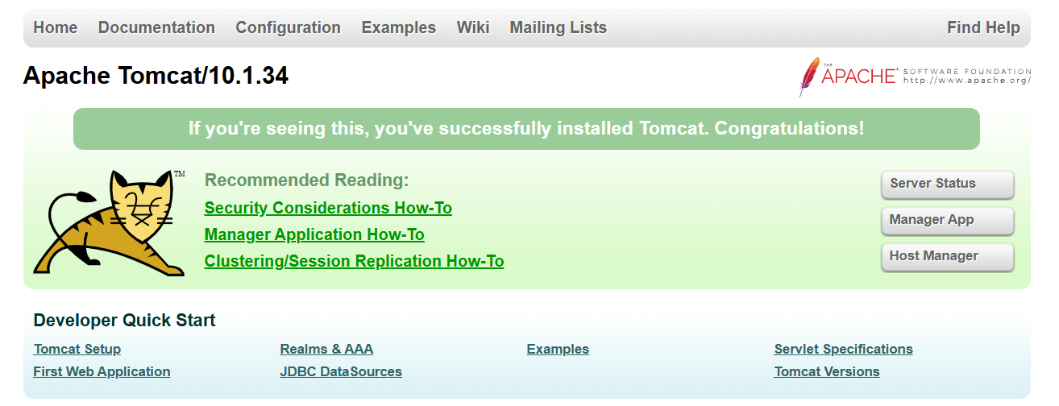
Tomcat has Started

3. Locate the Panopticon zip file on your system. Right-click on the file and choose the "Extract All" option. When prompted, set the destination to your Desktop and create a new folder—such as "PTR"—to store the extracted files.
4.create a folder in c:\panopticon\appdata
5. Copy the Panopticon.xml file from the PTR folder on your Desktop and paste it into the following directory: C:\ProgramFiles\Apache Software Foundation\Tomcat 10.1_Tomcat10.1\conf\Catalina\localhost . After pasting the file, open it with a text editor and update the value attribute to point to your new folder (for example, change it to c:\panopticon\appdata). Save your changes to ensure that the configuration reflects the new folder path.

6. Copy the panopticon.war file from the PTR folder and paste it into the Tomcat webapps directory ( C:\Program Files\Apache Software Foundation\Tomcat 10.0\webapps).

7. For a basic install using the Tomcat inbuilt XML file user directory, copy the provided snippet and overwrite the existing tomcat-users.xml file which is available in the Tomcat config folder (\Apache Software Foundation\Tomcat 10.0\conf). The provided snippet contains the following roles and users:
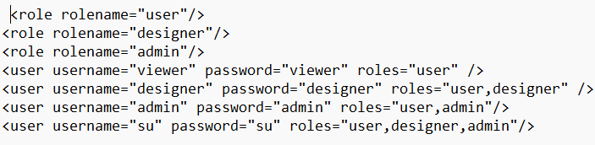

8.Use statup.bat to start Tomcat and it should populate the file (“c\panopticon\appdata”) which should look like this. After verifying use shutdown.bat to close server.
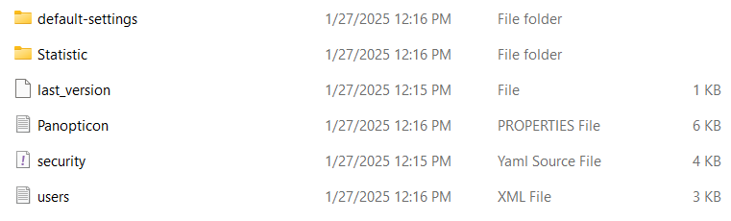

9. Panopticon Real Time supports three licensing modes, each suited to different deployment scenarios:
- Floating License (On-Premises License Server)
- Hosted License (Altair One Cloud)
- Standalone License (Volume XML File)
To apply the appropriate license, begin at step 9 and follow only the subsection that matches your chosen mode.

Configure a Floating License:
- Open the Panopticon.properties file in a text editor.
- Locate the entry that defines the server name (often labelled license.hwu.uri or similar).
- Replace the existing value with the exact network host name of your on-premises license server.
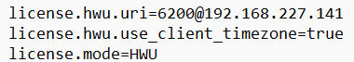
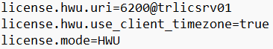

Configure a Hosted License:
Using an Altair One Authentication Code
- Log in to Altair One at https://admin.altairone.com.
- Navigate to User Profile → Authorized Machines and click Generate Auth Code.
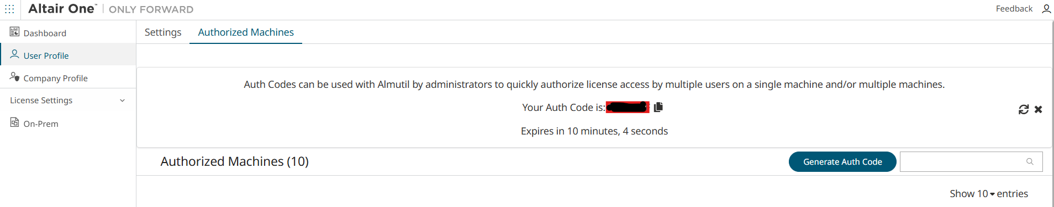

- Copy the displayed code (noting that it expires after the timer runs out).
- Open Panopticon.properties, find the property license.hwu.hosted.authorization.token, and paste in your auth code.
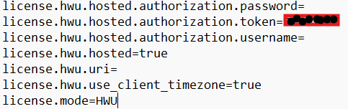

Using Altair One Credentials Directly:
- In Panopticon.properties, remove the license.hwu.hosted.authorization.token entry.
- Add or update the properties for license.hwu.hosted.username and license.hwu.hosted.password with your Altair One credentials.

Configure a Standalone License
- Open System Properties → Environment Variables.
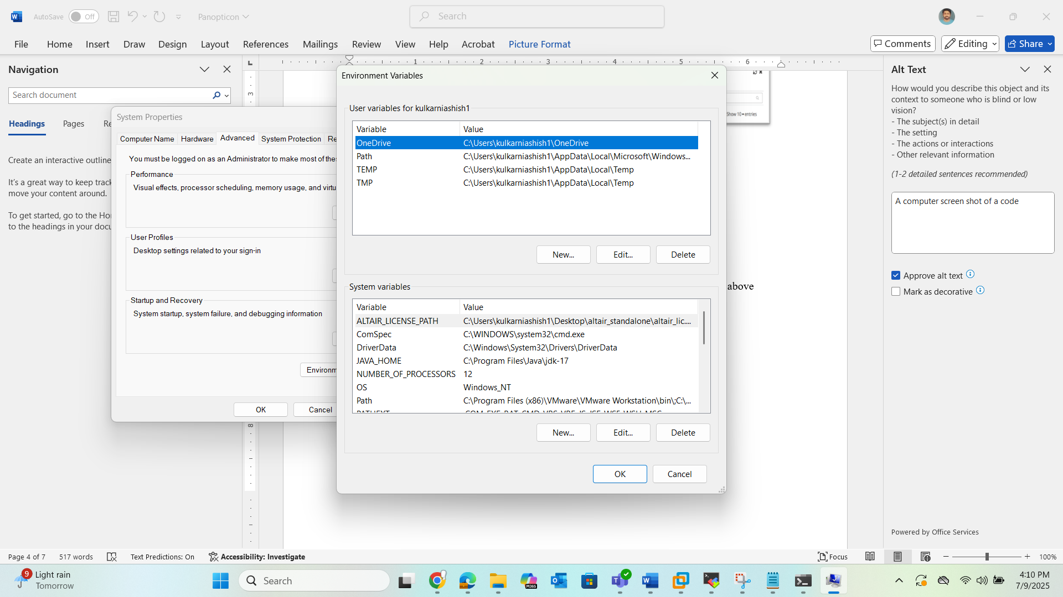
- Under System variables, create a new variable named ALTAIR_LICENSE_PATH.

- Set its value to the full folder path where your license file resides.
- In Panopticon.properties, set the license mode to HWU and set license.hwu.uri to true variable for the file location.
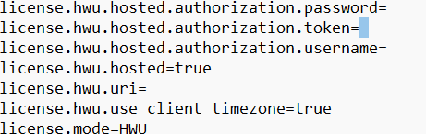

10.Open to users.xml present in appdata folder. Now uncomment <security:user-service> or replace it with this .
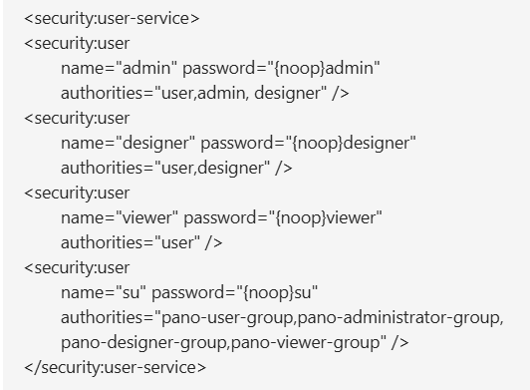

11. Open the security.yml file in appdata folder, uncomment the access section to include the appropriate users under both the administrator and designer roles, and save your changes. Then, navigate to Tomcat’s bin directory and run shutdown.bat to stop the server; once it has fully stopped, execute startup.bat to restart and apply the new group settings.
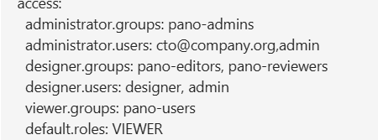

How to add new user:
- Open your users.xml file, locate the users section, and insert a new entry with the desired username, password, and authority groups.
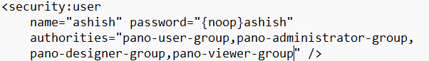

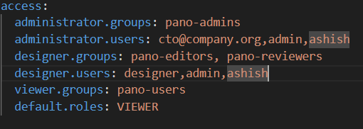
- Open your security.yml (the access block in your YAML image), and for each role the new user should have, append the username to that role’s users list.

- Save both the XML and YAML files and restart it to apply all the changes.

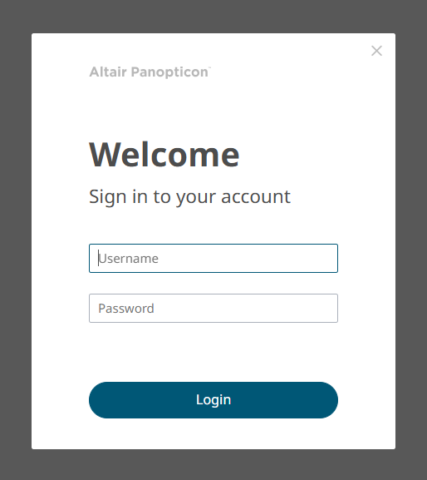
12.Open localhost:8080/panopticon in any browser that you like it should look like this then you can login.

Cautions:
- Open Task Manager and end any existing tomcat*.exe processes before reinstalling.
- Do not run more than one Tomcat instance at the same time to avoid port conflicts and errors.
- Grant full read, write, and modify permissions on both the Tomcat installation folder and the Panopticon data directory.
- Ensure TCP port 8080 is free and allowed through any firewall so Tomcat can bind to it.

