Heart Disease MLOps: Assignment Report
Course: AIMLCZG523, MLOps Assignment 01
Prepared by: Ashita Kumari
GitHub Repository: Ashita-kumari/MLOPs_project (https://github.com/Ashita-kumari/MLOPs_project)
Dataset: UCI Heart Disease, dataset 45 (https://archive.ics.uci.edu/dataset/45/heart+disease)
Video Link: https://drive.google.com/drive/folders/15Anzbpsxag13cpAZZUj2TdeTtH69ok2L?usp=drive_link

1. Summary
I built this project to demonstrate a reproducible MLOps workflow using the processed Cleveland subset of the UCI Heart Disease dataset. I implemented data acquisition and normalization, exploratory analysis, leakage-conscious preprocessing, comparison of three tuned classifiers, MLflow tracking, a FastAPI prediction service, Docker packaging, local Kubernetes deployment, and Prometheus/Grafana monitoring.
In the MLflow runs I captured, Logistic Regression ranked first by five-fold cross-validation ROC-AUC (0.911344). It achieved accuracy 0.885246, precision 0.838710, recall 0.928571, and ROC-AUC 0.961039. The whole project is uploaded in the GitHub whose link provide above.

2. Data and target definition
I used the processed Cleveland subset, which contains 303 records and 13 predictors. I binarized the original num target so source value 0 maps to class 0 and source values 1 through 4 map to class 1. The resulting distribution is 164 class-0 records (54.1%) and 139 class-1 records (45.9%). This is a moderately balanced split, not a population prevalence estimate.
The fields are age, sex, chest-pain type (cp), resting blood pressure (trestbps), cholesterol (chol), fasting blood sugar (fbs), resting ECG (restecg), maximum heart rate (thalach), exercise-induced angina (exang), ST depression (oldpeak), peak-exercise ST slope (slope), fluoroscopy vessel count (ca), and thal test category (thal). The source uses coded categories; those numeric codes are not generally meaningful measurements.
My normalized table has four missing ca values and two missing thal values. I use scripts/download_data.py to retrieve the processed data and normalize missing-value markers and the target; scripts/run_eda.py produces the figures in artifacts/eda/.

3. Exploratory data analysis
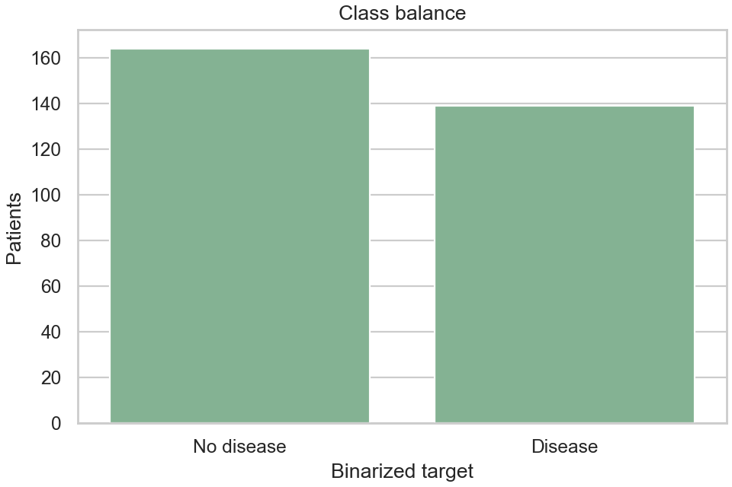
Target counts and missing-value counts
I found 164 class-0 records and 139 class-1 records. Missingness is limited to ca and thal; I leave those values explicit in the data and handle them in the fitted preprocessing pipeline.
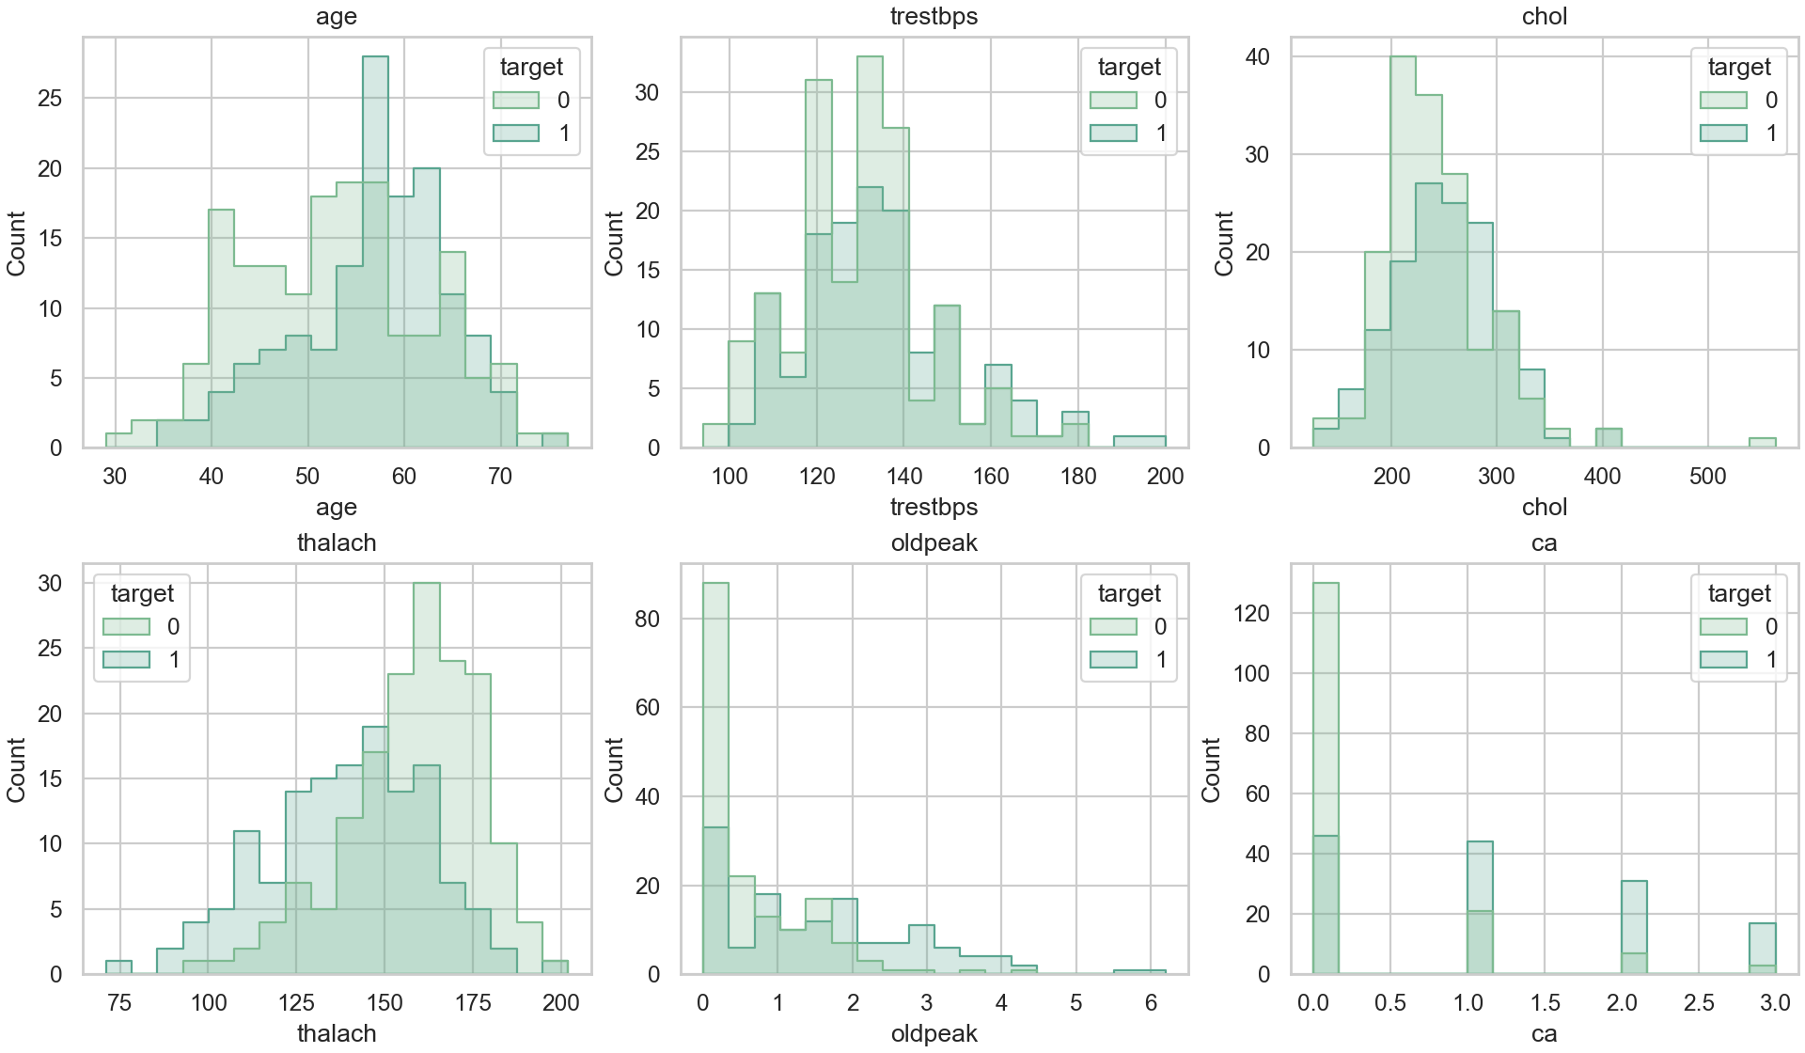
Numeric distributions by target
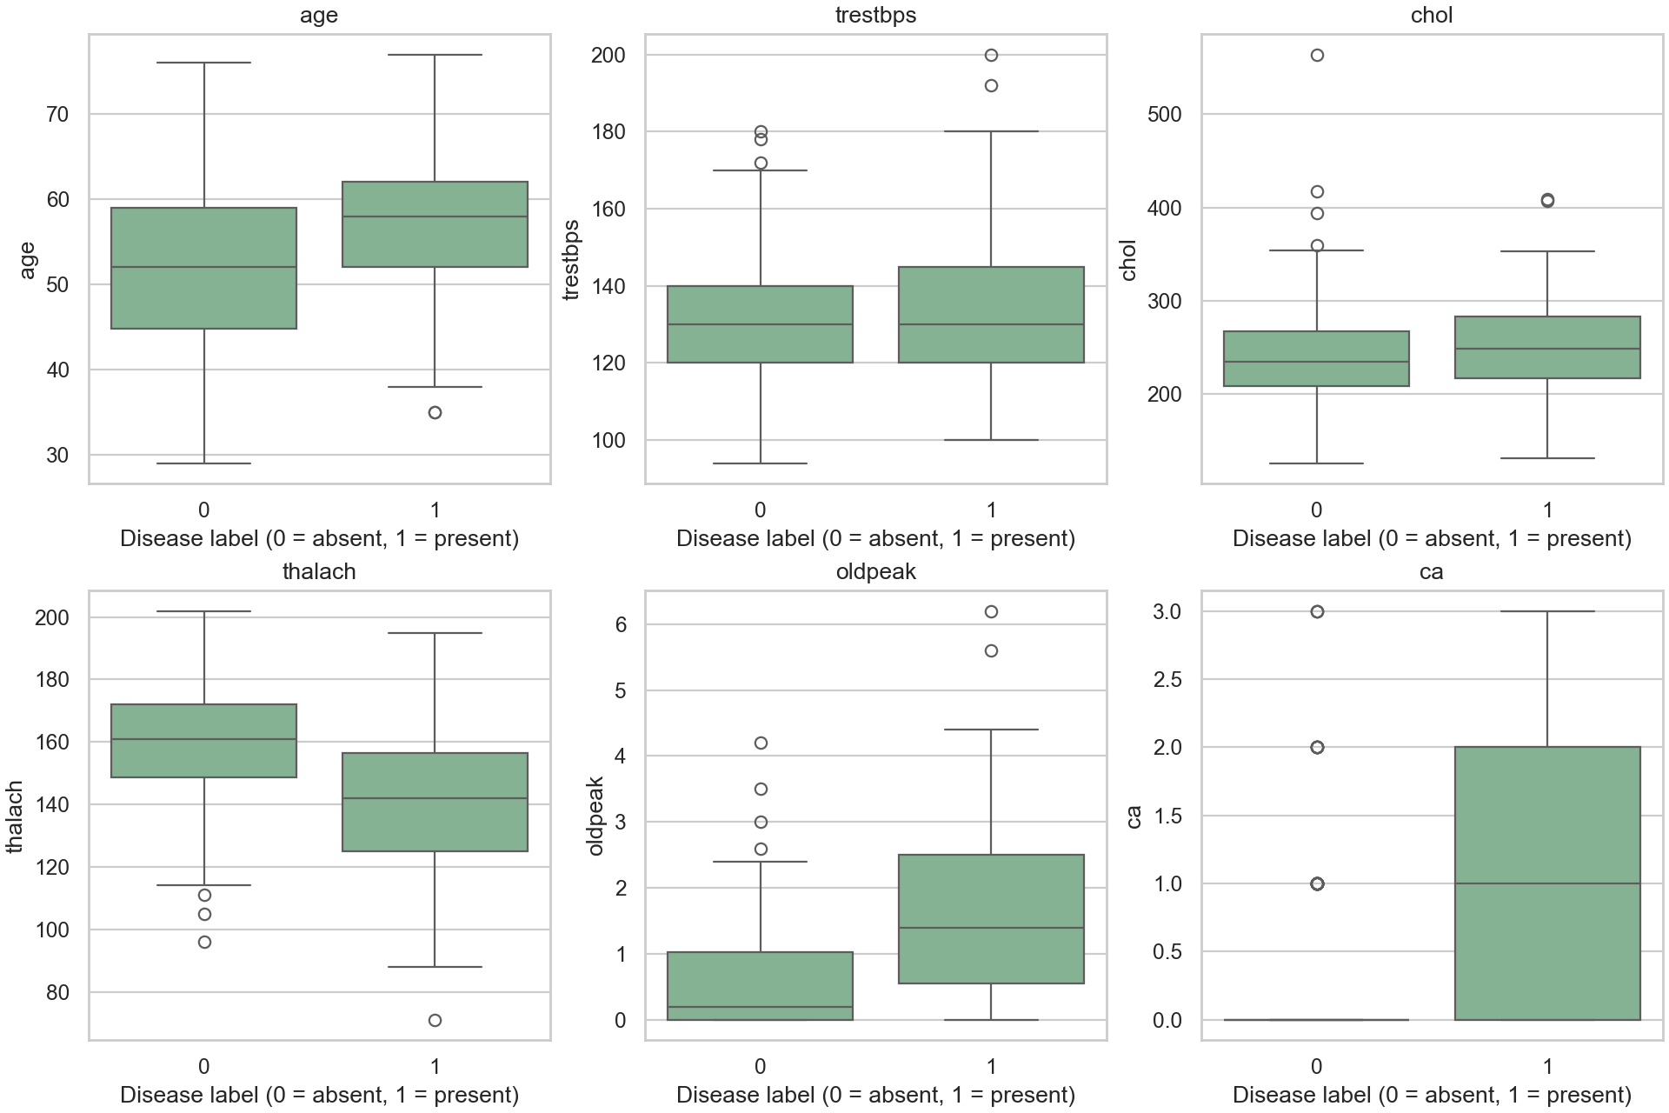
Numeric boxplots by target
The numeric distributions overlap substantially. In my analysis, the class-1 group is somewhat older, tends to have lower thalach, and tends to have higher oldpeak. These are descriptive associations only; they are not causal effects, clinical rules, or evidence that any feature predicts future disease.
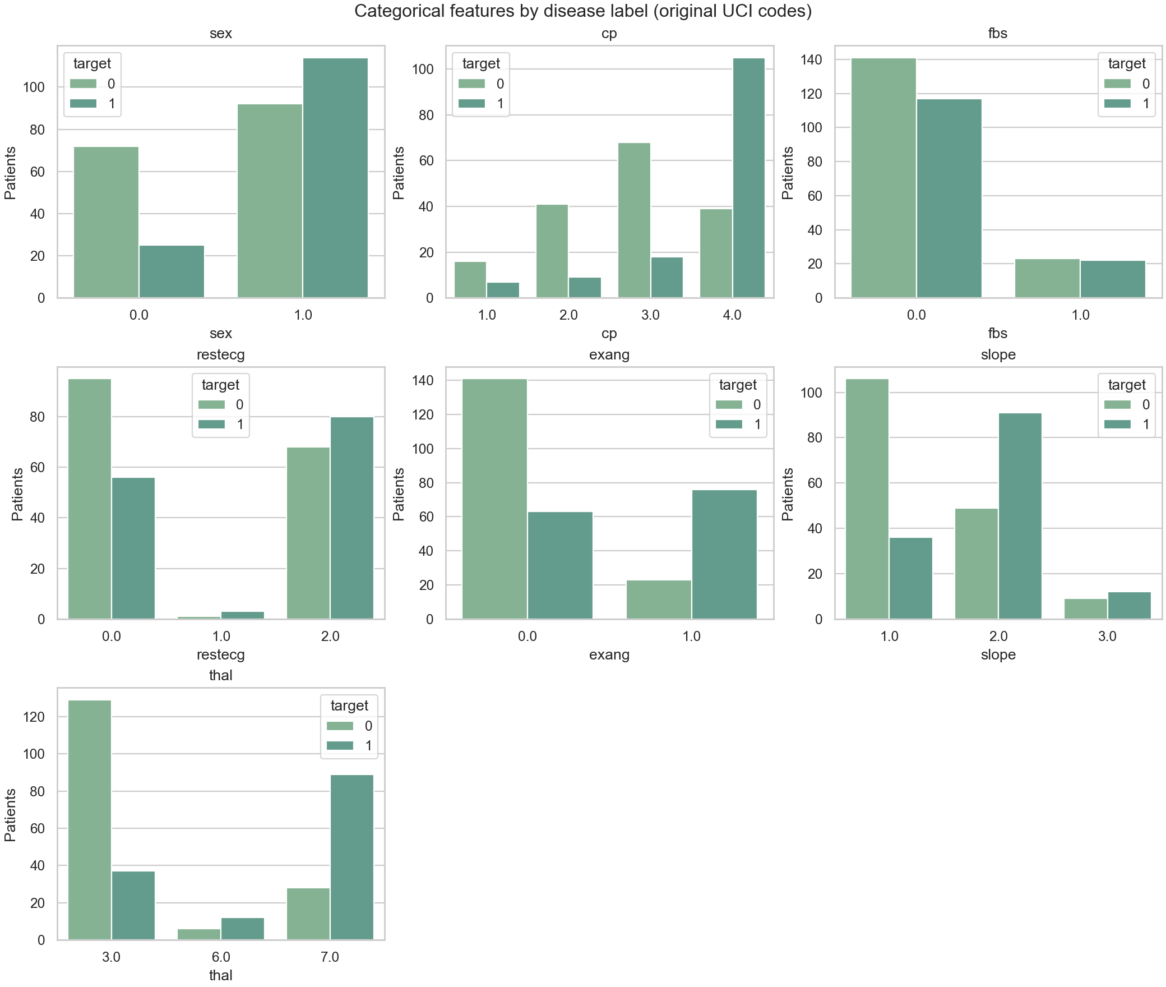
Categorical counts by target
The count plots show differing class counts across the original codes, notably cp, exang, ST slope, and thal. They show counts, not adjusted risks: class balance and the number of observations in each code influence the apparent pattern.
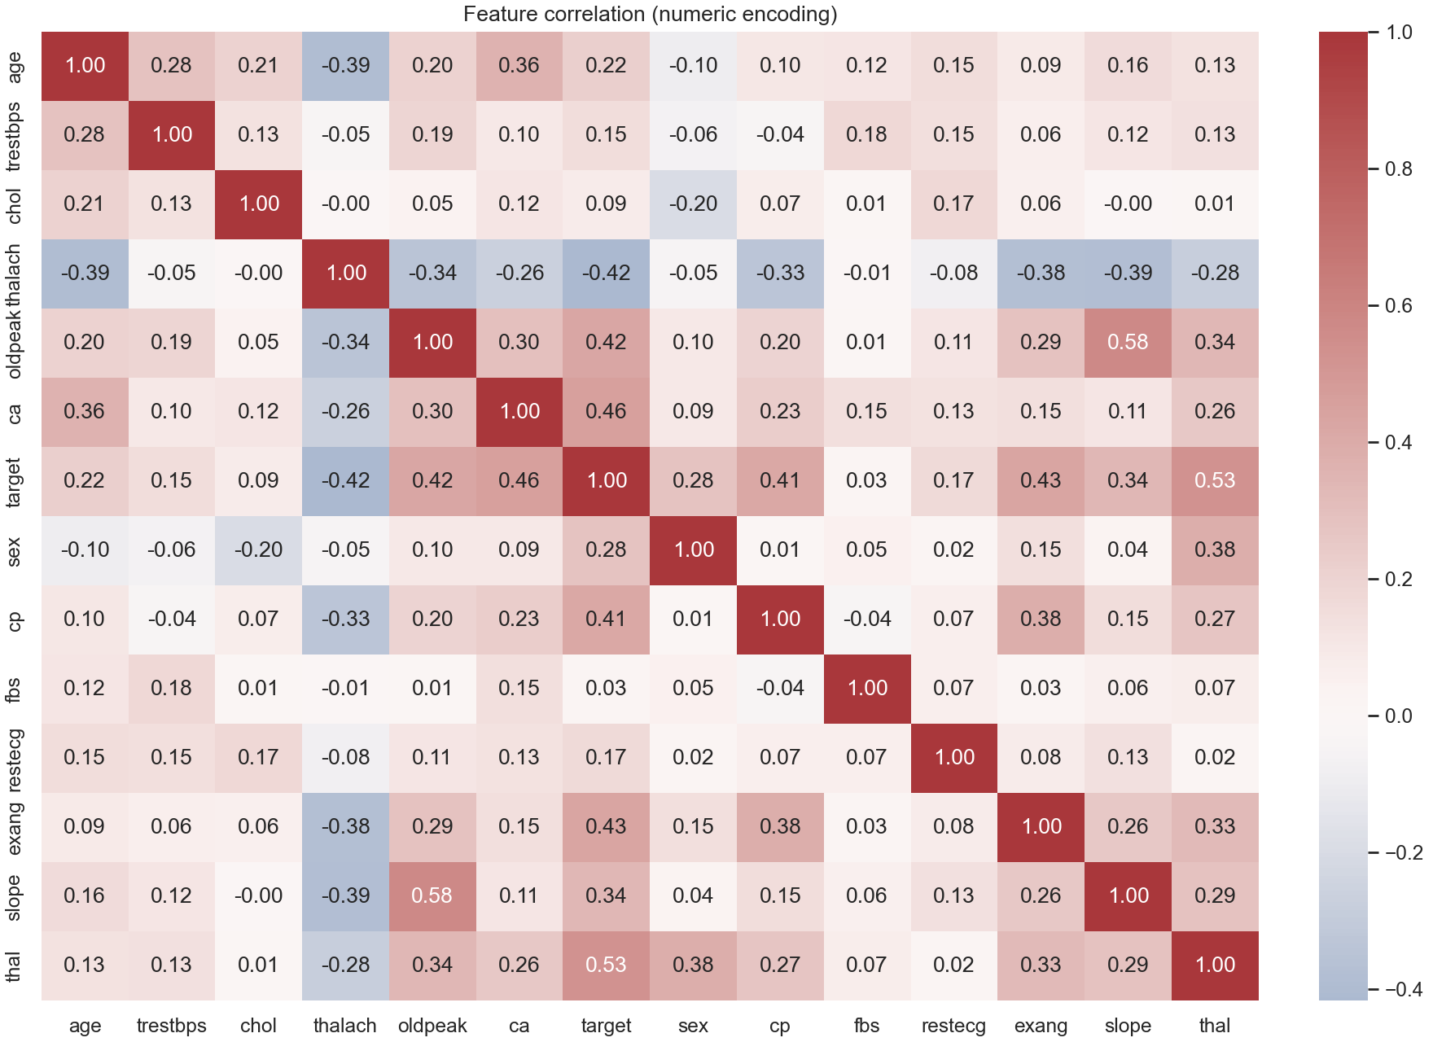
Correlation heatmap
I converted category codes to numbers to create the exploratory heatmap. Approximate correlations with the binary target include thal +0.53, ca +0.46, exang +0.43, oldpeak +0.42, cp +0.41, and thalach -0.42. A numeric correlation over category codes does not make the distance between category IDs meaningful, so used one-hot encoding for the categorical predictors in the model.

4. Preprocessing and model selection
I divided the data into a stratified 80/20 train/holdout split with seed 42, leaving 61 records in the holdout. Used median imputation and standard scaling for numeric predictors, and most-frequent imputation plus one-hot encoding for categorical predictors. These transformations are part of each scikit-learn pipeline, so they are fit within each cross-validation training fold and reused in the serialized serving pipeline.
Used GridSearchCV with stratified five-fold cross-validation and mean ROC-AUC to compare Logistic Regression, Random Forest, and AdaBoost with SAMME. I tuned Logistic Regression regularization and class weighting; Random Forest tree count, depth, and minimum leaf size; and AdaBoost estimator count and learning rate. Selected the model by CV ROC-AUC before examining holdout metrics, and did not use the holdout for tuning or threshold adjustment.

5. Results
Model | CV ROC-AUC | Holdout accuracy | Precision | Recall | Holdout ROC-AUC
Logistic Regression | 0.911344 | 0.885246 | 0.838710 | 0.928571 | 0.961039
Random Forest | 0.899917 | 0.885246 | 0.838710 | 0.928571 | 0.950216
AdaBoost (SAMME) | 0.894218 | 0.868852 | 0.857143 | 0.857143 | 0.944805

I get these results from MLflow screenshots rather than mixing them with an older local artifact. That older artifact reports slightly different Random Forest values (CV ROC-AUC 0.9003 and holdout ROC-AUC 0.9524). Logistic Regression leads CV ROC-AUC by about 0.011 over Random Forest and 0.017 over AdaBoost. Logistic Regression and Random Forest have the same thresholded holdout metrics in this run, although their ROC-AUC differs. With only 61 holdout cases, a few observations can change the percentages.
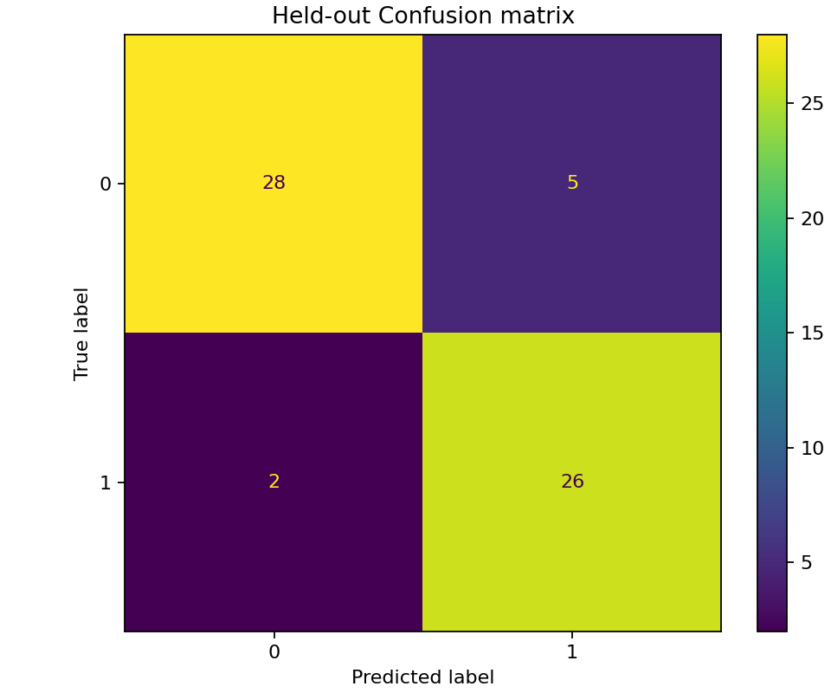
Random Forest confusion matrix
My saved Random Forest confusion matrix shows TN=28, FP=5, FN=2, and TP=26. I include it as an illustrative diagnostic from the local artifact; the results table remains sourced from screenshots.

6. MLflow tracking and artifacts
I tracked the experiments under uci-heart-disease. The three runs shown below finished successfully, and each logs the candidate, selected parameters, CV score, model, signature, and input example. I also saved holdout metrics and plots, tuning information, model comparison output, and fitted pipeline diagrams. Logistic Regression was my selected model.
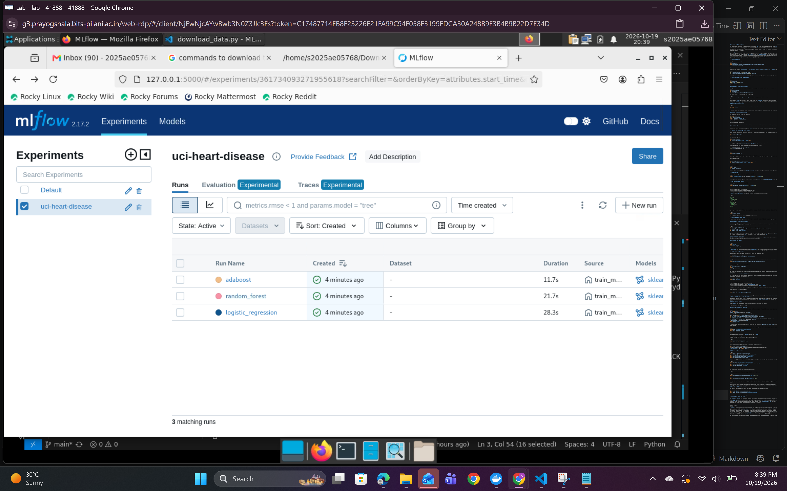
MLflow run list
Model | CV ROC-AUC
Logistic Regression (selected) | 0.911344
Random Forest | 0.899917
AdaBoost / SAMME | 0.894218

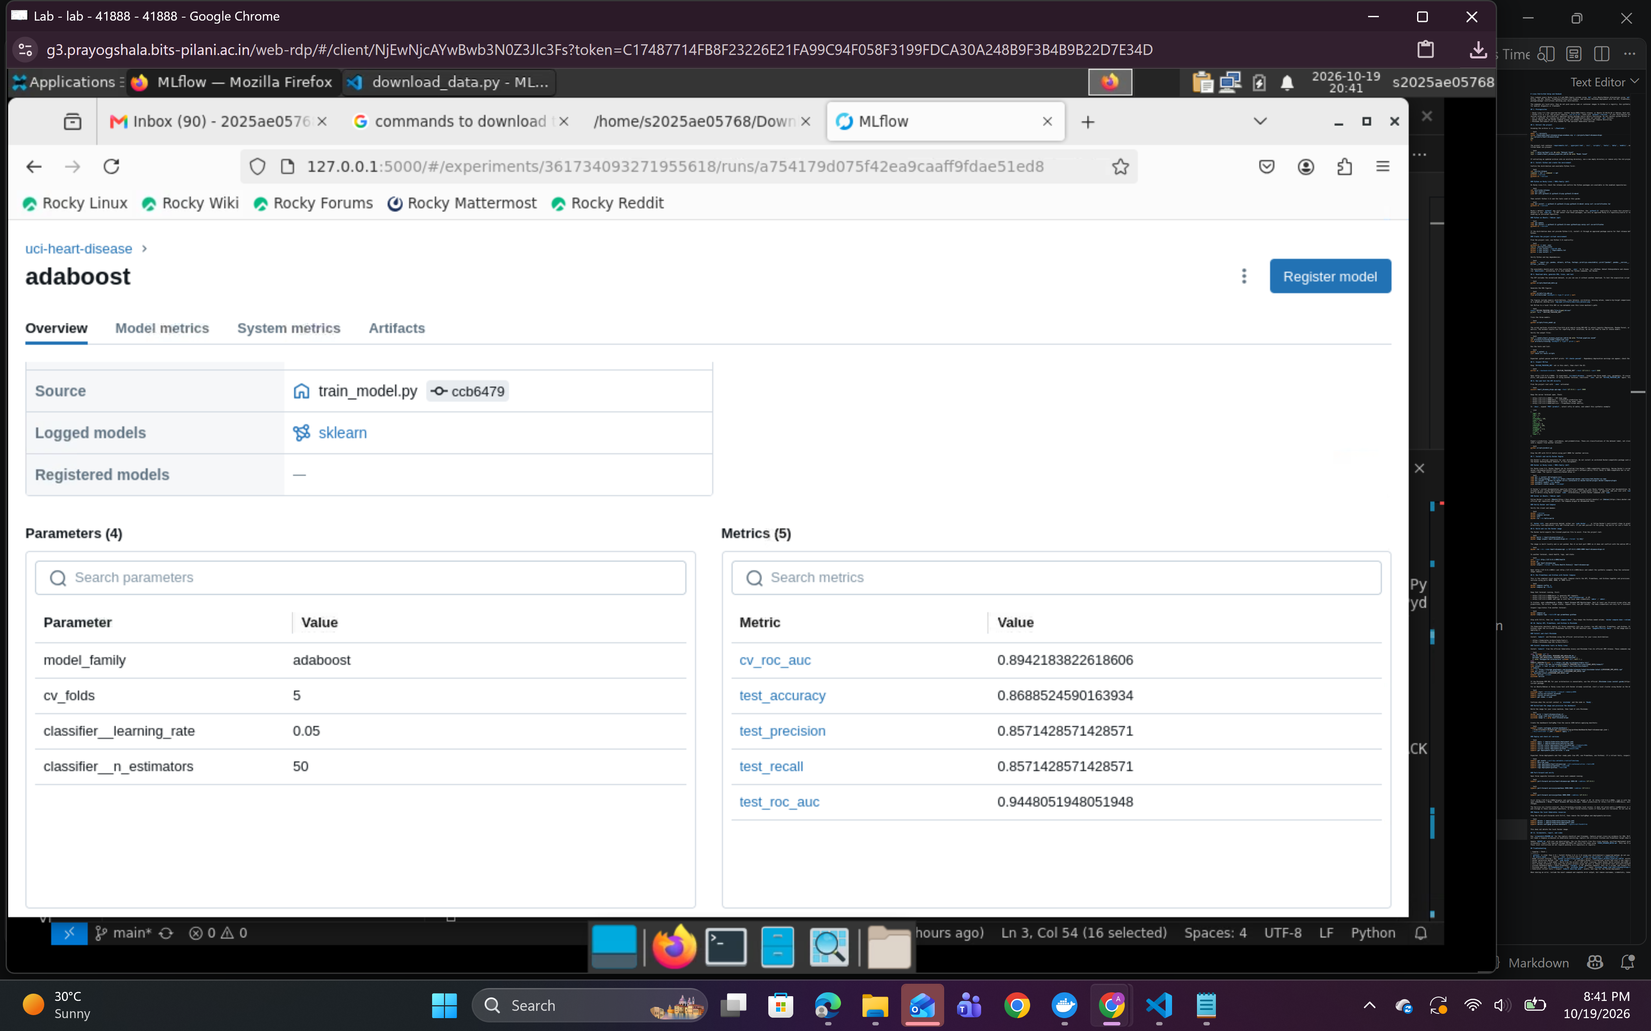
AdaBoost MLflow run details
This run detail shows the logged SAMME parameters and holdout metrics for one completed candidate. I use the run list and metric table above to compare all three models.
I saved the selected fitted pipeline as models/heart_disease_pipeline.joblib, bundling preprocessing and the classifier. API accepts raw named feature values and applies the same transformations used during training.

7. API and container
I implemented a FastAPI service with GET /health, POST /predict, and Prometheus-format GET /metrics. Its prediction response contains the binary dataset-label prediction and class probabilities. The service validates requests, assigns an X-Request-ID, and logs method, path, status, and duration without logging patient feature values.
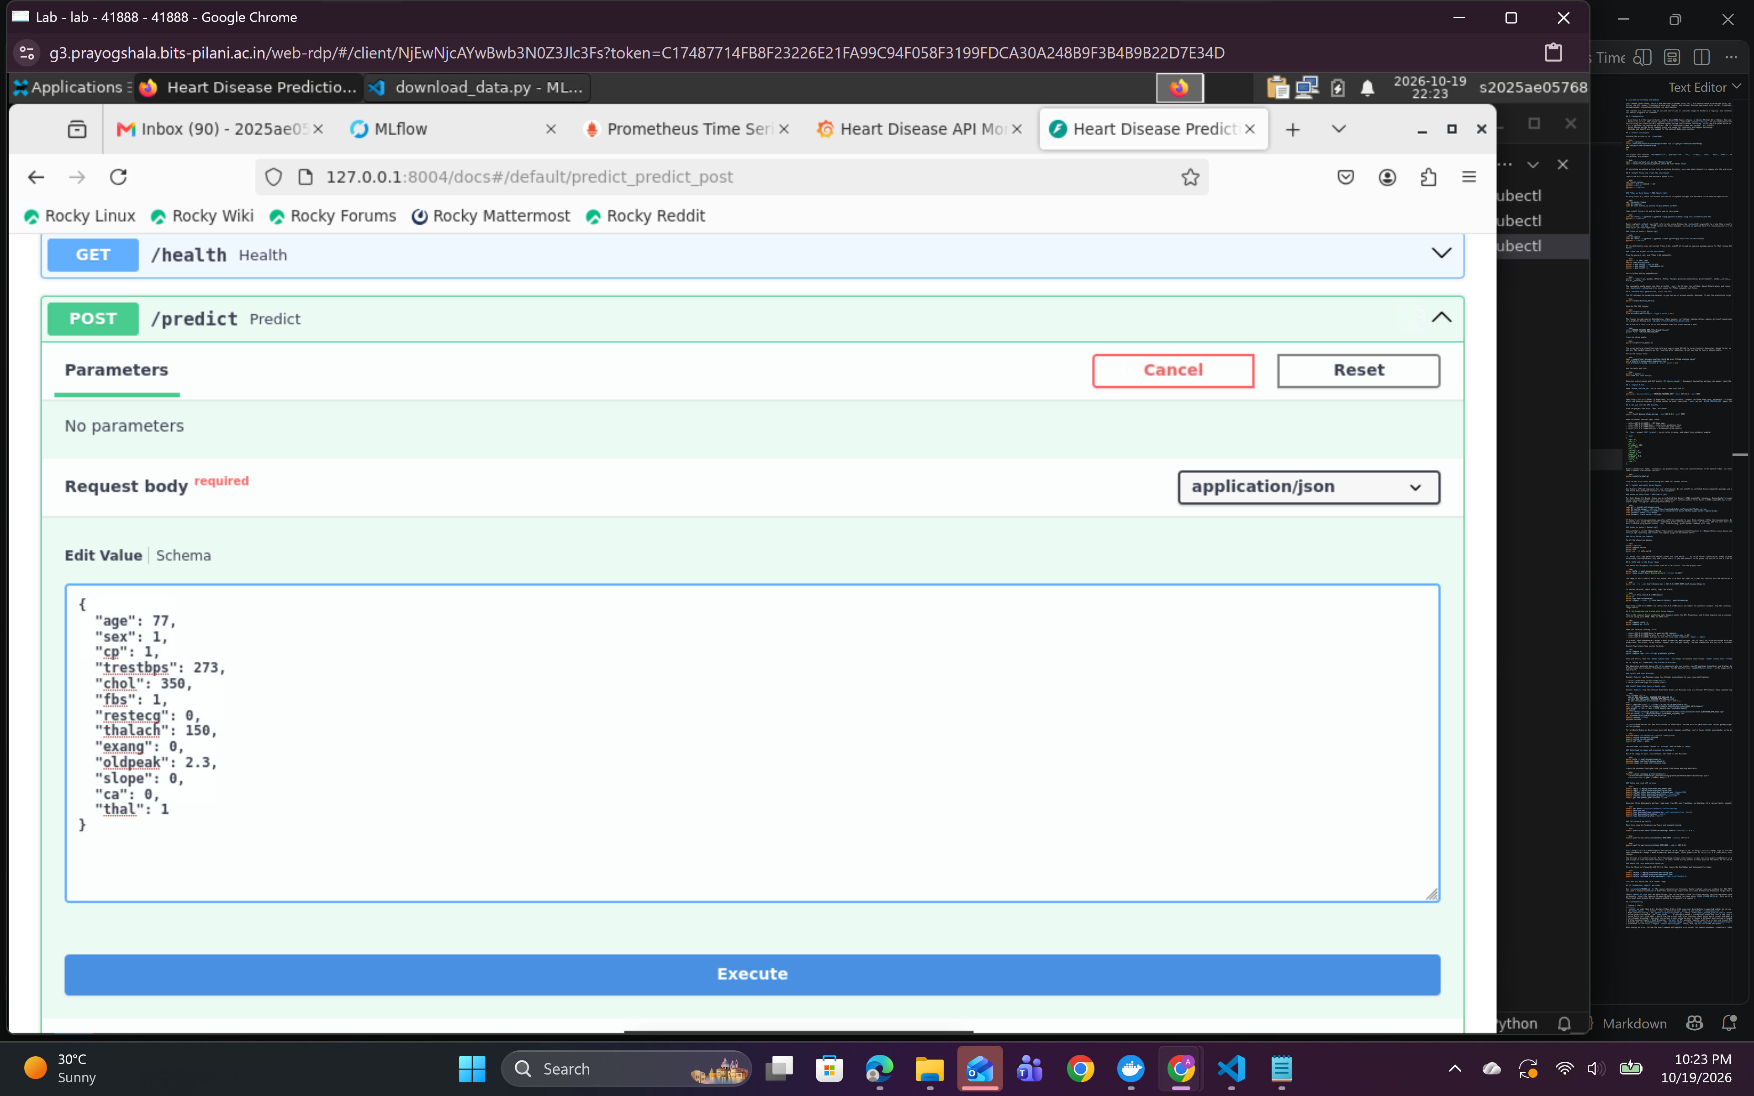
Successful Kubernetes API prediction
My captured request through the local Kubernetes port-forward returned HTTP 200 and probabilities 0.3106/0.6894. The address 127.0.0.1:8004 is local access, not a public endpoint.
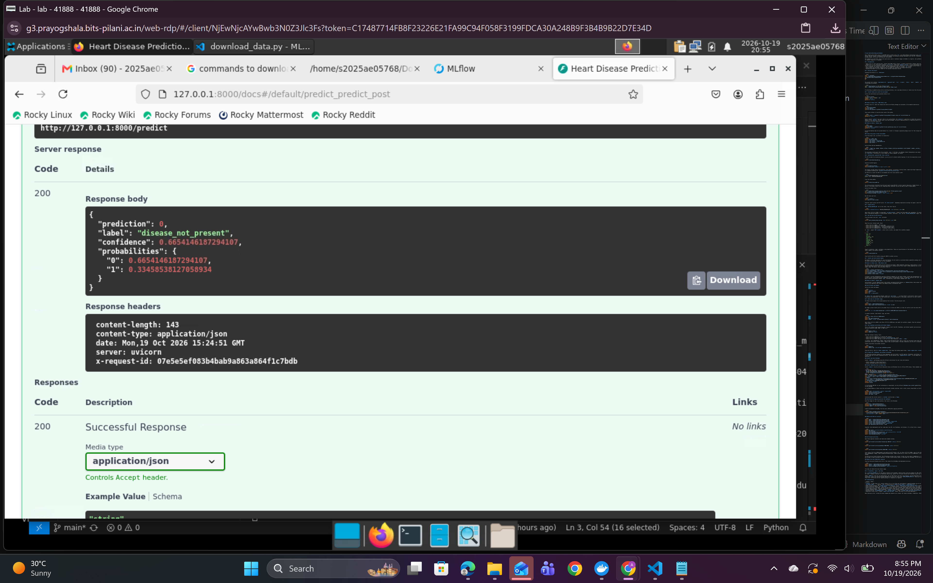
Successful local API prediction response
This separate local API test also returned HTTP 200 and a prediction response. Its input and probability differ from the Kubernetes example above because it is a separate request.
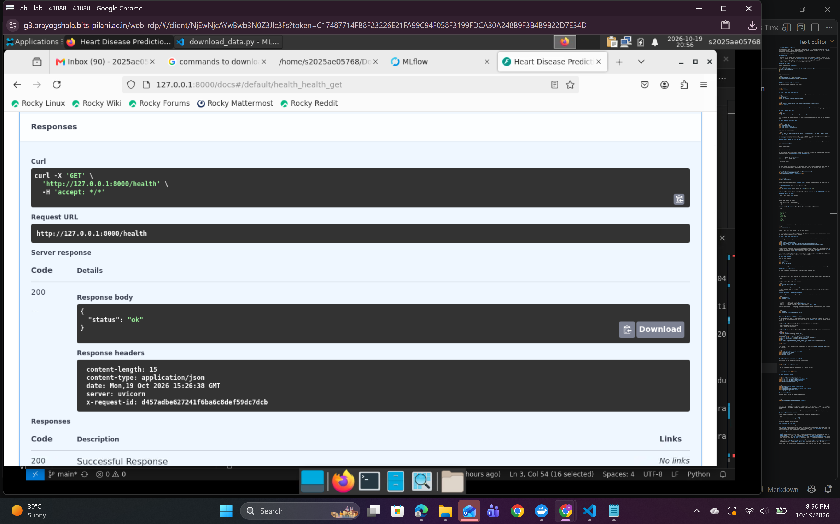
Local API health check
The health endpoint returned HTTP 200 with status ok during the local API check.
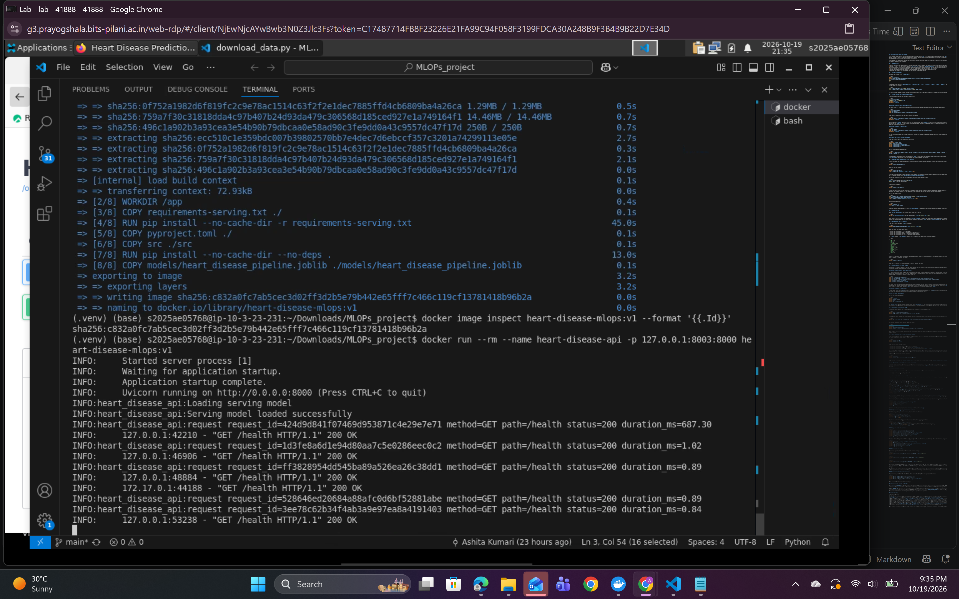
Docker build and startup evidence
I packaged the trained pipeline in a Docker image that runs the service as a non-root user and defines a health check. Screenshots show the image build and container activity. GitHub Actions builds a separate CI image and probes its health, metrics, and prediction endpoints.
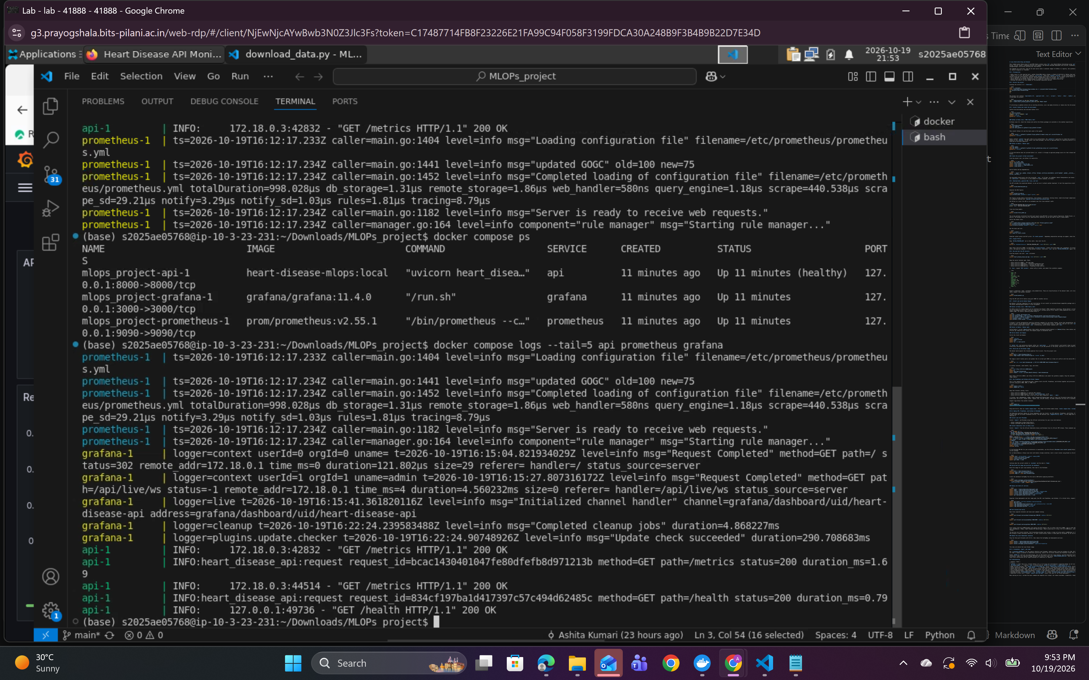
Docker Compose services
This terminal capture shows the API, Prometheus, and Grafana containers running together under Docker Compose, with the API container reporting healthy status.

8. Kubernetes and monitoring
I deployed the API locally to Kubernetes with two replicas, alongside Prometheus and Grafana. The API LoadBalancer external address is pending, so I verified access through local port-forwarding. Prometheus reports the API scrape target as UP.
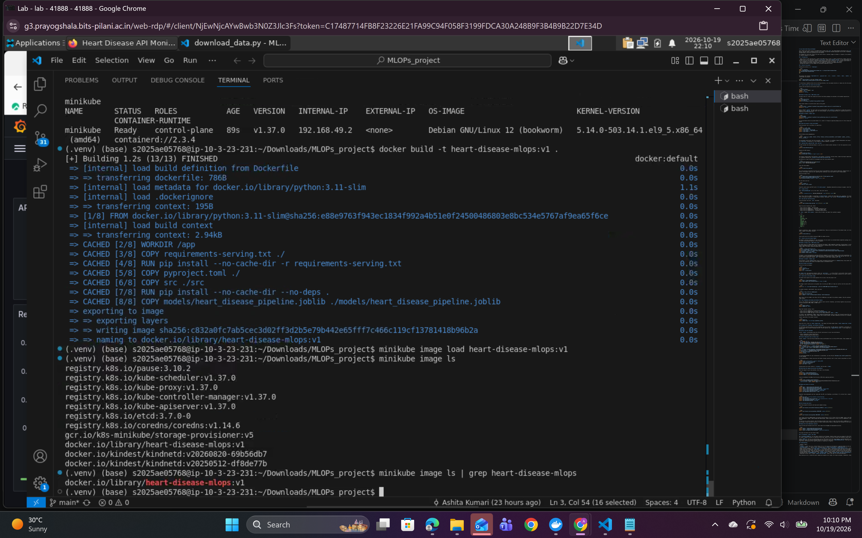
Kubernetes resources
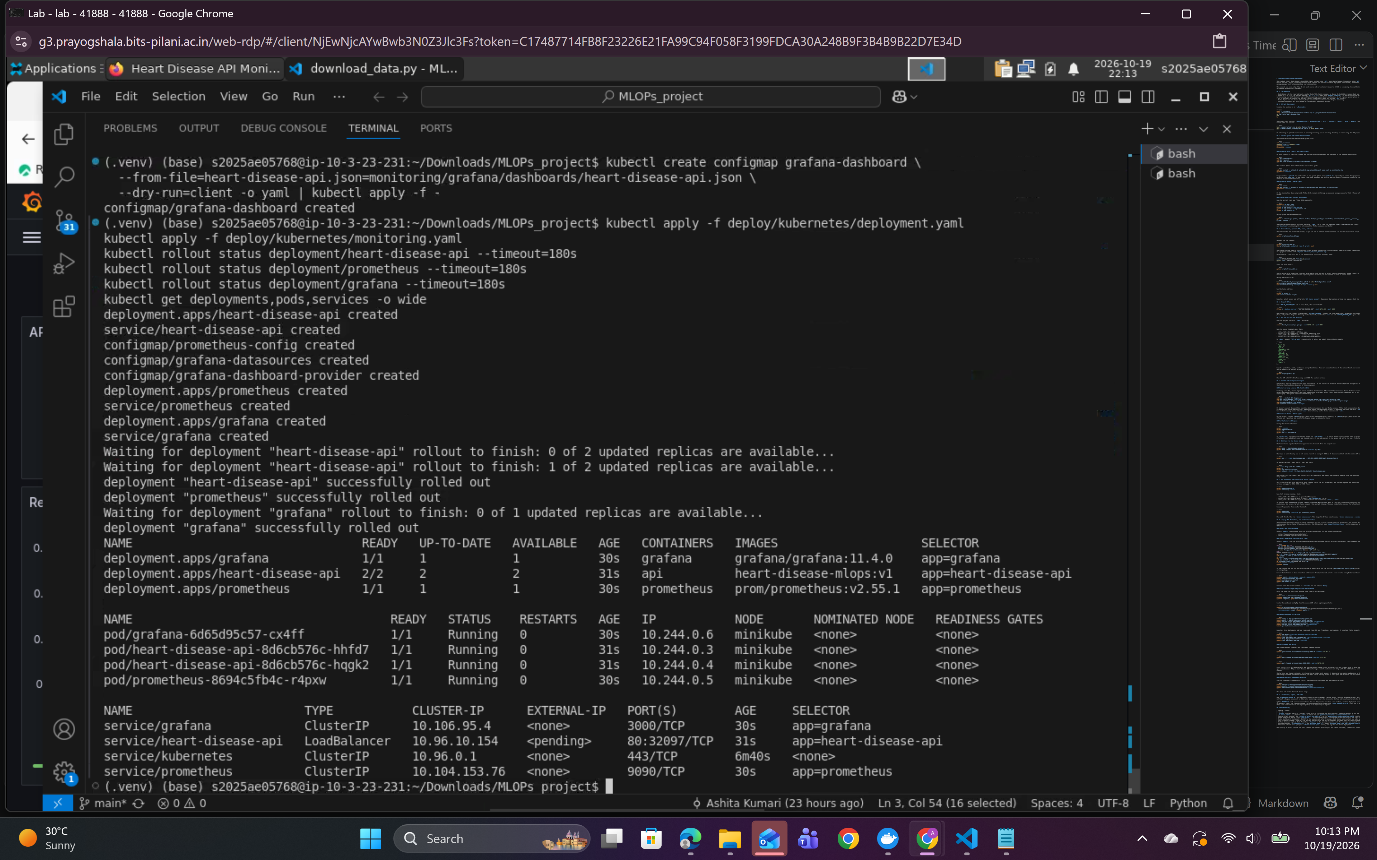
Kubernetes rollout and service status
The rollout output shows both API replicas and the monitoring deployments ready. The API service is a LoadBalancer, but its external address is pending in this local Minikube environment.
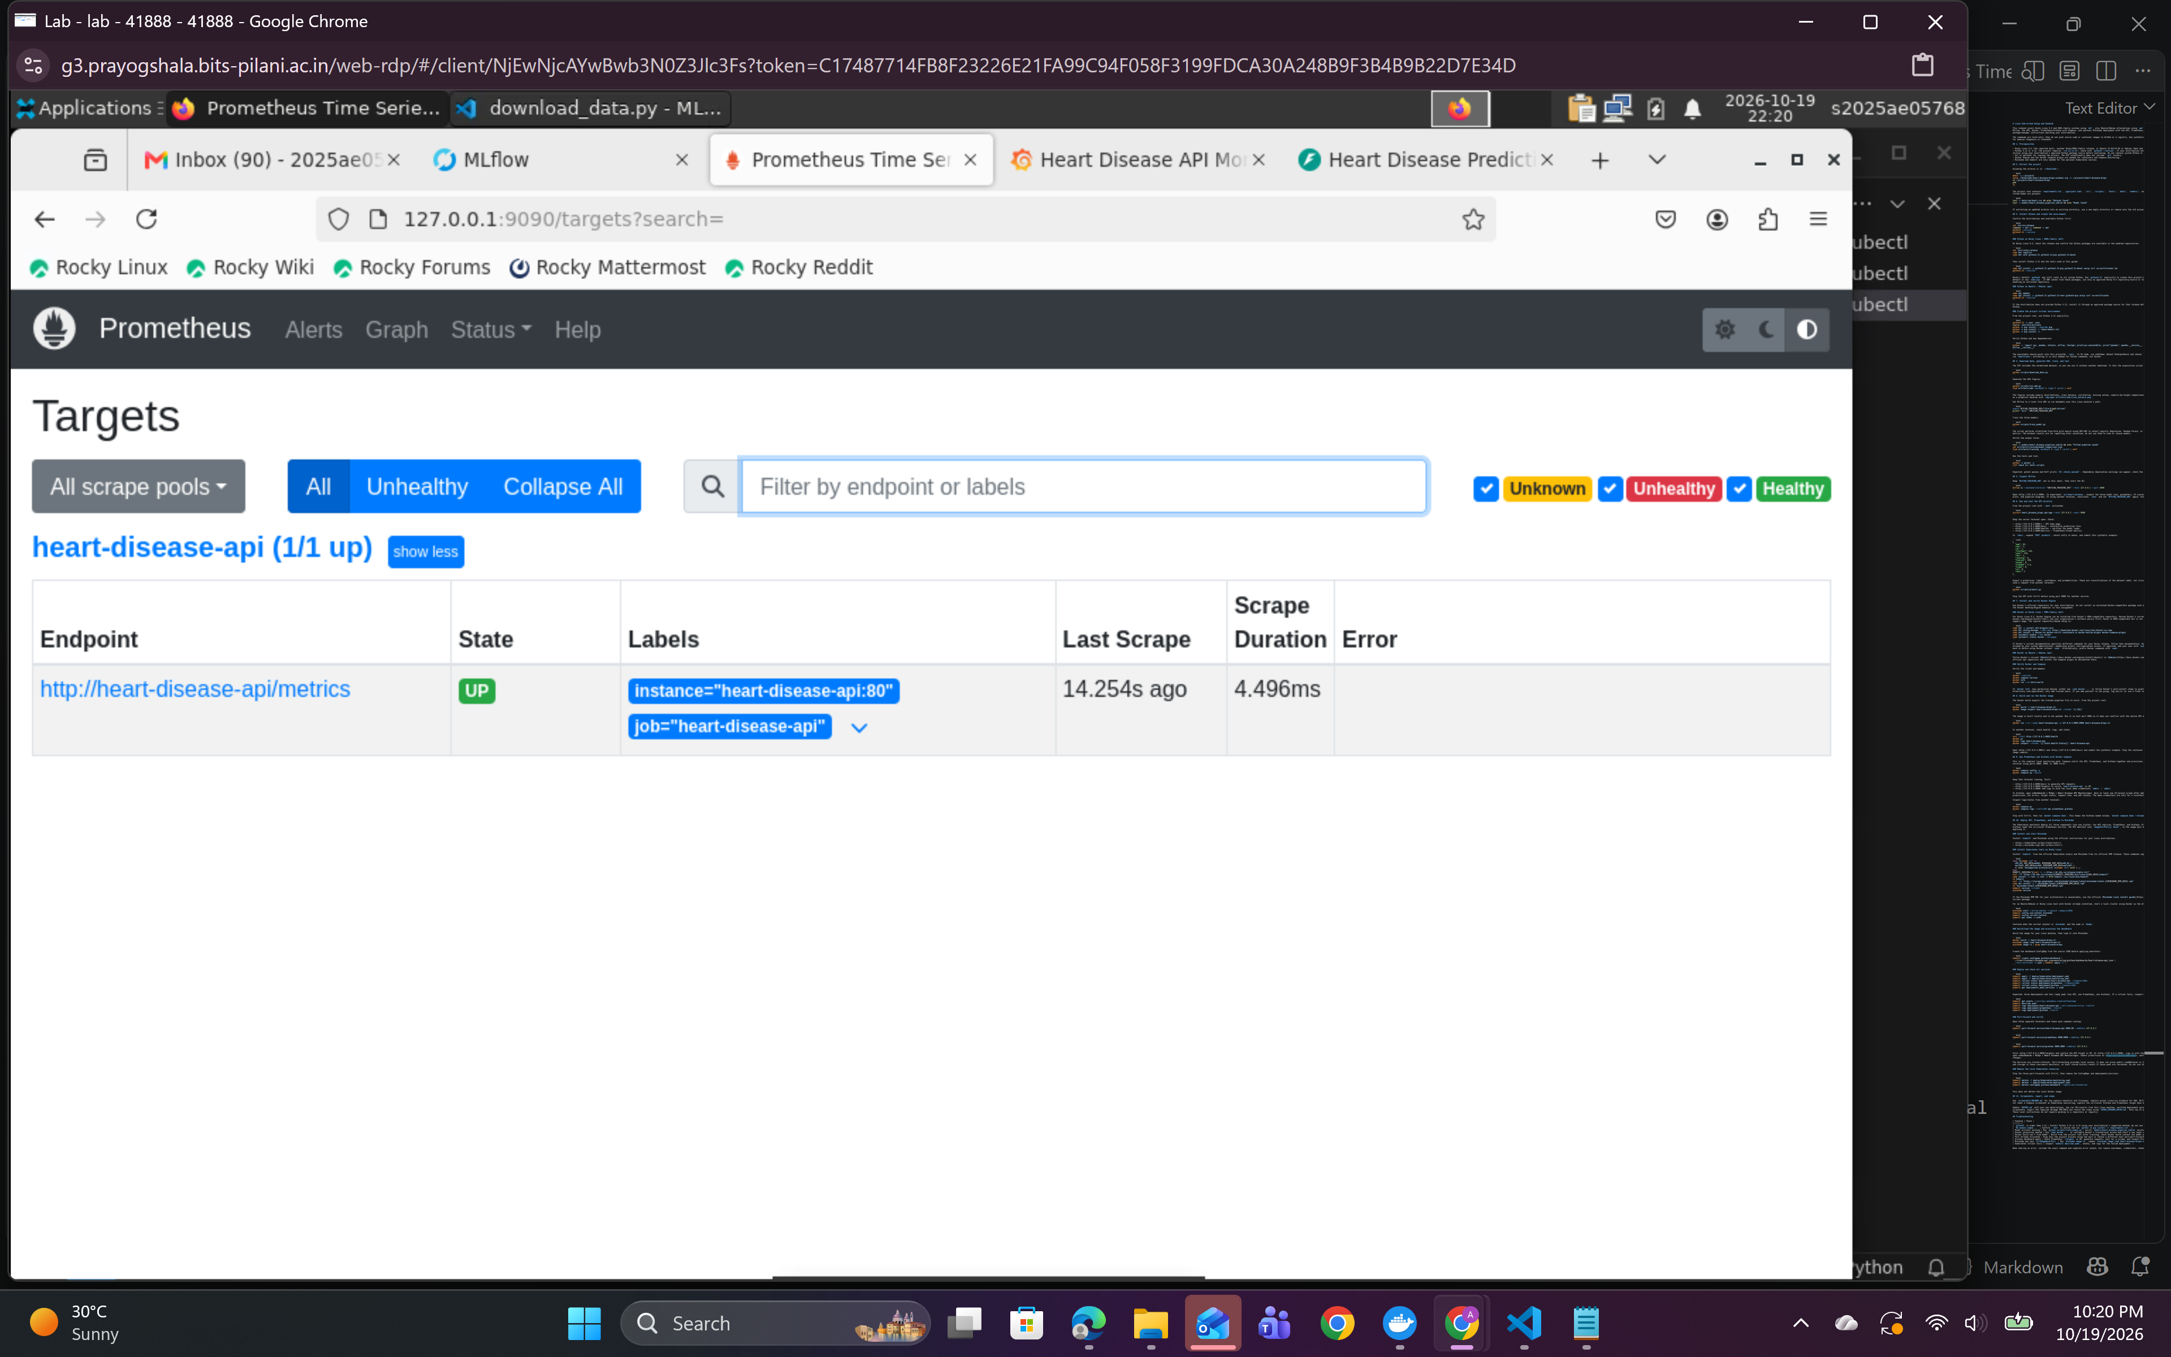
Prometheus scrape target
Prometheus lists the heart-disease-api target as UP, confirming the service metrics endpoint is reachable by the scraper.
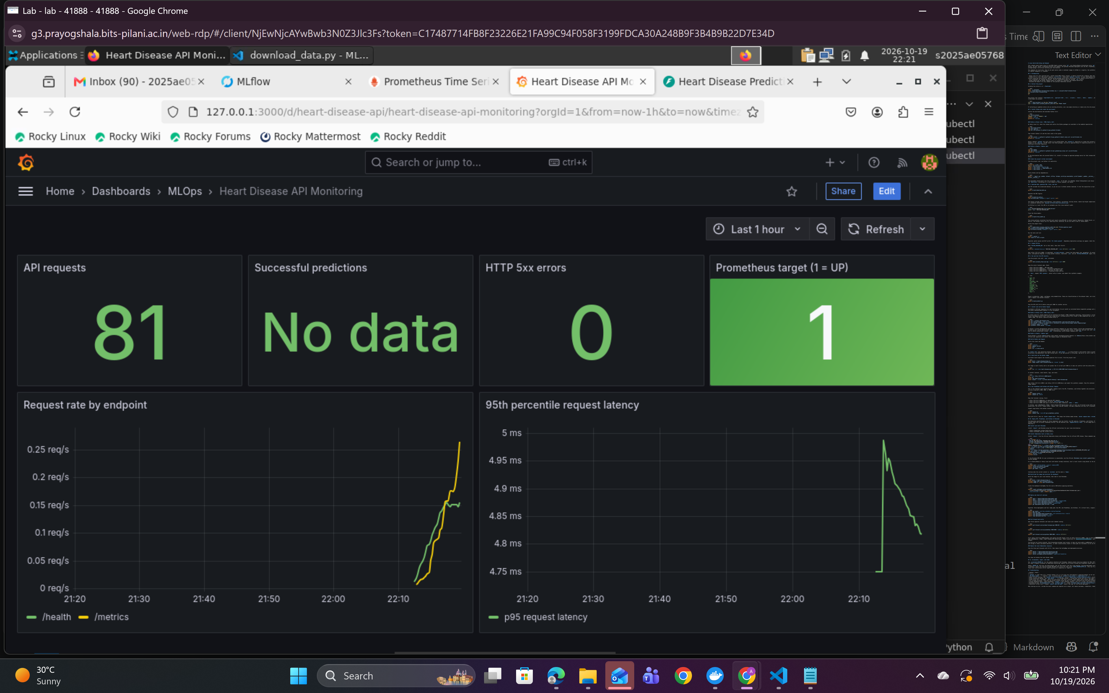
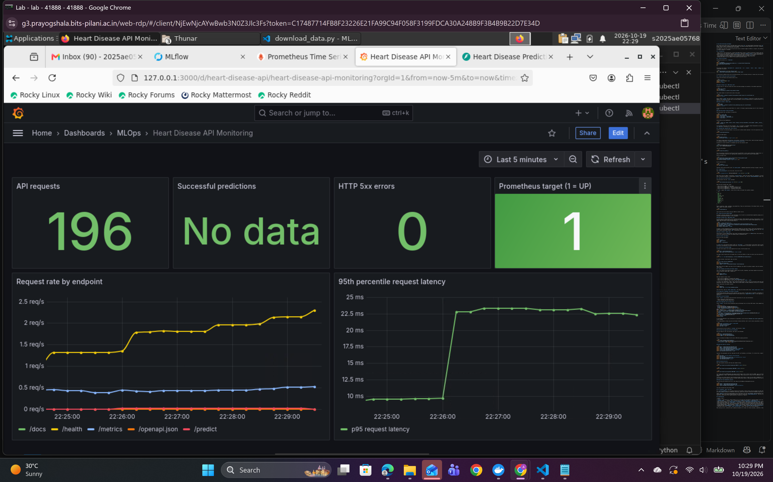
Kubernetes Grafana dashboard
My captured dashboard reports 81 API requests, zero HTTP 5xx errors, and target health 1 (UP). Its successful-predictions panel displays “No data.” Although a separate Kubernetes prediction request succeeded, I cannot confirm from this screenshot that Prometheus scraped the prediction counter. Before submission, I should generate a prediction, wait at least one scrape interval, and capture an updated dashboard before claiming that metric is verified.
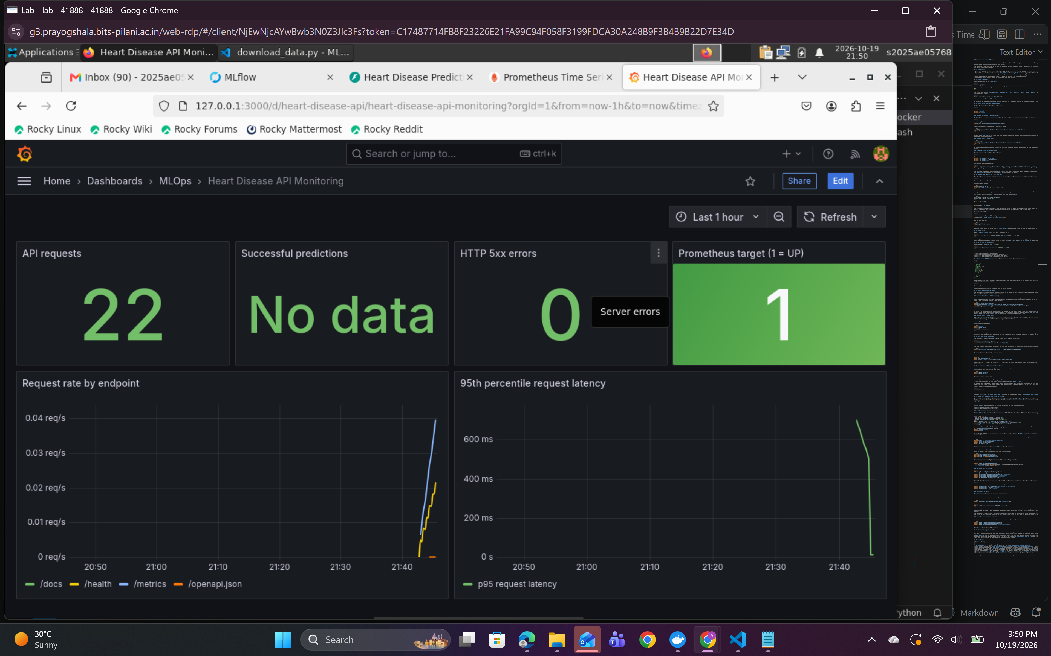
Docker Compose Grafana dashboard
This additional dashboard capture shows request-rate and p95-latency panels from my Docker Compose monitoring run. Its successful-predictions panel also shows “No data,” so I have not treated that counter as verified in either environment.

9. Limitations
I recognize that the dataset is small, historical, and region-specific, and that its target is a contemporaneous diagnosis label rather than a forecast. I have not performed external or prospective validation, a calibration study, a fairness evaluation, or clinical approval. Accuracy, precision, recall, and ROC-AUC do not establish safety or clinical utility. Medical use would require representative data, external and prospective validation, privacy safeguards, governance, and clinical oversight.

