**Wi-Fi & Automated Sprinkler System**

Implementing an Arduino Microcontroller will allow us to gather the data from different sensors throughout the house (heat sensors, light sensors, laser trip wire) and broadcast the data to a server that will be set up using Wi-Fi Interface. A Wi-Fi shield for

Arduino will be connected to the server using the TCP/IP protocol with an assigned IP address that the server will use to listen to the information on that IP. We are planning on running an Apache server where we could store the data that comes in from the micro controllers. This data will be formatted and displayed on a secure website which is accessible from any internet connections. Using the Wi-Fi we will be able to send and receive data. Once we get the information from a temperature sensor in one of the rooms, and we decide to turn on the fans in the room to make it cooler, we would send a command to that micro controller that will be in charge of running the fans, to start to pump the cold air inside that room. Below is a diagram to illustrate Wi-Fi operations in the house. *Figure 1 –* Shows how the overall look of the Wi-Fi will look like.



Figure 1

The following layout describes how the Sprinkler System will be automated in order to function through the WiShield that is attached to the Arduino. *Figure 2* explains the layout of the implementation.

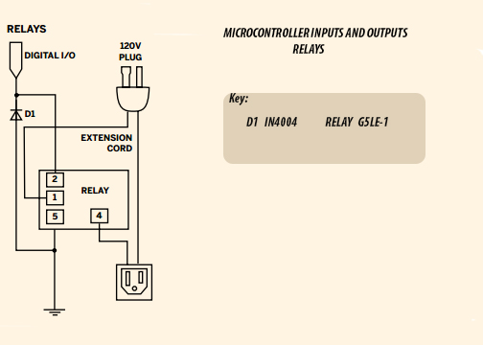

Figure 2

Relays will be controlled with digital outputs sent from the Arduino once the webserver initiates a certain command, that command will be based upon two different factors. One of the factors is the exact based on soil moisture level in the ground and the second is based on the time of the day. If the soil moisture is under the acceptable level and its night turn on the sprinkler system. Else leave it off until one the right parameters are acquired. *Figure 3* illustrates the next two steps necessary in controlling the sprinkler system.

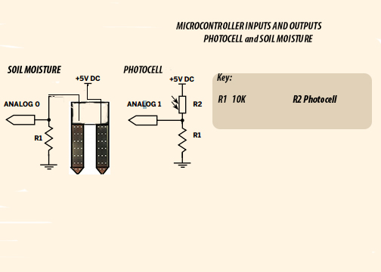

Figure 3