**I install npm in the folder by command:**

npm init

**installed express by following command:**

npm install –save express

**I opened the main project file with vs code:**

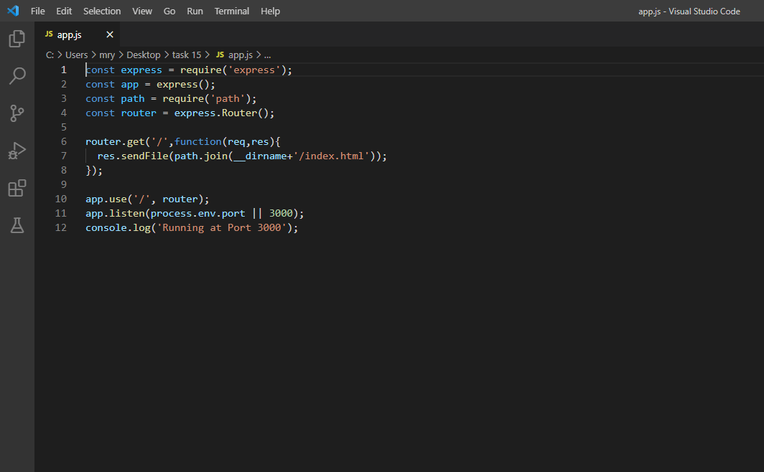

**Starting my app:**

node app.js

**local:**

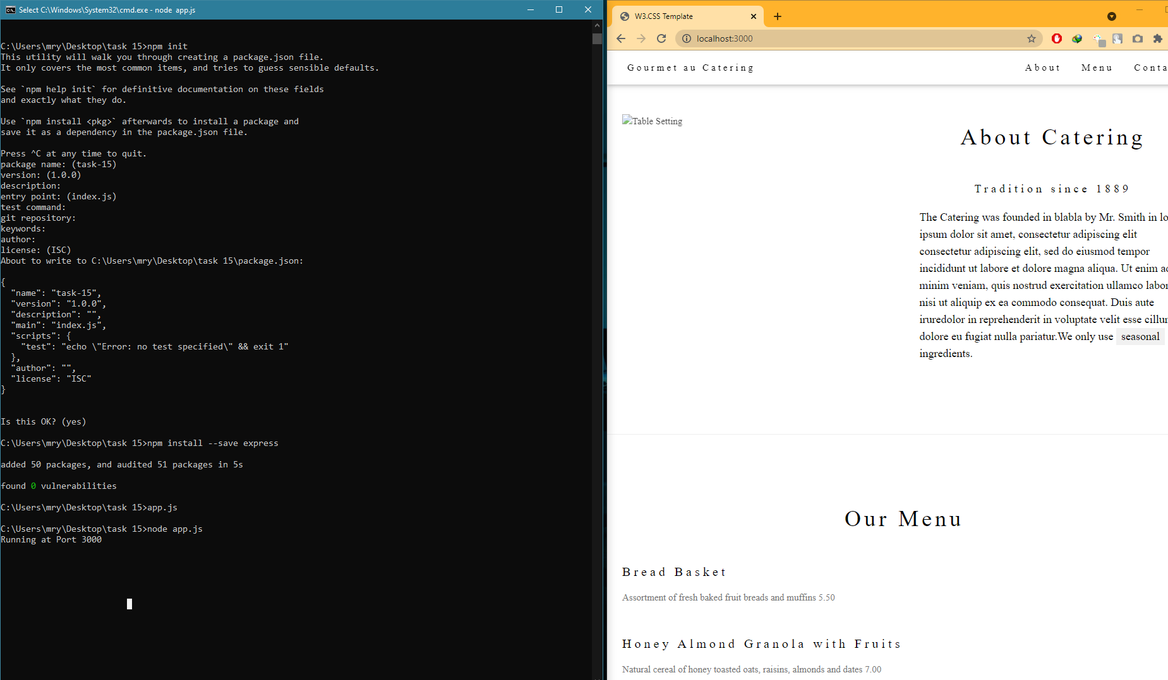

**Global:**

