HDSC Stage C Assignment Web Scraping: Most Expensive Used Cars in Nigeria

**NAME: Ashiyanbi Omotolani Lizzy**

**Hamoye ID: 148c00386b81f000**

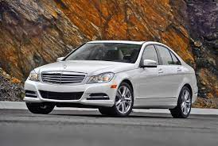

**INTRODUCTION**

As it turns out that Nigeria is one of the biggest markets for used cars as people who wish to own a personal car look for alternatives to the brand-new version.

Used cars are relatively cheaper and some are quite durable which are some of the reasons why they are popular in the country. In price comparison, used cars are almost 50% cheaper than brand new versions. Although, this would depend on a number of factors, they are more affordable option for the average Nigerian man and that is why they are preferred.

This article is to review the most and least expensive used cars in Nigeria based on market price has gotten from <https://jiji.ng/cars>. It is also very important to note that there are two types of used cars in Nigeria and this is one of the factors apart from car model, year of manufacture, whether accidented or unaccidented, etc. that affects the price of such car. They include the foreign used also known as Tokunbo and the local used versions also called the Nigeria used.

**Why Buy a Used Car in Nigeria? See Reasons**

The economy of Nigeria currently is nothing to write about, as we all know Nigeria imports most of the goods used in the country from Western and Asian countries and this has really affected the economy with bad leadership in the helms of affairs.

Though, as stated earlier we now produce good cars in Nigeria too but for someone who is just starting life with little monthly income buying the Nigerian automobile, brands can be very expensive because they also import most of the components used to build these cars.

Also, buying brand new cars from abroad is also very expensive and this is the reason for this article as you can cut costs and at the same time enjoy the best of brand-new cars in fairly-used ones.

So, to avoid standing for a long time waiting for transit or rushing and running after buses at every bus stop in Nigeria why not buy a used car and enjoy comfort at a cheaper price?

Let us take for instance; if you want to buy a brand-new Toyota Camry 2017 model then you should have close to ₦12,000,000 of which you can just opt for the used one which costs around ₦3.5 – ₦5 million. Instead of you spending millions of Naira on new cars you can get a good used car in Nigeria.

You enter the street of Lagos and you see young people with cars, it isn’t that they all bought it anew, the majority of them got used cars at a cheaper price, most Nigerians rocks used cars (Tokunbo Cars).

The most interesting part of it is that the cars are only used for a few years ranging from 3-5 years and they are still in almost new conditions based on how they were used and well handled by their owners, some are only used for a few months or a year.

Mind you there are different types of used cars in Nigeria, do not because I said you can opt for used cars then you went ahead to purchase a worn-out old car. You want to buy something that will last you for years and this is the reason why you need to know the types of used cars you can buy in Nigeria.

**Tokunbo (Foreign Used)**

Foreign used cars are vehicles that have been used outside the country before being shipped to Nigeria for sale. This means that any vehicle used outside the shore of Nigeria is a foreign used. Generally, vehicles in this category, are more expensive than locally used cars because they are more durable and less likely to develop lots of faults or require lots of maintenance in the long run. They are the more preferred choice though **more expensive.**

**Locally Used**

These ones are vehicles that were bought as brand new or as foreign used and then used in Nigeria before being sold. Locally used vehicles are mostly cheaper than foreign used ones and this is because they have lost a lot of quality, value and depreciated during the period of use. Most locally used vehicles are poorly maintained and will likely develop faults easily. As it is, they are the best option for those who are in a tight budget. But not likely to give you the value of your money. However, you might be fortunate to come across a durable locally used vehicle.

**List of Used cars and their prices**

|  |  |  |
| --- | --- | --- |
| **S/N** | **Name** | **Price (#)** |
| **1** | Honda Accord Cross tour 2011 White | 1,600,000.00 |
| **2** | Mazda 323 2002 1.6 Silver | 2,200,000.00 |
| **3** | Lexus RX 2014 Black | 2,450,000.00 |
| **4** | Lexus RX 350 2009 Silver | 2,500,000.00 |
| **5** | Toyota 4-Runner 2010 Limited 2WD Black | 2,500,000.00 |
| **6** | Toyota Sienna 2012 LE 7 Passenger Silver | 2,850,000.00 |
| **7** | Lexus ES 2008 350 Gold | 2,999,999.00 |
| **8** | Honda Accord 2014 Red | 3,000,000.00 |
| **9** | Hyundai Elantra 2017 White | 3,200,000.00 |
| **10** | Mercedes-Benz M Class 2012 ML 350 4Matic Gray | 3,350,000.00 |
| **11** | Mazda CX-5 2013 Gray | 3,500,000.00 |
| **12** | Toyota Avalon 2007 XLS Gray | 3,500,000.00 |
| **13** | Toyota Camry 2004 Gray | 3,600,000.00 |
| **14** | Mercedes-Benz E350 2014 White | 3,800,000.00 |
| **15** | Kia Rio 2005 Sedan Black | 3,800,000.00 |
| **16** | Acura MDX 2006 Gold | 4,150,000.00 |
| **17** | Toyota Sienna 2008 XLE Limited Silver | 4,200,000.00 |
| **18** | Honda Accord 2019 Gray | 4,300,000.00 |
| **19** | Toyota Camry 2008 Gold | 4,400,000.00 |
| **20** | Toyota Highlander 2013 Limited 3.5l 4WD Gray | 4,500,000.00 |
| **21** | Honda Accord 2009 2.0i Gray | 4,700,000.00 |
| **22** | Toyota Corolla 2013 Silver | 4,800,000.00 |
| **23** | Lexus ES 2003 300 | 6,000,000.00 |
| **24** | Honda Accord 2004 Automatic Black | 6,700,000.00 |
| **25** | Toyota Corolla 2017 Silver | 6,800,000.00 |
| **26** | Lexus RX 2019 Black | 7,000,000.00 |
| **27** | Mercedes-Benz M Class 2013 ML 350 4Matic Black | 7,500,000.00 |
| **28** | Ford Edge 2014 Black | 9,500,000.00 |
| **29** | Jeep Wrangler 2020 Rubicon 4x4 Green | 12,500,000.00 |
| **30** | Toyota Sienna 2006 LE AWD Blue | 12,500,000.00 |
| **31** | Ford Edge 2008 Blue | 12,800,000.00 |
| **32** | Mercedes-Benz C300 2012 Silver | 26,000,000.00 |

It is of great importance to note that this list is based on the market prices of the above listed cars as the time of writing of this article. We can see a variety of vehicle brands/names/year of manufacture among which are different brands of Honda Accord, Toyota, Lexus, Ford, Kia, Acura, Mercedes-Benz, etc. The choice of car to be bought by a potential buyer is largely dependent on the following.

1. **Needs**

There must be a reason for wanting to buy a car, one’s priorities must be set right, know your preference by observing the roads that lead to your house and your place of work or where you feel you will ply the most with the car, with this you can make a perfect choice. At the same time, there is a need to watch your pocket, you have to go with what you know you can afford so you check your budget.

If your usage is mostly from home to office daily then your best bet is a golf car e.g. Volkswagen, Toyota Camry, Honda and so on and if it is mainly to move your family that is your wife and children for fun or cruise then you want to go for Sienna or SUVs. As stated earlier if the roads that lead to your apartment or office are not so good then you need vehicles with high chassis i.e. the underbody of the car should be higher so there won’t be friction with the ground, bumps, and potholes. Examples of such are Honda Pilot, Nissan Xterra, RAV4, Toyota Highlander, and so on. You also want to check out other features like the rear-view camera, sound system, and so on, depending on the comfort you seek for.

1. **Budget**

The amount of money has, makes your budget and its always advisable to follow what you’ve budgeted for, you don’t spend more than your budget. We have listed the prices of used cars in Nigeria in this article so you can make a budget based on the list.

1. **Highlight Your Options**

You need to first know the type of car you want then you make a budget for it then you highlight a list of your car options that are within the range of your budget, this will help you to make the right selection at the end of the day. It could be that your choice is Japanese cars, then you will want to list down the likes of Honda Accord, Nissan, Toyota Camry, Corolla, Sedan, or even Avensis. On the other hand, if your choice will be based on German products then your best bet should be between Audi A4, BMW, Volkswagen Passat, and so on.

1. **Make choice based on research on car types and functionality**

Make your own research about each one of the cars you intend to buy. You want to ask people about their fuel usage, lifespan, speed, gear type, and many other functions of the cars listed. The best way to carry out this is to meet those that are currently using those car brands and models or if you do not want to do that, you can check on the internet, search for automobile forums, and there you can relate with car lovers.

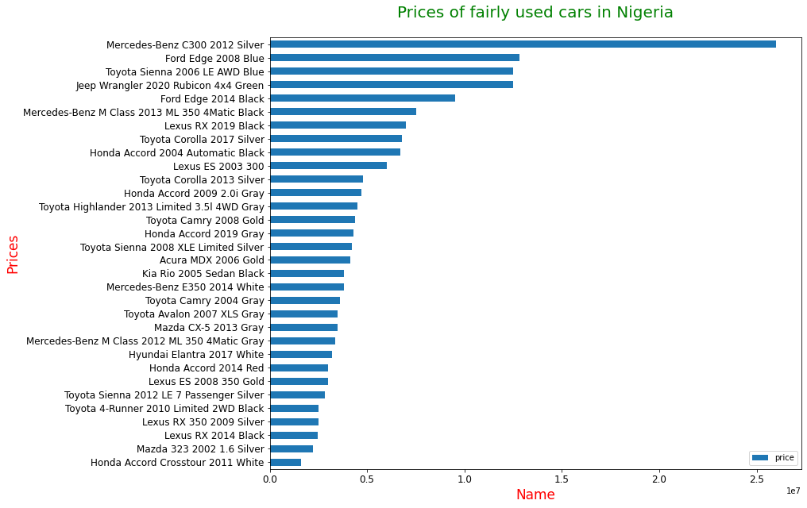

Lastly, I made a chart of the above listed cars to see the most expensive ones and it’s interesting to see that Mercedes-Benz C300 2012 Silver is the most expensive, as it costs # 26,000,000.00.

 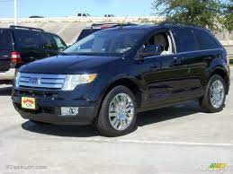 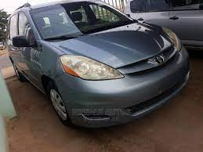 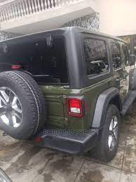

**Mercedes-Benz C300 2012 Silver Ford Edge 2008 Blue Toyota Sienna 2006 LE AWD Blue Jeep Wrangler 2020 Rubicon 4x4 Green**

**(Most Expensive) (2nd Most Expensive) (3rd Most Expensive) (3rd Most Expensive)**

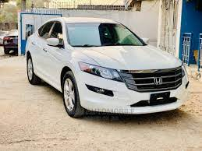

**Honda Accord Cross tour 2011**

**(Least Expensive)**

**In conclusion, from the above chart, we can deduce that the most expensive used car in Nigeria using this scraped data is Mercedes-Benz C300 2012 Silver which costs # 26,000,000.00, followed by Ford Edge 2008 Blue which cost # 12,800,000.00, then** **Toyota Sienna 2006 LE AWD Blue and Jeep Wrangler 2020 Rubicon 4x4 Green both costs about # 12,500,000.00 while the least expensive one is Honda Accord Cross tour 2011 White which costs # 1,600,000.00.**