Service Feature Architecture Diagram
Below is the system architecture diagram for the Service feature of the Skill Sharing app:
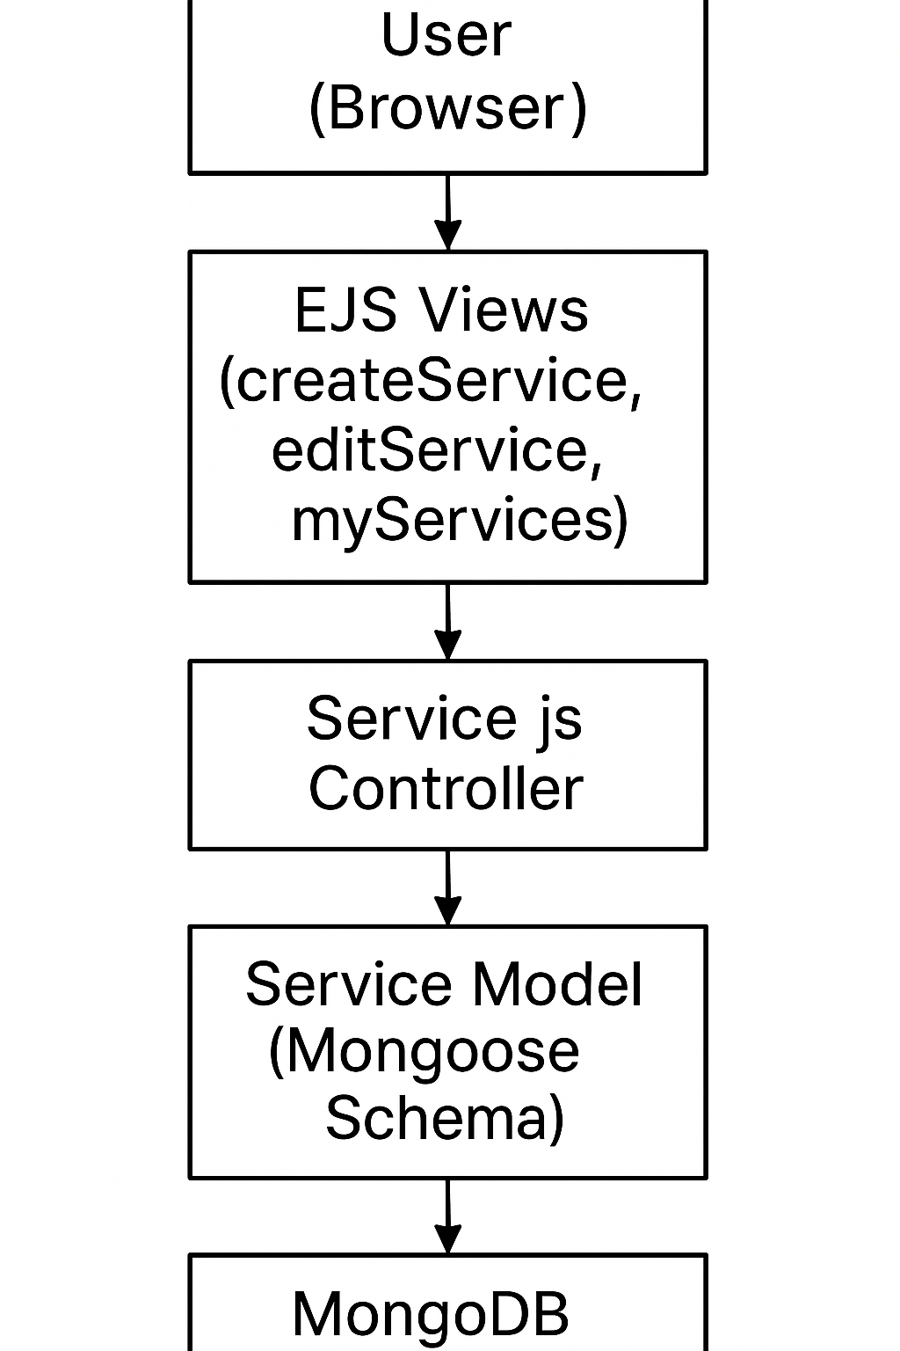
Service architecture diagram
This diagram shows how users interact through the views and routes to the controller, model, and MongoDB.

