Preface
The honored history of the Holy Defense is full of precious lessons and outstanding points. Dealing with each of these points would bring about valuable messages to explore past events once more and to take useful steps towards the future. It is obvious that discovering the roots of the harms/damages will provide an opportunity to set goals for defense plans and hence prevent similar accidents. This is why knowledge about enemy’s abilities adopting effective plans for repelling infringements has a special position in strategic logic of the Holy Defense.
After the Imposed War, the solidarity and consensus of Iran’s army units in using their operational abilities rose the hope to confront the strikers within the hearts of our Islamic nation’s warriors. And that’s how the enemy’s system of command, control, and capacity to attack was gradually crippled by a terrifying phantom of inability.
Meanwhile, the Air Force, which possessed Aviation Science and Technology, transferred the modern and fresh science of air war from the sky to the ground and then to the sea so that the Army and Armed Forces’ power become more effective in the battle against the spiteful enemy. The air and sea operation: Pearl is amongst the outstanding occurrences in which the Airforce and the Navy worked together having the total mastery of the peripheral conditions and adopting wise plans. They created one of the most durable operations of the Imposed War.
Our committed and self-perpetuated heroes’ sacrifice, courage and patriotism will never be forgotten in the glorious history of the Sacred Defense. Heroes like martyr Mohammad Ebrahim Hemmati, martyr Mohammad Reza Kousha, Naser Sarnevesht, the captain of battleship Hossein Hafizi, etc. as well as our brave fast flyers like Ali Bakhtyari, martyr Alireza Yasini, martyr Abbas Doran, martyr Ebrahim Sharifi, martyr Kazem Rousta, martyr Hassan Moftakhari, and martyr Hossein Khalatbari.
Along with these never-forgotten Myths, the behavior and martial tactics of commanders who navigated the honorable Peykan frigate, the sixth, seventh, and the eighth hunting air bases, the first Tarabari, and the ones who commanded air defense and joint airborne operations have a special dignity in the arena of the Sacred Defense and among Iran’s free and honorable nation.
Although differentiating between the Air Force and the Navy commanders is not considered fair, some of Air Force commanders are really well-known among the honest narrators of the operation: Pearl. Some of these names who are remembered for their skill and speed of operation are colonel pilot Mahdi Daadpey, the commander of battleship squadron the major general Mahmood Zarrabi, the commanders of seventh and eighth hunting bases consecutively the colonel pilot Habib Sadeghpour and the colonel pilot Hassan Shalchian and a skilled officer first captain Mostafa Madani Nejad –the martial commander of 421.
The Peykan frigate’s daring commander’s courage and merit – martyr Ebrahim Hemmati- have been repeatedly mentioned by those who picture sacrifices of figures that have created the history of the Imposed Defense.
In the meanwhile, if we approve with a fair look that arrangement and cooperation of Navy and Air Force on Azar 7th in 1359 was a precious joint operation, then it will be possible to consider captain 1th Mostafa Madani Nejad as the first commander of Navy-Air Force joint operation during the Imposed War. He played an important role in the process of the operation relying on his wisdom and professional knowledge.
Anyway, in a sensitive period of the Imposed War, the great martyrs and respectable survivors of this operation, only relying on their commitment, love of sacred military profession, and professional knowledge, started an event which shattered the enemy’s dream to have access to international waterways and to use sea for economic development.
Without any doubts, the existing experiences gained by these eternal myths’ through innovations and speed in destruction of enemy’s navy force would bring precious lessons for those researchers who are interested in navy-air force joint operations for a long time. Thus, we can refer to the Ba’athi regime’s loss of marine power over Persian Gulf and the sky above this sensitive area (against Iran’s superiority) to the end of war in addition to racket carriers, navigator carriers, and 13 military aircrafts.
Apparently, Iraq’s extremely quick attack to our Islamic country was looking quite promising to Saddam’s forces. However after only two month from the beginning of the war, enemy’s predictions failed one after the other, and Iraq’s tactics in quick attack and overbearing victory on the land and in the air turned into a funny joke. The Navy designed a new plan in order to destroy the faint hope remaining in Ba’athi’s dark hearts. Peykan frigate had intended a mission, a dangerous one but full of precious provisions for Army and Navy as well as for Islamic Iran’s victorious nation.
For creation of this eternal epic, the Airforce cooperated with its comrades to make one of the most successful military plans “the joint air-navy operation” happen.
This way, Iraq’s navy failed to accomplish what it was dreaming to achieve. Besides, its air force shamefully lost the heavyweight battle in the air to its victorious competitor. And this book narrates the story of the event the way it occurred.
Based on a cultural-epical need, Air Force Strategic Studies Center has collected and published all the occurrences of Azar seventh in 1359 including all the happy and sad moments with a new perspective to a joint army operation.
Although many books have been published about this great historical phenomenon, this book has documented this air-navy operation, which was among the most successful ones and was designed by Navy, performed by the martial support of the Air Force, and ended the enemy’s illusion of victory relying on their inefficient navy, from a research perspective. In collecting the content of the book, historical documents and conversational narratives of the history of the war narrated by the brave Air Force and Navy warriors have been used which enhances the credibility of the content.
The Army Air Force, being proud of and respectful toward the designers, commanders, and the ones involved in the “joint operation: Pearl”, has dedicated the present book to the martyrs and the survivors of this unforgettable operation and hopes that field studies and content analysis of similar events (for example “the joint operation: Aurora” which happened in 1364 and its thorough explanation will be published soon from this office) will propose invaluable strategies in the domain of research on defense and getting round operational bottlenecks to those who are interested in these subject matters.
The authors of the book are Amir Brigadier-general pilot Mohammad Masbough (one of the diligent pioneer masters, a member of Commanding Faculty and AJA headquarters, and one of the participating pilots in “operation: Pearl”) and Alireza Javaheri (one of the experienced analyzers of and researchers in peripheral threat assessment). They possess precious knowledge about operational affairs during and after the Holy Defense thus Strategic Studies Center hopes that documenting this operation revolving around the role of the Air Force would enjoy the necessary content to introduce the values of a joint operation and could incorporate researchers findings well. It is also intended to provide a suitable basis for directing the attempts to search on and write about the events of the Imposed War.

Introduction
Persian Gulf is one of the vital and sensitive points of the world as it is vast resources of fossil fuels and it is attached to Oman sea which makes it the only international waterway that the surrounding countries can use to export oil. As a result, any changes in the conditions of the countries around this gulf will lead to perceptible international consequences. That is why being present and maintaining the power in this important area is of particular importance for countries outside of the region. Besides, the countries locating in the coastlines of the Persian Gulf have always attempted to maintain their political control as well as their economical exploitations and powerful presence in the area because of their geopolitical situation.
Iraq that previously had access to Persian Gulf only through Arvand river and the entrance gate of Khour Abdollah, seezed the opportunity at the time of Iran’s Islamic revolution to take control of Arvand river by ignoring the 1975 contract so that its commercial and military floaters could move through the Persian Gulf more easily. Thus one of Iraq’s important motives for attacking Iran was Saddam Hossein’s disapproval of this written agreement in the Aljazeera contract and his ambition to take control of Arvand river which was the source of conflict between the two countries from the past.
However, the achievement of this point was beyond this person’s dream and his military army’s ability. It was only 68 days after the beginning of the Imposed War that Iran’s Navy and Air Force coherently cooperated in a joint operation in Azarv seventh of 1359 to ruin the body of Iraq’s navy and air force to the extent that not only was a great proportion of their navy and air force destroyed, but Iraq’s plan to access Persian Gulf from Khor Abdollah was also failed.
After this honorable event, Medias kept fixating on Saddam Hossein’s utterances at the beginning of the war based on which he claimed that “Iraq has invaded enough amount of Iran’s land that can achieve the goals they were seeking in the war”. Surprisingly he kept inviting Iran to discuss and recognize sovereignty over Shatol Arab water-way (the border-line between the two countries).
The success of the Operation: Pearl, maintained magnificence of Iran’s Navy in the seas of the region. In addition, the route got blocked for the ships which had entered the north-west of Persian Gulf from the Strait of Hormuz and were headed to Iraq. Consequently, this country was deprived of the right to move across the Persian Gulf.
The seventh of Azar in 1359 (an unforgettable day for Iran’s Navy) and NAHAJA’s performance in supporting Navy are among the best and the most remembered Air Force’s chain military operations in supporting surface forces throughout the Holy Defense. In this operation, the Air Force destroyed tens of Iraq’s frigates and fighter planes and took the revenge of the brave soldiers in Peykan frigate who fought fearlessly and rested in peace eternally in the turquoise water of Persian Gulf.
This glorious phenomenon, which has coincided with the Navy day and Peykan rocket frigate epic, is one of the eternal events of the Imposed War. This event finally, leaded to the creation of one of the most successful armed and joint operations. It also exhibited an acceptable sample of coherence and shared effort between two identical forces both enjoying advanced defense systems in its ideal picture. In the genesis of the unforgettable moments of this successful operation, not only did the Air Force support the surface floaters of NEDAJA, but it also followed and implemented “the complex cycle of the joint operation” to complete the scenario as it was fully aware of the region’s geography and the capacities of the insider and enemy forces.
The initial design of “the joint operation: Pearl” was developed truly skillfully by Navy. The powerful presence of the Air Force was also based on Navy’s request. However, in order to clarify for the readers of this book, it is essential to mention that Air Force is always and by nature on a mission to protect the general atmosphere of the country and maintain the interests of our Islamic fatherland on air, land, and seas (especially the coastline water which extends to the length of continental shelf). The Air Force intervenes with its full capacity in vital situations.
Protecting commercial caravans during the Imposed War (through the water ways of strait of Hormoz to the coastline terminals), and at the same time, fighting against the enemy in the sky during the tankers battle are instances of the independent and usual functions/actions of the Air Force to carry out its strategic responsibilities. Anyway, “the joint operation: pearl” finished with impressive and favorable results.
It was hard to believe for the strangers. The ones who were familiar also had their own doubts about the truth of what had happened. Iraq's slightest hope to access the sea and to restore its economic situation shattered through less than a few hours. Besides, one of the most unforgettable military actions in support of the surface forces provided country’s Armed Forces with an invaluable experience of Air-Navy joint operations for the future joint plans. As a result, not only Iran’s magnificence on air was maintained, but also the superiority in the north part of Persian Gulf was reassured and Iraq’s Navy got in fact deprived of any access to this strategic area.
Now, thirty five years after this outstanding defensive operation, attempts were made to investigate the valid historical documents and to take advantage of pioneers’ memories and knowledge who had been involved in the frontline of this effective operation and were the creators of landmark moments of the operation. On this basis, and relying on a strong backup of the available data, this book was written in seven chapters with an aim to achieve the goals which are mentioned in the following paragraph as well:
- Recreation of the operation: Pearl in order to renew the champions’ sweet memories, and stressing on undeniable role of the two forces (Navy and Air Force) in a joint operation;
- Qualitative and quantitative comparison of the design of this operation with the benchmark related to joint operations.
- Investigation of potential capacities in the performance of joint operations carried out by AJA and the Armed Forces.
- The ultimate effect of Pearl Operation on the view the enemy and experts from other countries had about Iran’s Army’ defensive capabilities.
Beside all the precious achievements in the Navy-Air Force Operation: Pearl, it holds a point in itself which is worth considering: although many years have passed from the Imposed War and this was a successful implementation of a military support design as a “joint operation”, the history of the Imposed War includes similar phenomena which involved triple troops of the Army specially the Air Force cooperating with Islamic Sepah (Revolutionary) guards. Thus lack of investment on such a high capacity of coordination will be considered as the loss of great opportunities for achieving chains of military victories and reaching the great goal of the Holy Defense.
The fascinating events of Azar 7th is written in seven chapters. The first chapter deals with the history of the Navy-Air Force operations and the formation of its doctrine by providing documented examples.
The second chapter deals with the political geography of Persian Gulf, and Iran and Iraq’s military strategy in the area, and the positions that the two countries’ Air Forces and Navies held in this waterway. In the third chapter, the reader is introduced to the essence of a joint operation and its ultimate goals in a vital battle, reviews the formation of Navy-Air Force Operation: pearl, and gets familiar with the location and position of the oil pipelines Albakr and Alomieh. The forth chapter first introduces the process of designing the operation, then deals with the implementation of the operation’s scenario in three stages, and finally presents the document of the sixth hunting base to the readers.
This chapter is elevated by memories of some of NADAJA’s brave champions and NAHAJA’s swift pilots as attempts to re-explore the oral history. In the fifth chapter, the exciting operation to explore and rescue the Persian and Iraqi survivors from the gulf water as well as the rest of the Navy-Air Force operation is described. After that, some observations and findings by some other champions and participants of this eternally remembered phenomenon are brought. This chapter is closed with the outcomes of the Pearl Operation. The sixth chapter is devoted to commanding elements, participating pilots, and the key armaments of the Pearl Operation. And finally in the seventh chapter titled as The Pearl narrates the documents, attachments, media reflection of Pearl Operation, and the resources used for writing the present book. (Mohammad Masboogh, Alireza Javaheri, Fall 1394)

Chapter One
The Historical Background of Joint Navy-Air Force Operations

The Historical Background of Joint Navy-Air Force Operations
The invention of airplane through the first years of the twenties century and entrance of this iron bird to military actions, which included a combination of new hardware and software technologies, brought enormous evolution to battleground conditions and the plans for surface battles on land and sea.
The first flying object which landed on an aircraft carrier in the history of aviation was an American helicopter in 1908. Based on the type of mission airplanes had and based on their limitations in radious of action at that time, it was necessary that they take off from ships with a particular design so that they could go for the target in the least possible time. In November 1910, this idea came true with designing a temporary runway on American floater “Birmangam” by “Capitan Irving Washington” with pilot Eugene Elyo’s cooperation. One year later, the first British water-landing airplane was made in order to ease the supporting operation to attack enemy’s warships.
Finally in May 1912, a British airplane carrying a forty five kilogram bomb (100 pounds) took off from “Hibernia” battleship to record a starting point for Aero-naval battles in the history.
Three month after the first worldwide war, aircraft carriers (in their early forms) entered battles as Britain started its Aero-Naval attacks against Germany’s Navy successfully. It took only less than 15 years for large floaters to include a runway on their decks for take-off and landing of fighters and rackets which easily used the sea battle fields for the completion of their missions traveling short distances.
Through the interval between the two worldwide wars, there was a great mutation in military industry. With development in the fields of electronics, radars, treats, and telecommunication equipment, varied large and small aircraft carriers were put out to sea. Along with the start of the second worldwide war, America, Britain, and Germany’s aircraft carriers were actually involved in Aero-Naval fights. Thus, supporting one’s forces against enemy’s cruisers started to have a new form.
As a result, in less than 50 years, those who could gradually equip their army with varied aircraft carriers could achieve domination in the sea and control over oceans. In the meanwhile, countries such as the United States America and Japan won the game by designing strategic patterns (based on maintaining national interests) and were looking for invasions through the sea. Interestingly, a major proportion of great Aero-Naval battles in the second worldwide war occurred between these two countries and other famous countries. Here, some of them are briefly mentioned.

Battle of Taranto
In early November 1940, a battle took place between Britain and Italy’s Navies. This battle is called “Battle of Taranto” in which the bombers located on Britain’s Illustrious Aircraft Carrier destroyed half of Italy’s rackets and bombarded port of Taranto. In this military event, Britain’s Navy used its aircraft carriers and bombers for the first time.
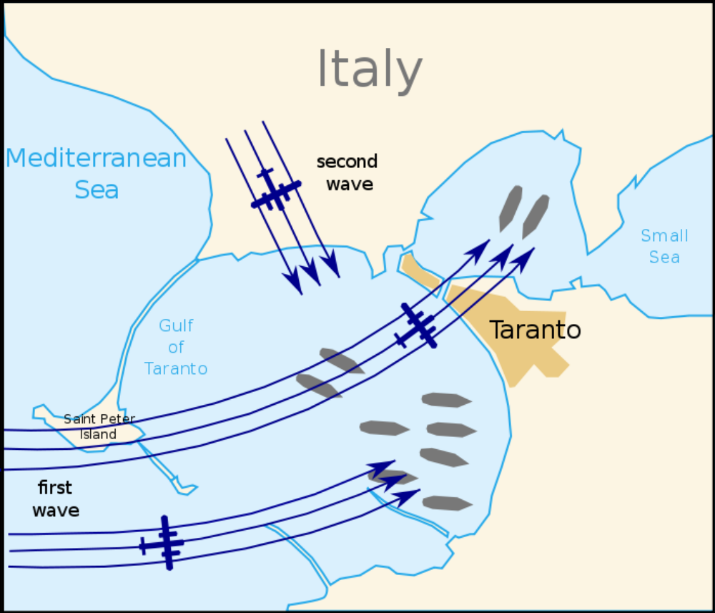
Figure 1British plane's attack path in the battle of Taranto
Repetitive requests from Italy’s Army in Africa for stablishing a support line from the port of Taranto to Libby and the British Navy’s plans for destroying this line were the starting point of war in the port of Taranto. Britain’s counter attacks caused Italy’s powerful military Navy called “Reji Marina” get massive damage before any defensive actions in the first place they were located.
This unnoticed and sudden attack leaded to victory and superiority of British Navy to Italy’s Navy. British airplanes lighted the target area with conventional bombs and fire bullets called “Flare” in order to make it easier for them to launch constant bombardment and then mark and destroy the targets. Admiral “Andrew Kaninghaume”, commander of the British Force, stated after successful flight of the airplanes under his control that:
“Taranto and that unforgettable night which our navy achieved victory so powerfully in an intense battle, will always spark in memories.”
By repetitive flights and constant bombardments British Air Force achieved victory in this strategic area thus it could cut off Italy’s path to Africa (Libya).
The Attack on “Pearl Harbor”
In the morning of (December 7, 1941), hundreds of Japanese fighter planes bombarded American Navy Basements in “Pearl Harbor” in the state of Hawaii. Japanese’s sneak bomb attack lasted only two hours. In this bombardment, 20 American cruisers, 8 destroyers, as well as around 200 planes were ruined and more than 2000 American soldiers and captains were killed and around 1000 wounded. On the other hand, Japanese’s casualties was limited only to 29 planes, 5 submarines, and 65 staff. A day after the attack, “Franklin Roosevelt” asked the congress to issue the permission for war against Japan. The congress approved the president’s enquiry with only one negative vote.
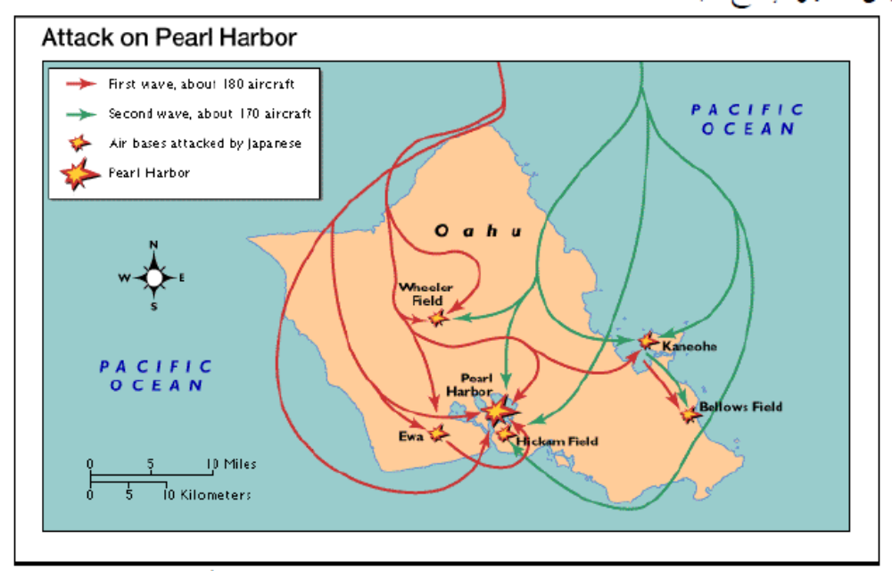
Figure 2-First and second wave of Japan's Attack on "Pearl Harbor"
The attack on “Pearl Harbor” by Japan’s emperor is considered as an amazing action. The goal for this attack was to prevent America to advance their military progress or to interfere in the region which was in the territory of Japan. Japanese made similar attacks simultaneously to America’s bases in Philippine, England, Malaysia, Singapore, and Hong Kong.
To military analysts, the attack on “Pearl Harbor” has some informative points in it which worth thinking about. Some of the points which exhibit Captain Yamamato’s far-sightedness include: gathering thorough information about the target, compatibility of the used facilities and weapons with climatic conditions of the region, investigating the best ways to impose highest levels of destruction to enemy’s properties, emphasis on professional training of the pilots, and designing a clear plan for a successful attack.
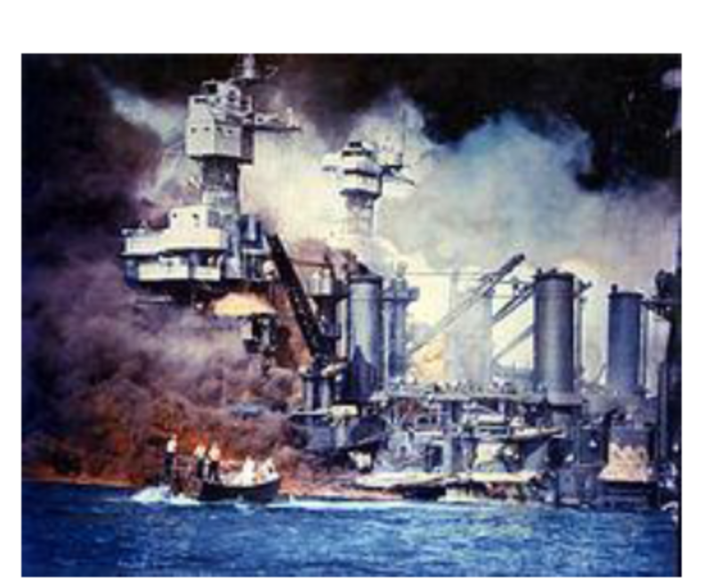
Figure 3-Destruction of Great "Virginia" Cruiser an Hour after the Attack
Beside the previously mentioned points, Yamamoto’s point of reliance was on Japan’s access to aircraft carriers in Pacific Ocean which helped him to make effective decisions and to fly a considerable number of aircrafts towards the target. The fact that there were six aircraft carriers (Akaji, Kaja, Sario, Hirio, Shoukako, and Zuyi Kako) at their service, had convinced the Japanese Navy that victory in “Pearl Harbor” was accessible. Having detective aircraft which could easily take off and investigate the area from above was also a privilege for Japan. By all these facilities, they owned an empowered Aero-Naval force which they could use in a defensive surprise attack.

Battle of Coral Sea
This battle took place in the second worldwide war (1942) in south part of Pacific Ocean. In this battle, Japanese force fought heavily against American and Australian Navies. Although a large number of various fighters from both sides attended the war, battle of “Coral Sea” is mostly considered as a sea battle rather than a joint aero-naval operation because these aircrafts took off from aircraft carriers. However, this massive battle was the first sea war in which the bombers determined the winner of the war.
Japan’s intention in “Coral Sea” was to attack Isle of Solomon and to invade New Guinea which was one of the Australia’s colonies. Australian and then American Navies resisted their attack. At the beginning, Japan succeeded for a while but entrance of American Navy naming Yorktown and Lexington changed the result in favor of America. Also as a result of this attack, some of Japanese floaters were drowned. An hour later, Japan started to use the two aircraft carriers “Shoho” and “Shokaku”. However, the enemy’s electronical listening system revealed their plan. Thus, constant attacks through air and sea put them in a passive position. Nevertheless, Japanese’s tenacity leaded to the drowning of “Lexinton” and severe damage to “York Town”.
But finally American forces, commanded by Captain Admiral Frank J. Fletcher, were able to defeat Japan after two days of intense air and naval battle. As a result, Japan was made to exit Isle of Solomon.
Although Japan managed to capture a strategic victory in the “Battle of Coral Sea”, American forces understood that how precious military espionage was, and at the same time, they understood very well how precious radio silence could be to protect the secret plans they had. And for the next battles they emphasized on the importance of these two factors even more, so that they could win the fight. The “Battle of Coral Sea” introduced a new kind of naval battle, something which is worth analysis and teaching.
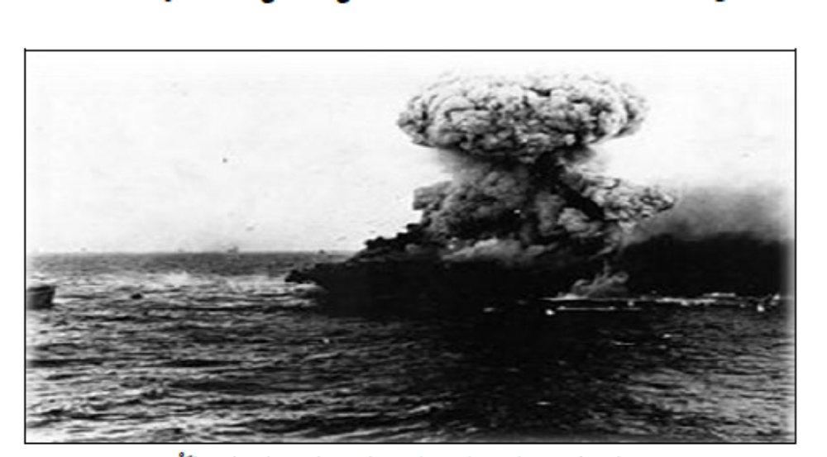
Figure 4-Japan's Air Attack to "Lexinton" Aircraft Carrier
This was the first battle in the sea, in which never none of the either sides fired the other one directly. Instead of that, aircrafts were used as mobile artillery for attacking their enemy for the first time in the history. As a matter of fact, this battle which occurred in the south of Pacific Ocean, was a fight between the two sides’ use of tricks and military knowledge. None of the two sides had the experience of this kind of war.
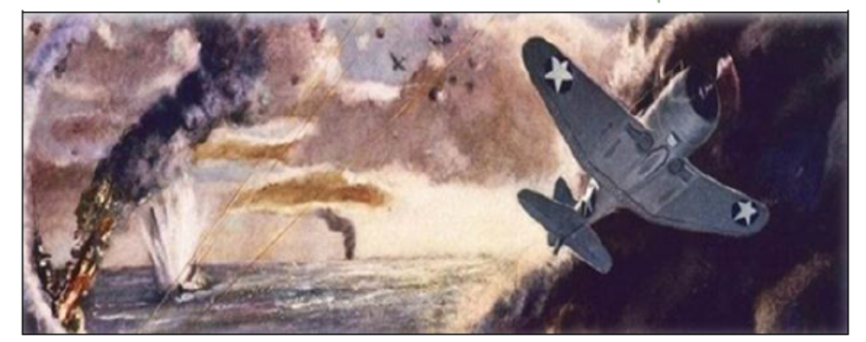Figure 5- America's Attack to Japanese Navy in the Sea
“H. P. Vilmot” the historian of the naval battles has stated in his book “Coral sea, a trap to Japanese navy” that Japanese and American Commanders needed to adapt themselves to the region’s weak and unstable communication systems as the area involved in the battle was enormously wider than the past battles and the speed of the actions was greatly higher than the past. This influenced the time for decision making a lot. Meanwhile, Japan’s situation was more difficult comparing to the opponent, and they also neglected the importance of two factors (speed and accuracy) in exchanging vital information.
The Battle of Midway
The battle in June 1942, in Pacific Ocean near “Midway Island”, is one of the cases in which the wise commanding made rational decisions in time which finally leaded to victory and surprising the enemy.
In this battle, each of the captains on the two sides_ “Captain Yamamoto” (the commander of Japanese Navy) and “Captain Chester Nimitz” (the commander of American Navy) _ had an evaluation of each other’s potential power. However, their evaluations were different. The first one underestimated American forces’ bugging system, while the second one evaluated the situation precisely and made a decision to announce that Japan is able to attack the United States’ territory in the Pacific Ocean.
In the Battle of the Midway, Captain Yamamoto’s decision was to exploit fighter planes in order to achieve what he could not get in “Pearl Harbor”. He hoped to invade Midway and to turn its airport to a base for bombarding Hawaii regularly. Thus the first target of its aircraft carrier was a single attack to Midway in order to destroy the equipment of enemy’s Air Force in the island to capture the island and to land on it.
On June 3, 1942 an American detecting plane which was flying over Midway accidentally found out that Japanese attacking navy was headed towards the island from the west side. After learning this, the pilot of the plane transferred a message to the land so as to attack Japanese Forces in anticipation of their plan.
Making correct decisions and trusting the capabilities of aircraft carriers and rocket cruisers, “Captain Nimitz” managed to surprise Japanese Navy as soon as Japan started to attack. As a result, the United States achieved a remarkable victory in their first sea war in the second worldwide war, and prevented Japan from getting control over the strategic islands in the Pacific Ocean.
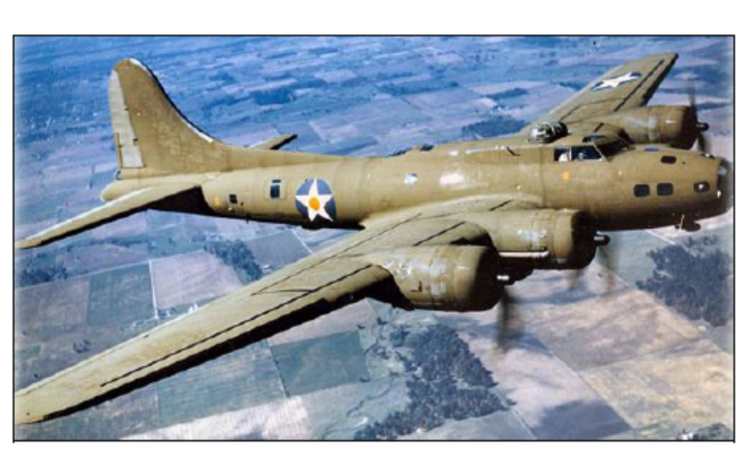
Figure 6- The "B-17" Bomber Had an Important Role in Destroying the Equipment of Japanese Navy by Frequent Flights from Midway Island.
Although in the Battle of Midway all three types of operations from air, surface, and undersurface were important, the presence of airplanes on American aircraft carriers along with bombers “B-17” and “B-26” had greater influence. The three American aircraft carriers were able to destroy four Japanese aircraft carriers and ultimately a Japanese submarine, while their own casualty was only one aircraft carrier. Japanese plan to attack and invade Midway Island was ruined because they had lost their defending forces in the second day of the war.
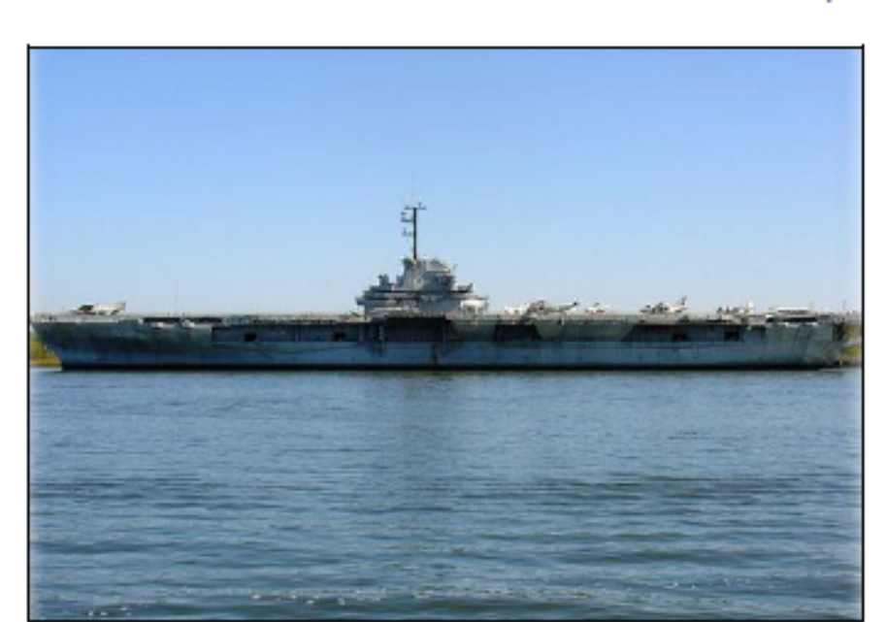
Figure 7- One of the Aircraft Carriers of "York Town" Which Was Drowned by Japanese Bombers.
The Battle of Philippine Sea
In June 1944, the Pacific Ocean was a theatre of an intense war again between American and Japanese aircraft carriers. As this war took place near Philippine, it was called “the Battle of Philippine”. This war leaded to the elimination of Japan’s dominance in high seas as well as Japan’s loss of capacity to use and navigate aircraft carriers in a very large scale. In this battle, which was started by attacking the Mariana Islands through sea and land, America successfully got favorable results by investing on: training pilots, exploiting effective flying tactics, attention to new technologies of war, and designing ships and planes well.
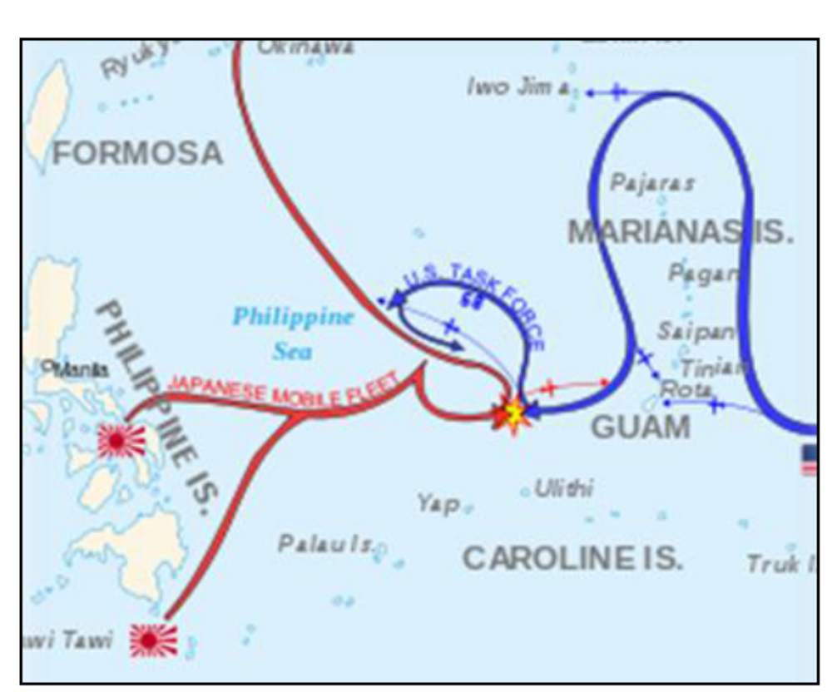
Figure 8- Map of Flight Path for the Planes Which Leaded to the War Area in Philippine Sea
The battle of Philippine Sea has been named as the greatest war between aircraft carriers through the history. In this battle, Japan lost its aircraft carriers as well as a great proportion of powerful war cruisers and never gained the ability to build them again.
The Battle of Atlantic
This battle is considered as the widest, the longest, and the most complicated joint aero-naval operation until Germany’s complete defeat in1945. In this battle, Germany and Italy were on one side, and the allies (generally Canadian and British Navies and Airforce) were on the other side of the war.
In order to survive and continue the war, Britain needed a support to equip them with supplies like different kinds of foodstuff, medicine, industrial, military, and row preliminary materials. The amount of the materials in need sometimes exceeded one million tons in less than a week.
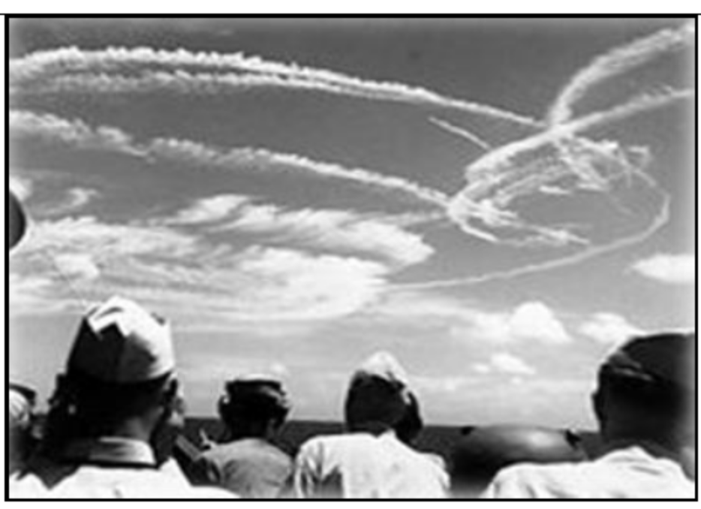
Figure 9- The Track of American Airplanes in the Sky of the Battlefield
The battle of the Atlantic was considered as a kind of tonnage in that the Allies attempted to support Britain constantly and the Axis were trying to attack the traffic of commercial ships and to destroy them.
Although 3,500 commercial ships as well as 175 war floaters were destroyed in the battle of Atlantic, the final result of the war was a strategic victory for the Allies and continuing the process of supporting England (in actual fact supporting Europe). In this battle, both sides’ Air Forces exhibited intense activities and constant effective flights by the Allies fighters and bombers determined the result of the war.
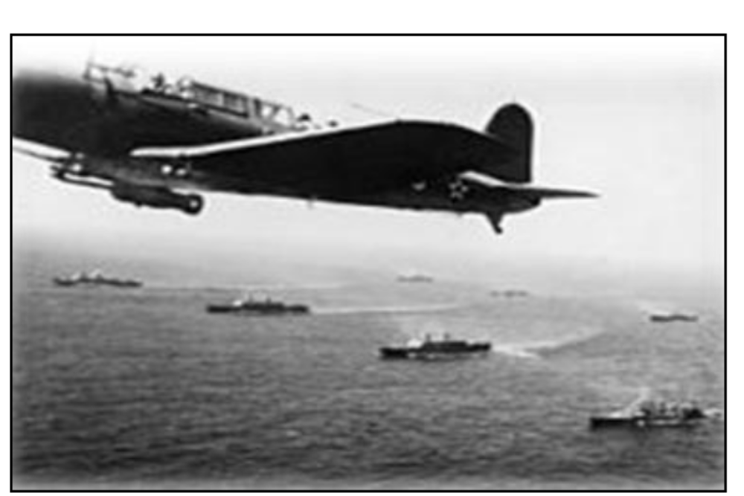Figure 10- American Bombers Flying Over Floaters of Its Navy

Formation of Air and Sea Doctrine
At the end of the Second World War, there were no doubts about the power of war in air and the huge impact of its support on surface forces. The great armies of the world stablished a third force beside the two existing forces -surface army and navy- to exploit its firing capacity and free movements for supporting their goals in sea and land.
Using these invaluable experiences, aero-naval battle is a part of defense doctrine of most of powerful countries now, and it plays a key role in military strategies and of course in attack strategies of those countries. Apparently, the goal of this doctrine is to stand against the probable threats in the water around the Indian Ocean, Persian Gulf, Middle East, and Far East. In 2010, in order to get more freedom in the south part of china’s sea, “President Barak Obama” announced that America is concerned about the essence of Vietnam, Brunei, Taiwan, Malaysia, and Philippine.
Based on this, PENTAGON officially announced that American Navy and Air Force were trying to plan new strategies of aero-naval operations in wide ranges of military operations for confronting their enemies. In this spectrum, they have included capacities of Air Force and Navy seamlessly as well as all operations in surface, air, navy, space, and cyber space.
4In a part of the doctrine of the United States it is stated about Aero-Naval battles:
- Aero-Naval battle is a part of balance strategy which is planned to maintain stability, military balance, and stablish peace in East Asia.
- Aero-naval battles ought to exhibit the authority and capabilities of the United States against any kind of interference or military attack.
- Aero-naval battles ought to bring comfort and relief for the region and those allied with America that any country which may enter a war with America or its friends would bear the consequences.
- America’s lack of ability to support and defend its allies may lead to instability in the region or even struggles or wars.
- “Information, Surviliance, and Reconnaissanse” systems are the Achilles heel of commanding and controlling network in aero-naval battles which should be protected constantly.
America’s aero-naval doctrine has frequently pointed to Persian Gulf region which shows this pivot point is still in the spotlight of the west, and thus there is no wonder why America has held the most varied and number of forces in this region during the course of the Imposed War and after that.
The above mentioned points gain extra importance as maintaining the benefit of Islamic Republic of Iran in the Persian Gulf is a top priority and putting the political tactics aside, attention to military strategies in the form of joint operations, like what Iran’s Air Force and Navy did during the Imposed War, is considered a kind of obstacle for prevention which is effective in maintaining peace and balance in this region.
Although the Pearl Aero-Naval Operation was not geographically vast, the qualitative analysis of this event shows that Iran’s Army and Armed Forces are highly capable of performing effective tactical operations. The general belief of experts who are familiar with defensive issues is that if such a strategy continued throughout the time of war in a systematic framework, it would absolutely have wonderful outcomes for Iranian forces and would accelerate the favorable results of defense plans.
In his book “How to Lose a War at Sea”, Edward J Williams has referred to the ups and downs of military forces in sea battles and has investigated 33 events which were related to important sea battles through the previous century as well as the present time. In that book, Williams draws readers’ attention to the point that how a simple mistake or a thoughtful decision can change the result of the sea war.
In one of the chapters of his book, the author has investigated the Operation: Pearl between Iraqi and Iranian navies. He has noted the importance of this operation in destroying three quarters of Iraqi forces at sea. Also, he believes Iranian Airforce’s effective role to take action the right moment was one of the reasons for Iran’s complete victory to achieve all the goals that had been designed in this operation’s scenario. Although he claimed that Iraq’s possessions and military strength was not comparable to their Iranian opponent, he has asserted that the coordination between Iranian Airforce and Navy in performing a joint aero-naval operation as well as their familiarity with the geography of the battle field were notable too.

Chapter Two
Geography,
Iran and Iraq’s Military Strategy in Persian Gulf

Geography, Iran and Iraq’s Military Strategy in Persian Gulf
A: Natural Geography
Geologists believe that about 500,000 years ago, the early form of Persian Gulf was made beside southern plains of Iran and gradually the current form was shaped as the internal and external layers of the Earth changed. Persian Gulf was at the beginning very vast, in a way that many parts of Borazjan, Behbehan, and Khouzestan Plains were under water up to Zagros Mountains till near the end of third geological period.
In one of the oldest documents about sailing in the Persian Gulf (four centuries before birth of Christ), Niarkhos who was a sailing adventurer, sailed from the river mouth of Send to the strait of Hormuz and anchored beside Karun river after pathing through the Persian Gulf at the time of
Macedonian Alexander. He has referred to the huge and amazing lighthouses in the Persian Gulf in his 146 days travelogue.
The islands in the Persian Gulf had always been under control of the Iranians since Achaemenes Kingdom to the time before Islam. Before and after Islam both, Iranian Navy had always been the greatest power of the region to the extent that the Persian Gulf and Indian Ocean were controlled by Iranians Navy during Alebuye, Ghaznavian, Saljughian, Safavieh, and Afsharieh’s Dynasties.
Arabs had no control over the Persian Gulf before Islam. However, after Islam, they got the control over the coastlines of the Persian Gulf specifically during the time of Omavian and Abbasian’s Dynasty.
The Persian Gulf is 237/473 square kilometers in area and is considered the world’s largest gulf after Mexican Gulf and Hudson Gulf. The deepest part of the Persian Gulf is 93 meters deep and is located at 15 kilometers distance to Tonbe Bozorg where as its shallowest part is between 10 to 30 meters which is located in the west side of the gulf.

“Radious of Action” refers to the capacity to fly from origin to destination, completing the mission, and turning back to the origin spot without refueling.
Washington was an American Navy officer who had an influential role in the creation of Aero-Naval force. His proposed plans are now kept as a precious document in the library of America’s congress.
At the end of worldwide war1, the Furious cruiser was designed for aircrafts’ take-off and landing enjoying a 69meter deck heading forward and an 82meter deck heading backward. This aircraft included nests which were capable to hold 16 aircrafts in their base section and an elevator to transfer them to the deck. This type of structure leaded to the design of today’s aircrafts.
Aero-Naval battles of the second worldwide war and all the relating information to this topic are gathered from the book “تدابیر فرماندهی” by Defense Industry Educational and Research Institution Publication.
Wikipedia websit
From Wikipedia
He has written many books on naval battles especially throughout the second world wide ward. His books are worth reading because of the research, investigating naval battles’ tactics and strategies.
Isoroku Yamamoto
Chester William Nimitz
As many of Japanese airplanes were destroyed by American fighters during air-to-air shooting, an d Japan’s military forces’ balance was disrupted in this war, it is also known as “Hunting ducks in the Mariana islands”
From Wikipedia
This is an expression which turned to a military strategy against commercial floaters and tankers after the Second World War.
The responsibility of planning this proposal is on thought room of aero-naval battle dependent to Evaluation of Budget and Defense Strategies Center. The activities of this organization are investigated and observed by 91 year old “Andrew Marshal” who is the theorist of America’s foreign policy in defense issues.

