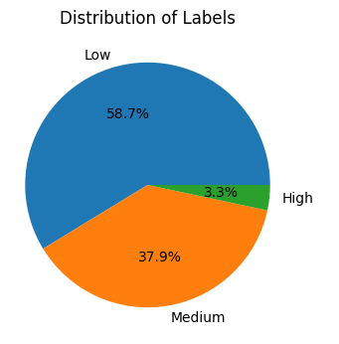
Content:

Usage
Step 1: Loading data
Step 2: EDA (optional)
Step 3: Modelling (optional)
Step 3.1: Preprocess
Step 3.2: Train and Evaluate models
3.2.a: Get model dict
3.2.b: Modelling (default, cv, grid)
Step 3.3: Predict test data

Usage:
./predicting_Irrigation_Need.py --train-dataset ../data/train.csv
--test-dataset ../data/test.csv [--drop-columns id] [--target-variable Irrigation_Need]
[--eda] [--test-size 0.1] [--models all] [--cv 5] [--imbalance smote]
[--grid-config-file ../data/grid_config.cfg] [--models-to-combine rf xgb ..]
[--output submission.csv]

Step 1: Loading data
train, test, test_id = load_data(train_path, test_path, drop_columns)

- As we drop id column from both train and test, we save it for test_id to later put it back after predictions.
- As in our two step process of modelling (custome_process explained later) we create .. delete .. which is not exist in …, we use a try and except loop here to avoid error.
-------------------------------------------------------------------------------------------

Step 2: EDA (optional)
eda(train, target_variable)

- If the user includes EDA in cmd, it will run and prints/shows:
List of columns:
Sample data:
Info:
Description:
Pair plot (if the size of data is less than 10000 to avoid a very long process):
Missing values:
Duplicated values:
Unique values for each column:
…
…
…
…
…
…
..
…
.
.
.
.
.

-------------------------------------------------------------------------------------------

Step 3: Modelling (optional)
If the user includes model in cmd, this main step runs which itself includes several sub steps:

Step 3.1: Preprocess
(
X_train_processed,
X_val_processed,
y_train_enc,
y_val_enc,
le,
preprocessor
) = preprocess_data(train, target_variable, test_size)

First, we separate X, y, then split them to train and val datasets based on the test_size which the user choose. As we have the final dataset for prediction with name test, here we use val.

We have 3 categories for y, (low, med, high) so we use LabelEncoder() to convert them to numerical values.

We gather numerical and categorical columns from X into: num_cols, cat_cols

Here, we have some hard coded part working only for this dataset:
There are natural orders in some columns which we should specify them so we can use OrdinalEncoder() with our defined order mappings on them and OneHotEncoder() for the other categorical columns without any natural order:

ordinal_cols = ['Soil_Type', 'Crop_Growth_Stage']

Soil_Type_mapping = ['Sandy', 'Loamy', 'Silt', 'Clay']
Crop_Growth_Stage_mapping = ['Sowing', 'Vegetative', 'Flowering', 'Harvest']

We have a binary column too:
binary_cols = ['Mulching_Used']
Mulching_Used_mapping = ['No', 'Yes']

Here we create a preprocessor with ColumnTransformer to takes care of all ordinal, binary, other categorical and nume rical column with their related Encoder/Scaler.

Finally, we return the processed X_train,val and y_tain,val in addition to the LabelEncoder instance and our preprocessor which we need them when it is time for predicting.

------------------------------------------------------------------------------------------------------------------------------------------

Step 3.2: Train and Evaluate models
best_model = train_and_evaluate_models(
X_train_processed,
y_train_enc,
X_val_processed,
y_val_enc,
models,
cv,
grid_config_file,
imbalance,
le,
models_to_combine
)

In this function we call several other functions as:

3.2.a: Get model dict

We get the dictionary of {model_name:model_instance} from those models that the user choose. If the user selects all, all available models in th erelated function, other than ['gb', 'svc', 'lsvc', 'qda', 'dummy'] are selected.

3.2.b: Modelling (default, cv, grid)

------------------------------------------------------------------------------------------------------------------------------------------

Step 3.3: Predict test data

------------------------------------------------------------------------------------------------------------------------------------------

Input: train.csv test.csv
no cv:
1. split train.csv to X_train, X_val, y_train, y_val
2. fit(train) on (X_train, y_train)
3. predict on X_val
4. Select the best model based on the score on x_val (=x_holdout)
5. Refit it on X_full, y_full (entire train.csv)
6. predict the unknown test.csv for submission.

With cv:
1. split train.csv to X_train, X_val, y_train, y_val
2. cross_validate on (X_train, y_train)
3. Select the best model based on the average scores of each model over its CV folds on X_train
4. Fit the best_model on X_train and predict the x_val just for sanity check

Columns:
numer = 20, types = object and float64
List:
['id', 'Soil_Type', 'Soil_pH', 'Soil_Moisture', 'Organic_Carbon',
'Electrical_Conductivity', 'Temperature_C', 'Humidity', 'Rainfall_mm',
'Sunlight_Hours', 'Wind_Speed_kmh', 'Crop_Type', 'Crop_Growth_Stage',
'Season', 'Irrigation_Type', 'Water_Source', 'Field_Area_hectare',
'Mulching_Used', 'Previous_Irrigation_mm', 'Region', 'Irrigation_Need']

Rows:
630,000 observation, no null, no duplicated, no missing value

There is imbalance in the label categories:

No outlier:
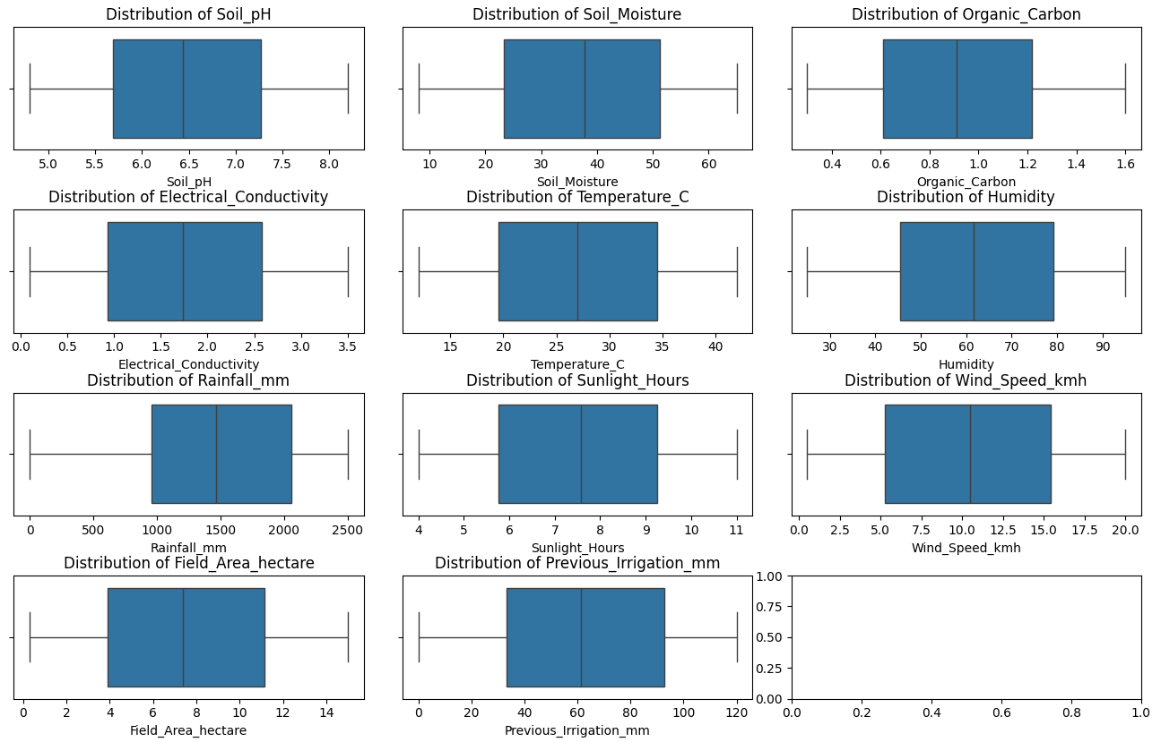

For some columns, an ordinal encoding makes sense:

1. Soil_Type
Soil differs in water retention, drainage, infiltration, irrigation frequency needs.
We can use ordinal encoding as:
Sandy < Loamy < Silt < Clay

2. Crop_Growth_Stage
There is a natural order in it, so we should use ordinal encoding as:
Sowing < Vegetative < Flowering < Harvest

3. Mulching_Used
It is binary, so we simply go with:
No: 0, Yes: 1
4. Irrigation_Need
Our target should be encoded using label encoder as:
Low < Medium < High

almost all models had no difficulty in differentiating low and high. The ambiguity was in the middle class: medium as we see here:
…

# 'hgb best':
# "max_iter": [200],
# "learning_rate": [0.1],
# "max_depth": [10],
# "min_samples_leaf": [50]

# "xgb best":
# "n_estimators": [300],
# "max_depth": [5],
# "learning_rate": [0.2],
# "subsample": [1.0],
# "colsample_bytree": [0.8],
# "reg_lambda": [1],
# "reg_alpha": [0]

