Introduction
An Online Cab Booking System is a modern web or mobile-based application that allows users to book cabs for their travels easily and conveniently. The system allows customers to register, login, and book cabs based on their location and preferred route. The main objective of the Online Cab Booking System is to provide users with a convenient platform to book cabs for their travel needs, either through a website or mobile application.
The system aims to streamline the process of booking cabs, ensuring an easy and hassle-free user experience. It can benefit both riders and cab drivers by providing a quick and reliable service.
The advent of online cab booking systems has revolutionized the way people commute, combining convenience, transparency, and efficiency into one seamless experience. These platforms serve as a digital bridge between riders and drivers, enabling users to book cabs effortlessly through mobile applications or websites. By leveraging technology and data, these systems have addressed many traditional pain points of transportation, such as the hassle of hailing a cab on the street or uncertainty regarding fares and availability.
An online cab booking system operates on a robust technological backbone that ensures real-time connectivity, precise location tracking, and secure payment gateways. The system primarily consists of three interconnected interfaces: one for riders, another for drivers, and an administrative panel for managing operations. This tripartite approach allows for smooth interaction and coordination among all stakeholders.
For riders, the online cab booking system offers unparalleled convenience. A user-friendly interface guides them through the registration and login process, making it easy to set up a profile and access services. Once logged in, users can search for cabs based on their location and vehicle preferences, such as sedans, SUVs, or economy options. With the help of integrated GPS technology, the system provides real-time tracking, allowing users to monitor the cab's location and estimated time of arrival. The process is further streamlined through digital payment integration, eliminating the need for cash transactions and providing multiple secure options, such as credit/debit cards, digital wallets, or UPI payments. Additionally, the system often includes a feedback mechanism, empowering users to rate and review drivers, which helps maintain service quality.
Problem In Existing System
Existing online cab booking systems, while offering convenience, often suffer from several recurring problems. Users frequently experience issues with inaccurate estimated times of arrival due to traffic or driver deviations, leading to frustration and wasted time. Surge pricing, while intended to balance supply and demand, can be unpredictable and exorbitant, leaving customers feeling exploited during peak hours. Finding available cabs in certain areas or during peak times can be a significant challenge, resulting in long wait times or outright unavailability. Communication between drivers and riders can be cumbersome, sometimes leading to misunderstandings about pickup locations or ride details. Furthermore, safety concerns remain a significant issue, with reports of driver misconduct or lack of proper verification processes. Finally, the cancellation policies of some platforms can be punitive, penalizing riders for legitimate cancellations while sometimes failing to hold drivers accountable for canceling confirmed rides. These problems highlight the need for improvements in areas like real-time tracking, transparent pricing models, better driver-rider communication, and enhanced safety measures.
Need for System
The Online Cab Booking System aims to provide a convenient, efficient, and safe transportation solution, addressing the limitations of traditional taxi services by offering on-demand booking, real-time tracking, and transparent pricing.
- Increased Convenience: A modern online cab booking system offers unparalleled convenience by allowing users to book rides from anywhere, anytime, through their mobile devices, eliminating the need to hail cabs on the street or call dispatch services.
- Improved Efficiency: These systems optimize cab dispatch and routing, leading to faster pickup times and more efficient use of resources, benefiting both riders and drivers. Real-time tracking and navigation minimize delays and ensure smoother rides.
- Enhanced Safety: Reputable online cab booking platforms typically incorporate safety features like GPS tracking, driver verification, and emergency contact options, providing riders with a greater sense of security compared to traditional taxi services.
- Transparent Pricing: Online systems often provide fare estimates upfront, allowing riders to know the cost of their trip before booking. This transparency helps avoid surprises and disputes regarding fares. Digital payment options further streamline the payment process.
- Data-Driven Insights: These systems collect valuable data that can be used to improve service quality, optimize routes, and understand rider preferences. This data can be used by both the company and city planners for better urban transportation management.
Scope Of Proposed System
The proposed Online Cab Booking System will encompass a comprehensive suite of features designed to streamline the cab booking process for both riders and drivers. For riders, the system will offer user-friendly mobile and web interfaces for registration, login, profile management, cab searching based on location and vehicle type, real-time ride tracking, secure digital payment integration, and a rating/review system for drivers. Drivers will have dedicated mobile interfaces for registration, profile management, accepting/rejecting ride requests, navigation to pickup and drop-off locations, and viewing trip earnings. The system will include an administrative panel for managing users, drivers, cab information, fare adjustments, reporting, and handling customer support inquiries. The initial scope will focus on local rides within a defined geographic area, with potential future expansion to include outstation trips and integration with other transportation services. The system aims to prioritize security, reliability, and scalability to ensure a positive user experience and accommodate future growth.
An Online Cab Booking System encompasses a diverse range of features, functionalities, and objectives tailored to meet the demands of riders, drivers, and system administrators. By leveraging advanced technologies and efficient workflows, the system aims to deliver a seamless, secure, and scalable solution for modern transportation needs. The scope of such a system ensures its usability, reliability, and adaptability for current and future requirements.
Feasibility Study & Fact Finding Technique Applied
A feasibility study for an Online Cab Booking System would typically involve examining several key areas to determine the viability of the project. Here's a breakdown of the study areas and the fact-finding techniques that could be applied:
1. Technical Feasibility:
- Study Area: Assesses the technical resources and infrastructure required to develop and implement the system. This includes evaluating the availability of suitable hardware, software, development tools, and skilled personnel. It also considers the scalability of the technology to handle future growth.
- Fact-Finding Techniques:
- Technical Interviews: Talking to software developers, system architects, and IT professionals to understand the technical requirements and challenges.
- Technology Research: Investigating available technologies, platforms, and tools that could be used for development (e.g., programming languages, database systems, mapping APIs).
- Vendor Evaluation: Assessing the capabilities and costs of potential technology vendors for software, hardware, or cloud services.
- Proof of Concept: Developing a small-scale prototype to test the feasibility of key technical aspects.
2. Economic Feasibility:
- Study Area: Analyzes the financial viability of the project. This involves estimating the development costs, operational costs (e.g., server maintenance, marketing), and potential revenue streams. It also considers the return on investment (ROI) and payback period.
- Fact-Finding Techniques:
- Cost Estimation: Gathering data on the costs of development, hardware, software, personnel, marketing, and ongoing maintenance.
- Market Research: Analyzing the demand for online cab booking services in the target area, including competitor analysis and pricing strategies.
- Financial Modeling: Creating financial projections to estimate revenue, expenses, and profitability.
- Surveys and Interviews: Gathering data from potential users about their willingness to pay for the service.
3. Operational Feasibility:
- Study Area: Examines the operational aspects of the system, including how it will be implemented, managed, and used. This involves defining the processes for booking rides, dispatching cabs, handling payments, and providing customer support. It also considers the impact on existing operations and the need for training.
- Fact-Finding Techniques:
- Process Analysis: Studying the current cab booking processes (if any) to identify areas for improvement.
- Workflow Analysis: Designing the new workflows for the online system, including user registration, booking, dispatch, payment, and support.
- Interviews with Stakeholders: Talking to potential users, drivers, and administrative staff to understand their needs and requirements.
- User Surveys: Gathering feedback from potential users on the proposed system and its features.
- Public Forums: Holding meetings to discuss the project with the community and address any questions or concerns.

Hardware and Software Requirement
Hardware:
Processor: 64-bit, Quad-core,2.5GHz minimum per core
RAM: 2/4 GB for development and evaluation use
HDD/SSD: 256GB

Software:
Operating System: Windows 10,11, 12, Linux
Database: MongoDB
Frontend: ReactJS
Backend: NodeJS, Express JS
Frameworks/libraries: Tailwind CSS library
Version control: GitHub
Design Specification
ER Diagram
UML Diagrams
ER Diagram:
user_id
user_name
Email
password
Works for both
own
Is selected for
model
image
type
price
standard
premium
Drop_location
time
pickup_location
date
Pay for
Payment_id
Payment_type
user

Customer
Driver
cab
Ride

Chosen for

booking

UML Designs:
Data Flow diagram:

- Level : 0
CAB BOOKING
USER
DATABASE

- Level : 1
Customer Details
Cab Booking
Admin
User
Cab Details
Booking
Booking Cancel/Confirm
DATABASE

- Level : 2

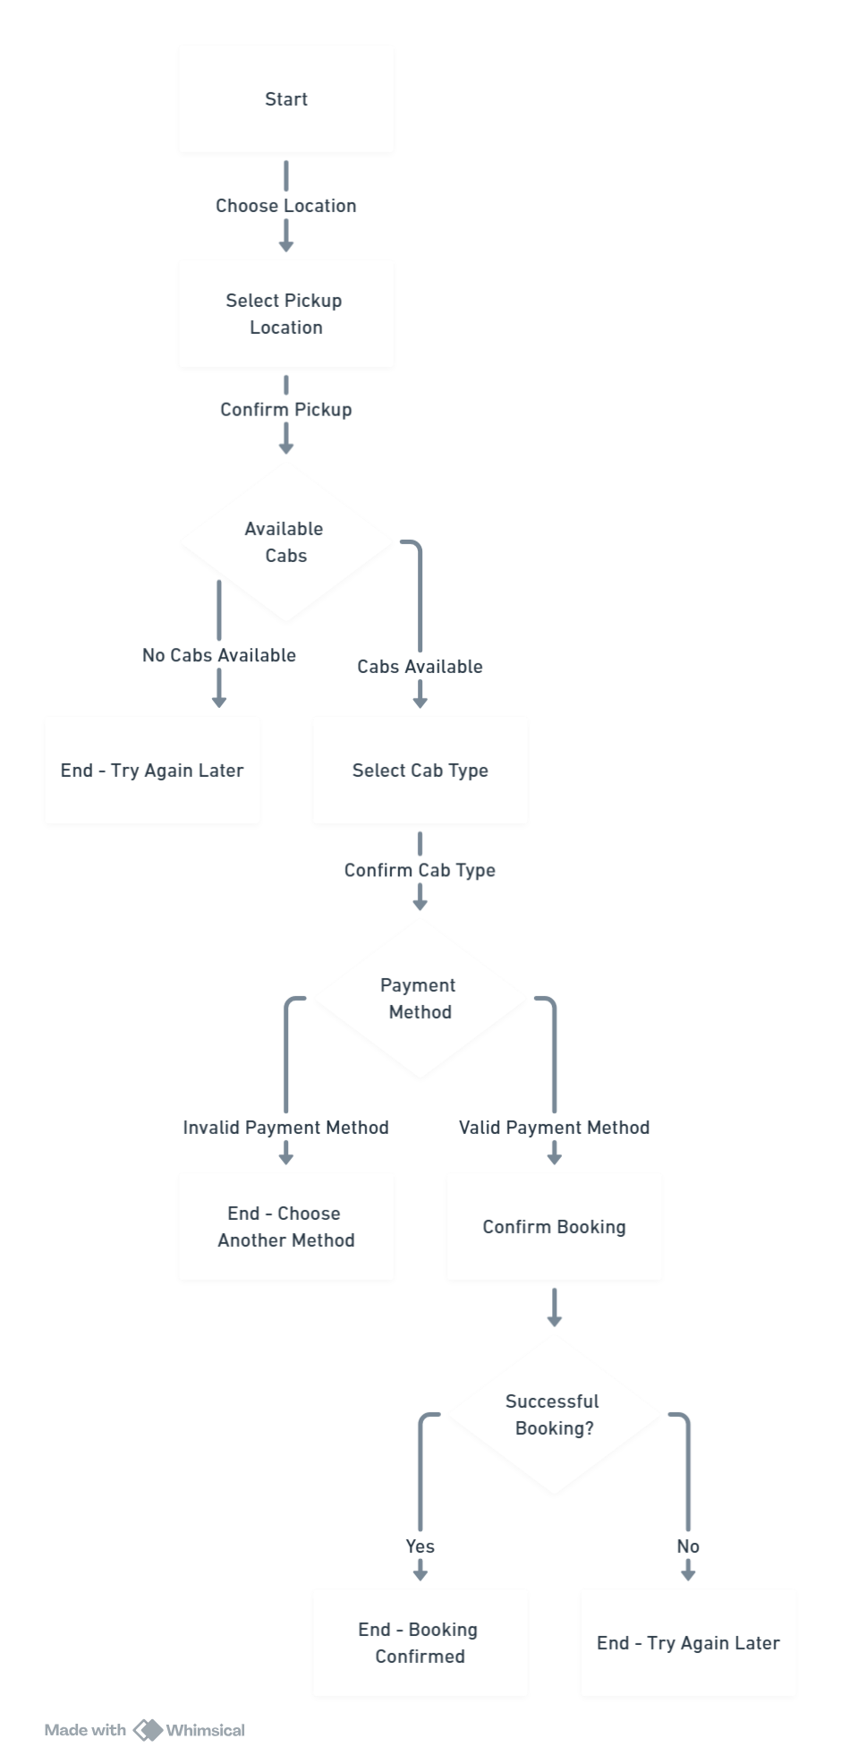
Available Cabs
Start
Select Pickup Location
Try Again Later
Select Cab Type
Choose another Method
Confirm Booking
Booking Confirmed
Try again later

1.Class Diagram :
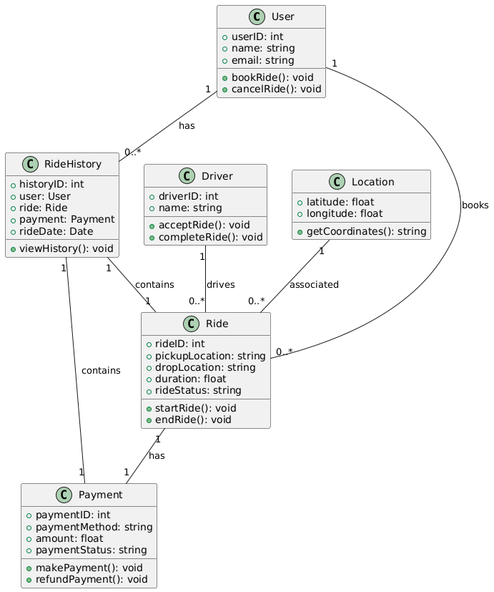

2.Object Diagram:
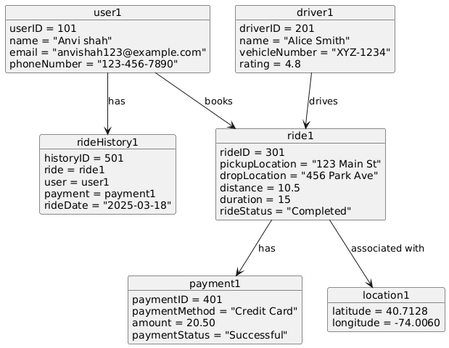
3.Use-Case Diagram:
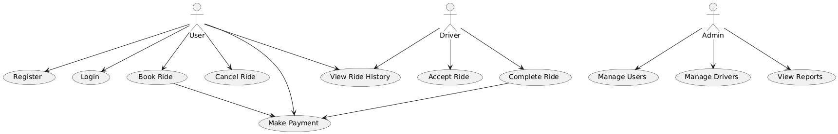

4.Sequence Diagram:
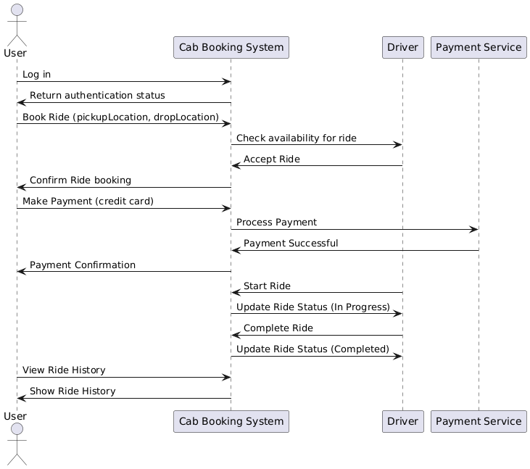
5.Activity Diagram:
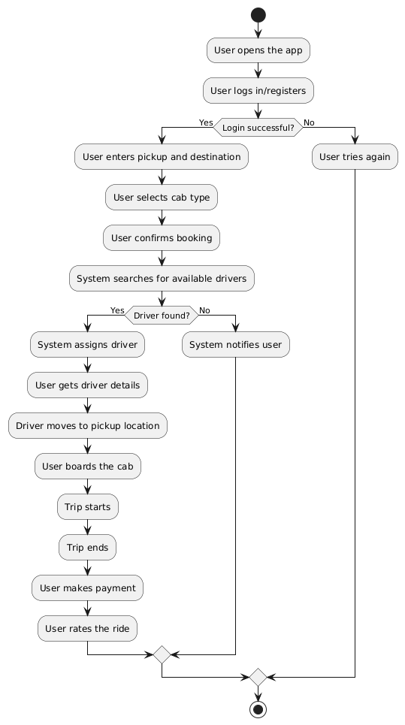
6.Deployment Diagram:
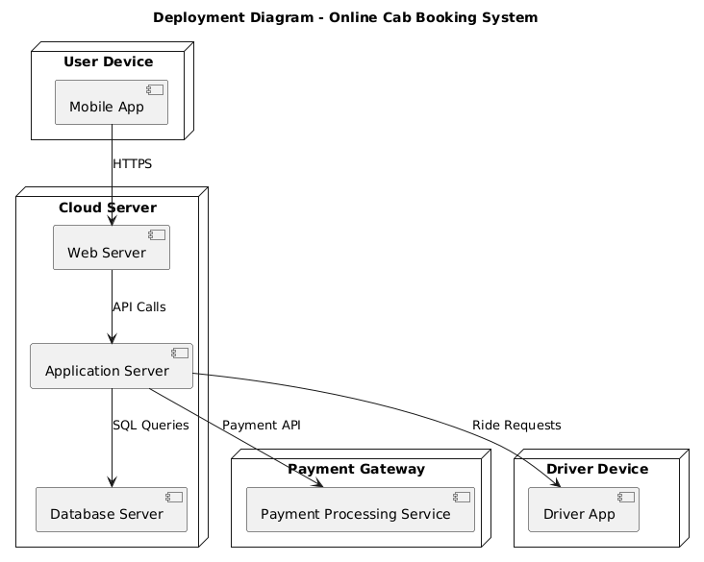

Data Dictionary
Sr. No | Field Name | Data Type | Description | Table Name | Constraints
1 | cab_name | String | Cab's Name | Booking Schema | NOT NULL, VARCHAR(255)
2 | cab_price | Number | Cab's Price | Booking Schema | NOT NULL, DECIMAL(10, 2), CHECK (cab_price >= 0)
3 | cab_image | String | Cab's Image URL | Booking Schema | VARCHAR(2048)
4 | cab_type | String | Cab's Type | Booking Schema | NOT NULL, VARCHAR(50)
5 | cab_seats | Number | Number of seats | Booking Schema | NOT NULL, INT, CHECK (cab_seats > 0)
6 | User_email | String | User's Email | Booking Schema | NOT NULL, VARCHAR(255), FOREIGN KEY (email) REFERENCES Sign_in_Schema(email)
7 | Booking_time | Date | Date of Booking | Booking Schema | NOT NULL, DATETIME
8 | Cab_name | String | Cab's Name | Cab Schema | NOT NULL, VARCHAR(255)
9 | Cab_price | Number | Price of cab | Cab Schema | NOT NULL, DECIMAL(10, 2), CHECK (cab_price >= 0)
10 | Cab_type | String | Types of cab | Cab Schema | NOT NULL, VARCHAR(50)
11 | Cab_seats | Number | Number of seats | CabSchema | NOT NULL, INT, CHECK (cab_seats > 0)
12 | email | String | Email ID | Sign in Schema | NOT NULL, VARCHAR(255), PRIMARY KEY, UNIQUE
13 | password | String | Password | Sign in Schema | NOT NULL, VARCHAR(255)
14 | name | String | User's Name | Sign Up Schema | NOT NULL, VARCHAR(255)
15 | email | String | Email ID | Sign Up Schema | NOT NULL, VARCHAR(255), PRIMARY KEY, UNIQUE
16 | password | String | Password | Sign Up Schema | NOT NULL, VARCHAR(255)
17 | id | Number | ID (Primary Key) | Test Schema | NOT NULL, INT, PRIMARY KEY, AUTO_INCREMENT
18 | name | String | name | Test Schema | NOT NULL, VARCHAR(255)
19 | User_email | String | User’s email | User schema | NOT NULL, VARCHAR(255), FOREIGN KEY (email) REFERENCES Sign_in_Schema(email), CHECK (User_email LIKE '%@%.%')
20 | User_cabs | Object | User cabs | User Schema | JSON (or similar depending on database)
21 | Customer_id | String | Customer’s id | User Data | NOT NULL, VARCHAR(255), PRIMARY KEY
22 | Customer_name | String | Customer’sname | UserData | NOT NULL, VARCHAR(255)
23 | Customer_email | String | Customer’s email id | User Data | NOT NULL, VARCHAR(255), CHECK (Customer_email LIKE '%@%.%')
24 | Customer_password | String | Customer’s password | User Data | NOT NULL, VARCHAR(255)
25 | agreeToTerms | Boolean | Agree to terms | User Data | NOT NULL

Table Design
1.Booking Schema
Sr. No | Field Name | Data Type | Description | Table Name | Constraints
1 | cab_name | String | Cab's Name | Booking Schema | NOT NULL, VARCHAR(255)
2 | cab_price | Number | Cab's Price | Booking Schema | NOT NULL, DECIMAL(10, 2), CHECK (cab_price >= 0)
3 | cab_image | String | Cab's Image URL | Booking Schema | VARCHAR(2048)
4 | cab_type | String | Cab's Type | Booking Schema | NOT NULL, VARCHAR(50)
5 | cab_seats | Number | Number of seats | Booking Schema | NOT NULL, INT, CHECK (cab_seats > 0)
6 | User_email | String | User's Email | Booking Schema | NOT NULL, VARCHAR(255), FOREIGN KEY (email) REFERENCES Sign_in_Schema(email)
7 | Booking_time | Date | Date of Booking | Booking Schema | NOT NULL, DATETIME

2.Cab Schema
1 | Cab_name | String | Cab's Name | Cab Schema | NOT NULL, VARCHAR(255)
2 | Cab_price | Number | Price of cab | Cab Schema | NOT NULL, DECIMAL(10, 2), CHECK (cab_price >= 0)
3 | Cab_type | String | Types of cab | Cab Schema | NOT NULL, VARCHAR(50)
4 | Cab_seats | Number | Number of seats | CabSchema | NOT NULL, INT, CHECK (cab_seats > 0)

3.Sign In Schema
1 | email | String | Email ID | Sign in Schema | NOT NULL, VARCHAR(255), PRIMARY KEY, UNIQUE
2 | password | String | Password | Sign in Schema | NOT NULL, VARCHAR(255)

4.Sign Up Schema
1 | name | String | User's Name | Sign Up Schema | NOT NULL, VARCHAR(255)
2 | email | String | Email ID | Sign Up Schema | NOT NULL, VARCHAR(255), PRIMARY KEY, UNIQUE
3 | password | String | Password | Sign Up Schema | NOT NULL, VARCHAR(255)

5.Test Schema
1 | id | Number | ID (Primary Key) | Test Schema | NOT NULL, INT, PRIMARY KEY, AUTO_INCREMENT
2 | name | String | name | Test Schema | NOT NULL, VARCHAR(255)

6.User Schema
1 | User_email | String | User’s email | User schema | NOT NULL, VARCHAR(255), FOREIGN KEY (email) REFERENCES Sign_in_Schema(email), CHECK (User_email LIKE '%@%.%')
2 | User_cabs | Object | User cabs | User Schema | JSON (or similar depending on database)

7.User Data
1 | Customer_id | String | Customer’s id | User Data | NOT NULL, VARCHAR(255), PRIMARY KEY
2 | Customer_name | String | Customer’sname | UserData | NOT NULL, VARCHAR(255)
3 | Customer_email | String | Customer’s email id | User Data | NOT NULL, VARCHAR(255), CHECK (Customer_email LIKE '%@%.%')
4 | Customer_password | String | Customer’s password | User Data | NOT NULL, VARCHAR(255)
5 | agreeToTerms | Boolean | Agree to terms | User Data | NOT NULL

Sample Input & Output Screen
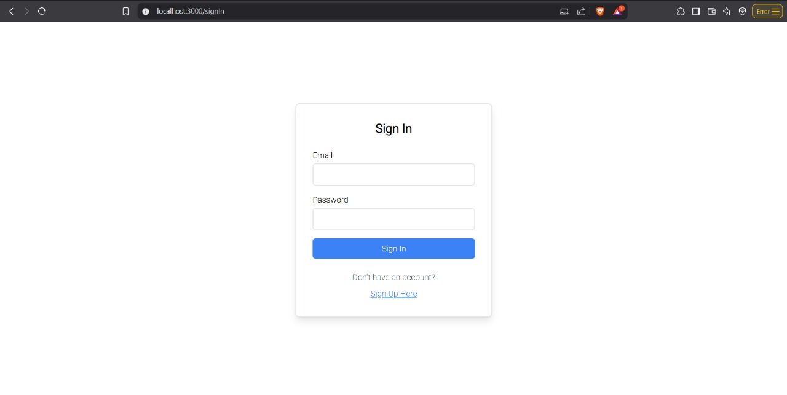

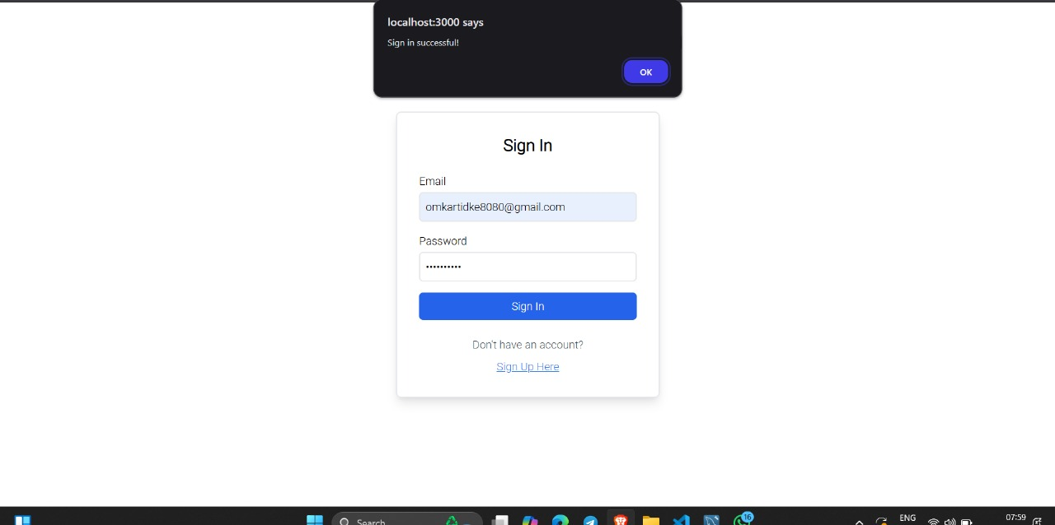
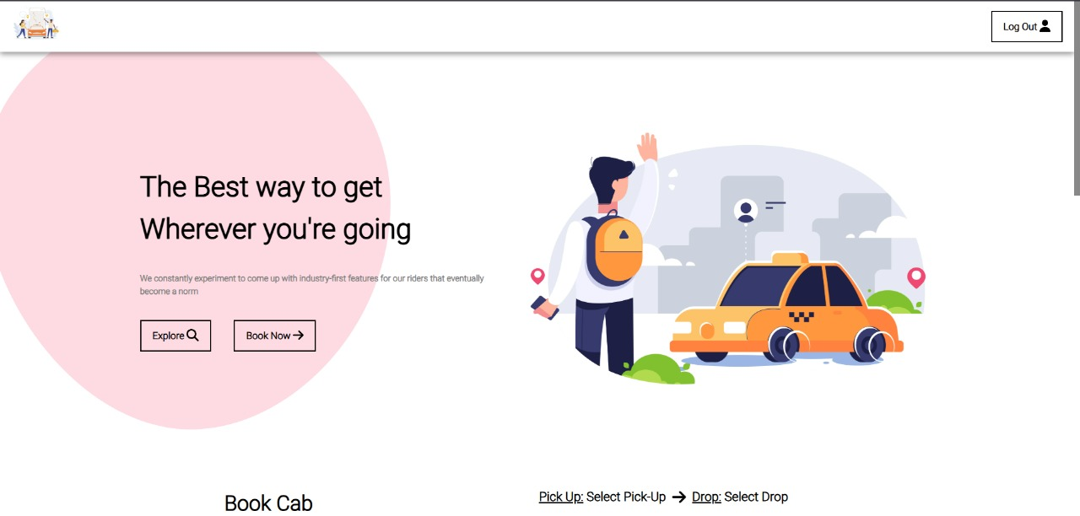

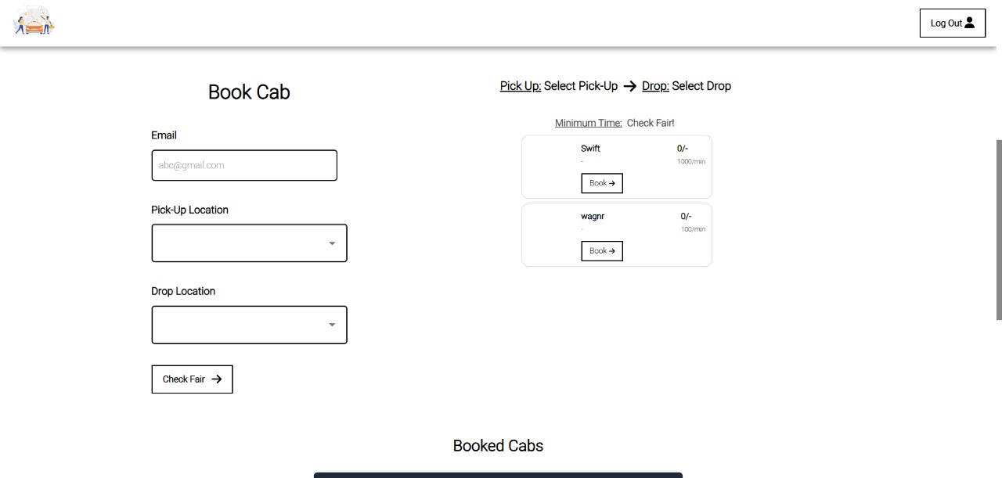
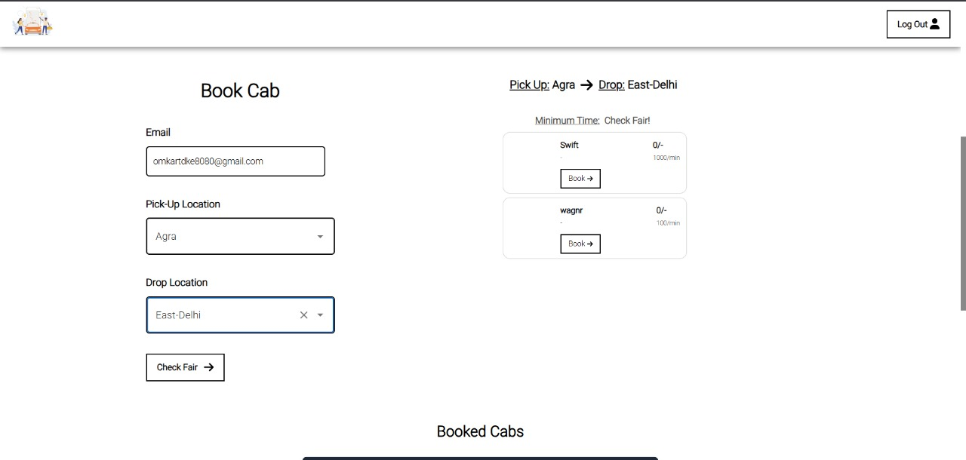

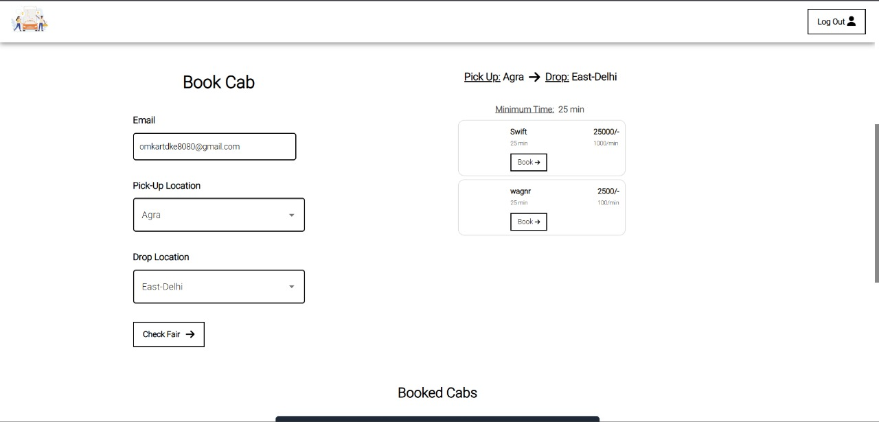




Testing Strategy
1.Functional Testing:
Functional testing is a critical phase of software testing that focuses on verifying that each feature and function of the online cab booking system operates according to the defined requirements and specifications. This involves testing the system from the user's perspective, ensuring that all functionalities, such as user registration and login, the booking process (including location input, cab selection, fare calculation, booking confirmation, and cancellation), driver functionalities (availability status, ride acceptance/rejection, navigation), payment gateway integration, real-time tracking, ride completion, feedback mechanisms, and the admin panel (user/driver management, reporting, etc.), work as expected. Testers create test cases that cover both positive and negative scenarios, providing valid and invalid inputs to ensure the system handles various situations gracefully and produces the correct outputs. The goal of functional testing is to validate that the system delivers the intended functionality to the end-users and meets the business requirements.
2.Performance Testing
Performance testing is essential for evaluating the responsiveness, stability, and scalability of the online cab booking system under various workload conditions. This type of testing aims to identify potential bottlenecks and ensure the system can handle a large number of concurrent users and transactions without performance degradation. Key performance testing activities include load testing, which simulates a typical user load to assess system behavior and identify performance limitations; stress testing, which pushes the system beyond its normal capacity to determine breaking points and understand its behavior under extreme conditions; and endurance testing, which evaluates system performance over an extended period. Performance metrics such as response times for key actions (e.g., booking a ride, searching for cabs), transaction throughput, resource utilization (CPU, memory, disk I/O), and error rates are monitored and analyzed. The results of performance testing help optimize the system's infrastructure and code to ensure a smooth and efficient user experience even during peak usage periods.
3.Usability Testing
Usability testing is a crucial part of the software development process that focuses on evaluating the user-friendliness, intuitiveness, and overall user experience of the online cab booking system. This involves observing real users as they interact with the system, typically through predefined scenarios that mimic typical tasks like booking a ride, managing their profile, or contacting customer support. Testers gather feedback from these users regarding the ease of navigation, clarity of information, efficiency of completing tasks, and overall satisfaction with the system. Usability testing can also involve A/B testing different design options to determine which version provides a better user experience. The goal of usability testing is to identify any usability issues or pain points that users might encounter and to make necessary improvements to the system's design and functionality to ensure a positive and efficient user experience for all users, including those with disabilities by performing accessibility testing.

Limitations
While a comprehensive testing strategy is crucial, certain limitations can impact the testing process for an online cab booking system. Time and budget constraints can restrict the scope of testing, potentially limiting the number of test cases and the depth of exploration in areas like performance or edge-case scenarios. The availability of realistic test environments and data, particularly for simulating real-world traffic patterns and user behavior, can also be a challenge. Furthermore, it's impossible to test every single possible combination of inputs and user actions, meaning some defects might slip through testing and appear in production. Finally, changes to requirements or the system itself during development can necessitate rework and potentially introduce new issues, requiring careful management of the testing process to adapt to these changes.
While online cab booking systems have transformed the way people commute, they are not immune to technical, user-related, operational, and financial limitations. Addressing these challenges requires ongoing investment in technology, rigorous testing, user education, and robust operational management. By understanding and mitigating these limitations, the system can continue to improve and provide a more reliable and efficient service to all stakeholders.

Future Enhancement

1. AI and Machine Learning Integration
- Ride Recommendations: Use AI to provide personalized suggestions based on a user’s travel history and preferences.
- Demand Prediction: Analyse patterns to predict peak hours and high-demand areas, ensuring better resource allocation.
- Smart Fare Optimization: Dynamic pricing models that balance affordability and profitability using AI.

2. Sustainability and Eco-Friendly Features
- Electric and Hybrid Vehicles: Offer environment-friendly transportation options to reduce carbon footprints.
- Ride Pooling Services: Introduce shared rides to lower travel costs and optimize resource usage.

3. Advanced Safety Features
- Facial Recognition for Drivers: Ensure that the verified driver is the one providing the service.
- Emergency Assistance: AI-based monitoring systems that detect unusual ride behaviour and automatically trigger alerts.

4. Multi-Modal Integration
- Connected Transport Ecosystem: Integrate other transport modes such as buses, trains, and bike taxis for seamless travel experiences.
- Last-Mile Connectivity: Include options like e-scooters or bikes for short-distance travel.

5. Autonomous Vehicles
- Driverless Cabs: Long-term integration of self-driving cars to offer futuristic, fully automated rides.
- Fleet Management: Efficient control of autonomous vehicles using AI-based dashboards.
Conclusion
The Online Cab Booking System has revolutionized the way people travel, offering a seamless, efficient, and user-centric approach to modern transportation. By integrating cutting-edge technologies such as real-time GPS tracking, secure digital payments, and intuitive interfaces, the system ensures convenience for riders and operational efficiency for drivers. Its administrative tools further strengthen the platform by enabling effective management of users, drivers, fares, and reporting, ensuring smooth operations.
Despite its advantages, the system is not without limitations. Challenges such as dependence on internet connectivity, algorithmic inaccuracies, and driver verification issues highlight areas for improvement. Additionally, user dissatisfaction with surge pricing and operational hurdles in remote regions emphasize the need for continuous optimization.
However, with its scalability and potential for future enhancements, the system is poised for significant growth. Features like AI-driven predictions, eco-friendly transport options, and integration with autonomous vehicles showcase its adaptability to evolving user demands and technological advancements.
In conclusion, the Online Cab Booking System represents a transformative leap in transportation. While it has challenges, its emphasis on innovation, safety, and customer experience ensures it will remain a cornerstone of modern commuting solutions. With ongoing development, it holds the promise of making travel smarter, safer, and more sustainable for all.

Bibliography
IMAGES:
https://www.cab.com/background.jpg
CODES (MERN Stack):
* "React.js: Version 18.2.0, https://reactjs.org/"
* "Express.js: Version 4.18.2, https://expressjs.com/"
* "Node.js: Version 16.14.0, https://nodejs.org/"
* "MongoDB: Version 5.0, https://www.mongodb.com/"
* "Mongoose: version 6.0, https://mongoosejs.com/”

